CS 491 SDD

CYBERSHIELD

Submitted by:

Ahmet Mete YILDIRIM

Mustafa Mert MUTLU

Arda SEVİNÇ

Augustus Okafor

Contents
1. INTRODUCTION 2
2. SOFTWARE DESIGN 2
2.1. SOFTWARE ARCHITECTURE 2
2.2. TOPOLOGY 5
2.3. MODULE STRUCTURE 5
2.4. INTERFACE DESIGN 6
2.5. CLASS DIAGRAMS 10
2.6. SEQUENCE DIAGRAMS 12
2.7. USER INTERFACE (UI) MOCKUPS 14
2.8. DATA DESIGN 16
2.9. TOOLS and TECHNOLOGY 17
3. PROJECT SCHEDULE 17

1. INTRODUCTION

Cybershield is a practical and efficient Bash script developed to improve the security of Linux-based systems by integrating nftables for geolocation-based filtering. The primary aim of Cybershield is to offer an easy and effective way to block or allow traffic based on geographic locations, helping to reduce the risks associated with malicious activities like malware, ransomware, phishing, and DDoS attacks.

Geolocation-based filtering is an increasingly valuable tool in cybersecurity. By restricting or allowing access from specific countries or regions, Cybershield enables administrators to set up customized firewall rules that enhance system security. This method provides a straightforward and scalable solution to managing incoming traffic, without the need for complex configuration or manual intervention.

The script uses a free, open-source geolocation database from db-ip.com, ensuring that the IP address ranges for each country are regularly updated and accurate. Cybershield automatically creates country-specific sets for nftables, which streamlines the process of implementing geolocation-based filtering. This automation reduces the potential for human error and provides users with the flexibility to tailor their firewall settings according to their specific needs.

Cybershield is designed to be lightweight and efficient, with a minimal memory footprint, making it ideal for systems with limited resources. Its configuration is simple and user-friendly, relying on a configuration file rather than complicated command-line arguments. The script’s source code is heavily commented to make customization and understanding easy for users.

This project is especially useful in environments that require automated adjustments to firewall rules based on geolocation. Whether used for personal servers or enterprise-level infrastructure, Cybershield provides a powerful solution for enhancing network security with nftables. This document will explore the design, functionality, and key features of the Cybershield project, highlighting its role in strengthening network defenses.

2. SOFTWARE DESIGN

2.1. SOFTWARE ARCHITECTURE

Cybershield is designed with simplicity and efficiency in mind, focusing on providing an automated solution for geolocation-based network traffic filtering using nftables. The architecture is modular, lightweight, and flexible, ensuring that users can easily configure and maintain it while maintaining high performance. The system relies on a combination of Bash scripting and nftables to filter traffic based on IP address ranges associated with specific countries or regions.

1. System Overview

At its core, Cybershield automates the process of fetching geolocation data, generating corresponding nftables sets, and applying them to firewall rules. The script retrieves up-to-date country-specific IP address ranges from the db-ip.com geolocation database and configures the system’s firewall based on that data. By automating the entire process, Cybershield reduces the chances of manual errors and offers a customizable, easy-to-use solution for implementing geolocation-based filtering.
The architecture is designed to be flexible and adaptable, allowing for easy customization and ensuring that the system can run efficiently even on low-resource devices. The main components of the architecture include:

2. Core Components

Bash Script: The Bash script is the main driver of Cybershield. It handles the entire process of downloading geolocation data, parsing it, and generating the nftables sets that will be used for firewall rules. Specifically, the script is responsible for:
Fetching IP address ranges from db-ip.com.
Parsing and organizing the data into country-specific sets.
Generating nftables rules that reference these sets.
Ensuring that the firewall configuration is kept up-to-date with the latest data.
Geolocation Database (db-ip.com): This free and regularly updated database provides the country-specific IP address ranges that Cybershield uses. The script pulls data from this database without requiring users to accept any EULA, ensuring it remains open and accessible.
nftables: The system uses nftables as the core framework for implementing firewall rules. It creates sets based on the IP address ranges and applies them to filter network traffic according to geographic location.

3. Data Flow

Data Retrieval:
The script starts by querying db-ip.com to get the latest geolocation data. The user can set the script to run on a regular schedule or manually trigger it when needed.
Data Parsing and Set Creation:
Once the data is retrieved, the script parses the IP address ranges and organizes them into sets that are specific to each country. These sets are formatted to be compatible with nftables.
nftables Configuration:
The script then generates the necessary configuration files for nftables, creating rules that reference the country-specific sets. These rules are designed to filter traffic from specific geographic regions.

Rule Application:
The generated rules are applied to the system’s nftables configuration, allowing traffic to be filtered according to the country-specific sets. The rules are automatically integrated into the firewall.
Updates and Maintenance:
Cybershield supports automatic updates. When new data becomes available or when IP address ranges change, the script refreshes the sets and updates the firewall rules accordingly.

4. Configuration Management

Cybershield uses a configuration file to store user settings, simplifying the setup process. This configuration file allows users to easily adjust various parameters, such as:
Which countries or regions to include in the IP sets.
The installed version of nftables, ensuring compatibility with the script.
Memory usage settings to optimize performance on systems with limited resources.
This central configuration file eliminates the need for complex command-line options and makes the system easy to configure and maintain.

5. Compatibility and Extensibility

Cybershield is compatible with several popular Linux distributions, including Ubuntu Server, Fedora Server, and Raspberry Pi OS. The script detects the installed version of nftables and adjusts its behavior to ensure that it works smoothly across different environments. For older versions of nftables that do not support wildcard includes, the script generates "include-all" files, allowing users to include all country-specific sets with a single reference.
Additionally, the design of Cybershield is modular, allowing for easy future extensions. New features, such as support for additional geolocation databases or advanced firewall rule configurations, can be integrated without significant changes to the core system.

6. Performance Considerations

Cybershield is optimized for performance and designed to run efficiently even on systems with limited resources, such as low-power servers or Raspberry Pi devices. The script is lightweight and completes the process of generating sets and configuring the firewall quickly—around 11 seconds on a low-power quad-core server with SSD storage. Furthermore, users can load only the required sets to reduce memory consumption, ensuring that Cybershield remains efficient even in resource-constrained environments.

7. Security and Error Handling

Cybershield places a strong emphasis on security. The script validates all incoming data from the geolocation database to prevent the introduction of malicious content. Error handling is built into the script, providing clear error messages and logs that help users troubleshoot any issues. The logging mechanism also tracks script execution, making it easier to monitor the system’s activity and ensure smooth operation.

2.2. TOPOLOGY

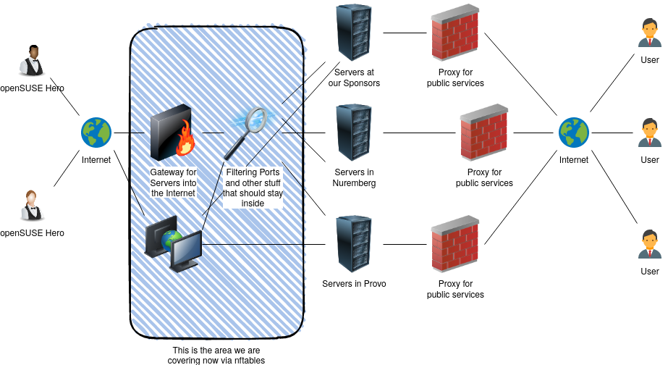

2.3. MODULE STRUCTURE

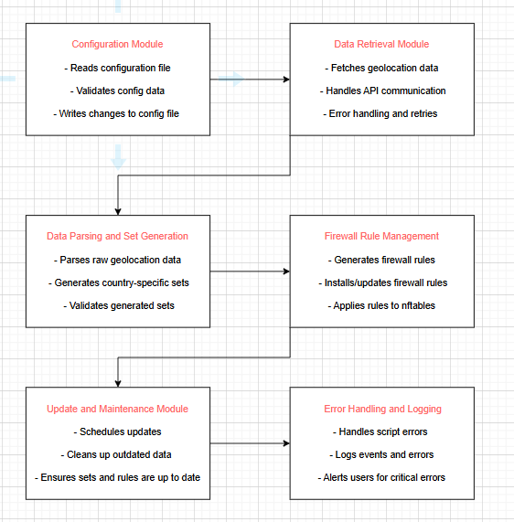

2.4. INTERFACE DESIGN

System Components:

Main Script (geo-nft.sh)

Purpose: This script serves as the primary interface for configuring and managing geolocation filtering rules with nftables. It allows users to define countries to filter, fetches relevant geolocation data, and generates nftables rule sets for firewall integration.

Input:
-A configuration file (/etc/geo-nft.conf) containing user-defined settings like countries to filter, nftables version, memory settings, etc.
Geolocation data fetched from db-ip.com.

Output:
-nftables sets for each country’s IP address range (both IPv4 and IPv6).
-Configured nftables rules (either individual sets or a unified file for all sets).
-Logs or error messages for debugging and status updates.
Key Functions:
-configure_geo_nft: Parses the user configuration file and sets up initial variables.
-generate_geo_sets: Downloads and processes geolocation data, creating the necessary IP address sets.
-create_nftables_rules: Generates nftables rule files based on the IP sets.
validate_nftables_version: Ensures compatibility between the script and the installed nftables version.
-clean_up: Optionally reduces memory usage by limiting the number of IP sets loaded.

Configuration File (/etc/geo-nft.conf)

Purpose: The configuration file provides a flexible way for users to specify the settings for geolocation filtering.
Input Format:
-The file consists of key-value pairs to define settings.
-It includes sections for country codes, memory settings, and script behavior preferences.
Parameters:
-countries_to_include: A comma-separated list of country codes (e.g., "US, DE, IN") whose IP ranges should be included.
-countries_to_exclude: A list of country codes (e.g., "CN, RU") whose IP ranges should be excluded.
-enable_ipv4: A boolean value (true/false) to enable IPv4 filtering.
-enable_ipv6: A boolean value (true/false) to enable IPv6 filtering.
-memory_optimization: A boolean value (true/false) to determine if the script should optimize memory by only loading necessary sets.
-nftables_version: The version of nftables installed on the system, used to adjust the rules configuration.
-db_ip_url: The URL to retrieve the geolocation data.

Geolocation Data (db-ip Database)

Purpose: The script uses a free geolocation database from db-ip.com to gather IP address ranges for different countries.
Interface:
-The script makes HTTP requests to the db-ip API to fetch geolocation data in JSON format, which it then processes.
Data Structure:
The data includes:
-country_code: Two-letter ISO country codes (e.g., "US").
-ip_ranges: A list of IP ranges in CIDR format (e.g., "192.168.0.0/24").
Data Handling:
-The script parses this data to generate separate sets for IPv4 and IPv6 IP ranges.
Fetching Data:
-The script uses a GET request to retrieve the geolocation data, processes the response, and extracts the relevant information for use in nftables rule creation.

nftables Rule Configuration

Purpose: The script generates nftables rule files that can be easily included in the system’s firewall configuration to apply geolocation filtering.
Input:
-The IP sets generated for each country.
-The user configuration from /etc/geo-nft.conf (e.g., selected countries to include or exclude, IPv4/IPv6 settings).
-The version of nftables installed on the system.
Output:
-Rule files that include references to the generated nftables sets.
-These rules can either be included individually or with a single include-all file for convenience.
Rule Structure:
-Each country is represented by an nftables set (e.g., @us_ranges), which matches traffic from that country's IP addresses.
Flexibility:
-The generated rules can be modified to either block or allow traffic based on the user’s needs.
-Multiple countries can be included via the include-all file, or individual country files can be referenced.

Logging and Debugging

Purpose: The script includes logging functionality to help users track its operation and troubleshoot issues.
Log Types:
-Info Logs: General information about the script’s progress (e.g., "Downloading geolocation data...").
-Error Logs: Errors encountered during the execution (e.g., "Failed to retrieve data from db-ip.com").
-Debug Logs: Detailed output for debugging purposes.
Log File Locations:
-Logs are saved in a standard directory (/var/log/geo-nft.log).
-Debug logs can be printed to the console or stored in a separate debug log file.

User Interaction Flow:
Initial Setup:
-The user installs the script on their system.
-The user configures the settings in /etc/geo-nft.conf, specifying which countries to filter and other preferences.
Running the Script:
-The user executes the script (geo-nft.sh).
-The script fetches the geolocation data, processes it, and generates the corresponding nftables rules.
Review and Application:
-The user reviews the generated rule files and incorporates them into the system’s firewall configuration.
-Optionally, the user can include multiple country sets by using the include-all file.

Post-Execution:
-Logs are reviewed to ensure the script executed correctly and to check for errors or misconfigurations.
-The user applies the final nftables rules to their system’s firewall.

Error Handling and Validation:
Configuration File Validation:
Ensures all required settings are correctly specified in /etc/geo-nft.conf. Missing or incorrect entries result in an error message guiding the user to resolve the issue.
Geolocation Data Retrieval:
If the script fails to retrieve data from db-ip.com, it attempts to retry or exits with a clear error message indicating the issue.
nftables Version Compatibility:
The script checks the installed version of nftables and adjusts the rule generation accordingly. If there’s a version mismatch, the script provides recommendations for resolving the issue.

2.5. CLASS DIAGRAM
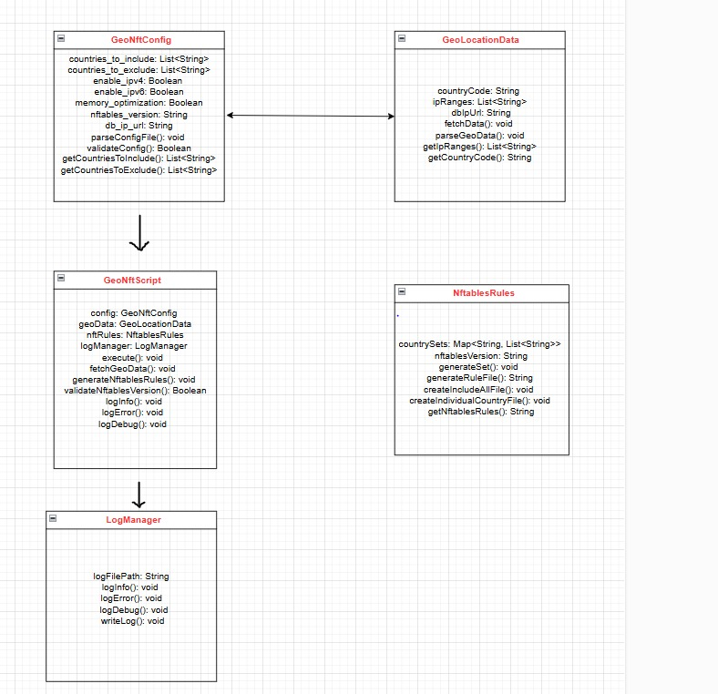

2.6. SEQUENCE DIAGRAM

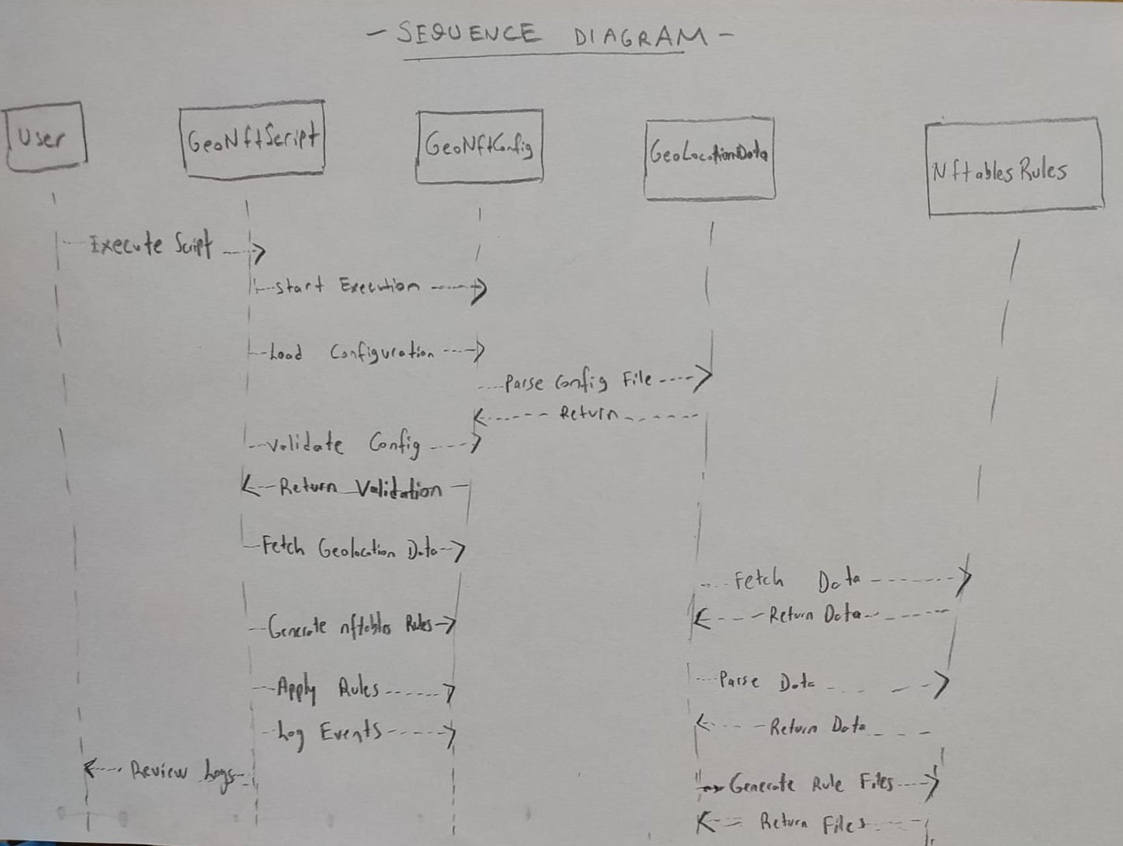

2.7. USER INTERFACE (UI) MOCKUPS

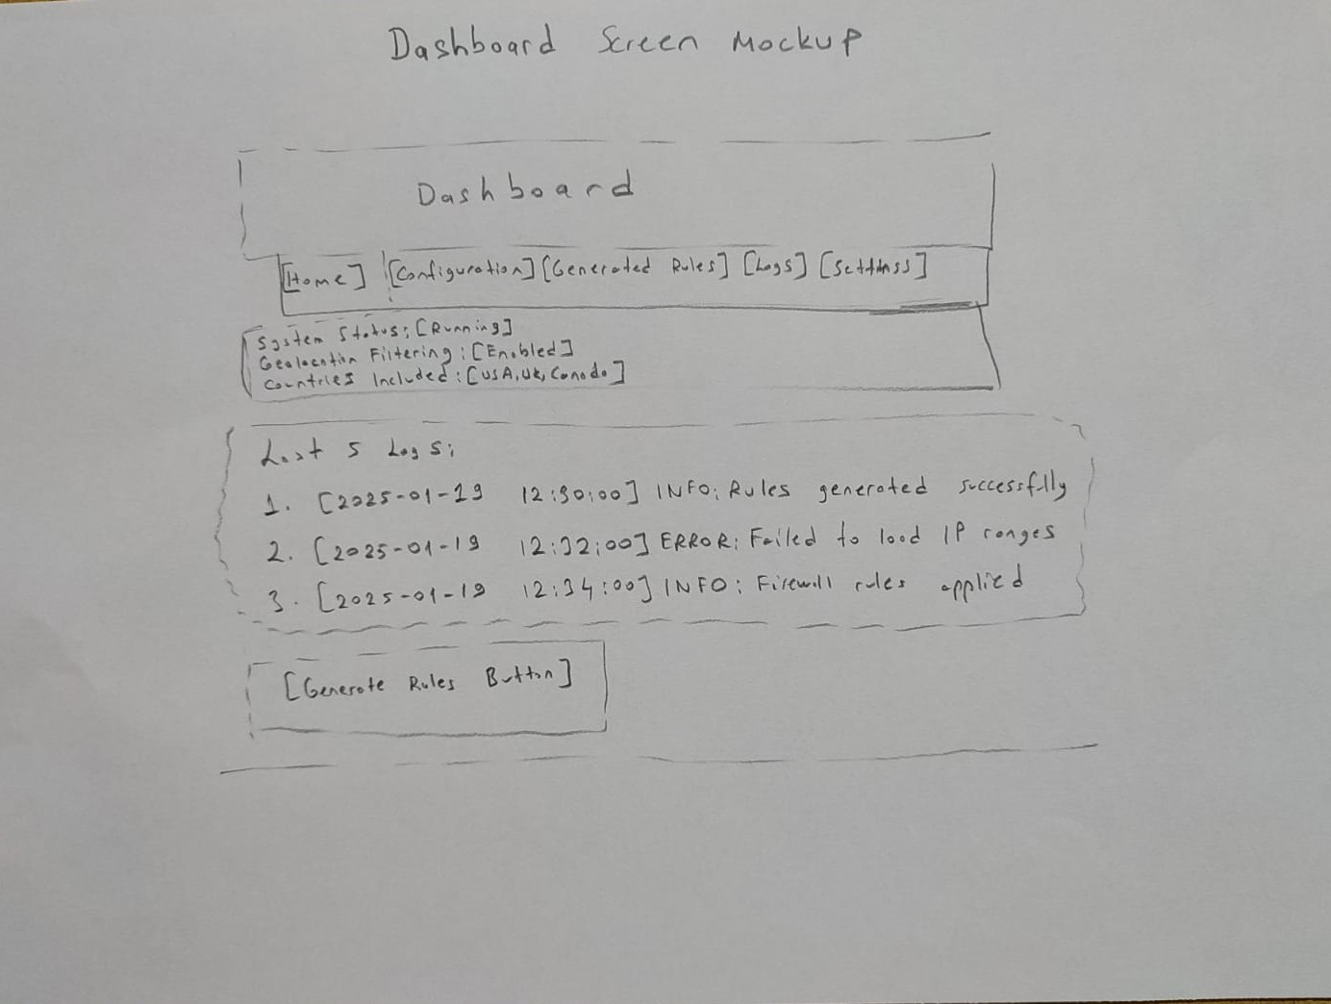

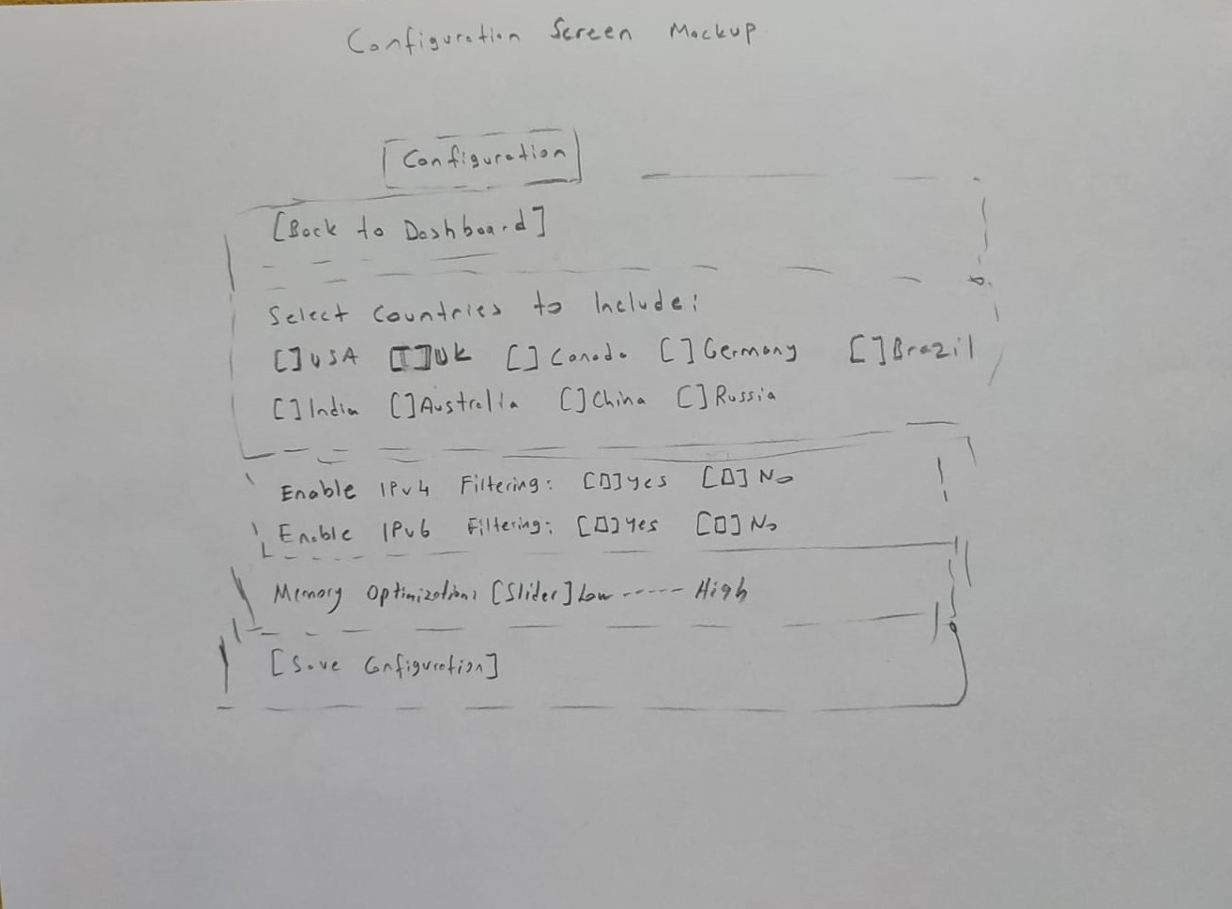
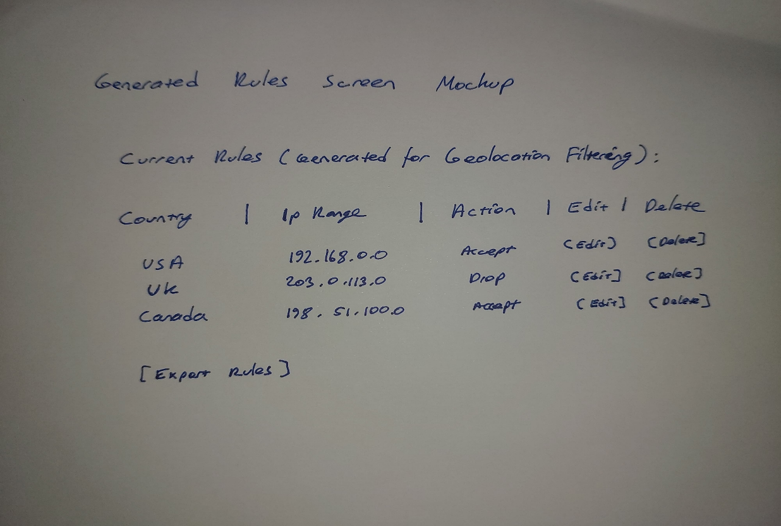
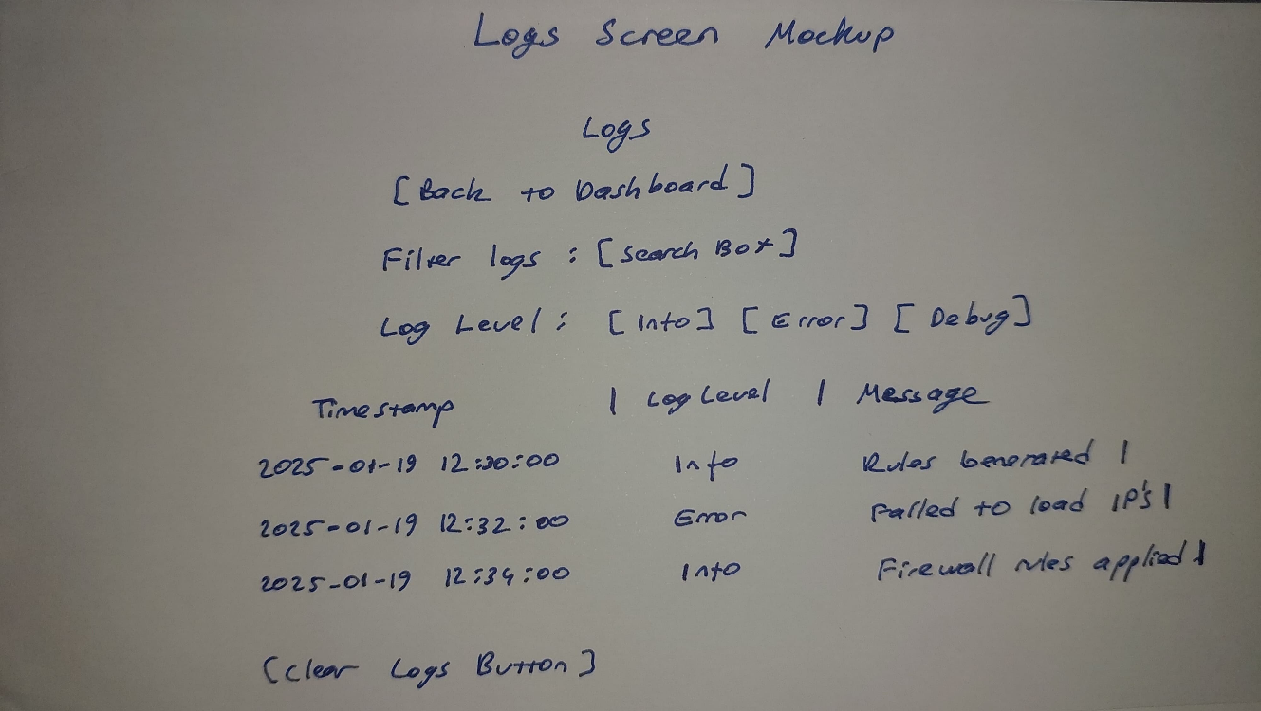

2.8. DATA DESIGN

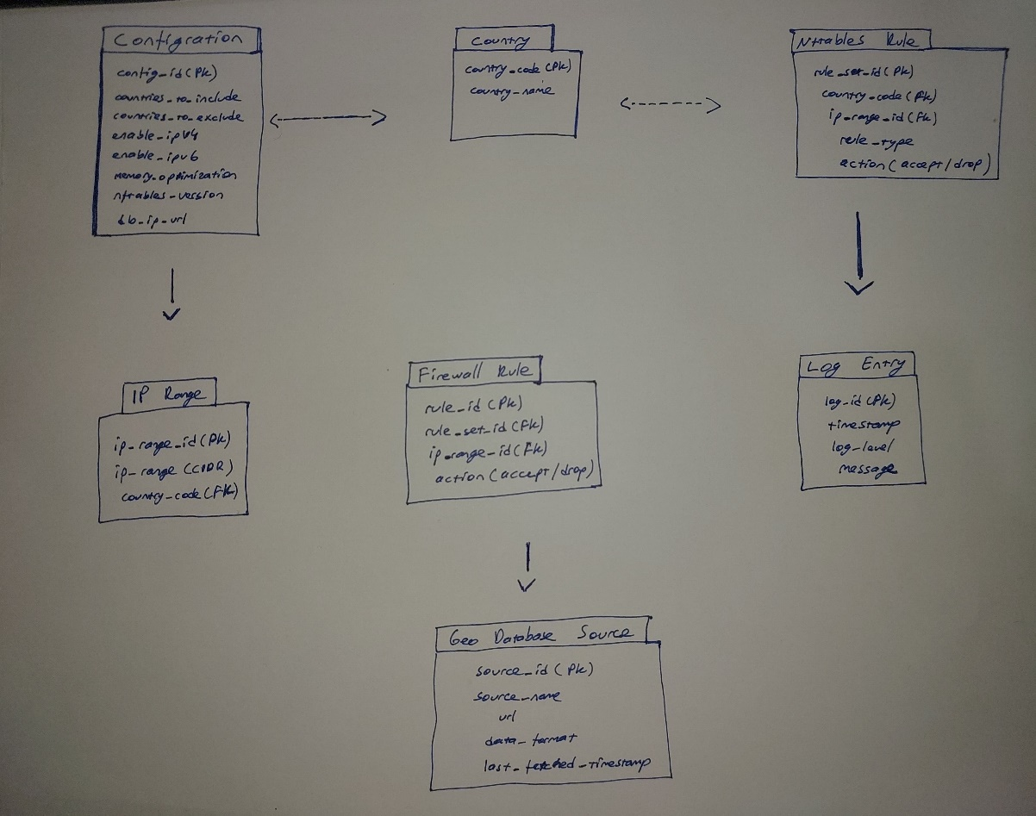

TOOLS and TECHNOLOGY

1. Bash Scripting

The core of Cybershield is built using Bash scripts. Bash, a widely used shell scripting language, allows for automation of system-level tasks and enables the easy interaction with system tools such as nftables. By using Bash, the script can run directly on Linux servers without requiring additional dependencies, providing simplicity and ease of deployment.

Why Bash?

High compatibility with Linux-based systems.
Simple syntax that makes the script easy to understand and modify.
Ideal for automating system configuration and management tasks.

2. Nftables

Nftables is the core technology used for creating firewall rules in Cybershield. It is the modern replacement for iptables and provides advanced packet filtering capabilities on Linux systems. Nftables is highly efficient and flexible, allowing for the creation of complex firewall rules based on a variety of conditions, including geolocation.

Why Nftables?

Provides improved performance over older solutions like iptables.
Native support for sets, which is a key feature for implementing country-specific IP filters.
Easier rule management with less complexity compared to older systems.

3. db-ip.com Geolocation Database

The db-ip.com database is used to fetch geolocation data for the Cybershield system. This free and open-access API provides IP address ranges mapped to specific countries, which can be used to create firewall rules based on geolocation. This data is periodically updated to ensure the system is using the most current IP address ranges.

Why db-ip.com?

Free and no EULA requirements for commercial and non-commercial use.
Accurate and up-to-date geolocation data for IP ranges.
Simple integration with Bash scripts for fetching and processing data.

4. Linux Operating System

The project is designed to run on Linux servers, where nftables is natively supported. Linux offers stability, security, and flexibility, making it the ideal environment for deploying firewall management scripts. The project has been tested and validated on popular Linux distributions, including Ubuntu, Fedora, and Raspberry Pi OS, ensuring broad compatibility.

Why Linux?

Natively supports nftables and other firewall tools.
High customization and control over system processes.
Strong community support for troubleshooting and improvements.

5. Git

Git is used for version control in the project. This allows the development team to track changes to the codebase, collaborate on new features, and ensure that previous versions can be reverted if needed. Git is also used to manage releases of the Cybershield script, ensuring that users can easily access the latest version.

Why Git?

Efficient version control for managing script changes and updates.
Facilitates collaboration between multiple developers.
Simplifies deployment by using versioned releases.

6. Cron Jobs

To automate the process of fetching new geolocation data and updating firewall rules, cron jobs are used. This Linux-based tool allows the scheduling of repetitive tasks, such as downloading the latest geolocation data or running the firewall script at set intervals. It ensures that the Cybershield system stays up-to-date with minimal user intervention.

Why Cron?

A lightweight and effective tool for automating tasks in a Linux environment.
Provides precise scheduling and task repetition.
Simple to configure and manage for periodic tasks.

7. Text-based User Interface (CLI)

The Cybershield project uses a text-based Command Line Interface (CLI) to interact with users. This interface provides a straightforward way for system administrators to manage firewall rules and configurations. The interface is simple, with clear menus and user prompts, making it ideal for administrators who are comfortable with working in a terminal environment.

Why CLI?

Fast and resource-efficient, especially for low-powered systems.
No need for graphical resources or additional libraries.
Ideal for system administrators familiar with terminal-based management.

8. Documentation and User Guides

A key component of Cybershield is its well-documented setup and user guide. The guides are written in clear, concise language, helping users configure the tool, troubleshoot issues, and understand the functionality of the firewall system. Documentation is available both in the project repository and in-built into the CLI for on-demand access.

Why Documentation?

Ensures that users can quickly understand how to set up and configure the system.
Helps reduce the need for external support.
Provides detailed troubleshooting steps for common issues

3. PROJECT SCHEDULE

 | METE | ARDA | MERT | AUGUSTUS
Week 1-2 | Set up version control (GitHub/GitLab) | Plan script structure and core flow | Define technical requirements and dependencies, prepare README | Research db-ip.com geolocation database and its usage
Week 3-4 | Write initial setup code for downloading and parsing the db-ip database | Implement configuration file structure | Research nftables version detection, prepare dynamic include logic | Develop script to handle creation of nftables sets
Week 5-6 | Implement code to generate country-specific nftables address range sets | Store generated sets in user-defined directory with clear structure | Ensure sets are correctly formatted for nftables compatibility | Create IPv4 and IPv6 sets from geolocation data
Week 7-8 | Conduct system testing (Ubuntu, Fedora, Raspberry Pi OS) | Develop benchmarking tool for performance testing | Review and test generated sets for nftables loading speed | Optimize memory usage, test on systems with limited RAM
Week 9-10 | Write logic to create nftables rules for country-specific sets | Create user guide for firewall rule setup | Integrate configuration file system, ensure customization options | Implement wildcard include system for older nftables versions
Week 11-12 | Fix bugs related to parsing db-ip database and generating sets | Finalize user guide and documentation | Polish script, assist with final testing and bug fixing | Conduct end-to-end testing on all supported OS
Week 13-14 | Handle release push to GitHub/GitLab, including tagging and versioning | Assist with user troubleshooting and guide updates | Provide integration support and handle user feedback | Provide post-launch bug fixes or improvements

REFERENCES

-IEEE International Conference on Computer and Communications Security (CCS), 2020
https://ieeexplore.ieee.org/document/9189673
“Network-based synchronous control of memristive neural networks with denial of service attack”

-A Survey on IP Geolocation Techniques and Applications in Cybersecurity IEEE Access, 2021

-IEEE International Conference on Cyber Security and Protection of Digital Services (CyberSec), 2020
https://ieeexplore.ieee.org/document/9281105
“From Edge to Keypoint: An End-to-End Framework For Indoor Layout Estimation”

https://wiki.archlinux.org/title/Nftables
https://linuxsecurity.com/
https://db-ip.com/faq.php
https://en.wikipedia.org/wiki/ISO_3166-1_alpha-2

https://www.netfilter.org/

