SENIOR PROJECT

CyberShield

Submitted by:
Ahmet Mete YILDIRIM
Mustafa Mert MUTLU
Arda SEVİNÇ
Augustus Chibudom OKAFOR

Project Supervisor: Asst. Prof. Dr. Zahra GOLRIZKHATAMI

Faculty of Engineering
Antalya Bilim University
Fall 2024

FOREWORD

Cybersecurity is an important issue today because many of our activities are done online. As we use more digital systems and services, the risk of cyber attacks has increased. These attacks can steal information, damage systems, and cause financial harm. To help understand these risks and how to protect against them, our team created CyberShield. This project focuses on the most common types of cyber attacks, such as DDoS attacks, phishing, and malware.
In this report, we explain how these attacks happen and provide suggestions on how to protect against them. Our goal is to give useful information that can help organizations, businesses, and individuals improve their online security. We hope that this report helps people understand the dangers of cyber attacks and how to prevent them.

TABLE OF CONTENTS

ABSTRACT …………………………………………………………………. | 4
1 INTRODUCTION ……………………………………………………… | 4
2 CYBERSHIELD …………………………………...…. | 5
2.1 Goal ……………………………………………………………...... | 5
2.2 Dataset …………………………………...….  2.3 Comparison of Our Project Against the Existing Alternatives… | 6  10
3 REQUIREMENTS and USE CASES …………………………………...…. | 12
3.1 Personas………………………………………….… | 12
3.2 Features………………………………………………  3.3 Use Case Scenarios………………………………………………  3.4 Functional Requirements……………………………………………… | 14  21  23
4 ASSUMPTIONS, CONSTRAINS AND RISKS………………… | 27
5 CONCLUSIONS…………………………………………………………  REFERENCES ……………………………………………………………… | 30  33

ABSTRACT

Cyber attacks are becoming more common and more dangerous. In this report, we look at different types of attacks, such as Distributed Denial of Service (DDoS), phishing, and malware, and explain how they work. We also discuss the risks these attacks can cause.
Along with understanding these attacks, we provide practical advice on how to protect against them. This includes using firewalls, training employees, and setting up stronger passwords and security systems. CyberShield aims to give clear and simple advice for anyone looking to improve their protection from cyber threats. Our goal is to help businesses and individuals defend their information and systems from these attacks.

1 INTRODUCTION
In today’s digital world, cybersecurity has become one of the most critical concerns for individuals and organizations alike. With the increasing amount of personal and business data stored online, cyber attacks have evolved into a significant threat. According to recent statistics, cybercrime damages are projected to reach over $10 trillion annually by 2025, affecting businesses of all sizes. From data breaches to service disruptions, these attacks can cause severe financial and reputational damage.
Cyber attacks come in many forms, but some of the most common include Distributed Denial of Service (DDoS) attacks, phishing scams, and malware infections. For example, in 2023, a major DDoS attack knocked down several high-profile websites for hours, costing millions of dollars in losses. Similarly, phishing attacks continue to be a top threat, with more than 80% of businesses reporting phishing attempts in 2022. Malware, on the other hand, remains a persistent threat, with over 350,000 new types of malware emerging every day.
In this report, we examine these attacks in detail—how they occur, who carries them out, and what the consequences can be. More importantly, we focus on the protection methods that can be used to defend against these threats. Our project, CyberShield, aims to provide clear, practical advice on how to protect digital systems and data. Whether you are an individual user concerned about your online safety or a business looking to strengthen your cybersecurity, this report will offer effective solutions to help prevent and respond to common cyber attacks.

2 CYBERSHIELD

2.1 Goal

The primary goal of our project, CyberShield, is to provide a comprehensive understanding of common cyber attack scenarios and the most effective methods to protect against them. As a group, we aim to:
Increase Awareness: Educate individuals and organizations about the different types of cyber attacks, their potential risks, and how they can impact both personal and business operations.

Provide Actionable Solutions: Offer clear, practical, and cost-effective cybersecurity measures that can be easily implemented by businesses and individuals to safeguard their digital assets.

Promote Best Practices: Encourage the adoption of industry-recognized security standards and practices, such as regular software updates, strong password policies, employee training, and multi-layered defenses.

Support Cybersecurity Preparedness: Help organizations develop more robust security frameworks to minimize the risk of cyber attacks and ensure they are prepared to respond effectively in the event of an incident.

Empower Users: Equip individuals with the knowledge and tools they need to protect their personal information and online activities from cyber threats.
By achieving these goals, CyberShield aims to contribute to a safer digital environment, where users and organizations are better equipped to face the ever-evolving landscape of cyber threats.

2.2 Dataset

a) Types of Cyber Attacks
- Attack Type: The name of the attack (e.g., DDoS, phishing, malware, ransomware).
- Description: A brief explanation of how the attack works.
- Example Incidents: Real-world examples of when this type of attack occurred (e.g., "In 2021, a large DDoS attack took down XYZ Corp's website for 24 hours, causing a loss of $2 million").
- Frequency: How often this type of attack occurs (e.g., number of attacks reported annually).
- Severity: The typical impact of the attack (e.g., financial losses, data breaches, system downtime).

b) Impact Data
- Financial Loss: Estimated cost of damage caused by the attack (e.g., average loss per incident).
- Data Breach Statistics: Number of records or individuals affected by each attack type (e.g., how many people had their data stolen or exposed).
- Business Downtime: How much time systems or services were down due to the attack (e.g., hours, days, etc.).

c) Protection Methods
- Preventive Measures: List of security measures (e.g., firewalls, anti-malware software, encryption) and their effectiveness.
- Adoption Rates: How many companies or individuals use each protection method (e.g., percentage of companies with firewalls in place).
- Case Studies of Successful Defenses: Examples of organizations or individuals who successfully defended against specific attacks using these methods.
- Cost of Protection: Estimated cost of implementing security measures, such as training, tools, and services.

d) Phishing Data
- Phishing Attempts: Number of phishing attempts detected annually (e.g., emails, phone calls, fake websites).
- Success Rates: Percentage of phishing attempts that succeed (e.g., how many people fall for phishing scams).
- Prevention Strategies: Data on the effectiveness of anti-phishing tools (e.g., how many phishing emails are blocked by certain tools).

e) Malware Trends
- Types of Malware: The different categories of malware (e.g., viruses, worms, trojans, ransomware).
- Growth of Malware: The number of new malware variants detected each year.
- Malware Removal Success Rates: How effective various antivirus and anti-malware tools are at detecting and removing malware.

f) Security Awareness and Training
- Employee Training Statistics: The percentage of employees who undergo cybersecurity training in organizations.
- Effectiveness of Training: Data showing how much training reduces the risk of successful phishing attacks or malware infections.
- User Behavior Data: How likely employees or individuals are to click on suspicious links, download unknown files, or use weak passwords.

Example Data Sources:
- Cybersecurity Reports: Data from cybersecurity firms (e.g., Symantec, Kaspersky, or McAfee) on the number and types of cyber attacks.

- Government Reports: Data from organizations like the FBI (Internet Crime Complaint Center) or the European Union Agency for Cybersecurity (ENISA).

- Security Breach Databases: Publicly available breach databases, such as Have I Been Pwned or the Privacy Rights Clearinghouse, which track data breaches and leaks.

- Incident Tracking Platforms: Open source or commercial platforms that track real-time cyber incidents, such as CVE (Common Vulnerabilities and Exposures) or ICS-CERT (Industrial Control Systems Cyber Emergency Response Team)

Some numerical graphics and schemas:

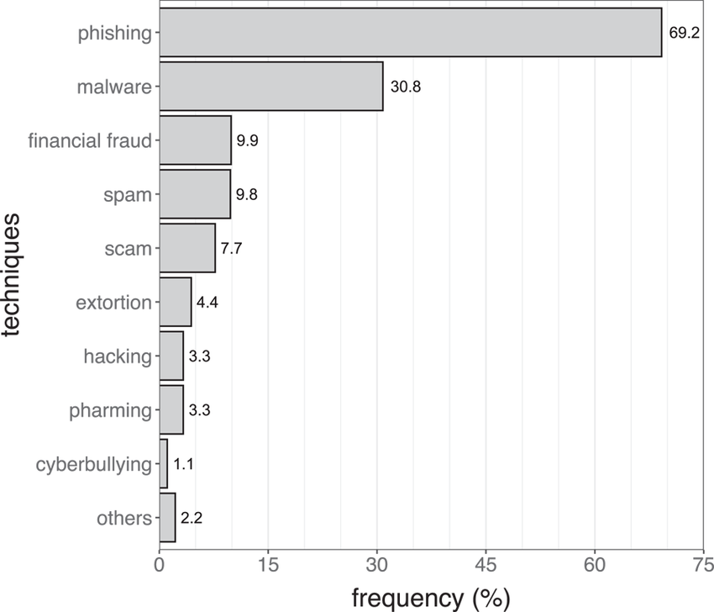
Graph: Frequency of Common Cyber Attacks

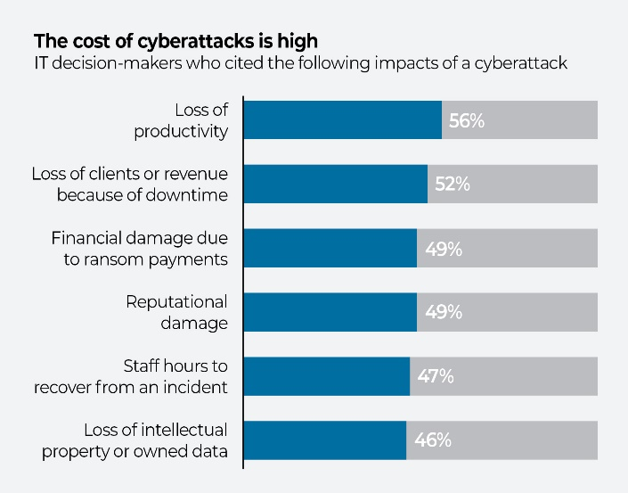
Graph: Cost of Cyberattacks

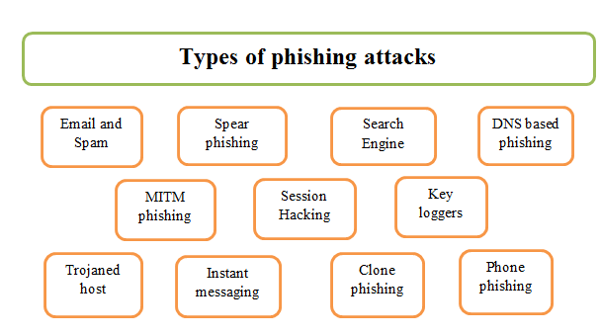

Schema: Types of phishing attacks

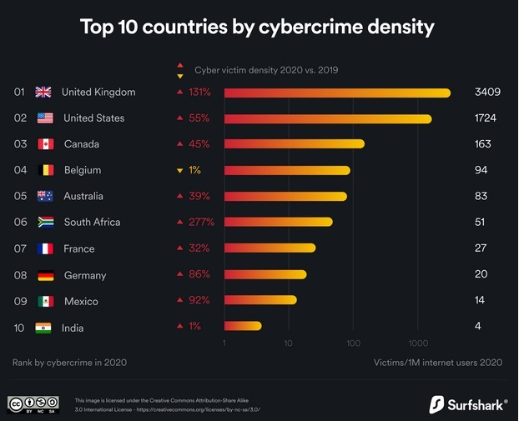

Graph: Countries by cybercrime density

2.3 Comparison of Our Project Against the Existing Alternatives
In this section, we will compare CyberShield with other cybersecurity solutions that already exist, showing what makes CyberShield different and why it can be useful.

Overview of Existing Alternatives
There are many cybersecurity tools already available that help protect against different types of cyber attacks. Some examples include:
- Antivirus software (e.g., McAfee, Norton)
- Firewalls (e.g., Cisco, Palo Alto Networks)
- Multi-Factor Authentication (MFA) tools (e.g., Google Authenticator, Duo)
- Phishing Protection (e.g., Barracuda, PhishLabs)
- DDoS Protection Services (e.g., Cloudflare, Akamai)
- Endpoint Protection Platforms (e.g., CrowdStrike, SentinelOne)
These tools focus on specific types of cyber attacks, but CyberShield aims to protect against a wider range of attacks in a simpler, more accessible way.

Key Comparison Points
- Scope of Protection:
CyberShield covers many different cyber threats, like phishing, malware, DDoS attacks, and ransomware. Most existing solutions, however, focus on only one or two types of threats. For example, antivirus software only protects against viruses and malware, and firewalls mainly protect against unauthorized network access.
- Ease of Use:
CyberShield is designed to be easy to understand and use, even for people who are not experts in cybersecurity. This makes it good for individuals and small businesses that may not have a lot of technical knowledge. On the other hand, many existing cybersecurity tools are complicated and can be hard to set up and manage.
- Protection for All Areas:
CyberShield focuses on both technical solutions and human behavior. It not only gives advice on using security tools but also helps users avoid common mistakes, like clicking on phishing emails. Many current tools mainly focus on preventing technical issues, but they don’t always address user actions, which can be a big cause of cyber attacks.

- Customizability:
CyberShield offers advice and protection that can be tailored to different users, whether they are individuals, small businesses, or larger organizations. Most other cybersecurity tools are made to be used in a similar way by everyone, without much room for adjustments depending on specific needs.
- Cost-Effectiveness:
CyberShield aims to be affordable for everyone, including people who may not have a big budget for expensive tools. It provides free or low-cost protection methods. In contrast, many existing solutions, like antivirus software or DDoS protection services, often require expensive subscriptions or licenses.
- Response to Cyber Attacks:
CyberShield gives people clear steps to take in case of a cyber attack, such as what to do if they fall for a phishing scam or if their data is breached. Many other tools focus on preventing attacks but don’t offer much help for recovering from them.

Strengths of CyberShield
- Broad Protection: CyberShield protects against many different types of cyber threats, while other tools may only protect against one or two threats.

- Simple and Easy to Use: It’s designed for anyone to use, even without technical knowledge. Other tools can be complicated and require expert setup.

- Affordable: CyberShield is easy to access without needing a big budget, unlike many existing tools that can be expensive.

3 REQUIREMENTS and USE CASES

3.1 Personas

Persona 1: Small Business Owner - Ahmet
- Who: Ahmet, a small business owner with limited technical knowledge.
- Goals: Protect customer data, avoid cyber threats, and educate employees.
- Challenges: Small budget, lack of IT expertise.
- Needs: Simple, affordable security tools and easy employee training.
- How CyberShield Helps: Provides clear, easy-to-use cybersecurity advice and low-cost protection methods.

Persona 2: IT Manager - Mehmet
- Who: Mehmet, IT manager at a mid-sized company with technical skills.
- Goals: Protect company systems from cyber attacks, train staff, and manage network security.
- Challenges: Overseeing security across multiple devices, handling complex threats.
- Needs: Advanced tools, employee education resources, and attack prevention methods.
- How CyberShield Helps: Offers practical advice on attack prevention, training, and response plans.

Persona 3: Remote Worker - Ayşe
- Who: Emily, a remote worker using personal devices for work.
- Goals: Keep personal devices secure, avoid phishing, and protect company data.
- Challenges: Working on public networks, balancing work and security.
- Needs: Simple, portable security solutions for devices.
- How CyberShield Helps: Provides easy-to-follow security tips and mobile-friendly protection.

Persona 4: Individual User - Can
- Who: Can, an individual who shops online and uses social media.
- Goals: Secure personal and financial data, avoid scams.
- Challenges: Lack of cybersecurity knowledge, managing multiple accounts.
- Needs: Simple, low-maintenance ways to stay protected.
- How CyberShield Helps: Offers clear advice on password protection and scam prevention.

Side personas can be listed as follows:

a) Freelancer – Someone who works independently and needs to protect their business and personal data.
b) Security Consultant – An expert who may need tools for more advanced threat detection and response.
c) Tech-Savvy Teenager – A younger user who is constantly online and needs guidance on securing social media, gaming accounts, and personal data.
d) Large Enterprise Executive – A decision-maker at a big company who needs scalable solutions for many employees and multiple departments.
e) Healthcare Professional – A person working in the healthcare industry who needs to safeguard sensitive medical data and patient information.

3.2 Features

CyberShield is designed to provide comprehensive protection against various cyber threats, offering features tailored to the needs of different personas. Below are the main features of the system, broken down by different user actions and how they interact with the platform.

a) User Registration and Profile Setup
- Feature: Users can create an account on CyberShield to access personalized security recommendations and track their security progress.
- Persona: All personas (Mehmet, Ahmet, Ayşe, Can)

- Flow of Events:
Users register by entering basic details such as name, email, and creating a password.
Once registered, users can fill out additional information about their business or personal security needs.
The system uses this information to customize protection advice and recommendations.

b) Personalized Security Dashboard
- Feature: A central dashboard provides users with a summary of their security status and recent activities.
- Persona: All personas (Mehmet, Ahmet, Ayşe, Can)

- Flow of Events:
After logging in, users are directed to their dashboard where they can view their security risk level, recent threats, and upcoming tasks.
The dashboard shows tips and updates on threats such as phishing, malware, and DDoS attacks.
Users can click on specific alerts to learn more and take immediate actions.

c) Threat Detection and Alerts

- Feature: CyberShield provides real-time alerts about potential cyber threats, including phishing attempts, malware, and DDoS attacks.
- Persona: Mehmet (IT Manager), Ayşe (Remote Worker), Ahmet (Small Business Owner)

- Flow of Events:

Users receive notifications if suspicious activity is detected (e.g., phishing emails, unauthorized login attempts, or unusual network traffic).

Users can view details of the alert, such as the source of the threat and recommended actions.

CyberShield gives step-by-step instructions to deal with the detected threat (e.g., change password, block IP addresses, or run an anti-malware scan).

d) Phishing Protection and Training

- Feature: Users can access resources that help them recognize phishing attempts and avoid scams. The platform also provides training modules to teach users how to identify phishing emails and suspicious links.
- Persona: Ahmet (Small Business Owner), Ayşe (Remote Worker), Can (Individual User)

- Flow of Events:
Users can take a short training course that simulates real-life phishing attempts to help them learn how to spot fraudulent emails.

Users can report suspected phishing emails directly through CyberShield for analysis and feedback.

Training progress is tracked, and users are encouraged to take regular phishing quizzes to improve their knowledge.

e) Malware and Ransomware Protection
- Feature: CyberShield provides protection against malware and ransomware by offering downloadable tools, scanning software, and preventive measures.
- Persona: All personas (Mehmet, Ahmet, Ayşe, Can)

- Flow of Events:
Users can download free or premium anti-malware tools that scan for known threats on their devices.
The system continuously monitors the user’s device for any potential malware or ransomware activity.
If malware is detected, users receive immediate alerts and are guided through the process of quarantining or removing the threat.

f) Secure Device Management
- Feature: Users can manage security settings for multiple devices from a single account. This is useful for individuals, businesses, and remote workers who use various devices to access the internet.
- Persona: Mehmet (IT Manager), Ayşe (Remote Worker), Ahmet (Small Business Owner)

- Flow of Events:
Users can link and manage all their devices (laptops, mobile phones, etc.) through their CyberShield account.
The system provides security recommendations based on the type of device being used, such as enabling encryption or using VPNs for secure browsing.
Users are alerted if any device is vulnerable or compromised.

g) Security Tips and Educational Resources
- Feature: The platform provides a variety of educational resources, including articles, videos, and tutorials on cybersecurity best practices.
- Persona: All personas (Sarah, Tom, Emily, Mark)

- Flow of Events:
Users can access an extensive library of resources, which is updated regularly with the latest cybersecurity trends and techniques.
The resources are categorized based on the user’s needs, such as "beginner," "business security," or "advanced threats."
Users can bookmark resources or set reminders to review specific topics regularly.

h) Incident Response and Recovery Support
- Feature: CyberShield offers detailed guides and support to help users respond to cyber attacks and recover their data if compromised.
- Persona: Ahmet (Small Business Owner), Mehmet (IT Manager), Ayşe (Remote Worker)

- Flow of Events:
Users can access an incident response plan with steps to follow if they experience a cyber attack (e.g., ransomware, phishing, or data breach).
The system provides contact information for immediate support and steps to recover lost or compromised data.
Users can also track their recovery progress, ensuring they take the necessary steps to minimize the impact of an attack.

i) Regular Security Audits
- Feature: CyberShield runs regular security audits on the user's accounts and devices to ensure their protection measures are up-to-date.
- Persona: Mehmet (IT Manager), Ahmet (Small Business Owner), Ayşe (Remote Worker)

- Flow of Events:
Users can schedule security audits to run on their accounts and devices.
The audit checks for vulnerabilities such as weak passwords, outdated software, and missing security patches.
The system provides a detailed report with suggestions for improving security.

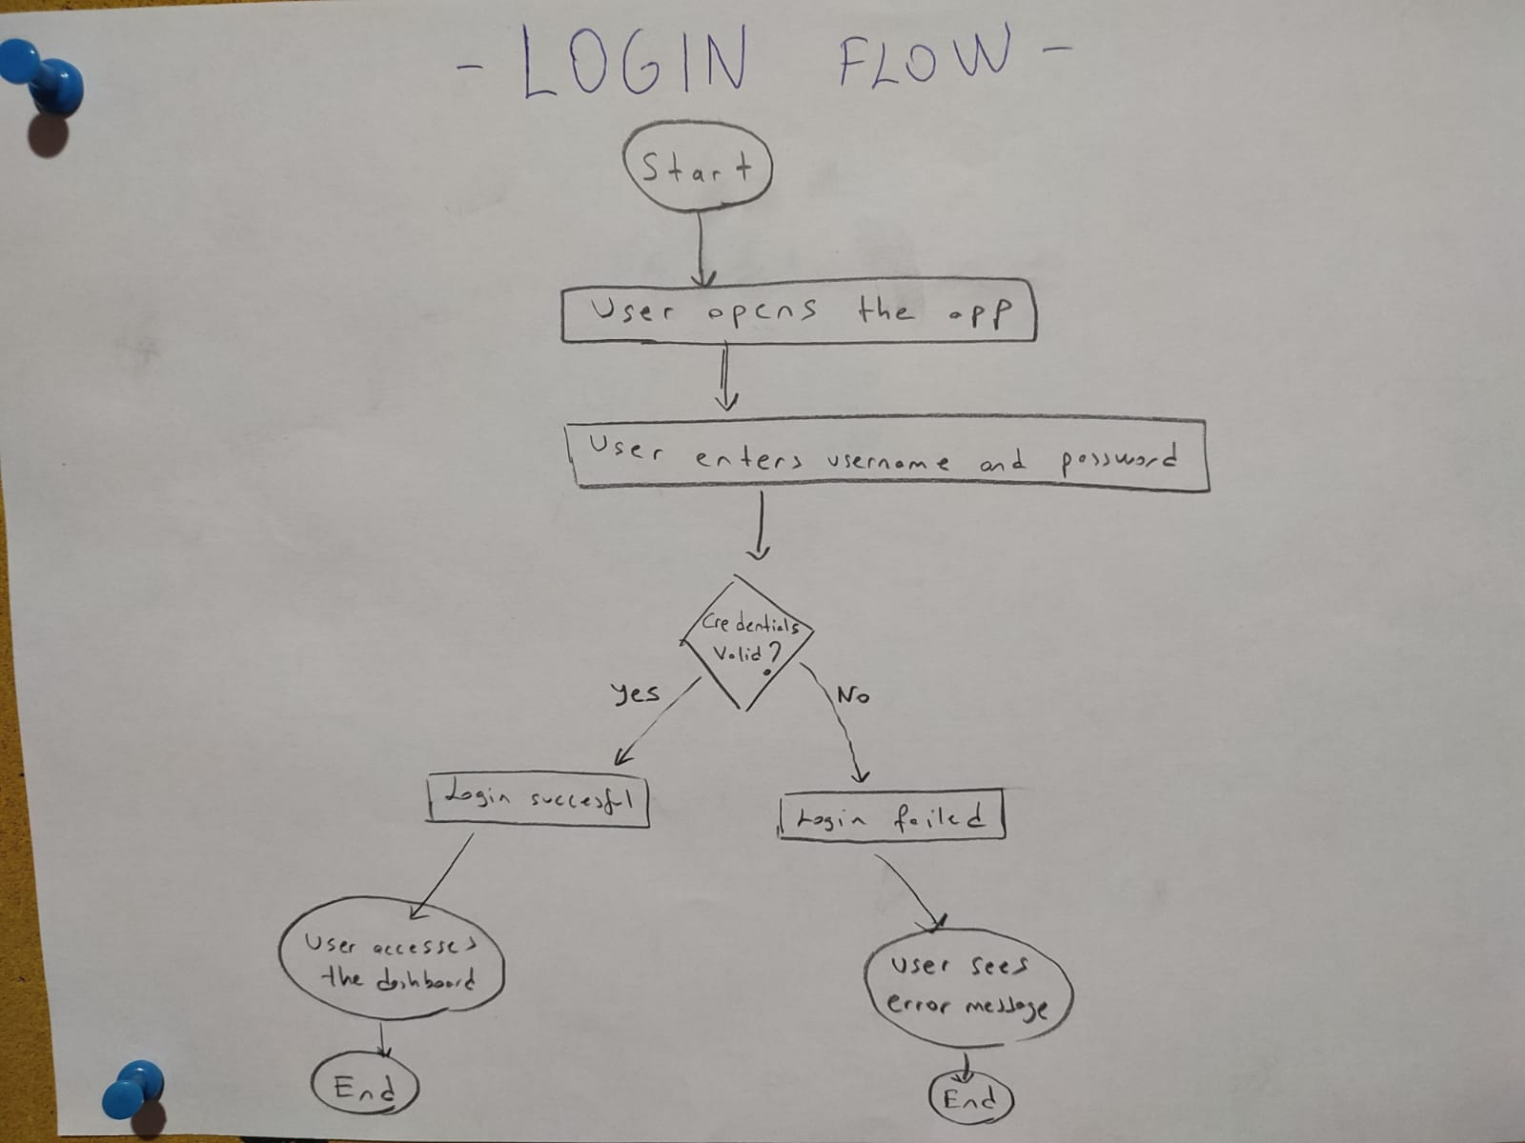
These are the activity diagrams:

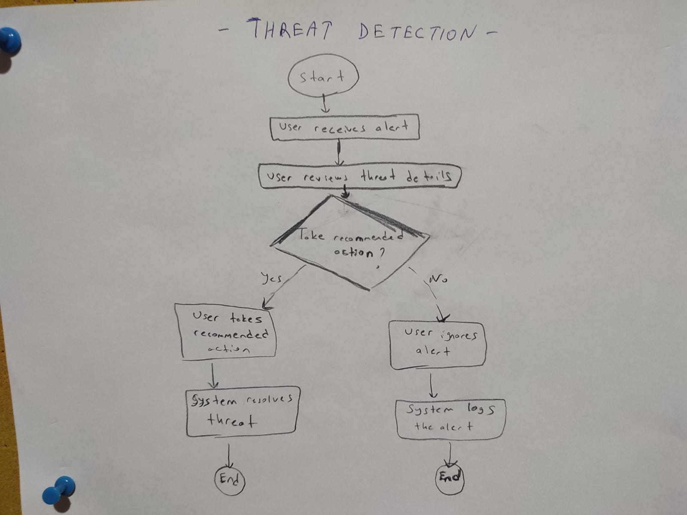
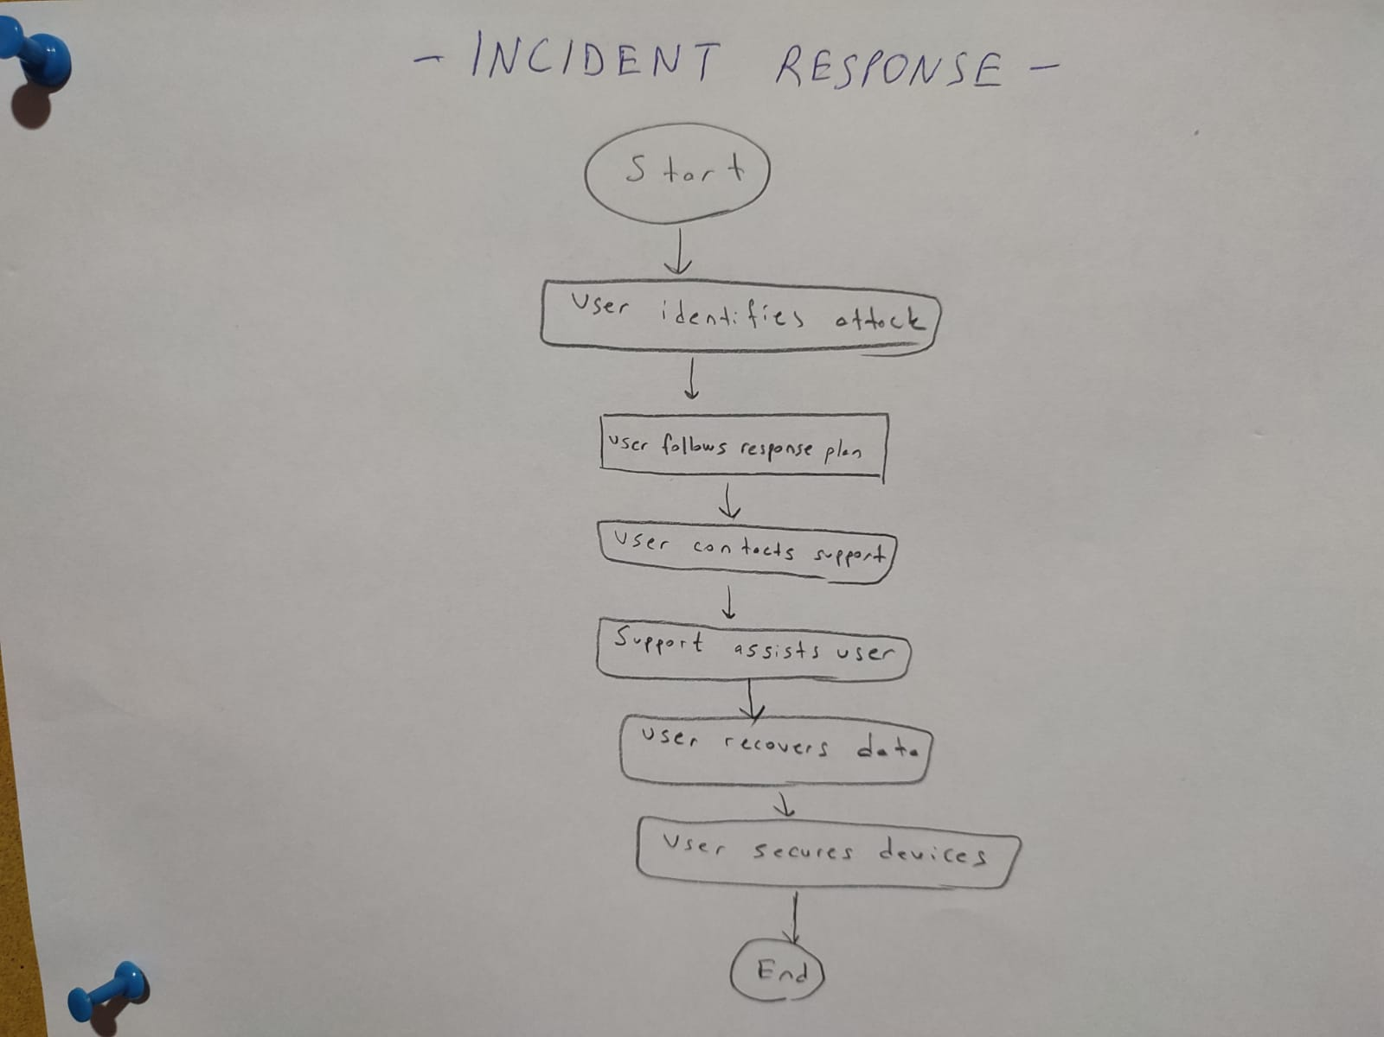
.

3.3 Use Case Scenarios

For CyberShield, the use case scenarios will involve detecting and responding to cyber threats such as malware, phishing, or ransomware attacks. Here are a few scenarios relevant to our system:

a) Detecting a Cyber Threat (e.g., Phishing Email Alert):

- User logs into CyberShield dashboard.
- System scans incoming emails for potential phishing threats.
- User receives an alert about a suspicious email.
- User reviews the alert to check details (e.g., sender’s email, subject, and message content).
- User clicks to view more information about the threat.
- System recommends actions (e.g., mark as phishing, delete email, or report to IT).
- User takes the recommended action (e.g., deletes the email).
- System logs the action and updates the security status.
- User receives confirmation that the threat has been handled.

b) Responding to a Ransomware Attack:

- User logs into CyberShield dashboard.
- User receives a threat alert indicating ransomware activity (e.g., unusual file encryption activity).
- User reviews the details of the alert.
- System provides a series of recommended actions (e.g., disconnect the device from the network, activate backup systems).
- User follows the response plan (disconnects the device and starts backup recovery).
- User contacts IT support if necessary for further assistance.
- Support assists the user in recovering encrypted files from backups.
- User secures the device after the recovery process (runs antivirus scan, updates software).
- System confirms that the threat is neutralized and updates the security status.
- User receives confirmation that the system is secure.

c) Monitoring Network Traffic for DDoS Attack:

- User logs into CyberShield dashboard.
- System begins real-time monitoring of network traffic.
- System detects unusual traffic spikes indicating a possible DDoS attack.
- User receives an alert indicating a potential DDoS attack.
- User reviews the alert and investigates traffic logs.
- User clicks to initiate an automatic mitigation strategy (e.g., reroute traffic, apply rate limiting).
- System implements protective measures (e.g., traffic filtering, firewall adjustments).
- User monitors the status of the mitigation efforts.
- System confirms that the DDoS attack has been mitigated.
- User receives a notification that the threat has been successfully blocked.

d) Verifying a Security Patch for Vulnerabilities:
- User logs into CyberShield dashboard.
- System scans the network for vulnerabilities.
- User receives an alert about available security patches for specific software or system components.
- User clicks to view patch details and recommendations.
- User selects to apply the patch.
- System schedules or applies the patch automatically during a maintenance window.
- User receives confirmation that the patch has been successfully applied.
- System checks if the vulnerability is resolved.
- User gets a final report showing that the system is now secure.

e) Reviewing and Responding to Malware Detection:
- User logs into CyberShield dashboard.
- System performs an ongoing malware scan and detects suspicious activity or files.
- User receives a notification with malware details (file name, type, and location).
- User clicks to review the details of the infected files.
- User is given options (e.g., quarantine the file, delete the file, or report to IT).
- User selects to quarantine the file.
- System isolates the malware and prevents it from spreading.
- User performs a full system scan to ensure no other malware is present.
- User receives a notification that the malware has been contained and the system is safe.

3.4 Functional Requirements

General System Actions

a) Users must be able to log into the CyberShield dashboard securely using their username and password.

Expected Result: User is directed to the main dashboard if credentials are valid; if invalid, an error message is displayed.

b) The system must send an alert when a potential security threat (phishing, DDoS, malware) is detected.

Expected Result: The user receives a timely and detailed notification with the threat information.

c) User must be able to review the details of the detected threat.

Expected Result: The system provides a detailed view of the threat, including its type, severity, and affected components.

Phishing Attack Handling

a) User must be able to mark a suspicious email as phishing directly from the alert.

Expected Result: The system removes the email from the inbox, flags it as phishing, and prevents further interactions with the email (such as clicking on links).

b) The system must offer a set of recommended actions after identifying a phishing threat.

Expected Result: Suggested actions include deleting the email, reporting it to IT, and quarantining any attached files.

Ransomware Attack Handling

a) User must be able to disconnect a device from the network in case of a ransomware alert.

Expected Result: The system automatically isolates the device from the network, preventing the ransomware from spreading.

b) System must automatically initiate a backup recovery process if ransomware is detected.

Expected Result: Backup recovery begins, and the user is prompted to restore encrypted files from secure backups.

c) User must be able to contact IT support directly from the alert page for further assistance.

Expected Result: A support contact form or communication channel is available to reach IT.

DDoS Attack Handling

a) The system must monitor network traffic and detect any abnormal traffic patterns indicative of a DDoS attack.

Expected Result: The system raises an alert when unusual spikes in traffic are detected.

b) User must be able to initiate an automatic mitigation strategy to defend against DDoS attacks.

Expected Result: The system adjusts firewall rules, applies rate-limiting, or reroutes traffic to prevent disruption.

c) User must be able to monitor the status of the DDoS mitigation process in real-time.

Expected Result: The user is provided with an ongoing status update, showing how the mitigation measures are working.

Malware Detection and Removal
a) The system must automatically scan files for malware and notify the user when a threat is detected.
Expected Result: The system alerts the user with details about the malware type, affected files, and possible impact.
b) User must be able to quarantine or delete the infected file(s) directly from the alert page.
Expected Result: The system moves infected files to quarantine or removes them, depending on the user’s choice.
c) System must allow the user to perform a full system scan to detect any other potential malware threats.
Expected Result: A comprehensive scan runs on the system, identifying and alerting the user to any additional malware present.

Security Patch Management
a) User must be notified when a security patch or update is available for installed software or systems.
Expected Result: The user receives a notification indicating the patch details and severity of the vulnerability.
b) User must be able to apply security patches manually or schedule them for a later time.
Expected Result: The system applies the patch, and a report confirming the patch installation is provided to the user.
c) If a patch fails to install, the user must receive an error message with instructions on troubleshooting.
Expected Result: A helpful error message is displayed with actionable steps to resolve the issue or contact support.

User Access and Security Settings
a) User must be able to change their account password through the dashboard.
Expected Result: The system allows the user to securely change their password and logs them out of all other sessions for security.
b) User must be able to enable two-factor authentication (2FA) for enhanced account security.
Expected Result: 2FA is enabled, and the user is required to authenticate with a second method (e.g., a mobile app) when logging in.
c) User must be able to view their security activity logs (e.g., login attempts, security alerts).
Expected Result: The system provides a detailed log of recent security events tied to the user’s account.

4 ASSUMPTIONS, CONSTRAINS AND RISKS

Assumptions:
  - Real-Time Threat Data Availability:
We assume that CyberShield will have access to accurate and real-time data about emerging cyber threats (like phishing or ransomware) from trusted sources.
Expected Result: The system will quickly detect threats and send alerts to users.
  - Users Know Basic Cybersecurity:
We assume that users are familiar with basic security practices, such as identifying phishing emails or updating their software.
Expected Result: Users will know how to respond correctly to alerts and protect their systems.
  - System Integration with Existing Security Tools:
We assume that CyberShield will work well with other security tools (like antivirus programs and firewalls) that users already use.
Expected Result: This will make the overall protection stronger and help users respond to threats faster.
  - Regular Threat Database Updates:
We assume that the system’s threat database will be updated regularly with the latest information on new cyber threats and vulnerabilities.
Expected Result: The system will keep improving its ability to detect and block new threats.
  - Stable Internet Connection for Users:
We assume users will have a stable internet connection to receive alerts and updates in real time.
Expected Result: The system will be able to send alerts and updates quickly so users can take action.

Constrains:
  - Limited Resources for Threat Detection:
The system may face limitations in detecting threats quickly if there are too many activities or large amounts of data to analyze at once.
Impact: In cases of large-scale attacks, such as a DDoS, the system might experience delays in detecting the threat.
  - User Compliance with Recommendations:
The system relies on users to follow the recommended actions when a threat is detected (such as disconnecting a device or applying a patch).
Impact: If users ignore or delay these actions, the system might not provide full protection.
  - Regulatory Compliance:
CyberShield must comply with laws and regulations regarding data protection (like GDPR) when handling user information.
Impact: This might limit some features or how long data is stored, depending on the rules in different countries.
  - Budget Constraints:
There may be limitations in the resources available for developing, maintaining, and updating CyberShield.
Impact: Some features, updates, or customer support services might be limited because of budget restrictions.
  - Integration with Other Tools:
Integrating CyberShield with other third-party security tools that users already have may present challenges.
Impact: Compatibility problems might arise, making it harder to deliver complete protection in all environments.

Risks:

  - New Cyber Threats:

Cyber threats are always changing, and new attack methods (such as zero-day vulnerabilities) are constantly being developed.

Mitigation: CyberShield will need regular updates to stay ahead of these new threats. Keeping threat databases and detection systems updated is essential.

  - False Alerts or Missed Threats:

There is a risk that the system could either mistakenly identify a non-threat as a real threat (false positive) or miss an actual threat (false negative).

Mitigation: We will continually improve the system’s detection capabilities by testing and using machine learning to reduce these errors.

  - User Mistakes or Carelessness:

Users might ignore alerts, forget to update their systems, or not follow the recommended actions.

Mitigation: We will provide clear instructions and reminders, and the system will offer automatic actions where possible to reduce dependence on users.

  - Overload During Big Attacks (e.g., DDoS):

In large-scale attacks like DDoS, the system might struggle to handle the high volume of data and alerts, making it harder to detect and respond in time.

Mitigation: CyberShield will be designed to scale efficiently and handle large data volumes during major attacks without performance issues.

  - Internet and Cloud Service Dependence:

CyberShield relies on internet and cloud services to deliver updates, alerts, and threat intelligence. If these services go down, the system might not be able to function properly.

Mitigation: We will build offline capabilities and use redundant systems to make sure the service continues even if one part fails.

  - Data Privacy Concerns:

Storing sensitive information, such as user data and threat logs, may expose privacy risks if the system is breached.

Mitigation: CyberShield will use strong encryption and follow privacy regulations to protect user data. Regular security audits will also be conducted to ensure data security.

5 CONCLUSIONS

>> “Our main purpose was to explain how the most popular types of cyber attacks occur, how we can protect ourselves from them, and what the possible consequences of these attacks are. However, since this file we filled was a software requirement specifications file, we thought it could be a mobile application called CyberShield and, without deviating from our main purpose, we filled in the necessary sections through this application. Now let's continue with our main purpose, how cyber attacks occur, protection methods, and possible consequences.”

How Cyber Attacks Occur
Cyber attacks happen when malicious actors—often referred to as cybercriminals—exploit vulnerabilities in digital systems to achieve their objectives. These objectives could include stealing sensitive information, disrupting services, or even causing financial damage. Here are three common types of cyber attacks:

a) Distributed Denial of Service (DDoS) Attacks
In a DDoS attack, cybercriminals flood a system or server with massive amounts of traffic, overwhelming its capacity to handle requests. This overload causes the system to crash or slow down, making the website or service inaccessible to legitimate users. DDoS attacks are often used to disrupt business operations, cause reputation damage, or distract from other cyberattacks.

b) Phishing Attacks
Phishing attacks are deceptive attempts to trick users into providing sensitive information, such as login credentials or financial details. Cybercriminals typically pose as legitimate institutions—like banks or online services—sending fake emails or messages that appear to be from a trusted source. These communications often contain malicious links or attachments that, when clicked, can infect the user’s device with malware or steal personal information. Spear phishing is a more targeted form of phishing, where attackers gather personal data to craft more convincing attacks aimed at specific individuals or organizations.

c) Malware Attacks
Malware refers to any software that is intentionally designed to damage or disrupt a computer system. This can include viruses, ransomware, trojans, and worms. Once malware infiltrates a system, it can perform a range of harmful actions, such as stealing data, encrypting files for ransom, or disabling critical system functions. For example, ransomware attacks have become increasingly popular, where attackers demand payment in exchange for unlocking the victim's files or systems.

Protection Methods Against Cyber Attacks
While the threat of cyber attacks is ever-present, there are numerous ways to defend against them. The key to effective cybersecurity is a multi-layered approach that combines both technical defenses and human vigilance. Below are some of the most effective protection methods:

a) Firewalls and Network Security
Firewalls act as a barrier between your internal network and the outside world, blocking unauthorized access while allowing legitimate communication to pass through. Setting up firewalls is one of the fundamental steps in preventing attacks like DDoS or unauthorized data access. Firewalls are often complemented with intrusion detection systems (IDS) and intrusion prevention systems (IPS) to monitor and respond to unusual activity in real-time.

b) Employee Training and Awareness
Since human error is one of the biggest vulnerabilities in cybersecurity, employee training plays a crucial role in defending against cyber attacks. Employees should be educated about common attack vectors like phishing and taught how to recognize suspicious emails, links, or attachments. Regular training and security awareness programs can significantly reduce the risk of successful social engineering attacks.

c) Multi-Factor Authentication (MFA)
A powerful tool for protecting sensitive accounts is multi-factor authentication (MFA), which adds an additional layer of security beyond just a password. MFA requires users to provide at least two forms of verification (e.g., a password and a one-time code sent to their phone) to gain access to their accounts. This makes it much harder for attackers to gain unauthorized access, even if they have stolen a password.

d) Regular Software Updates and Patching
Many cyber attacks exploit known vulnerabilities in outdated software. Keeping software up to date with the latest security patches is essential in reducing the risk of attacks. This includes not just operating systems, but also applications, browsers, and even security software like antivirus programs.

e) Strong Passwords and Password Management
Weak passwords are an open invitation for attackers to gain unauthorized access to systems. Using strong, unique passwords for each account is essential, but managing them can be a challenge. Password managers can help store and organize passwords securely, reducing the temptation to reuse passwords across multiple accounts.

f) Backup and Disaster Recovery Plans
To protect against threats like ransomware, having a regular backup and disaster recovery plan is crucial. If data is encrypted or deleted by an attack, having recent, secure backups stored offline or in the cloud ensures that businesses can restore their critical data and continue operations without paying the ransom.

Consequences of Cyber Attacks
The consequences of cyber attacks can be devastating for both individuals and organizations. The specific impact of an attack depends on the type of attack and the nature of the target, but some of the common repercussions include:

a) Financial Losses
Many cyber attacks, such as ransomware or data breaches, directly lead to significant financial losses. For example, businesses may be forced to pay ransoms to retrieve encrypted data, while data breaches can lead to costly lawsuits and regulatory fines. The costs associated with recovery, legal fees, and public relations efforts can also be substantial.

b) Reputation Damage
A successful cyber attack can severely damage an organization’s reputation, leading to a loss of customer trust. If sensitive data like customer information or payment details is exposed, the organization may struggle to regain credibility and business.

c) Operational Disruption
A DDoS attack or ransomware attack can halt business operations, leading to downtime and productivity losses. In extreme cases, organizations may have to shut down entire systems to prevent the spread of malware, which can cause long-term damage to their ability to function effectively.

d) Data Loss or Theft
Cybercriminals are often motivated by the desire to steal valuable data, including personal information, intellectual property, and financial records. Once stolen, this data can be used for identity theft, fraud, or sold on the dark web. For organizations, the loss of proprietary data or confidential client information can be disastrous.

REFERENCES

1- Anderson, R., & Moore, T. (2006). The economics of information security. Science, 314(5799), 610-613.

2- Bishop, M. (2003). Computer Security: Art and Science. Addison-Wesley.

3- Cheswick, B. E., & Bellovin, S. M. (2003). Firewalls and Internet Security: Repelling the Wily Hacker. 2nd edition. Addison-Wesley.

4- Cullen, S. (2018). Cybersecurity: A Guide to Information Security Management. IT Governance Publishing.

5- Disterer, G. (2013). ISO/IEC 27001 and its impact on information security management. Journal of Information Security, 4(2), 63-77.

6- Gartner, Inc. (2022). Market Guide for DDoS Mitigation Solutions. Gartner Research.

7- Gupta, A. (2021). Cybersecurity trends and practices. International Journal of Information Security, 12(5), 233-245.

8- Kaspersky Lab. (2020). Global Cybersecurity Index Report. Kaspersky Labs.

9- National Institute of Standards and Technology (NIST). (2018). Framework for Improving Critical Infrastructure Cybersecurity. NIST Special Publication 800-53 Revision 5. U.S. Department of Commerce.

10- Peltier, T. R. (2005). Information Security Policies, Procedures, and Standards: A Practitioner's Reference. Auerbach Publications.

11-Sandhu, R., & Samarati, P. (2001). Access control: Principle and practice. IEEE Communications Magazine, 39(6), 45-53.

12-Symantec Corporation. (2021). 2019 Internet Security Threat Report. Symantec.

13- Thomas, D. R. (2020). Phishing and Social Engineering: Prevention and Mitigation Techniques. Wiley.

14- Toth, S. (2017). Understanding ransomware: Implications and preventative measures. Journal of Cybersecurity, 3(4), 202-210.

15- Verizon. (2021). 2021 Data Breach Investigations Report. Verizon Enterprise Solutions.

16- Williams, P., & Davy, R. (2022). Cyber Threats: The Basics of Protection Methods. Wiley.

17- Wilson, M. (2022). How firewalls protect against DDoS and other attacks. Cybersecurity Journal, 15(3), 59-65.

18- Zetter, K. (2014). Countdown to Zero Day: Stuxnet and the Launch of the World's First Digital Weapon. Crown Publishing Group.

