Second Project Title: UI/UX Visual Testing
Submitted By: Mrunmayee Milind Wani
Internship: Software Testing Intern
Company: Codtech IT Solutions Pvt. Ltd.

1. Objective
The objective of this project is to perform basic UI/UX visual testing on a web application by checking its user interface elements and overall user experience.

2. Website Tested
- Application Name: SauceDemo
- Website: https://www.saucedemo.com/
3. Testing Type
- UI Testing
- UX Testing
- Visual Testing
- Manual Testing

4. Modules Tested
- Login Page
- Products Page
- Shopping Cart
- Checkout
- Logout

5. Tools Used
- Google Chrome
- Microsoft Excel
- Microsoft Word

6. UI/UX Checklist
The following UI/UX elements were verified:
- Login page displayed properly.
- Logo visible.
- Username and Password fields aligned correctly.
- Buttons were clearly visible.
- Product images loaded correctly.
- Product names were readable.
- Cart icon displayed properly.
- Navigation was easy.
- Layout was clean.
- Colors and fonts were consistent.

7. Text Execution Summary
Total Test Cases | Passed | Failed
10 | 10 | 0

8. Screenshots
- Login Page
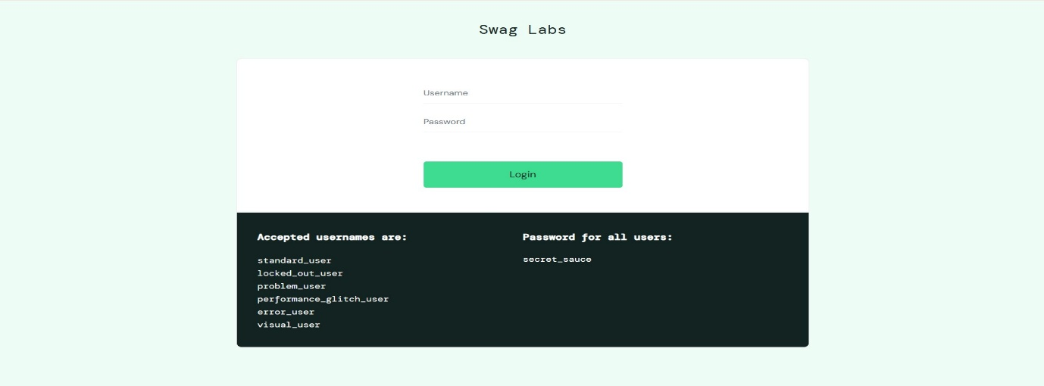

- Products Page
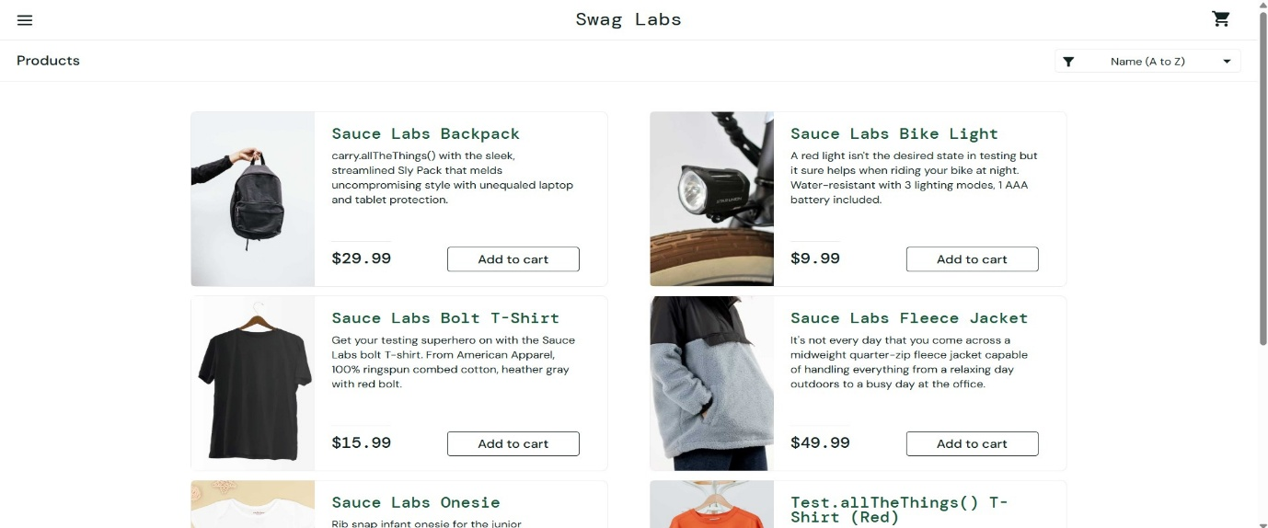

- Cart Page
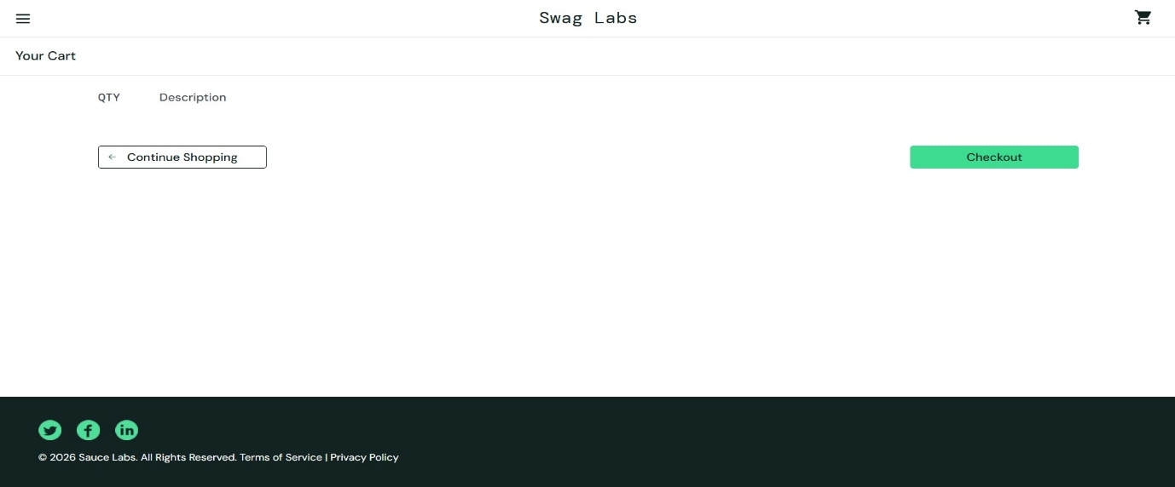

- Checkout Page
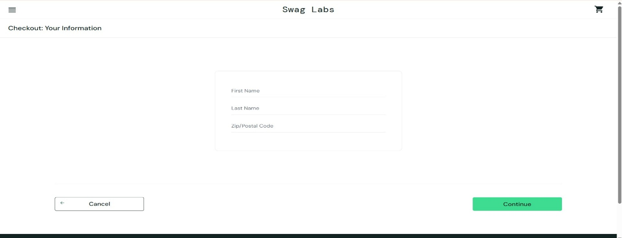

9. Conclusion
The UI and UX of the SauceDemo application were tested by visually inspecting different pages and interface elements. All tested UI components appeared correctly, and the website provided a simple and user-friendly experience. The application met the basic UI/UX requirements during testing.

