Third Project Title: Bug Reporting & Tracking
Submitted By: Mrunmayee Milind Wani
Internship: Software Testing Intern
Company: Codtech IT Solutions Pvt. Ltd.

1. Objective
The objective of this project is to understand the basics of bug reporting and tracking in software testing. This project focuses on identifying application behavior, documenting observations, and maintaining bug records.

2. Application Under Test
- Application Name: SauceDemo
- Website: https://www.saucedemo.com/
3. Testing Type
- Manual Testing
- Functional Testing
- Bug Reporting
- Bug Tracking

4. Modules Tested
- Login
- Products
- Add to Cart
- Cart
- Logout

5. Tools Used
- Google Chrome
- Microsoft Excel
- Microsoft Word

6. Bug Reporting Process
The application was tested manually. Different modules were checked to verify their functionality. Observations were recorded in a bug report document for tracking purposes.

7. Test Execution Summary
Description | Count

Total Bug Reports | 5

Closed | 5

Open | 0

8. Screenshots
- Login Page
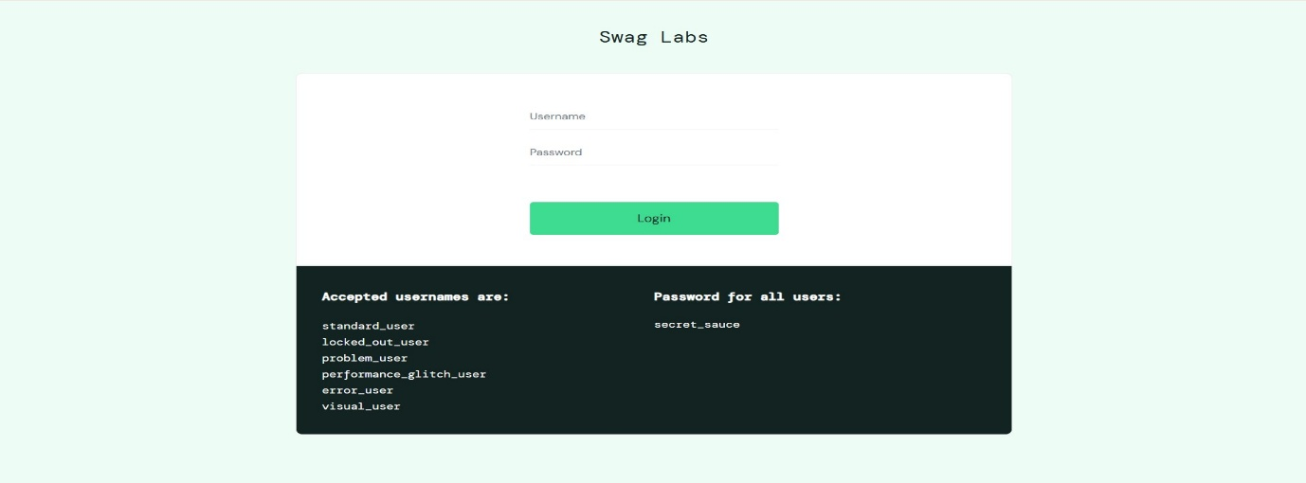

- Products Page
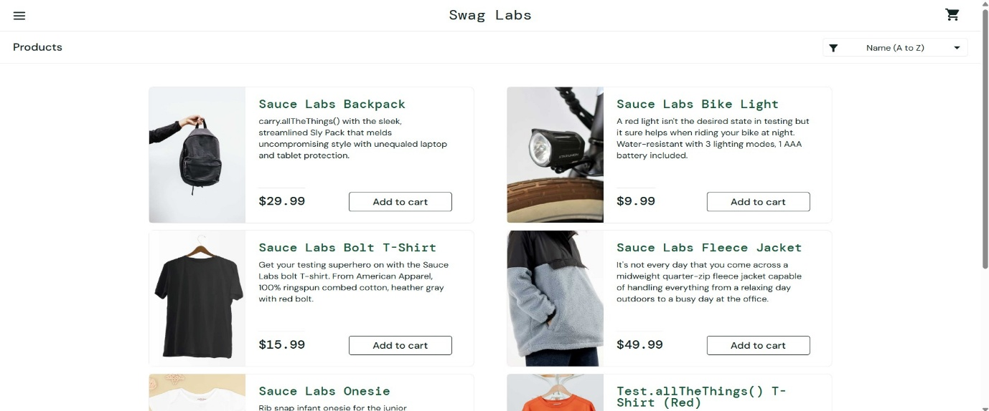

- Cart Page
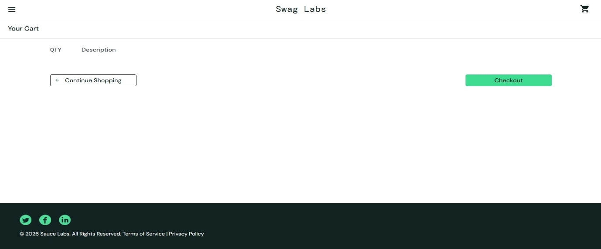

- Checkout Page
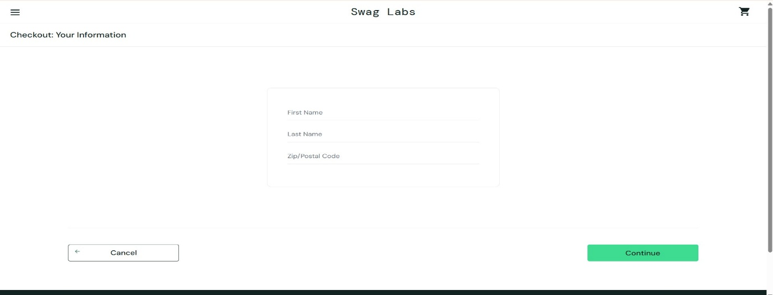

9. Conclusion
This project provided practical experience in understanding the bug reporting and tracking process. The application's basic functionalities were verified, and the observations were documented successfully.

