实验报告
2022 年 4 月 24 日 成绩：
姓名 | mm1ord | 学号 |  | 班级
专业 | 计算机科学与技术 |  | 课程名称 | 《计算机组成原理课程设计》
任课老师 | 刘鹏 | 指导老师 | 刘鹏 | 机位号 | 随机
实验序号 | 3 | 实验名称 | 《实验三 多功能ALU设计实验》
实验时间 |  | 实验地点 |  | 实验设备号 | 个人电脑
一、实验程序源代码
1.数据选择模块代码：
module choice(AB_SW,A,B);
input[2:0] AB_SW;
output[31:0] A,B;
reg[31:0] A,B;
wire[2:0] AB_SW;
always@(*)
begin
case(AB_SW)
3'b000:begin A=32'h0000_0000; B=32'h0000_0000; end
3'b001:begin A=32'h0000_0003; B=32'h0000_0607; end
3'b010:begin A=32'h8000_0000; B=32'h8000_0000; end
3'b011:begin A=32'h7FFF_FFFF; B=32'h7FFF_FFFF; end
3'b100:begin A=32'hFFFF_FFFF; B=32'hFFFF_FFFF; end
3'b101:begin A=32'h8000_0000; B=32'hFFFF_FFFF; end
3'b110:begin A=32'hFFFF_FFFF; B=32'h8000_0000; end
3'b111:begin A=32'h1234_5678; B=32'h1111_2222; end
default:begin A=32'h9ABC_DEF0; B=32'h1111_2222; end
endcase
end
endmodule

2.LED显示模块代码：
module CLED_M(F_LED_SW,LED,F,ZF,OF);
input[31:0] F;
input ZF,OF;
input[2:0] F_LED_SW;
output[7:0] LED;
reg[7:0] LED;
wire[31:0] F;
wire[2:0] F_LED_SW;
wire ZF,OF;
always@(*)
begin
case(F_LED_SW)
3'b000:LED=F[7:0];
3'b001:LED=F[15:8];
3'b010:LED=F[23:16];
3'b011:LED=F[31:24];
default:begin LED[7]=ZF;LED[0]=OF;LED[6:1]=6'b0;end
endcase
end
endmodule

3.ALU模块代码：
module OP(A,B,F,ZF,OF,ALU_OP);
input[31:0] A,B;
output[31:0] F;
input[2:0] ALU_OP;
output ZF,OF;
reg[31:0] F;
reg ZF,OF;
reg[5:0] i;
reg[32:0] CF;
reg C;

always@(ALU_OP or A or B)
begin
case(ALU_OP)
3'b000:begin CF=A&B; end
3'b001:begin CF=A|B; end
3'b010:begin CF=A^B; end
3'b011:begin CF=A~^B; end
3'b100:begin CF=A+B; end
3'b101:begin CF=A-B; end
3'b110:begin CF=(A<B); end
3'b111:begin CF=B<<A; end
endcase

F[31:0]=CF[31:0];
C=CF[32];
ZF=0;
for(i=0;i<32;i=i+1)
ZF=ZF|F[i];
ZF=~ZF;
OF=A[31]^B[31]^F[31]^C;
end
endmodule

4.顶层模块代码：
module ALU_TOP(AB_SW,ALU_OP,F_LED_SW,LED);
input[2:0] AB_SW,ALU_OP,F_LED_SW;
output[7:0] LED;
wire[2:0] AB_SW,ALU_OP,F_LED_SW;
wire[31:0] A,B,F;
wire ZF,OF;
wire[7:0] LED;
choice M1(AB_SW,A,B);
OP M2(A,B,F,ZF,OF,ALU_OP);
CLED_M M3(F_LED_SW,LED,F,ZF,OF);
endmodule

二、仿真波形
A= 32'h0000_0000 B = 32'h0000_0000
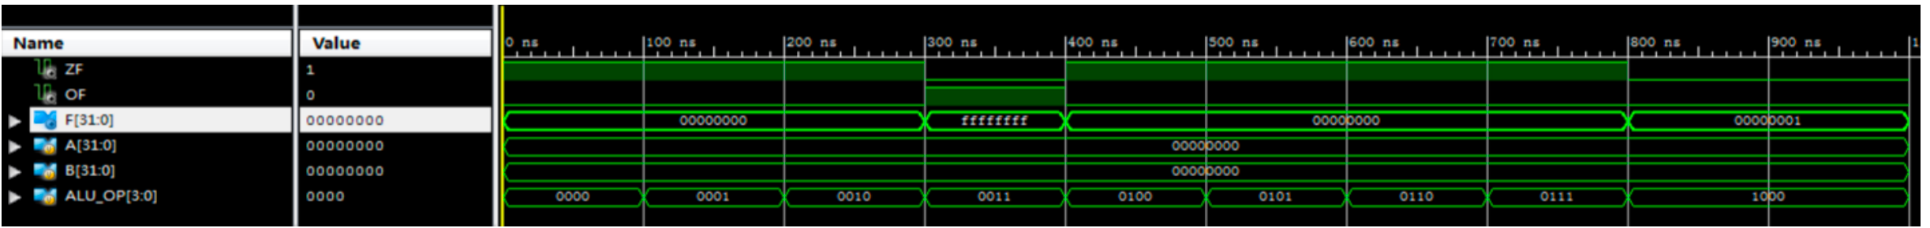A = 32'hffff_ffff B = 32'h0000_0001
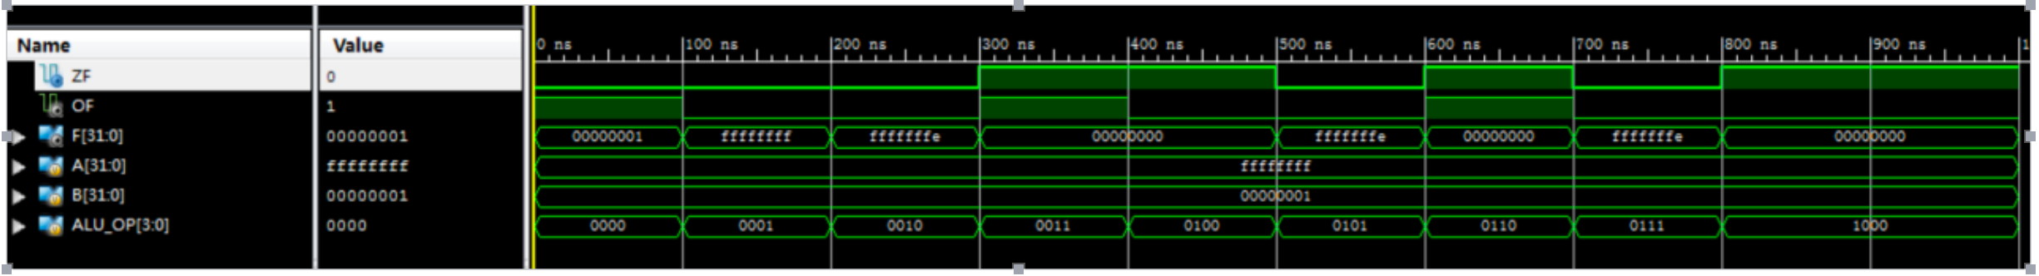A = 32'hffff_ffff B = 32'hffff_ffff
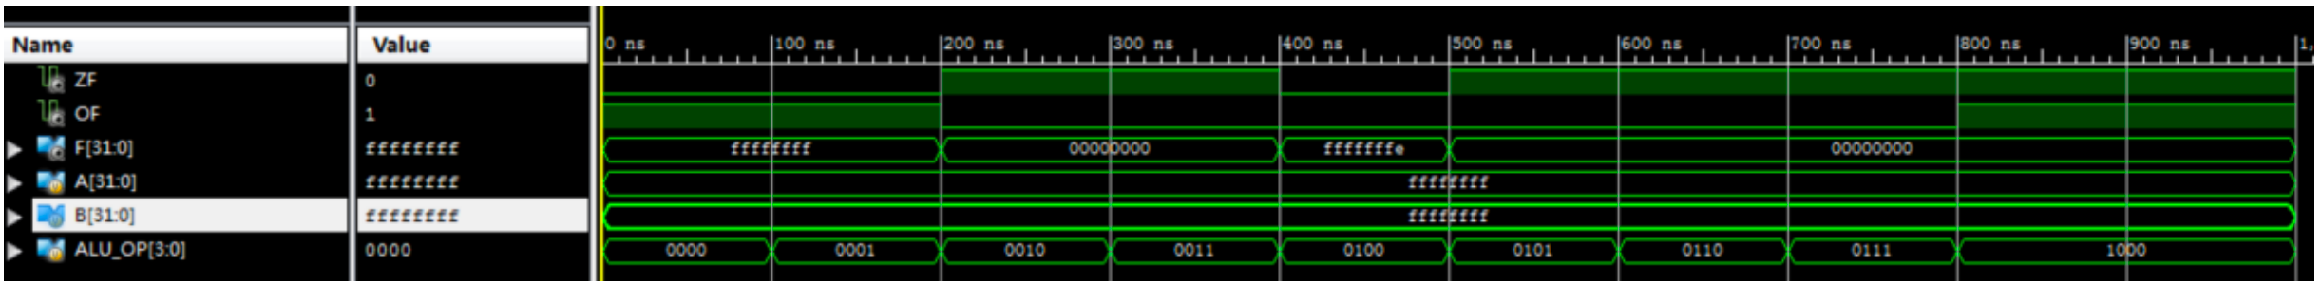
A = 32'h8000_0000 B = 32'hffff_ffff
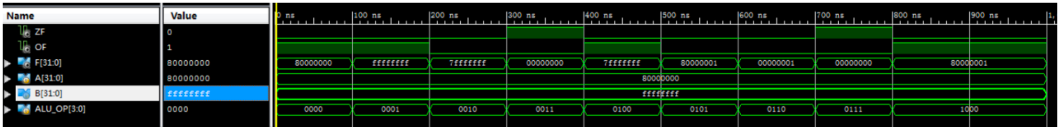

三、电路图
顶层电路模块

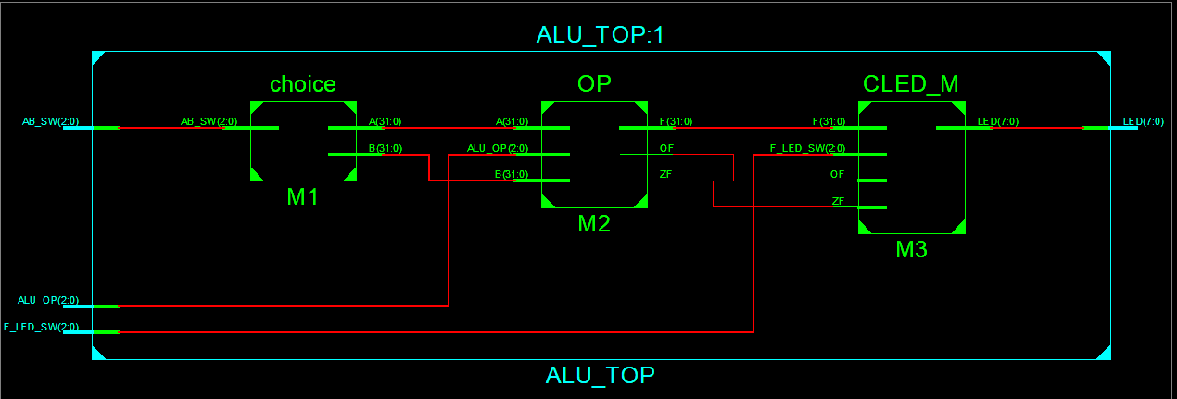

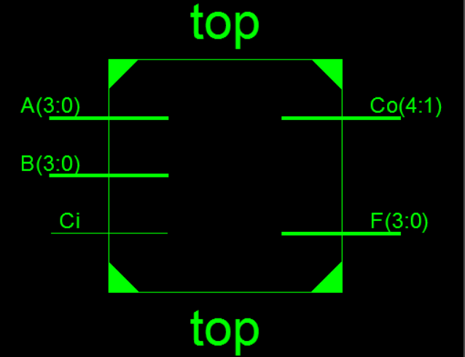
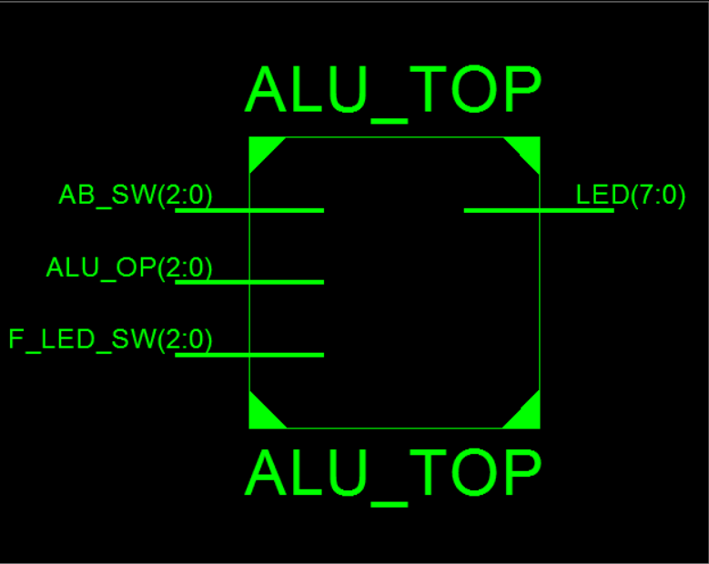
顶层电路内部结构：

四、引脚配置（约束文件）
NET "AB_SW[2]" LOC = T3;
NET "AB_SW[1]" LOC = U3;
NET "AB_SW[0]" LOC = T4;

NET "ALU_OP[2]" LOC = V3;
NET "ALU_OP[1]" LOC = V4;
NET "ALU_OP[0]" LOC = W4;

NET "F_LED_SW[2]" LOC = R4;
NET "F_LED_SW[1]" LOC = Y6;
NET "F_LED_SW[0]" LOC = Y4;

NET "LED[7]" LOC = R1;
NET "LED[6]" LOC = P2;
NET "LED[5]" LOC = P1;
NET "LED[4]" LOC = N2;
NET "LED[3]" LOC = M1;
NET "LED[2]" LOC = M2;
NET "LED[1]" LOC = L1;
NET "LED[0]" LOC = J2;

# PlanAhead Generated IO constraints

NET "AB_SW[2]" IOSTANDARD = LVCMOS18;
NET "AB_SW[1]" IOSTANDARD = LVCMOS18;
NET "AB_SW[0]" IOSTANDARD = LVCMOS18;
NET "ALU_OP[2]" IOSTANDARD = LVCMOS18;
NET "ALU_OP[1]" IOSTANDARD = LVCMOS18;
NET "ALU_OP[0]" IOSTANDARD = LVCMOS18;
NET "F_LED_SW[2]" IOSTANDARD = LVCMOS18;
NET "F_LED_SW[1]" IOSTANDARD = LVCMOS18;
NET "F_LED_SW[0]" IOSTANDARD = LVCMOS18;
NET "AB_SW[2]" PULLDOWN;
NET "AB_SW[1]" PULLDOWN;
NET "AB_SW[0]" PULLDOWN;
NET "ALU_OP[2]" PULLDOWN;
NET "ALU_OP[1]" PULLDOWN;
NET "ALU_OP[0]" PULLDOWN;
NET "F_LED_SW[2]" PULLDOWN;
NET "F_LED_SW[1]" PULLDOWN;
NET "F_LED_SW[0]" PULLDOWN;
NET "LED[7]" IOSTANDARD = LVCMOS18;
NET "LED[6]" IOSTANDARD = LVCMOS18;
NET "LED[5]" IOSTANDARD = LVCMOS18;
NET "LED[4]" IOSTANDARD = LVCMOS18;
NET "LED[3]" IOSTANDARD = LVCMOS18;
NET "LED[2]" IOSTANDARD = LVCMOS18;
NET "LED[1]" IOSTANDARD = LVCMOS18;
NET "LED[0]" IOSTANDARD = LVCMOS18;

五、思考与探索
（1）实验三实验结果记录表
 | A=0000_0000  B=0000_0000 | A=0000_0003  B=0000_0607 | A= 8000_0000  B=8000_0000 | A=7FFF_FFFF  B=7FFF_FFFF
A·B | F=0000_0000  ZF=1 OF=0 | F=0000_0003  ZF= 0 OF=0 | F=8000_0000  ZF=0 OF=0 | F=7FFF_FFFF  ZF=0 OF=0
A+B | F=0000_0000  ZF= 1 OF=0 | F=0000_0607  ZF=0 OF=0 | F=8000_0000  ZF=0 OF=0 | F=7FFF_FFFF  ZF=0 OF=0
A⊕B | F=0000_0000  ZF=1 OF=0 | F=0000_0604  ZF=0 OF=0 | F=0000_0000  ZF=1 OF=0 | F=0000_0000  ZF=1 OF=0
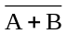 | F=FFFF_FFFF  ZF= 0 OF=0 | F=FFFF_F9FB  ZF=0 OF=0 | F=FFFF_FFFF  ZF=0 OF=0 | F=FFFF_FFFF  ZF=0 OF=0
A加B | F=0000_0000  ZF= 1 OF=0 | F=0000_060A  ZF=0 OF=0 | F=0000_0000  ZF=1 OF=1 | F=FFFF_FFFE  ZF=0 OF=0
A减B | F=0000_0000  ZF= 1 OF=0 | F=FFFF_F9FC  ZF=0 OF=1 | F=0000_0000  ZF=1 OF=0 | F=0000_0000  ZF=1 OF=0
A<B置1 | F=0000_0000  ZF= 1 OF=0 | F=0000_0001  ZF=0 OF=0 | F=0000_0000  ZF=1 OF=0 | F=0000_0000  ZF=0 OF=0
B<<A | F=0000_0000  ZF= 1 OF=0 | F=0000_0000  ZF=1 OF=0 | F=0000_0000  ZF=1 OF=0 | F=0000_0000  ZF=0 OF=0
 | A=FFFF_FFFF  B=FFFF_FFFF | A=8000_0000  B=FFFF_FFFF | A=FFFF_FFFF  B=8000_0000 | A=1234_5678  B=3333_2222
A·B | F=FFFF_FFFF  ZF=0 OF=0 | F=8000_0000  ZF=0 OF=0 | F=8000_0000  ZF=0 OF=0 | F=1230_0220  ZF=0 OF=0
A+B | F=FFFF_FFFF  ZF=0 OF=0 | F=FFFF_FFFF  ZF=0 OF=0 | F=FFFF_FFFF  ZF=0 OF=0 | F=3337_767A  ZF=0 OF=0
A⊕B | F=0000_0000  ZF=1 OF=0 | F=7FFF_FFFF  ZF=0 OF=0 | F=7FFF_FFFF  ZF=0 OF=0 | F=2107_745A  ZF=0 OF=0
 | F=FFFF_FFFF  ZF=0 OF=0 | F=8000_0000  ZF=0 OF=0 | F=8000_0000  ZF=0 OF=0 | F=DEF8_8BA5  ZF=0 OF=0
A加B | F=FFFF_FFFE  ZF=0 OF=1 | F=7FFF_FFFF  ZF=0 OF=1 | F=7FFF_FFFF  ZF=0 OF=1 | F=4567_789A  ZF=0 OF=0
A减B | F=0000_0000  ZF=1 OF=0 | F=8000_0001  ZF=0 OF=1 | F=7FFF_FFFF  ZF=0 OF=0 | F=DF01_3456  ZF=0 OF=1
A<B置1 | F=0000_0000  ZF=1 OF=0 | F=0000_0001  ZF=0 OF=0 | F=0000_0000  ZF=1 OF=0 | F=0000_0001  ZF=0 OF=0
B<<A | F=0000_0000  ZF=1 OF=0 | F=0000_0000  ZF=1 OF=0 | F=0000_0000  ZF=0 OF=0 | F=0000_0000  ZF=1 OF=0
（2）
经过分析，该ALU不能实现MIPS核心指令集的所有指令。他还需要，带进位的加法运算、带进位的减法运算、位清除指令、负数比较、位测试指令、比较指令、相等测试指令等。
（3）通过本实验，无法得出该问题的结论。若A=32’b0，B=32’bFFFF_FFFF，则所得到的答案是F=0000_0001。这个问题应该再设置一个sig信号，控制ALU是执行“带符号证书比较小于置于1”还是“无符号数比较小于置1”功能，当sig=0，则执行“无符号数比较小于置1”，当sig=1，则执行“带符号整数比较小于置1”。

