实验报告

姓名 | mm1ord | 学号 |  | 班级
专业 | 计算机科学与技术 |  | 课程名称 | 《计算机组成原理课程设计》
任课老师 |  | 指导老师 |  | 机位号
实验序号 | 2 | 实验名称 | 取指令与指令译码实验
实验时间 | 2022.5.24 | 实验地点 | 一教225 | 实验设备号 | 个人电脑
一、实验程序源代码
顶层模块：
module top(clk,rst,LED);
input clk;
input rst;
output reg [31:0]LED;
wire [31:0]Inst_code;

PC PC_test(clk,rst,Inst_code);

always@(*)
begin
LED[31:26] = Inst_code[31:26];//opcode
LED[25:21] = Inst_code[25:21];//rs
LED[20:16] = Inst_code[20:16];//rt
LED[15:11] = Inst_code[15:11];//rd
LED[10:6] = Inst_code[10:6];//shamt
LED[5:0] = Inst_code[5:0];//func
end
endmodule

PC取指令模块：
module PC(clk,rst,Inst_code);
input clk;
input rst;
output wire [31:0]Inst_code;
reg [31:0]PC;
wire [31:0]PC_new;
initial
PC = 32'h00000000;
Inst_ROM Inst_ROM1(
.clka(clk), // input clka
.addra(PC[7:2]), // input [5 : 0] addra
.douta(Inst_code[31:0]) // output [31 : 0] douta
);
assign PC_new=PC+4;
always@(posedge rst or negedge clk)
begin
if(rst)
PC = 32'h0000_0000;
else
PC={24'h000000,PC_new[7:0]};
end
endmodule

测试代码：
module test;

// Inputs
reg clk;
reg rst;

// Outputs
wire [31:0] Inst_code;

// Instantiate the Unit Under Test (UUT)
pc uut (
.clk(clk),
.rst(rst),
.Inst_code(Inst_code)
);

initial begin
// Initialize Inputs
clk = 0;
rst = 0;

// Wait 100 ns for global reset to finish
#100;
clk = 1;
rst = 0;

#100;
clk = 0;
rst = 0;

#100;
clk = 1;
rst = 0;

#100;
clk = 0;
rst = 0;

#100;
clk = 1;
rst = 0;

#100;
clk = 0;
rst = 0;

#100;
clk = 1;
rst = 0;

#100;
clk = 0;
rst = 0;

// Add stimulus here

end

endmodule
二、仿真波形（下图是例子，请根据你们的实际情况替换）
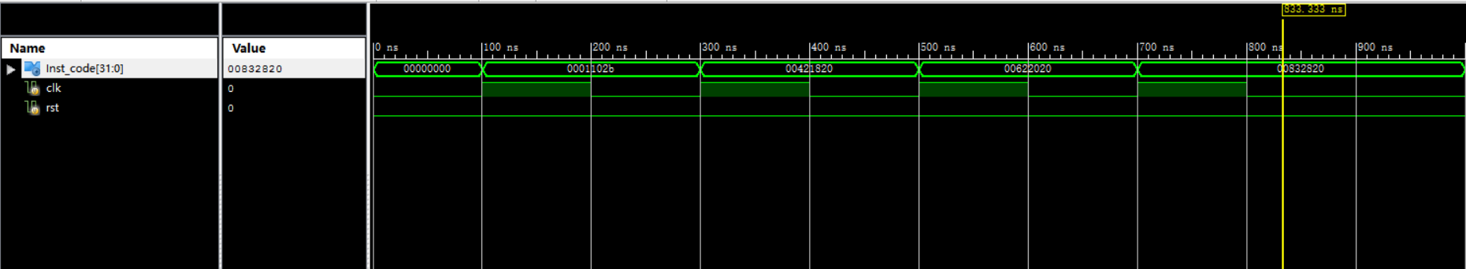
三、电路图
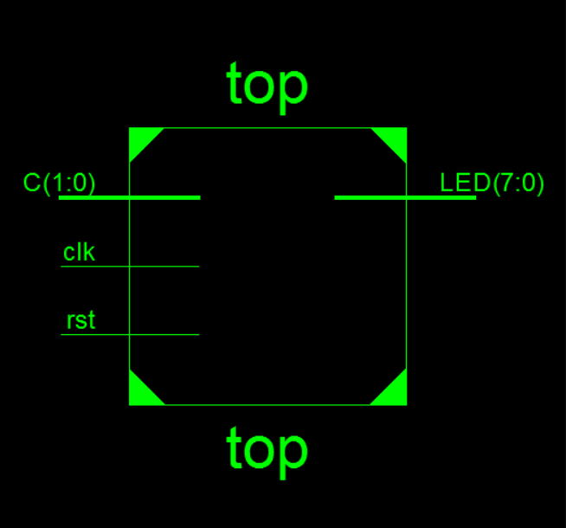

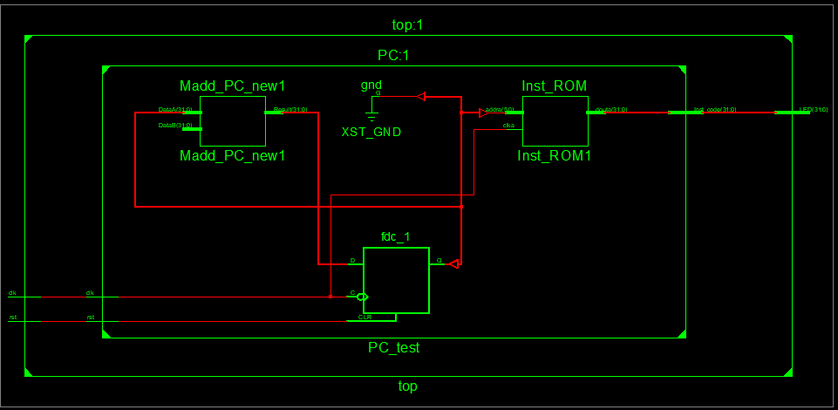
四、引脚配置（约束文件）
# PlanAhead Generated physical constraints

NET "clk" LOC = R4;
NET "rst" LOC = AA4;

# PlanAhead Generated IO constraints

NET "clk" IOSTANDARD = LVCMOS18;
NET "rst" IOSTANDARD = LVCMOS18;
NET "clk" PULLDOWN;
NET "rst" PULLDOWN;

# PlanAhead Generated physical constraints

NET "LED[31]" LOC = R1;
NET "LED[30]" LOC = P2;
NET "LED[29]" LOC = P1;
NET "LED[28]" LOC = N2;
NET "LED[27]" LOC = M1;
NET "LED[26]" LOC = M2;
NET "LED[25]" LOC = L1;
NET "LED[24]" LOC = J2;
NET "LED[23]" LOC = G1;
NET "LED[22]" LOC = E1;
NET "LED[21]" LOC = D2;
NET "LED[20]" LOC = A1;
NET "LED[19]" LOC = L3;
NET "LED[18]" LOC = G3;
NET "LED[17]" LOC = K4;
NET "LED[16]" LOC = G4;
NET "LED[15]" LOC = K1;
NET "LED[14]" LOC = J1;
NET "LED[13]" LOC = H2;
NET "LED[12]" LOC = G2;
NET "LED[11]" LOC = F1;
NET "LED[10]" LOC = E2;
NET "LED[9]" LOC = D1;
NET "LED[8]" LOC = B1;
NET "LED[7]" LOC = B2;
NET "LED[6]" LOC = N3;
NET "LED[5]" LOC = M3;
NET "LED[4]" LOC = K3;
NET "LED[3]" LOC = H3;
NET "LED[2]" LOC = N4;
NET "LED[1]" LOC = L4;
NET "LED[0]" LOC = J4;

# PlanAhead Generated IO constraints

NET "LED[31]" IOSTANDARD = LVCMOS18;
NET "LED[30]" IOSTANDARD = LVCMOS18;
NET "LED[29]" IOSTANDARD = LVCMOS18;
NET "LED[28]" IOSTANDARD = LVCMOS18;
NET "LED[27]" IOSTANDARD = LVCMOS18;
NET "LED[26]" IOSTANDARD = LVCMOS18;
NET "LED[25]" IOSTANDARD = LVCMOS18;
NET "LED[24]" IOSTANDARD = LVCMOS18;
NET "LED[23]" IOSTANDARD = LVCMOS18;
NET "LED[22]" IOSTANDARD = LVCMOS18;
NET "LED[21]" IOSTANDARD = LVCMOS18;
NET "LED[20]" IOSTANDARD = LVCMOS18;
NET "LED[19]" IOSTANDARD = LVCMOS18;
NET "LED[18]" IOSTANDARD = LVCMOS18;
NET "LED[17]" IOSTANDARD = LVCMOS18;
NET "LED[16]" IOSTANDARD = LVCMOS18;
NET "LED[15]" IOSTANDARD = LVCMOS18;
NET "LED[14]" IOSTANDARD = LVCMOS18;
NET "LED[13]" IOSTANDARD = LVCMOS18;
NET "LED[12]" IOSTANDARD = LVCMOS18;
NET "LED[11]" IOSTANDARD = LVCMOS18;
NET "LED[10]" IOSTANDARD = LVCMOS18;
NET "LED[9]" IOSTANDARD = LVCMOS18;
NET "LED[8]" IOSTANDARD = LVCMOS18;
NET "LED[7]" IOSTANDARD = LVCMOS18;
NET "LED[6]" IOSTANDARD = LVCMOS18;
NET "LED[5]" IOSTANDARD = LVCMOS18;
NET "LED[4]" IOSTANDARD = LVCMOS18;
NET "LED[3]" IOSTANDARD = LVCMOS18;
NET "LED[2]" IOSTANDARD = LVCMOS18;
NET "LED[1]" IOSTANDARD = LVCMOS18;
NET "LED[0]" IOSTANDARD = LVCMOS18;

五、思考与探索
（1）
读取指令存储器的前16条指令代码记录到表6.15中，分析取出的指令代码是否和指令存储器关联文件中的指令码一致？如果不一致，请分析原因
Pc地址 | 读出指令代码 | 关联文件中指令代码
00000000H | 00000827 | 00000827
00000004H | 0001102b | 0001102b
00000008H | 00421820 | 00421820
0000000cH | 00622020 | 00622020
00000010H | 00832820 | 00832820
00000014H | 00a33020 | 00a33020
00000018H | 00463804 | 00463804
0000001cH | 00a64820 | 00a64820
00000020H | 01264004 | 01264004
结果与关联文件中的一致

- （2）在复位后，第一次按动clk按钮，你的程序读出的指令是哪个单元的？0号单元还是4号单元的指令？分析为什么？如果要求在复位后的第一个clk来临时，读出的是0号单元的指令，你实现了吗？如果没有实现，尝试修改程序实现。

第一次按动clk读出的指令为4号单元的指令，但是这是用assign的连续赋值语句。
如果说想要读出0号单位，那么只有通过这样的方案改成上述的已经给出的代码块，也就是
always@(posedge rst or negedge clk)
begin
if(rst)
begin
PC_new=32'h00000000;
PC=32'h00000000;
end
else
begin
PC={24'h000000,PC_new[7:0]};
PC_new=PC+4;
end
end
这样的一段代码去将PC_new与PC进行绑定这样就可以调整。
（3）
一开始对pc的电路结构看的不是很懂，后来认真翻看了计算机组成原理课本上的知识，彻底明白这个模块要进行什么操作，成功的将实验做出来
六、意见和建议
采取多样形式开展实验，这样能督促学生积极学习，相信效果比较好。

