实验报告

姓名 | mm1ord | 学号 |  | 班级
专业 | 计算机科学与技术 |  | 课程名称 | 《计算机组成原理课程设计》
任课老师 |  | 指导老师 |  | 机位号 | 随机
实验序号 | 3 | 实验名称 | 存储器实验
实验时间 | 2022.5.13 | 实验地点 | 一教225 | 实验设备号 | 个人电脑
一、实验程序源代码
1.存储器顶层电路代码：
module RAMB_top(Mem_Addr,WD_SW,Mem_Write,Clk,LED);
input [7:2]Mem_Addr; //6个逻辑开关 读写存储器地址
input [2:0]WD_SW; // 指定8组数据
input Mem_Write; //读写控制信号 =1为写操作；=0为读操作
input Clk; //时钟信号
output reg[31:0] LED;//显示从存储器读出的数据
wire [31:0]M_R_Data; //存储器中读出的数据
reg [31:0]M_W_Data; //向存储器写入的数据
RAM_B MY_RAM (
.clka(Clk), // input clka
.wea(Mem_Write), // input [0 : 0] wea
.addra(Mem_Addr[7:2]), // input [5 : 0] addra
.dina(M_W_Data[31:0]), // input [31 : 0] dina
.douta(M_R_Data[31:0]) // output [31 : 0] douta
);
always@(*)
begin
LED=0; //初始化
M_W_Data=0; //初始化
if(!Mem_Write)//读操作 Mem_Write == 0
begin
LED = M_R_Data[31:0];
end
else //写操作 Mem_Write == 1
begin
case(WD_SW)
3'b000: M_W_Data = 32'h1111_1111;
3'b001: M_W_Data = 32'h2222_2222;
3'b010: M_W_Data = 32'h3333_3333;
3'b011: M_W_Data = 32'h4444_4444;
3'b100: M_W_Data = 32'h5555_5555;
3'b101: M_W_Data = 32'h6666_6666;
3'b110: M_W_Data = 32'h7777_7777;
3'b111: M_W_Data = 32'h8888_8888;
endcase
end
end
endmodule

2.测试代码
odule test;

// Inputs
reg clka;
reg [0:0] wea;
reg [5:0] addra;
reg [31:0] dina;

// Outputs
wire [31:0] douta;

// Instantiate the Unit Under Test (UUT)
RAM_B uut (
.clka(clka),
.wea(wea),
.addra(addra),
.dina(dina),
.douta(douta)
);

initial begin
// Initialize Inputs
clka = 0;
wea = 0;
addra = 0;
dina = 0;

// Wait 100 ns for global reset to finish
#100;

// Add stimulus here
clka = 1;
wea = 0;
addra = 6'b000001;
dina = 32'h0000_0003;

#100;
clka = 0;
wea = 0;
addra = 6'b000001;
dina = 32'h0000_0607;

#100;
clka = 1;
wea = 1;
addra = 6'b000001;
dina = 32'hFFFF_FFFF;

#100;
clka = 0;
wea = 1;
addra = 6'b000001;
dina = 32'hFFFF_FFFF;

end

endmodule

二、仿真波形（下图是例子，请根据你们的实际情况替换）
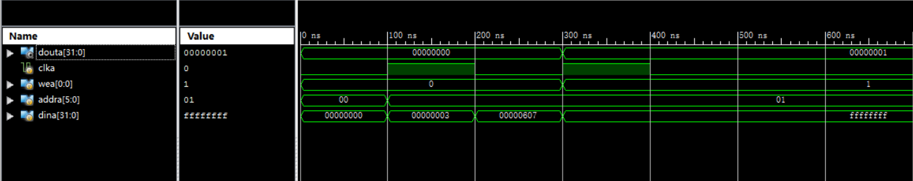
三、电路图
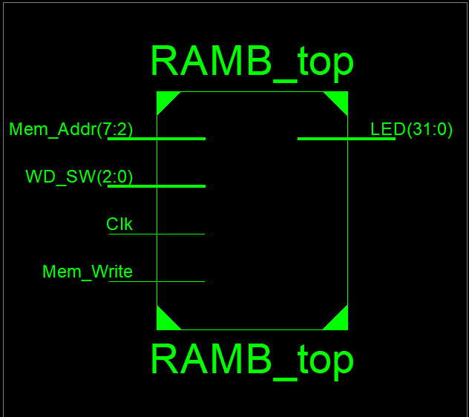
四、引脚配置（约束文件）
NET "LED[31]" IOSTANDARD = LVCMOS18;
NET "LED[30]" IOSTANDARD = LVCMOS18;
NET "LED[29]" IOSTANDARD = LVCMOS18;
NET "LED[28]" IOSTANDARD = LVCMOS18;
NET "LED[27]" IOSTANDARD = LVCMOS18;
NET "LED[26]" IOSTANDARD = LVCMOS18;
NET "LED[25]" IOSTANDARD = LVCMOS18;
NET "LED[24]" IOSTANDARD = LVCMOS18;
NET "LED[23]" IOSTANDARD = LVCMOS18;
NET "LED[22]" IOSTANDARD = LVCMOS18;
NET "LED[21]" IOSTANDARD = LVCMOS18;
NET "LED[20]" IOSTANDARD = LVCMOS18;
NET "LED[19]" IOSTANDARD = LVCMOS18;
NET "LED[18]" IOSTANDARD = LVCMOS18;
NET "LED[17]" IOSTANDARD = LVCMOS18;
NET "LED[16]" IOSTANDARD = LVCMOS18;
NET "LED[15]" IOSTANDARD = LVCMOS18;
NET "LED[14]" IOSTANDARD = LVCMOS18;
NET "LED[13]" IOSTANDARD = LVCMOS18;
NET "LED[12]" IOSTANDARD = LVCMOS18;
NET "LED[11]" IOSTANDARD = LVCMOS18;
NET "LED[10]" IOSTANDARD = LVCMOS18;
NET "LED[9]" IOSTANDARD = LVCMOS18;
NET "LED[8]" IOSTANDARD = LVCMOS18;
NET "LED[7]" IOSTANDARD = LVCMOS18;
NET "LED[6]" IOSTANDARD = LVCMOS18;
NET "LED[5]" IOSTANDARD = LVCMOS18;
NET "LED[4]" IOSTANDARD = LVCMOS18;
NET "LED[3]" IOSTANDARD = LVCMOS18;
NET "LED[2]" IOSTANDARD = LVCMOS18;
NET "LED[1]" IOSTANDARD = LVCMOS18;
NET "LED[0]" IOSTANDARD = LVCMOS18;

NET "Mem_Addr[7]" LOC = T3;
NET "Mem_Addr[6]" LOC = U3;
NET "Mem_Addr[5]" LOC = T4;
NET "Mem_Addr[4]" LOC = V3;
NET "Mem_Addr[3]" LOC = V4;
NET "Mem_Addr[2]" LOC = W4;

NET "Mem_Addr[7]" IOSTANDARD = LVCMOS18;
NET "Mem_Addr[6]" IOSTANDARD = LVCMOS18;
NET "Mem_Addr[5]" IOSTANDARD = LVCMOS18;
NET "Mem_Addr[4]" IOSTANDARD = LVCMOS18;
NET "Mem_Addr[3]" IOSTANDARD = LVCMOS18;
NET "Mem_Addr[2]" IOSTANDARD = LVCMOS18;
NET "Mem_Addr[7]" PULLDOWN;
NET "Mem_Addr[6]" PULLDOWN;
NET "Mem_Addr[5]" PULLDOWN;
NET "Mem_Addr[4]" PULLDOWN;
NET "Mem_Addr[3]" PULLDOWN;
NET "Mem_Addr[2]" PULLDOWN;

NET "WD_SW[2]" LOC = Y4;
NET "WD_SW[1]" LOC = Y6;
NET "WD_SW[0]" LOC = W7;

NET "WD_SW[2]" IOSTANDARD = LVCMOS18;
NET "WD_SW[1]" IOSTANDARD = LVCMOS18;
NET "WD_SW[0]" IOSTANDARD = LVCMOS18;
NET "WD_SW[2]" PULLDOWN;
NET "WD_SW[1]" PULLDOWN;
NET "WD_SW[0]" PULLDOWN;

NET "Clk" LOC = R4;
NET "Mem_Write" LOC = AA4;

NET "Clk" IOSTANDARD = LVCMOS18;
NET "Mem_Write" IOSTANDARD = LVCMOS18;
NET "Clk" PULLDOWN;
NET "Mem_Write" PULLDOWN;

# PlanAhead Generated physical constraints

NET "LED[31]" LOC = R1;
NET "LED[30]" LOC = P2;
NET "LED[29]" LOC = P1;
NET "LED[28]" LOC = N2;
NET "LED[27]" LOC = M1;
NET "LED[26]" LOC = M2;
NET "LED[25]" LOC = L1;
NET "LED[24]" LOC = J2;
NET "LED[23]" LOC = G1;
NET "LED[22]" LOC = E1;
NET "LED[21]" LOC = D2;
NET "LED[20]" LOC = A1;
NET "LED[19]" LOC = L3;
NET "LED[18]" LOC = G3;
NET "LED[17]" LOC = K4;
NET "LED[16]" LOC = G4;
NET "LED[15]" LOC = K1;
NET "LED[14]" LOC = J1;
NET "LED[13]" LOC = H2;
NET "LED[12]" LOC = G2;
NET "LED[11]" LOC = F1;
NET "LED[10]" LOC = E2;
NET "LED[9]" LOC = D1;
NET "LED[8]" LOC = B1;
NET "LED[7]" LOC = B2;
NET "LED[6]" LOC = N3;
NET "LED[5]" LOC = M3;
NET "LED[4]" LOC = K3;
NET "LED[3]" LOC = H3;
NET "LED[2]" LOC = N4;
NET "LED[1]" LOC = L4;
NET "LED[0]" LOC = J4;
五、思考与探索
(1)读操作实验结果记录表
存储器地址 初始化数据 读出数据 写入新数据 读出数据
5’b000000 32’b00000000 32’b00000000 32'h0055_7523 32'h0055_7523
5’b000001 32’b00000001 32’b00000001 32'h0055_7523 32'h0055_7523
5’b000002 32’b00000002 32’b00000002 32'h0055_7523 32'h0055_7523
5’b000003 32’b00000003 32’b00000003 32'h0055_7523 32'h0055_7523
5’b000004 32’b00000004 32’b00000004 32'h0055_7523 32'h0055_7523
5’b000005 32’b00000005 32’b00000005 32'h0055_7523 32'h0055_7523
5’b000006 32’b00000006 32’b00000006 32'h0055_7523 32'h0055_7523
5’b000007 32’b00000007 32’b00000007 32'h0055_7523 32'h0055_7523
(2)答：这些单元的数据已经被改写了。读出数据与写入数据一致。
(3)答:设计实现一个ROM，常规存储器是单端口存储器，每次只接收一个地址，访问一个存储单元，从中读取或写入一个字节或字。主存储器是信息交换的中心，一方面CPU频繁地与主存交换信息，另一方面外设也较频繁地与主存交换信息，而单端口存储器每次只能接受一个访存者，或是读或是写，这就影响到存储器的整体工作速度。
(4)
module Mem_Exp(
input clk_m,Mem_Write,
input [4:0]R_Addr_A,//A端口读寄存器地址
input [4:0]R_Addr_B,//B端口读寄存器地址
input [4:0]W_Addr,//写寄存器地址
input Write_Reg,
input [2:0]ALU_OP,
input rst,clk,
output [31:0]M_R_Data,
output [31:0]R_data_A,
output [31:0]R_data_B,
output [31:0] ALU_F,
input [7:0] Mem_Addr
);

wire ZF,OF;
RAM_B Data_RAM (
.clka(clk_m), // input clka
.wea(Mem_Write), // input [0 : 0] wea
.addra(R_data_B[5:0]), // input [5 : 0] addra
.dina(R_data_B), // input [31 : 0] dina
.douta(M_R_Data) // output [31 : 0] douta
);

//register REGS_1(R_data_A,R_data_B,M_R_Data,R_Addr_A,R_Addr_B,W_Addr,Write_Reg,rst,clk);
register r1(
.R_Addr_A(R_Addr_A),
.R_Addr_B(R_Addr_B),
.W_Addr(W_Addr),
.Write_Reg(Write_Reg),
.W_Data(ALU_F),
.clk(clk),
.rst(rst),
.R_Data_A(R_data_A),
.R_Data_B(R_data_B)
);
ALU a(
.A(R_data_A),
.B(M_R_Data),
.F(ALU_F),
.ZF(ZF),
.OF(OF),
.ALU_OP(ALU_OP)
);

endmodule
测试代码:
module Mem_test;

// Inputs
reg clk_m;
reg Mem_Write;
reg [4:0] R_Addr_A;
reg [4:0] R_Addr_B;
reg [4:0] W_Addr;
reg Write_Reg;
reg [2:0] ALU_OP;
reg rst;
reg clk;
reg [7:0] Mem_Addr;

// Outputs
wire [31:0] M_R_Data;
wire [31:0] R_data_A;
wire [31:0] R_data_B;
wire [31:0] ALU_F;

// Instantiate the Unit Under Test (UUT)
Mem_Exp uut (
.clk_m(clk_m),
.Mem_Write(Mem_Write),
.R_Addr_A(R_Addr_A),
.R_Addr_B(R_Addr_B),
.W_Addr(W_Addr),
.Write_Reg(Write_Reg),
.ALU_OP(ALU_OP),
.rst(rst),
.clk(clk),
.M_R_Data(M_R_Data),
.R_data_A(R_data_A),
.R_data_B(R_data_B),
.ALU_F(ALU_F),
.Mem_Addr(Mem_Addr)
);
always begin
#3 clk_m=~clk_m;
clk=~clk;
end
initial begin
// Initialize Inputs
clk_m = 0;
Mem_Write = 0;
R_Addr_A = 1;
R_Addr_B = 1;
W_Addr = 8;
Write_Reg = 1;//保持写入
ALU_OP = 4;
rst = 0;
clk = 0;
Mem_Addr = 0;

// Wait 100 ns for global reset to finish
repeat(256)
begin
#10 {Mem_Addr[7:2]}={Mem_Addr[7:2]}+1;
{R_Addr_B} ={R_Addr_B}+ 1;
{W_Addr}={W_Addr}+1;
end

// Add stimulus here

end
endmodule

六、意见和建议
采取多样形式开展实验，这样能督促学生积极学习，相信效果比较好。

