实验报告

姓名 | mm1ord | 学号 |  | 班级
专业 | 计算机科学与技术 |  | 课程名称 | 《计算机组成原理课程设计》
任课老师 |  | 指导老师 |  | 机位号
实验序号 | 2 | 实验名称 | 超前进位加法器设计实验
实验时间 | 2022.4.7 | 实验地点 | 一教225 | 实验设备号 | 个人电脑
一、实验程序源代码
module cqjwjfq(output [3:0] F, output C4, input [3:0] A, input [3:0] B, input C0);
wire [3:0]G,P;
wire [4:0]C;

assign C[0]=C0;
cqjw cqjw1(G,P,C[4:1],A,B,C0);
ywjfq ywjfq1(A[0],B[0],C[0],,F[0]);
ywjfq ywjfq2(A[1],B[1],C[1],,F[1]);
ywjfq ywjfq3(A[2],B[2],C[2],,F[2]);
ywjfq ywjfq4(A[3],B[0],C[0],,F[3]);

assign C4 = C[4];

endmodule

module ywjfq(input A,input B,input C_IN,output C_OUT,output F);

assign F = A^B^C_IN;
assign C_OUT = A&B|(A^B)&C_IN;

endmodule

module cqjw(output [3:0] G, output [3:0] P, output [4:1] C, input [3:0] A, input [3:0] B, input C0);

assign G = A&B;
assign P = A|B;

assign C[1] = G[0] | P[0]&C0;
assign C[2] = G[1] | P[1]&G[0] | P[1]&P[0]&C0;
assign C[3] = G[2] | P[2]&G[1] | P[2]&P[1]&G[0] | P[2]&P[1]&P[0]&C0;
assign C[4] = G[3] | P[3]&G[2] | P[3]&P[2]&P[1]&G[0] | P[3]&P[2]&P[1]&P[0]&C0;

endmodule
二、仿真波形（下图是例子，请根据你们的实际情况替换）
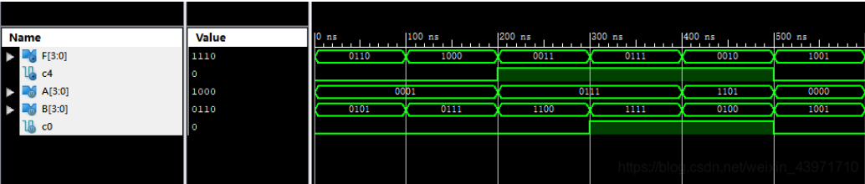

三、电路图
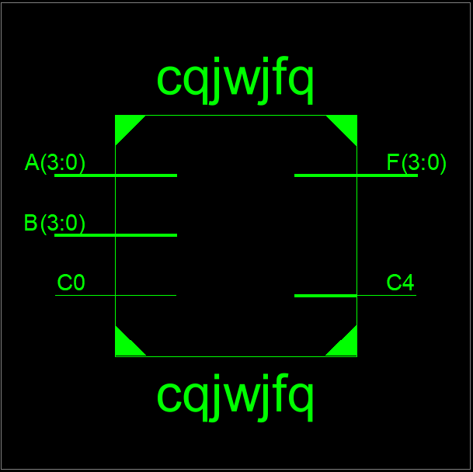
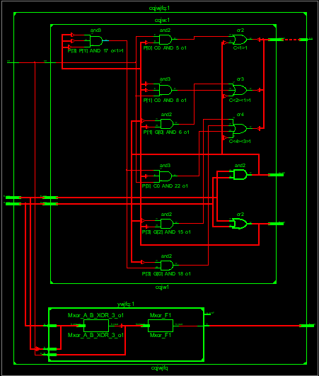

四、引脚配置（约束文件）
# PlanAhead Generated IO constraints
NET "A[3]" PULLDOWN;
NET "A[2]" PULLDOWN;
NET "A[1]" PULLDOWN;
NET "A[0]" PULLDOWN;
NET "B[3]" PULLDOWN;
NET "B[2]" PULLDOWN;
NET "B[1]" PULLDOWN;
NET "B[0]" PULLDOWN;
NET "C_IN" PULLDOWN;
NET "A[3]" IOSTANDARD = LVCMOS18;
NET "A[2]" IOSTANDARD = LVCMOS18;
NET "A[1]" IOSTANDARD = LVCMOS18;
NET "A[0]" IOSTANDARD = LVCMOS18;
NET "B[3]" IOSTANDARD = LVCMOS18;
NET "B[2]" IOSTANDARD = LVCMOS18;
NET "B[1]" IOSTANDARD = LVCMOS18;
NET "B[0]" IOSTANDARD = LVCMOS18;
NET "F[3]" IOSTANDARD = LVCMOS18;
NET "F[2]" IOSTANDARD = LVCMOS18;
NET "F[1]" IOSTANDARD = LVCMOS18;
NET "F[0]" IOSTANDARD = LVCMOS18;
NET "C_IN" IOSTANDARD = LVCMOS18;
NET "C_OUT" IOSTANDARD = LVCMOS18;
# PlanAhead Generated physical constraints
NET "A[3]" LOC = T3;
NET "A[2]" LOC = U3;
NET "A[1]" LOC = T4;
NET "A[0]" LOC = V3;
NET "B[3]" LOC = V4;
NET "B[2]" LOC = W4;
NET "B[1]" LOC = Y4;
NET "B[0]" LOC = Y6;
NET "F[3]" LOC = R1;
NET "F[2]" LOC = P2;
NET "F[1]" LOC = P1;
NET "F[0]" LOC = N2;
NET "C_IN" LOC = R4;
NET "C_OUT" LOC = K1;
五、思考与探索
- 和预想的电路图几乎一致，就是将4个一位二进制全加器集成到了一起，其他几乎一致

- 8位二进制超前进位加法器：
module add_8_1(
input wire [7:0] add1,
input wire [7:0] add2,
input wire cin,
output wire [7:0] sum,
output wire cout
);
wire[7:0] g,p,c;//c代表每一位计算的进位，c[0]表示原始的进位cin
assign c[0]=cin;
assign p=add1 ^ add2;
assign g=add1 & add2;
assign c[0] = g[0] | (p[0] & c[0]);
assign c[1] = g[1] | (p[1] & (g[0] | (p[0] & c[0])));
assign c[2] = g[2] | (p[2] & (g[1] | (p[1] & (g[0] | (p[0] & c[0])))));
assign c[3] = g[3] | (p[3] & (g[2] | (p[2] & (g[1] | (p[1] & (g[0] | (p[0] & c[0])))))));
assign c[4] = g[4] | (p[4] & (g[3] | (p[3] & (g[2] | (p[2] & (g[1] | (p[1] & (g[0] | (p[0] & c[0])))))))));
assign c[5] = g[5] | (p[5] & (g[4] | (p[4] & (g[3] | (p[3] & (g[2] | (p[2] & (g[1] | (p[1] & (g[0] | (p[0] & c[0])))))))))));
assign c[6] = g[6] | (p[6] & (g[5] | (p[5] & (g[4] | (p[4] & (g[3] | (p[3] & (g[2] | (p[2] & (g[1] | (p[1] & (g[0] | (p[0] & c[0])))))))))))));
assign c[7] = g[7] | (p[7] & (g[6] | (p[6] & (g[5] | (p[5] & (g[4] | (p[4] & (g[3] | (p[3] & (g[2] | (p[2] & (g[1] | (p[1] & (g[0] | (p[0] & c[0])))))))))))))));
assign sum=p^c[7:0];
assign cout=c[7];
endmodule
3、16位二级逻辑的超期进位加法器：
将原有的4位超前进位的二进制加法器通过两次级联拼成1个16位的二级逻辑的超前进位加法器即可。
4、因为之前没有上过计科的数电没有使用过ISE软件，在ISE的下载安装使用仿真下载，各步骤都花费了不少时间，通过在网上搜索资料终于学会了ISE软件的使用，完成了实验。
六、意见和建议
可以多讲解一下超前进位加法器的“超前进位”内部逻辑的实现原理，也可以讲一下进位产生函数、进位传递函数是如何得出来的。

