Step 1 - all fine it seems

all seems is saved properly (meaning those texts that i entered are there, so they can see what they have entered and easily find and fix if they entered some mistakes – this should be on all pages).

Still have to check pic if it's optimized

Step 2 – just minor things

All texts are there so that's perfect, but pics are not shown. Here this is not crucial and it can eventually stay if it takes time to fix it. But for some other steps this will be needed.

This needs to be changed – First field = subheadline. Make the subheadline (you made it well and this is my fault, but here is meant to be subheadline and not tiny text)

Please fix these pics = boxes are too apart of each other, pics inside boxes are too wide (there is not shown that nice border around; it's just tiny and it doesn't look attractive). Compare <https://dev485.osmrtnica.com/floristdetails> and <https://dev111.osmrtnica.com/floristdetails/1>

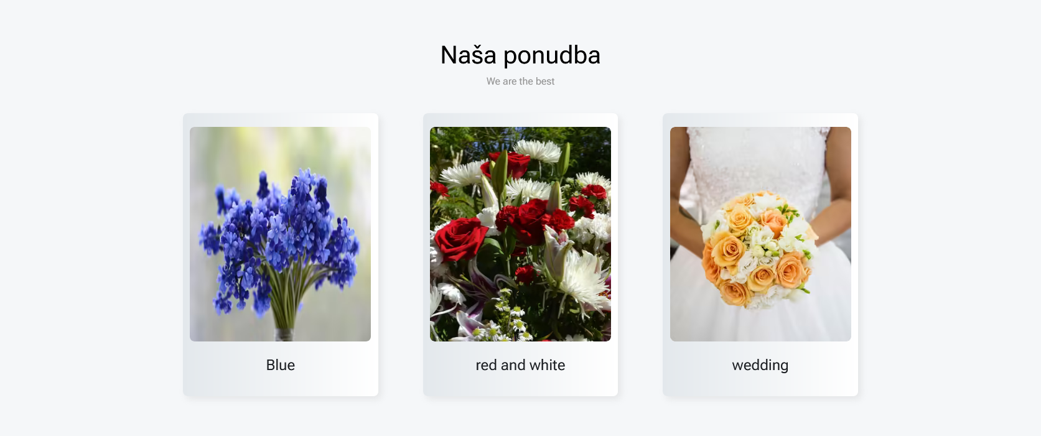 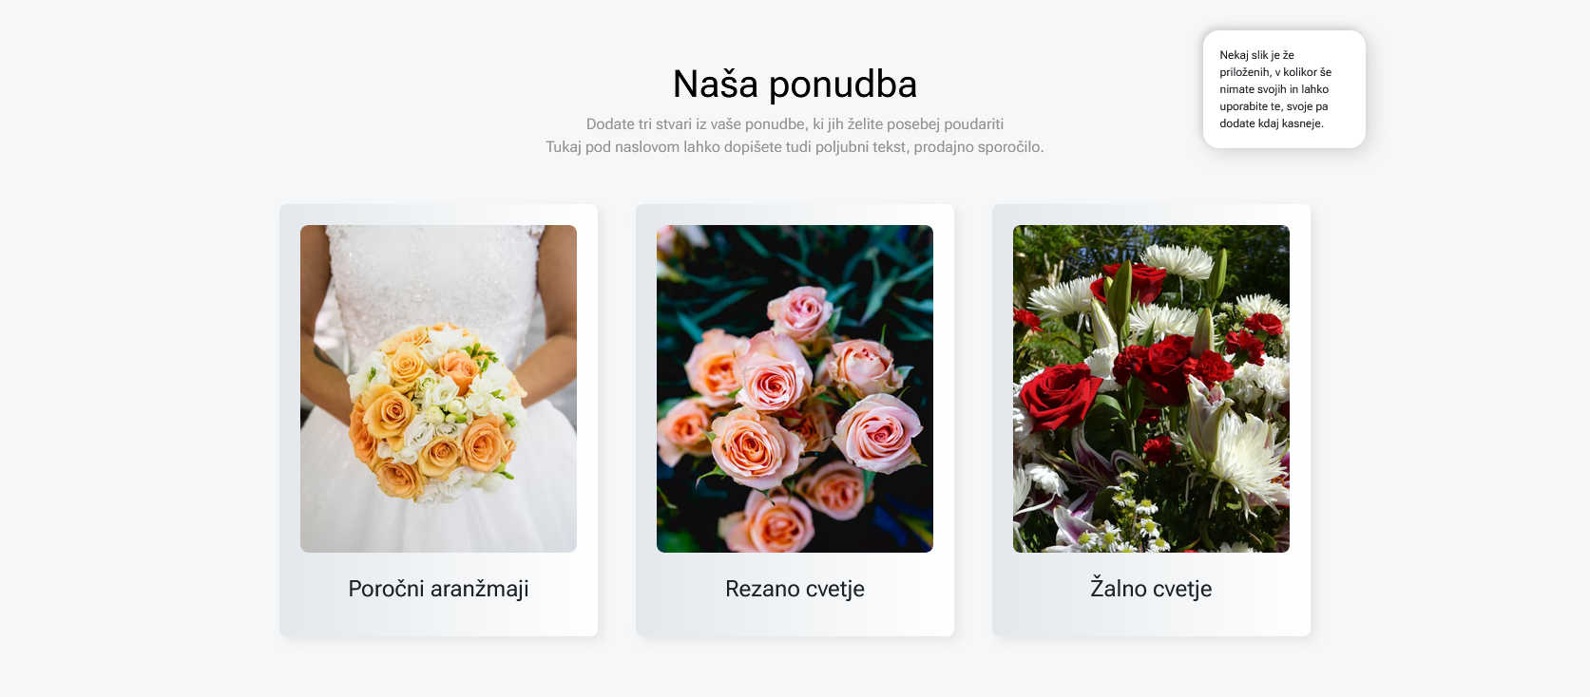

Step 3 – this step is not working properly

Our entries are NOT saved. Whatever texts they enter, those should be shown since it's their page and that will allow them to find and fix any mistake easily or adapt texts.

Neither are our entries shown on page. (when you will fix this, then please add 4 different pictures in top 4 products, so you would test this properly (before was made that first 3 were done properly, while others later were not).

Step 4 – Icons are resizing

Anywhere on this whole website, not just this theirs page, but on all website, NO pic is EVER resized (except backgrounds). We don't want squeezed pics. This here is completely wrong – DO NOT resize icons = they are from the same pack of icons are they are same size, so this should never happen.



Then i tried to add one icon only and i can't. It always shows two icons. Make that delete icon there workable = so that should delete the icon with a glass completely. If they choose to have one icon, they can, if two icons, they can have that too.

And ofc, you would also have to make it that texts are SHOWN after they come back to this step later = are saved.

Then i added this pic to be shown there,

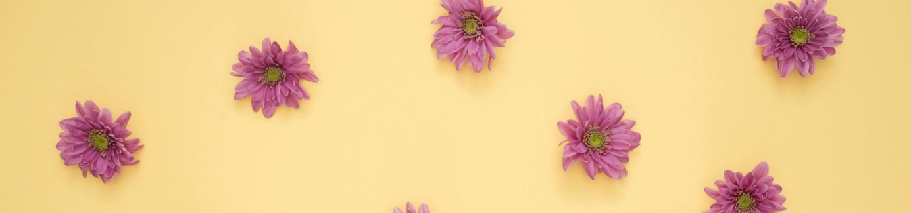

but what it really showed is this



So again, it is not showing pic properly based on pre-determined size.

If they want to change background pic, then that whole background pic should be changed.

Then i added another pic there, but it shows this same background (new one is not saved it seems; it is definitely not shown; yes, i refreshed the site).

Step 5

Pic works perfectly it seems !!!

There is one thing that we will have to adapt and that will be easy and convenient to users (and for you too to make it). We desperately need paragraphs. We can't force them to write it all in one line, because that's not readable and not advertising and that is limiting the use of this block (and overall, the flexibility of whole page).

You would add one more field there – for the second paragraph (if someone will need it, then they can use it; if not, then they will be able to write it all in one paragraph). Simple!! And easy for them and easy for you. We just need to determine the space in between and that's it. I'll send you how it should be made in this Step – on figma (just one field added and some text to explain them better and that's all).



Otherwise you fixed this block perfectly!

Step 6 – footer

Publish button is not working – that should do 2 things = open their page automatically and send it all to us, so we can check if all is fine and then we would publish it. So make it just to open their new page for now and when all the rest is working, you will connect it to be sent to us.

And neither is save button working, so that footer there cannot be even saved. Please test it.

Why am i so annoying with this page – because based on this page, they will pay us subscription. It's their advertising page, so it has to be done perfectly, otherwise noone will be crazy enough to pay anything for some shitty page. It needs to look magnificent and be flexible as it can be to their needs and that is what we wanted to do here.

I haven't checked all pics and their optimizations yet. (the one in step 5 looks it is done perfectly, so the coding is there).