**Problem Statement:**

Big Mountain Resort, situated in Montana, seeks to refine its ticket pricing strategy to maximize revenue while ensuring competitiveness within the ski resort market***. The resort management aims to leverage data-driven insights to optimize ticket prices based on facility offerings and market dynamics.***

**1. Data Wrangling:** Exploration of the dataset revealed insights into resort characteristics and ticket pricing trends. Initial data cleaning involved addressing missing values and identifying unique resort names. Notably, Montana did not rank in the top 10 in terms of the number of resorts nationwide, highlighting the competitive landscape (**Figure 1**). Further analysis examined the relationship between regions and states, facilitating a comprehensive understanding of geographical distribution. We discovered that most prices appear to lie in a broad band from around 25 to over 100 dollars. Some states have significant variability, while others, like Montana, showed small variability and matching weekend and weekday ticket prices (**Figure 2**).

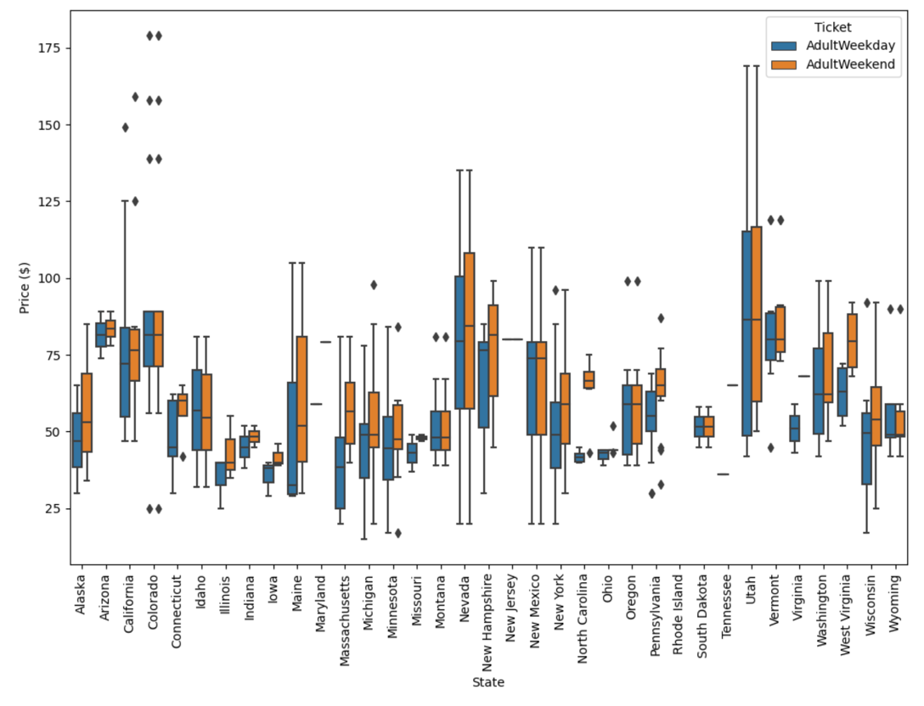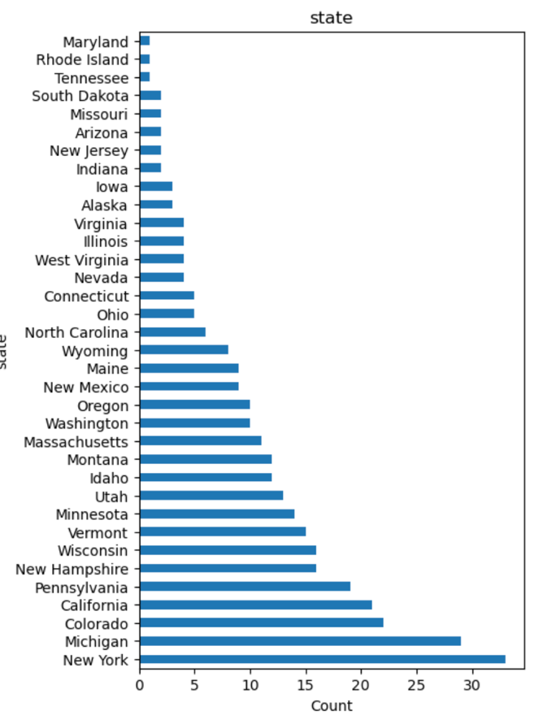

**Figure 2**

**Figure 1**

**2. Exploratory Data Analysis:** An in-depth exploration of resort data uncovered significant trends and correlations between features. We decided to conduct a Principal Components Analysis (**PCA; Figure 3**) to understand better the relationships between features and how much variance they explain. Even though we did not see any clear grouping, we did capture potentially relevant state features that might be useful for our subsequent modeling efforts. We calculated ratios to better understand resorts’ share of the supply for a given state, after which we created a heatmap to explore correlations and identify patterns (**Figure 4**). We observed that our target feature, ticket price, was positively correlated with fastQuads, Runs, total_chairs, vertical drop, and Snow Making_ac.

**Figure 4**

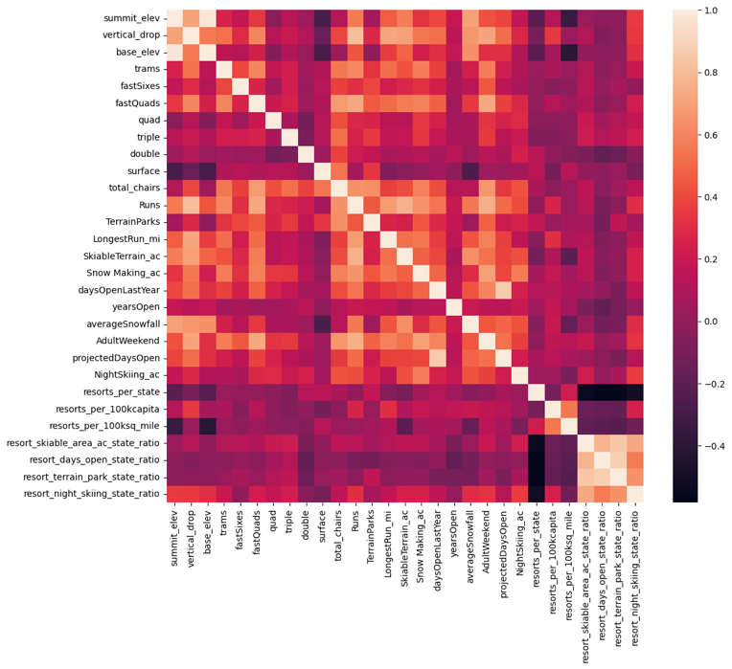

**Figure 4**

**Figure 3**

**3. Preprocessing and Training:** In the preprocessing phase, we meticulously cleaned and prepared the data, addressing missing values and outliers to ensure the reliability of our models. Subsequently, we split the dataset into training and testing sets to evaluate model performance accurately.We established a baseline using the average ticket price and then explored two machine-learning approaches: linear regression and random forest. Both models were trained and evaluated, with the random forest model ultimately selected for its superior performance, demonstrating lower mean absolute error (MAE) and greater stability.

**4. Modeling:** Our modeling endeavors explored different scenarios to optimize ticket prices and enhance Big Mountain Resort's competitive stance. Through predictive modeling, we estimated a market-supported ticket price of approximately $95.87, indicating the potential for a price increase while maintaining competitiveness. The random forest model emerged as the preferred choice for its superior predictive performance. Considering the impact of various factors, such as additional facilities and operating costs, we simulated scenarios to assess revenue implications and identify strategies for maximizing profitability. These insights inform strategic decision-making, guiding pricing strategies and resource allocation to achieve sustainable growth.

**Pricing Recommendation:** Based on our analysis, Big Mountain Resort should consider adjusting ticket prices to better align with the value proposition offered by its facilities***. An increase in ticket prices, coupled with strategic facility enhancements such as adding new runs and increasing vertical drop, could help offset operating costs associated with recent investments, such as installing an additional chair lift.***

**Conclusion:** Our comprehensive analysis provides actionable insights to guide Big Mountain Resort in refining its pricing strategy and maximizing revenue potential. By leveraging data-driven approaches, the resort can optimize pricing decisions while maintaining competitiveness in the ski resort market.

**Future Scope of Work:** Continued analysis and refinement of pricing strategies will be essential to adapt to evolving market dynamics and consumer preferences. Future work could integrate additional data sources, such as visitor demographics and competitor pricing, to further enhance pricing optimization efforts. Additionally, ongoing monitoring and evaluation of pricing initiatives will enable the resort to iterate and optimize strategies over time, ensuring sustained success in the competitive ski resort industry.