Implement **a python program** that periodically downloads and extracts the information about the most active stocks on NYSE (The New York Stock Exchange), and saves/updates the information in a database. Implement **a PHP script** that can generate web pages to serve the information through a web server upon user requests.

# Instructions

In an infinite loop, the ***python program*** sends HTTP requests to get the web page containing the data about the most active stocks on NYSE from ***https://finance.yahoo.com/most-active***, checks HTTP status (retries the request if it fails to get the page and terminates if the retry fails), analyzes the response to extract the data, add the data in your mongodb database as new mongodb documents, and **sleeps 3 minutes** to limit request frequency. The program only saves the following 5 fields into the database: Symbol, Name, Price (Introday), Change, and Volume. For simplicity, it only adds new data into the database as new documents, and does not merge it with the existing data in the database (e.g., calculating average prices, total volumes, etc).

When the program is running, the database is updated every 3 minutes. You can stop the program after several rounds (e.g., 15 minutes). Then, you can run the ***PHP script*** to read the data out from the database and check the HTML page generated by the PHP script. You can use php to run the script on the command line first, so you can see error messages if the script contains bugs. Only after you have confidence that it runs correctly, “deploy” it and test it in a web server (more instructions below).

The ***PHP script*** connects to and queries your mongodb database to obtain the data saved earlier by the python program. With the data, it generates a web page containing a table. The table should allow users to sort the data by clicking the column title on the header row, as shown with the screenshots below (one sorted based on *Index*, and the other sorted based on *Symbol*).

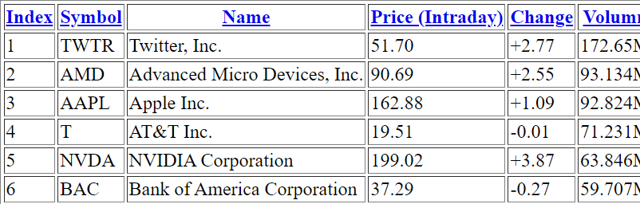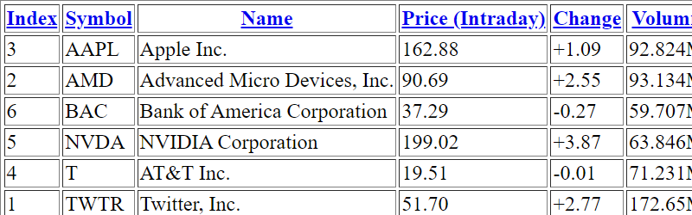

Set up and use your own mongodb server and web server.