Mark Meade

Project 4 analysis questions.

Question 5:

After running 5 iterations of testPenData, the accuracies were as follows:

1. 83.35
2. 86.10
3. 86.10
4. 84.65
5. 87.05

The max is 87.05%, and the average is 85.45%, The standard deviation is 1.3%

Question 6:

|  |  |  |  |  |  |
| --- | --- | --- | --- | --- | --- |
| Iteration = | 1 | 2 | 3 | 4 | 5 |
| Size 0: | 0 | 0 | 0 | 0 | 0 |
| Size 5: | 52.4 | 26.20 | 44.25 | 47.35 | 60.25 |
| Size 10: | 78.8 | 75.80 | 80.5 | 76.05 | 81.35 |
| Size 15: | 84.35 | 81.25 | 83.35 | 79.75 | 80.15 |
| Size 20: | 85.15 | 84.85 | 84.95 | 81.35 | 85.70 |
| Size 25 | 86.55 | 87.70 | 84.40 | 85.35 | 86.45 |
| Size 30: | 87.00 | 87.75 | 85.75 | 87.35 | 88.45 |
| Size 35: | 86.85 | 85.75 | 86.65 | 85.55 | 87.45 |
| Size 40: | 86.25 | 87.55 | 85.35 | 86.05 | 88.25 |

Size 0: Max: 0 Average: 0 Standard Deviation: 0

Size 5: Max: 60.25 Average: 46.09 Standard Deviation: 12.65

Size 10: Max: 81.35 Average: 78.5 Standard Deviation: 2.52

Size 15: Max: 84.35 Average: 81.77 Standard Deviation: 2.01

Size 20: Max: 85.7 Average: 84.4 Standard Deviation: 1.74

Size 25: Max: 87.7 Average: 86.09 Standard Deviation: 1.26

Size 30: Max: 88.45 Average: 87.26 Standard Deviation: 1.00

Size 35: Max: 87.45 Average: 86.45 Standard Deviation: 0.79

Size 40: Max: 88.25 Average: 86.69 Standard Deviation: 1.18

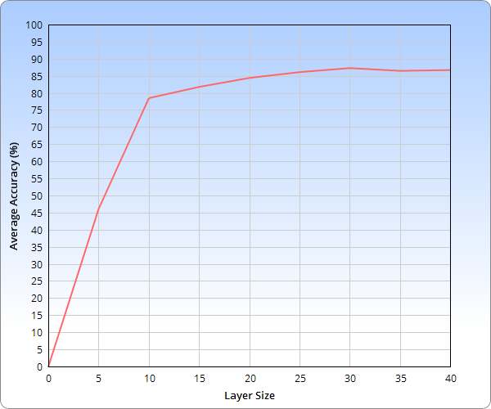

Discussion:

From what I could tell, the performance of the Neural Net was better when there were less nodes in the hidden layer. I expected this to be the case, but I expected more of a difference a hidden layer with 0 nodes vs a hidden layer with 40. I thought 0 would be almost instant, and 40 would take about a half hour, but instead 0 was around 10 seconds, and 40 was around 2 minutes or so.

In terms of accuracy, it seems like my neural net is trying to approach 90% accuracy, but never will. The accuracy increases very quickly in the beginning, with each additional perceptron in the hidden layer making a large difference. As the hidden layer reaches 10 perceptron’s in size, it seems that every additional perceptron doesn’t help increase accuracy as much as the ones previous to it did. As such, it seems the ideal layer size is around 20, as it’s close to best accuracy, and doesn’t take as long to run in comparison to the layer sizes after it.