Unit 7: Get to the top!

Section 1: Vocabulary in context (Jobs and work words / Personal qualities)
1) Read the sentences and check the words in bold in your dictionary if necessary.
1. They work outdoors.
2. They work with the public.
3. They do paperwork, e.g. producing reports, articles and documents or writing letters.
4. They look after and work with children.
5. They do manual work.
6. Teamwork is important in their job.
7. They work in an office, with figures or with computers.
8. They earn a high salary.
9. They often work overtime.
10. They work in retail or finance.

2) Find two jobs for each sentence in 1.
Jobs
architect • au pair • chef • company director • construction worker • economist • fashion designer • firefighter • journalist • lawyer • mechanic • nurse • photographer • plumber • police officer • receptionist • shop assistant • vet

1. construction worker, firefighter
2. ……………………………………………………
3. ……………………………………………………
4. ……………………………………………………
5. ……………………………………………………
6. ……………………………………………………
7. ……………………………………………………
8. ……………………………………………………
9. ……………………………………………………
10. ……………………………………………………

3) Can you think of one more job (not from the list in 2) for each sentence in 1?
1. ……………………………………………………
2. ……………………………………………………
3. ……………………………………………………
4. ……………………………………………………
5. ……………………………………………………
6. ……………………………………………………
7. ……………………………………………………
8. ……………………………………………………
9. ……………………………………………………
10. ……………………………………………………

4a) Complete the text with some of these words.
Personal qualities
ambitious • calm • caring • clever/bright • confident • creative • determined • fit • flexible • hard-working • patient • reliable • responsible • sensitive • sociable/friendly • strong • well-organised

Essential qualities in the world of work
There are jobs where you need to have a specific skill or personal quality. But there are many personal qualities that are useful in almost any job. For example, it’s always important to be (a) ………………………, i.e. to plan things carefully and know exactly what you’re doing. It’s also important to be (b) ……………………… so that you adapt to changing situations. Being (c) ……………………… isn’t just a quality that artists and writers need – it’s essential in any job where you need imagination to think of new ideas or solutions to problems. Working in teams is always important, so it’s good if you are (d) ……………………… and (e) ……………………… and like working with other people. It’s vital that you are (f) ……………………… and (g) ………………………, too, so that people know they can depend on you. It also helps if you’re (h) ……………………… and (i) ……………………… so that you don’t panic or get angry when things start to go wrong. And, finally, it’s OK to be (j) ……………………… and to want to be a big success in your job!

4b) Listen and check your answers.

5) Ask and answer the questions.
1. Which of the things in 1 would you like in your future job? Which would you not like?

2. Which two jobs in 2 would you be interested in doing in the future? Which two are you definitely not interested in doing? Why?

3. What is one another job, not in 2, that you think you would like to do? Why?

4. Which qualities in 4a can you use to describe yourself? Justify your answer.

Section 2: Developing vocabulary (Compound adjectives)
1) Hard-working is a compound adjective made by joining two words. The two words are usually connected with a hyphen (-).
Join words in A with words in B to make compound adjectives. You can use some of the words in A more than once.
A | B
badly  blue/brown/green  easy  full/part  good  long/short  right/left  well | -time  -going  -paid  -eyed  -handed  -looking  -behaved  -known  -haired

badly
blue/brown/green
easy
full/part
good
long/short
right/left
well

2a) Listen and check your answers in 1. Do you have all the words?

3) Read the text. Complete the compound adjectives in the text using these words.
18-year • badly • forward • full • hard • well • well

A determined teenager
A (a)……………………-working teenager from a modest part of London got a place at university and then a great (b)……………………-time job in finance in the centre of London’s business district, all thanks to his determination. (c)……………………-old Reggie Nelson decided to visit a very rich, (d)……………………-off street in London. He knocked on people’s doors and asked what skills and qualities you needed to be able to live in that rich area. One resident invited him in and then helped him find work experience in a (e)……………………-known US financial company. There they told him he should go to university, which he did. Instead of getting a (f)……………………-paid job in the area where he lived, or indeed no job at all, the (g)……………………-thinking Reggie now has his dream job!

Use it … don’t lose it!
4) Which of the compound adjectives in 1 and 3 can you use to describe …
a) Lisa from BLACKPINK? ……………………………………………………………………
b) another famous person? ……………………………………………………………………
c) yourself? ……………………………………………………………………
d) your friend? ……………………………………………………………………
e) your choice ……………………………………………………………………
Section 3: Great Learners Great Thinkers (Attitudes to work)
Lesson aim: To think about the different things that we all want from a job
Video: Working in the great outdoors
Social and emotional learning: Listening to others
1) Look at the options. With your partner, say which you prefer and why.
1. Working indoors/Working outdoors
2. Working from 9 to 5/Having flexible working hours
3. Working individually/Working in a team
4. Working with technology/Working with no technology
5. A well-paid job/A satisfying job, the salary is not important
2) Watch a video about a young man and woman. Which of the options in 1 have they both chosen?
1. …………………………………………………… | 4. ……………………………………………………
2. …………………………………………………… | 5. ……………………………………………………
3. ……………………………………………………
3) Watch the video again. Are the statements about Jess Wheeler (J), Zeki Basan (Z) or both (B)?
1. They’re 25 years old. | ……………………
2. They used to live in London. | ……………………
3. They only need a few objects to live. | ……………………
4. They sometimes work with others. | ……………………
5. Their eating habits are quite primitive and simple. | ……………………
6. They don’t mind living without modern gadgets. | ……………………
7. They make money by creating things. | ……………………

GREAT THINKERS – Step inside
4) Work with a partner. What do you think about Jess and Zeki’s lifestyles? What do you like and what you don’t like about them? Present it to the class.
………………………………………………………………………………………………………………………………………………………………
………………………………………………………………………………………………………………………………………………………………
5) Look at the statements below about what can be important in a job. Give each factor a mark from 0 (completely disagree) to 5 (completely agree).
a) ‘I want a job where I can help and look after others. That’s more important than money.’ | Mark: ……………
b) ‘I don’t mind doing a boring job or working long hours, but it has to be well-paid.’ | Mark: ……………
c) ‘I prefer a job that doesn’t pay well but that I enjoy, not a job with a great salary that I hate.’ | Mark: ……………
d) ‘Working on your own is boring. I want to work in a team and have contact with people.’ | Mark: ……………
e) ‘I’d prefer to work fewer hours and get paid less, but have time for my hobbies.’ | Mark: ……………
f) ‘I love travelling. I want a job where I can see the world.’ | Mark: ……………
6) Compare your answers in 5. Are they similar?
7) Suggest jobs for your partner according to the marks they gave to the statements in 5.
………………………………………………………………………………………………………………………………………………………………
………………………………………………………………………………………………………………………………………………………………
………………………………………………………………………………………………………………………………………………………………
………………………………………………………………………………………………………………………………………………………………
………………………………………………………………………………………………………………………………………………………………
Section 4: Listening
1) Look at the photos. What do you think Louise and Christopher have to do in their jobs? Make a list of good and bad things about each job.
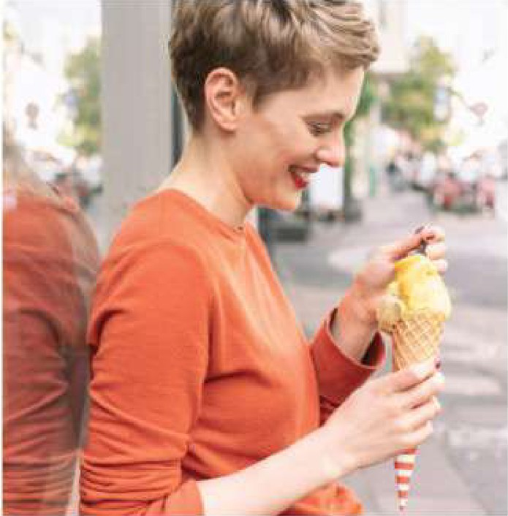 | Louise (ice cream taster)  …………………………………………………………  …………………………………………………………  ………………………………………………………… | 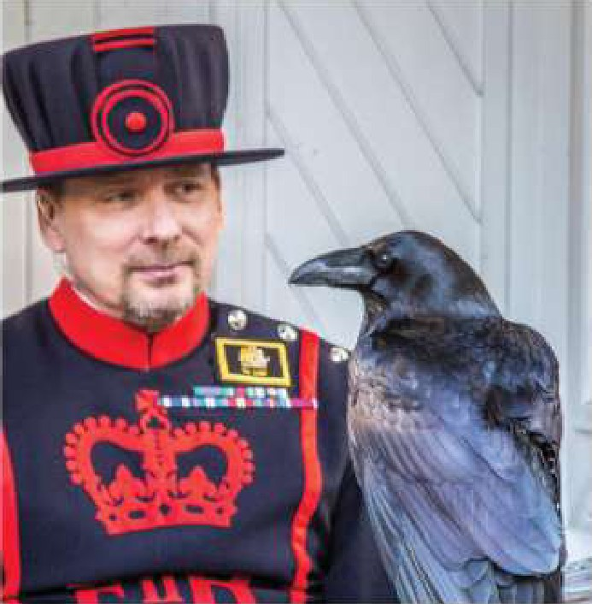 | Christopher (ravenmaster)  …………………………………………………………  …………………………………………………………  …………………………………………………………
2) Listen to two teenagers discussing the two jobs. Do they talk about any of your ideas in 1? If so, which?
………………………………………………………………………………………………………………………………………………………………
………………………………………………………………………………………………………………………………………………………………
3) Listen again and choose the best answers.
1. Harry isn’t very enthusiastic about being an ice cream taster because …
a) he doesn’t enjoy eating ice cream.
b) he thinks ice cream is bad for you.
c) he doesn’t want to eat ice cream all year.
2. Layla likes Louise’s job because …
a) she enjoys travelling to new places.
b) she likes the creative side of the job.
c) she enjoys eating all types of ice cream.
3. Harry thinks being a ravenmaster is an important job because …
a) of a traditional story about the ravens.
b) the ravenmaster is in charge of the Tower of London.
c) ravenmasters also write books and stories.
4. The ravenmaster …
a) has to have worked in the army.
b) must have worked with birds for more than 20 years.
c) needs to travel to the Tower of London every day.
5. Christopher Skaife thinks that visitors should …
a) only give the birds food that they usually eat.
b) be very careful because the birds attack.
c) stay at a short distance from the birds, just in case.

Critical thinkers
4) In your opinion, how useful or important are these two jobs? What factors make a job useful or important? What makes you say that?
Use ideas from the listening and other information to justify your opinion. Then share your ideas.
………………………………………………………………………………………………………………………………………………………………
………………………………………………………………………………………………………………………………………………………………
………………………………………………………………………………………………………………………………………………………………
………………………………………………………………………………………………………………………………………………………………
………………………………………………………………………………………………………………………………………………………………
………………………………………………………………………………………………………………………………………………………………
………………………………………………………………………………………………………………………………………………………………
………………………………………………………………………………………………………………………………………………………………
………………………………………………………………………………………………………………………………………………………………
………………………………………………………………………………………………………………………………………………………………
Section 5: Developing speaking (Giving detailed personal information)
1) Look at this list of qualities and skills. What qualities or skills do you think you need for the activities in the photos? Give reasons and examples to justify your answer.
1. Being friendly and caring  2. Having good communication skills  3. Being good at motivating others  4. Being good at organising others  5. ICT skills  6. Leadership  7. Numeracy skills (maths and money)  8. Patience  9. Problem solving  10. Ability to work in a team | 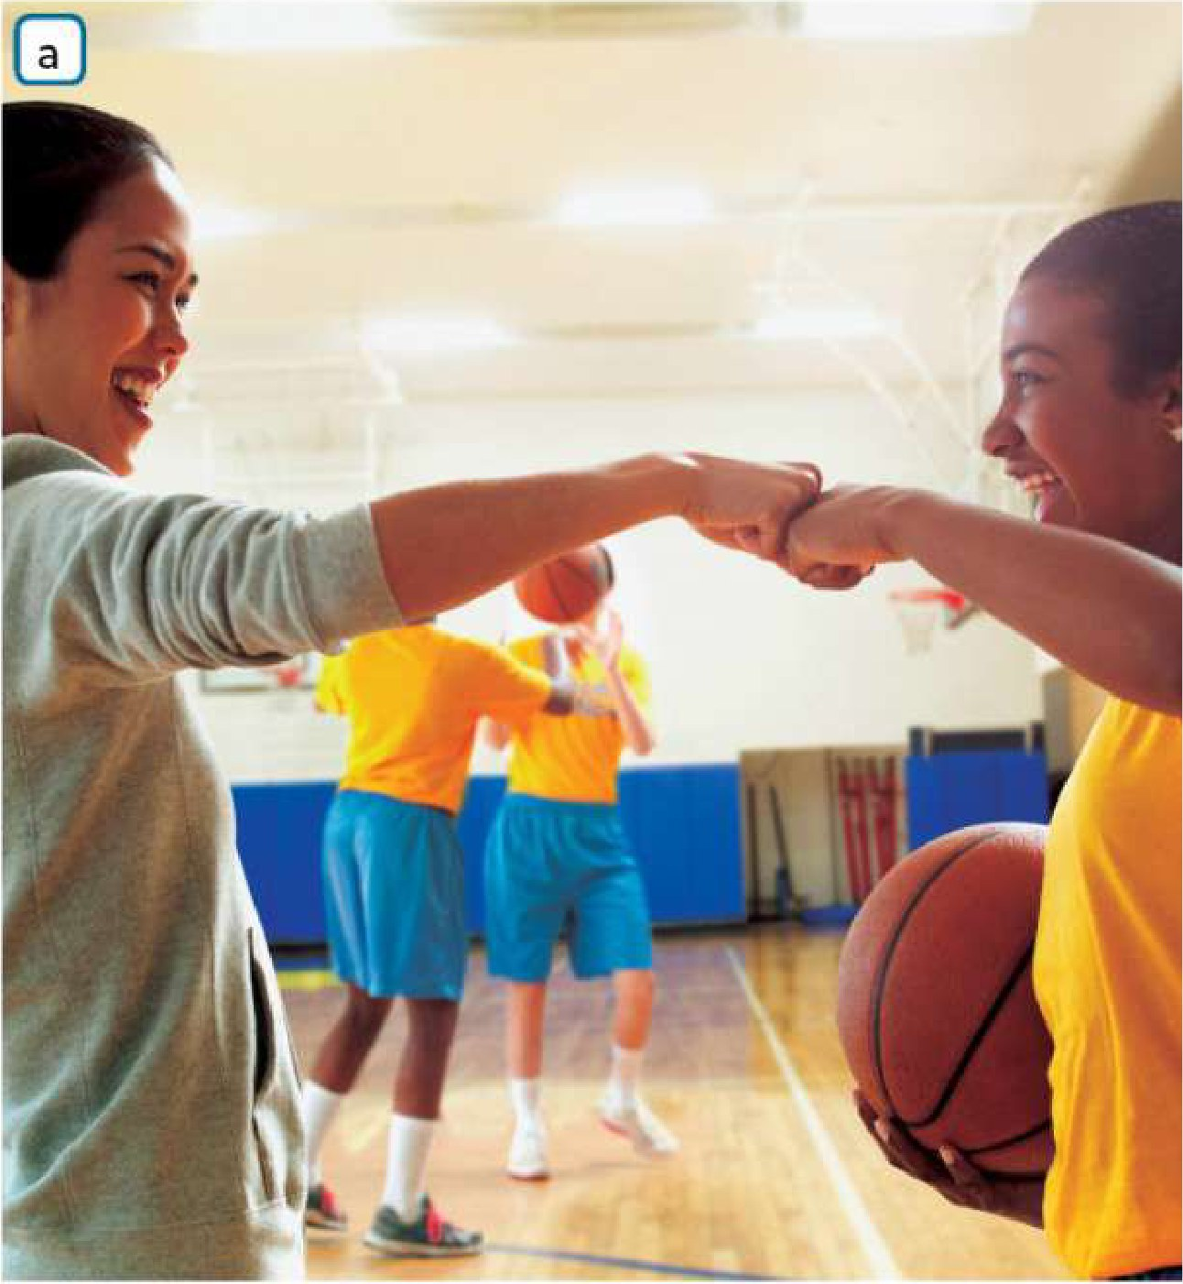

2) Listen to a part of an interview with Amelia, the girl in photo a, and answer the questions.
1. What three questions do they ask her? ………………………………………………………………………………………………….
………………………………………………………………………………………………….………………………………………………………………….
2. What is Amelia doing this year? ……………………………………………………………………………………………………………..
3. Does she give just one answer to the second question? …………………………………………………………………………
4. Does she just give one answer to the third question? ………………………………………………………………………….…
………………………………………………………………………………………………….………………………………………………………………….
5. Does she mention any of your ideas in 1? Which? …………………………………………………………………………………

3) Listen again. What examples does Amelia give to justify the qualities and skills she mentions in her answer?
Motivating others | ………………………………………………………………………………………………………………………………..
Friendly and caring | ………………………………………………………………………………………………………………………………..
Good at organising | ……………………………………………………………………………………………………………………………..…

4) Look at the Speaking bank. Which expression did Amelia not use? Listen again if necessary.
Speaking bank Useful expressions for giving and adding examples
For example • For instance • Let me give you an example • A good example is …
Also … • Another thing to say is …

5) Use the same three questions that the Amelia answered and your ideas in 1 to create an interview with the boy in the picture b. Also, use some expressions from the Speaking Bank.
1. What do you like doing in your free time?…………………………………………………………………………………………….
2. What skills have you learned from that? ………………………………………………………………………………………………
……………………………………………………………………………………………………………………………………………………………..
3. And what qualities do you think you have that help you? …………………………………………………………………….
………………………………………………………………………………………………………………………………………………………………
6) Think about one of your favourite free-time activities (hobbies, interests, sports, etc.). What three skills or qualities has it helped you to develop?
………………………………………………………………………………………………………………………………………………………………
………………………………………………………………………………………………………………………………………………………………
………………………………………………………………………………………………………………………………………………………………
………………………………………………………………………………………………………………………………………………………………
………………………………………………………………………………………………………………………………………………………………

