big data and ai

Project Documentation

Group 9-10:

# 1. Use case diagram

For the use case diagram, we decided to merge both of the models into one singular use case model. This is primarily since most steps are similar for both models. However, some of the steps are different for license plate detection as it requires the use of more techniques and libraries. Aside from that, the use case diagram represents the way we envision our application to function from a functional user perspective. Our application consists of a dashboard where the user can provide an image or a video file and in return receive results based on the raw data which is composed of the vehicle information. Due to the simplicity, we kept our use case diagram relatively simple and easy to understand. Furthermore, we provided use case description for every possible case provided within the diagram.

Figure 1: Use case diagram

Use case description

|  |  |
| --- | --- |
| ***Name of use case*** | **Character Recognition** |
| **Number of use case (within diagram)** | 1 |
| **Actor(s)** | • License Plate Detection Model |
| **Goal** | It can recognize characters on a license plate using Optical Character Recognition (OCR) technology |
| **Preconditions** | • The License Plate Detection Model has successfully detected a license plate in the image or video.  • The image or video has been processed and the license plate is visible and readable. |
| **Activities** | 1. The License Plate Detection Model extracts the license plate region from the image or video.  2. The License Plate Detection Model applies OCR to recognize the characters on the license plate.  3. The License Plate Detection Model converts the recognized characters into text.  4. The License Plate Detection Model verifies that the extracted license plate number is valid. |
| **Postconditions** | • The License Plate Detection Model has successfully recognized the characters on the license plate using OCR.  • The extracted license plate number is accurate and valid. |

|  |  |
| --- | --- |
| ***Name of use case*** | **Object recognition** |
| **Number of use case (within diagram)** | 1 |
| **Actor(s)** | • Logo Model  • License Plate Detection Model |
| **Goal** | The goal of object recognition is to classify the object into a specific category. |
| **Preconditions** | * A bounding Box coordinates. The coordinates provided by object localization use case. |
| **Activities** | 1. Identifying the class of an object within an image or a video. |
| **Postconditions** | * Provide a label for each detected object |

|  |  |
| --- | --- |
| ***Name of use case*** | **Object localization** |
| **Number of use case (within diagram)** | 1 |
| **Actor(s)** | • Logo Model  • License Plate Detection Model |
| **Goal** | The goal of object localization is to find the coordinates of a bounding box that surrounds the object of interest. This bounding box provides an approximate location and size of the object. |
| **Preconditions** | A preprocessed image of video. |
| **Activities** | 1. Identifying the location of a specific object within an image or a video |
| **Postconditions** | * Provide a bounding box coordinate. |

|  |  |
| --- | --- |
| ***Name of use case*** | **Morphological Processing** |
| **Number of use case (within diagram)** | 1 |
| **Actor(s)** | * License Plate Detection Model |
| **Goal** | It can enhance the quality of license plate images through morphological processing techniques. |
| **Preconditions** | The model is trained on morphological processing techniques for license plate enhancement.  The image of a license plate to be enhanced is available. |
| **Activities** | 1. The model has an image of a license plate. 2. The model analyzes the license plate image to identify the regions of interest, such as characters and edges. 3. The model applies morphological operations such as dilation, erosion, opening, or closing to enhance the regions of interest. |
| **Postconditions** | * The model has successfully applied morphological operations to the license plate image to enhance its quality. |

|  |  |
| --- | --- |
| ***Name of use case*** | **User Navigating to Application Dashboard** |
| **Number of use case (within diagram)** | 1 |
| **Actor(s)** | * User |
| **Goal** | User can navigate to the application dashboard to upload an image for license plate and brand detection, and to view the results of the analysis. |
| **Preconditions** | The User has access to the application |
| **Activities** | 1. The User launches the application. 2. The User clicks the "Upload Image" button to upload an image for license plate detection and morphological processing. 3. The User selects the desired image and uploads it to the application. 4. The application presents the User with the results of the license plate and brand detection. 5. The User clicks the "View Results" button to view the detailed results of the analysis. |
| **Postconditions** | * The User has successfully navigated to the application dashboard. * The User has successfully uploaded an image on application. * The User has successfully viewed the detailed results of the analysis. |

|  |  |
| --- | --- |
| ***Name of use case*** | ***Display results*** |
| **Number of use case (within diagram)** | 1 |
| **Actor(s)** | * Logo Model * License Plate Detection Model |
| **Goal** | To display the results of what was gathered through the models. |
| **Preconditions** | A result has been gathered from at least the LP model or the Logo model. |
| **Activities** | 1. The results from both the LP model and the Logo model are combined into a json file. 2. This file is then returned to the system. 3. The system displays this on the screen for the user to see. |
| **Postconditions** | The results are successfully displayed on the screen of the user. |

|  |  |
| --- | --- |
| ***Name of use case*** | ***Data preprocessing*** |
| **Number of use case (within diagram)** | 1 |
| **Actor(s)** | • Logo Model  • License Plate Detection Model |
| **Goal** | The goal of data preprocessing is to prepare the raw data for further analysis and modeling.  The goal of object recognition is to classify the object into a specific category. |
| **Preconditions** | There is raw data to be preprocessed |
| **Activities** | 1. The model performs the cleaning of the raw data by removing any missing components, errors and outliers. 2. The model performs selection of relevant features or variables needed for the analysis such as reducing noise to improve accuracy. 3. The model performs transformation by converting the data into appropriate format, such as normalization/standardization. |
| **Postconditions** | The raw data was successfully preprocessed and is ready to be used for object detection. |

# 2. Activity diagram

For the activity diagram it is important to note that the definitive result of what the model will display contains both the results of the license plate model and the logo detection model. In other words, we want to retrieve the results from both models simultaneously. This means that in the case of the object not being a license plate, it will return the results of the logo detection model. However, if the object is a license plate, then it will go through the extra process of applying morphological processing and character recognition to retrieve the license plate characters. The steps before the detection of the object are the same for both models (uploading the raw data, data pre-processing, localization and recognition).

Figure 2: Activity diagram

# 3. Sequence diagram

For the sequence diagram, we wanted to represent the various interactions between the objects and components that will reside within our application. The following sequence diagrams provides a visual representation of the flow of message, actions and events. The system starts with a user that interacts with the application by firstly navigating to the dashboard and then getting redirected by the GUI. After performing the upload of the image or video file, the stream goes through various data processing steps which are labelled within the pipelines. Depending on which model/system is chosen (Logo or License plates) it will take the path accordingly and come out with the corresponding data from the detection as a result.

Figure 3: Sequence diagram

# 4. Class diagram

For the class diagram, we wanted to present the visual structure and behaviour of our application in terms of the technical aspects such as various classes, attributes, methods and relationships between the classes. Since our application is relatively small, we did our best to come up with a logical class structure which outlines the relationship between all of the components and their purpose. Within this class diagram we defined the main Vehicle class which contains all the information which will be retrieved from the Open Data API from RDW. The enumeration represents the vehicle brands which the LogoModel uses for the detection of brands. The LicensePlateModel will use an API key and URL to retrieve the needed information after the detection of the license plates has been completed. Both of the models are the extension of the Model class which serves as the parent class and contains methods and attributes that both of these two models share. Furthermore, the Model class makes use of the Vehicle class since we want to distribute the vehicle information to both of the models, especially for comparisons. Lastly, we made a System class which serves as the root class for this application and provides prediction and result methods to the whole models to use. The relations between the classes (multiplicity, generalisation) can be viewed within the diagram below.

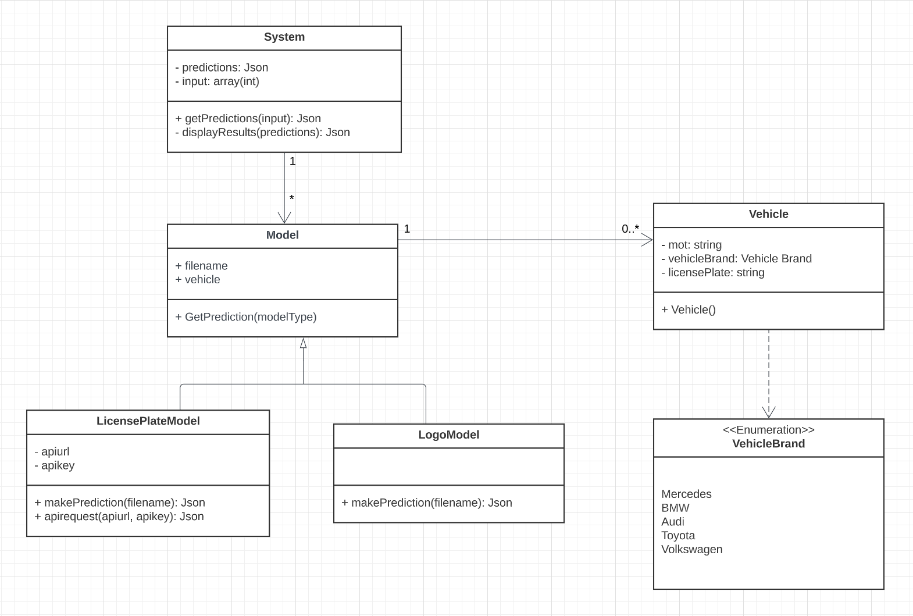

Figure 4: Class diagram

# 5.Graphical design

The goal of the graphical design is to provide a proof of concept as to what our web application could look like when we are done with the project. To represent our visual design a Figma project was made, after which wireframes were designed. The design elements that were used were kept modular so that the building blocks would be more easily accessible for any changes that would have to be made. After the wireframes were made, they were linked in and turned into a more functional prototype. The design and prototype are available at the links mentioned below.

Link to Figma file: <https://www.figma.com/file/11F0T54D1efFoyVe0vgjb7/Graphical-Design?node-id=0%3A1&t=OCVAKcpr4tabLMiR-1>

Link to prototype: <https://www.figma.com/proto/11F0T54D1efFoyVe0vgjb7/Graphical-Design?node-id=67-15&scaling=min-zoom&page-id=0%3A1&starting-point-node-id=67%3A15>