Tasks done for the project: Enes

**Dataset:** The part with the dataset that I was involved in was with discussing how we would go about it. After we decided that we would be annotating images that task was then delegated, where Mohammed and Musavir annotated the license plates of cars.

**Model:** For the model I have used this annotated dataset and experimented on it separately from the others, first training it through roboflow, using starting weights of the MS COCO dataset. For the first training I applied the Auto-Orient, resized the images to 640x640, and split the images to tiles in a 4x4 grid. The augmentation used here was only a minor blur of up to 0.5px. This yielded a mAP of 90.9%, a precision of 98.0%, and a recall of 80.0%.

I then attempted to improve on this by training it again, using the same preprocessing, but leaving the division into tiles out this time. The augmentation would be further improved on by adding a rotation of -15° to +15°, keeping the blur at 0.5px, and adding additional noise of up to 2% so as to avoid overfitting. This resulted in a mAP of 99.5%, a precision of 100.0% and a recall of 100.0%.

I trained it on roboflow one final time, using additional augmentations of adding a hue of -40° up to +40°, and brightness of -10% up to +10%, and upped the blur to 1px, and the noise to 3%. I ended up with the same results, having a mAP of 99.5%, and a precision and recall of 100.0%.

Following this, I imported the model from Roboflow and trained it once more using an image size of 640, a batch size of 30, and 200 epochs, from which I managed to get the results shown in the graphs underneath, and extracted the weights, which are included as a file. Note however that my model only performed for the sole detection of license plates, and not the actual reading of the license plates. Mohammed and Musavir instead built further upon that part since we had split up to try and get more results. The Roboflow project I worked on is accessible through this link: <https://app.roboflow.com/project-big-data-ai/car-plates-xxoqr/deploy/3>

Statistics from Roboflow: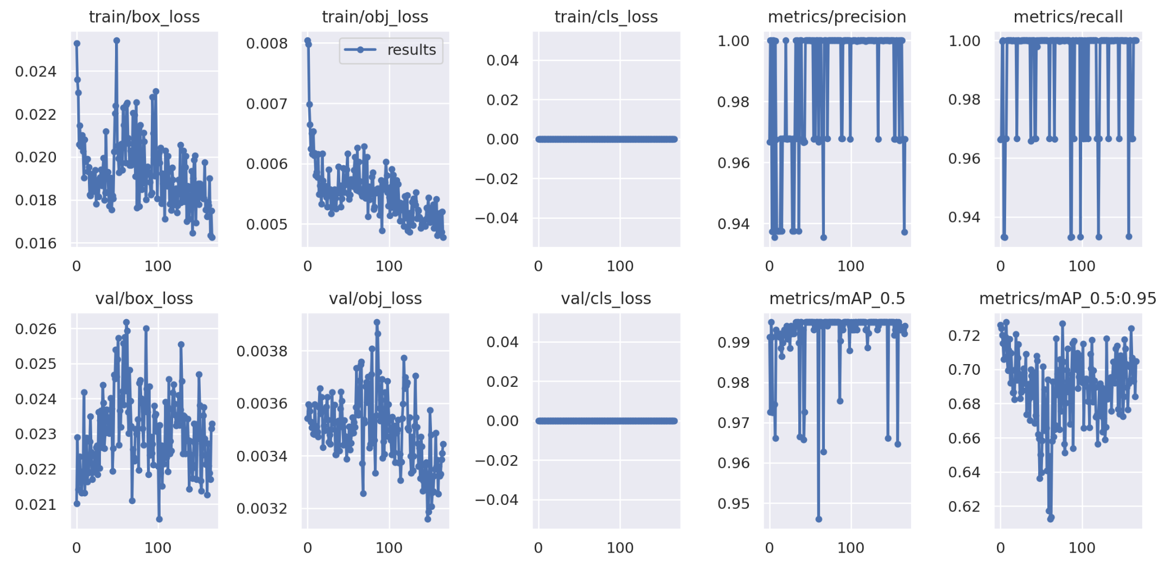

Statistics from Separately trained model:

**Technical, functional and graphical design:**

Everyone on the team helped and had input for the use case diagram, use case description, activity diagram, sequence diagram and the class diagram. I myself made the graphical design/Figma wireframes and prototype completely on my own and had more input to the class and use case diagrams with the help and feedback of everyone else.