

Spring 2012
Module Name: Computer Networks
CMPE 323

Laboratory Experiment # 1

Experiment Title: Building a Network Cable

Aim:
- Introduce students to the components of computer network lab such as hardware devices and software application; and
- Teach students how to build various cables, the use of crimping tools, and test cables and network connections.

Objectives:
- Recognize networking devices;
- Identify different types of cables available and the difference between them; and
- Build and test straight-through cable and understand its use.

Materials Required:
- Spool of Cat 5e/6 cable;
- Network cable building tools (wire cutter, wire stripper, crimp tool, and cable tester);
- RJ-45 modular plugs;
- RJ-45 colored caps (optional); and
- PC(s) connected to either a hub or switch.

Change log:
- 2011: Original document – Fatma Bazrgan.
- 2014: Addition of cross-over cables + Auto-MDIX – mkhonji.

Introduction:
Students are required to work on their own in this Lab experiment to demonstrate their skills in building network cables.

Each team will make two types of cables and test their functionality, namely: a straight-through cable, and a cross-over cable as depicted in Figure 1.

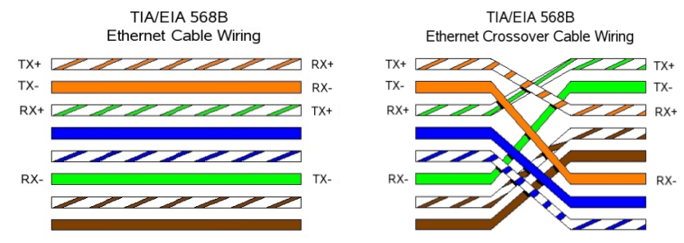Figure 1: The wiring standard for straight through and cross-over cables. Note that the transmission pins (TX+ and -) need to be connected with reception pins (RX+ and -).
Common cable termination instructions:
- Obtain a segment of a Cat 5e/6 cable.
- Use wire stripper to strip the protective plastic coasting off of the cable that you just cut. This should expose 4 pairs of twisted wires.
- Untwist the twisted wires.
- Straighten the wires and order them according to the Figure 1, depending on the type of cable you want to make (i.e. straight-through or cross-over).
- Use the cutter to cut excess wires such that all the individual 8 wires have their ends leveled.
- Insert wires into an RJ-45 jack with the tab on the jack towards the floor.
- Use the crimping tool to crimp the RJ-45 connector.
- Test the cable using the provided cable tester.

When to use which type?
When connecting two Ethernet network adapters, one end's transmission pins must connect to the other end's receiving end. This is the fundamental reason behind different cable types. i.e. our goal is to ensure that transmission pins on one side connect to the receiver pins on the other side.

When connecting two network adapters that are identical to each other (such as when connecting two PCs with each other, or two switches, or two routers, …), then a cross-over cable type should be chosen.

However, devices that are designed to inter-connect other devices (e.g. Ethernet switches are designed to connect to PCs or routers) have such cross-over wiring done internally. For this reason, you should not connect them with cross-over cables (as they are already crossed internally) and use straight-through cables instead.

Note: Modern interfaces may have Auto-MDIX (Automatic Medium-Dependent Interface Crossover) enabled by default. This feature allows the automatic internal pin arrangement of the local adapter in order to adapt the cable's wiring. This feature eventually allows successful usage of either cross-over or straight-through cables in any situation. E.g. if you are able to connect two similar adapters together with straight-through, it is likely due to this feature.

Task 1 – a straight-through cable
Construct 2 straight-through cable following the provided instructions earlier, and answer the following questions:

- 25pts – Connect one end of a straight-through cable to a PC, and the other end to a switch. Similarly by using another cable, connect another PC to the same switch. Assign them usable IP addresses. Ping the PCs.
  - Does the ping succeed?
  - Why?

- 25 pts – Disconnect the two PCs from the switch, and connect them directly to each other using a single cable. Ping the PCs.
  - Does the ping succeed?
  - Why?

When done, show the lab engineer your results.

Task 2 – a cross-over cable
Construct 2 cross-over cable following the provided instructions earlier, and answer the following questions:

- 25pts – Connect two PCs directly using the cross-over cable you have made, then ping them.
  - Does the ping succeed?
  - Why?

- 25pts – Connect the two PCs to a single switch.
  - Does the ping succeed?
  - Why?

When done, show the lab engineer your results.

Task 3 – Auto-MDIX (optional; not graded)
This is an easy task to familiarize yourself with the Auto-MDIX feature. All you need is disabling the feature. Feel free to ask the lab engineer in case you wonder how to configure a Cisco 3560 switch (an easy task too).
Try to disable the Auto-MDIX feature on the relevant ports (if they the feature existed) as follows:
Switch# configure terminal
Switch(config)# interface fastethernet 0/1
Switch(config-if)# no mdix auto
Switch(config-if)# end
Then repeat the 4 tests earlier and note down the differences.

