

**Khalifa University of Science, Technology and Research**

**Electronics Engineering Department**

**Module Name: Microprocessor Systems Laboratory**

**Module Code: ELCE333**

**Pre-Laboratory Experiment No. 1**

**Microcontroller Assembly Program Development**

**Laboratory Partners**

Hamad Eisa Alhazami 100036985

Jasim Alhammadi 100035510

**Date pre-lab submitted:** 28-Jan-2015

**Laboratory Instructor:** Mr.Mohammed Alzaabi/ Mahmoud Khounji

**Spring 2015**

**1.3.1:**

In the beginning, random values will be stored in accumulator D. After that, the step by step execution method will be used to see how the program runs.

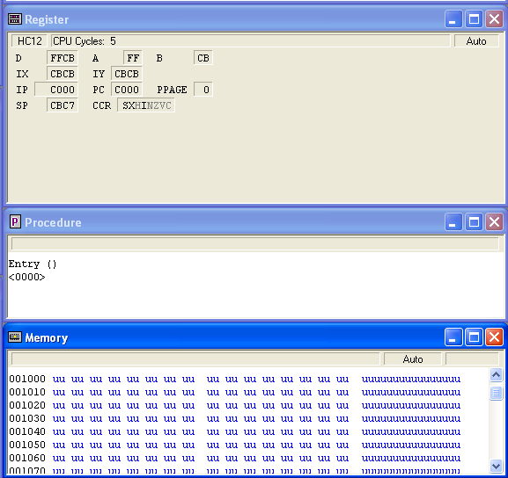

Figure 1: Random values in the accumulator before starting the program

Each figure below demonstrates the operation executed, the caption below the figures explains the process.

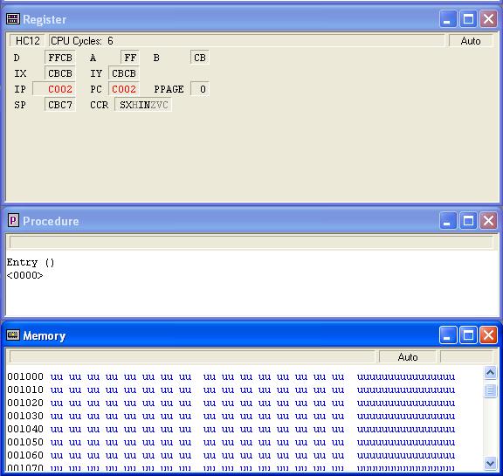

Figure 2: Loading FF to A.

This value is stored in hexadecimal form.

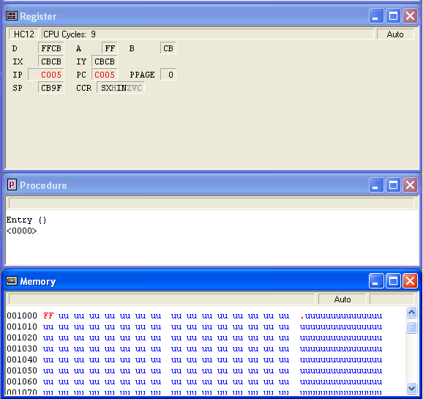

Figure 3: Storing the accumulator A content in 0x1000

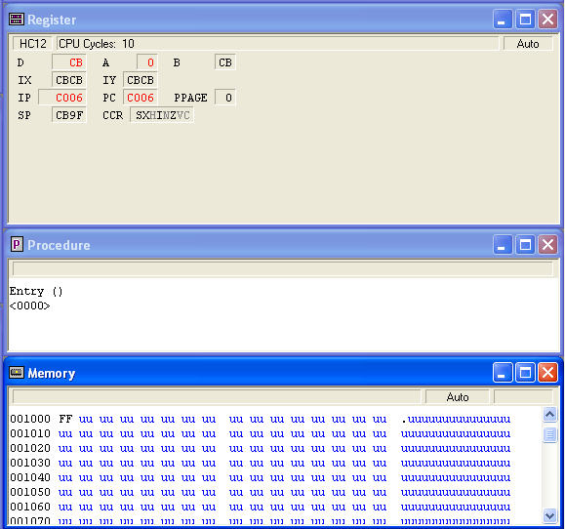

Figure 4: Clearing the content of A

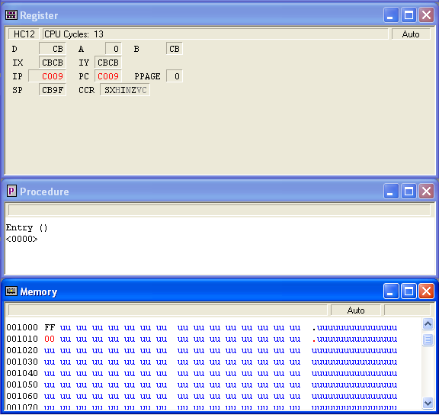

Figure 5: Storing the new value of A in 0x1010

As the figure shows, the content of memory location 1010 becomes 00.

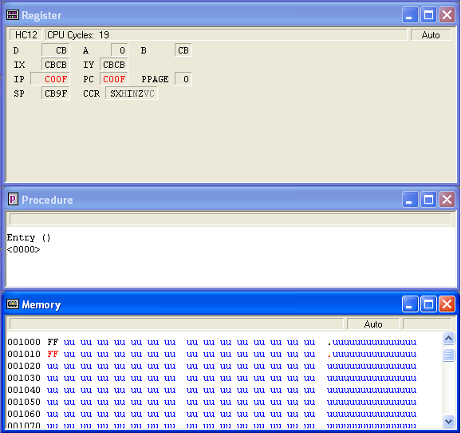

Figure 6: Moving a byte from memory location 0x1000 to 0x1010 using the MOVB command.

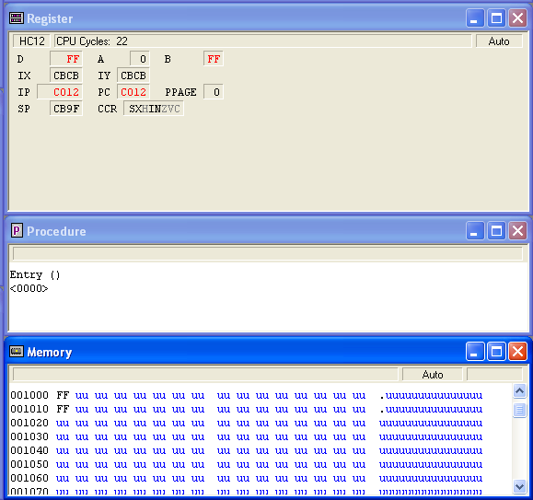

Figure 7: LDAB $1010 step

The content of 0x1010 were taken and stored in B, note that the sign # is no longer being used.

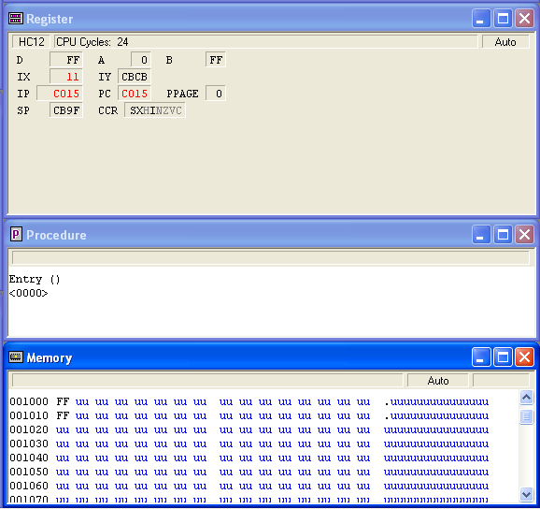

Figure 8: Code LDX #$0011 step

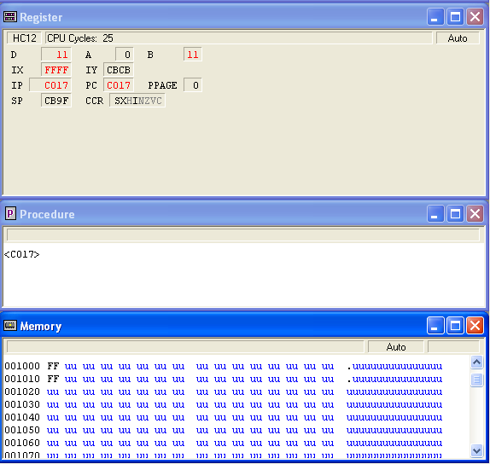

Figure 9: Code EXG X, B step

In this step, the contents of X and B are swapped.

**1.3.2: Memory contents examination:**

Table 1: instruction set execution results:

|  |  |  |  |  |  |
| --- | --- | --- | --- | --- | --- |
| Instruction | Memory Location 0x1000 | Memory Location 0x1010 | Accumulator A | Accumulator B | Index Register X |
| LDAA #$FF | uu |  | FF |  |  |
| STAA $1000 | FF |  | FF |  |  |
| CLRA | FF | uu | 0 |  |  |
| STAA $1010 | FF | 00 | 0 |  |  |
| MOVB $1000,$1010 | FF | FF | 0 | CB |  |
| LDAB $1010 | FF | FF | 0 | FF |  |
| LDX #$0011 | FF | FF | 0 | FF | 0011 |
| EXG X,B | FF | FF | 0 | 11 | FFFF |

**1.3.3: addressing mode instructions:**

1. Immediate addressing mode
2. Inherent addressing mode
3. Direct addressing mode

**1.4.1 The MC9S12DG256 microcontroller has:**

* 12K bytes of RAM,
* 4K bytes of EEPROM,
* 256K bytes of flash memory,
* Other memories:
  + Registers

**1.4.2 Memory map for the MC9S12DG256 microcontroller as it shown in the figure below:**

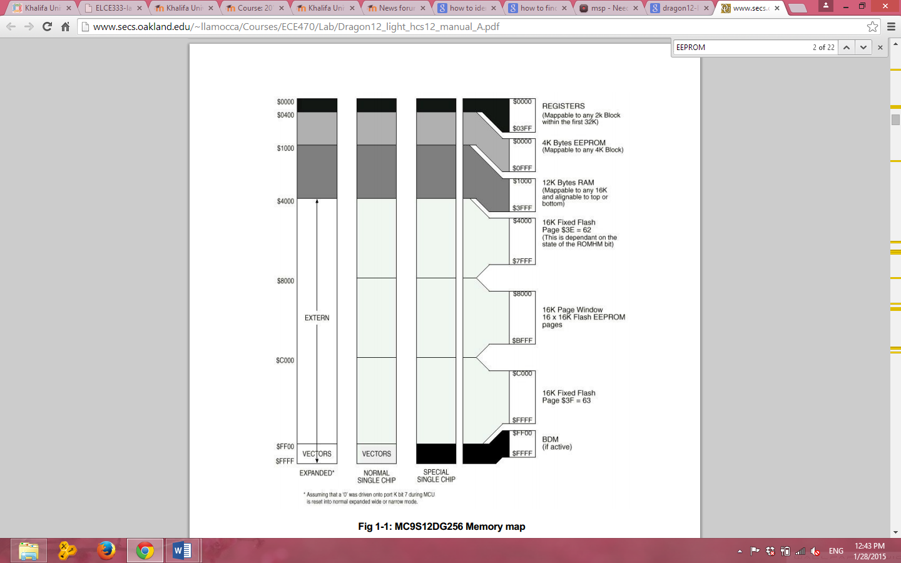

Figure 10: MC9S12DG256 microcontroller memory map

**1.4.3 The MC9S12DG256 microcontroller contains:**

* Accumulator A
* Accumulator B
* Accumulator D
* Index register X
* Index register Y
* Program Counter
* Stack Pointer
* Condition Code Register