[](http://www.kustar.ac.ae/default.aspx)

**Khalifa University of Science, Technology and Research**

**Electronic Engineering Department**

**ELCE333**

**Microprocessor Systems Laboratory**

**Laboratory Experiment No. 1**

**Pre-Lab Report**

# Microcontroller Assembly Program Development

**Partners:**

Leena El Neel 100037083

Mona Darweesh 100035522

Shamsah Al Nabooda 100036984

**Spring 2015**

Table of Contents

Microcontroller Assembly Program Development 1

Table of Illustrations 2

Questions: 5

## Table of Illustrations

**List of figures**

Figure 1: Step 5, instruction: MOVB $1000,$1010 3

Figure 2: step 5, location $1010 filled 4

Figure 3: HCS12 CPU structure 5

Figure 4: Memory map of MC9S12DP256 5

Figure 5: Microcontroller registers 6

**List of tables**

Table 1: The contents of elements at each step 3

**Pre-Lab1**

In this pre-lab report, the basics of assembly language codes are experienced and analyzed. Starting off, we simulate a given code by using code warrior software. By simulating the code, we were able to view the addresses of the memory at different locations. Table 1 below shows the results we analyzed and noted down.

Table 1: The contents of elements at each step

|  |  |  |  |  |  |
| --- | --- | --- | --- | --- | --- |
| **Instruction** | **Memory**  **Location**  **0x1000** | **Memory**  **Location**  **0x1010** | **Accumulator**  **A** | **Accumulator**  **B** | **Index**  **Register X** |
| **LDAA #$FF** | FF |  | 0 |  |  |
| **STAA $1000** | FF |  | FF |  |  |
| **CLRA** | FF | FF | FF |  |  |
| **STAA $1010** | FF | FF | 0 |  |  |
| **MOVB $1000,$1010** | FF | 00 | 0 | FF |  |
| **LDAB $1010** | FF | FF | 0 | FF |  |
| **LDX #$0011** | FF | FF | 0 | FF | 11 |
| **EXG X,B** | FF | FF | 0 | FF | 11 |

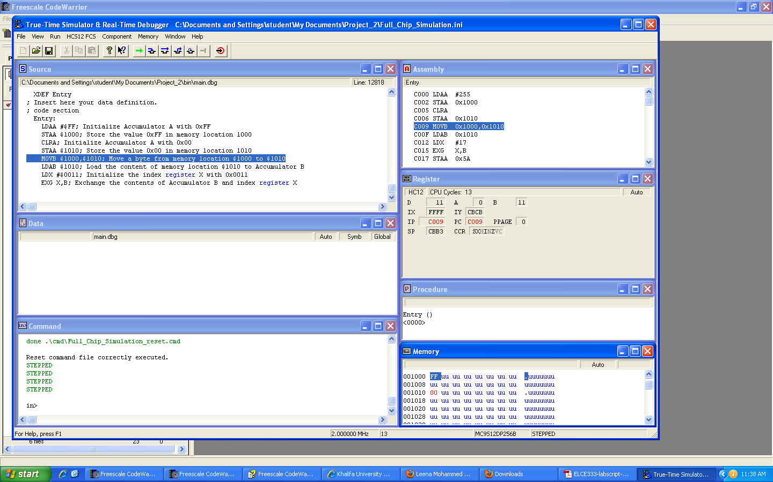

**Figure 1: Step 5, instruction: MOVB $1000,$1010**

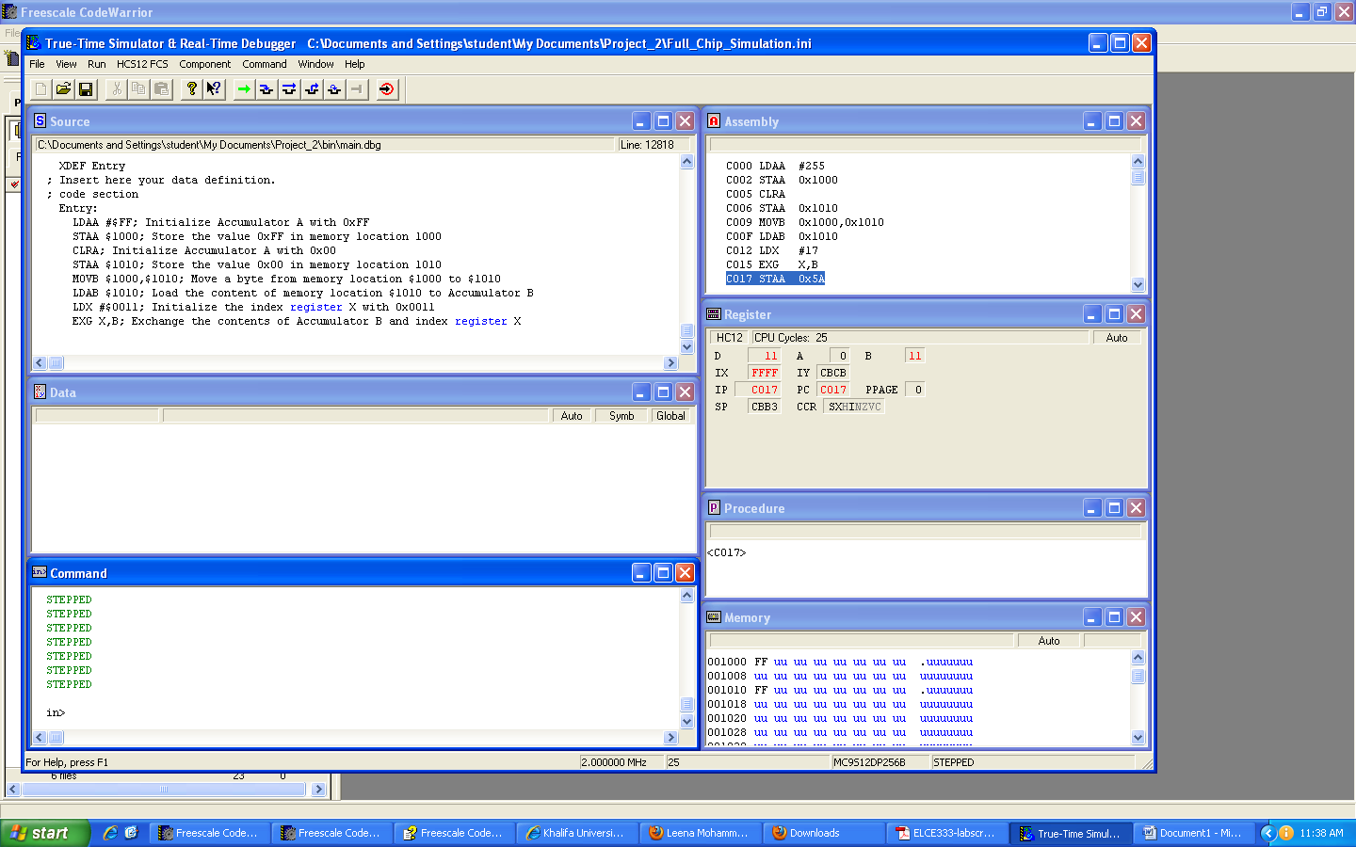

Figure 2: step 4, instruction: STAA $1010

Figure 1 and 2 shows some of the results. As we can see, the changes that those instructions make in the memory contents on the given memory locations and registers.

## Questions:



Figure 3: HCS12 CPU structure

**1. How much RAM does your microcontroller have? How much EEPROM and how much**

**Flash? Does it have any other kind of memory?**

In our lab simulations we used the microcontroller MC9S12DP256. This microcontroller has a RAM of 12 KB, EEPROM of 4KB and Flash of 256 KB.

No, such memory

**2. Draw the memory map of your microcontroller.**

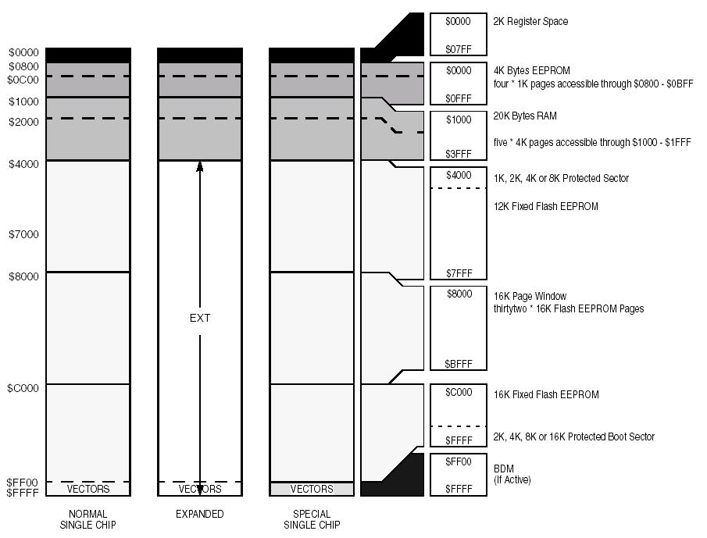

Figure 4: Memory map of MC9S12DP256

**3. What registers does your microcontroller have?**

* Accumulators A & B
* Double accumulator D
* Index register X
* Index register Y
* Condition Codes Register (CCR)
* Stack pointer
* Program counter (used as a base address in some indexed addressing modes)



Figure 5: Microcontroller registers