

**Khalifa University of Science, Technology and Research**

**Electronics Engineering Department**

**Module Name: Microprocessor Systems Laboratory**

**Module Code: ELCE332**

**Pre-Laboratory Experiment No. 2**

**Microcontroller Assembly Program Development**

**Laboratory Partners**

Hamad Eisa Alhazami 100036985

Jasim Alhammadi 100035510

**Date pre-lab submitted:** 4-Feb-2015

**Laboratory Instructor:** Mr.Mohammed Alzaabi/ Mahmoud Khounji

**Spring 2015**

**Pre-Lab Tasks**

1. Load Acc A = #$10 and Acc B = #$20. Use BGT or BLE branch instructions. The following code shows the program

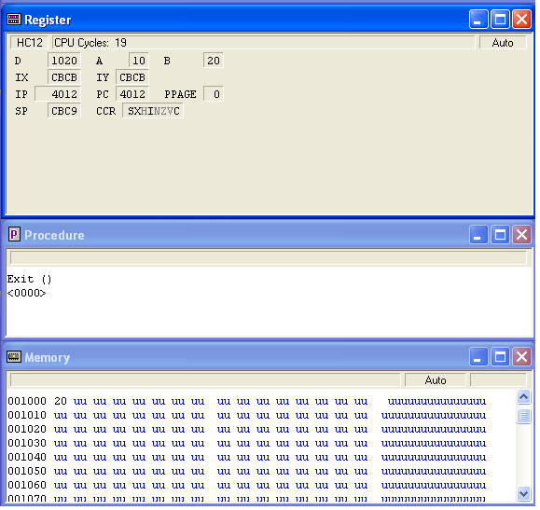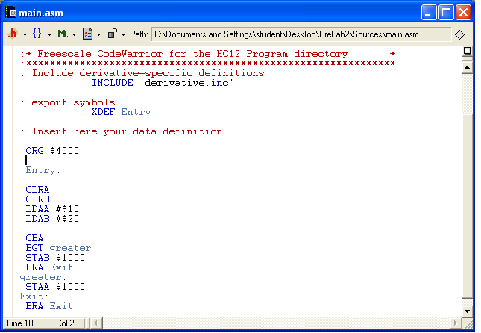

Accumulator A yields the location $10 and accumulator A yields the location $20 ( A=$10, B=$20), in this task it is required to compare between accumulator A and B. The CBA command gives the result from subtracting B from A (A-B), after that the BGT loop will start. If the result is positive, that means that A>B: therefore, store the contents of accumulator A in [$1000]. If the result is negative, , that means that B>A: therefore, store the contents of accumulator B in [$1000] and exit.

In the case above, it is clear that B>A. This is why the image above shows that the contents of accumulator B are stored in location [$1000] in the memory.

1. Load Acc A = #$93 and Acc B = #$56. Use BMI or BPL branch instructions.

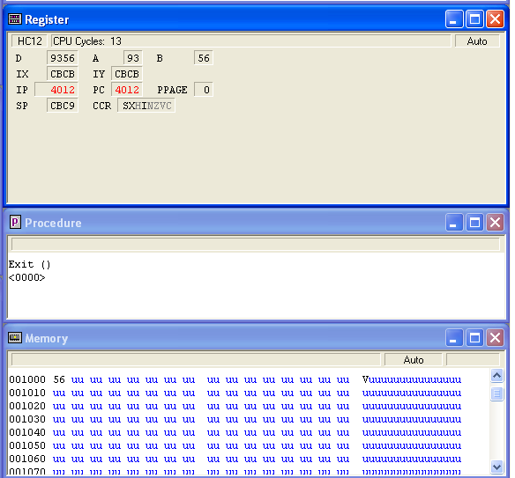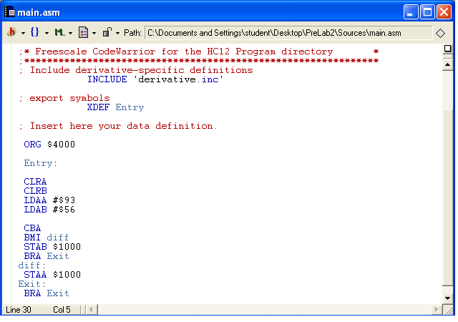

Accumulator A yields the location $93 and accumulator A yields the location $56 (A=$93, B=$56), in this task it is required to compare between accumulator A and B. The CBA command gives the result from subtracting B from A (A-B), after that the BMI loop will start. BMI is the exact opposite of BGT; hence, the lesser value will be store in location [$1000].

1. Load Acc A = #$85 and Acc B = #$92. Use BCC or BCS branch instructions. The following code shows the program.

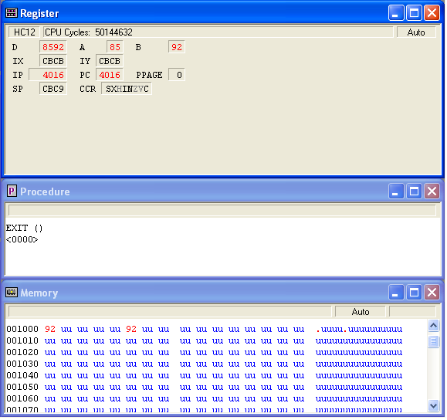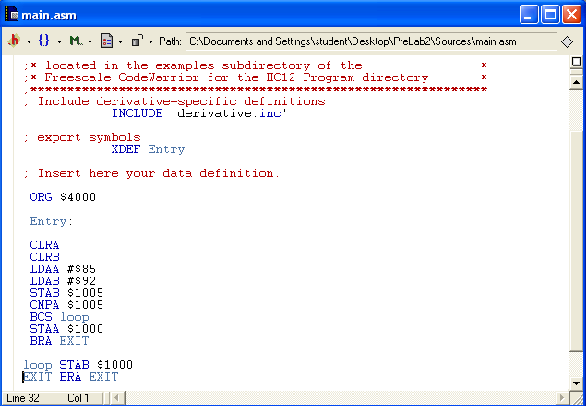

In this task it is required to compare between accumulator A and B. After loading the values of both accumulators the CMPA command will be used to compare the values of accumulator B which is stored in location [$1005] with the value of accumulator A. Then the BCS loop will start, if A>B then the contents of accumulator B will be stored in location [$1000]. If B>A then the contents of accumulator A will be stored in location [$1000].

**Pre-Lab Questions:**

What is the value of the operand register (i.e., IX, IY, and Acc A) after the execution of each of the following individual instructions? Assume LOC is the label on memory location $1000 and the contents of memory location $1000 is $15 and $1001 is $24.

1. LDX # LOC

$1000 🡪 X

1. LDX LOC

$1524 🡪 X

1. LDY #(LOC-1)

$0FFF: $1000 🡪 Y

1. LDAA (LOC+1)

Content of address $0024 🡪 A