

**KhalifaUniversity of Science, Technology and Research**

**Electronic Engineering Department**

ELCE333: Microprocessor Systems Laboratory

Pre-Laboratory Experiment No. 2

**Development and Testing of HCS12 Programs Using Branching and Loops**

**Laboratory Partners**

Khalid Alhosani 100037003

Khalid Alzarouni 100035499

Mohamed Jassem 100037002

**Date Report Submitted**: 04/02/2015

**Laboratory Instructor:** Dr. Mohamed Alzaabi

**Spring 2015**

**Pre-Lab Tasks**

1. Load Acc A = #$10 and Acc B = #$20. Use BGT or BLE branch instructions. The following code shows the program.

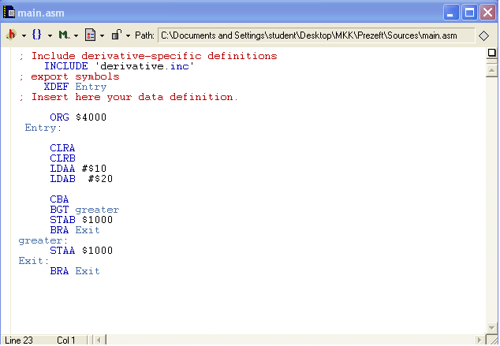

Figure 1 Source code

We first cleared Accumulators A and B then we loaded them with two different values then we subtract B from A then we stored the result in A. After that we compared to see which one is greater, if A is greater than B then it will store the value of A in address $1000, if not it will go to the exit area where the BRA command will be executed and the program will end.

Figure 2 shows how the program will be executed.

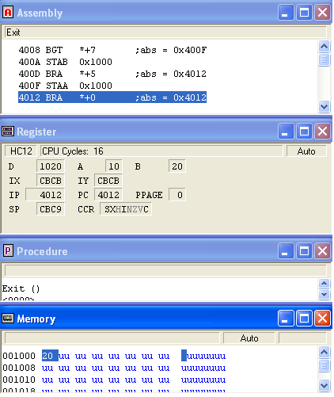

Figure 2 the status of registers and memory

1. Load Acc A = #$93 and Acc B = #$56. Use BMI or BPL branch instructions. The following code shows the program.

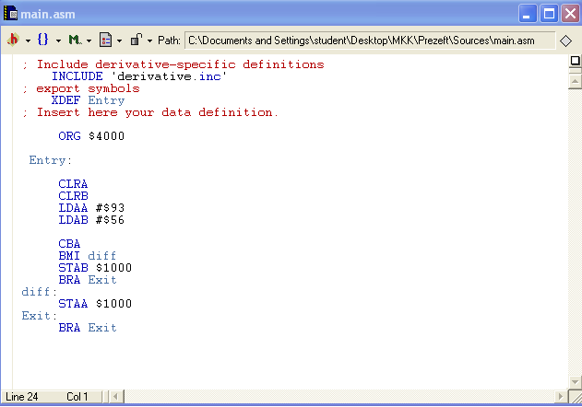

Figure 3 Source code

First of all we cleared the value of A and B to 0. Then, we loaded to immediate Hex variables to the accumulators A and B. Then we subtracted B from A from this value we will check if it is negative, if so, the value of A will be stored in the address $1000 in the memory. Else, the value of B will be stored in the address $1000. The command BRA will be executed to end the program.

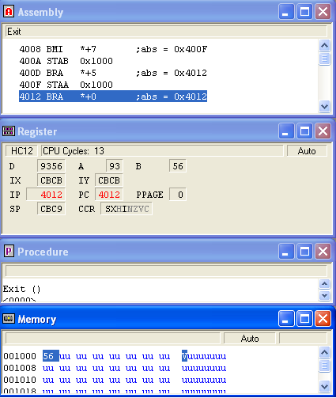

Figure 4 the status of registers and memory

1. Load Acc A = #$85 and Acc B = #$92. Use BCC or BCS branch instructions. The following code shows the program.

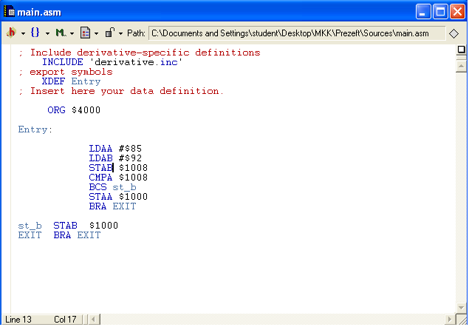

Figure 5 Source code

First of all we cleared the value of A and B to 0. Then, we loaded to immediate Hex variables to the accumulators A and B. Then, we stored the value of B in the address $1008. After that, we compared A with the value of the address $1008. If carry exists it will jump to st_b where the value of the accumulator B will be stored in the address $1000. Then, the BRA command will be executed to end the program. Else, the value of the accumulator B will be stored in the address $1000. Then, the BRA command will be executed to end the program.

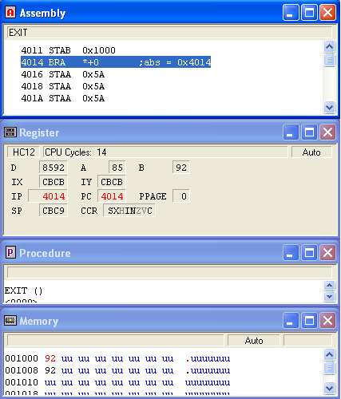

Figure 6 the status of registers and memory

**Pre-Lab Questions:**

What is the value of the operand register (i.e., IX, IY, and Acc A) after the execution of each of the following individual instructions? Assume LOC is the label on memory location $1000 and the contents of memory location $1000 is $15 and $1001 is $24.

1. LDX # LOC

$1000 🡪 X

1. LDX LOC

$1524 🡪 X

1. LDY #(LOC-1)

$0FFF : $1000 🡪 Y

1. LDAA (LOC+1)

Content of address $0024 🡪 A