**Team Members**

Name: Mahaboob Ali Ashraf Mohammad, NetID: mmoha055

Name: Anvaya, NetID: an001

Week 6 (Due Thursday, November 09 by midnight)

What did we learn?   
BFS selects the closest corner whereas A* search will select the lowest cost route. Hence A* provides a better result on the medium maze size. BFS is good for smaller maze size.

Question 5:

For tiny corners BFS does well, expanding to only 435 nodes.

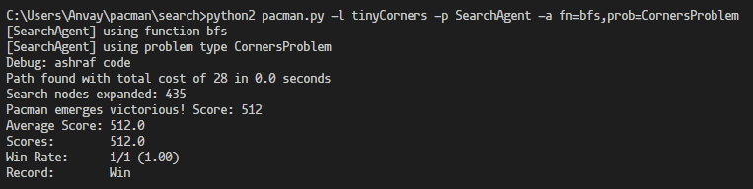

Here the search nodes are expanded to 2448 nodes which is relatively high compared to the A* search on medium corners.

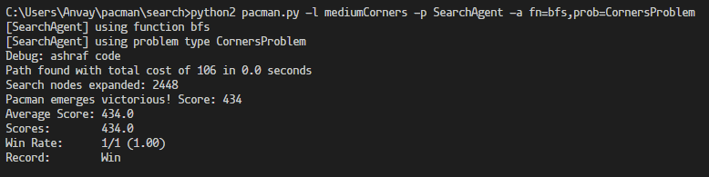

Auto-grader Results:

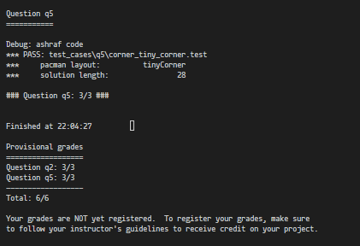

Question 6:

As visible in the snippet the A* search only expands to 978 nodes. Which is why it provides a good performance.

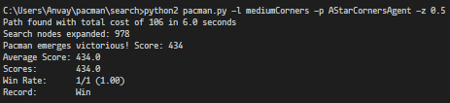

Auto-grader Result:

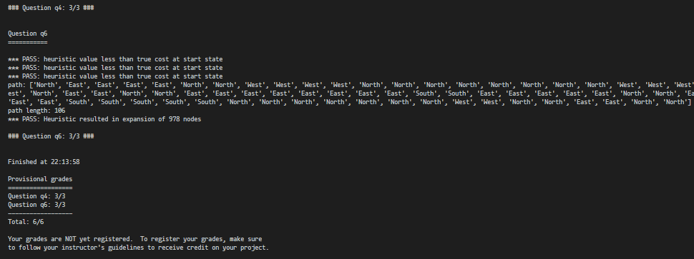

References: ??