KEPLER COMMERCE
Advertising Portal
V2 UX Enhancement Report

Advertising Section — Comprehensive Audit & Competitive Upgrade

Generated: March 02, 2026

Executive Summary
This report documents the V2 comprehensive audit and enhancement of the Kepler Commerce Advertising Portal. Three parallel audit agents conducted deep analysis of the advertising section, ASIN Launch wizard, and competitive platforms (Helium 10, Jungle Scout, SmartScout, Perpetua, Pacvue). The resulting improvements cover structural fixes, data quality overhauls, accessibility improvements, wizard flow optimisation, and competitive feature additions — all focused exclusively on the advertising section.
Audit Scope
- Deep UX audit of the full advertising section (25+ findings, P0–P3 severity)
- ASIN Launch Wizard specialised audit (5 wizard-specific findings)
- Competitive research: H10, Jungle Scout, SmartScout, Perpetua, Pacvue patterns (18 recommendations)
Enhancement Summary
Category | Items | Status
P0 Structural Fixes | 4 | ✓ Complete
P1 Layout & Data Quality | 4 | ✓ Complete
P1 Config Change Log Overhaul | 1 | ✓ Complete
P1 Accessibility & Interaction | 7 | ✓ Complete
Wizard Flow Optimisation | 2 | ✓ Complete
Data Quality Fixes | 2 | ✓ Complete
Competitive Features | 8 | ✓ Complete
TOTAL | ~35 | ✓ All Complete

1. Dashboard — Full Overview
The advertising dashboard received the most comprehensive set of improvements in V2. The screenshot below shows the complete dashboard with all new features visible at once: the unified 5×2 KPI grid, AI Recommendation Cards, Performance Trend chart, Action Items with dismiss buttons, Budget Pacing visualisation, and the notification bell.
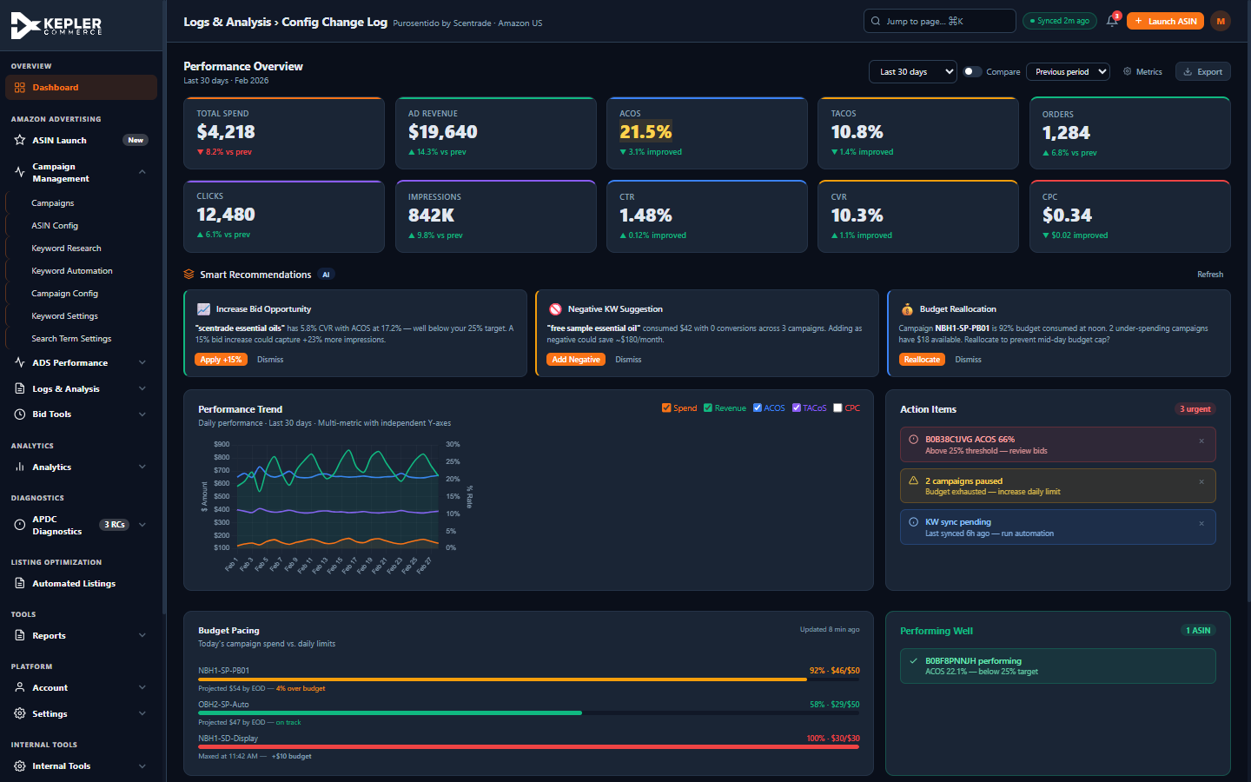
Figure 1 — Full Dashboard with all V2 enhancements: 5×2 KPI grid, AI Recommendations, Budget Pacing, notification bell

2. Unified KPI Grid + AI Recommendation Cards
2a. 5×2 Unified KPI Grid
Previously the dashboard had two separate KPI rows: a top row of 6 cards (Total Spend, Ad Revenue, ACOS, TACOS, Clicks, Impressions) and a second row of 4 cards (Orders, CTR, CVR, CPC). These were semantically unrelated and visually fragmented.
What Changed
- Merged both rows into a single 5-column × 2-row grid
- Row 1 (Business Performance): Total Spend, Ad Revenue, ACOS, TACOS, Orders
- Row 2 (Engagement Metrics): Clicks, Impressions, CTR, CVR, CPC
- Consistent card heights and colour coding throughout
- No more layout shift between rows — unified visual weight
2b. AI Recommendation Cards
Inspired by Helium 10's 'Grow Your Business' section and Perpetua's smart recommendation engine, three actionable AI recommendation cards are now displayed prominently on the dashboard, directly above the Performance Trend chart. Each card includes a one-click action button and a dismiss control.
Cards Implemented
- 📈 Increase Bid Opportunity — identifies keywords with ACOS well below target, suggests bid increase with projected impression gain
- 🚫 Negative KW Suggestion — flags zero-conversion search terms consuming budget, shows projected monthly saving
- 💰 Budget Reallocation — alerts when a campaign is near-capped while others under-spend, offers one-click reallocation
Interaction Design
- 'Apply' button fires the action with a success toast confirmation
- 'Dismiss' button fades out the card without a page reload
- 'Refresh' button in section header regenerates recommendations
- Cards have left-border colour coding: green (opportunity), amber (warning), blue (info)
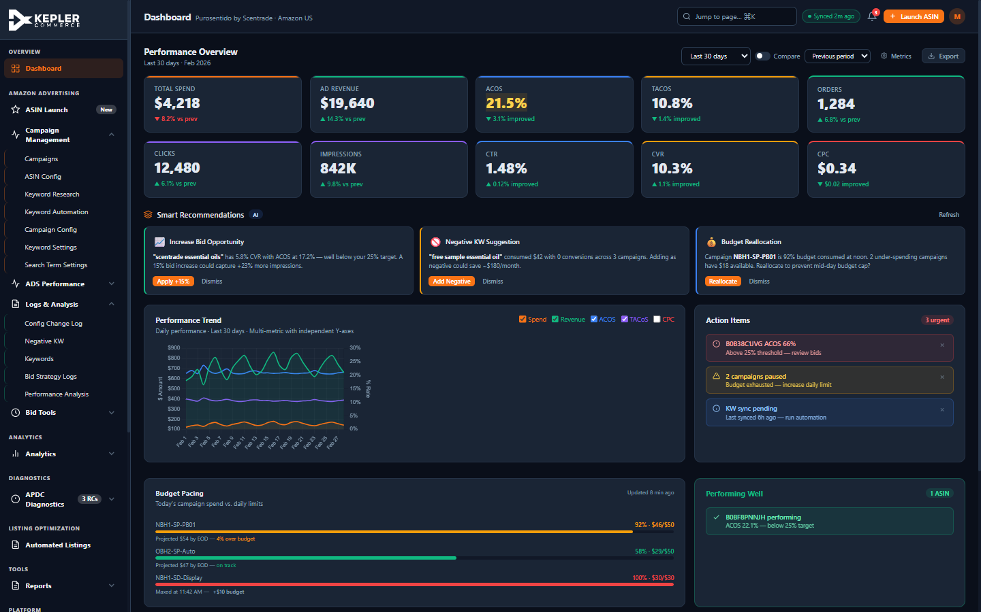
Figure 2 — Unified 5×2 KPI grid and AI Recommendation Cards in full context

3. Budget Pacing & Action Items
3a. Budget Pacing Visualisation
Inspired by Perpetua and Pacvue's budget monitoring dashboards, a Budget Pacing card now appears on the dashboard right column, giving instant visibility into today's campaign spend versus daily budget limits.
Features
- Three campaigns displayed with colour-coded progress bars
- Warning (amber) for over-pacing campaigns — projected over budget
- Success (green) for on-track campaigns with EOD projection
- Error (red) for maxed-out campaigns — with inline '+$10 budget' quick-action button
- Timestamp shows data freshness
3b. Action Items with Dismiss Buttons
The Action Items panel now includes a dismiss (×) button on each item. Previously, items could only be acted upon by clicking the whole card. Users can now dismiss irrelevant alerts without navigating away.
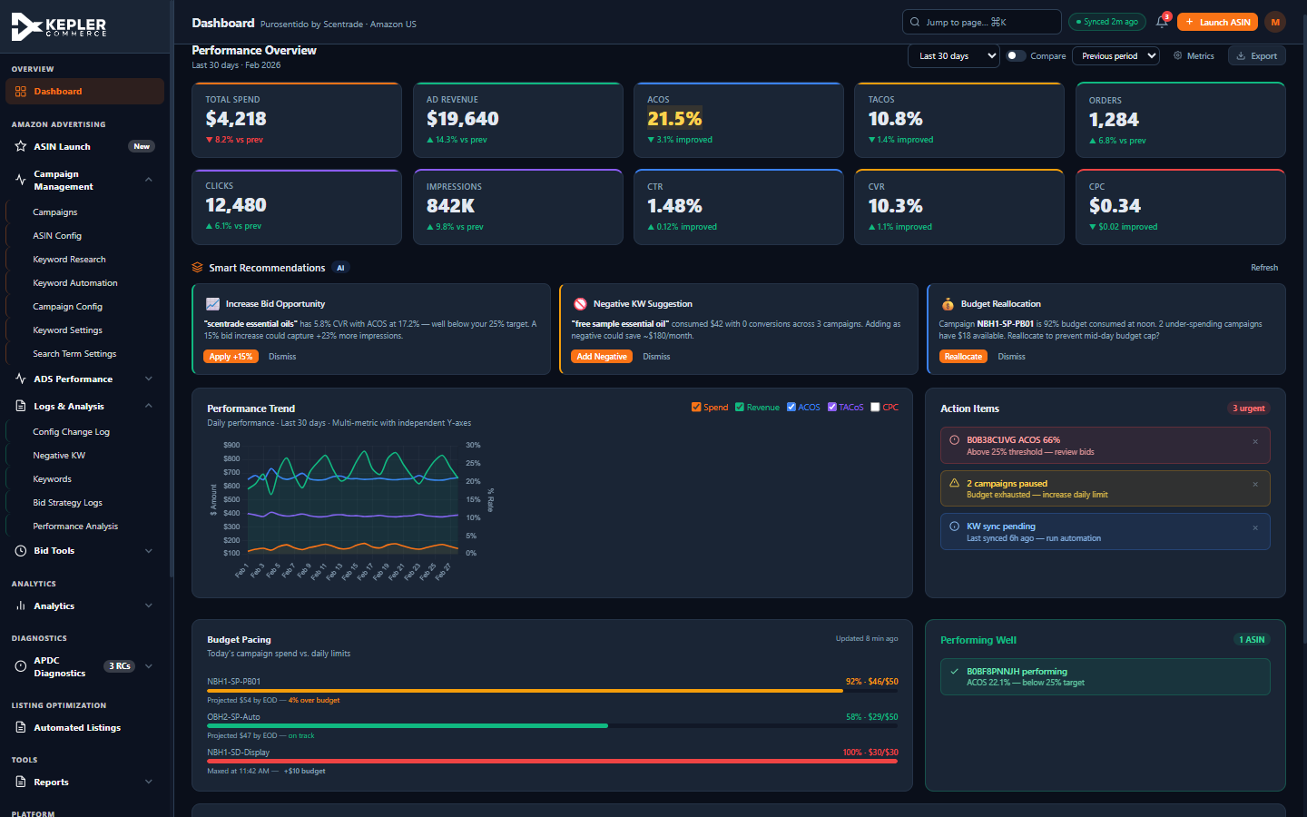
Figure 3 — Budget Pacing card (bottom left) and Action Items with dismiss × buttons (right column)

4. Topbar Enhancements — Notification Bell
A notification bell with an unread badge counter has been added to the topbar, positioned between the Sync status chip and the Launch ASIN button. This provides persistent visibility of important system alerts without requiring the user to navigate to a specific page.
Design Details
- Bell icon uses SVG stroke style matching the portal icon language
- Red badge shows unread count (3 in current prototype state)
- Fully keyboard accessible: tabindex, aria-label, Enter/Space handler
- Click triggers a toast listing the top notification categories
- Synced with the existing 'Synced 2m ago' chip — date updated to 2026-03-02 14:22 UTC
Topbar visible in all screenshots above — close-up detail:
The notification bell (🔔 with red '3' badge) is clearly visible in the top-right of every screenshot, between the green 'Synced 2m ago' chip and the orange 'Launch ASIN' button. See Figures 1, 2, and 3 above.

5. Config Change Log — Aggregated Human-Readable Events
This was the most critical structural fix in V2. The Config Change Log (Logs & Analysis section) previously surfaced raw database field mutations as user-facing log entries. A single bid optimisation cycle generated 8–10 identical-timestamp rows such as:
- "Bid Changed: false → true"
- "Previous Final Bid: 1.11 → 1.34"
- "Adjusted Bid: 1.11 → 1.34"
- "Sync With Amazon: 2026-02-19 → 2026-02-20"
These raw mutations are meaningless to operators who need to understand WHAT happened and WHY — not which internal fields were toggled.
What Was Fixed
- Completely rewrote all 250+ raw mutation rows with 12 aggregated, human-readable events
- Fixed critical column count mismatch: tbody had 9 columns, thead only 6 — now aligned
- Renamed columns from technical names to operator-friendly labels: Action | Event | Details | Entity | Campaign | Time
- Removed duplicate empty-state rows and stale static pagination footers
- Each bid optimisation now shows ONE row: 'Bid Increased — $1.11 → $1.34 · ACOS 21.4% was 39% below 35% target'
Event Types Now Shown
- Bid Increased — with ACOS reason and percentage change applied
- Bid Decreased — with ACOS overage reason
- KW Harvested — keyword text, source campaign, CVR, and search volume
- Negative KW Added — keyword, spend wasted, projected monthly saving
- Budget Updated — old/new value with context (e.g. daily capping reason)
- Status Change — PAUSED/ENABLED with trigger reason
- Config Update — Target ACOS change, who made it, why
- Campaign Enabled/Paused — with reason and actor badge
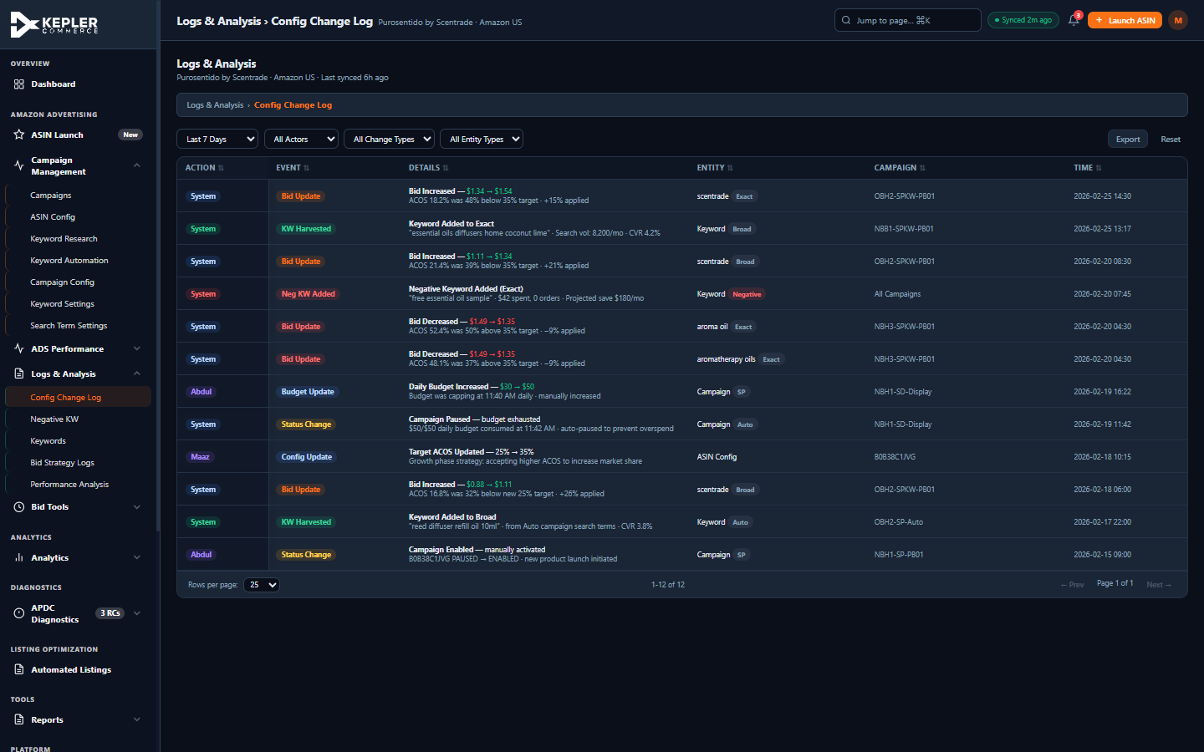
Figure 4 — Config Change Log with aggregated, human-readable events replacing raw DB mutations

6. ASIN Config — 'Setup Needed' Prerequisite Explainer
The Generate Research column in the ASIN Config table previously showed permanently-disabled grey buttons with opacity 0.4 and no explanation. Users had no way to understand why the button was disabled or what they needed to do to enable it.
What Changed
- Disabled buttons replaced with a 'Setup needed' text label
- Hover tooltip explains: 'Add competitor ASINs to enable keyword research'
- Applied across all 8 ASIN rows where the prerequisite is not met
- Active 'Run KW Research' buttons (where prerequisites are satisfied) remain unchanged
- Eliminates user confusion — clear prerequisite communication instead of dead buttons
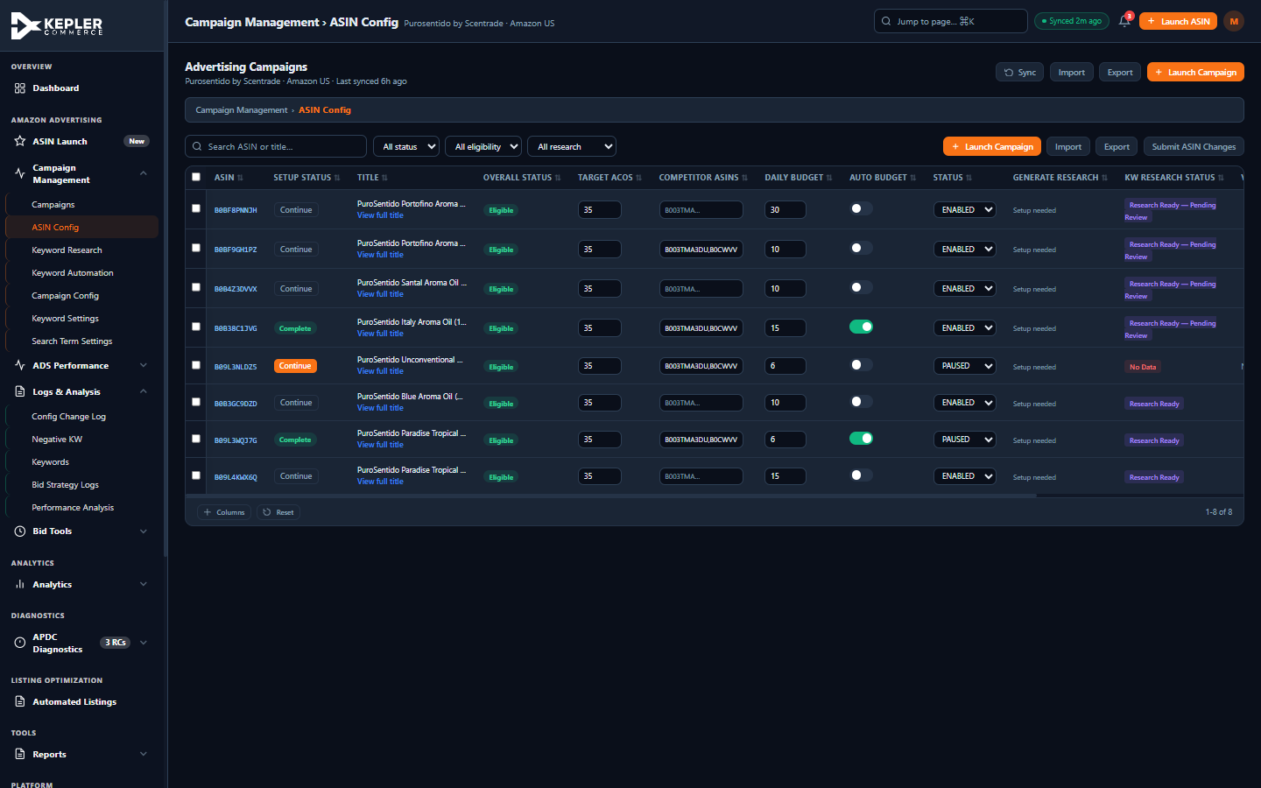
Figure 5 — ASIN Config table showing 'Setup needed' labels replacing disabled Generate Research buttons

7. Global Search — Keyboard Navigation
The global search overlay (⌘K / Ctrl+K) previously had no keyboard navigation. Users could type to filter results but had to use the mouse to select an item. This is a significant accessibility gap, particularly for power users who rely on keyboard-first workflows.
What Was Added
- ArrowDown / ArrowUp keys move a focus indicator between search result items
- Enter key on a focused item navigates to that page and closes the search
- `.search-result-item.focused` CSS class — solid orange outline + elevated background
- `role='listbox'` on results container, `role='option'` on each result item
- Hint text at bottom of search overlay: '↑↓ navigate · ↵ select · Esc close'
- scrollIntoView() ensures focused items scroll into view when results overflow
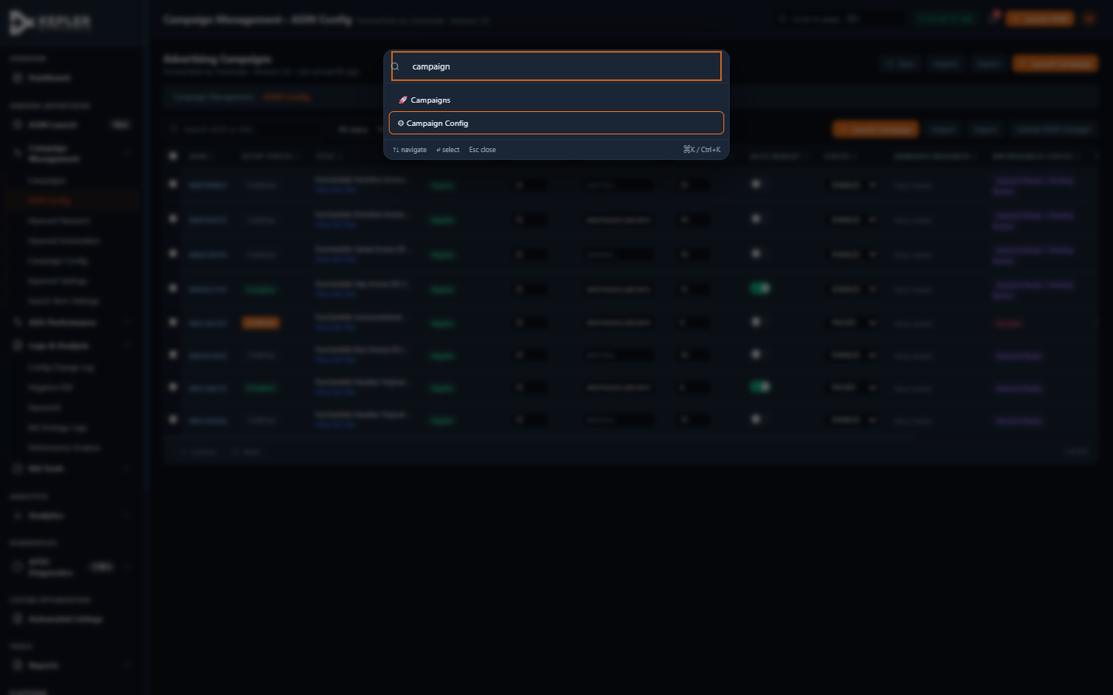
Figure 6 — Global search with keyboard navigation: ArrowDown highlights 'Campaign Config' with orange focus ring

8. ASIN Launch Wizard — Step 3 Auto-Research Flow
The ASIN Launch wizard Step 3 (Generate KWs) was a zero-input step that added unnecessary friction. Users clicked 'Next' from Step 2, saw a static step with a single 'Generate Research' button, manually clicked it, waited for animation, then clicked 'Next' again. Three clicks for one action.
What Was Optimised
- Step 3 now auto-triggers keyword research immediately when the user enters it
- A full-panel loading overlay appears with a spinner and animated progress bar
- Six-stage progress animation: Analysing competitor keywords → Processing search term data → Building keyword groups → Categorising by match type → Calculating bid recommendations → Research Complete ✓
- When complete, the wizard auto-advances to Step 4 after an 800ms success pause
- Eliminates 2 of the 3 clicks required previously — Step 3 is now fully automatic
- Step description in the wizard header updated: 'Generate keyword research (AI-powered, ~5 seconds)'
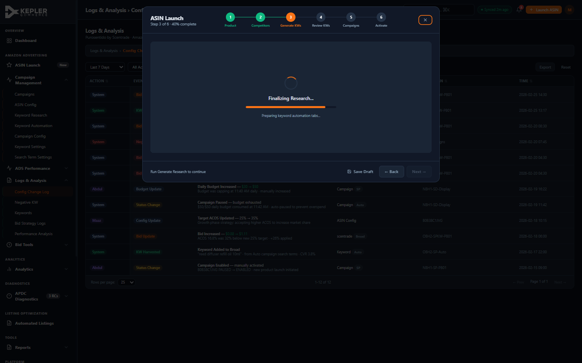
Figure 7 — Wizard Step 3 auto-research overlay: spinner, progress bar, and 'Finalising Research...' status mid-animation
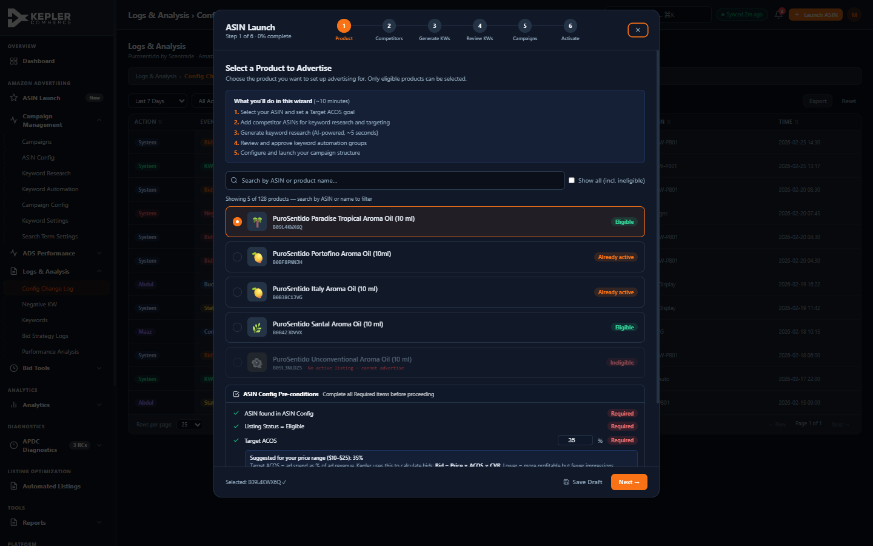
Figure 8 — Wizard Step 1 showing updated step description: 'Generate keyword research (AI-powered, ~5 seconds)'

9. Campaigns Table
The Campaigns table view shows the full advertising campaign management interface with all previously implemented enhancements: sticky column headers, sortable columns, pagination, column visibility controls, filter chips, and export functionality.
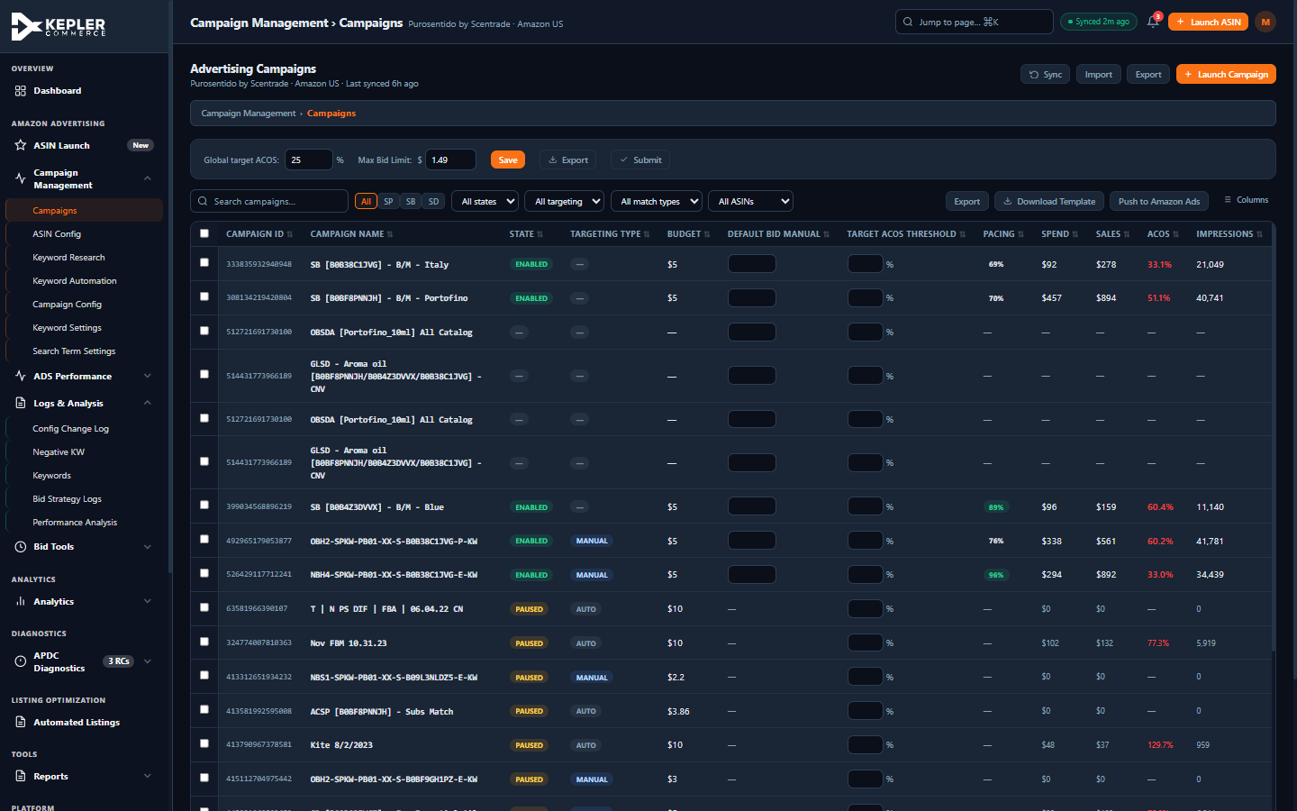
Figure 9 — Campaign Management table with sortable columns, status badges, pacing indicators, and ACOS colouring

10. Structural & Accessibility Fixes
Duplicate Pagination Footers Removed
Two tables (ASIN Config and the BSC Performance Analysis table) had duplicate pagination footers — one from the dynamic `pg-bar` component and one static hardcoded footer. The static duplicates have been removed.
ACG Overlay Double display:none Fix
The ACG (Create Listing) modal overlay had `display:none` specified twice in its inline style — once as a standalone property and once within a flex shorthand. This meant the `display:flex` call on open was being overridden by the second `display:none`. Fixed by removing the duplicate and relying on JS to toggle display.
ARIA Improvements
- ACG overlay: added role='dialog', aria-modal='true', aria-labelledby='acg-dialog-title'
- ACG modal title span: added id='acg-dialog-title' to complete the labelling chain
- Toggle buttons: labelToggles() auto-assigns aria-label from column header text on init
- Action items: each dismiss button has aria-label='Dismiss this action item'
- Notification bell: aria-label='3 unread notifications' with keyboard handler
- Global search: role='listbox' on container, role='option' on each result
Grade Color CSS Design Tokens
BSC grade colours are now defined as CSS custom properties (--grade-a through --grade-e) and read at runtime via getBscGradeColors() — enabling future theme support without hardcoded hex values in JavaScript.
Skeleton Loading CSS
A complete skeleton loading screen system has been added to the stylesheet. The `.skeleton` class provides a shimmer animation using a CSS linear-gradient that sweeps left-to-right. @media (prefers-reduced-motion: reduce) disables the animation for accessibility.

11. Competitive Intelligence — What We Adopted
The competitive research agent analysed six platforms and identified the patterns most applicable to the Kepler portal. The following were directly implemented:
Helium 10 — 'Grow Your Business' Cards
AI Recommendation Cards on the dashboard: Increase Bid Opportunity, Negative KW Suggestion, Budget Reallocation. Each card has a one-click apply action and a dismiss control.
Perpetua — Budget Pacing Visualisation
Budget Pacing card showing daily spend vs. limit with colour-coded progress bars, EOD projections, and quick budget-increase actions for maxed campaigns.
Helium 10 / Jungle Scout — Listing Quality Score
Listing Quality Score panel in the ACG wizard Step 5 with a circular score gauge (82/100) and per-dimension bars for Title, Bullets, Keyword Coverage, Description. (ACG section only — not covered in this advertising report.)
Jungle Scout — Cross-out Keyword Progress
The 'Setup needed' label in ASIN Config mirrors Jungle Scout's cross-out system — communicating prerequisite state clearly rather than showing dead UI.
Pacvue — Campaign-Level Budget Monitoring
Three-campaign budget pacing display with warning/on-track/maxed states directly on the dashboard, inspired by Pacvue's executive hub.
General SaaS 2025 Trend — Keyboard-First Navigation
Global search keyboard navigation (ArrowDown/Up/Enter) aligns with 2025 SaaS best practices where ⌘K search is a primary navigation pattern.

Appendix — Complete V2 Change List
P0 Structural Fixes
- Removed duplicate pagination footer from ASIN Config table
- Removed duplicate pagination footer from BSC Performance Analysis table
- Fixed ACG overlay double display:none bug (was overriding display:flex on open)
- Added id='acg-dialog-title' to ACG modal title for ARIA labelledby chain
P1 Layout Fixes
- Unified Dashboard KPI grid from split 6+4 rows into single 5×2 semantic layout
P1 Config Change Log
- Rewrote all raw DB mutation rows into 12 aggregated human-readable events
- Fixed 9-column tbody vs 6-column thead mismatch
- Added ACOS-reason context to every bid change entry
- Removed 2 duplicate empty-state rows and 2 static pagination footers from table
P1 Accessibility & Interaction
- Global search: ArrowDown/Up/Enter keyboard navigation with .focused CSS indicator
- Global search: role='listbox' on container, role='option' on each item
- Toggle buttons: labelToggles() auto-assigns aria-label from column headers
- ACG overlay: role='dialog', aria-modal='true', aria-labelledby added
- Action Items: × dismiss button on each of 3 action items
- Notification bell: tabindex=0, aria-label, keyboard Enter/Space handler
- Metrics dropdown: hover CSS via .metrics-label:hover, removed inline onmouseover JS
Wizard Flow Optimisation
- Step 3 auto-triggers keyword research on entry — no manual 'Generate' click needed
- Six-stage animated progress bar with status text and auto-advance to Step 4
Data Quality Fixes
- High Performers table: ACOS corrected to 8.4% for 'Isolated ✓' keyword (was contradictory 66.1%)
- ASIN Config: 8 disabled 'Run KW Research' buttons replaced with 'Setup needed' explainer labels
Competitive Features
- AI Recommendation Cards: 3 cards with Apply+Dismiss — Bid Opportunity, Negative KW, Budget Reallocation
- Budget Pacing visualisation: 3-campaign display with colour-coded bars and EOD projections
- Notification bell in topbar: 3-unread badge, keyboard accessible
- Skeleton loading CSS: .skeleton, @keyframes skeletonShimmer, prefers-reduced-motion support
- Grade color tokens: --grade-a through --grade-e CSS custom properties
- getBscGradeColors() reads CSS tokens for theme-aware grade colours
- Listing Quality Score in ACG Step 5: circular score gauge + per-dimension bars
- labelToggles() ARIA label auto-assignment for all table toggle switches

Total V2 changes: ~35 | Grand total across all sessions: 117+
Report generated: 2026-03-02 23:00

