

Assignment 1

17.03.2017

Nashmia Riaz

BESE 5B

REG#111779

# Overview

We had to build an android game that implemented the classic Snakes & Ladders game with the following rules:

There are 2 players in this game and board size is 100.(10 X 10)

1. Possible outcomes by throwing a dice are 1,2,3,4,5,6.
2. If output is 6 then current player will get a chance again to throw the Dice.
3. If outcome of the Dice is 1,2,3,4,5,6 and player positioned on mouth of snake then his current position will change to tail of snake, and he will not get other chance until he throws a dice which has value 6.
4. If outcome of the Dice is 1,2,3,4,5,6 and player positioned at below of ladder then His current position will change to topmost position of ladder and he will get another chance to throw the dice again.
5. If player's current position+ roll >100 then the other player will get a chance to throw the dice.
6. Any player reaching 100 earlier than the other player will be the winner and the game will end.

# Approaches

Logically, the entire game was build with an object oriented approach. The following classes were made:

1. GameView: This extended the surface view and implemented the graphics as an OpenGL surface. It also contained some basic game logic such as score.
2. Player: This was the player class and contained the player position, set the player position as well as drew the player on the board. It also contained the AI logic for a biased dice roll.
3. Board: This class contained the board, it’s position as well as it’s graphics
4. Box: This class implemented and contained the individual box positions. It has no graphics and only contains the logic part.

The following algorithms were used for the player movement:

1. The board contained an array of boxes objects to contain the position of each box. The player rolled a dice that generated a random number and the player moved to the indicated box using the box array. For example, if the player had to go to the 5th box, it would access the coordinates using board.boxes[5]
2. The player rolled a dice that generated a random number. This number was incremented to the player’s previous position with respect to the board’s boxes array, and the position was set to this.
3. Boolean variables called extraMove and canPlayerMove exist in the player class. extraMove gives is true when the player lands on a ladder, giving him an extra move. canPlayerMove is set to false when the player hits a snake, and is set to true once the player rolls a 6.
4. The algorithm for AI was very similar. The board contained a list of all the positions of snakes and ladders. We got the position of the next ladder and a biased dice was thrown to get this position. Chances of getting this number increased as difficulty increased.

# Screens

Start screen:

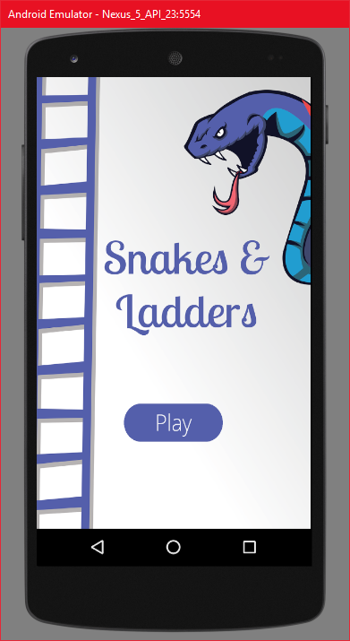

Play screen

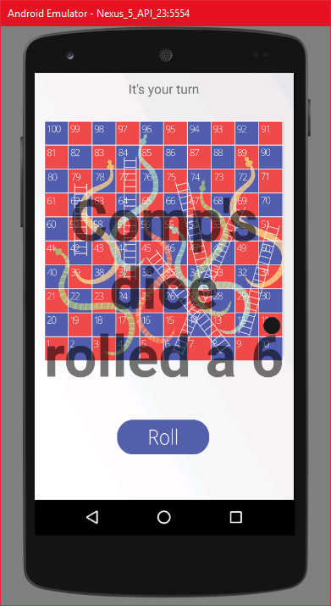

# Analysis & Github Link

This assignment taught me Android programming, as well as some basic AI programming. I learned how to integrate OpenGL into Android and make an object oriented game.

The github link is:

<https://github.com/nashmia-riaz/Snakes-Ladders>