**How to run files system**

A. when the system is lost due to power the ip of the computer most likely changes.

So to find out, search for cmd and type ipconfig so that you can see the current ip.

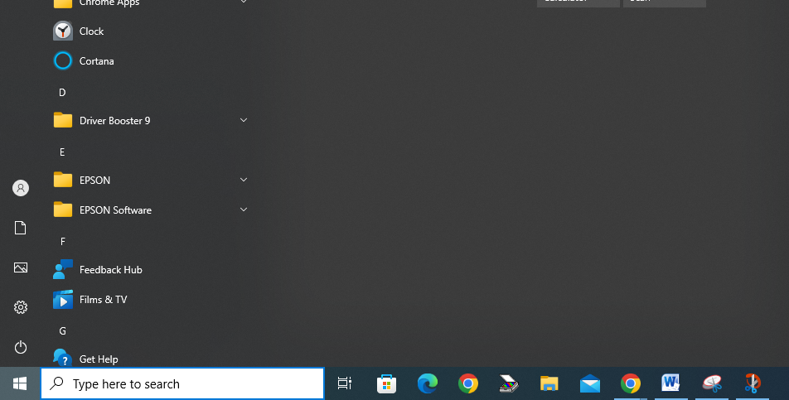

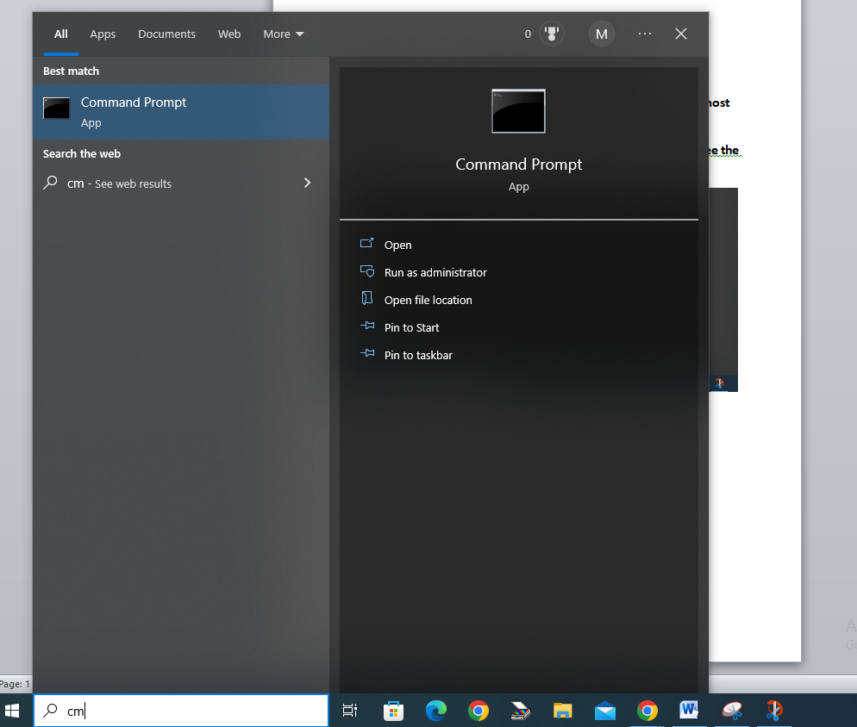

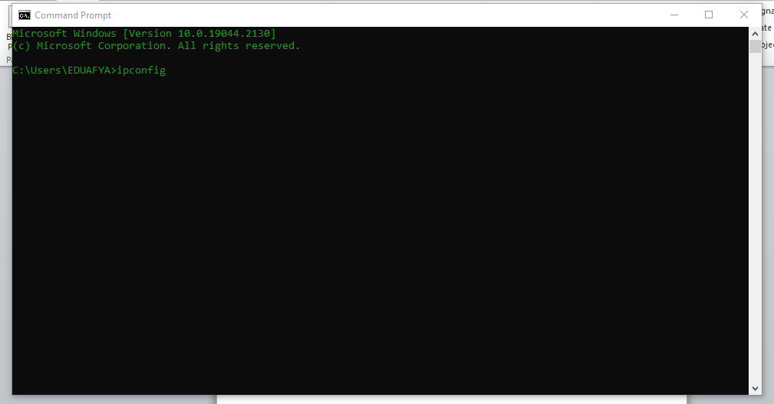**type ipconfig then hit enter**

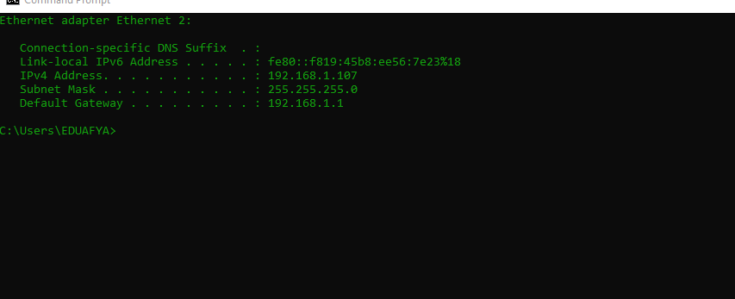**the ip in this case is 107 it might be different in your case.**

**Now go to the desktop and right click on the bat file**



Click edit and change the former ip to your current in this case 107

You will put the ip you got after typing ipconfig

Once you’ve edited click file on the top right of the bat and save.

Now you can cancel the bat file and double click it to run the file system.

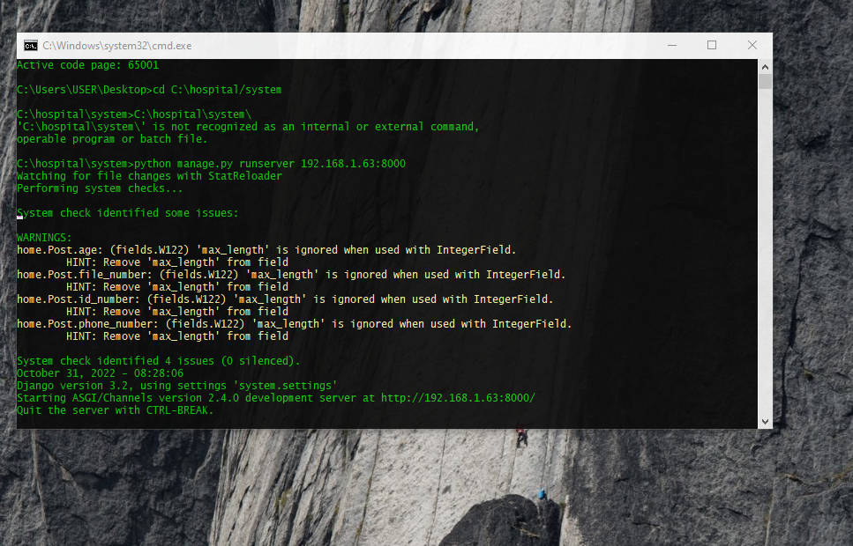**A cmd that looks like this will pop up.**

Make sure to its only one and confirm there is no listening failure written at the bottom.

**You can now open the browser and open with this URL**



**You are good to go.**

**Remember to add slash login**

[**http://192.168.1.your-ip:8000/login**](http://192.168.1.your-ip:8000/login)

**Happy filing!!!**