|  |  |  |  |  |  |  |
| --- | --- | --- | --- | --- | --- | --- |
|  | **7:30 am** | **10:30 am** | **12:40 pm** | **3:30 pm** | **6:00 pm** | **9:00 pm** |
| **Mon** |  |  |  |  |  |  |
| **Tue** |  |  |  |  |  |  |
| **Wed** |  |  |  |  |  |  |
| **Thur** |  |  |  |  |  |  |
| **Fri** |  |  |  |  |  |  |
| **Sat** |  |  |  |  |  |  |
| **Sun** |  |  |  |  |  |  |

**MEAL PLAN**

Patient name : ……………………… File Ip Number:…………………………………………………….

Mode of Payment:…………………………………………………………………………………………

DOA:……………………………………….. DOD: ………………………………………………………

Ward: …………………… Bed Number:………………………………………

Diagnosis:…………………………………………………………………………………………………

**DIABETIC PLATE**

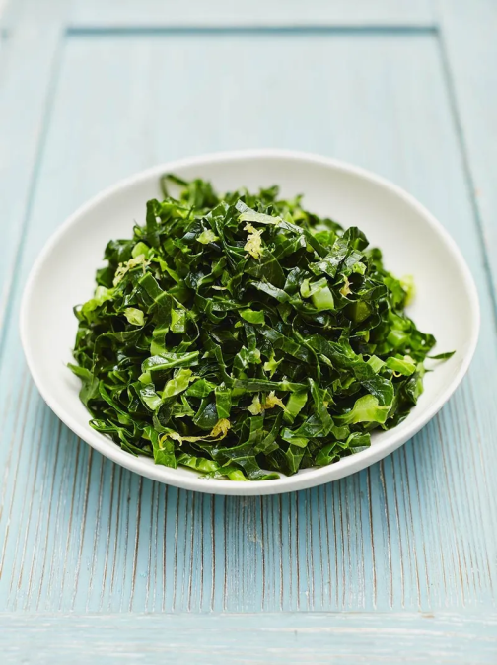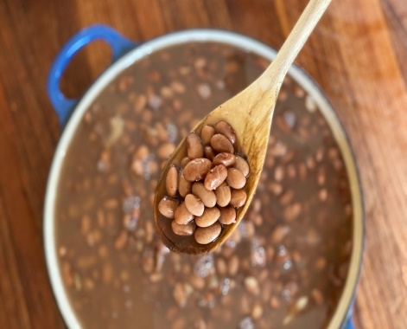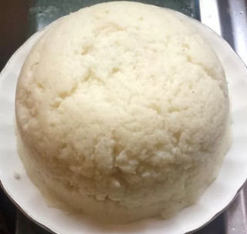

**VEGETABLES**

**PROTEIN**

**CABORHYDRATES**