Answer to Question 1

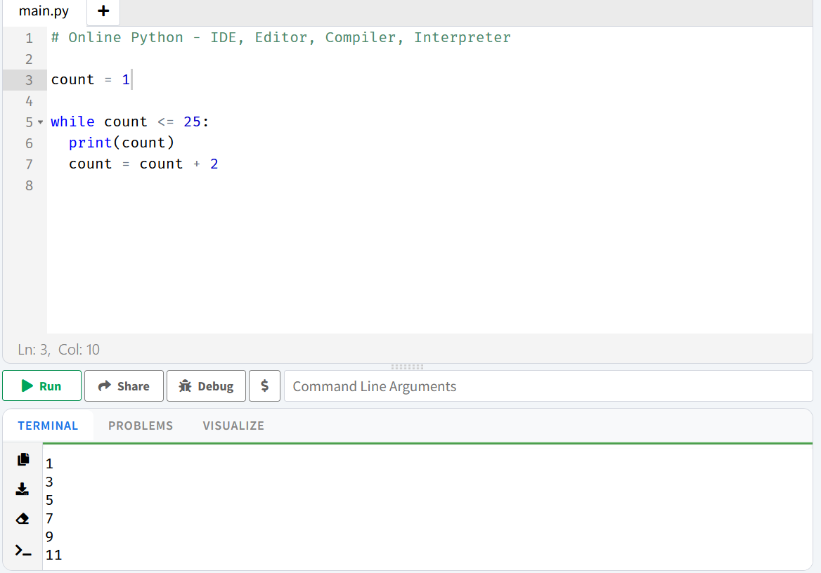
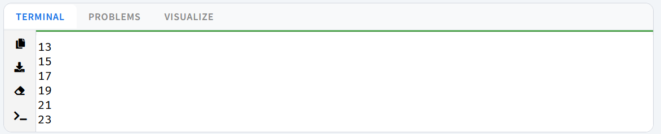
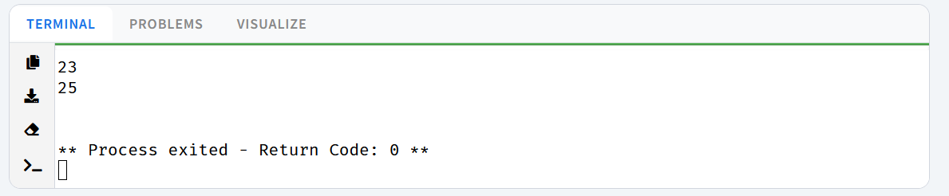

Answer to Question 2
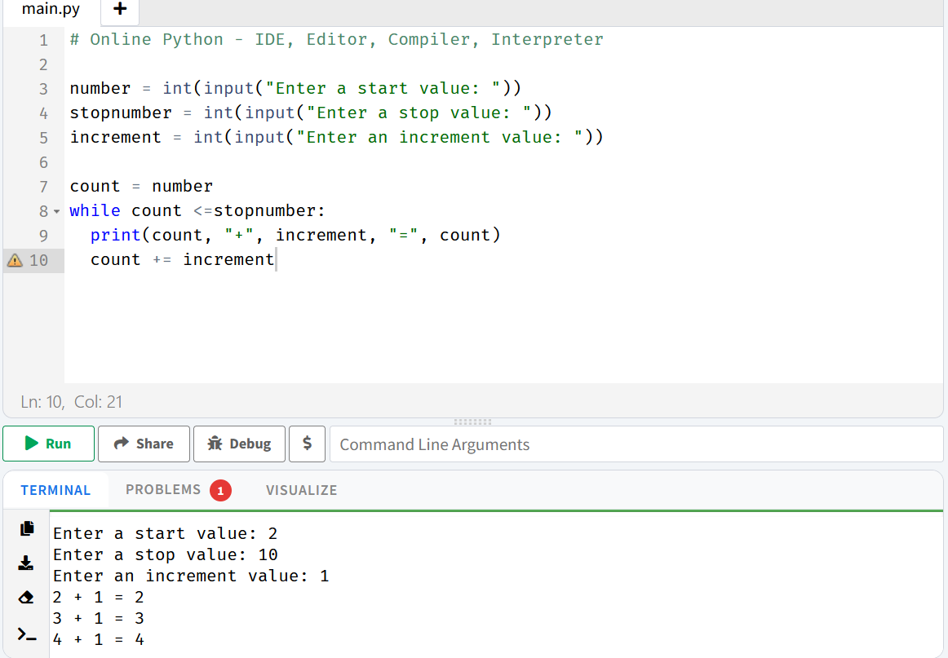
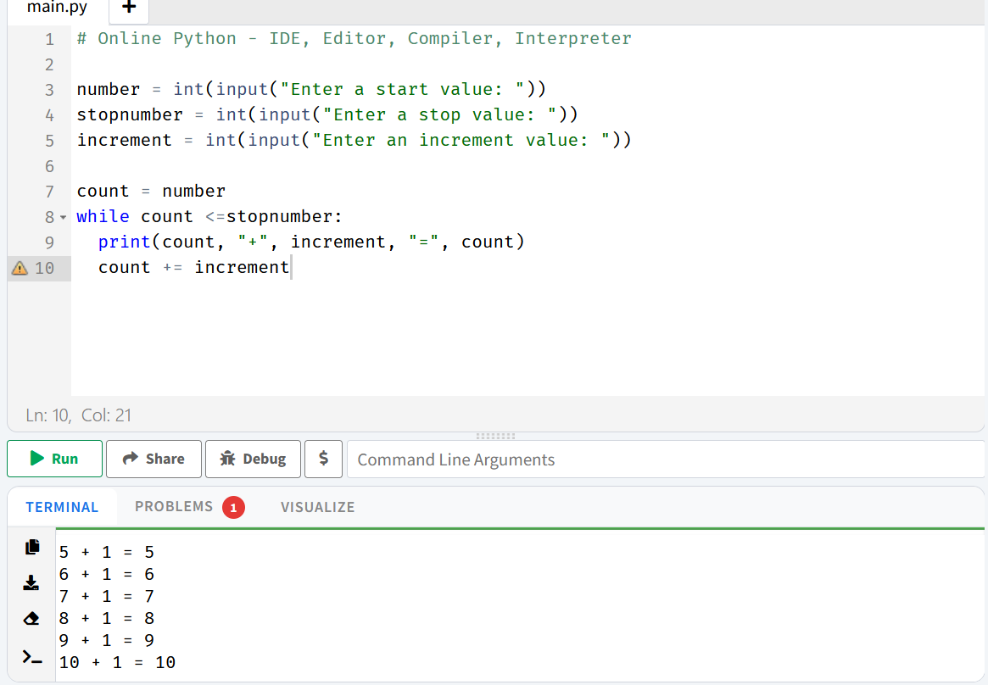
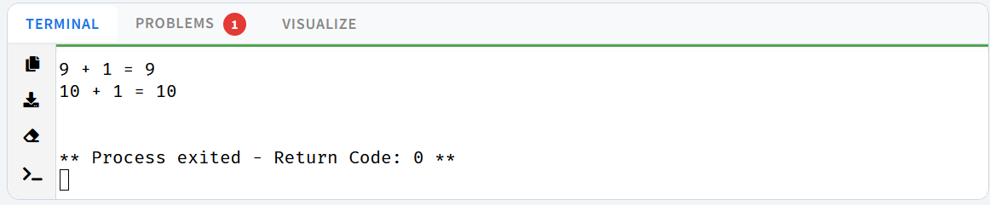

Answer to Question 3
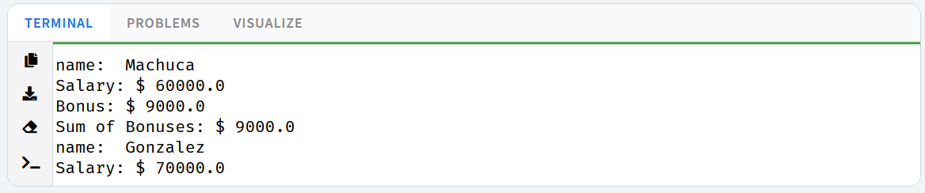
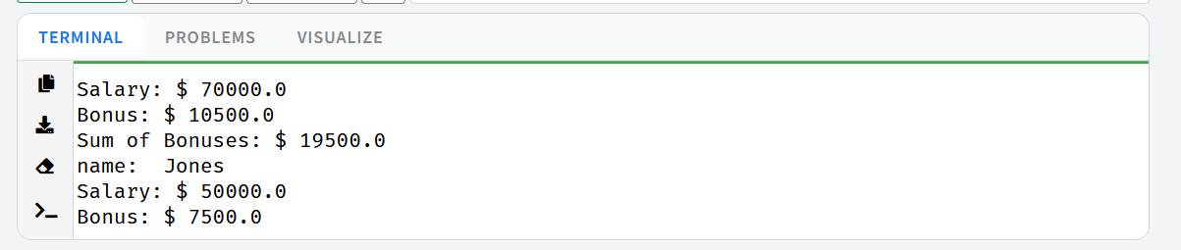
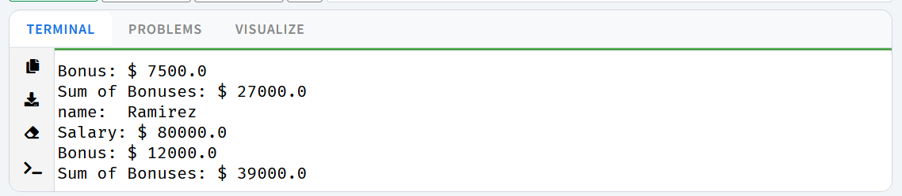
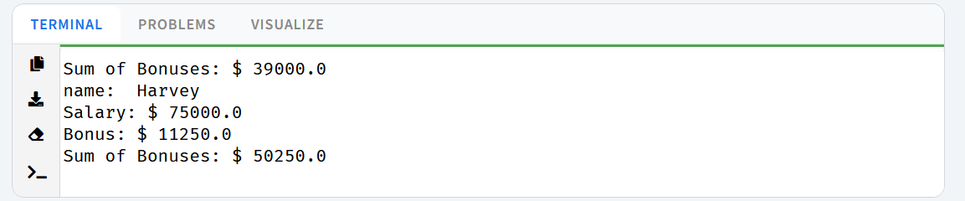

Answer to Question 5

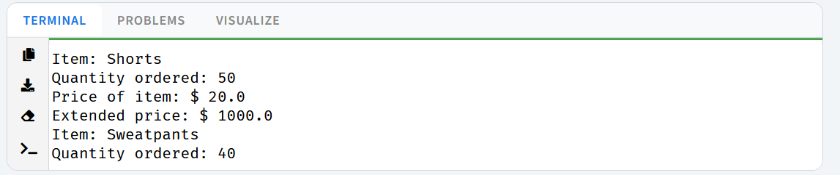
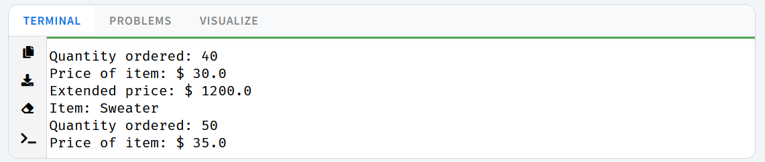
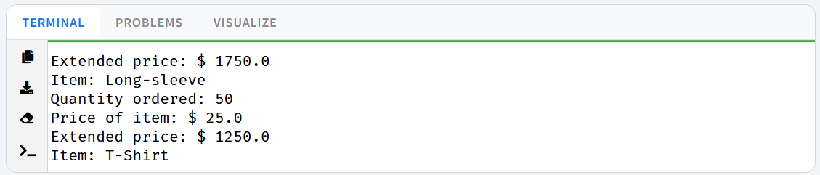
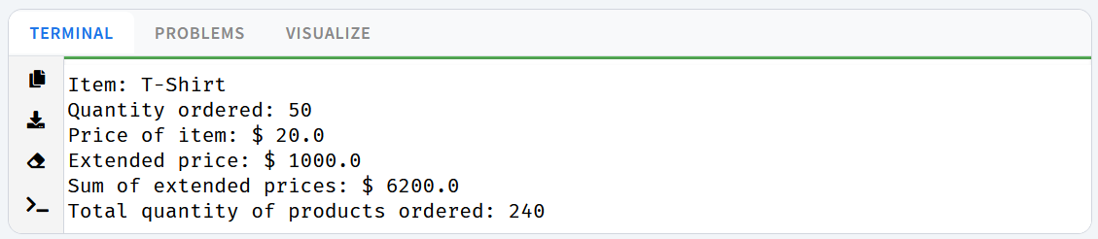
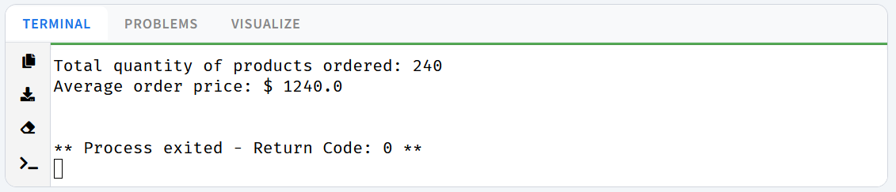

Answer to Question 5

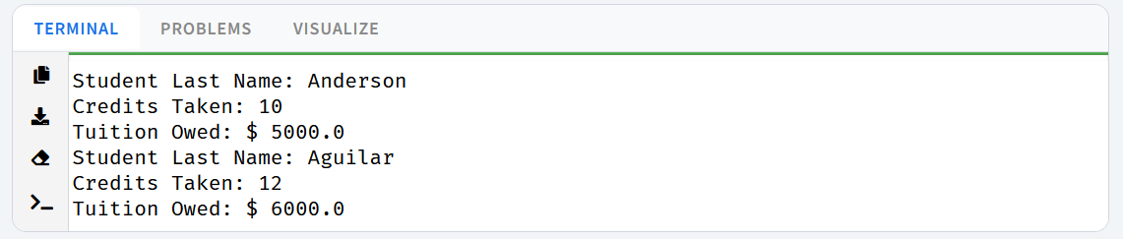
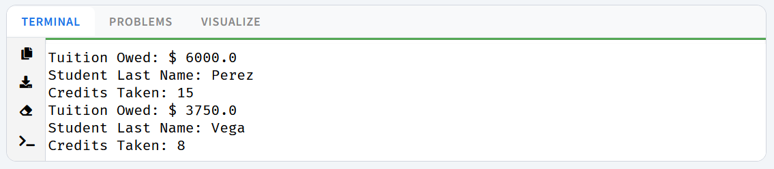
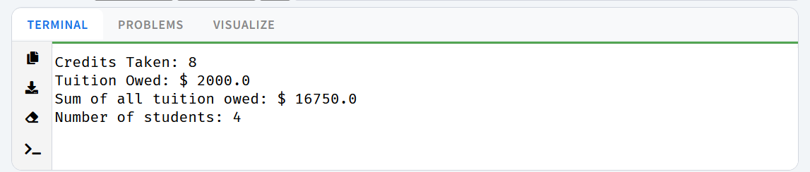

Answer to Question 6
