Output to Question 1:
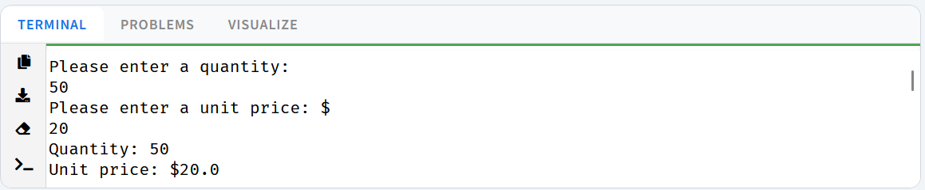
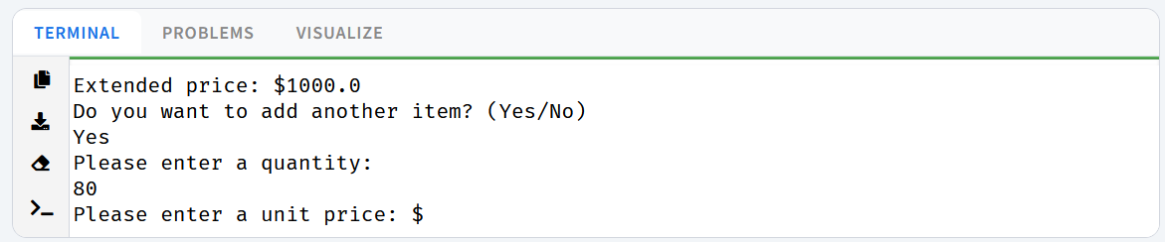
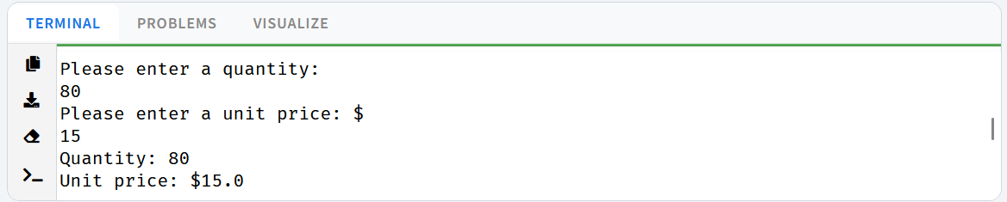
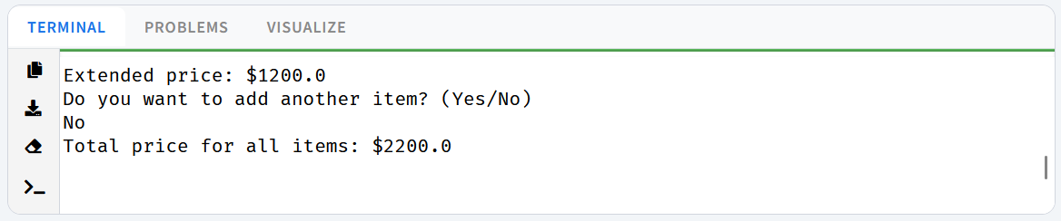

Output to Question 2:
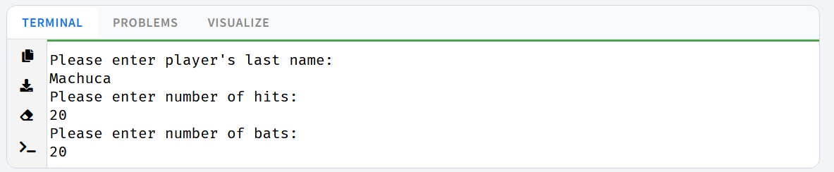
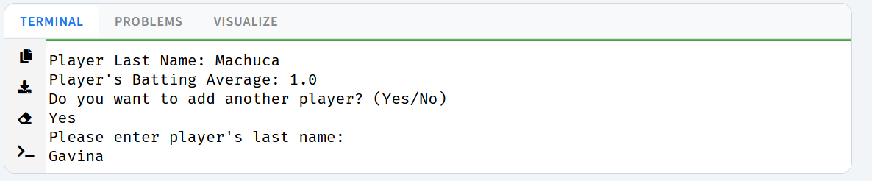
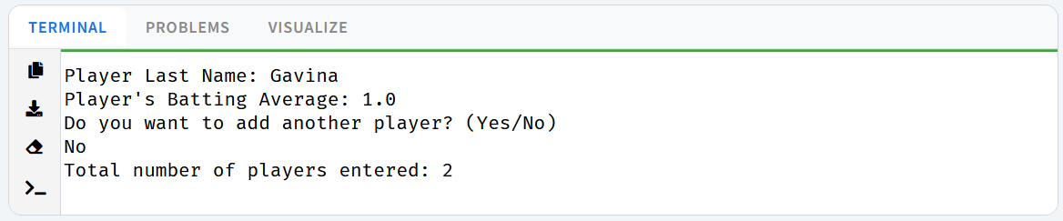
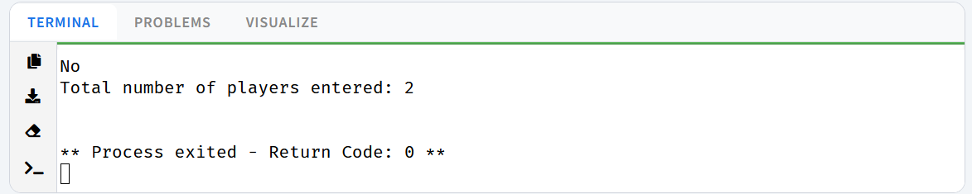

Output to Question 3:
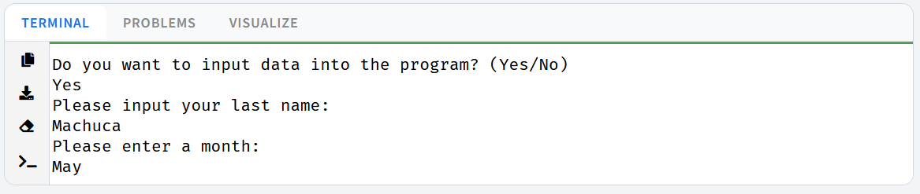
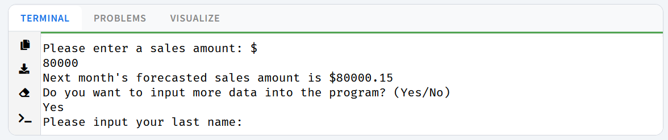
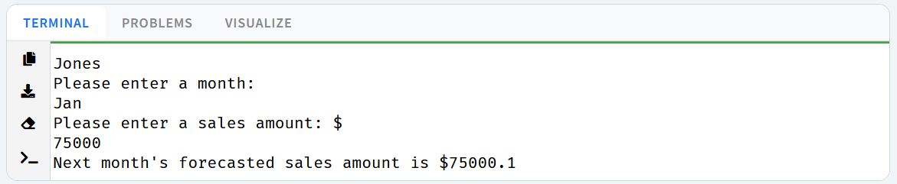
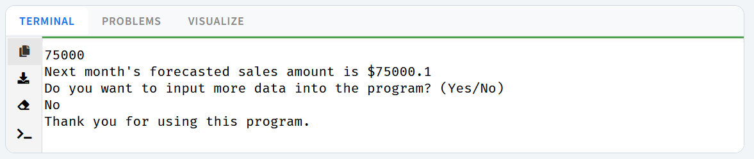

Answer to Question 4:
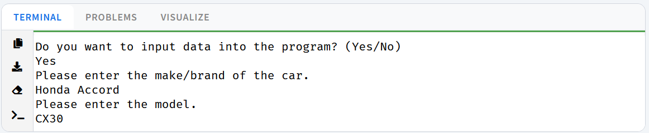
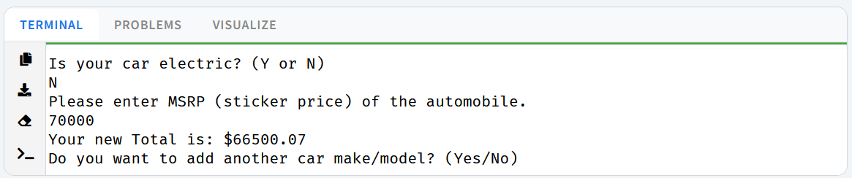
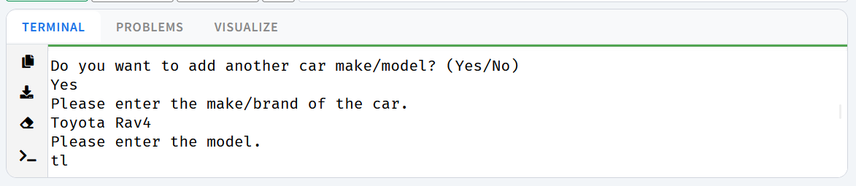
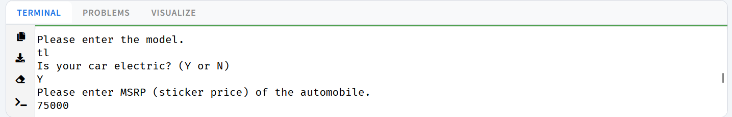
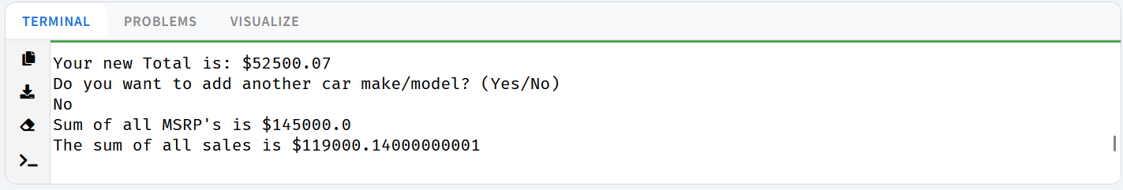

Answer to Question 5:
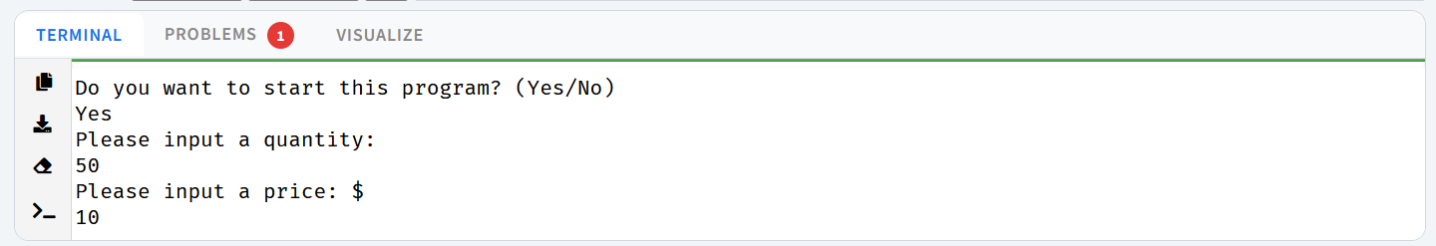
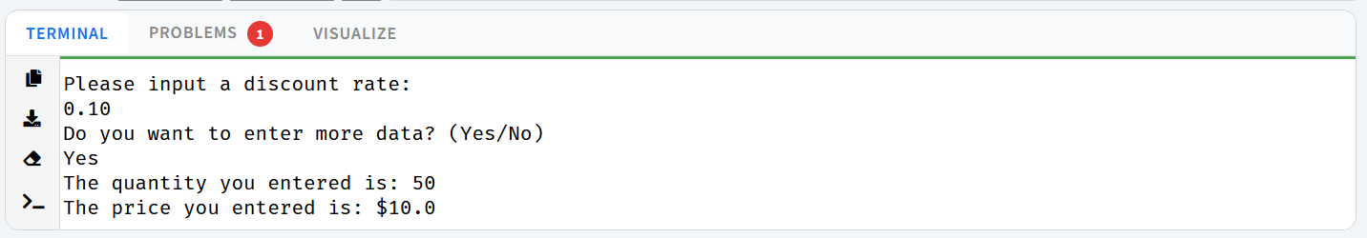
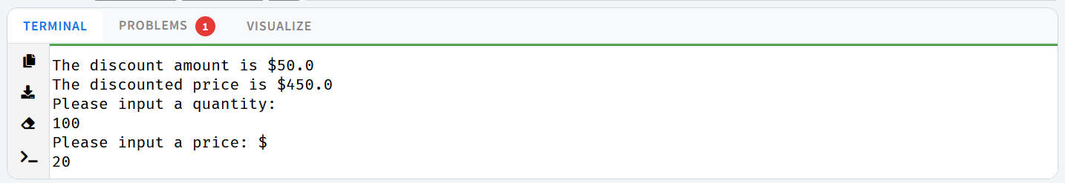
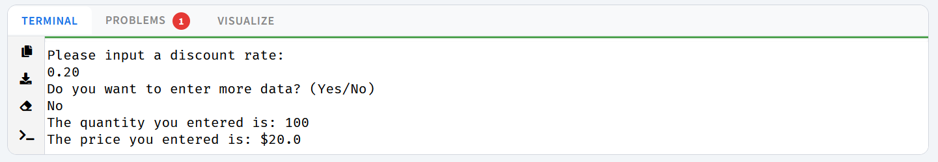
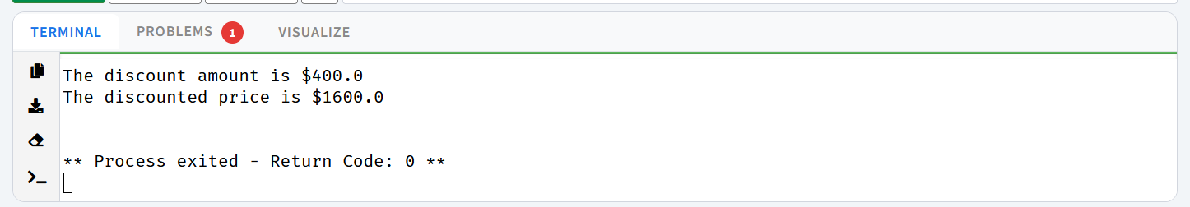
Answer to Question 6:
