Answer to Question 1:
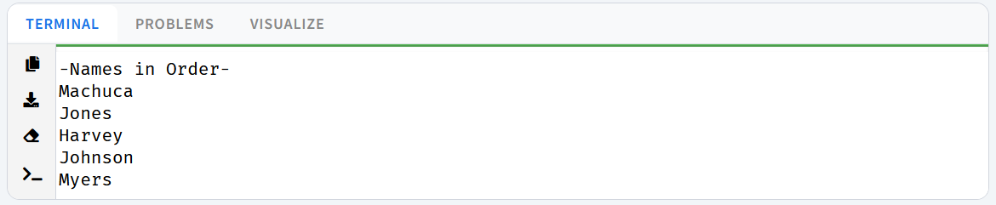
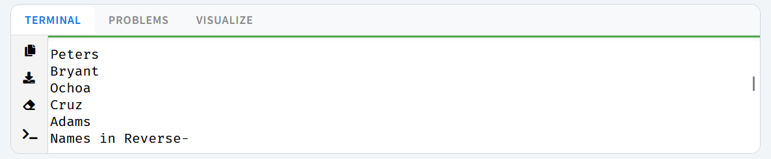
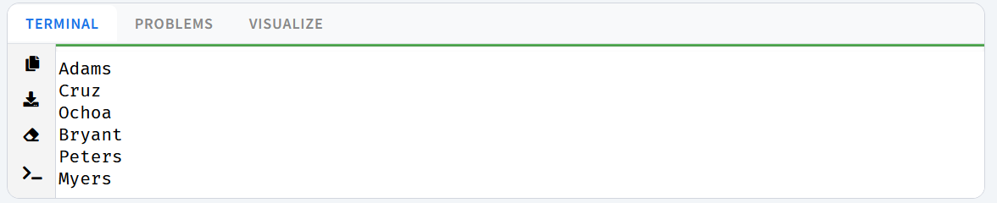
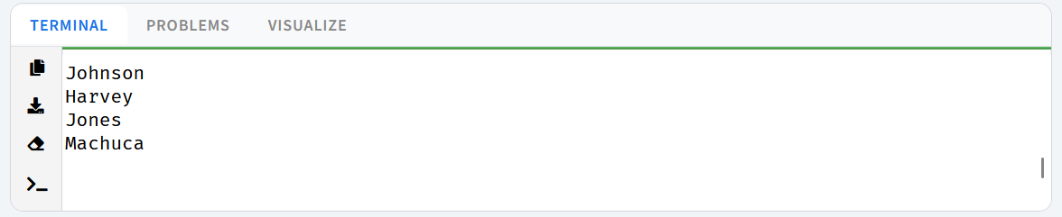

Answer to Question 2:
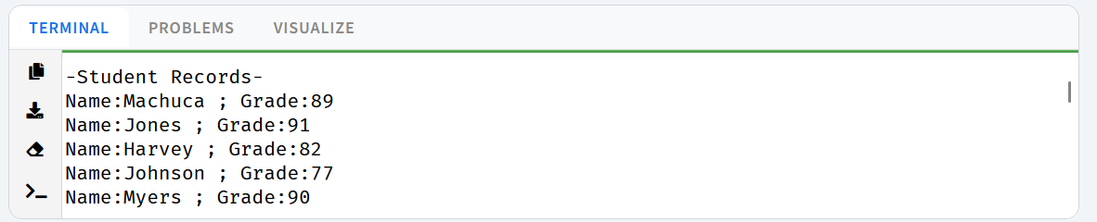
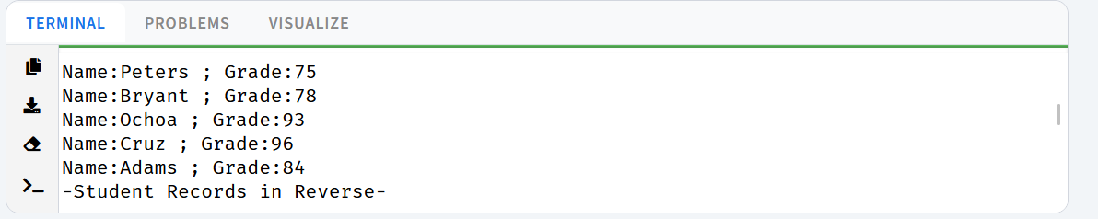
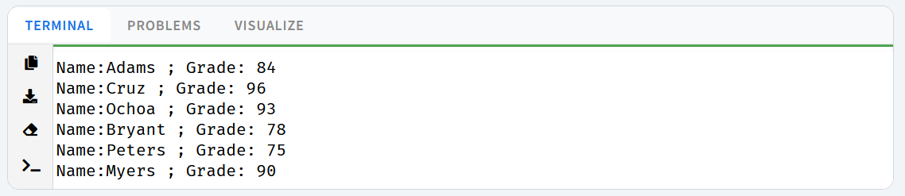
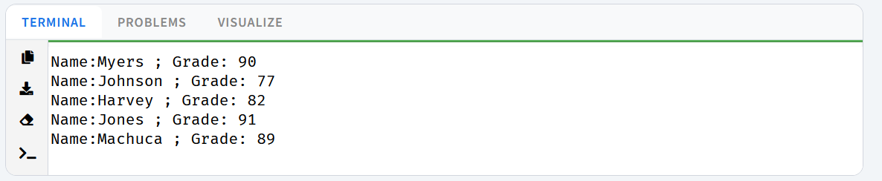
Answer to Question 3:
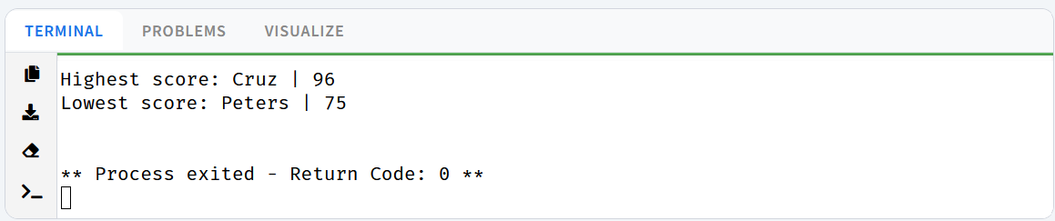
Answer to Question 4:
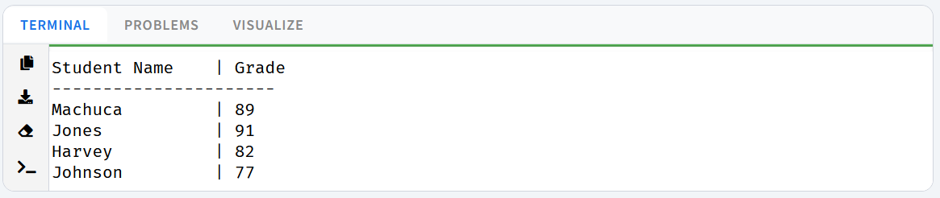
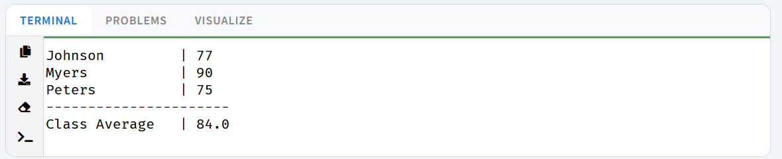
Answer to Question 5:
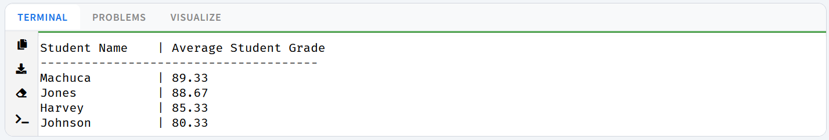
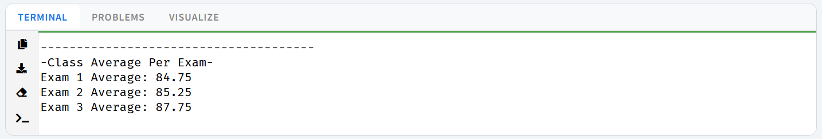
Answer to Question 6:
