Database ERD for soap fields tables
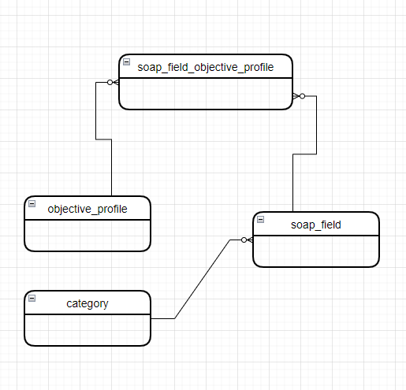
API’s
- Update soap fields names old version to new one
- Update soap-Field (field_value:name , field_name) with new naming convention as following:
  - <category_name>_<soap_parent_field_id>_<soap_dispaly_name>
- API URL
  - http://localhost:8080/emr/api/soap/update/field-name/category/{categoryId}
- Post-Man Collection
  - EMR/medical-Note/SOAP/Update SOAP Field Name

- Assign all category’s fields to objective profile
- API URL
  - http://localhost:8080/emr/api/soap/assign/fields/profile/name/{profile}/category/id/{categoryId}
- Post-Man
  - EMR/medical-Note/SOAP/ Assign SOAP Fields To Profile

- Find objective profile’s soap fields that has been assigned to it
- API URL
  - http://localhost:8080/emr/api/soap/find/field-name/profile/name/{profile_name}
- Post-Man Collection
  - EMR/medical-Note/SOAP/ Find SOAP Fields By Profile

- Generate List of styles per soap field for selected category. These styles will be added in category style file with the following convention:
  - <category>. fields.styles.ts
- API URL
  - http://localhost:8080/emr/api/soap/generate/field-name/style/category/id/{category_id}
- Post-Man Collection
  - EMR/medical-Note/SOAP/ Generate SOAP Fields Styles

