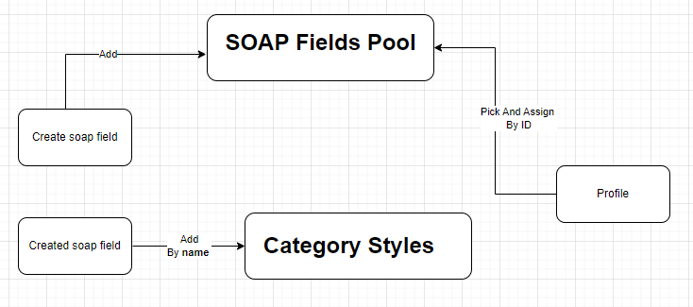
- Add Soap Field
- Create new soap field, attach it to category and add it to soap fields pool
  - API:
    - http://localhost:8080/emr/api/soap/create/field/category/Inspection
  - Postman collection
    - EMR/SOAP/Create SOAP Fields
- Pick and assign Soap field
  - Assign created soap field to profile. Use new created soap field ID to assign it
  - API:
    - http://localhost:8080/emr/api/soap/assign/field/profile/name/{profile_name}/field/id/{soap_id}
  - Postman collection
    - EMR/SOAP/Assign SOAP Field To Profile
- Style Soap field
  - Add in category style file new item for created soap field

- Un-assign Soap field
  - Un assign soap field from profile
  - API:
    - http://localhost:8080/emr/api/soap/unassign/field/profile/id/{profile_id}/field/id/{field_id}
  - Postman collection
    - EMR/SOAP/ Un-Assign SOAP Fields From Profile

