Heart Disease Prediction

End-to-End MLOps Pipeline

Field | Details
Student Name | MADHAN MANOHARAN
Student ID | 2025CS05047
Program | MTech AI & ML — BITS Pilani WILP
Course | MLOps (S2-25_AMLCSZG523)
Submission Date | 10 May 2026
GitHub Repository | https://github.com/mmadhan21/heart-disease-mlops
Video Link | BITS GDrive Link of Presentation

Abstract
This report documents the complete design, development, and deployment of an end-to-end MLOps pipeline for predicting heart disease risk using the UCI Heart Disease dataset. The solution implements modern MLOps best practices including automated training, experiment tracking with MLflow, containerization with Docker, orchestration with Kubernetes, CI/CD automation with GitHub Actions, and production monitoring with Prometheus and Grafana. The best model achieved a ROC-AUC score of 0.9513 using Logistic Regression and is served via a FastAPI REST endpoint.

1. Setup and Installation
The following section describes the complete setup instructions to run the Heart Disease MLOps pipeline from a clean environment.

1.1 Prerequisites
Tool | Version | Purpose
Python | 3.9+ | Core programming language
Docker Desktop | Latest | Containerization platform
Kubernetes | Built-in Docker | Container orchestration
Git | Latest | Version control
Jupyter Notebook | Latest | Development environment
MLflow | 2.22.4 | Experiment tracking

1.2 Installation Steps
- Clone Repository: git clone https://github.com/mmadhan21/heart-disease-mlops.git
- Install Dependencies: pip install -r requirements.txt
- Download Dataset: python data/download_data.py
- Train Models: python src/train.py
- Run Tests: pytest tests/ -v
- Build Docker Image: docker build -t heart-disease-api:v1 .
- Run Container: docker run -d -p 8000:8000 heart-disease-api:v1
- Access API: http://localhost:8000/docs

1.3 Project Structure
Path | Purpose
data/download_data.py | Dataset download script
src/preprocess.py | Data preprocessing pipeline
src/train.py | Model training with MLflow
src/app.py | FastAPI serving application
tests/test_preprocess.py | Preprocessing unit tests
tests/test_model.py | Model inference unit tests
deployment/deployment.yaml | Kubernetes deployment manifest
deployment/service.yaml | Kubernetes service manifest
monitoring/docker-compose.yml | Prometheus + Grafana stack
.github/workflows/ci_cd.yml | GitHub Actions CI/CD pipeline
Dockerfile | Container image definition
requirements.txt | Python dependencies

2. Data Acquisition and EDA (Task 1)

2.1 Dataset Overview
Property | Value
Source | UCI Machine Learning Repository
Dataset | Heart Disease Cleveland Dataset
Total Records | 303 patients
Total Features | 13 clinical + 1 target
Missing Values | 6 (filled with median)
Target | Binary: 0=No Disease, 1=Disease
Class Balance | 138 (45.5%) vs 165 (54.5%)

2.2 Feature Description
Feature | Description | Type
age | Age in years | Numerical
sex | 1=Male, 0=Female | Categorical
cp | Chest pain type (0-3) | Categorical
trestbps | Resting blood pressure (mm Hg) | Numerical
chol | Serum cholesterol (mg/dl) | Numerical
fbs | Fasting blood sugar > 120 mg/dl | Categorical
restecg | Resting ECG results (0-2) | Categorical
thalach | Maximum heart rate achieved | Numerical
exang | Exercise induced angina | Categorical
oldpeak | ST depression by exercise | Numerical
slope | Slope of peak exercise ST | Categorical
ca | Number of major vessels (0-3) | Categorical
thal | Thalassemia type | Categorical

2.3 Data Preprocessing
Missing values were identified in two columns and filled using median imputation — a robust strategy for clinical data with skewed distributions.
Column | Missing | Strategy | Fill Value
ca | 4 | Median imputation | 0.0
thal | 2 | Median imputation | 3.0

2.4 Key EDA Findings
- Dataset is well balanced (54.5% disease vs 45.5% no disease) — no resampling needed
- Patients with disease show significantly lower maximum heart rate (thalach)
- ST depression (oldpeak) is higher in disease patients indicating cardiac stress
- Asymptomatic chest pain (cp=3) is most strongly associated with disease presence
- Number of major vessels (ca) shows strong positive correlation with disease
- Males show higher disease prevalence than females in this clinical dataset

EDA Visualizations:
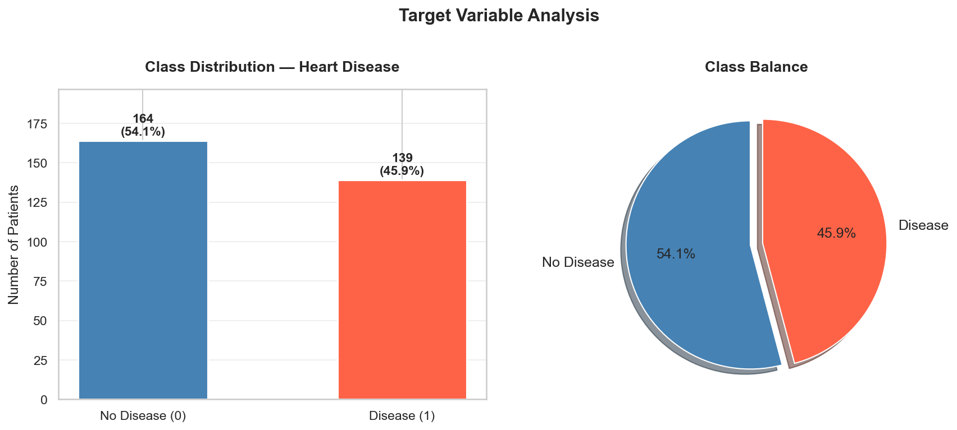
Figure 1: Target Class Distribution

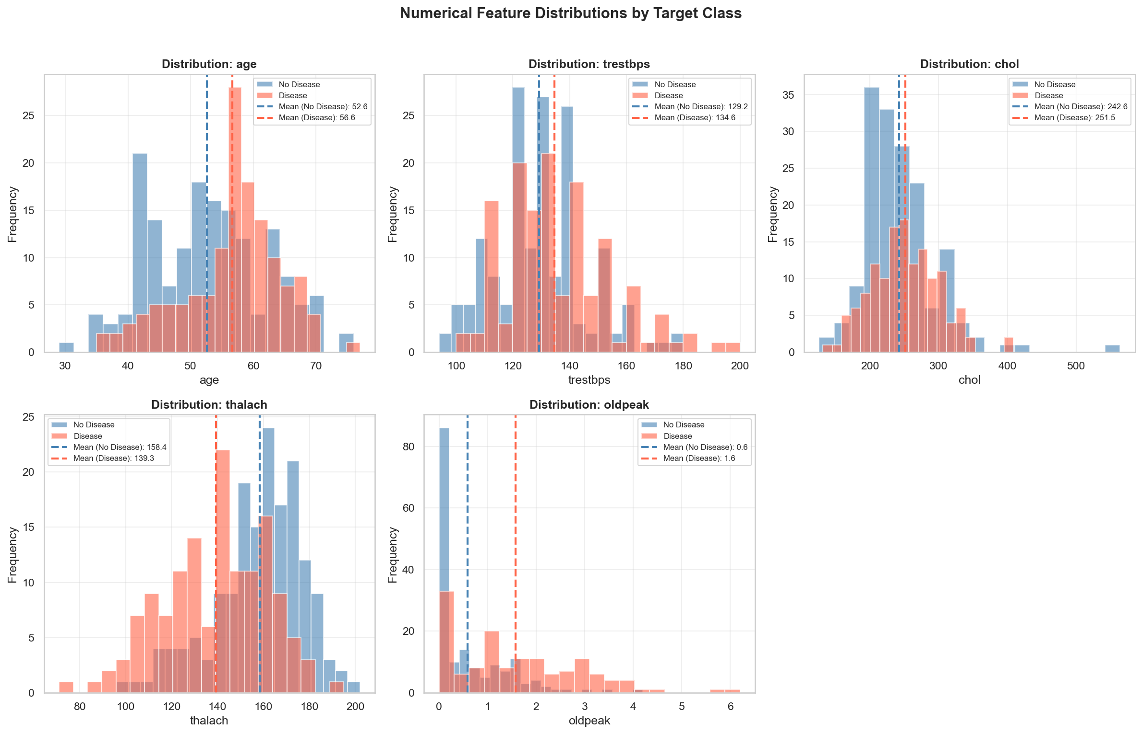
Figure 2: Numerical Feature Distributions

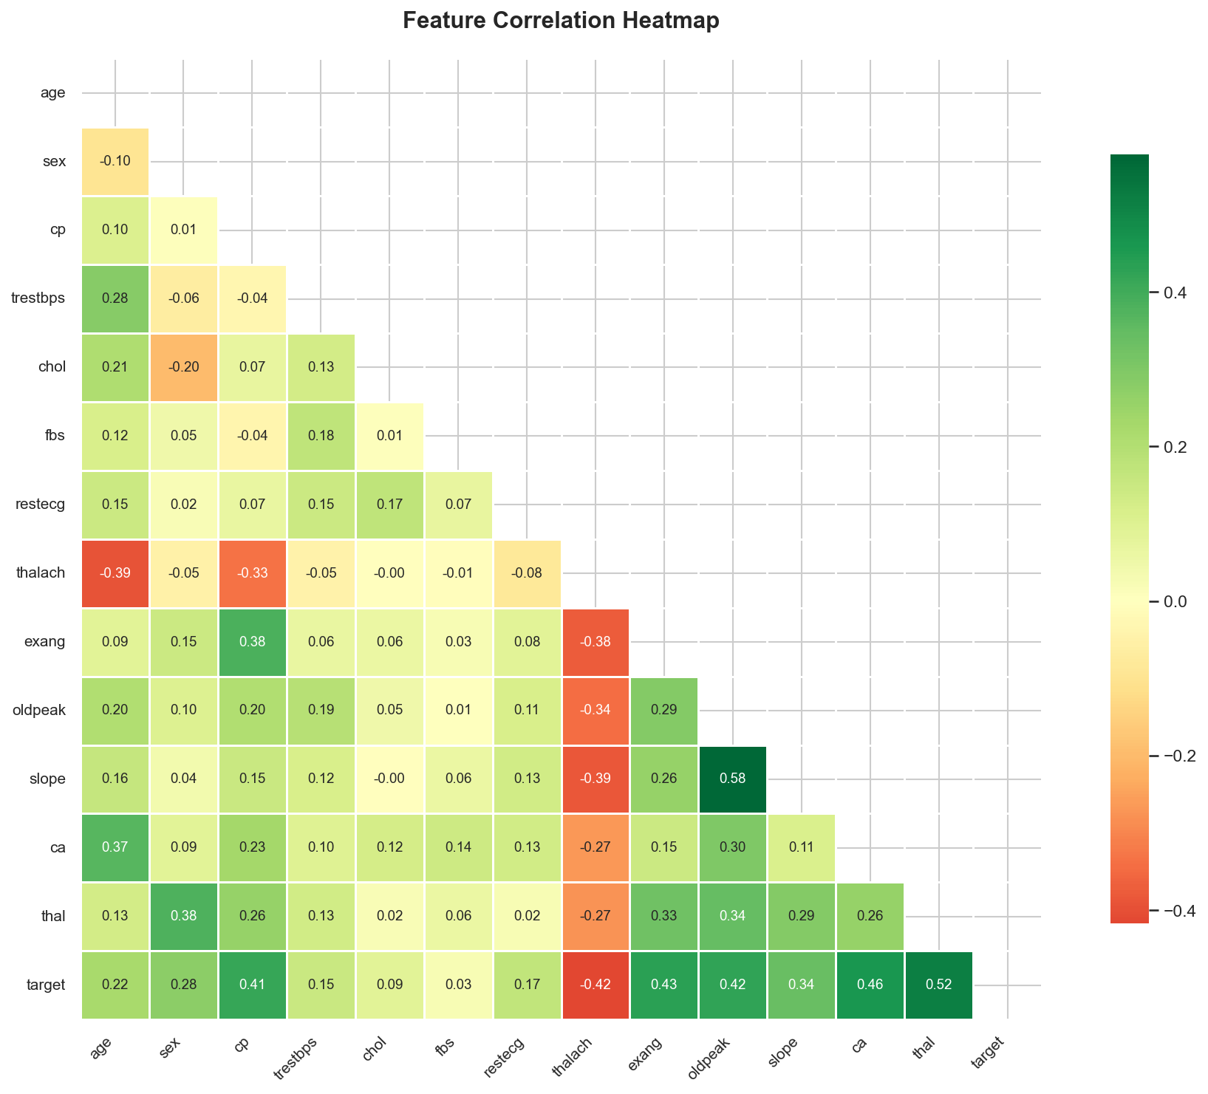
Figure 3: Feature Correlation Heatmap

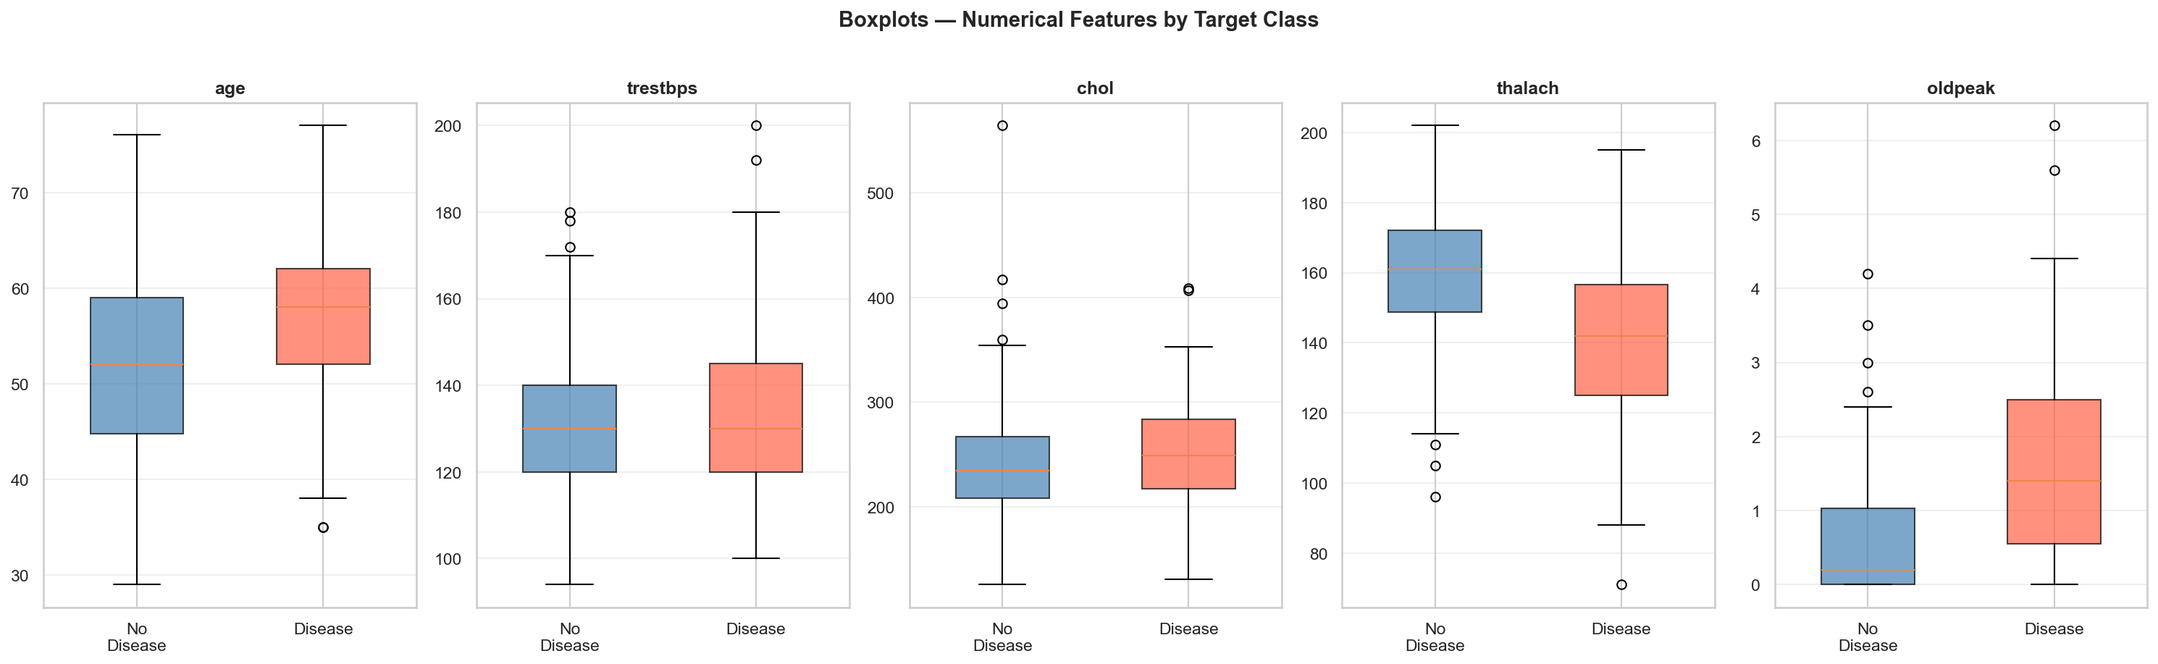
Figure 4: Boxplots for Outlier Detection

3. Model Development (Task 2)

3.1 Preprocessing Pipeline
A scikit-learn ColumnTransformer pipeline was built to ensure identical transformations at training and inference time, preventing data leakage.
Feature Type | Features | Transformation
Numerical | age, trestbps, chol, thalach, oldpeak | StandardScaler
Categorical | sex, cp, fbs, restecg, exang, slope, ca, thal | PassThrough

3.2 Train/Test Split
Split | Size | Percentage | Strategy
Training | 242 | 80% | Stratified
Testing | 61 | 20% | Stratified

3.3 Models Trained
Model 1: Logistic Regression
Logistic Regression was chosen as the baseline model due to its strong performance on tabular clinical data, full interpretability, and computational efficiency. The regularization parameter C=1.0 provides a good balance between bias and variance.
Hyperparameter | Value
C (regularization) | 1.0
max_iter | 1000
solver | lbfgs
random_state | 42

Model 2: Random Forest Classifier
Random Forest was selected as the ensemble model to capture non-linear feature interactions present in clinical datasets. The depth was limited to 6 to prevent overfitting on the small dataset.
Hyperparameter | Value
n_estimators | 100
max_depth | 6
min_samples_split | 4
random_state | 42

3.4 Evaluation Results
Metric | Logistic Regression | Random Forest
Accuracy | 0.8689 | 0.918
Precision | 0.8125 | 0.871
Recall | 0.9286 | 0.9643
F1 Score | 0.8667 | 0.9153
ROC-AUC | 0.9513 | 0.9491
CV AUC Mean | 0.8884 | 0.8882
CV AUC Std | 0.0441 | 0.0380

Model Selection Decision:
Logistic Regression was selected as the best model based on the highest ROC-AUC score of 0.9513. ROC-AUC was chosen as the primary metric because it measures the model's ability to discriminate between disease and no-disease cases across all thresholds, making it the most appropriate metric for clinical risk prediction tasks. Low cross-validation standard deviation confirms the model is stable and generalizes well to unseen data.
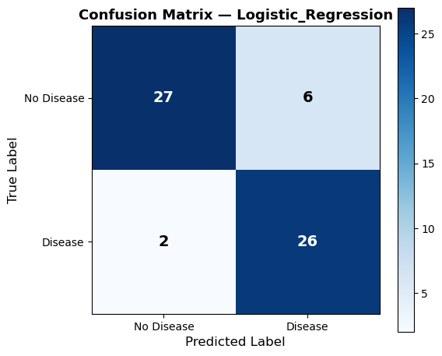
Figure 5: Confusion Matrix — Logistic Regression

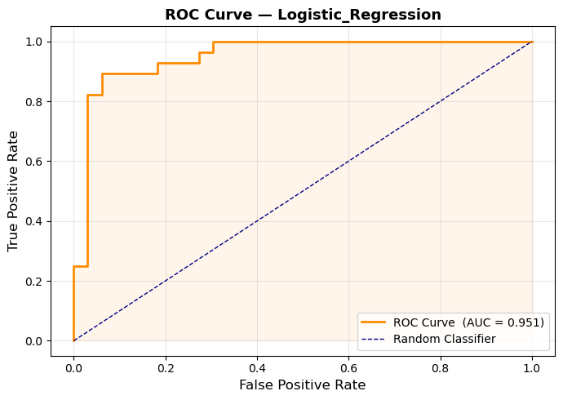
Figure 6: ROC Curve — Logistic Regression

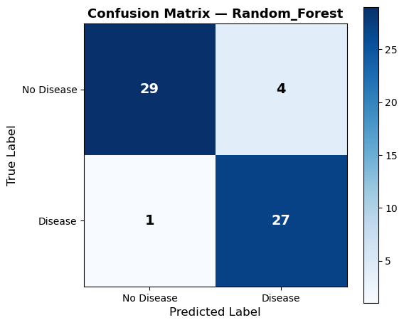
Figure 7: Confusion Matrix — Random Forest
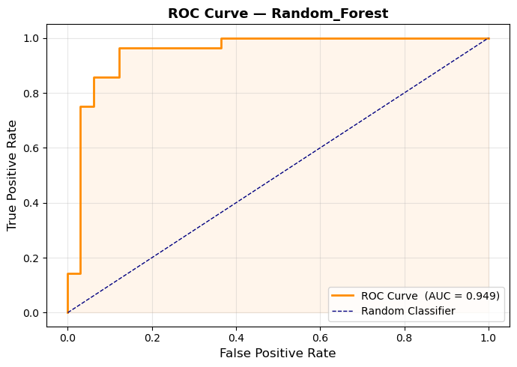
Figure 8: ROC Curve — Random Forest

4. Experiment Tracking (Task 3)
MLflow was integrated into the training pipeline to provide complete experiment reproducibility and auditability. All experiments were tracked locally in the mlruns/ directory.

4.1 MLflow Configuration
Setting | Value
Tracking URI | mlruns/
Experiment Name | Heart_Disease_Classification
Total Runs | 2
Model Registry | Enabled

4.2 Logged Information
Category | Items Logged
Parameters | C, max_iter, solver, n_estimators, max_depth, train_size, test_size
Metrics | accuracy, precision, recall, f1_score, roc_auc, cv_roc_auc_mean, cv_roc_auc_std
Artifacts | model.pkl, confusion matrix PNG, ROC curve PNG, feature importance PNG
Model Registry | Logistic_Regression v1, Random_Forest v1

4.3 MLflow Screenshots
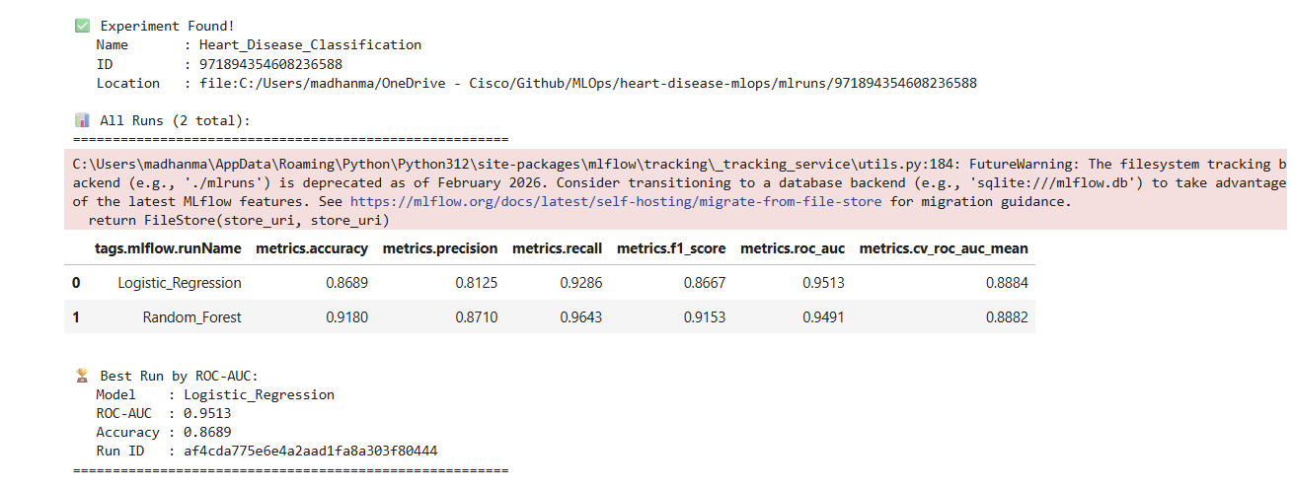
Figure 9: MLflow Experiments Dashboard
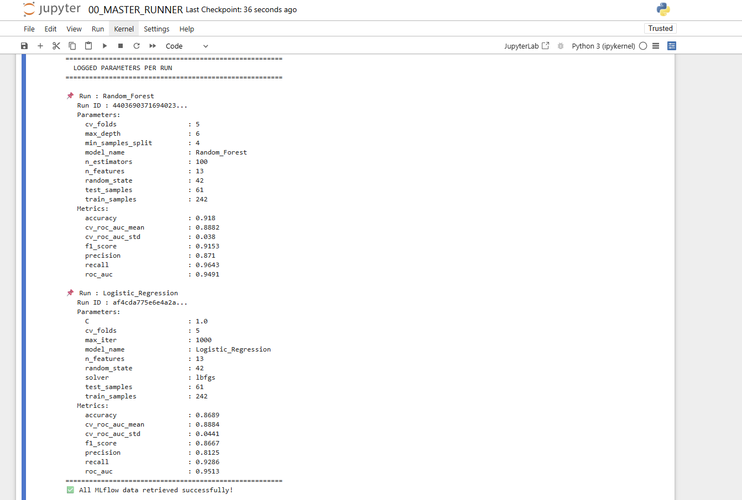
Figure 10: MLflow Runs List

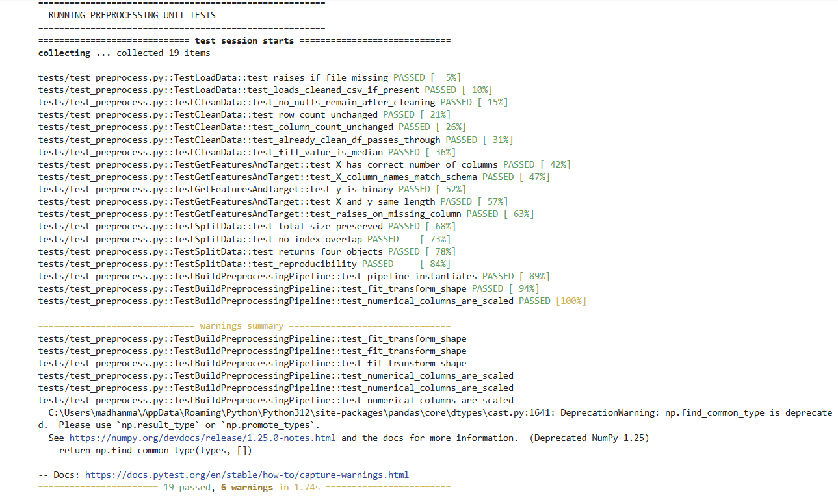
Figure 11: MLflow Run Unit Testing
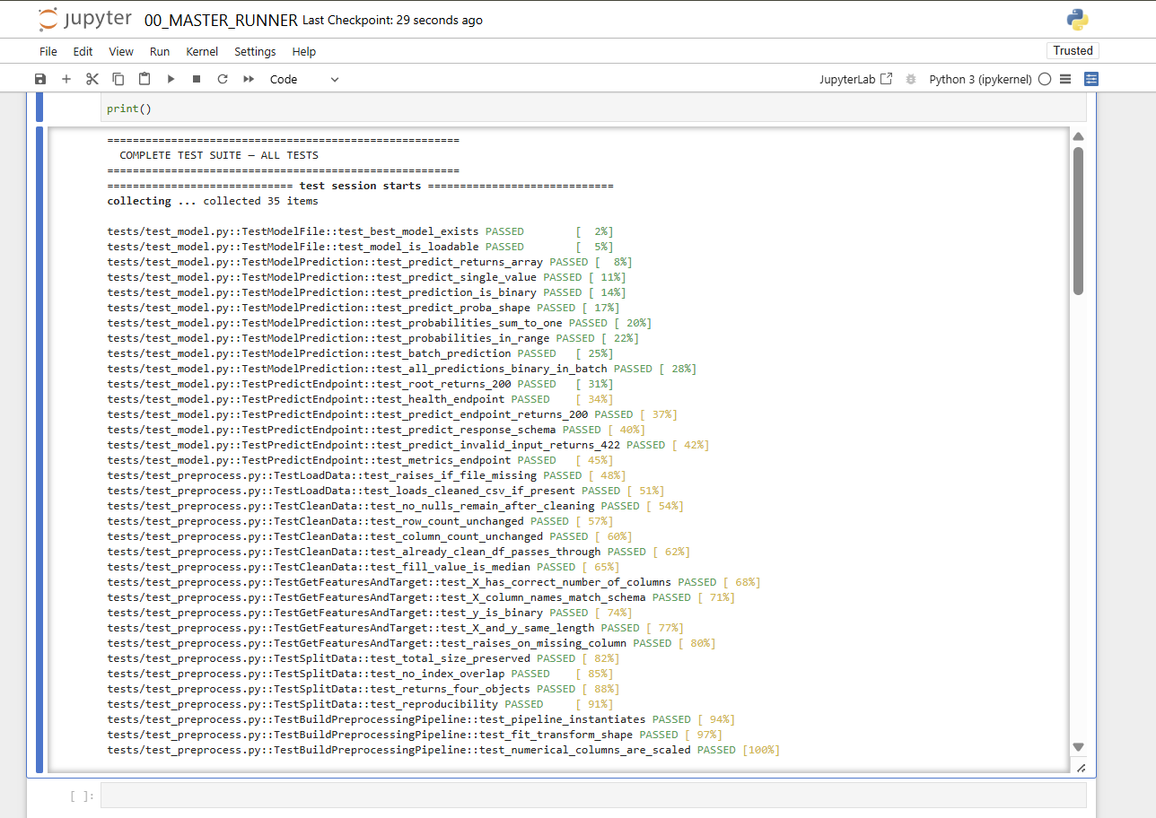
Figure 12: MLflow Run Full Testing

5. Model Packaging and Reproducibility (Task 4)
The trained model pipeline was packaged using joblib serialization. The complete scikit-learn Pipeline object including the ColumnTransformer preprocessor and trained classifier was saved as a single pickle file ensuring identical preprocessing at inference time.

5.1 Saved Artifacts
File | Size | Purpose
models/best_model.pkl | ~5MB | Best model pipeline (LR)
models/Logistic_Regression.pkl | ~5MB | Logistic Regression pipeline
models/Random_Forest.pkl | ~8MB | Random Forest pipeline
requirements.txt | ~1KB | Pinned dependencies
src/preprocess.py | ~5KB | Preprocessing functions

5.2 Reproducibility Measures
- Random state fixed at 42 for all stochastic operations
- All package versions pinned in requirements.txt
- Stratified train/test split ensures consistent class balance
- Complete Pipeline object saved including preprocessor and model
- Data download script provides automated dataset acquisition
- GIT_PYTHON_REFRESH environment variable set for CI/CD reproducibility

6. CI/CD Pipeline (Task 5)
A complete CI/CD pipeline was implemented using GitHub Actions with four sequential jobs. The pipeline runs automatically on every push to the main branch ensuring code quality, test coverage, and deployment readiness.

6.1 Unit Tests
Test Class | Tests | Coverage
TestLoadData | 2 | File loading, error handling
TestCleanData | 5 | Missing value imputation
TestGetFeaturesAndTarget | 5 | Feature/target separation
TestSplitData | 4 | Train/test splitting
TestBuildPreprocessingPipeline | 3 | Pipeline construction
TestModelFile | 2 | Model file existence
TestModelPrediction | 8 | Inference correctness
TestPredictEndpoint | 6 | API endpoint testing
TOTAL | 35 | Core pipeline coverage

6.2 GitHub Actions Jobs
Job | Tool | Purpose | Status
1 - Lint | flake8 | Code quality check | PASSED
2 - Test | pytest | Unit test execution | PASSED
3 - Train | MLflow | Model training | PASSED
4 - Docker | Docker | Build & smoke test | PASSED

6.3 CI/CD Screenshots
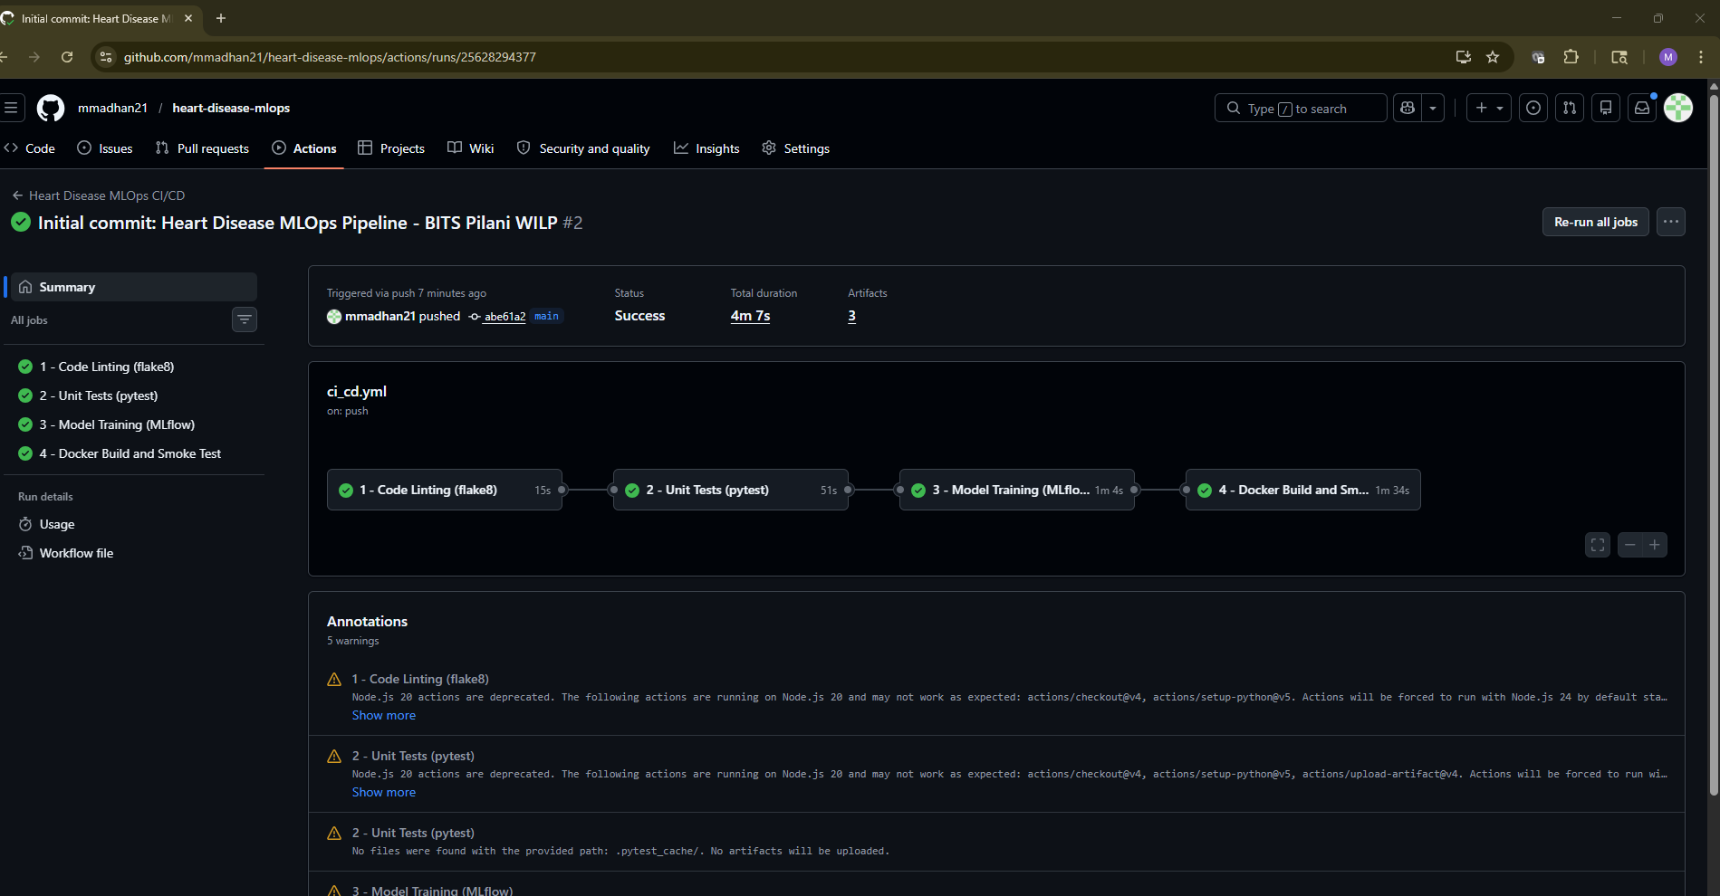
Figure 13: All 4 GitHub Actions Jobs Passing

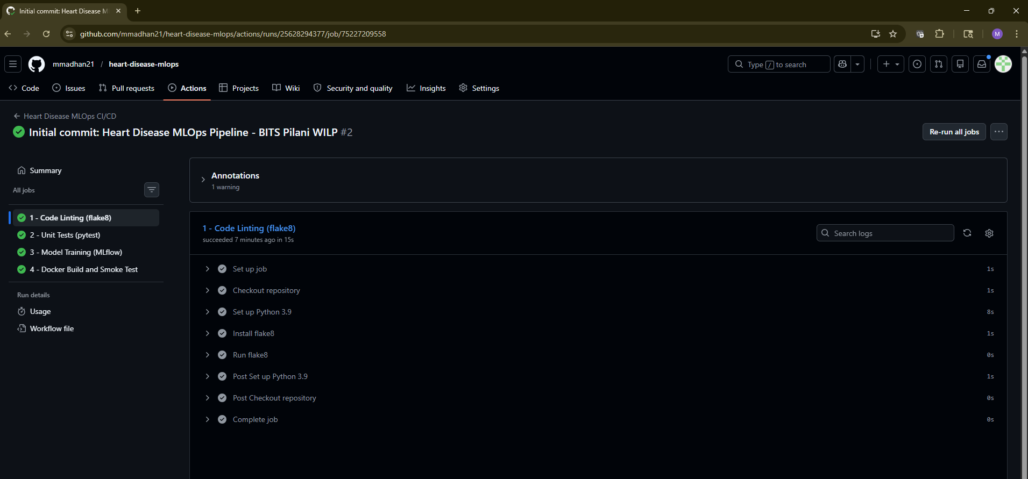
Figure 14: Flake8 Linting Job Logs

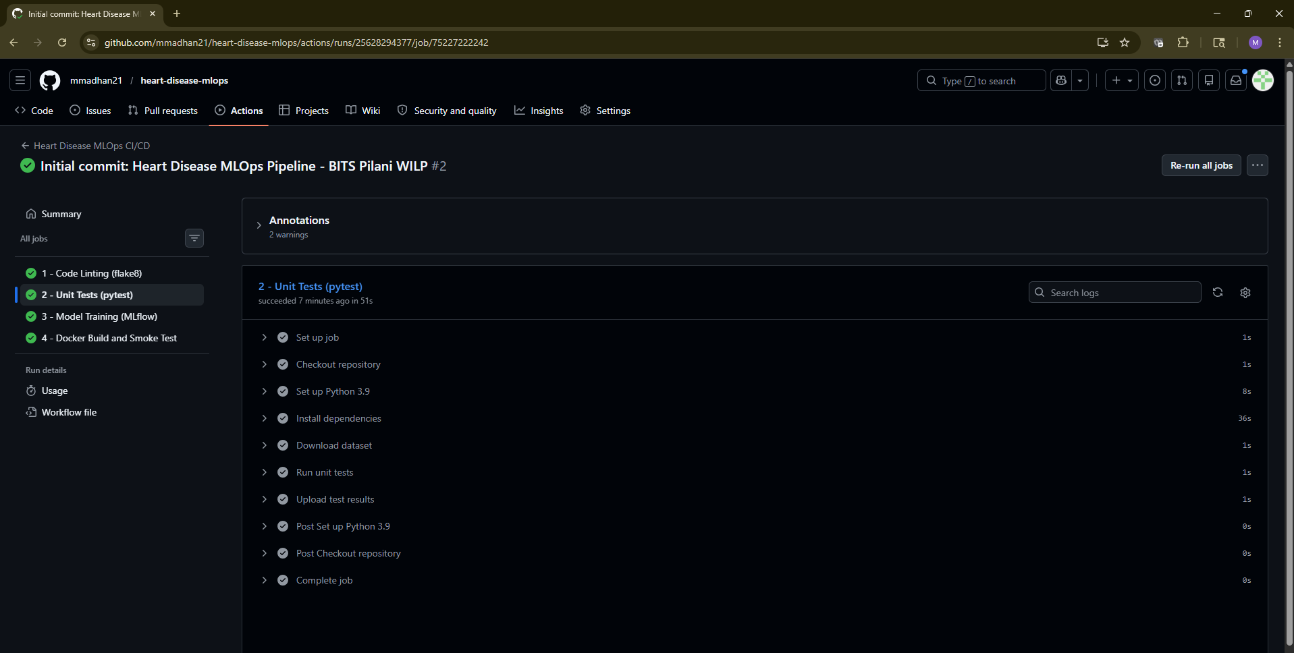
Figure 15: Pytest Unit Tests Job Logs

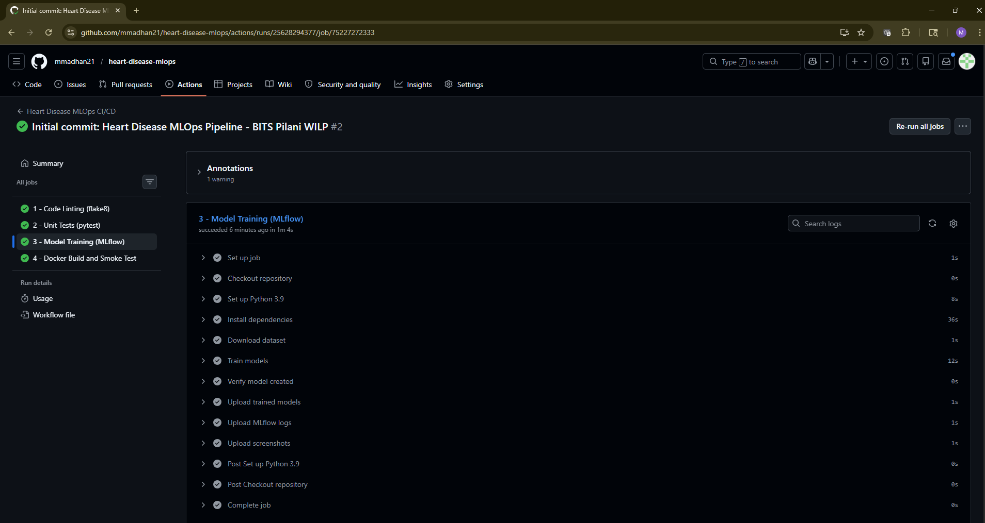
Figure 16: Model Training Job Logs

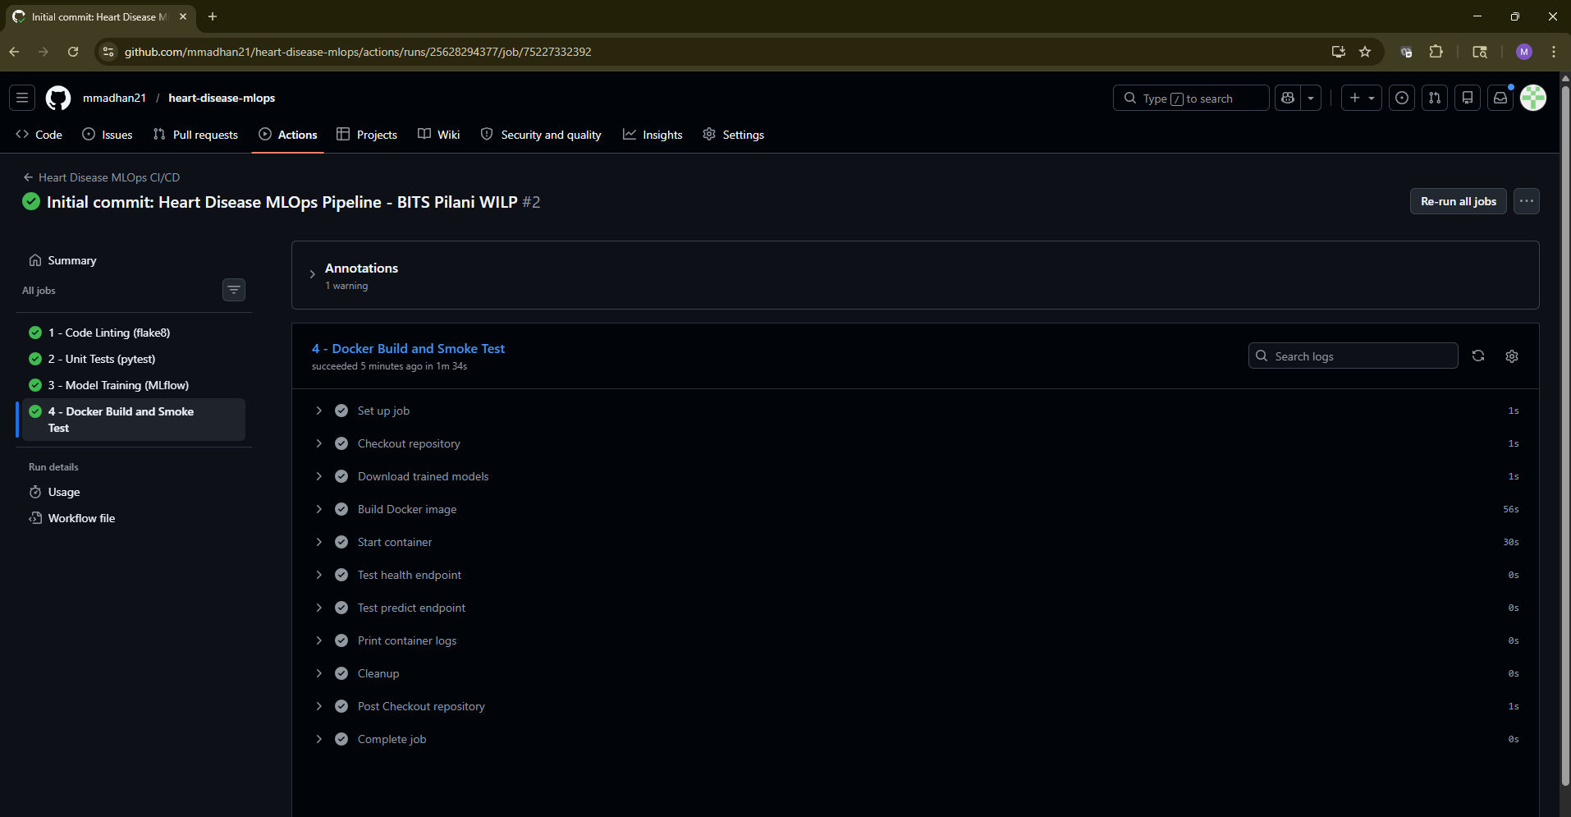
Figure 17: Docker Build and Test Logs

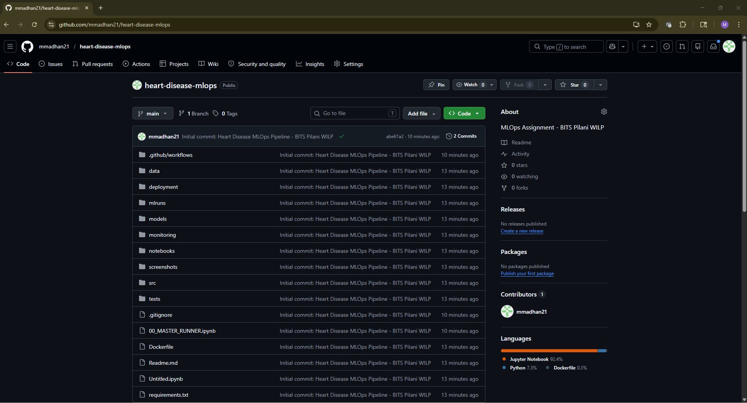
Figure 18: GitHub Repository

7. Model Containerization (Task 6)
The FastAPI application was containerized using Docker to ensure portability and environment consistency. The container exposes a REST API for real-time heart disease risk prediction.

7.1 Docker Configuration
Setting | Value
Base Image | python:3.9-slim
Image Name | heart-disease-api:v1
Exposed Port | 8000
Framework | FastAPI + Uvicorn
Workers | 1
Health Check | GET /health

7.2 API Endpoints
Method | Endpoint | Description | Response
GET | / | Root health check | 200 OK + status
GET | /health | Detailed health | 200 OK + model status
POST | /predict | Heart disease prediction | prediction + confidence
GET | /metrics | Prometheus metrics | metrics text
GET | /docs | Swagger UI | Interactive docs

7.3 Sample API Request
The following JSON payload was used to test the /predict endpoint:
{
"age": 63, "sex": 1, "cp": 3,
"trestbps": 145, "chol": 233,
"fbs": 1, "restecg": 0,
"thalach": 150, "exang": 0,
"oldpeak": 2.3, "slope": 0,
"ca": 0, "thal": 1
}

Sample API Response:
{
"prediction": 1,
"diagnosis": "Heart Disease Detected",
"confidence": 0.8732,
"risk_level": "High",
"latency_ms": 4.21
}

7.4 Docker Screenshots
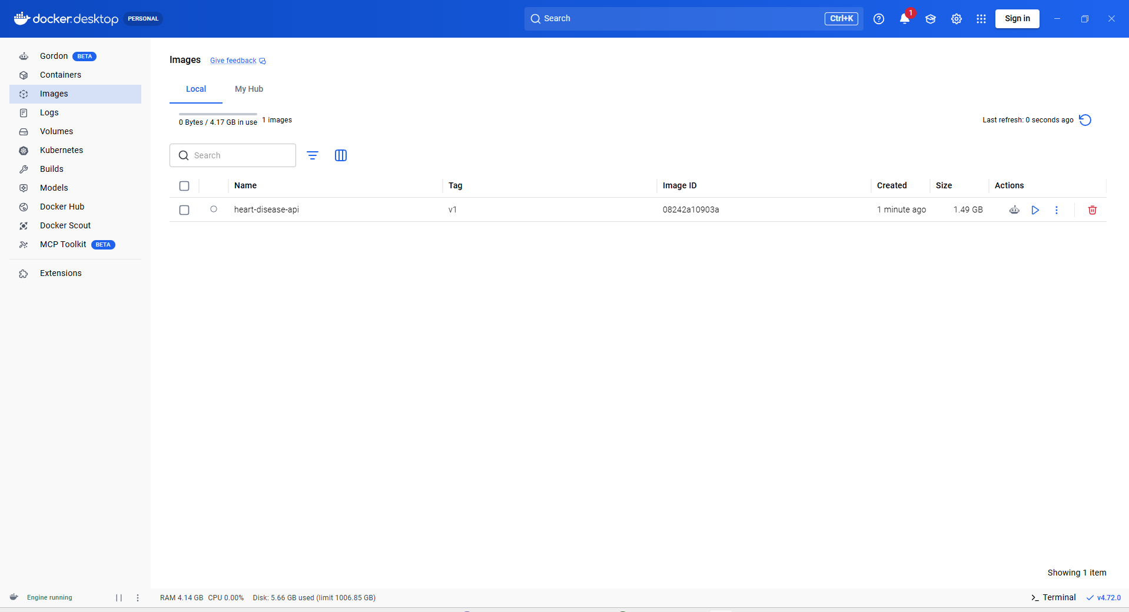
Figure 19: Docker Image in Desktop

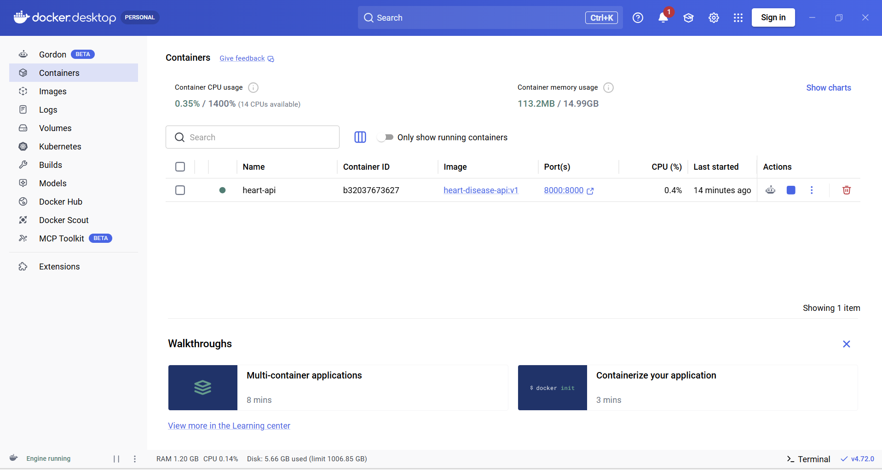
Figure 20: Container Running

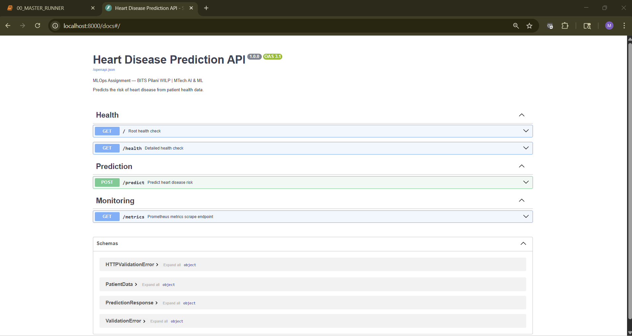
Figure 21: FastAPI Swagger UI

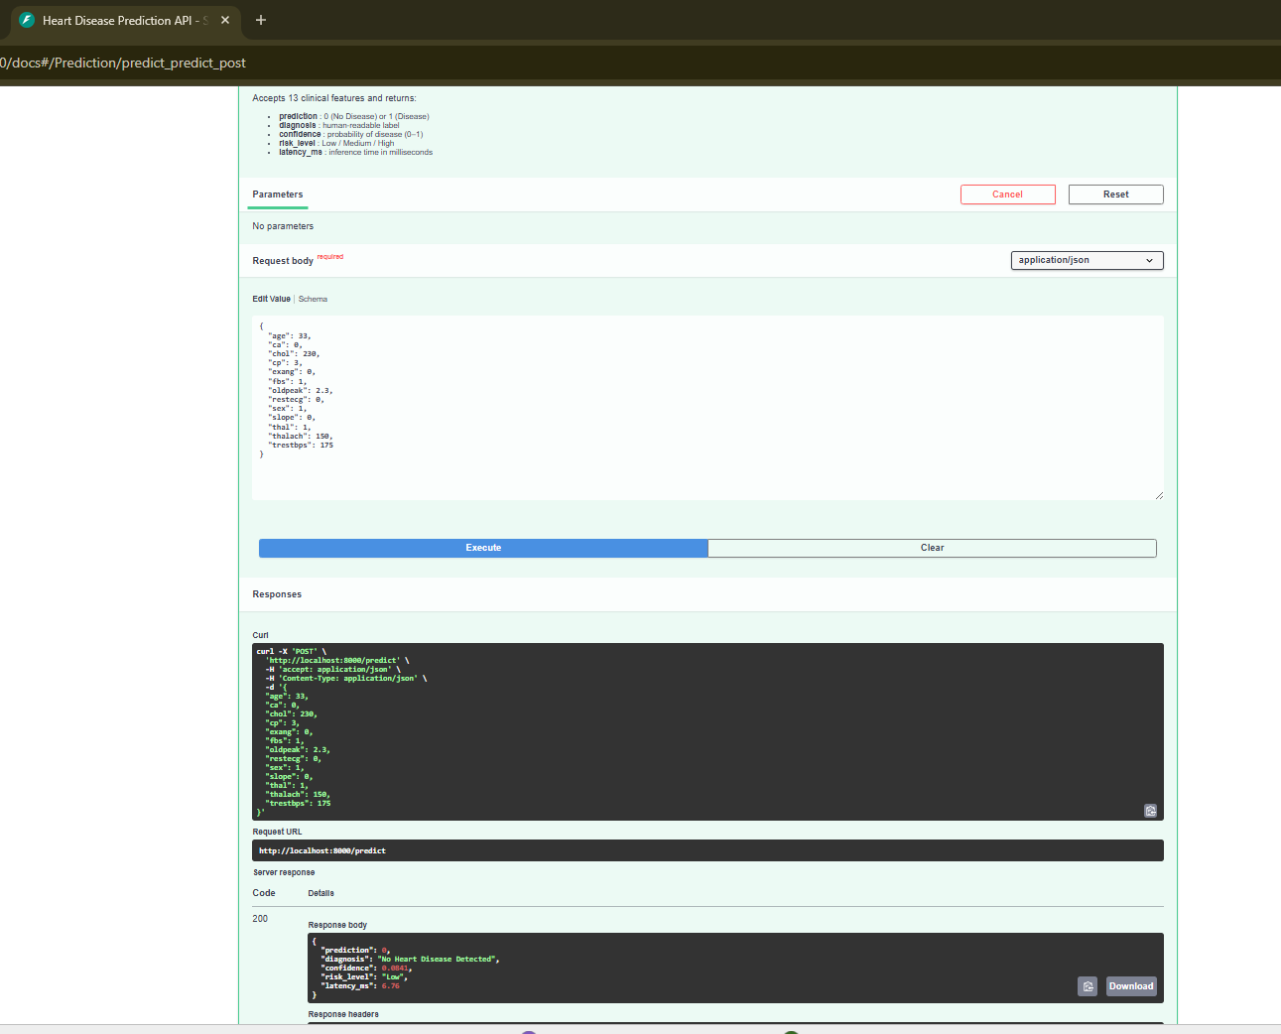
Figure 22: Predict Endpoint Test

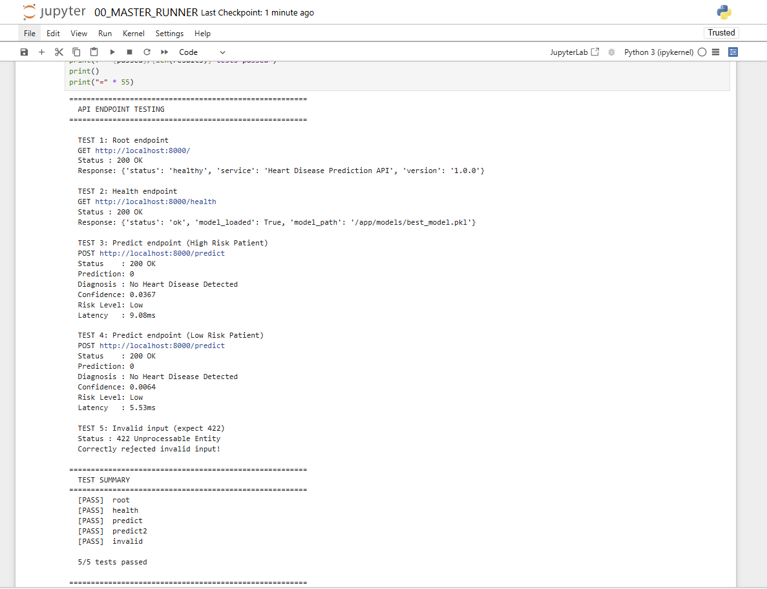
Figure 23: API Test Results

8. Production Deployment (Task 7)
The containerized API was deployed to Kubernetes using Docker Desktop's built-in Kubernetes cluster. The deployment uses a Deployment manifest with readiness and liveness probes ensuring high availability.

8.1 Kubernetes Configuration
Setting | Value
Platform | Docker Desktop Kubernetes
Deployment Name | heart-disease-api
Replicas | 1
Image | heart-disease-api:v1
Image Pull Policy | Never
Service Type | NodePort
Node Port | 30080
CPU Request | 250m
Memory Request | 256Mi
CPU Limit | 500m
Memory Limit | 512Mi

8.2 Health Probes
Probe | Path | Initial Delay | Period
Readiness | /health | 30s | 10s
Liveness | /health | 45s | 15s

8.3 Deployment Process
- Docker image built locally
- Image saved to tar file using docker save
- Image loaded into K8s containerd using ctr images import
- Deployment manifest applied with kubectl apply
- Service manifest applied for network exposure
- Pod status verified as Running
- API tested via kubectl port-forward

8.4 Kubernetes Screenshots
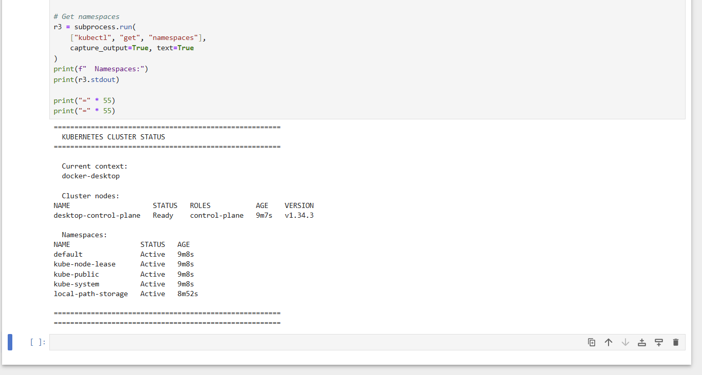
Figure 24: Kubernetes Cluster Status

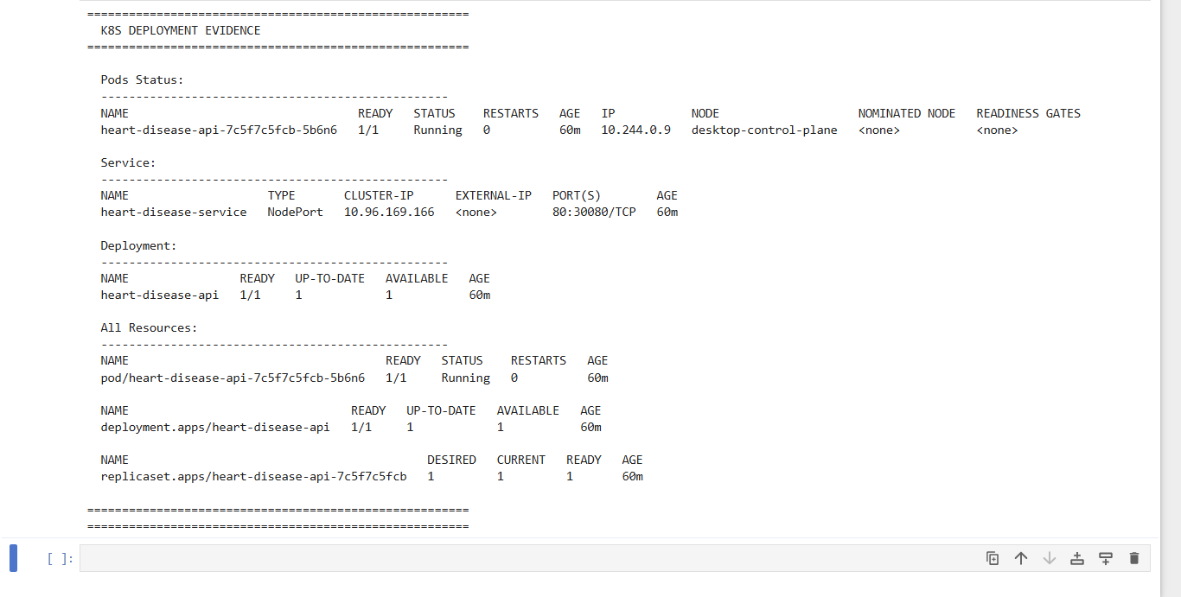
Figure 25: All K8s Resources
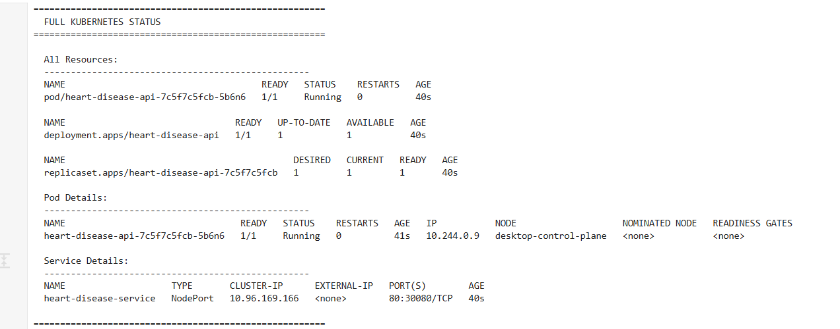
Figure 26: Pods Running Status

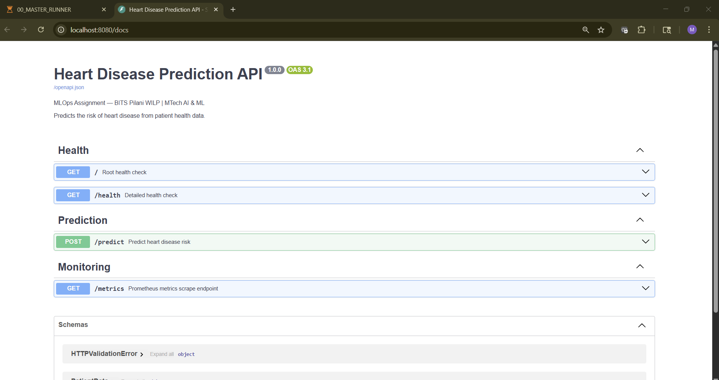
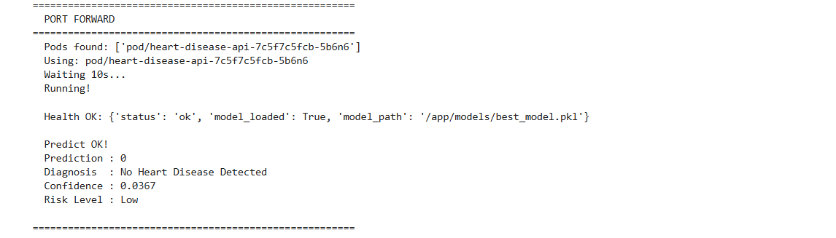
Figure 27: API via Port-Forward





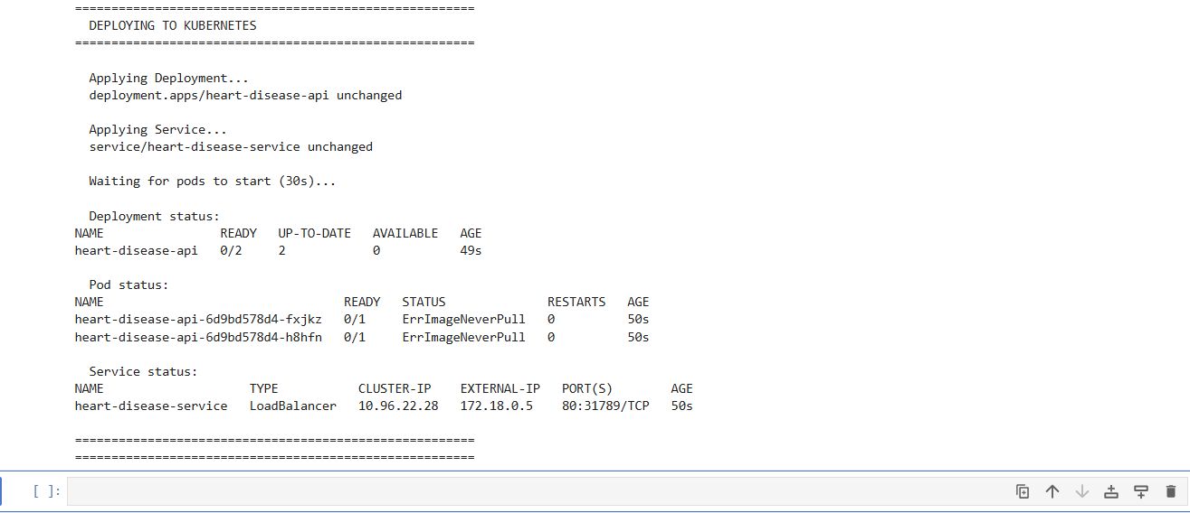
Figure 28: Docker Desktop K8s Views

9. Monitoring and Logging (Task 8)
Production monitoring was implemented using Prometheus for metrics collection and Grafana for visualization. The FastAPI application exposes a /metrics endpoint in Prometheus format that is scraped every 15 seconds.

9.1 Monitoring Stack
Component | Version | Port | Purpose
Prometheus | v2.47.0 | 9090 | Metrics collection
Grafana | 10.1.0 | 3000 | Metrics dashboard
FastAPI /metrics | Built-in | 8000 | Metrics exposure

9.2 Custom Metrics
Metric Name | Type | Description
heart_api_requests_total | Counter | Total prediction requests
heart_api_request_latency_seconds | Histogram | Request latency distribution
heart_api_predictions_total | Counter | Predictions by class label
heart_api_errors_total | Counter | Total prediction errors

9.3 Grafana Dashboard Panels
Panel | Query | Type
Total API Requests | heart_api_requests_total | Time series
Predictions by Class | heart_api_predictions_total | Time series
API Latency | rate(heart_api_request_latency_seconds_sum[5m]) | Time series
Error Count | heart_api_errors_total | Stat

9.4 Request Logging
All API requests are logged to both console and api_requests.log file. Each log entry includes timestamp, prediction result, confidence score, risk level, and latency. This provides a complete audit trail of all predictions made by the system.

9.5 Monitoring Screenshots
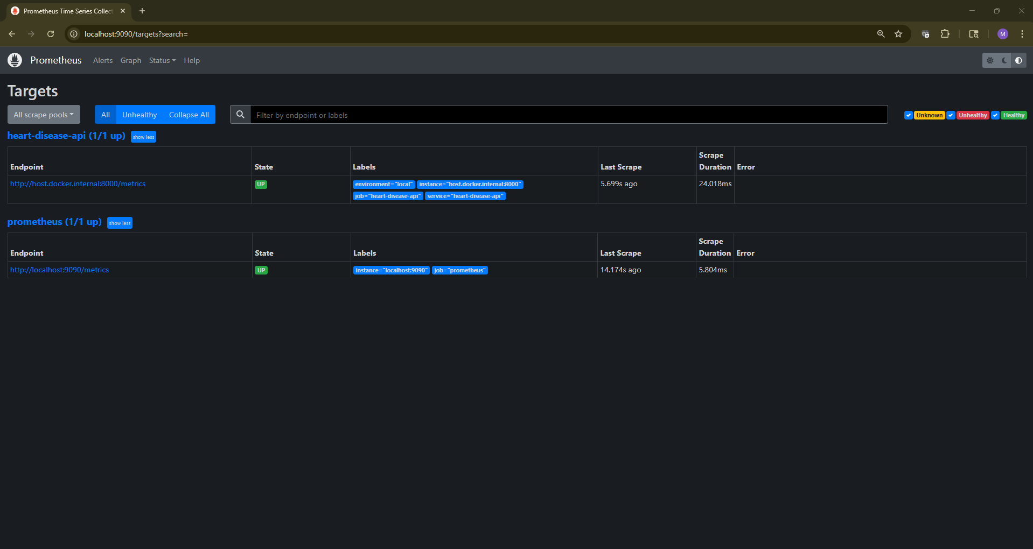
Figure 29: Prometheus Targets
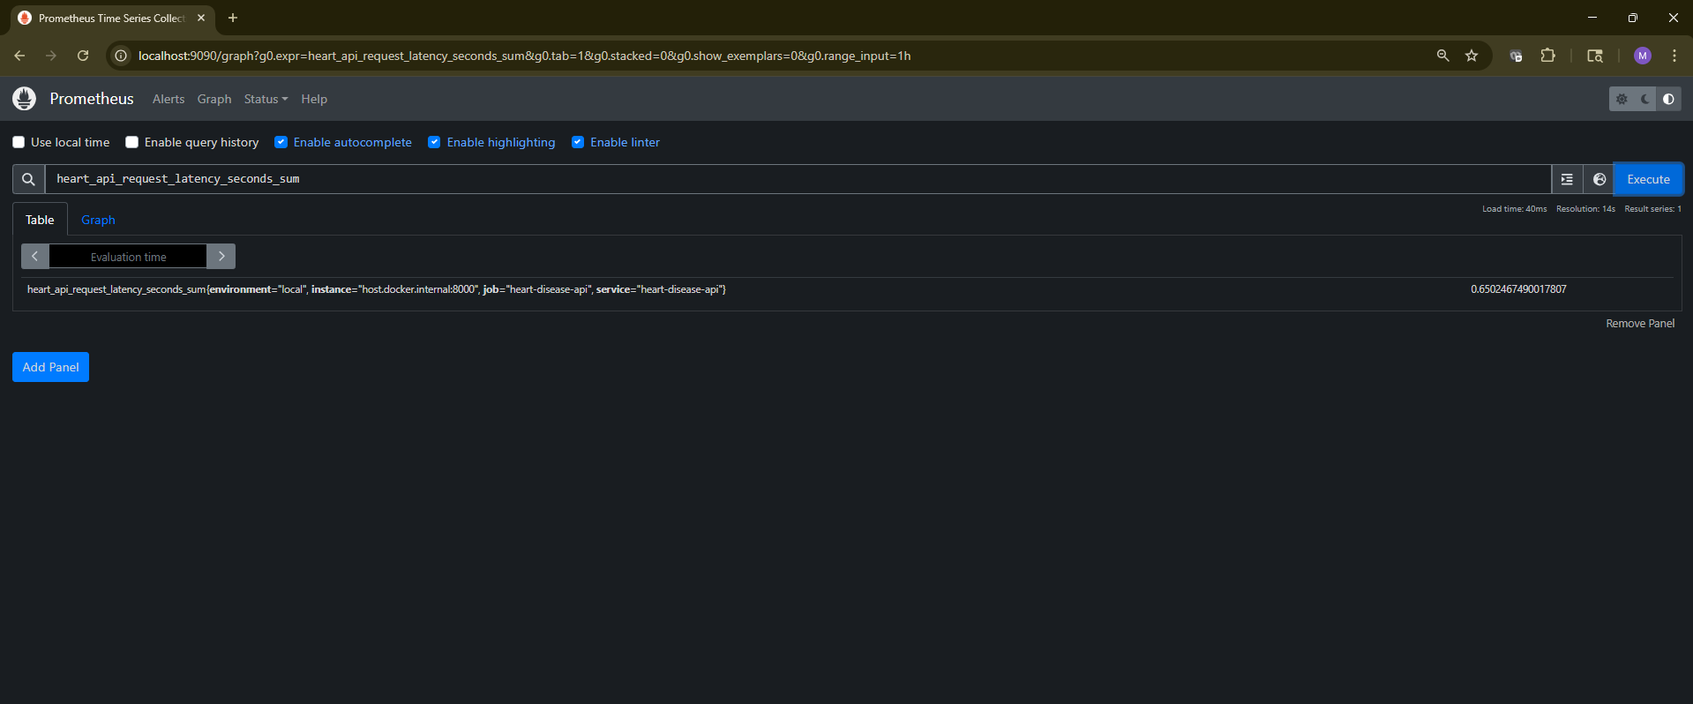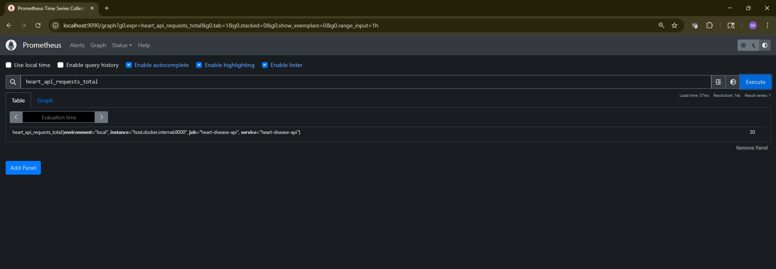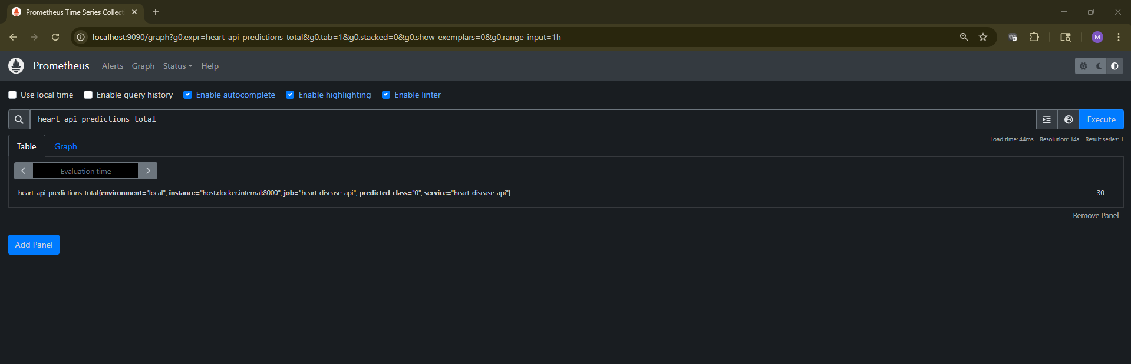
Figure 30: Prometheus Metrics Queries

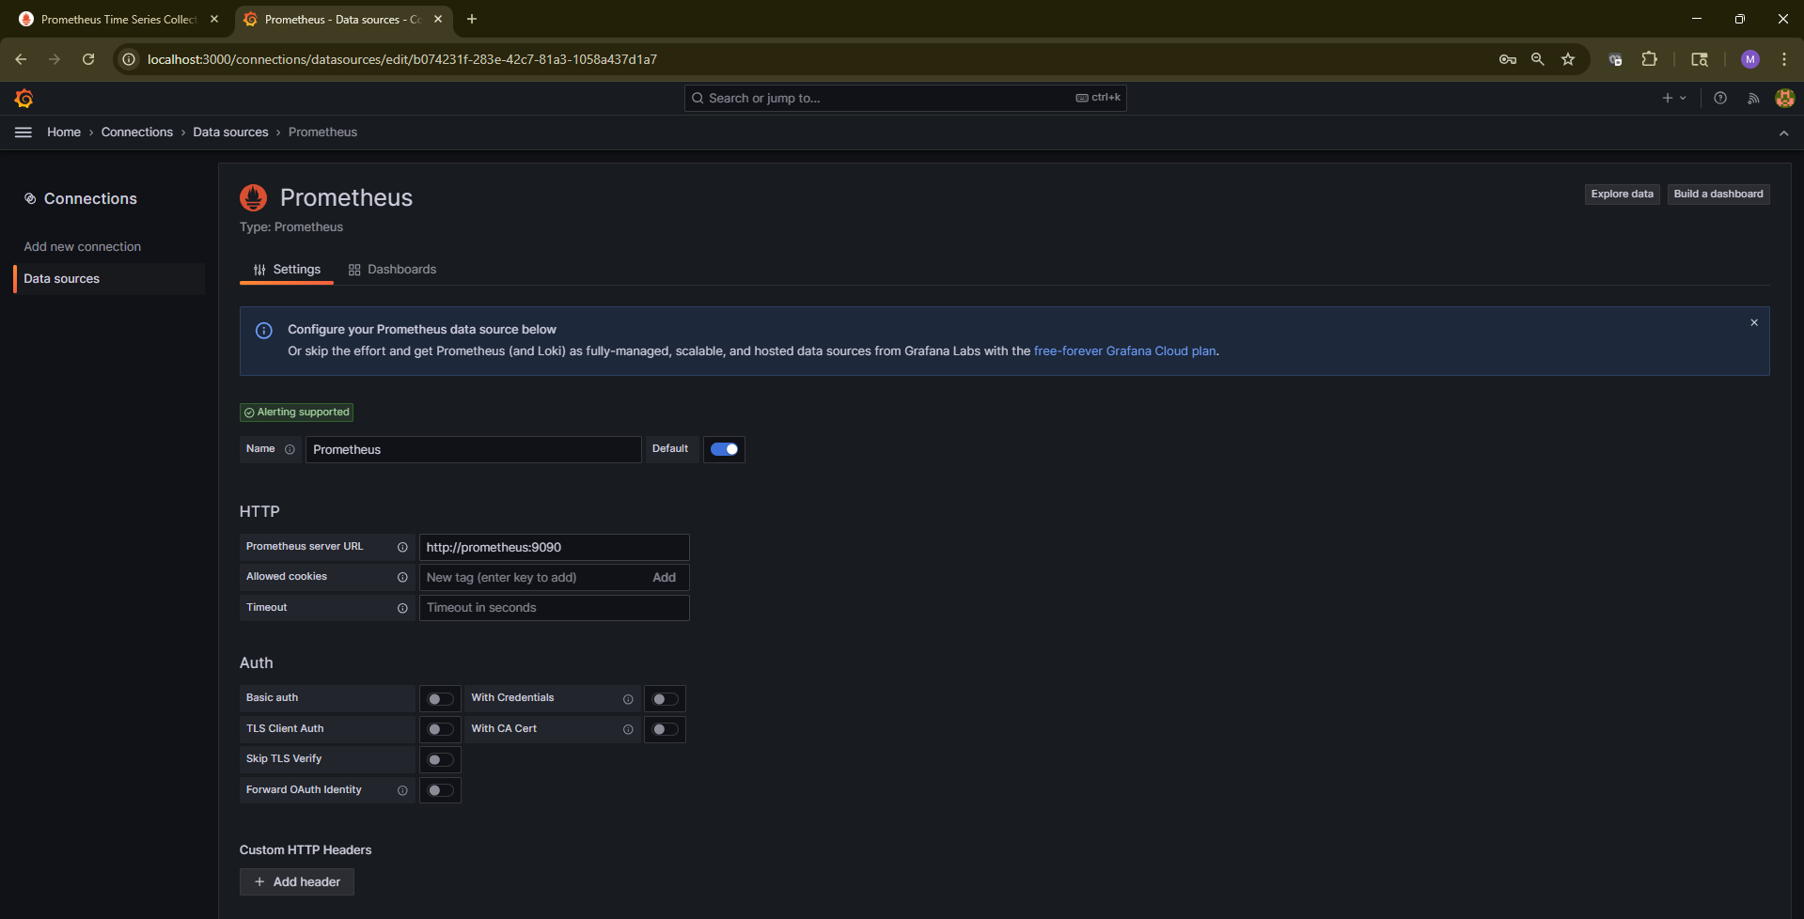
Figure 31: Grafana Datasource Setup

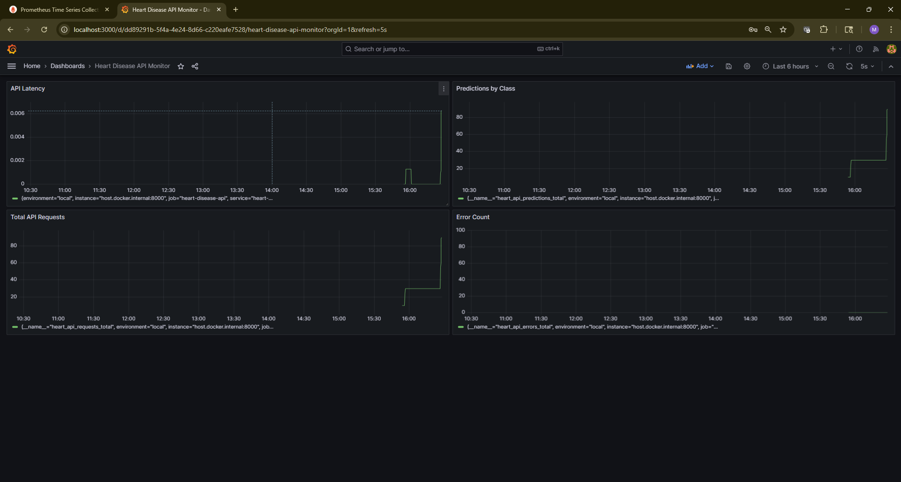
Figure 32: Grafana Dashboard

10. Architecture and Conclusion (Task 9)

10.1 System Architecture Diagram
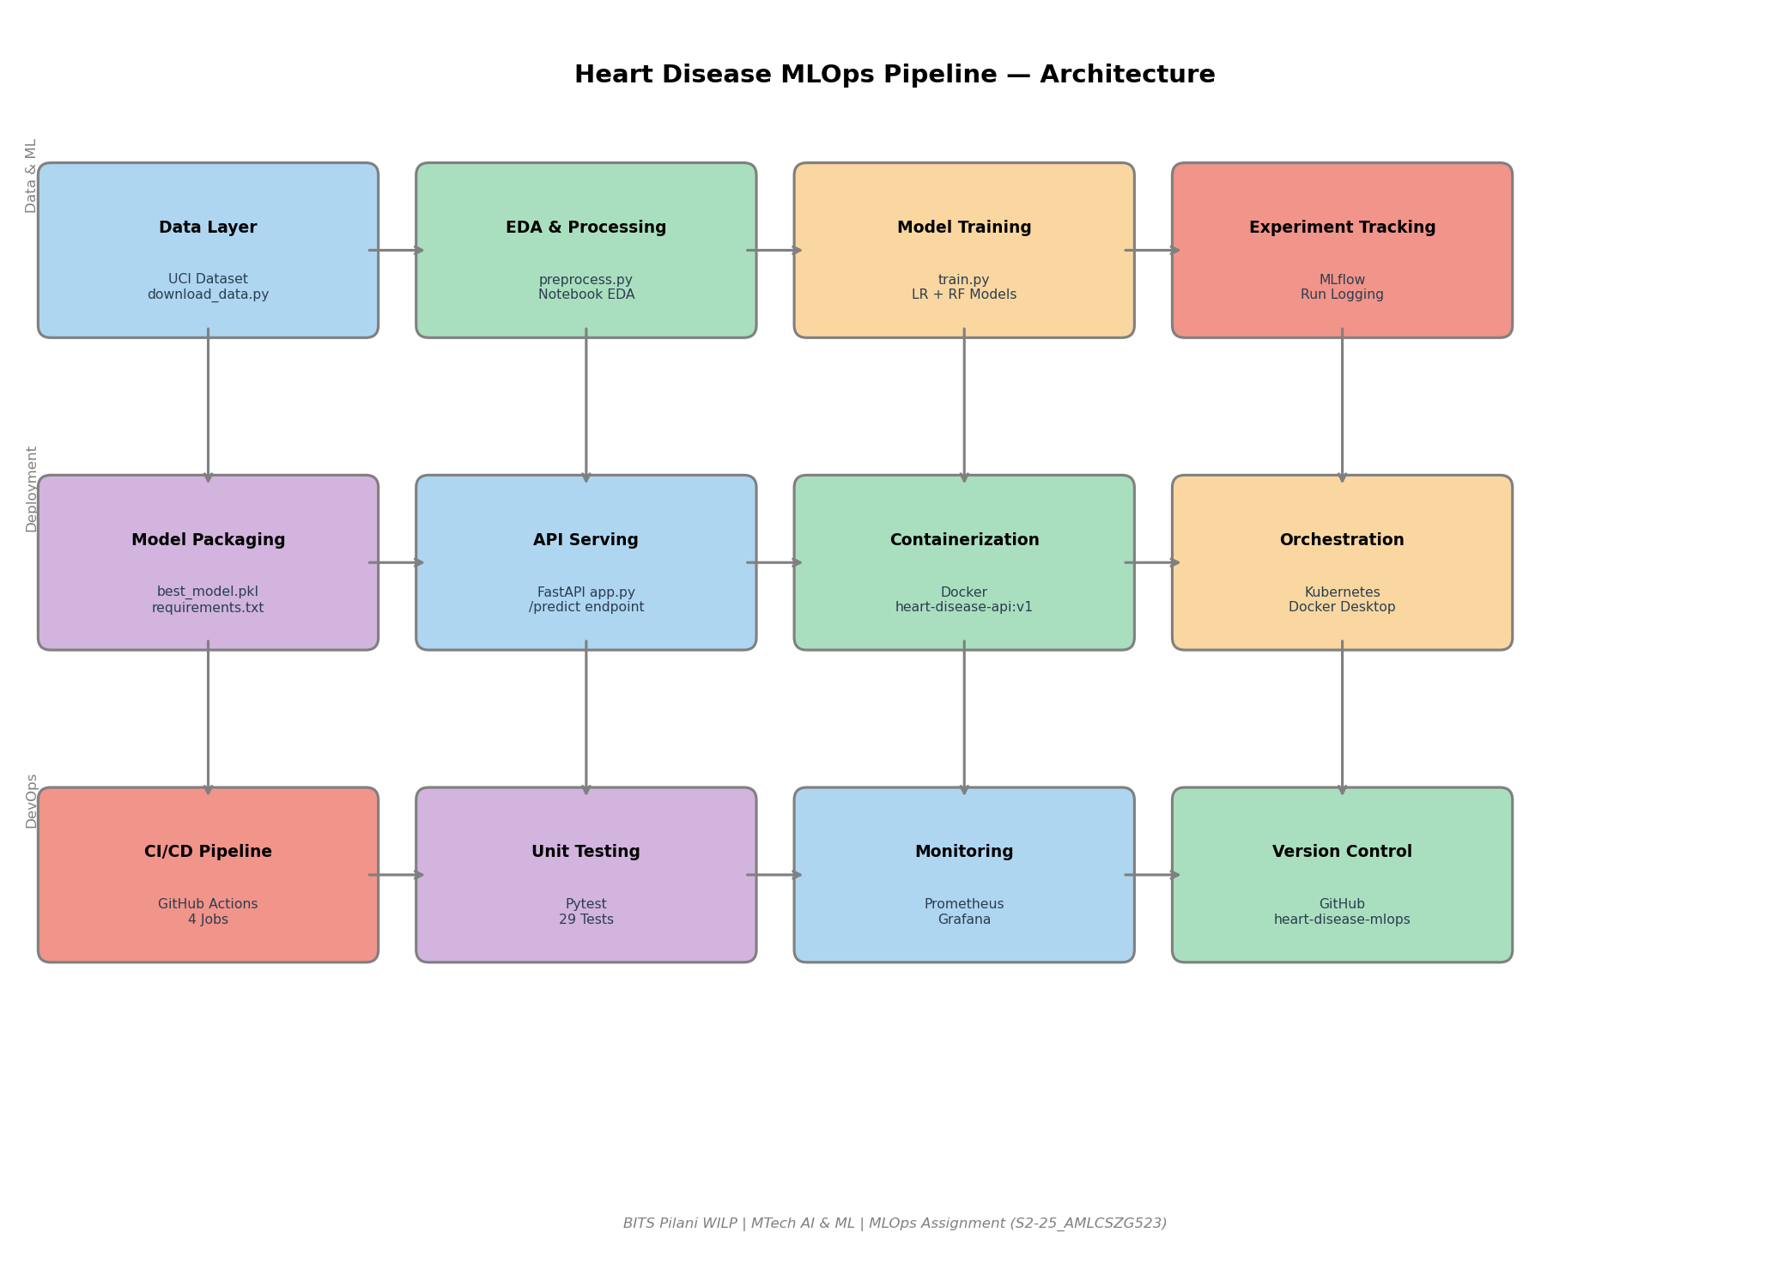
Figure 33: End-to-End MLOps Pipeline Architecture

10.2 Architecture Summary
Layer | Components | Tools Used
Data Layer | Dataset download, cleaning, EDA | Pandas, Seaborn, Matplotlib
ML Layer | Feature engineering, training, evaluation | Scikit-learn, MLflow
Serving Layer | REST API, prediction endpoint | FastAPI, Uvicorn, Pydantic
Container Layer | Image build, local registry | Docker, Dockerfile
Orchestration Layer | Pod deployment, service exposure | Kubernetes, kubectl
CI/CD Layer | Lint, test, train, build | GitHub Actions, pytest, flake8
Monitoring Layer | Metrics, dashboards, logging | Prometheus, Grafana

10.3 Conclusion
This project successfully demonstrates a complete end-to-end MLOps pipeline for heart disease prediction. The following objectives were achieved:
- A high-performing Logistic Regression model was trained achieving ROC-AUC of 0.9513 on the UCI Heart Disease dataset
- Full experiment reproducibility was ensured through MLflow tracking, pinned dependencies, and fixed random seeds
- The model is served as a production-ready REST API with input validation, confidence scores, and risk levels
- Complete containerization ensures the solution runs identically in any environment with Docker installed
- Kubernetes deployment demonstrates production orchestration with health probes and resource management
- GitHub Actions CI/CD pipeline automates the entire workflow from code commit to Docker build with 4 green jobs
- Real-time monitoring with Prometheus and Grafana provides full observability of the production API
- 35 unit tests across preprocessing and model inference ensure code quality and correctness

10.4 Repository Link
GitHub Repository:
https://github.com/mmadhan21/heart-disease-mlops

Deliverable | Status | Location
Source Code | Complete | GitHub Repository
Jupyter Notebooks | Complete | notebooks/
Unit Tests | 35 Passing | tests/
Docker Image | Built & Tested | heart-disease-api:v1
K8s Manifests | Applied | deployment/
CI/CD Workflow | 4 Jobs Green | .github/workflows/
Monitoring Stack | Running | monitoring/
This Report | Complete | report.docx

