Assignment Screenshot

* an employee's collection to insert 10 records

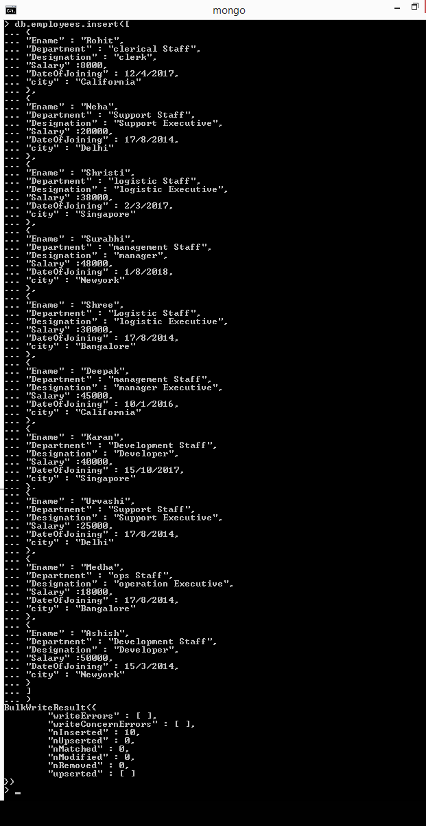

* Display designation of an Employee

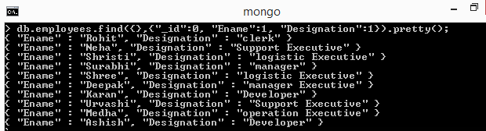

* Display the records of employee whose salary is greater than 7000

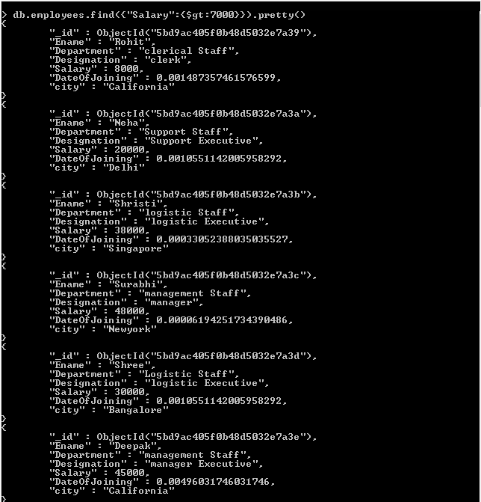

* Display the records of an employee based on the date of joining

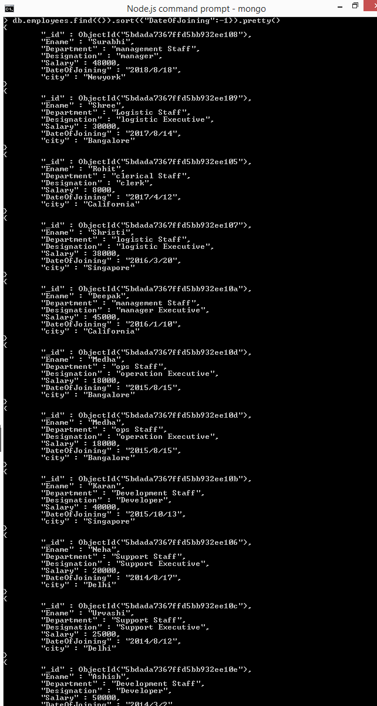

* Display the records of an employee based on the salary in ascending order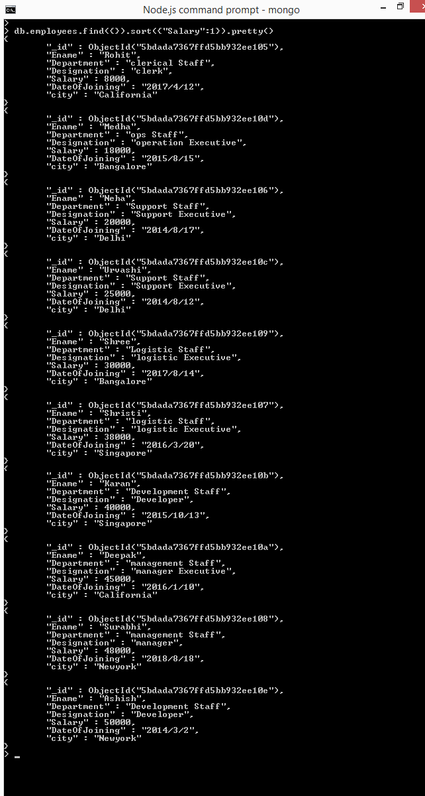
* display records of employees except whose designation is developer.

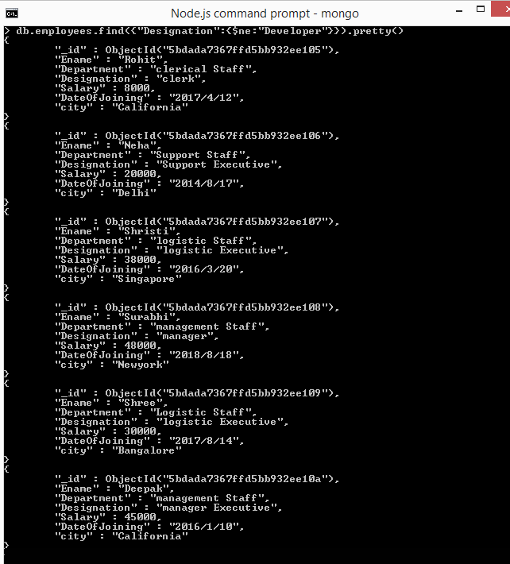

* Display the records of an employee whose salary in between 5000 to 40000

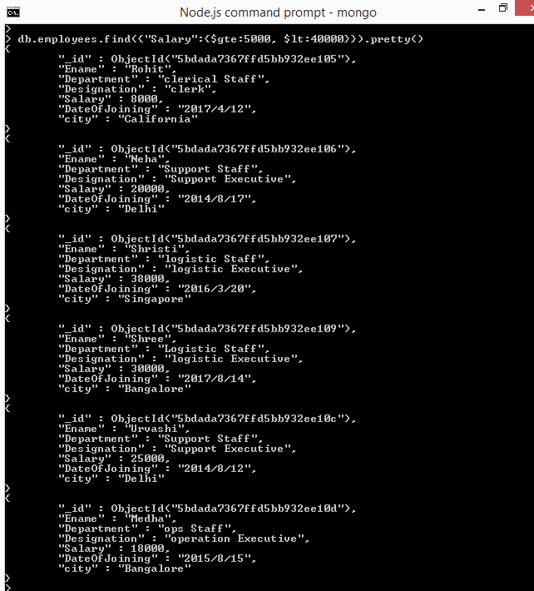

* Drop the employee records and display

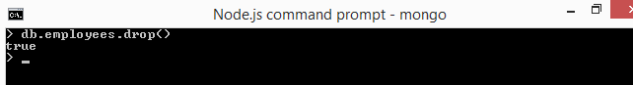

* display the records of an employee's city in descending order

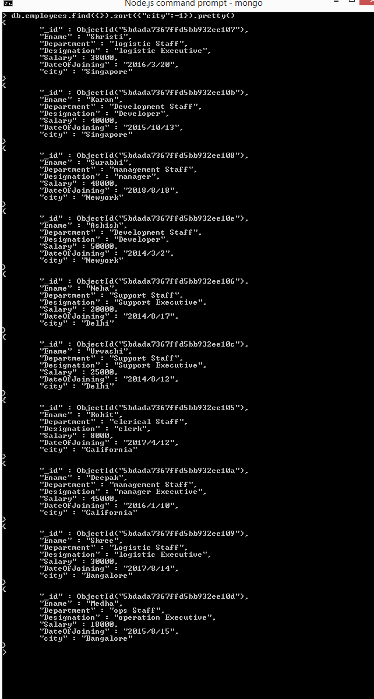

* records of an employee's whose city starts with Singapore and salary is greater than 8000

