ENZYME Activity
Title
Benchmarking Bayesian Optimization – Enzyme activity usecase
Authors
Nadjime MMADI DAROUECHE, Daniel CURULLA-FERRE
Abstract
Enzyme requires that certain group (amino acids) to be in specific protonation states for the enzyme to catalyze the reaction of purpose. If these groups are not in the correct state, then the enzyme is inactive. Assuming that the enzyme has two ionizable groups with pKa1 and pKa2, and that the group 1 for the enzyme to catalyze the reaction, then the fraction of the enzyme in the correct state is the product of probability that group 1 is deprotonated and group 2 protonated.
$f_{active}=\frac{1}{1+{10}^{\left(pK_{a1}-pH\right)}}×\frac{1}{1+{10}^{\left(pH-pK_{a2}\right)}}$
Where :
$pK_{a2}>pK_{a1}$

The enzymatic rate can be expressed then as:
$υ\left(pH\right)=\frac{υ_{max}}{1+{10}^{\left(pK_{a1}-pH\right)}+{10}^{\left(pH-pK_{a2}\right)}}$
$υ=\frac{υ_{max}\left[S\right]}{K_{m}+\left[S\right]}$
Where $υ_{max}$ refers to the maximum reaction velocity achievable by the enzyme when the substrate concentration is saturating, and the enzyme is in its optimal protonation state (fraction of active enzyme = 1). $υ_{max}$ comes directly from Michaelis-Menten kinetics as has units of $mol∙L^{-1}{∙s}^{-1}$ or $μmol∙\min^{-1}$ or U (1 µmol substrate converted per minute). $υ_{max}$ depends on assay conditions (substrate type, temperature, pH and enzyme concentration. For practical purposes, we can declare $υ_{max}$ as 100 in the present study.

Assuming the data of measurement rate is noisy, we want to find the optimal pH maximizing the velocity of the reaction and use Markov Chain Monte Carlo through the python library PyMC, to estimate the function parameters, pKa1, pKa2 and vmax
Date
15 octobre 2025

Background

Bayesian Optimization
Bayesian optimization (BO) is a powerful active learning algorithm used for finding the tuple of parameters $X$ that maximize (or minimize) an objective function $f(x)$ over some domain $X$ consisting of finite lower and upper bounds on every variable in relatively few iterations. It is particularly useful when the objective function $f$ is :
- Expensive-to-evaluate: The number of evaluations of the objective function is limited, typically to a few tens or even less.
- Black-box: The functional form of objective function is unknown, but it is presumably highly complex and non-linear.
- Derivative-free: Only $f(x)$ can be observed, but not its first or second-order derivatives.

Fig 1. Objective function (black box)
BO adopts a sequentially approach, it is initialized with a few observations of the target function f based on what it builds a surrogate model, usually a Gaussian Process, that provides a probabilistic estimate of the function being optimized. The surrogate model extrapolates our belief about what the objective function looks like thus it allows us to predict the function’s behaviour in unexplored regions. After each new observation, the surrogate model is updated, improving its accuracy over time.
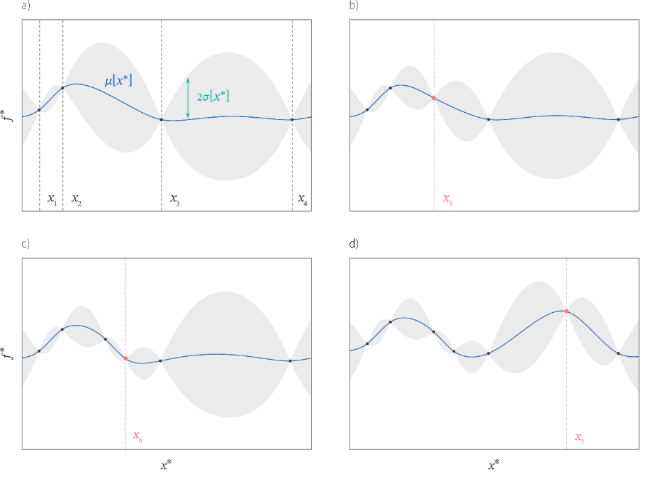
Fig 2. Consider a case where we have sampled 4 points of a function at positions x1, x2, x3 and x4. The Gaussian Process (GP) describes a probability distribution over possible functions that pass through these four points. This can be visualized as a mean function and an uncertainty around that mean at each point. As we sequentially add points, the mean of the function changes to pass smoothly through the new points and the uncertainty decreases in response to the extra information that each point brings.
Then, after the initialization, BO uses an acquisitions function to decide where to evaluate next. Depending on how they are defined, these functions can favor either areas close to the best observations of the function being optimized that we’ve seen so far (exploitation) or areas that we’ve not yet measured and so with high uncertainty (exploration). Common acquisitions functions include Expected Improvement (EI) and Upper Confidence Bound (UCB). After evaluating the objective function on the next point suggested by BO, we repeat the process with the new observation (that we add on the pool of data to initialize Bayesian optimization).
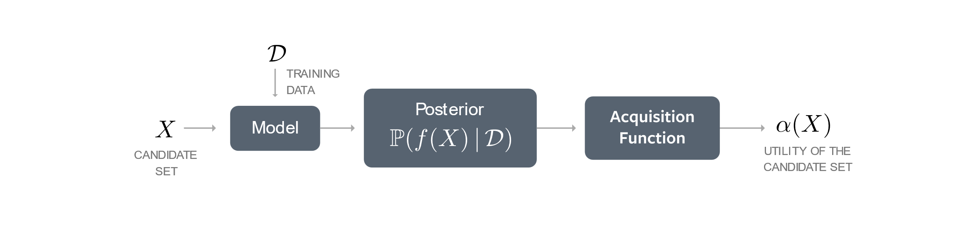
Fig.3 Bayesian optimization’s schema
By using surrogate model and acquisition functions, BO can find optimal solutions in fewer iterations compared to traditional methods which is particularly valuable when each evaluation is costly or time-consuming. In top of its efficiency, BO is highly flexible and can be applied to various types of optimization problems including continuous, discrete, and mixed-variable problems. It can handle noisy evaluations and is robust to different types of objective functions.
BO has been successfully applied in many fields. In machine learning for hyperparameter tuning which consists of finding the best settings of an algorithm to improve its performance. In engineering for optimizing design to achieve desired properties. In scientific research for helping identify optimal experimental conditions.
Bayesian Optimization with Python
Many python libraries have been developed based on Bayesian optimization but, despite being built over the same algorithm, these libraries do not necessarily share the same approach. For example, EdBo (Experimental design with Bayesian optimization) is an open source with a practical implementation of BO but mainly for chemical synthesis, its purpose is to enable chemists to integrate Bayesian optimization routines into their everyday laboratory practices. BayesOpt is an open source which offers an efficient python implementation of Bayesian global optimization with gaussian process for nonlinear optimization, experimental design and hyperparameter tuning. It is a solid, user-friendly and versatile package that is still being monitoring. It works with classical acquisition function such as Expected Improvement (EI), Probability of Improvement (PI), Upper Confidence Bound (UCB). BayesOpt can handle duplicates but there is no principles way of dealing with discrete parameters. GpyOpt is another python open-source library for Bayesian optimization developed by the Machine Learning group of the University of Sheffield. It is based on GPy, a python framework for Gaussian process modelling. With GPyOpt it is possible to automatically configure models and machine learning algorithms or design wet-lab experiments saving time and money. It can handle continuous, discrete and mixed parameters but the maintenance for the package has ended.

BoTorch
BoTorch is an open-source python library for Bayesian optimization research built on top of PyTorch and is also part of its ecosystem. BoTorch provides a modular and easily extensible interface for composing Bayesian optimization primitives including probabilistic models, acquisition functions and optimizers. It is a large and vast package that can be used to solve many problems.
BayesOpt
BayesOpt is an open source which offers an efficient python implementation of Bayesian global optimization with gaussian process for nonlinear optimization, experimental design and hyperparameter tuning. It is a solid, user-friendly and versatile package that is still being monitoring. It works with classical acquisition function such as Expected Improvement (EI), Probability of Improvement (PI), Upper Confidence Bound (UCB). BayesOpt can handle duplicates but there is no principles way of dealing with discrete parameters.
PyMC
….
Workflow
Our objective is to find the optimal pH maximizing the velocity of the enzyme reaction while adding noise to the data of measurement rate used to initialize our Bayesian optimization algorithm.
$υ\left(pH\right)=\frac{υ_{max}}{1+{10}^{\left(pK_{a1}-pH\right)}+{10}^{\left(pH-pK_{a2}\right)}}$
Given $pK_{a1}=1.6,$ $pK_{a2}=5$ and $υ_{max}=100$
Since our case is a 1-D problem with a single input (pH) and single output (velocity), we use a SingleTaskGP as our surrogate model. A single-task exact GP that supports both inferred and observed noise. As our input data is noisy, we use two different acquisition functions, qNoisyExpectedImprovement and qLogNoisyExpectedImprovement that can handle
Many common acquisition functions can be expressed as the expectation of some real-valued function of the model output(s) at the design point(s):
$α\left(X\right)=E\left[ξ∼P\left(D\right)\right]$
where $X=\left(x1,…,xq\right)$ and $P\left(D\right)$is the posterior distribution of the function f at X given the data D observed so far.
Evaluating the acquisition function thus requires evaluating an integral over the posterior distribution. In most cases, this is analytically intractable. Analytic expressions generally do not exist for batch acquisition functions that consider multiple design points jointly (i.e. q>1).
An alternative is to use Monte-Carlo (MC) sampling to approximate the integrals. An MC approximation of α at X using N MC samples is
$α(X)≈\frac{1}{N}\sum_{i=1}^{N}{}a(ξi)$
where $ξi​∼P(f(X)∣D)$
They use (quasi) Monte-Carlo sampling to estimate the expectation of some real-valued function of the model output(s) at the design point(s). acquisition functions use (quasi) Monte-Carlo sampling to estimate

We test our BO algorithm in different conditions; we initialize the surrogate model with a different number of initial values (1, 2 and 4) and for each case, we build a loop of 4 trial to find the optimal pH maximizing the velocity of the reaction.
4 initial observations
We use four starting points evenly distributed to initialize the surrogate model SingleTaskGP from BoTorch library : $X_{input}​=[0. , 2.66666667, 5.33333333, 8. ]$ (using numpy.linspace function) and their noisy observations.
Then, we build a loop of 4 trial to optimize the objective function in which we initialize the model with the initial observations, we optimize the acquisition function to get the point suggested by BO that should be evaluated next, we add this point in the pool of input data with its noisy observation and restart the loop, initializing the model this time with the new added points.
At the end, we’ve got 8 observations, 4 used to start the BO algorithm and 4 generated values. To evaluate the fitness of our surrogate model with the data, we plot the GP mean, its uncertainty along with the true objective function and the state of the acquisition function.
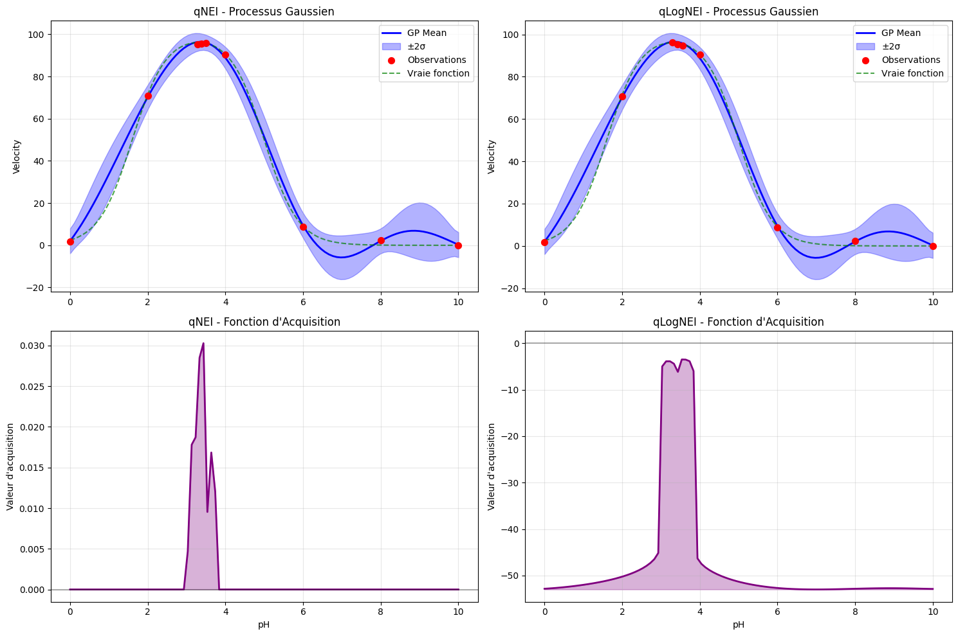 Fig.4 The mean function and the uncertainty of the Gaussian Process compared to the true objective function, with the state of the acquisition function, at left we used qNoisyEI, at right qLogNoisyEI.
With the two acquisition functions, the GP fits well to the data and is close to the true function particularly in the area where the uncertainty is small, which is expected since it corresponds to the area where the GP gets a lot of information (observations). On the other hand, the uncertainty is large where the GP does not gather that much observation, and there we can see that the GP mean does not follow the same pattern than the true objective function; between [6;10] the GP decreases then increases slightly before decreasing again while the true objective function keeps decreasing until reaching a plateau. Overall, the GP displays a good approximation of the true objective function, that can be explained by the small research space [0;10], the simplicity of the use case even with noisy observations (single input with a single output), and the number of initial points (4) which in our case is enough to provide massive information to our Gaussian Process.
vid.1 Bayesian Optimization over iteration
Indeed, as you can see in this video showing how the GP evolves while adding new observation, from the initial step, the GP mean already follows the global trend of the true objective function, even if the uncertainty is quite large. And, after the first iteration, the uncertainty decreases massively, and our GP is already like the true function.
Another point deserved to be raised is the state of the acquisition function. In both cases, even if the uncertainty is larger in some area like previously mentioned [6;10], both acquisition functions from the 3rd iteration keep suggesting points of the same area (near 3 pH), which means that our algorithm is aware of the area where the optimal value is located and that since the 3rd iteration.

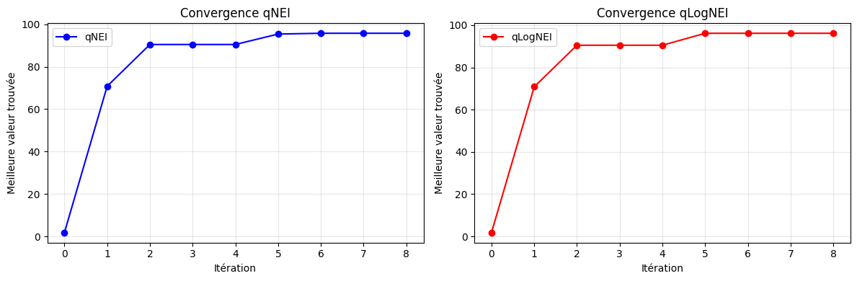fig.5 Comparison between qNoisyEI and qLogNoisyEI acquisition function
The acquisition function qLogNoisyExpectedImprovement is recommended to be used instead of qNoisyExpectedImprovement for showing better performance but here we hardly find a difference. Again, that is understandable since our case is simple to the point where we do not see too much performance difference between these acquisition functions.
4 initial observations (Randomly chosen + increasing the research space)
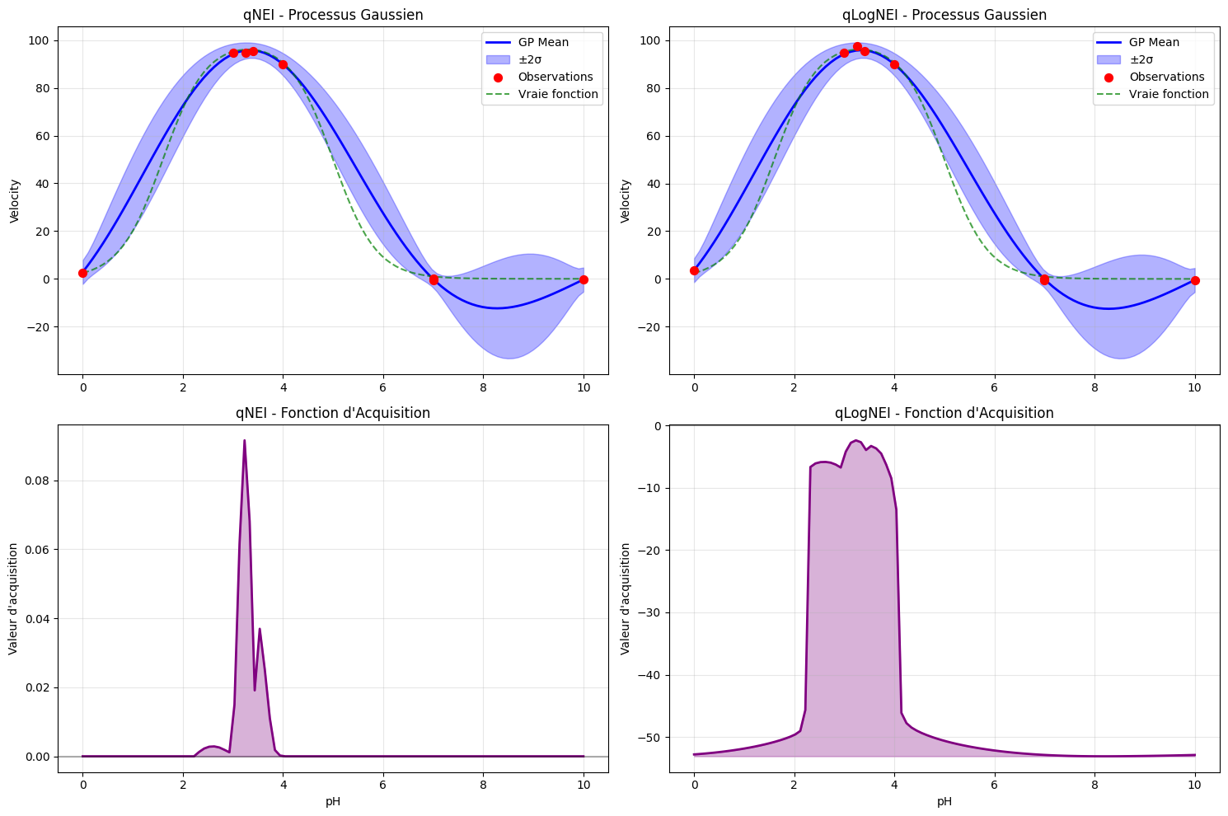
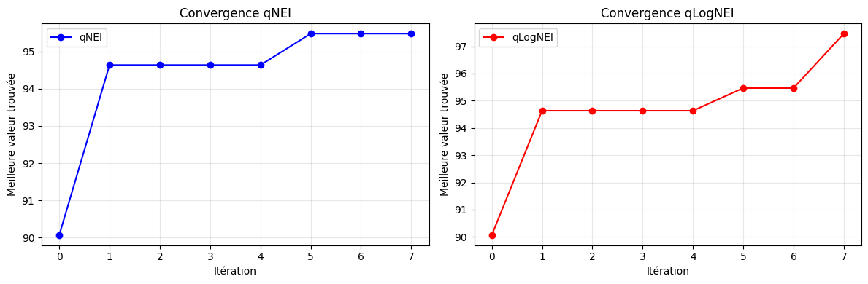


2 initial observations
This time, we use two starting points evenly distributed to initialize the surrogate model SingleTaskGP from BoTorch library : $X_{input}​=[0., 8. ]$ (using numpy.linspace function) and their noisy observations.
Following the same workflow of the previous case, we build a loop of 4 trial to optimize the objective function.
At the end, we’ve got 6 observations, 2 points used to initialize the Bayesian optimization algorithm and 4 generated values. Here, you can see the plot of the GP mean function and its uncertainty, along with the true objective function and the acquisition function.
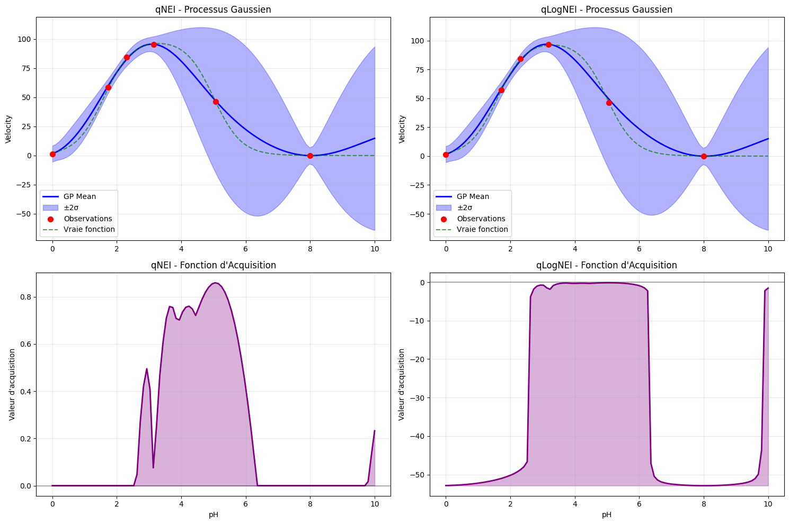 Fig.6 The mean function and the uncertainty of the Gaussian Process compared to the true objective function, with the state of the acquisition function, at left we used qNoisyEI, at right qLogNoisyEI.
Compared to the case with 4 initial observations, here the uncertainty is much larger. Despite this, the GP mean function follows quite well the true objective function. And we are able to get a result

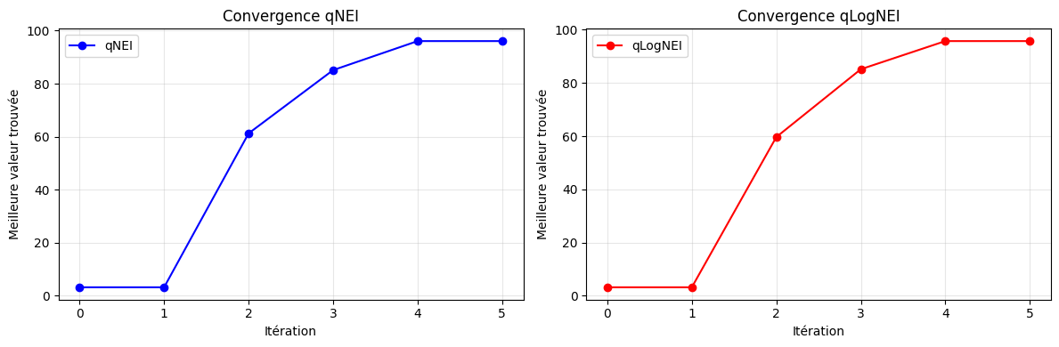



They tend to the same optimal value in the same amount of iteration,

