

**CIE203**

**Software Engineering**

StethoMan

Software Implementation Document

SIGSEGV

December & 2016

**Contents**

Instructions

Team

I. Document Purpose and Audience

II. Program Structure

III. Installation and Setup Guide

IV. User Manual

Team members roles

Ownership Report

Policy Regarding Plagiarism:

# Team

|  |  |  |  |
| --- | --- | --- | --- |
| **ID** | **Name** | **Email** | **Mobile** |
| 201301463 | Mohamed Maher | m.maher525@gmail.com | 01141763525 |
| 201304603 | Youhana Mourad | s-youhana.mikhaiel@zewailcity.edu.eg | 01281596847 |
| 201304322 | Omar Tarek Merghany | [s-omar.merghany@zewailcity.edu.eg](mailto:s-omar.merghany@zewailcity.edu.eg) | 01117496377 |
| 201305531 | Randa Selim Negm | s-randa.negm@zewailcity.edu.eg |  |

# I. Document Purpose and Audience

* **This document contains simple instructions and guide of how to operate StethoMan application and use its numerous features**
* **We target by this document the end user and customer in addition to developers and testers since it represents a documentation for the implementation process.**

# II. Program Structure

**-Project Files Distribution Tree:**

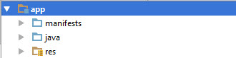

**Our android app is divided into Three main folders as shown above:  
1) Res Folder** 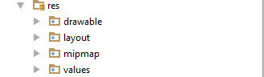Which is the main folder of interface data containing four directories:  
a)Drawable: is the folder containing our designs that we want to import into our app  
b)Layout: That contains XML files describing the structure of each interface in the application  
c)mimap: Contains images at different sizes in order to be suitable for different devices  
d)Values: which contains types of colors, fonts, etc used in the interface  
  
**2)Manifest Directory:** **-** Contains the XML file which is used to describe the basic details of the application as the application logo, theme, font…  
- It defines names of Activities (Interfaces) included in the application and their details  
  
3) **Java Directory:**

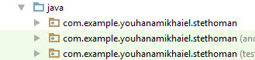It is composed of three main folders:  
a) First Folder (Stethoman Package Java Files)  
- it contains all java files for each activity (interface) so for each interface we will have an XML file + Java file describing it  
- All Java Classes and Interfaces needed for the Application  
b)Second and Third Folder:  
They contain android emulator testing files  
  
4)PHP Files to connect with Database using MySQL  
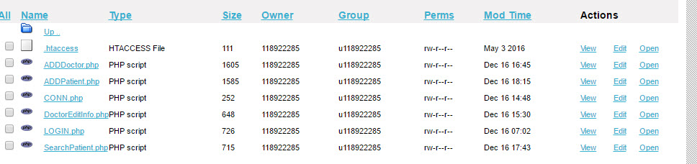

Repository on Server host for PHP files that can connect to Database and enable Android Java application to retrieve, insert and modify data in the database using MySQL commands

**List of Files:  
1)Java Activities (Interface) Files:**

* adddoctor
* addmanager
* addmedication
* addpatient
* addtopatient
* deletetimeslot
* deleteuser
* doctoreditinfo
* doctorpage
* doctorprofile
* editdoctorstimeslot
* editpatient
* edittimeslots
* forgotpassword
* Login
* Managerpage
* msgtomanager
* patientpage
* requestvisit
* reviewdoctor
* searchforpatient
* sendmsg
* sendmsgdoctor
* viewmyhistory

**2) Java System Manager Files:**

* AsyncResponse
* BackgroundWorker

**3)PHP Files:**

* CONN.php
* LOGIN.php
* ADDPatient.php
* ADDDoctor.php
* ADDManager.php
* DoctorEditInfo.php
* SearchPatient.php

**Navigation tree:**

1. The login interface has a clickable button “Sign in” and a clickable text “Forgot Password?”. “Sign in” leads to one of the three main pages of the three types of users and “Forgot Password” leads to the forgot password activity.
2. The manager’s main page has six buttons each of them lead to a different activity. Send message button leads to send message activity, view notifications button leads to notifications page and so on as was introduced earlier in the images above.
3. The same happens with the doctor’s and the patient’s main pages. The three types of users share both view notifications send message activities.

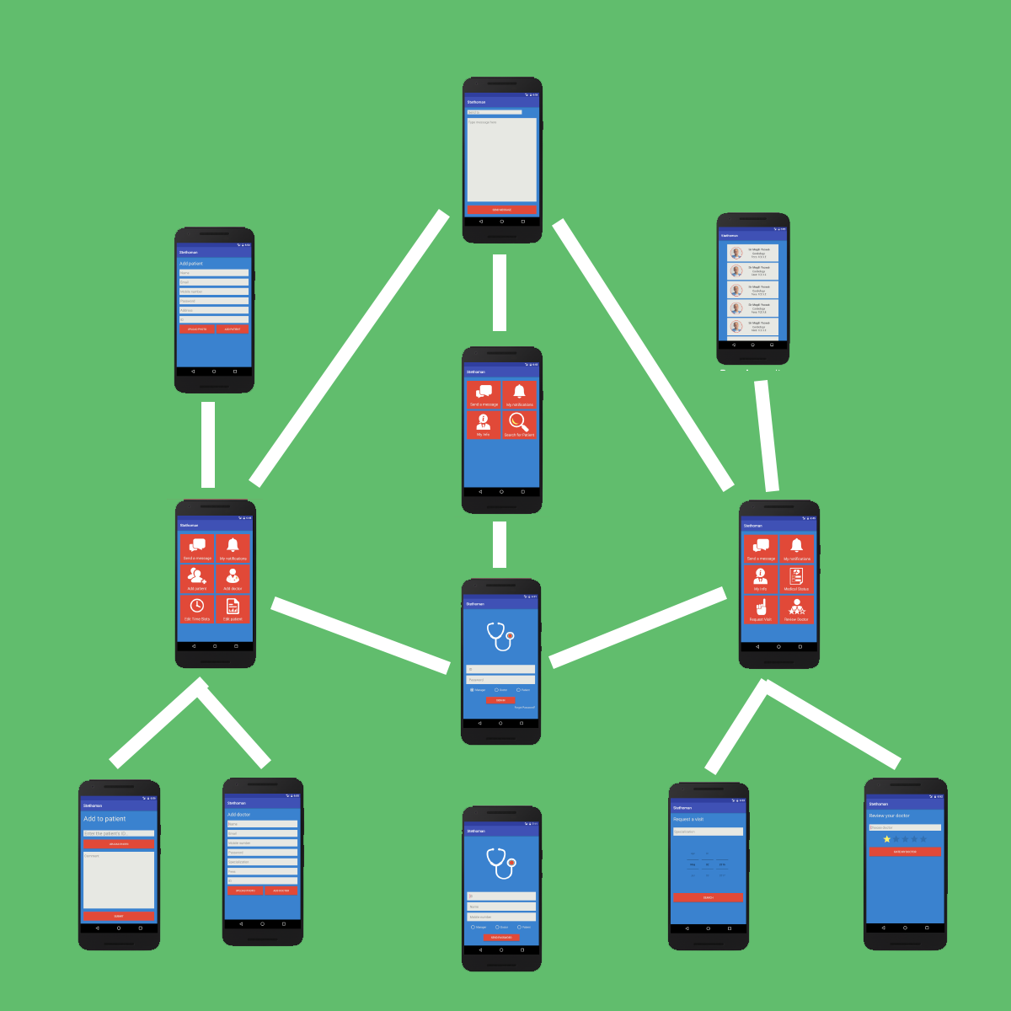

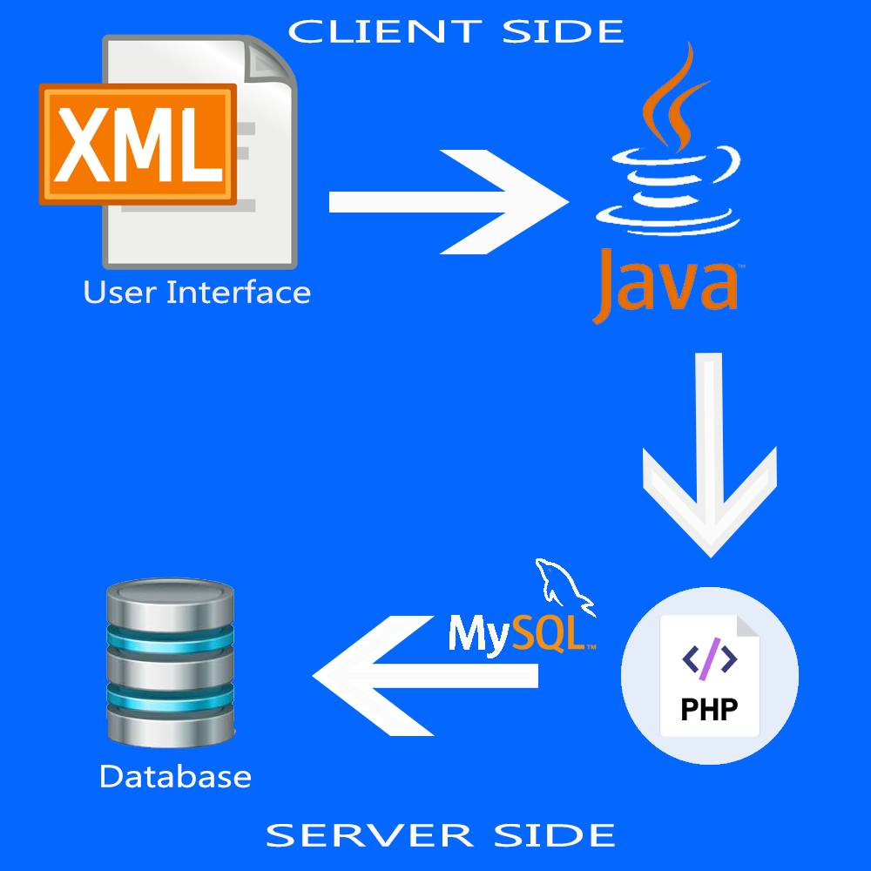

As it is shown from the above diagram, the client side manipulates the data on the database which is installed on the server side through different steps :  
1) XML Files are used to describe layout of User Interface  
2) Java Files used to take orders from user and communicate with PHP files on Server Side  
3) Php files manipulate the database by using MySQL Commands.

# 

# III. Installation and Setup Guide

* **Application can be used by:  
  1) Building and Running Application through an android emulator using Android Studio  
  2) Building Application as .apk (Android app) that can be installed on any (Mobile Phone OR Windows Emulator OR Linux Emulator) with android version of API level greater than 15 → More than 97% of Android users**
* **In order to initialize the application we need:  
  1)Server Hosting for installing the database**
* **2)Connect Application with Server data (SQL server - DB Username - DB Password) using PHP**
* **3)Uploading Database metadata (Structure of DB) can be found on GitHub or on Google Drive:** [**https://drive.google.com/file/d/0B_2HmgII6g3YU2hhZi1SR2d2MVk/view?usp=sharing**](https://drive.google.com/file/d/0B_2HmgII6g3YU2hhZi1SR2d2MVk/view?usp=sharing)
* **4)Adding a manager user manually for the application**
* **Then the Application will be ready to be used.  
  ***In our demo, we are using “Hostinger” Free hosting Service that offers 200MB free space with ability of installing 2 databases.**

# 

# 

# 

# 

# 

# 

# IV. User Manual ( Interface + Implementation are Done(100%) | Interface is Done + Implementation in progress(50%) | Interface in progress + Implementation in progress(0%))

**0)Member Login (Manager - Doctor - Patient): (Percent Finished: 100%)  
-** User enters his ID number, Password and type(Manager\Patient\Doctor)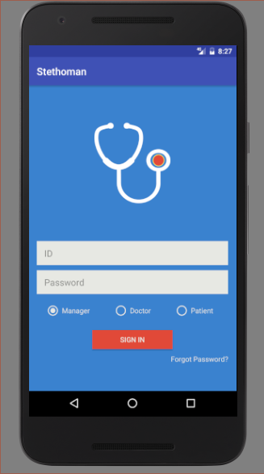

**1)Manager (System Admin): (Percent Finished: 72%)**

* A manager can do all of the following functionalities:  
  1)Add new Doctor  
  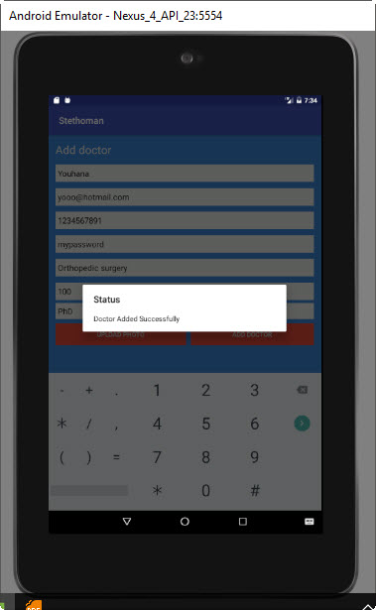  
  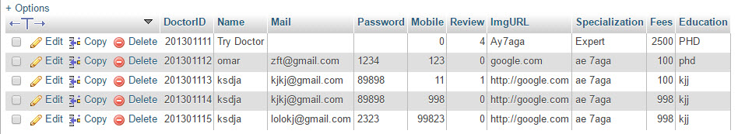
* 2)Add new Patient  
  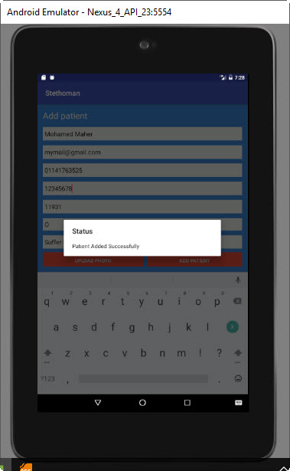  
  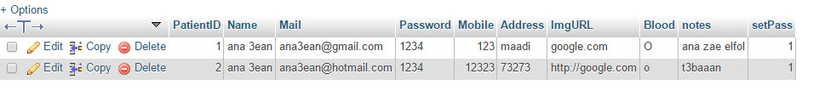
* 3)Add new manager  
  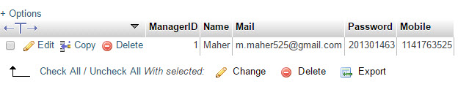  
  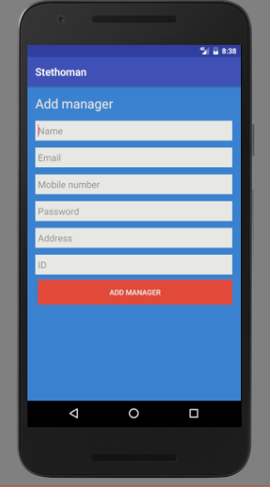

4)Add Doctor Time Slot

* 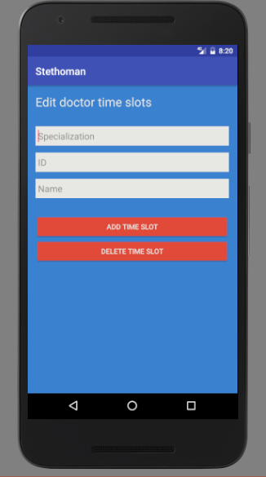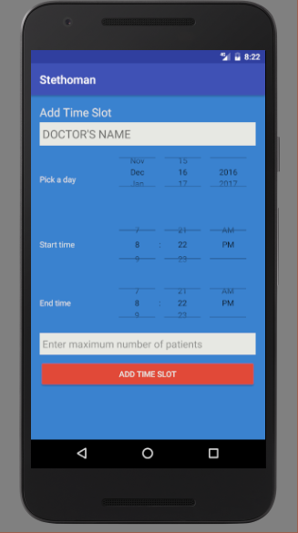

5)Set number of patients allowed to register at each time slot



6)Confirm Patient Request to visit a doctor at available time slots

7)Cancel an available time slot

* 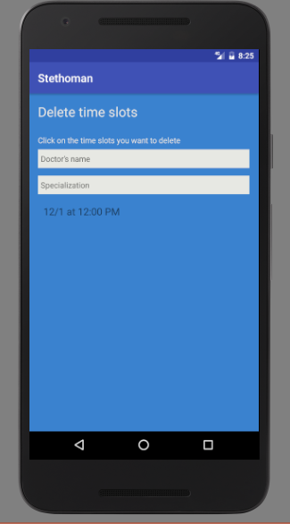

8)Add a medical Record to a patient

* 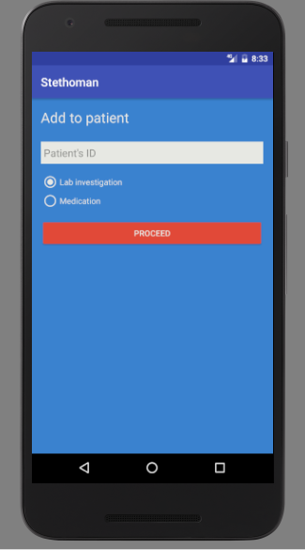

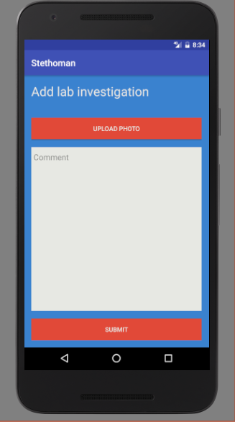

9)Delete a patient

* 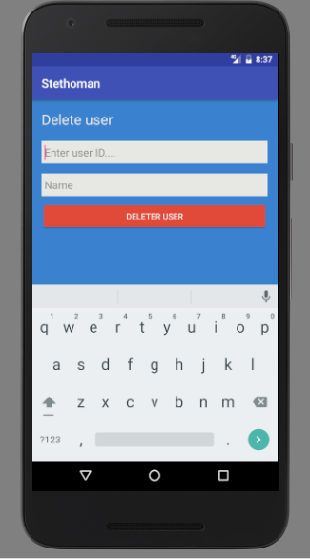

10)Delete a doctor

* 

**2)Doctor : (Percent Finished: 50%)**

* A doctor can do all of the following functionalities:  
  1)Edit his Profile Info

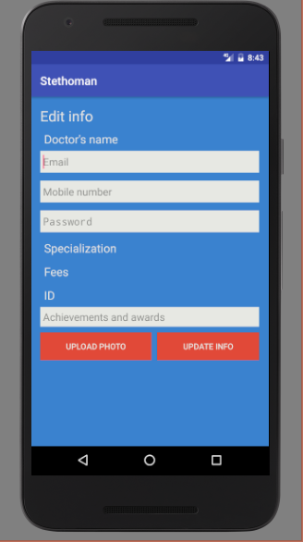

2)Add & View medical records of patient

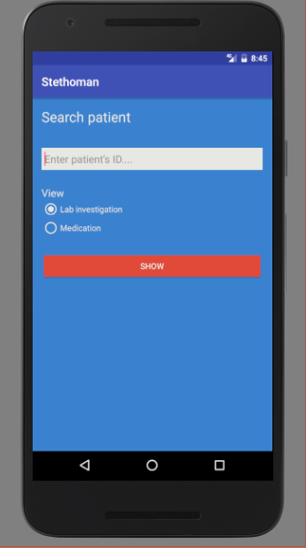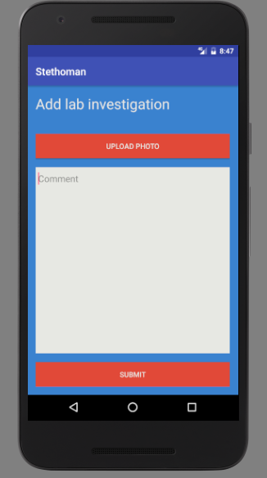

3)Add Medication to a patient

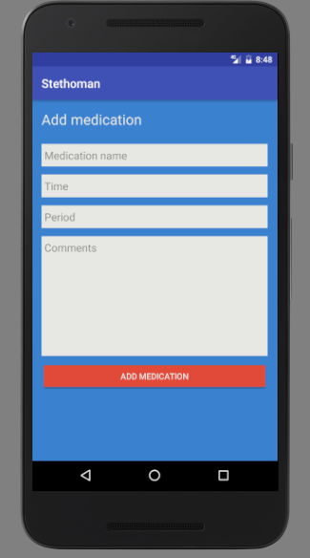

**3)Patient : (Percent Finished: 50%)**

* A patient can do all of the following functionalities:  
  1)Edit his Profile Info

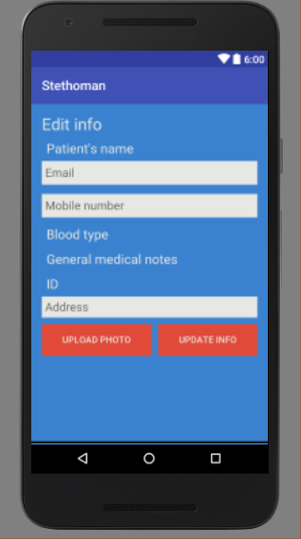

2) View his medical records

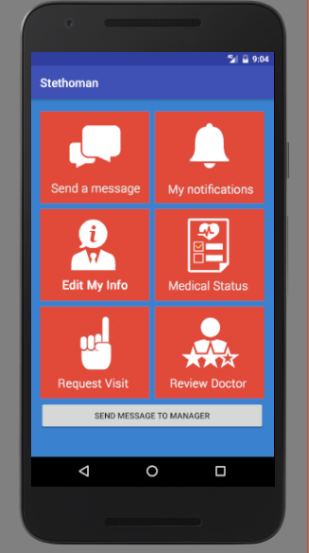

3)Review a doctor

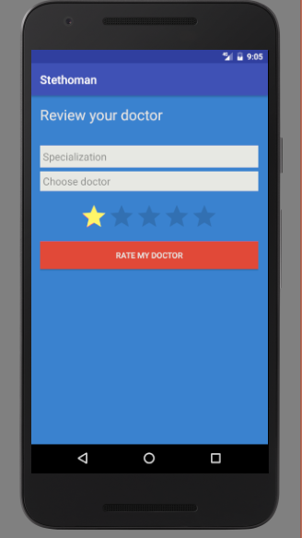

4)Request an appointment at available time slot

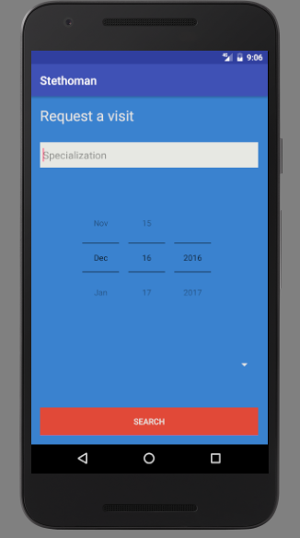

**Troubleshooting and Error messages:**

|  |  |  |
| --- | --- | --- |
| **Action** | **System Response** | **Recovery** |
| Username and password don’t match | Error Message | Renter valid username and password |
| Enter wrong data type in a field (example: enter string value in the mobile phone field) | System will not allow the user to type string, and will type integer values instead. Also the system provide hint in each field showing the expected data that will be entered | Enter proper data type in each field |
| Creating new user but missing some fields (for example: creating new patient but forgetting to enter the Email field) | Error message telling the the user that there are some missing fields | The user should enter the all required fields |
| Creating new user with already existed data | Error message telling the user that the data is already exist | Enter new data |
| User Enter wrong email | Error Message | Enter new data |
| Patient try to choose time slot that is already scheduled for other user | System will display only the available time that is not scheduled yet | Handled from the system also the manager can override and reschedule a time slot. |
| User enters big image | System will compress the image to the desired size |  |

# Team Members Roles

* **In this part you should mention the role of each member in your team in this phase**

|  |  |
| --- | --- |
| **Team member** | **Role** |
| 1-Youhana Mourad | *User Interface* |
| 2-Mohamed Maher | *Manager Functionalities* |
| 3- Omar El-Merghany | *Doctor Functionalities* |
| 4- Randa Negm | *Patient Functionalities* |

# Policy Regarding Plagiarism:

**Students have collective ownership and responsibility of their project. Any violation of academic honesty will have severe consequences and punishment for ALL team members.**

1. تشجع الكلية على مناقشة الأفكار و تبادل المعلومات و مناقشات الطلاب حيث يعتبر هذا جوهريا لعملية تعليمية سليمة
2. ساعد زملاءك على قدر ما تستطيع و حل لهم مشاكلهم فى الكود و لكن تبادل الحلول غير مقبول و يعتبر غشا.
3. أى حل يتشابه مع أى حل آخر بدرجة تقطع بأنهما منقولان من نفس المصدر سيعتبر أن صاحبيهما قد قاما بالغش.
4. قد توجد على النت برامج مشابهة لما نكتبه هنا أى نسخ من على النت يعتبر غشا يحاسب عليه صاحبه.
5. إذا لم تكن متأكدا أن فعلا ما يعد غشا فلتسأل المعيد أو أستاذ المادة.
6. فى حالة ثبوت الغش سيأخذ الطالب سالب درجة المسألة ، و فى حالة تكرار الغش سيرسب الطالب فى المقرر.