Rankwise
Engineering overview: what was built, how it fits together, and how it works

Product: SEO, AEO and GEO website audits with ranked fixes, monitoring and credit-based plans
Live: https://rankwise-xi.vercel.app (website) · https://ira-analytics.onrender.com (API)
Repository: github.com/mmahesh09/Ira-Analytics (branch main)
Business: Rankwise, Hyderabad, Telangana, India · rudraai737@gmail.com
Document date: 20 October 2026

Contents
Contents
1. Summary
1.1 What was delivered
2. Work log
3. Technology stack
4. Folder structure
5. Architecture
6. Workflows
6.1 Free preview (no account)
6.2 Sign-up and sign-in
6.3 Full audit (paid with credits)
6.4 Light checks, scheduling and monitoring
6.5 'Mark fixed' verification
6.6 Deploy hook
6.7 Subscription payment
6.8 Credit packs
6.9 Account deletion
7. Plans and credits
8. Data model
9. Security
10. API reference
11. Deployment and operations
12. Testing
13. Status and next steps
13.1 Before taking real money
13.2 Reliability
13.3 Product and growth
Appendix: diagrams

If the list is empty, right-click it in Word and choose Update Field.

1. Summary
Rankwise audits a website for classic search (SEO), answer engines (AEO) and AI assistants (GEO), measures speed and accessibility, ranks every issue by what it is worth, gives ready-to-paste fixes, and keeps watching the site afterwards. Users sign up, add websites, run audits with monthly credits, and pay for larger plans through Razorpay.
This document records the work done on the codebase and describes the system as it stands: folders, technology, architecture, every major workflow, the data model, security, deployment, testing and what is left to do.

1.1 What was delivered
- Credit-based plans. Free, Pro, Business and Scale with monthly full-audit credits, website limits and daily light-check allowances, defined once on the server.
- Credit ledger. Reserves, captures and refunds credits atomically, never charges the same request twice, and stays correct under concurrent requests.
- Metered audits. Manual, deep, deploy-triggered and scheduled audits all use credits; monitoring uses free light checks; the anonymous preview is limited per visitor.
- Razorpay payments. Subscriptions with upgrades and downgrades, one-time credit packs, payment history and a hardened webhook.
- Website and app UI. Four-plan pricing page, billing dashboard (credits, usage, payments, plan changes, account deletion), credit-aware audit buttons.
- Security. Private-network guards for the fetcher and the headless browser, DNS-rebinding protection, security headers, database-backed sign-in rate limits.
- Legal pages. Privacy, cookies, terms, refund policy and contact, written from what the code actually does.
- Deployment. Website on Vercel, API on Render, database on Neon, with the configuration fixes that connect them.

2. Work log
Every change below is a commit on the main branch, in order.
Commit | Change
6580a8b | README: resolved a leftover merge conflict and refreshed the 'not built yet' list.
3af4f3a | Visual Doctor screenshots can be stored in Neon Object Storage instead of the container disk.
108334d | Broke an import cycle between the app shell, monitoring and site pages.
68fadb6 | Render service placed in Ohio, next to the Neon database (us-east-2).
046b68e | Credit-based plans: plan table, credit ledger, metered audits, migration 0002, tests.
74b14a9 | Pricing and billing UI for four plans; light-check and full-audit buttons; honest feature copy.
714d4f9 | Root requirements.txt and .python-version so Render's Python service builds.
08459f4 | Root main.py so Render's 'uvicorn main:app' runs migrations and starts the API.
4647cfe, fa88bea | CORS: the production frontend origin is always allowed.
07b707a | Razorpay: plan changes, credit packs, payment history, hardened webhook, payment tests.
d340c7f | Security: network guard for the headless browser; security headers on every page.
6f03a0a | Legal pages: privacy, cookies, terms, refund policy, contact.
0ad5b16 | Sign-in rate limits stored in Postgres; stricter on sign-in and sign-up.
91346b9 | Self-serve account deletion with a cascade test.

3. Technology stack
Layer | Technology | Notes
Frontend | Next.js 16 (App Router), React 19, TypeScript | Turbopack, Cache Components, partial prerendering
Styling | Tailwind CSS v4, Framer Motion, lucide-react, Radix UI | Black and purple brand; Inter Tight, Google Sans, JetBrains Mono
Auth | Better Auth 1.7 (email + password) | Runs in Next.js; sessions in Postgres; FastAPI validates the cookie
Backend | FastAPI, Python 3.13, Uvicorn | Async throughout; 33 API routes
Database | PostgreSQL on Neon (us-east-2) | SQLAlchemy 2 async + asyncpg; Alembic; 23 tables
Background work | Postgres job queue + embedded worker | FOR UPDATE SKIP LOCKED; scheduler inside the API on Render
Audit engine | httpx, BeautifulSoup/lxml, Playwright + axe-core | SEO/AEO/GEO rules; Speed via Google PageSpeed; accessibility in headless Chromium
Payments | Razorpay Subscriptions and Orders | Server-side prices; HMAC-verified checkout and webhooks
Optional | OpenRouter (AI), DataForSEO (traffic) | Off unless their keys are configured
Hosting | Vercel, Render, Neon | Free tiers; Docker and Cloudflare builds also kept
Testing | pytest + pytest-asyncio on a disposable Postgres | Backend suite; frontend typecheck, lint, build

4. Folder structure
The repository holds two applications, the Next.js website and the FastAPI API, plus deployment files at the root.
neww/
├─ frontend/ Next.js website + app (Vercel)
│ ├─ src/app/(marketing)/ home, features, pricing, audit preview, legal pages
│ ├─ src/app/(auth)/ login, signup
│ ├─ src/app/app/ workspace: sites, issues, links, monitoring, settings, billing
│ ├─ src/app/api/auth/ Better Auth route handler
│ ├─ src/components/ app/, audit/, pricing/, marketing/, ui/, legal-page.tsx
│ ├─ src/lib/ api, auth, plans, company, features, types
│ ├─ src/proxy.ts sign-in gate for /app/*
│ └─ next.config.ts /api rewrite to the backend + security headers
├─ backend/ FastAPI API (Render)
│ ├─ app/main.py app, health, screenshots, anonymous preview
│ ├─ app/routers/ sites, monitoring, billing, content, auth
│ ├─ app/credits.py, plans.py credit ledger and plan table
│ ├─ app/jobs.py, worker.py job queue, handlers, scheduler
│ ├─ app/runner.py + modules seo, aeo, geo, performance, accessibility, crawler, fetcher
│ ├─ app/schema.py SQLAlchemy models
│ ├─ alembic/versions/ 0001_initial, 0002_credits_billing
│ ├─ tests/ pytest suite
│ └─ scripts/ create_razorpay_plans.py
├─ docs/ this document + diagrams
├─ main.py, requirements.txt entry point for Render's Python runtime
└─ render.yaml, docker-compose.yml, DEPLOY.md

Key file | Responsibility
backend/app/plans.py | Prices, credits, website limits, crawl sizes, light-check allowances.
backend/app/credits.py | Credit ledger: grants, reservations, capture, release, monthly grants, stale-hold sweep.
backend/app/jobs.py | Job handlers: paid audits, light checks, verification, link crawls, refunds on failure.
backend/app/worker.py | Scheduler loop: light checks, opt-in monthly audits, daily clean-up.
backend/app/routers/billing.py | Subscriptions, plan changes, credit packs, payment history, webhook.
backend/app/fetcher.py | Every fetch of a user URL: private-network guard per redirect, IP pinning.
frontend/src/lib/auth.ts | Better Auth: database rate limits, account-deletion guard.
frontend/src/components/app/billing.tsx | Billing dashboard: credits, usage, plans, packs, payments, deletion.

5. Architecture
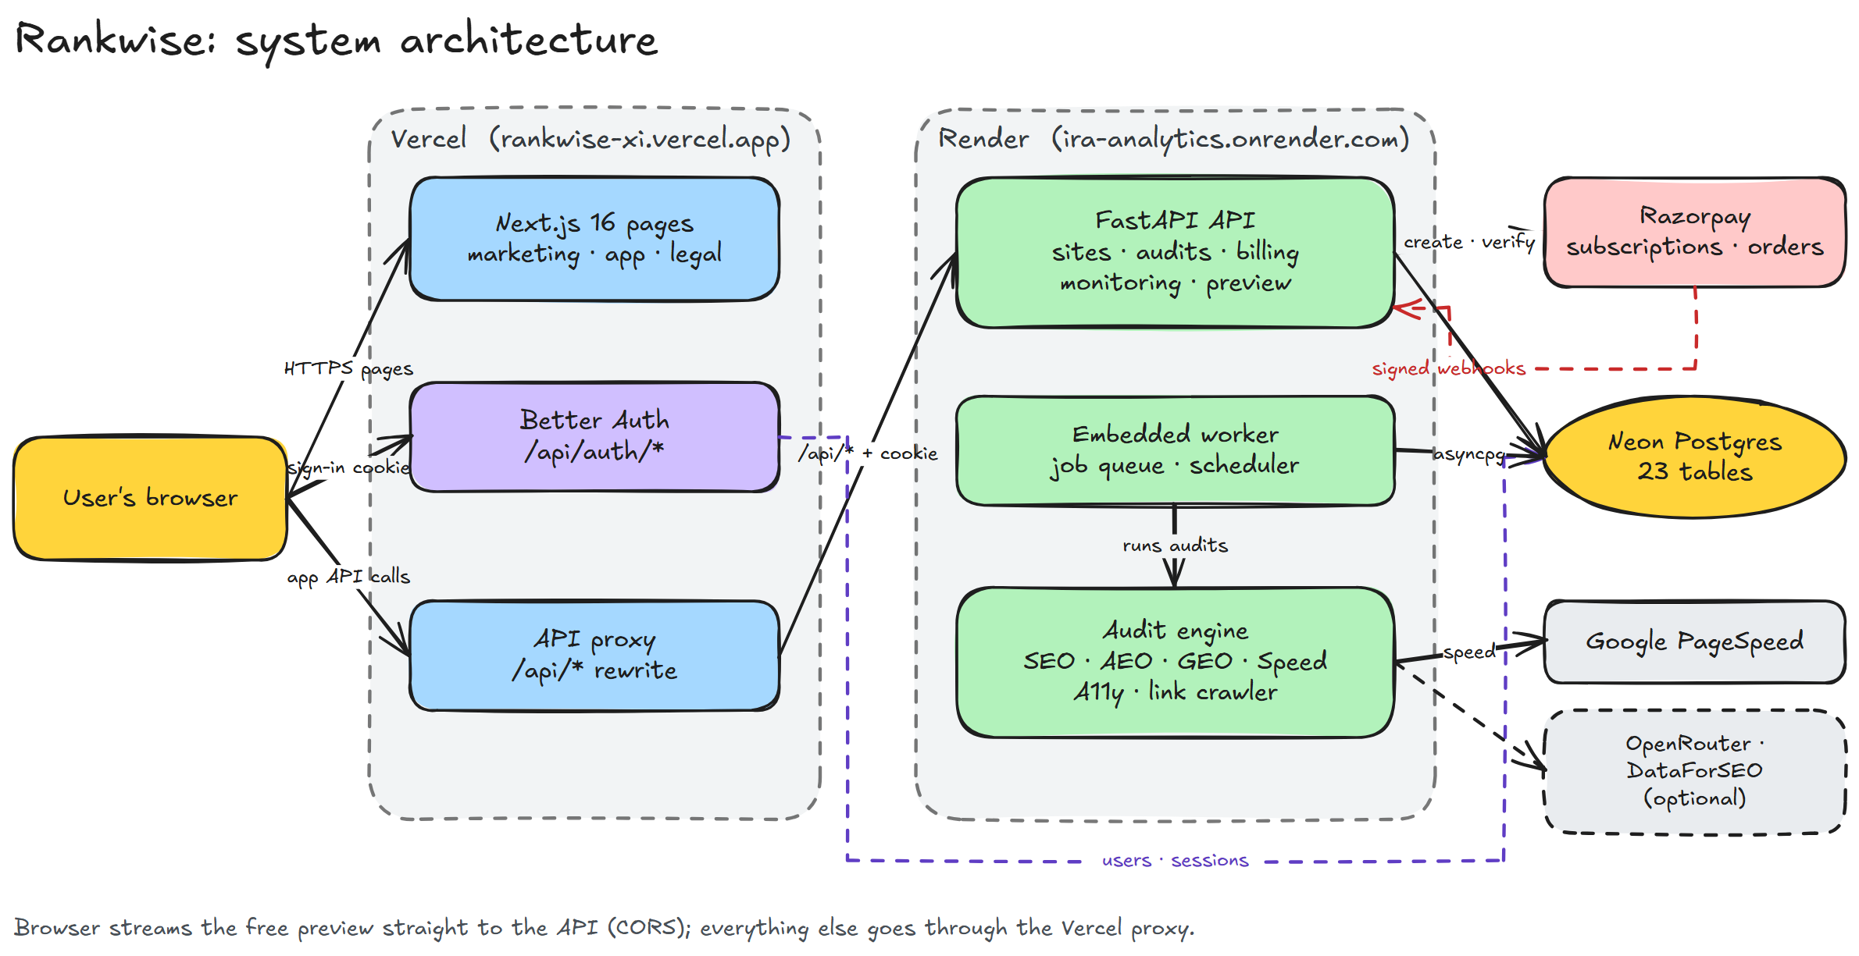
Figure 1. System architecture
- Website (Vercel). Next.js serves marketing, app and legal pages. Better Auth runs inside it and stores users and sessions in Neon. Browser calls to /api/* are forwarded to the API by a rewrite, so the sign-in cookie is first-party for both.
- API (Render). FastAPI exposes sites, audits, monitoring, billing and the free preview, and validates the Better Auth session cookie against the session table on every request.
- Worker. A Postgres job queue runs inside the API process; jobs are claimed with FOR UPDATE SKIP LOCKED.
- Audit engine. Guarded HTTP fetch, SEO/AEO/GEO rules, Speed via PageSpeed, accessibility in headless Chromium, broken-link crawl.
- Neon Postgres. One database for Better Auth's tables and Rankwise's 23 tables; Alembic skips Better Auth's.
- Razorpay. Subscriptions and one-time orders, verified with HMAC signatures.
The anonymous preview is the one exception to the proxy: the browser streams it straight from the API, which is why the API allows the production frontend origin through CORS.

6. Workflows

6.1 Free preview (no account)
- A visitor enters a URL on /audit; the browser opens an event stream to the API.
- The request is counted under a salted hash of the visitor's IP: 2 per day per visitor, 200 per day overall.
- A light check runs (SEO, AEO, GEO rules; no PageSpeed, browser, traffic or AI calls) and streams each module's result.
- Nothing is saved; the report invites the visitor to sign up for a free full audit.

6.2 Sign-up and sign-in
- Better Auth in Next.js handles sign-up and sign-in, limited to 5 sign-ins a minute and 5 sign-ups an hour, counted in Postgres.
- The session cookie is set; proxy.ts sends anyone without it from /app to /login.
- Each API call looks the session up in the database and rejects expired ones.

6.3 Full audit (paid with credits)
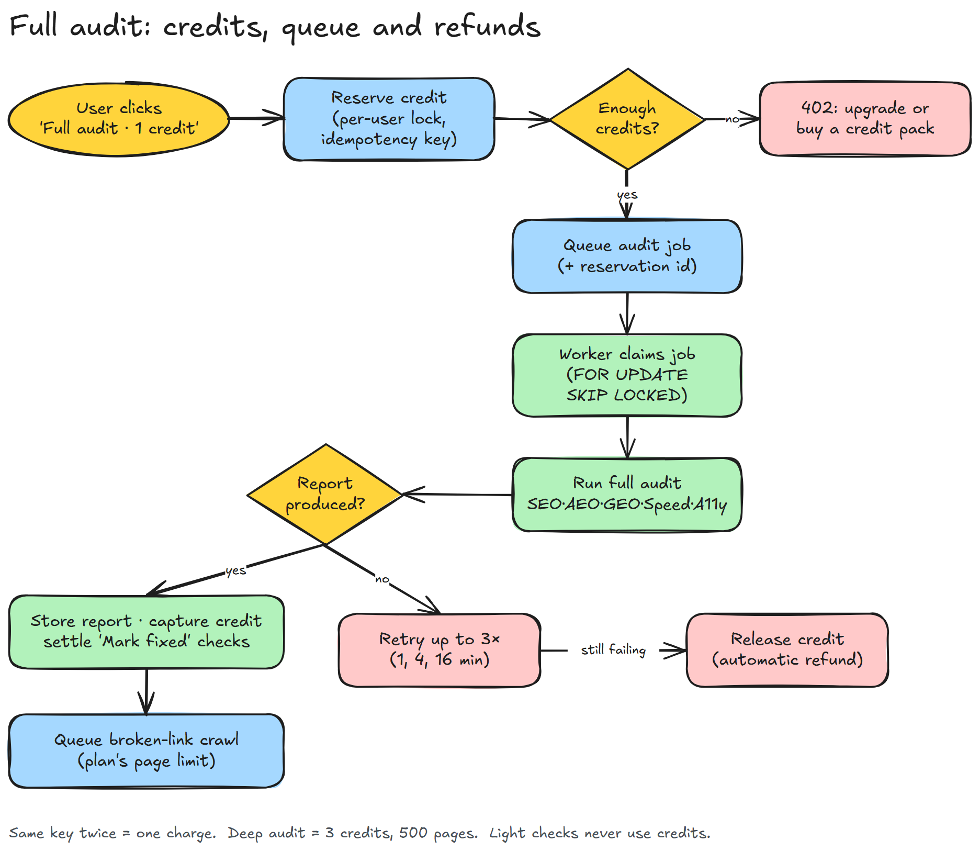
Figure 2. Full audit: credits, queue and refunds
- The user clicks 'Full audit · 1 credit' (or 'Deep audit · 3 credits' on Business and Scale).
- The API takes a per-user lock and reserves credits: monthly first, then refunds, then packs, soonest-expiring first. A repeated idempotency key returns the same reservation.
- Without enough credits the API answers 402 and the app offers an upgrade or a credit pack.
- Otherwise an audit job carrying the reservation id is queued; the worker claims it, runs every module and stores the report.
- On success the credit is captured, pending 'Mark fixed' checks are settled and a broken-link crawl is queued with the plan's page limit.
- On failure the job retries after 1, 4 and 16 minutes; if no report comes out, the credits are released automatically.

6.4 Light checks, scheduling and monitoring
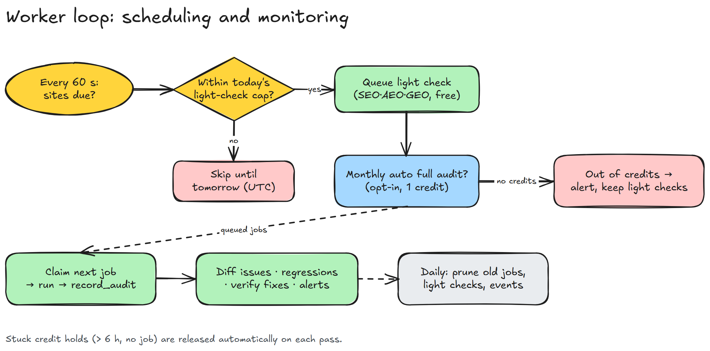
Figure 3. Worker loop: scheduling and monitoring
- Every 60 seconds due sites get a free light check, within the plan's daily cap (Free 3, Pro 10, Business 40, Scale 100).
- Opted-in sites also get one full audit a month, paid with a credit; without credits it is skipped and the user is alerted.
- Each stored audit is compared with the previous one of the same kind: new and resolved issues, score drops and slower Core Web Vitals become alerts.
- Stuck credit holds are released, and once a day old jobs, light-check reports, webhook records and preview counters are pruned.

6.5 'Mark fixed' verification
- Marking an SEO, AEO or GEO issue fixed queues a free light recheck that settles it as fixed or still failing.
- Speed and accessibility fixes wait for the next full audit, which settles every pending verification at no extra cost.

6.6 Deploy hook
- CI calls a secret per-site URL after a release; at most one deploy audit runs per site per hour.
- A full audit runs if a credit is available, otherwise a light check plus an alert.

6.7 Subscription payment
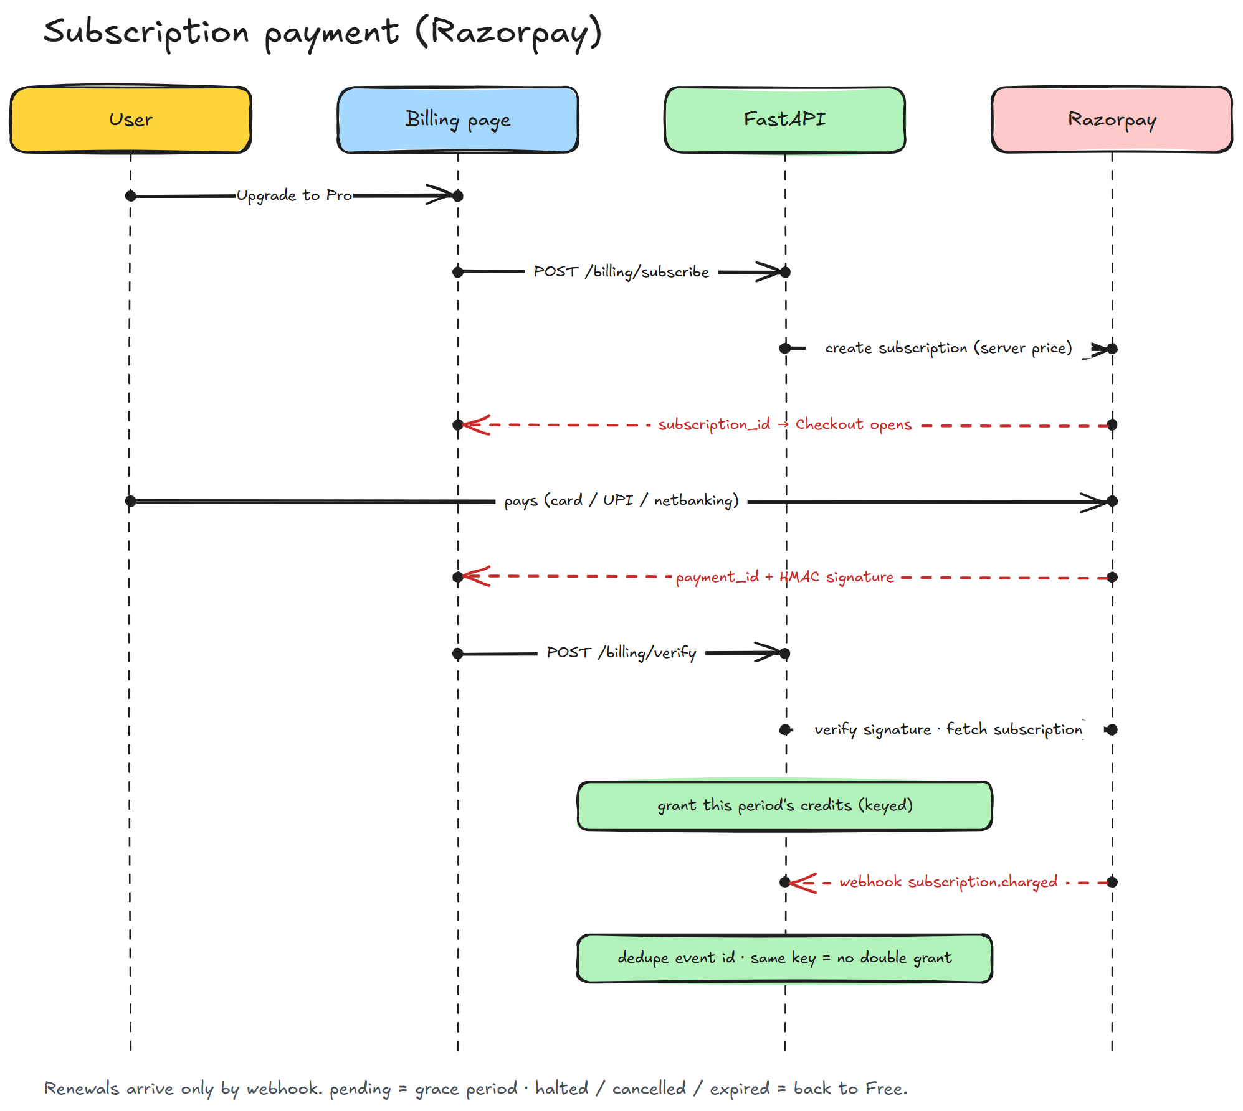
Figure 4. Subscription payment with Razorpay
- The user picks a plan; the API creates a Razorpay subscription for that plan's configured plan id. Prices never come from the browser.
- Razorpay Checkout collects the payment and returns a payment id with an HMAC signature.
- The API verifies the signature, reads the subscription back from Razorpay and grants the period's credits straight away.
- Webhooks keep the subscription in sync. Each event is recorded once by its event id, older events are ignored, and every grant uses a unique key, so nothing is granted twice.
- Upgrades apply immediately with a one-off top-up; downgrades wait for the period end. A failed renewal keeps the plan during Razorpay's retries, then drops the account to Free.

6.8 Credit packs
- Paid plans can buy 5 or 20 credits as a one-time Razorpay Order, priced on the server and tied to the buyer.
- Pack credits are used after monthly credits and last 12 months; checkout and the order.paid webhook grant through the same key.

6.9 Account deletion
- From Billing the user re-enters their password and types DELETE; every Rankwise table cascades, removing websites, reports, credits and billing history.
- Deletion is refused while a paid plan is set to renew.

7. Plans and credits
 | Free | Pro | Business | Scale
Price per month (INR / USD) | ₹0 / $0 | ₹1,499 / $19 | ₹5,999 / $79 | ₹11,999 / $149
Websites | 1 | 3 | 10 | 25
Full-audit credits per month | 1 | 3 | 7 | 11
Pages crawled per audit | 10 | 50 | 100 | 100
Deep audit (500 pages, 3 credits) | – | – | Yes | Yes
Scheduled light checks | Weekly | Daily | Daily | Daily
Light checks per day | 3 | 10 | 40 | 100
Credit packs | – | Yes | Yes | Yes

- Full audit 1 credit, deep audit 3; light checks and opening saved reports are free. Monthly credits don't roll over.
- Packs: 5 credits for ₹1,199 / $15, 20 credits for ₹3,999 / $49, valid 12 months.
- Charged at the listed price (not GST-registered). USD only once Razorpay International Payments is enabled. No refunds on subscriptions; unused packs refundable within 7 days.

8. Data model
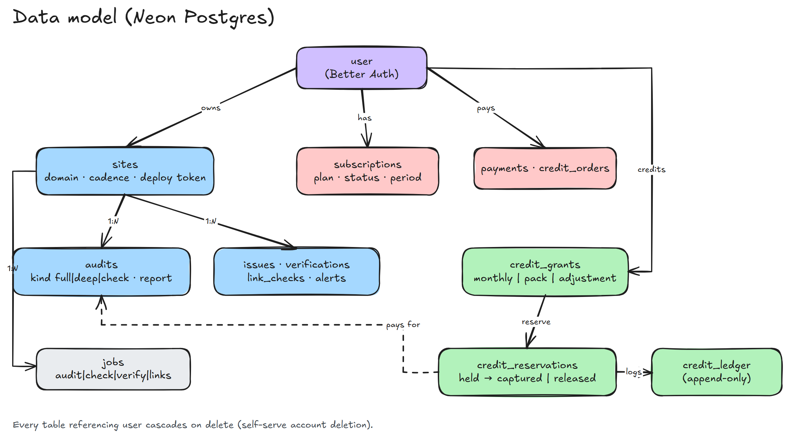
Figure 5. Data model (Neon Postgres)
Table | Holds
user, session, account, verification, rateLimit | Better Auth: accounts, sessions, sign-in rate-limit counters.
sites | Domain, light-check cadence, monthly-audit opt-in, deploy token.
audits | Every stored report, kind full, deep or check, with module scores.
issues, verifications, link_checks, alerts | Issue history, 'Mark fixed' verdicts, broken links, alerts.
jobs | Background queue: audit, check, verify, links.
subscriptions, billing_events, payments, credit_orders | Razorpay state, webhook dedupe, payment history, pack orders.
credit_grants, credit_reservations, credit_ledger | Credit buckets, holds for queued audits, append-only movement log.
preview_usage | Daily anonymous-preview counts per hashed IP.

Migrations: 0001_initial (platform schema) and 0002_credits_billing (credits, payments, preview usage; additive, existing rows kept).

9. Security
- Authorisation. Every route loads data through the signed-in user; other users' sites and reports return 404.
- Outbound requests. http/https only, every redirect hop checked against private and reserved networks, connection pinned to the checked IP. The headless browser routes every request through the same check and blocks service workers.
- Payments. HMAC-verified checkout and webhooks, server-side prices, owner checks, idempotent grants, duplicate and out-of-order protection.
- Abuse limits. Credits and daily caps; previews limited per salted IP hash; X-Forwarded-For trusted only through configured proxy hops; database-backed sign-in limits.
- Browser protections. No framing (clickjacking), nosniff, HSTS, strict referrer policy, permissions policy that only lets Razorpay request payments.
- Secrets. Keys live only in host settings and gitignored .env files. Keys pasted into chat must be rotated.

10. API reference
All routes except health, the preview, screenshots, the deploy hook and the webhook require the Better Auth session cookie.
Method | Route | Purpose
GET | /api/health | Health and database status
GET | /api/audit/stream | Anonymous preview (event stream)
POST | /api/audit | Anonymous preview (JSON)
GET | /api/shots/{name} | Visual Doctor screenshot
GET | /api/me | Signed-in user
GET, POST | /api/sites | List / add websites
GET, PATCH, DELETE | /api/sites/{id} | Read / update / delete a website
POST | /api/sites/{id}/audits | Full or deep audit (credits)
POST | /api/sites/{id}/check | Light check (free, capped)
GET | /api/sites/{id}/history | Score history
GET | /api/sites/{id}/audits/{audit} | Stored report
GET | /api/sites/{id}/issues | Issues
POST | /api/sites/{id}/issues/{issue}/verify | 'Mark fixed'
GET | /api/sites/{id}/verifications | Verification results
GET | /api/sites/{id}/links | Broken links
GET | /api/sites/{id}/status | Running and queued jobs
GET, POST, DELETE | /api/sites/{id}/deploy-hook | Deploy hook URL
POST | /api/hooks/deploy/{token} | Deploy hook (called by CI)
POST | /api/sites/{id}/rewrite | AI rewrite (optional)
GET, POST | /api/alerts, /api/alerts/read | Alerts inbox
GET | /api/billing | Plan, credits, usage
POST | /api/billing/subscribe, /verify, /cancel | Subscription lifecycle
POST | /api/billing/change-plan | Upgrade or downgrade
POST | /api/billing/packs/{pack}/order, /packs/verify | Credit packs
GET | /api/billing/payments | Payment history
POST | /api/webhooks/razorpay | Razorpay webhook

11. Deployment and operations
Piece | Where | How it is deployed
Website | Vercel project 'rankwise' | vercel --prod from the repo root (root directory: frontend)
API | Render service 'Ira-Analytics' (Python 3.13) | Builds from GitHub main; root main.py runs migrations then serves the app
Database | Neon, us-east-2 | Alembic on API start; Better Auth tables via 'npx auth migrate'
Payments | Razorpay | scripts/create_razorpay_plans.py; webhook to /api/webhooks/razorpay

Render variable | Value / purpose
DATABASE_URL | Neon direct connection string
EMBEDDED_WORKER | true: run the job queue inside the API
TRUSTED_PROXY_HOPS | 1: count previews per real visitor
BROWSER_CHECKS, LOCAL_LIGHTHOUSE | false on the free plan
PAGESPEED_API_KEY | Speed scores via Google PageSpeed
PUBLIC_API_URL | https://ira-analytics.onrender.com
PREVIEW_SALT | Random string for hashing visitor IPs
CORS_ORIGINS | https://rankwise-xi.vercel.app
RAZORPAY_* (key id, secret, webhook secret, plans) | Test keys first, live keys after approval

- Vercel: NEXT_PUBLIC_API_URL and BACKEND_URL (Render URL; redeploy after changing), DATABASE_URL (Neon pooled), BETTER_AUTH_SECRET, BETTER_AUTH_URL.

12. Testing
Suite | Covers
test_credits.py | Grants, reservations, capture, refunds, expiry, 20 parallel reserves against 3 credits, idempotent retries.
test_enforcement.py | Charging, refunds, deep-audit gating, forged jobs, light-check caps, deploy cooldown, other users' data, parallel site creation, scheduler, preview limits, billing dashboard.
test_payments.py | Webhook signatures and event ids, duplicates, out-of-order events, renewals, failed payments, checkout verify, plan changes, credit packs.
test_account_deletion.py, test_retention.py | Account deletion cascade; daily clean-up keeps what matters.
Earlier suites | Billing signatures, plan table, deploy config, fix snippets, monitoring, verification, storage.

Database tests use a disposable local Postgres and refuse any non-local host. The frontend is checked with a typecheck, ESLint and a production build. A GitHub Actions workflow running all of this is written and waiting for GitHub permission.

13. Status and next steps

13.1 Before taking real money
- Run 'npx auth migrate' on production for the rate-limit table, then redeploy the website.
- Finish the Render environment variables and turn on Auto-Deploy.
- Razorpay Test Mode end to end: subscribe, audit, pack, upgrade, cancel.
- Rotate the Neon password and the Razorpay live keys that were pasted in chat.
- Keep-alive ping on /api/health every 10 minutes.

13.2 Reliability
- Commit DNS pinning and data clean-up after a full test run; enable CI.
- Error monitoring (Sentry) and transactional email (password reset, receipts, failed renewals).

13.3 Product and growth
- End-to-end browser tests, email alerts, onboarding audit, PDF reports, marketing SEO, accessibility pass.
- Google Search Console / GA4, competitor gap, white-label reports and AI features.

Appendix: diagrams
Made with the excalidraw-diagram-generator skill conventions (github/awesome-copilot); files in docs/diagrams/:
- build_diagrams.py writes the .excalidraw files; open them at excalidraw.com or with the Excalidraw VS Code extension.
- render_png.py renders them to PNG with Excalidraw's own exporter in headless Chrome.
backend/.venv/Scripts/python docs/diagrams/build_diagrams.py
backend/.venv/Scripts/python docs/diagrams/render_png.py

