Tool Used:

Python Matplotlib Pyplot

Settings: Default

* Number of bins 10
* Density Calculation: No

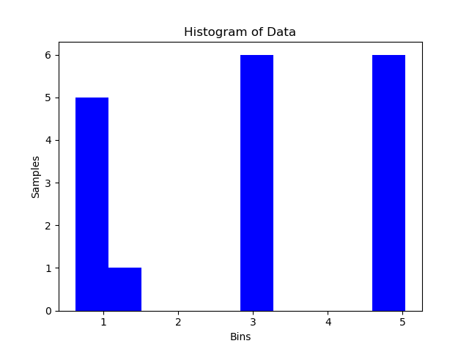

Description: Here 18 samples are divided into 10 equal sized bins. First bin contains 5 samples, second bin contains 1 sample, 6th and 10th bin contains 6 samples each. All other bins are empty.