
Tehran University of Medical Sciences
School of Nutritional Sciences and Dietetics
Ultra-Processed Foods and Addictive-Like Eating Behaviors
From Neurobiological Mechanisms to Community Nutrition Policy

غذاهای فوق‌فرآوری‌شده و رفتارهای غذایی اعتیادگونه:
از مکانیسم های عصبی‌زیستی تا سیاست‌گذاری تغذیه جامعه
Presented by: Yasmin Ayatollahi
Course instructor: Dr. Pouraram
Autumn 2026 (1405 SH)

Abstract
Background. Over recent decades, ultra-processed foods (UPF) have come to account for a growing share of population food intake, and at the same time “food addiction” has become one of the most debated research topics in nutrition, psychiatry and neuroscience. This seminar separates three distinct claims that are usually conflated in the literature and the media: (a) the association of UPF consumption with energy intake and health outcomes; (b) the association of some of these products with addictive-like eating behaviors; and (c) the conceptual and diagnostic validity of “addiction”; and it examines their policy implications for community nutrition and for Iran.
Methods. A narrative review based on a structured search of PubMed/MEDLINE, Web of Science, Scopus and Google Scholar, prioritizing umbrella reviews, meta-analyses, randomized trials, large prospective cohorts and Iranian studies. This is not a systematic review: the search strategy was not recorded in a reproducible form, and neither dual-reviewer screening nor a systematic risk-of-bias assessment was performed.
Results. The NOVA classification has been criticized for ambiguous criteria and the heterogeneity of Group 4, and UPF is not synonymous with hyper-palatable food. For claim (a), the evidence is relatively strong: in the trial by Hall et al., the ultra-processed diet was associated with about 508 kcal/day higher intake and weight gain, and in the trial by Dicken et al., weight loss was greater on the minimally processed diet; the umbrella review by Lane et al. reported associations between higher UPF consumption and 32 of 45 outcomes, although the GRADE certainty of this observational evidence is mostly low or very low. In the Tehran Lipid and Glucose Study, higher UPF consumption was associated with prediabetes, but not with type 2 diabetes. For claim (b), the evidence is limited, mostly cross-sectional and dependent on the self-report YFAS instrument, and the proposed mechanisms—speed of nutrient delivery, the supra-additive effect of fat and carbohydrate on reward, dopaminergic changes and evidence from GLP-1-based drugs—are mainly hypothesis-generating. For claim (c), the debate remains unresolved: the concept is not accepted in DSM-5-TR or ICD-11, no specific addictive agent has been identified, human neuroimaging evidence is heterogeneous, and energy density, eating rate and protein leverage are alternative explanations. By contrast, evaluations of Chile’s policy package and of sugar-sweetened beverage taxes in Mexico and the United Kingdom have shown reductions in purchases and product reformulation, although this evidence rests mainly on intermediate outcomes.
Conclusion. The available evidence supports policy action on the food environment, especially to protect children, without first requiring acceptance that food is “addictive.” The addiction model, if valid at all, probably applies only to a vulnerable subgroup, and its added clinical value over existing treatments for eating disorders has not been demonstrated. The main limitations of this review are its narrative nature and the fragmentary Iranian data; regular national monitoring of UPF consumption, evaluation of the nutrition labeling system and improvement of the school food environment are the proposed priorities for Iran.
Keywords: ultra-processed foods; NOVA classification; food addiction; Yale Food Addiction Scale; hyper-palatable foods; obesity; nutrition policy; warning labels; sugar-sweetened beverage tax.
Table of Contents
Abstract 2
List of Figures and Tables 6
Figures 6
Tables 6
1. Introduction and Problem Statement 7
1.1 Background and Significance 7
1.2 Objectives of the Seminar 7
1.3 Methods of Source Collection and Selection 9
1.4 Historical Overview 10
2. Ultra-Processed Foods: Definition, Classification and Consumption Trends 12
2.1 Food Processing: From Necessity to Product Engineering 12
2.2 The NOVA Classification 13
2.3 Structural and Nutritional Characteristics of UPF 13
2.4 Critiques of NOVA and Alternative Systems 14
2.5 Global Consumption Trends 16
2.6 The Situation in Iran 17
3. Food Addiction: Concept, Measurement and Prevalence 19
3.1 Definition and Conceptual Boundaries 19
3.2 Translating DSM-5 Criteria to Eating Behavior 19
3.3 The Yale Food Addiction Scale (YFAS) 21
3.4 Prevalence of Food Addiction 23
3.5 Which Foods Are Most Associated with Addictive-Like Eating? 24
3.6 Withdrawal Syndrome 26
4. Mechanisms: Why Do Ultra-Processed Foods Behave Differently? 27
4.1 Speed of Nutrient Delivery 27
4.2 The Supra-Additive Effect of Combining Fat and Carbohydrate 28
4.3 Dopaminergic Circuits and Competing Theories 28
4.4 The Opioid and Endocannabinoid Systems 29
4.5 Evidence from Incretin-Based (GLP-1) Drugs 30
4.6 Energy Density versus Palatability: A Live Debate 31
5. Human Evidence: UPF Outcomes and Direct Evidence on Addictive-Like Eating 32
5.1 The Clinical Trial by Hall et al. 32
5.2 The Crossover Trial by Dicken et al. 33
5.3 The Umbrella Review by Lane et al. 34
5.4 Prospective Cohorts 35
6. Discussion: Two Competing Narratives 37
6.1 The Supportive Camp: The Four-Criterion Framework 37
6.2 The Critical Camp 38
6.3 Alternative Explanations 40
6.4 Methodological Limitations of the Current Evidence 40
7. Policy Implications and Community-Based Nutrition Interventions 42
7.1 Why Are Individual-Level Interventions Not Enough? 42
7.2 Front-of-Package Warning Labels: The Chilean Experience 42
7.3 Taxes on Sugar-Sweetened Beverages 44
7.4 Marketing Restrictions and the School Food Environment 45
7.5 National Dietary Guidelines and the Concept of Processing 45
7.6 The Tobacco Industry Analogy and the Commercial Determinants of Health 46
8. Vulnerable Groups and Clinical Implications 49
8.1 Children and Adolescents 49
8.2 Obesity and Eating Disorders 49
8.3 Mental Health and Socioeconomic Factors 50
8.4 Clinical Implications and the “Abstinence versus Moderation” Question 50
8.5 The Problem of Stigma 51
8.6 Limitations of This Review 51
9. Research Gaps and Suggestions for Future Studies 53
10. Summary and Conclusions 55
References 57

List of Figures and Tables

Figures
- Figure 1 — Timeline of the development of the concepts of food addiction and ultra-processed foods
- Figure 2 — The four groups of the NOVA classification
- Figure 3 — Share of UPF in daily energy intake in selected countries
- Figure 4 — Prevalence of food addiction in different populations
- Figure 5 — Ranking of foods based on the study by Schulte et al.
- Figure 6 — Conceptual model from ultra-processed food to addictive-like eating
- Figure 7 — The clinical trial by Hall et al.
- Figure 8 — The umbrella review by Lane et al.
- Figure 9 — Changes reported after implementation of policy interventions

Tables
- Table 1 — Translation of DSM-5 substance use disorder criteria to eating behavior
- Table 2 — Comparison of YFAS, YFAS 2.0 and the Persian versions
- Table 3 — Summary of key human evidence on UPF
- Table 4 — Arguments for and against the concept of food addiction
- Table 5 — Policy interventions and evidence of their effectiveness

1. Introduction and Problem Statement

1.1 Background and Significance
According to the Global Burden of Disease Study (GBD 2019), high body mass index and other metabolic risk factors are important contributors to the global burden of disease, and exposure to these factors—particularly high body mass index and high fasting plasma glucose—has increased in recent years (1). However, explanations of obesity based solely on individual factors and choices cannot by themselves account for the rapid and simultaneous rise in obesity prevalence across different populations; evidence indicates that changes in the food environment and the global food system have been important drivers of the rising prevalence of obesity in recent decades (2, 3). Energy balance should not be interpreted as an outcome of individual choices alone; although weight gain ultimately involves a disruption of the balance between energy intake and expenditure, environmental factors—especially the food environment—can set the stage for weight gain and rising obesity prevalence by increasing energy intake and altering the regulation of food intake (3). From 1990 to 2022, the combined burden of underweight and obesity increased in many countries; this trend has been driven mainly by rising obesity, while underweight has declined in many countries (4); this pattern highlights the role of environmental factors in the rise of obesity, among which changes in the global food system play a fundamental role (2). Reduced physical activity, changes in sleep patterns, certain medications, stress, socioeconomic changes and prenatal factors have also been proposed as possible contributors to rising obesity prevalence (5), and the focus of this seminar on the food environment does not imply that they are dismissed.
In recent decades, ultra-processed products have expanded increasingly within the global food system, to the point that they dominate the food supply of high-income countries and their sales are rising rapidly, particularly in middle-income countries (6, 7). Ultra-processed products are distinguished not merely by their unfavorable nutritional composition; rather, the processes and ingredients used to manufacture them are designed to create highly profitable products from low-cost ingredients with a long shelf life, which are at the same time ready-to-consume and highly palatable—characteristics that have given these products an advantage and have driven their spread and the gradual displacement of unprocessed and minimally processed foods (8, 9). This has raised a new point: given that some ultra-processed products are designed to be highly rewarding and palatable and to reinforce repeated consumption, the “addiction” framework may be used, alongside the concept of individual choice, to explain patterns of compulsive consumption and loss of control over the consumption of these products (10–12).
This point also has important clinical implications. Preliminary, albeit inconsistent, evidence suggests that symptoms of addiction to ultra-processed foods may be associated with poorer weight-management outcomes; in a randomized trial with 609 participants, UPF addiction symptoms were, among 41 demographic and psychosocial factors examined, the strongest predictor of treatment dropout and smaller weight loss (13). Therefore, if such a subgroup truly exists, conventional approaches based on controlling food quantity and portion size may not by themselves be sufficient to manage these individuals’ compulsive consumption patterns, and intervention strategies tailored to addictive-like mechanisms may also be needed (11). In terms of policy implications, the history of tobacco policy showed that recognizing cigarettes as an addictive product shifted attention from individual responsibility to industry responsibility and accountability, and supported legal, regulatory and policy measures to reduce tobacco use (10, 14, 15).

1.2 Objectives of the Seminar
This seminar pursues three main objectives:
- Conceptual clarification: clarifying how “ultra-processed food” and “food addiction” are each defined and measured, and why neither concept enjoys the degree of scientific consensus that is assumed in the media.
- Evidence appraisal: examining biological mechanisms, evidence from human trials and cohort studies, together with grading the certainty of the evidence and identifying methodological biases.
- Deriving policy implications: translating scientific evidence into practical recommendations for community nutrition policy, with a particular focus on Iranian society.
The title of this seminar brings together three different claims for which the strength of evidence is not the same: (a) Is the consumption of ultra-processed foods associated with higher energy intake and adverse health outcomes? (b) Do some of these products induce addictive-like eating behaviors? (c) Do these behaviors have conceptual and diagnostic validity as “addiction” in the clinical and neurobiological sense? A large part of the strongest evidence in this field—from the Hall trial (16) to the Lane umbrella review (17) and policy evaluations (18–22)—answers question (a) and did not measure addiction at all. Box 1 summarizes this distinction, and the line of argument in the following chapters is built on the same distinction.
Table 1 — Distinguishing the three claims of the seminar: type of evidence required, available evidence and overall status of the evidence
Claim | Type of evidence required | Available evidence | Overall status of the evidence
a) UPF consumption is associated with higher energy intake and adverse health outcomes | Controlled feeding trial + large prospective cohort + umbrella review | Hall (16), Dicken (23), Lane (17), NutriNet-Santé (24), Tehran Lipid and Glucose Study (25) | Relatively strong for short-term energy intake and weight; low to very low (GRADE) for long-term observational outcomes (17, 26)
b) Some of these products are associated with addictive-like eating behaviors | Psychometric studies with validated instruments, experimental behavioral studies, longitudinal designs | Schulte (27), YFAS-based studies (10, 28), LaFata et al. (13) | Limited; mostly cross-sectional, self-reported and dependent on a single instrument
c) These behaviors have conceptual and diagnostic validity as “addiction” | Convergent and discriminant validity against BED and emotional eating, predictive and incremental validity, longitudinal stability, functional impairment and specific treatment response | Debate between Gearhardt (12, 29) versus Hebebrand (30, 31) and Ziauddeen (32); no diagnosis in DSM-5-TR (33) or ICD-11 (34) | Unresolved; low certainty
d) Environmental interventions change purchasing and product composition | Quasi-experimental policy evaluation (interrupted time series, pre–post, household purchase data) | Chile (18, 20), Mexico (21, 22), United Kingdom (19) | Relatively strong for intermediate outcomes (purchases, reformulation); weak for hard clinical outcomes
Note: The rows of this box are independent; rejecting or confirming claim (c) does not invalidate claims (a) and (d). It is this independence that allows policy recommendations to be put forward in Chapter 7 without depending on the resolution of the addiction controversy.

1.3 Methods of Source Collection and Selection
The sources for this seminar were collected through a targeted search of PubMed/MEDLINE, Web of Science, Scopus and Google Scholar. The main keywords included combinations of the following: ultra-processed food, NOVA classification, food addiction, Yale Food Addiction Scale, hyper-palatable food, addictive-like eating, front-of-pack labelling and sugar-sweetened beverage tax. Priority was given to umbrella reviews, meta-analyses, systematic reviews, randomized trials and large prospective cohorts. For local data, Iranian studies, including the Tehran Lipid and Glucose Study (25) and the Persian validations of the YFAS (35–37), were also searched and included.
Because this field has evolved rapidly in recent years, an effort was made to cover the evidence published between 2023 and 2025 in full; nevertheless, the argumentative weight of each study was determined by its design, risk of bias, precision, directness and consistency, and not merely by how recently it was published—being newer is not in itself equivalent to being stronger. However, the older foundational papers that built the conceptual framework—including the two key papers by Meule and Gearhardt (38) and by Ziauddeen and Fletcher (32)—have been retained as conceptual pillars.
Source selection priorities: First priority was given to umbrella reviews, meta-analyses, systematic reviews, randomized trials and large prospective cohorts (more than 10,000 participants), and to psychometric studies with complete statistical reporting, published in peer-reviewed journals. Smaller, qualitative or case studies were used only where the question under discussion—such as the conceptual validity of the YFAS or the experience of withdrawal syndrome—could not be answered with larger designs, and their limitations are noted in the text. For data without peer review, including findings presented at a conference (39), a methodological caveat is included in the text, and these data are used only as an “ongoing study” and not as evidence.
The methodological nature of this work must be stated explicitly: this is a narrative review with a structured search and not a systematic review. The search strategy was not recorded in a complete and reproducible form, inclusion and exclusion criteria were not fixed in writing before the start, screening was not performed by two independent reviewers, no PRISMA flow diagram is presented, and no systematic risk-of-bias assessment was carried out for all studies. In total, 117 sources—including peer-reviewed articles, laws and official reports—are cited in the text. The findings of this seminar should therefore be regarded as a narrative synthesis rather than a systematic estimate; the consequences of this limitation are revisited in Section 8.6.

1.4 Historical Overview
The term “food addiction” was first used in the scientific literature in 1956 by Theron Randolph (40), but until the early 2000s there was no systematic attempt to define and measure it (38). In 2001, a study using positron emission tomography (PET) showed that striatal dopamine D2 receptor availability in individuals with obesity was lower than in controls and was inversely related to body mass index (41). Subsequently, animal models of intermittent, excessive sugar intake provided evidence of addiction-like behaviors and neural changes in rodents (42). Also, in the study by Johnson and Kenny, rats with extended access to highly palatable, high-fat food developed reward dysfunction, compulsive eating resistant to aversive consequences and reduced striatal D2 receptors (43). During the same period, the Yale Food Addiction Scale (YFAS) was introduced in 2009 to measure addictive-like eating patterns (44), and a system for classifying foods by the extent of processing also took shape in this period, later becoming, as NOVA, one of the most widely used processing-based food classification systems (8).
In the 2010s, important critiques of the “food addiction” framework were raised. Ziauddeen et al., examining this concept, pointed to the limited human evidence and fundamental theoretical problems and emphasized inconsistencies in the human neurobiological evidence and the need for caution in accepting “food addiction” as a valid concept (45). Also, Hebebrand et al., noting the weakness of the existing evidence for a substance-based “food addiction,” proposed using the concept of “eating addiction” instead of “food addiction” to describe an addictive-like behavioral pattern (30). At the same time, new policies and approaches to reform the food environment emerged in the 2010s. The 2014 Brazilian dietary guidelines classified foods with an emphasis on the extent of processing and, in their recommendations, emphasized limiting the consumption of processed foods and avoiding ultra-processed foods (46). In Chile, a comprehensive law on nutrition labeling and restrictions on the advertising of certain foods was implemented from 2016 (18). In the United Kingdom, a tax on sugar-sweetened beverages came into force in 2018, and subsequent evidence reported a substantial reduction in purchases of these beverages (19). In 2019, further important experimental evidence was added to the field. In an inpatient clinical trial, Hall et al. showed that, compared with a diet composed of minimally processed foods, consuming a diet rich in ultra-processed foods was associated with higher energy intake and weight gain (16). During the same period, neuroscientific research also examined brain reward mechanisms in response to processed foods and the factors underlying individual differences in responses to food (47). Subsequent reviews pursued this evidence within the framework of “addictive-like eating.” According to the review by Gearhardt and Schulte, ultra-processed foods containing high amounts of added fat and refined carbohydrates have been implicated more than other types of foods in addictive-like eating patterns. These findings have contributed to the view that the characteristics of some ultra-processed foods, particularly the combination of added fat and refined carbohydrates, may play a role in creating or reinforcing addictive-like consumption patterns (11, 12).
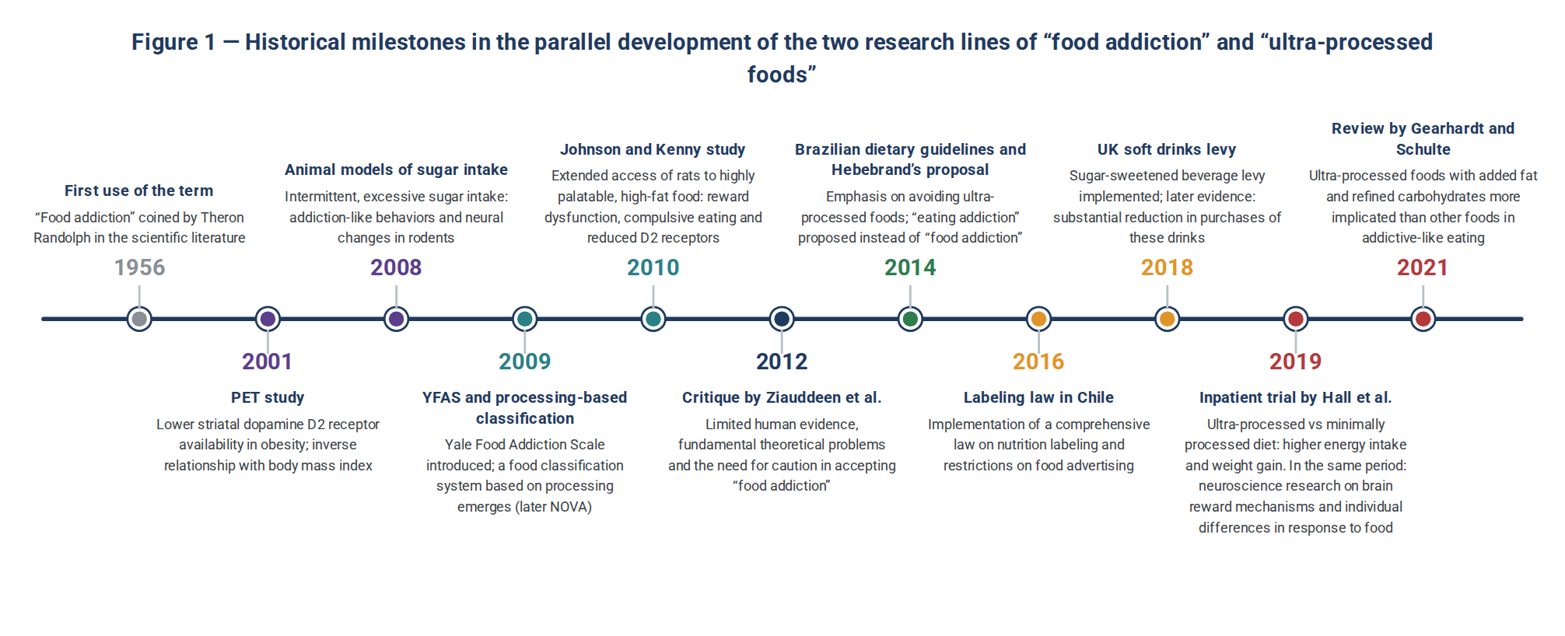
Figure 1 — Historical milestones in the parallel development of the two research lines of “food addiction” and “ultra-processed foods.” Source: compiled by the author based on references (8, 11, 16, 18, 19, 30, 40–45).

2. Ultra-Processed Foods: Definition, Classification and Consumption Trends

2.1 Food Processing: From Necessity to Product Engineering
Food processing is not inherently negative; processes such as drying, non-alcoholic fermentation, pasteurization, chilling and freezing can help preserve foods, extend their shelf life and safety, and make them suitable for consumption (9). The main distinction between ordinary processing and ultra-processing lies in the purpose and nature of the processes: whereas ordinary processing may be carried out to preserve food and extend its shelf life, the processes and ingredients used to manufacture ultra-processed foods are designed to create products from low-cost ingredients that have a long shelf life and are ready-to-consume and highly palatable (8, 9). In this process, the constituents of whole foods are separated from one another and in some cases chemically modified; these substances are then used in new combinations through industrial processes, together with additives such as flavorings, colorings and emulsifiers (8). As a result, although processed foods remain sources of nutrients, the way these nutrients are presented and combined can affect nutritive signals between the gut and the brain and, consequently, how the reward value of food is processed (47).
This approach, which distinguishes foods by the nature, extent and purpose of processing, was the basis for the NOVA classification system; this system was developed by a team of researchers at the University of São Paulo, including Carlos Monteiro (8, 9).

2.2 The NOVA Classification
NOVA classifies all foods and food products into four groups according to the nature, extent and purpose of industrial processing (8, 9):
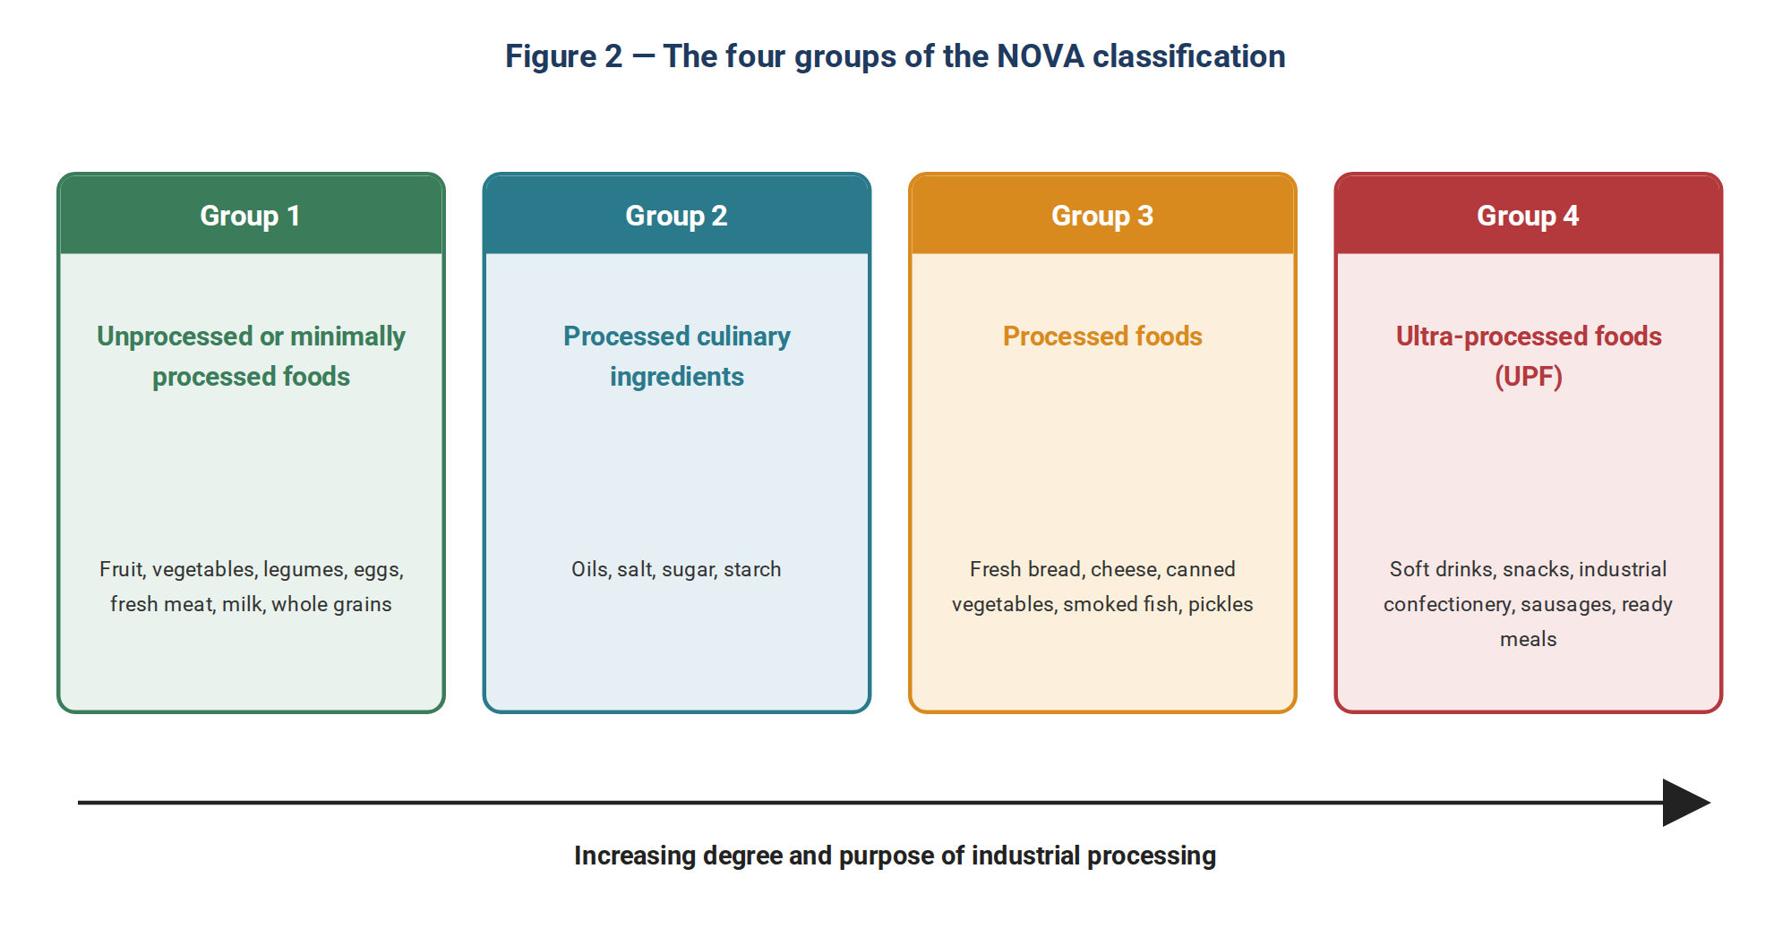
Figure 2 — The four groups of the NOVA classification. Source: adapted from Monteiro et al. (8).
Group 4 (UPF) is the subject of this seminar. This group comprises formulations of ingredients, mostly of exclusive industrial use, in which foods are fractionated into their constituents during manufacture and then recombined through industrial processes, so that little or no whole food remains in the final product. A practical way to identify these products is to examine the ingredient list: the presence of at least one substance never or rarely used in kitchens—such as high-fructose corn syrup, hydrogenated or interesterified oils, maltodextrin and soy protein isolate—or of an additive that modifies sensory and visual properties—such as flavorings, colorings, emulsifiers, sweeteners and thickeners—can indicate that a product belongs to the ultra-processed food group (8).

2.3 Structural and Nutritional Characteristics of UPF
Many ultra-processed products have one or more characteristics that may affect food reward, eating behavior and processes involved in regulating food intake; moreover, the combination of some of these characteristics can influence food-reward responses (11, 47):
- High energy density: more energy per unit weight of food, which can be associated with higher energy intake and reduced satiety (48).
- Disruption of the food matrix: the intensive processing used in UPF manufacture can substantially alter the physical structure and integrity of the food matrix. By changing properties such as texture and particle size, these alterations can affect the need for chewing, the rate of consumption and the availability of nutrients during digestion (49, 50).
- Simultaneous combination of fat and refined carbohydrate: many ultra-processed foods provide high amounts of fat and carbohydrate at the same time—a combination that is less common in natural or minimally processed foods. Evidence indicates that combining fat and carbohydrate can have a supra-additive effect on the brain reward system, such that its reward value exceeds the effect of either macronutrient alone (10).
- High glycemic load and low fiber: foods containing refined carbohydrates and with a higher glycemic load can facilitate faster carbohydrate absorption and have, in some studies, been associated with increased hunger, food craving and addiction-like behaviors (11, 27).
- Soft texture and ease of chewing: a softer texture and less need for chewing can increase the rate of food consumption; experimental evidence has shown that a faster eating rate is associated with higher energy intake. A faster eating rate and higher energy intake have also been observed on ultra-processed diets (16, 51).
- Sensory and technological additives: different groups of additives are used in UPFs; some, such as flavorings and flavor enhancers, are used to create or enhance the sensory properties and appeal of the product, while other additives have functional roles such as providing texture, stability or longer shelf life. Therefore, not all additives should be regarded as equivalent in terms of function and purpose of use (8).
Less favorable nutrient profile: at the population level, a higher share of UPF in the diet has been associated with lower nutritional quality, higher intakes of energy, saturated and trans fats and cholesterol, and lower intakes of fiber and certain vitamins and minerals; however, these findings reflect an association at the level of dietary patterns and populations and do not mean that every UPF product is necessarily nutritionally unfavorable on its own (52, 53). In the UK National Diet and Nutrition Survey (UK NDNS), moving from the lowest to the highest quintile of UPF consumption, the share of energy from free sugars rose from about 9.9% to 15.4%, while dietary fiber density fell from 8.4 to 6.9 g per 1000 kcal (52).

2.4 Critiques of NOVA and Alternative Systems
Despite its widespread use in nutrition research and food policy debates, the NOVA classification has been criticized by some researchers, particularly in food science and technology, for the ambiguity and inconsistency of some of its classification criteria and the difficulty of defining and identifying ultra-processed foods uniformly (54, 55). The most important of these critiques are:
- Ambiguity of the operational definition: in some cases NOVA’s criteria are vague and imprecise for practical application, which can lead to different interpretations when classifying foods; this ambiguity is particularly notable for certain borderline foods whose placement depends on their composition and production method (54).
- Conflating processing with health: this classification places the extent of processing, rather than the nutritional or health-related properties of food, at the center of its definition; therefore, placing a product in Group 4 does not necessarily mean that its nutrient profile is the same as that of other products in this group. Gibney has also emphasized the ambiguity and variability in the definition and examples of ultra-processed foods (55).
- Overlooking the different roles of processing: one of the critiques of the NOVA-based approach is that focusing on the extent of processing may give less attention to differences in the functions and characteristics of different types of food processing. Hence, the policy implications related to ultra-processed foods should be examined with regard to the precise definition of this group and the diversity of foods it includes (55).
- Existence of competing systems: processing-based classification systems, including NOVA, IARC-EPIC, IFPRI and UNC, offer different criteria and boundaries for grouping foods; as a result, the amount of highly/ultra-processed food estimated for a single dietary pattern can differ substantially depending on the classification system used (54, 56).
In this debate, Monteiro et al. emphasize that NOVA classifies foods essentially by the extent and purpose of processing, not by their nutrient profile. From this perspective, NOVA and nutrient profile models such as that of the Pan American Health Organization (PAHO) offer two different approaches to evaluating food products: NOVA focuses on processing, whereas the PAHO model focuses on excessive amounts of critical nutrients such as sugar, sodium and fats (57, 58). NOVA is useful for studying patterns of food processing, but ambiguity in some classification criteria and the possibility of misclassification can affect estimates of the relationships between NOVA groups and health outcomes; hence, especially in observational studies, causal inferences based on this classification should be interpreted with caution (54, 57).
NOVA Group 4 is not a homogeneous group and encompasses diverse products such as carbonated soft drinks, processed meats, fortified industrial breads, breakfast cereals, flavored yogurts and plant-based meat alternatives—products that are not necessarily equivalent in composition, sensory properties and potential health effects (8, 55). This point becomes even more important for the discussion of addictive-like eating: UPF and hyper-palatable foods are not the same concepts, because hyper-palatability depends on specific combinations and levels of components such as fat, simple sugars, carbohydrate and sodium. Therefore, a product’s placement in NOVA Group 4 does not by itself necessarily indicate that the product is hyper-palatable (59).
Three terms should not be treated as synonyms: “ultra-processed” refers to the fourth group of the NOVA system, defined by the nature and purpose of industrial processing; “highly processed” is a more general term that does not necessarily refer to a specific classification system; and “hyper-palatable” is a different concept that has been quantitatively defined on the basis of specific combinations of palatability-enhancing components, including fat, simple sugars, carbohydrate and sodium (8, 59). Not every UPF should be equated with a hyper-palatable food, and hyper-palatability is not confined to NOVA Group 4, because the two concepts are defined by different criteria: UPF is identified by the nature and purpose of processing, and HPF by specific combinations of components that affect palatability (8, 59). Likewise, “food addiction,” “addictive eating” and “loss-of-control eating” are related but distinct concepts and should not be used as synonyms; the first refers to the concept of addiction in relation to food consumption, the second to an addictive-like behavioral pattern of eating, and the third to the experience of losing control over eating (13, 30, 38).

2.5 Global Consumption Trends
The share of UPF in daily energy intake varies markedly between countries. This wide variation reflects the heterogeneity of UPF consumption across populations (60).
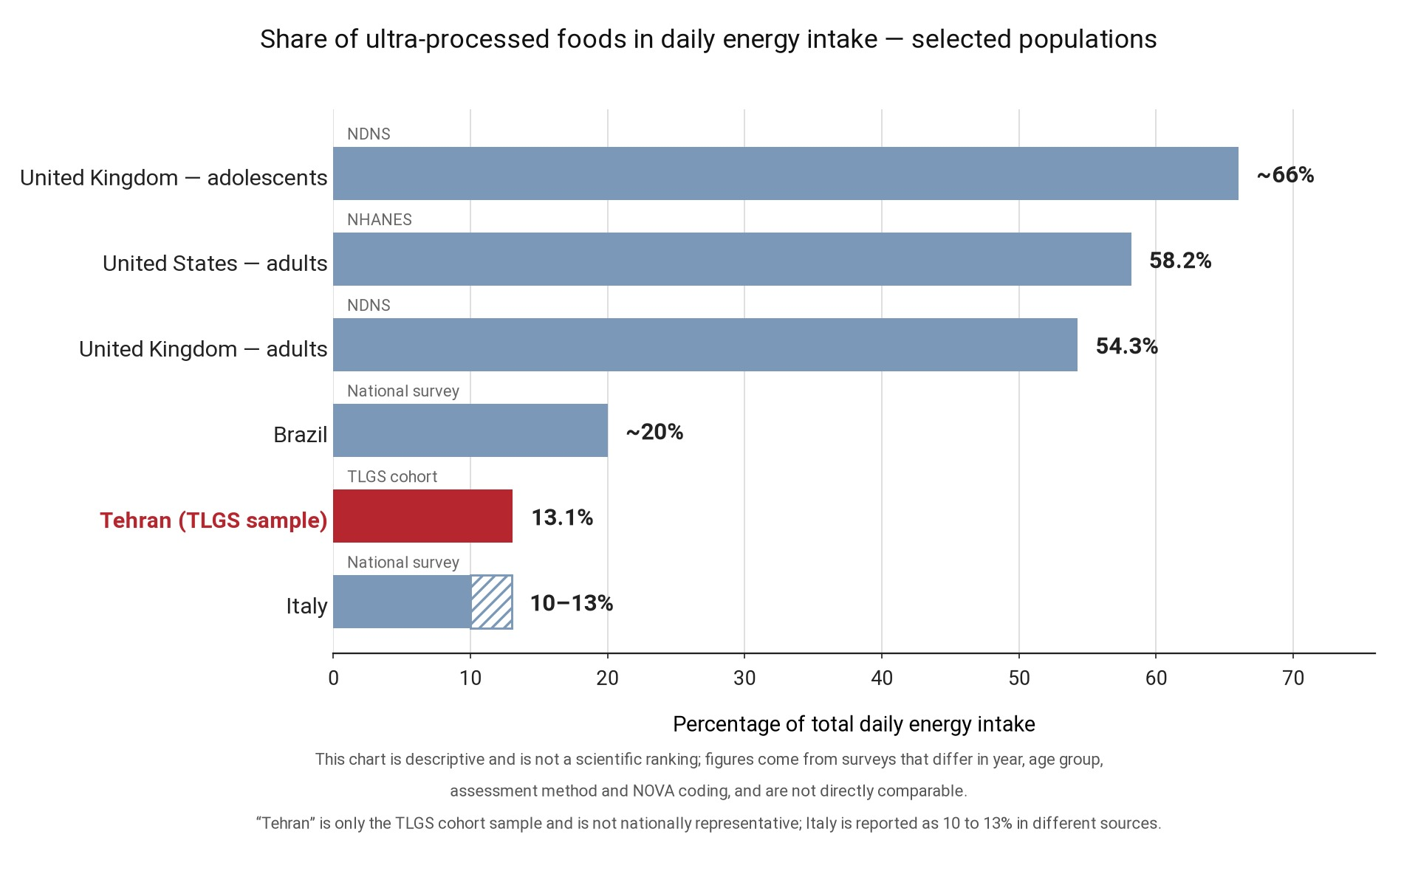
Figure 3 — This chart is descriptive and is not a scientific ranking of countries; the figures are drawn from studies that differ in year, age groups, dietary assessment methods and ways of applying the NOVA classification. The figure for Iran comes from the Tehran Lipid and Glucose Study (TLGS) and is not representative of national consumption in Iran. Sources: (25, 60–62)
In the United States, according to NHANES data for 2017–2018, about 58% of total energy intake comes from NOVA Group 4 (62). In the United Kingdom, this share has been reported at about 54% in adults and reaches about 66% in adolescents aged 11–18 years (61). By contrast, Italy has a much lower share of about 10%; in Brazil, estimates have varied considerably across studies, ranging from about 8% to more than 50% of energy (60). At the global level, evidence from sales data indicates that the supply and sales of ultra-processed products have been rising in middle-income countries (6, 7).

2.6 The Situation in Iran
Iranian data are still fragmentary and give a preliminary but worrying picture. In the Tehran Lipid and Glucose Study, the median share of UPF in daily energy intake was about 13.4% (equivalent to about 91 g/day), and participants with the highest intake, compared with the lowest, had a higher risk of developing prediabetes (hazard ratio 1.28; 95% CI: 1.07 to 1.52). In addition, each 10-percentage-point increase in the share of energy from UPF was associated with a 12% increase in the risk of prediabetes (HR=1.12; 95% CI: 1.02 to 1.23). Interestingly, the same study found no significant association with overt type 2 diabetes; the most plausible explanations are the small number of events, the short follow-up, measurement error in dietary intake and residual confounding. It should also be noted that these data come from an urban Tehran cohort and are not representative of the country as a whole (25).
Other Iranian studies have reported a different range: from about 8.5% in a multicenter study in five Iranian cities (53) to about 20% (20.17%) in a sample of 1459 Iranian adults (63). In children, the domestic evidence is not consistent: in a cross-sectional study of 788 six-year-old children in Tehran, after adjustment for energy intake, socioeconomic status and physical activity, no significant association was observed between UPF consumption and overweight or obesity; comparing children with the highest UPF intake with those with the lowest, an odds ratio of 0.86 (95% CI: 0.59 to 1.25) was reported (64); this finding should be interpreted in light of the cross-sectional design and the limitations of assessing dietary intake with a food frequency questionnaire in children, and on its own it cannot establish the absence of an association between UPF consumption and overweight or obesity. At the population level, too, one of the important research gaps in Iran is the lack of regular national data on the share of UPF in the population’s food basket; such data would be essential for monitoring trends in UPF consumption and for a more accurate evaluation of the effects of future policy interventions.

3. Food Addiction: Concept, Measurement and Prevalence

3.1 Definition and Conceptual Boundaries
“Food addiction” refers to a pattern of eating in which certain behavioral and psychological features similar to those of substance use disorders are observed, including intense craving, repeated unsuccessful attempts to cut down or control consumption, spending considerable time obtaining or consuming food, continued eating despite awareness of physical or psychological consequences and, in some cases, withdrawal-like symptoms when consumption is reduced or stopped (11, 38, 44). “Food addiction” is not recognized as an independent diagnosis in any of the official diagnostic systems, including DSM-5-TR (2022) and ICD-11 (33, 34). In ICD-11, the category “Disorders due to addictive behaviours” includes two main specific diagnoses, namely gambling disorder and gaming disorder; both can also be specified as predominantly online or predominantly offline according to the predominant form of the behavior. Alongside these two, ICD-11 also includes the general categories “Other specified disorders due to addictive behaviours” and “Disorders due to addictive behaviours, unspecified.” “Food addiction” is not defined as an independent diagnosis in ICD-11 (34).
Three closely related but distinct concepts must be distinguished from one another. Binge-eating disorder (BED) is an official diagnosis focusing on recurrent episodes of eating large amounts of food accompanied by a sense of loss of control. Bulimia nervosa also involves recurrent binge-eating episodes, but these are accompanied by inappropriate compensatory behaviors (33). By contrast, “food addiction” is a different concept that emphasizes the presence of addictive-like eating patterns and a dependence-like relationship with food consumption, and does not necessarily imply the presence of classic binge-eating episodes (30, 38).

3.2 Translating DSM-5 Criteria to Eating Behavior
The key paper by Meule and Gearhardt showed that the eleven DSM-5 criteria for substance use disorder can be extended to eating behavior with varying degrees of empirical support. For some criteria there is empirical evidence, others are considered merely conceivable or plausible for eating behavior, and for some criteria there is insufficient evidence or no clear application in the context of eating (38).
Table 1 — Translation of DSM-5 substance use disorder criteria to eating behavior (38)
DSM-5 criterion for substance use disorder | Possible equivalent in eating | Status of evidence
Taking the substance in larger amounts or over a longer period than intended | Eating more food, or for longer, than the person intended | Empirical support
Persistent desire or unsuccessful efforts to cut down use | Persistent desire or unsuccessful efforts to cut down or control food intake | Empirical support (one of the most common criteria)
A great deal of time spent obtaining, using or recovering from the effects | A great deal of time spent obtaining food or overeating and recovering from its consequences | Conceivable
Craving or a strong desire to use | Intense craving for specific foods | Empirical support
Failure to fulfil major role obligations at work, school or home | Recurrent overeating resulting in failure to fulfil major role obligations at work, school or home | Conceivable; little evidence
Continued use despite social or interpersonal problems | Continued overeating despite persistent or recurrent social or interpersonal problems related to the eating pattern | Conceivable
Giving up important social, occupational or recreational activities | Giving up or reducing important social, occupational or recreational activities because of overeating | Conceivable
Recurrent use in physically hazardous situations | Recurrent overeating in physically hazardous situations (such as driving while intoxicated) | Conceivable in the context of an acute health condition, but probably of little relevance
Continued use despite knowledge of physical or psychological harm | Continued overeating despite knowledge of a persistent or recurrent physical or psychological problem that is likely to have been caused or exacerbated by overeating | Empirical support
Tolerance; need for larger amounts to achieve the desired effect | Need for larger amounts of food to achieve the desired effect or satisfaction, or a diminished effect with continued consumption of the same amount of food | Conceivable
Withdrawal syndrome | Symptoms such as restlessness or irritability when abstaining from specific foods | Conceivable; difficult to distinguish from energy deficit
Examining this table reveals two important points about extending substance use disorder criteria to eating behavior. First, as Meule and Gearhardt point out, the symptom pattern of substance use disorder is not the same for all substances, and the expectation that “food” must meet all eleven criteria to be considered addictive is an asymmetric expectation (38). For example, some substance use disorder criteria do not apply to caffeine, and for tobacco, although the substance use disorder criteria apply, no intoxication syndrome is defined. Moreover, “intoxication” is not itself one of the eleven substance use disorder criteria but a separate diagnostic concept in the DSM. For caffeine, “caffeine intoxication” and “caffeine withdrawal” are defined separately, whereas “caffeine use disorder” was placed in DSM-5 in the section on conditions for further study (65). Second, the lowering of the diagnostic threshold in DSM-5 (from at least three symptoms in DSM-IV to at least two symptoms for mild severity in DSM-5) creates the risk that directly applying these criteria to define “food addiction” will lead to overestimation of its prevalence. Meule and Gearhardt also explicitly warn that applying the new DSM-5 criteria to diagnose food addiction may carry the risk of overestimating its occurrence, and they emphasize the need to set diagnostic thresholds appropriate to the eating domain (38).

3.3 The Yale Food Addiction Scale (YFAS)
The YFAS, introduced in 2009 by Gearhardt, Corbin and Brownell (44), was the first standardized instrument to translate the DSM-IV substance dependence criteria to eating behavior. The original version had 25 items and measured seven symptoms, plus two items assessing clinically significant impairment or distress (44). The instrument’s proposed diagnostic threshold (“YFAS-defined food addiction”) was met when at least three symptoms plus the distress criterion were present; this is a questionnaire threshold, not a clinical diagnosis (44). With the publication of DSM-5, the YFAS 2.0 (66) was developed with 35 items covering all eleven criteria, and it allowed severity grading (mild, moderate, severe). Short versions (mYFAS 2.0) (67) and a children’s version (YFAS-C) (68) are also available.

Table 2 — Comparison of YFAS versions and Persian validations (35–37, 44, 66–68)
Version | Diagnostic basis | Number of items / symptoms | Status in Iran
YFAS (44) | DSM-IV substance dependence | 25 items / 7 symptoms | Research use; original version of the instrument
YFAS 2.0 (66) | DSM-5 substance use disorder | 35 items / 11 symptoms + severity grading | Validated in Iranian university students and an Iranian clinical sample (35, 36)
mYFAS 2.0 | Short version of YFAS 2.0 based on DSM-5 criteria | 13 items / 11 symptoms + assessment of impairment or distress | Persian validation and confirmatory factor analysis in a large Iranian sample (37)
YFAS-C | Version adapted for children and adolescents | Children’s version of the YFAS | Persian validation in Iranian children and adolescents, including a study of 1186 adolescents with overweight/obesity

Persian, validated versions of the YFAS instruments are available for the Iranian population. In the study by Ghanbari et al. of 451 Iranian university students, the single-factor structure of the Persian YFAS 2.0 was confirmed, and convergent validity was demonstrated with the subscales of the Food Craving Questionnaire (correlations 0.58 to 0.72) and the subscales of the Depression–Anxiety–Stress Scale (0.30 to 0.39) (35). In a sample of bariatric surgery candidates, a Cronbach’s alpha of 0.89 and an intraclass correlation coefficient of 0.88 were reported, and the prevalence and severity of food addiction were higher in women, single and unemployed individuals and those with a higher BMI (36). The Persian short version was also subjected to confirmatory factor analysis in a sample of 9,606 people; its single-factor structure performed well, a Cronbach’s alpha of 0.83 was reported, and its gender invariance was assessed by examining measurement models (37). The availability of these validated Persian versions has made the research use of YFAS instruments possible in the Persian-speaking population; nevertheless, further validation in diverse population and age groups and a closer examination of the diagnostic properties of these instruments, including comparison with structured clinical assessments, could still help strengthen the evidence on their use in Iran (35–37).
A conceptual critique that should not be overlooked. The YFAS was built by operationalizing the criteria for substance use disorder, and the prevalence obtained with this same instrument is then sometimes interpreted as evidence for the existence of “food addiction”; this approach is at risk of conceptual circularity, because if the same instrument that was designed to operationalize a construct is used on its own to prove the existence of that construct, the independent validity of the construct has not been fully tested (32). Therefore, the decisive question is not merely what percentage of people meet the “food addiction” criteria according to the YFAS, but whether this instrument measures a distinct construct beyond binge-eating disorder, emotional eating, loss-of-control eating, dietary restraint and other dimensions of eating psychopathology. The importance of this issue stems from the fact that directly transferring substance use disorder criteria to eating, without demonstrating sufficient distinction from other eating patterns, cannot on its own establish the validity of the concept of “food addiction” (31, 32). The evidence on the discriminant validity of the YFAS is also mixed; some studies have reported evidence of its distinction from related constructs, while in others its distinction from certain dimensions of eating has not been fully confirmed. Therefore, the discriminant validity and added value of the YFAS relative to existing eating disorders and patterns remain important research questions (13); until this is clarified, the figures in the next section should be read as “prevalence of YFAS-defined food addiction” and not as “prevalence of a diagnostic disorder.”

3.4 Prevalence of Food Addiction
The prevalence of YFAS-defined food addiction depends strongly on the population studied, the version of the instrument and the chosen threshold. In the systematic review by Pursey et al. (28) of 25 studies, the weighted mean prevalence was estimated at 19.9% (95% CI: 16.3 to 24.0); this figure was 11.1% in people of normal weight and 24.9% in those with overweight or obesity (28). In later pooled reviews, Gearhardt et al. (10) reported an overall estimate of 14% in adults and 12% in children; this figure rose to 32% in people with obesity who were candidates for bariatric surgery and to more than 50% in people with binge-eating disorder (10).
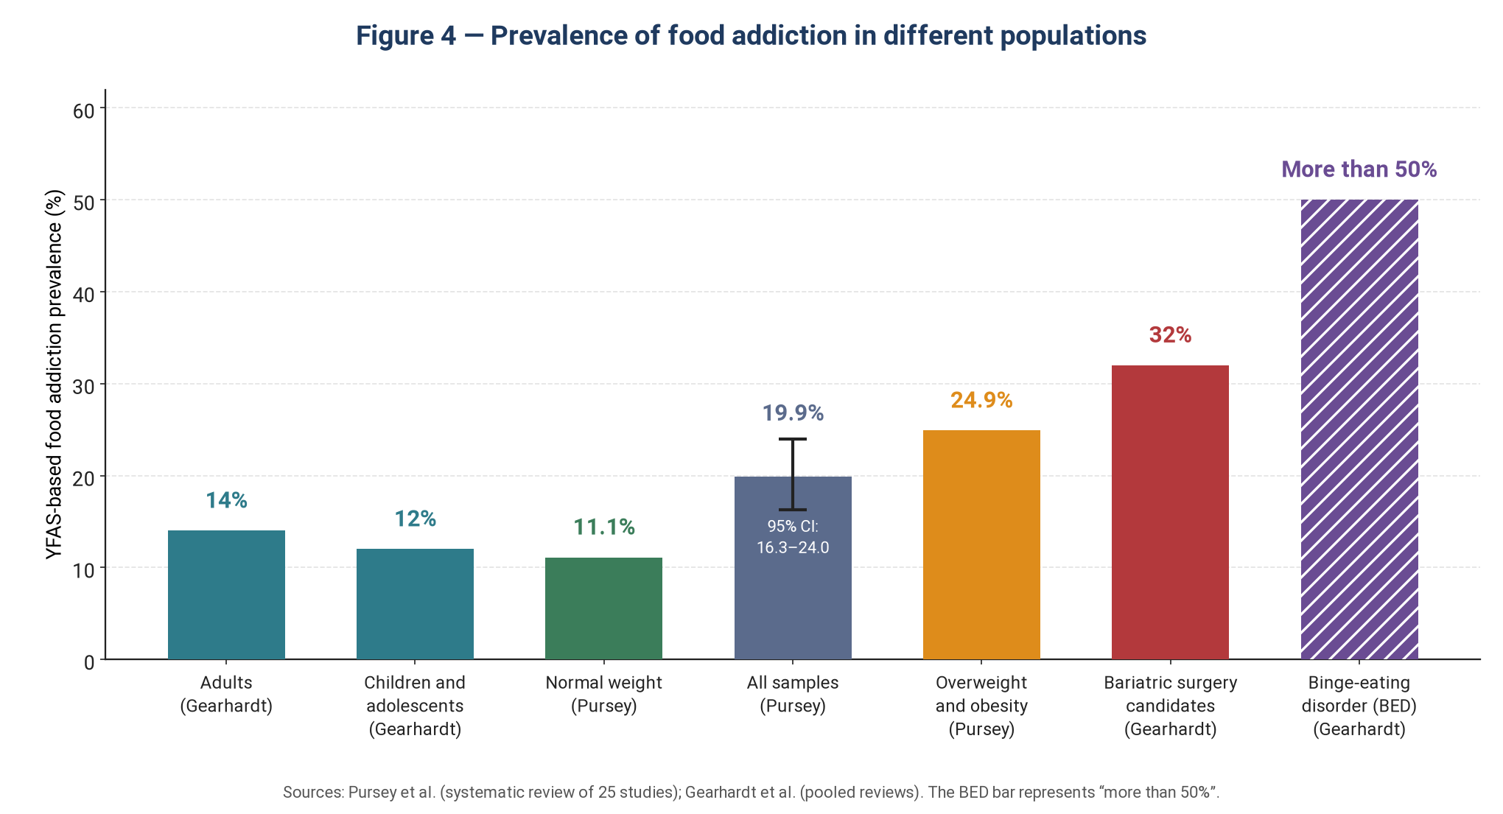
Figure 4 — Prevalence of YFAS-defined food addiction in different populations. These bars are not directly comparable with one another: the instrument version, threshold, sample type and reference population differ between studies. Sources: (10, 28).
Notably, there is serious methodological disagreement about some of these estimates. Meule (69), in a critique of the meta-analysis by Praxedes et al. (70), showed that the meta-analysis’s estimate of the prevalence of “food addiction” in people with bulimia nervosa was inconsistent with the results of individual studies; in many studies, the prevalence of YFAS-positive status in this group had been reported as above 80% and in some cases about 95% or higher. On this basis, he argued that the meta-analysis’s conclusion that the prevalence of “food addiction” is higher in people with binge-eating disorder (BED) is also probably incorrect (69). The importance of this critique increased with the publication of a correction by Praxedes et al.; the authors acknowledged that in some analyses of subgroups with eating disorders, the prevalence of the whole sample had been entered instead of the prevalence of the relevant subgroup, and as a result some pooled estimates were, in general, underestimated (70).
Interpretation and limitations of food addiction prevalence estimates: According to national NESARC-III data, the 12-month prevalence of alcohol use disorder among US adults was 13.9% and the 12-month prevalence of drug use disorder (excluding tobacco) was 3.9% (71, 72). This comparison must be read with serious caution, and placing 14% and 13.9% side by side should not be taken to mean that the two concepts are truly equivalent: alcohol use disorder is an official clinical diagnosis based on DSM-5 criteria that was assessed in NESARC-III with in-person structured interviews, whereas “food addiction” still has no official diagnostic status and is operationalized in research with self-report instruments such as the YFAS. In addition, the assessment period, assessment method and study population differ between these two estimates. Therefore, a valid comparison of the two concepts would require measuring them simultaneously, with comparable methods and instruments, in the same sample (71, 72).
Gearhardt et al. (10) rely precisely on this numerical parity to argue that the 14% prevalence of food addiction in adults, similar to the prevalence reported for some legal substances such as alcohol, merits policy attention; they also describe the 12% prevalence reported in children as “unprecedented” (10). However, this comparison cannot be regarded as equivalent to a diagnostic comparison: alcohol and tobacco use disorders are assessed within official diagnostic frameworks, whereas “food addiction” is not yet an official diagnosis and these estimates were obtained with YFAS instruments. Moreover, the time frame, assessment method and study population differ between these estimates. Therefore, the numerical closeness of these percentages cannot on its own indicate the same severity or clinical importance for these phenomena.

3.5 Which Foods Are Most Associated with Addictive-Like Eating?
One of the most cited and influential studies in this field is the research by Schulte, Avena and Gearhardt (27). In this study, participants in a forced-choice task among 35 foods identified those most associated with symptoms of addictive-like eating (27). The results showed that processed foods, especially those with more fat and refined carbohydrates and a higher glycemic load, were more strongly associated with addictive-like eating; in the second study, 9 of the 10 highest-ranked foods were processed and at the same time high in fat and refined carbohydrates (27). However, it should be noted that this study was conducted in 2015 and did not use the NOVA classification or the term “ultra-processed food” (UPF); therefore, its findings cannot be interpreted directly as evidence about UPFs; rather, the study provides preliminary evidence on the association of processing and food composition with addictive-like eating (27).
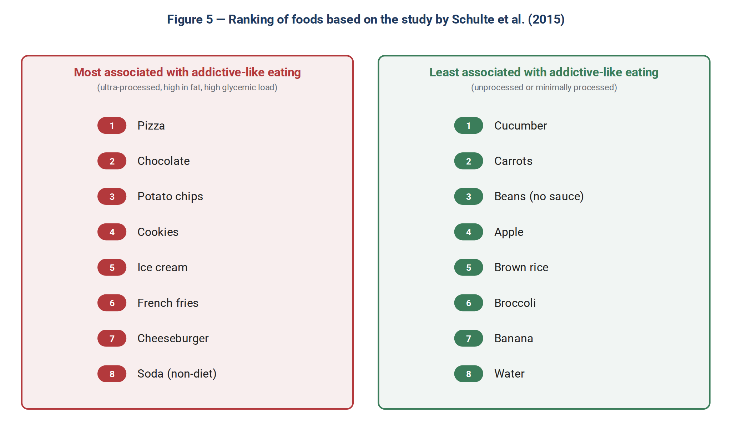
Figure 5 — Ranking of foods by their association with symptoms of addictive-like eating in the study by Schulte et al. Source: (27).
The significance of this finding goes beyond a simple list: Schulte et al. brought the “abuse potential” argument into the discussion of highly processed foods; in their view, increasing the dose of reinforcing ingredients and the speed of their absorption may increase the abuse potential of these foods (27). In addiction science, the speed and amount of delivery of a substance to the brain are important determinants of its abuse potential, although this phenomenon is not limited to a single property, and factors such as pharmacodynamic properties, reinforcing efficacy, half-life, individual characteristics and the context of use can also play a role. This framework has also been used in later reviews on food addiction to explain the hypothesis that ultra-processed foods, especially those containing high amounts of refined carbohydrates and added fat, can deliver reinforcing ingredients to the body at a higher dose and a faster rate (11, 12). Schulte and Gearhardt argue that industrial processing can alter these same two factors in foods: it can increase the amount or “dose” of fat and refined carbohydrates and accelerate the absorption of refined carbohydrates (11, 27). This is an analogy and not a pharmacokinetic equivalence: post-ingestive nutrient signaling and the processes of digestion and absorption of food are not the same as the absorption, distribution and central nervous system action of a psychoactive substance (30, 73).
In recent years, this same argument has shifted the focus of the debate from the general question “Is food addictive?” to a more precise question: “Can some food products, particularly highly or heavily processed foods, have addictive potential by virtue of their compositional properties and the way they deliver nutrients?” Gearhardt and Schulte, and subsequently Gearhardt and DiFeliceantonio, argue that the available evidence points more to the role of processed foods containing high amounts of refined carbohydrates and/or added fat in addictive-like eating than to food in general (11, 12). This reframing is one of the main points of connection between the two research lines of UPF and food addiction: attention has shifted from “food” in general to the properties of certain food products, particularly ultra-processed foods rich in refined carbohydrates and added fats (10, 12).

3.6 Withdrawal Syndrome
Withdrawal syndrome is one of the weaker links in the chain of argument. Schulte et al. developed the Highly Processed Food Withdrawal Scale (ProWS), which measures symptoms such as irritability, fatigue, restlessness and craving during attempts to cut down on these foods; in that study, symptom severity was generally highest on days 2 to 5 after reducing intake (74). However, the available evidence on withdrawal syndrome is still preliminary. YFAS-based studies have shown that food addiction is observed in about 32% of people with obesity who are candidates for bariatric surgery and in more than 50% of people with binge-eating disorder; however, these figures reflect the prevalence of food addiction according to YFAS criteria and should not be interpreted directly as the prevalence of withdrawal syndrome. Recent reviews also continue to describe the evidence on the experience of withdrawal after reducing UPF intake as preliminary (10, 13).
However, the fundamental methodological problem is that in humans it is very difficult to separate withdrawal symptoms from the consequences of a general energy deficit (that is, simply eating less) (32). If a person reduces their total calorie intake at the same time as eliminating sweets, their irritability cannot be attributed with certainty to “sugar withdrawal” (32, 73). Ziauddeen and Fletcher (32) regard this as one piece of evidence of the conceptual weakness of the construct and point out that in the study by Gearhardt et al. (75), about 55% of the sample endorsed withdrawal symptoms, even though they had not been given any clear operational definition of a “withdrawal symptom.” In addition, several other limitations overshadow this evidence: reliance on retrospective self-report, an expectancy effect in people who already believe they are “addicted,” the absence of an objective biomarker, an unclear time course of symptoms, and the non-specificity of the symptoms themselves—irritability, fatigue and craving are also seen in many other states (32, 73).
However, one fundamental methodological problem is that in humans it is difficult to determine whether the reported symptoms truly result from eliminating a particular food or from the general consequences of energy restriction and reduced calorie intake (32, 76). For this reason, to establish the existence of specific “withdrawal symptoms,” responses to restricting a specific food need to be distinguished from similar responses caused by calorie deficit. In this regard, Ziauddeen and Fletcher have emphasized the problems of defining and operationalizing the concept of withdrawal in the food domain; for example, in the YFAS the concept of withdrawal is not defined precisely and specifically (32).
In the study by Gearhardt et al., about 55% of obese individuals with binge-eating disorder endorsed the YFAS item on withdrawal symptoms (75); however, this finding was based on self-report and does not by itself show that these individuals experienced a specific and objective withdrawal syndrome (32, 76). Therefore, the available evidence on withdrawal from eliminating food or sugar still faces limitations such as ambiguity in the precise definition of symptoms, reliance on subjective reports and a lack of direct experimental evidence in humans. Westwater et al., reviewing the evidence on “sugar addiction,” have also emphasized the limited human evidence and the difficulty of determining whether the reported symptoms can be attributed to a specific nutrient or food (73).

4. Mechanisms: Why Do Ultra-Processed Foods Behave Differently?
If we want to go beyond statistical correlation and make a causal claim, we must offer a plausible biological mechanism. In this chapter, the proposed mechanisms are examined in four layers: product characteristics, physiological response, neural reward circuits and individual vulnerability factors.
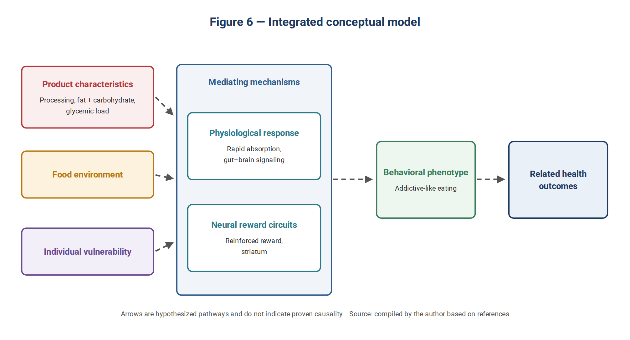
Figure 6 — Integrated conceptual model: the interaction of product characteristics, the environment and individual vulnerability is linked through mediating mechanisms to the behavioral phenotype and health outcomes. The arrows are hypothesized pathways and do not indicate proven causality. Source: compiled by the author based on references (11, 27, 47, 77–79).
Mechanisms: Why Do Ultra-Processed Foods Behave Differently?
If we want to go beyond statistical correlation and make a causal claim, we must offer a plausible biological mechanism. In this chapter, the proposed mechanisms are examined in four layers: product characteristics, physiological response, neural reward circuits and individual vulnerability factors.
Figure 6 — Integrated conceptual model: the interaction of product characteristics, the environment and individual vulnerability is linked through mediating mechanisms to the behavioral phenotype and health outcomes. The arrows are hypothesized pathways and do not indicate proven causality. Source: compiled by the author based on references (11, 27, 47, 77–79).

4.1 Speed of Nutrient Delivery
In addiction research, the speed at which a substance is delivered to the body and brain is one of the factors that can affect its reinforcing strength and addictive potential; in particular, routes and forms of use that allow faster delivery of the substance can produce stronger reinforcing effects (11, 12). Based on this framework, Schulte and Gearhardt have proposed that highly processed foods may, by rapidly supplying refined carbohydrates and other nutrients, create some of the features associated with rapid delivery of reinforcing substances. In this view, intensive processing—by altering the food matrix and reducing some of its components, including fiber—can contribute to faster consumption and availability of refined carbohydrates; however, this link has been put forward as a hypothesis about the reinforcing potential of highly processed foods and should not be regarded as a proven mechanism of addiction (11, 27). A simple example of the importance of the structure and physical form of food can be seen in the study by Haber et al. In this study, fiber-free apple juice was consumed much faster than whole apples, and the glucose and insulin responses also differed between the different forms of apple; compared with whole apple, apple juice was associated with a greater rise in insulin and a more pronounced rebound fall in glucose (80). However, this example should not be regarded as directly equivalent to a comparison between an ordinary food and an ultra-processed food within the NOVA framework, because NOVA classification is based on the degree and purpose of industrial processing, and fruit juice is not necessarily placed in the ultra-processed food group merely because it is liquid or has had its fiber removed (8). Therefore, the available evidence mainly supports a mechanistic, hypothesis-generating analogy: that is, the possibility that intensive processing and changes in the physical and compositional properties of food can alter the rate of consumption and nutrient availability and thereby affect the reinforcing properties of food. However, it cannot be concluded from this evidence that faster carbohydrate availability is by itself a proven mechanism for producing addiction to ultra-processed foods (30, 32).

4.2 The Supra-Additive Effect of Combining Fat and Carbohydrate
One of the important findings of recent research on food reward is the study by DiFeliceantonio et al. They showed that foods containing a combination of fat and carbohydrate, compared with foods containing mainly one of these two macronutrients, were associated with a higher willingness to pay and a greater response in brain regions involved in reward valuation, including the striatum. This effect was described as supra-additive; that is, the effect of the fat–carbohydrate combination on the reward value of food was greater than would be expected from the effect of either macronutrient alone. This difference was observed when the foods were comparable in familiarity, reported liking and calorie content, and the interactive effect of fat and carbohydrate persisted after controlling for these factors (77).
The evolutionary explanation proposed for this finding is that natural foods containing high amounts of both fat and carbohydrate have been relatively less available than many modern food products; to illustrate this point, the authors refer to the combination of fat and carbohydrate in breast milk compared with some processed foods. According to this view, the systems that regulate reward and energy intake may have a different sensitivity or adaptation when exposed to combinations very rich in fat and carbohydrate. However, this explanation is a proposed evolutionary hypothesis, not a finding directly tested in a human study (47, 77). Accordingly, products such as chocolate, ice cream, pizza and donuts, which usually contain substantial amounts of both fat and carbohydrate, have attracted attention in discussions of the modern food environment and the potential effect of this combination on food reward. However, the presence of this combination does not by itself mean that a product is ultra-processed, and the “supra-additive effect” observed in the experiment by DiFeliceantonio et al. should not be regarded as directly equivalent to an addictive effect of ultra-processed foods (27, 77). Small and DiFeliceantonio have placed these findings within the broader debate on processed foods and food reward. Their paper raises the possibility that the properties of some processed foods, including the combination of fat and carbohydrate, may influence signals related to nutritional value and reward in a way that differs from the mechanisms regulating energy intake in a natural food environment. This explanation should be regarded as an interpretive and hypothesis-generating framework, not an established biomarker or proven mechanism of addiction to ultra-processed foods (47).

4.3 Dopaminergic Circuits and Competing Theories
The landmark study by Wang, Volkow et al., using PET imaging, showed that striatal dopamine D2 receptor availability was lower in individuals with obesity than in those of normal weight. However, this study was cross-sectional, and therefore no conclusion can be drawn from it about whether this change precedes obesity or about a causal relationship between reduced D2 receptors and overeating. Moreover, this finding does not by itself show that the observed changes specifically reflect an addictive process (41, 45). In some neurobiological models, this finding has been interpreted within the framework of “reward deficiency syndrome”; according to this view, reduced dopaminergic function may lead a person to seek more reward—for example, energy-dense food—to achieve the desired level of reward. However, this interpretation is only one of the proposed models, and reduced D2 receptors cannot on their own be considered conclusive evidence of such a mechanism (45, 81). In the animal model of Johnson and Kenny, rats with access to a cafeteria diet also showed reduced striatal D2 receptor availability and increased addiction-like behaviors; for example, when consumption of palatable food was paired with an unpleasant consequence, some animals continued to eat. These findings were interpreted as evidence of a link between impaired D2 signaling, reduced reward sensitivity and compulsive feeding behavior, but because of the animal nature of the study, they cannot be regarded as directly equivalent to food addiction in humans (43).
However, this interpretation is not without rivals. Robinson and Berridge’s “incentive sensitization” theory offers a different model: repeated use can sensitize brain systems to reward-related cues and increase “wanting,” without a similar increase in “liking.” In this framework, the motivation to obtain a reward can become dissociated from the pleasurable experience of consumption; put simply, a person may “want” something more without necessarily “liking” it more (78). A third model, the transition from goal-directed behavior to habit and then compulsion proposed by Everitt and Robbins, emphasizes a gradual shift in the control of behavior. In this model, with continued use and learning, control of reward-seeking and reward-taking behavior can shift from goal-directed processes to habit-based behaviors, and in more advanced stages dorsal striatal circuits play a more prominent role. Therefore, unlike the reward deficiency model, increased compulsive behavior does not necessarily mean that the person simply needs more reward to compensate for reduced pleasure; rather, it can result from a change in how behavior is controlled and from the reduced sensitivity of habitual behavior to its consequences (79).
These three models are not fully aligned and have different emphases and predictions in explaining the mechanism of compulsive behavior. The “reward deficiency” model rests on the assumption that reduced reward sensitivity can drive a person to consume more to reach the desired level of reward; by contrast, the habit-transition model emphasizes that, as habitual behavior forms, the control of behavior can become partly independent of the value of the reward outcome, so that behavior continues even after the reward has been devalued (45, 79). Fletcher et al. have also emphasized the need for caution in interpreting the evidence on “food addiction” and have shown that selective reliance on findings consistent with a particular theoretical model, without regard to limitations and inconsistent evidence, can lead to an artificial strengthening of this construct. Therefore, the existence of findings supporting any one of these models cannot by itself be regarded as evidence confirming a single, definitive framework for food addiction (32, 45).

4.4 The Opioid and Endocannabinoid Systems
Whereas dopamine is associated more with the “wanting” dimension and motivation toward reward, the endogenous opioid system plays a role in the experience of “liking” and the sensory pleasure of rewards, including food. This distinction is part of the theoretical framework of incentive sensitization, which differentiates between the motivational processes of “wanting” and the pleasurable experience of “liking” (78, 82). Genetically, too, some variants of genes related to reward systems have been linked to eating behaviors and eating disorders. For example, the A118G variant of the μ-opioid receptor gene (OPRM1) and the Taq1A variant of the DRD2 gene have been examined in human studies in relation to differences in food-reward-related behaviors and binge-eating disorder. However, these findings do not by themselves show that these variants cause binge-eating disorder or that a shared genetic mechanism between binge eating and substance addiction has been conclusively established (82). In the supportive literature, this overlap has been put forward as one piece of possible evidence for shared pathways between addictive-like behaviors and eating disorders, but the weight of this evidence should not be exaggerated. Findings from candidate-gene studies—particularly on polymorphisms such as DRD2 Taq1A—have faced problems including sample-size effects and difficulty replicating some findings. Therefore, the existence of a robust genetic overlap cannot be concluded from these studies alone (83); for a stronger claim about genetic overlap between different disorders, genomic approaches such as GWAS, polygenic scores and estimates of genetic correlation carry greater weight. However, direct genomic evidence confirming a specific genetic overlap for the “food addiction” construct remains limited, and candidate-gene findings cannot be regarded as equivalent to large-scale genomic evidence (84).
The endocannabinoid system also plays a role in regulating food intake and processes related to food reward, and the CB1 receptor has been one of the pathways of interest in this regard. The available evidence shows that activation of the cannabinoid system can affect the motivation to eat and the hedonic aspects of eating; however, these findings do not in themselves indicate the existence of a specific mechanism of addiction to ultra-processed foods (81). The pharmacological experience with rimonabant also illustrated the complexity of intervening in this pathway. This CB1 receptor antagonist was associated in clinical studies with weight loss and some metabolic benefits, but because of an increased risk of psychiatric adverse effects, including depression and suicidal ideation, its clinical use ran into serious problems and it was eventually withdrawn from the European market. This experience showed that pharmacological targeting of pathways related to food reward and the endocannabinoid system, even when metabolic effects are observed, can be accompanied by important safety limitations (85).

4.5 Evidence from Incretin-Based (GLP-1) Drugs
The emergence of incretin-based drugs has added new evidence to this debate. This class is not uniform: semaglutide is a GLP-1 receptor agonist, whereas tirzepatide is a dual GIP and GLP-1 receptor agonist and differs pharmacologically and in its pattern of effects from selective GLP-1 agonists (86, 87). In a small trial, semaglutide, in addition to reducing appetite and energy intake, was associated with reduced food craving and a change in preference for some high-fat, energy-dense foods. In a small trial, semaglutide, in addition to reducing appetite and energy intake, was associated with reduced food craving and a change in preference for some high-fat, energy-dense foods. In this study, 30 individuals with obesity were enrolled, and after 12 weeks of treatment, reduced food craving and better control of eating were observed (86). These findings can therefore be regarded as evidence of an effect of semaglutide on eating behavior and motivation, but not as evidence specific to “food addiction.”
In a small randomized trial of 48 individuals with alcohol use disorder, weekly semaglutide reduced alcohol consumption in a laboratory self-administration test, reduced the number of drinks per drinking day and reduced weekly craving compared with placebo; however, the number of drinking days and the mean number of drinks per calendar day did not differ significantly (88); the authors themselves regarded these findings as preliminary evidence and emphasized the need for larger trials; therefore, the sample size and the preliminary nature of the study should be taken into account when interpreting the results (88).
These findings can be read in two ways. The supportive reading is that if a drug can affect motivation and craving for food as well as some indicators of alcohol consumption, this raises the possibility that some of the neural mechanisms regulating reward and motivation are shared between these behaviors (11, 12). This interpretation is consistent with the literature emphasizing similarities between addictive-like eating behaviors and substance use disorders; however, similarity in response to a drug does not by itself establish a shared mechanism or the “addictive” nature of a behavior.
The more cautious reading is that a reduction in craving for, or consumption of, a substance does not necessarily imply the existence of “addiction,” and the human evidence on the validity of the food addiction construct still requires cautious interpretation (32). Moreover, animal findings on the effect of semaglutide on the dopamine system do not show a simple, uniform pattern. In a study in mice, semaglutide at a dose of 1 mg/kg, while reducing sucrose intake, increased the activity of ventral tegmental area dopaminergic neurons during reward receipt but did not change the activity related to the reward-predicting cue (89); in another study in male rats, semaglutide reduced the alcohol-induced increase in dopamine in the nucleus accumbens shell and was associated with increased dopamine metabolism in this region (90); therefore, the effect of semaglutide cannot be explained by a simple pattern such as “reduced dopamine signaling.” In addition to reward pathways, GLP-1 agonists affect several components of eating regulation, including appetite, satiety, energy intake and food preference; thus, the observation of reduced craving after these drugs does not in itself indicate that the effect results from a specific change in an “addiction” circuit (86); consequently, these findings are best regarded as hypothesis-generating: they raise the possibility of links between incretin pathways, reward regulation, craving and addictive-like behaviors, but they do not by themselves establish the validity of the concept of “food addiction,” or specifically of “ultra-processed food addiction.”

4.6 Energy Density versus Palatability: A Live Debate
One important question in explaining the higher energy intake on ultra-processed diets is to what extent this effect relates to specific food properties such as energy density, eating rate and palatability. The available evidence indicates that the degree of processing alone cannot explain all of the observed differences in energy intake, and the physical and sensory properties of food must also be considered (16). In the trial by Hall et al., the ultra-processed and minimally processed diets were matched for presented energy, macronutrients, sugar, sodium and fiber; nevertheless, in practice the ultra-processed diet had a higher energy density of the non-beverage portion of the food and a faster rate of energy intake. On the ultra-processed diet, participants consumed on average about 508 kcal/day more, and the rate of energy intake was about 48 versus 31 kcal per minute (16). Therefore, the energy density of the non-beverage portion and the eating rate have been proposed as possible explanations for the difference in energy intake, but the trial itself was not designed to causally separate these mechanisms from the effect of the “degree of processing” (16). Independent evidence also shows that energy density is an important determinant of energy intake: when people tend to eat a relatively constant amount of food, increasing the energy per gram can lead to higher energy intake; conversely, reducing energy density, without necessarily reducing volume or increasing conscious restraint, can reduce energy intake (91). However, this general finding about energy density should not be turned directly into the conclusion that “energy density is the cause of the UPF effect,” because in the Hall study the non-beverage energy density and the eating rate both changed together with processing status (16).
Subsequent studies have further complicated this issue. In the trial by Dicken et al., ultra-processed and minimally processed diets were compared within the framework of the UK dietary guidelines, but the ultra-processed diet was more energy-dense; in addition to energy density, the authors proposed differences in eating rate and in sensory properties and palatability as potential factors influencing energy intake (23). Therefore, this study did not test the “degree of processing” as a single factor independent of the physical and sensory properties of food either (23). From this perspective, the important methodological conclusion is that the Hall and Dicken studies should not be interpreted as if they had tested the “UPF effect” independently of energy density, eating rate or palatability. The minimally processed and ultra-processed diets in these experiments were bundles of food properties that differed simultaneously; therefore, it cannot be concluded from these studies that the observed effect is due solely to energy density (16, 23).
Consequently, energy density can currently be regarded as one of the important and testable hypotheses for explaining overconsumption on ultra-processed diets, but not as a definitive factor or an exclusive explanation. Eating rate, textural properties and palatability are also in play alongside it, and more recent evidence has even raised the possibility of an independent effect of eating rate on predominantly ultra-processed diets. Therefore, the more precise scientific question is not “UPF or energy density?” but rather: what share of the increase in energy intake attributed to UPF can be attributed to energy density, eating rate, sensory properties and other features of the formulation?

5. Human Evidence: UPF Outcomes and Direct Evidence on Addictive-Like Eating

5.1 The Clinical Trial by Hall et al.
This study (16) is one of the most important pieces of experimental evidence on the effect of an ultra-processed diet on ad libitum energy intake and short-term weight change, but it is not direct evidence on addictive-like eating. Twenty adults, with a mean age of 31.2 years and a mean BMI of about 27, were admitted for four weeks to a controlled clinical setting and, in random order, received an ultra-processed diet for two weeks and a minimally processed diet for two weeks (16). An important feature of the study design was that the two diets were largely matched for presented energy, sugar, fat, carbohydrate, protein, fiber and sodium, while participants could eat as much of the food offered as they wished (16). However, this matching did not mean that all the physical and sensory properties of the diets were identical. The overall energy density of the diets was similar by design, but when beverages were excluded, the energy density of the non-beverage portion was higher on the ultra-processed diet. In addition, the eating rate—that is, the number of kilocalories consumed per minute—was higher on the ultra-processed diet (16). Therefore, the difference between the two diets was not limited to the “degree of processing”; there were also differences in the physical and structural properties of the food—an issue that limits the mechanistic interpretation of the findings.
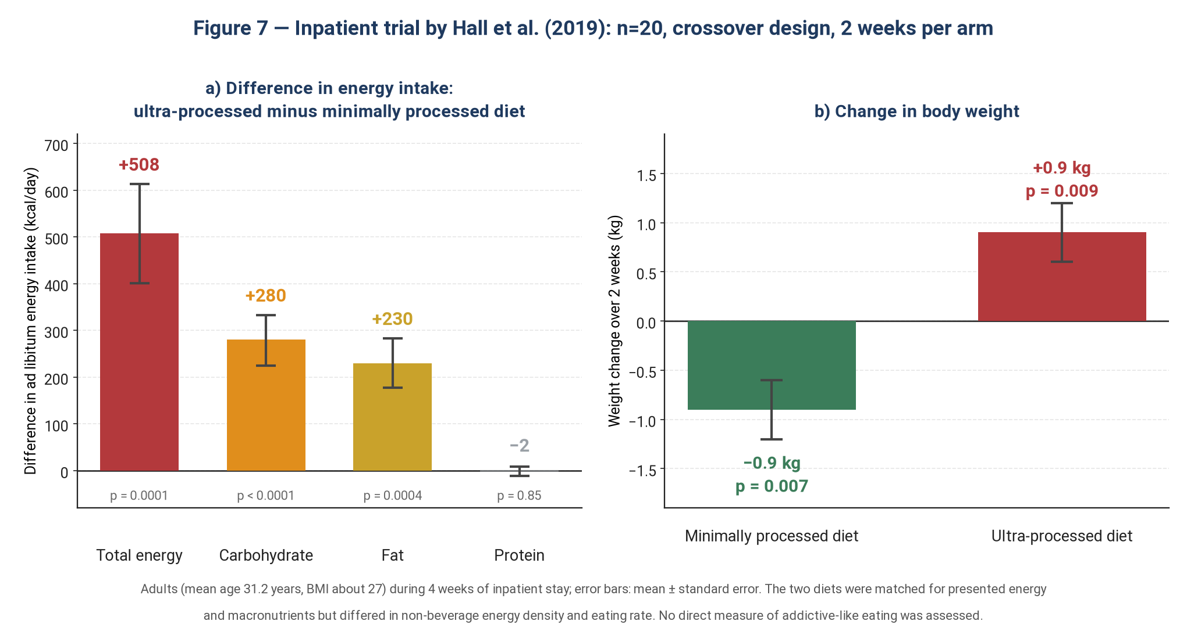
Figure 7 — Results of the clinical trial by Hall et al.: ad libitum energy intake and change in body weight (error bars as reported in the original paper). Source: (16).
The main result was striking: on the ultra-processed diet, participants consumed on average about 508 kcal/day more and gained about 0.9 kg over two weeks, whereas they lost about 0.9 kg during the minimally processed diet period. This increase in energy intake came mainly from carbohydrate and fat; by contrast, protein intake did not differ appreciably (16). This pattern is consistent with the “protein leverage hypothesis,” according to which the body may increase food intake when protein intake is insufficient; however, the Hall study was not designed to test this hypothesis directly, and its finding alone cannot confirm the protein leverage hypothesis (16, 92).
Important limitations: the small sample size (20 people), the short intervention (two weeks per diet), the conduct of the study in a fully controlled inpatient setting, and the simultaneous differences between the diets—including differences in the energy density of the non-beverage portion, eating rate and textural properties—limit the generalizability of the results and the ability to separate the independent effect of the “degree of processing” from other properties of the diet. In addition, because the main outcomes of the study were energy intake and weight and no direct measure of “addictive-like eating” was used, no direct conclusion can be drawn from this trial about the presence or absence of food or UPF addiction (16).

5.2 The Crossover Trial by Dicken et al.
The most recent trial-based evidence is the study by Dicken, Batterham et al. (23). In this randomized crossover trial, 55 adults in England were enrolled and 50 were included in the intention-to-treat analysis. Participants had a BMI from 25 to less than 40 kg/m² and a habitual UPF intake of at least 50% of daily energy. They received two eight-week ad libitum diets in random order, with a four-week washout period between them (23).
Both diets were designed according to the official UK dietary guidance (Eatwell Guide); one relied mainly on minimally processed foods and the other on ultra-processed foods (23); both diets led to weight loss, but weight loss was greater on the minimally processed diet: a relative weight change of −2.06% versus −1.05% on the ultra-processed diet; the difference between the diets was −1.01% (95% CI: −1.87 to −0.14; p=0.024) (23). Fat mass reduction was also greater on the minimally processed diet, and some measures of food craving changed in the same direction (23).
The importance of this study lies in showing that even when both dietary patterns are designed within an official dietary guideline and on similar nutritional principles, a difference in the level of processing can be associated with a difference in weight outcome (23). However, this finding does not by itself show that the “degree of processing” is the independent cause of the observed difference, because the two diets also differed in a set of food properties, including energy density, eating rate and some sensory and structural properties. Therefore, as in the Hall study, the independent effect of processing cannot be separated from all of its accompanying properties in this trial. From a nutrition policy perspective, the study’s finding raises the possibility that recommendations based on nutrient composition and food groups may not capture all dimensions of the difference between ultra-processed and minimally processed diets (23). This is consistent with the broader debate on the place of the “degree of processing” in dietary guidelines. A global analysis of 106 dietary guidelines showed that nutrient-based messages are far more common than explicit messages about the level of processing, and only some guidelines refer specifically to ultra-processed foods (93). The Dicken study can therefore be regarded as one of the new pieces of evidence in the debate on whether the level of processing should be considered alongside traditional nutritional criteria when developing dietary recommendations, rather than as proof on its own that national guidelines must be changed.

5.3 The Umbrella Review by Lane et al.
This umbrella review (17) is one of the most comprehensive available assessments of the meta-analytic evidence on the health outcomes of ultra-processed food consumption. It included 14 meta-analyses and 45 pooled analyses, which together involved 9,888,373 participations in the analyses; this figure is not the number of unique individuals, because a single study or cohort may have been included in several analyses and for several outcomes (17). Of the 45 analyses, 32 (71%) showed a direct association between higher UPF consumption and a higher risk of the outcome examined (17).
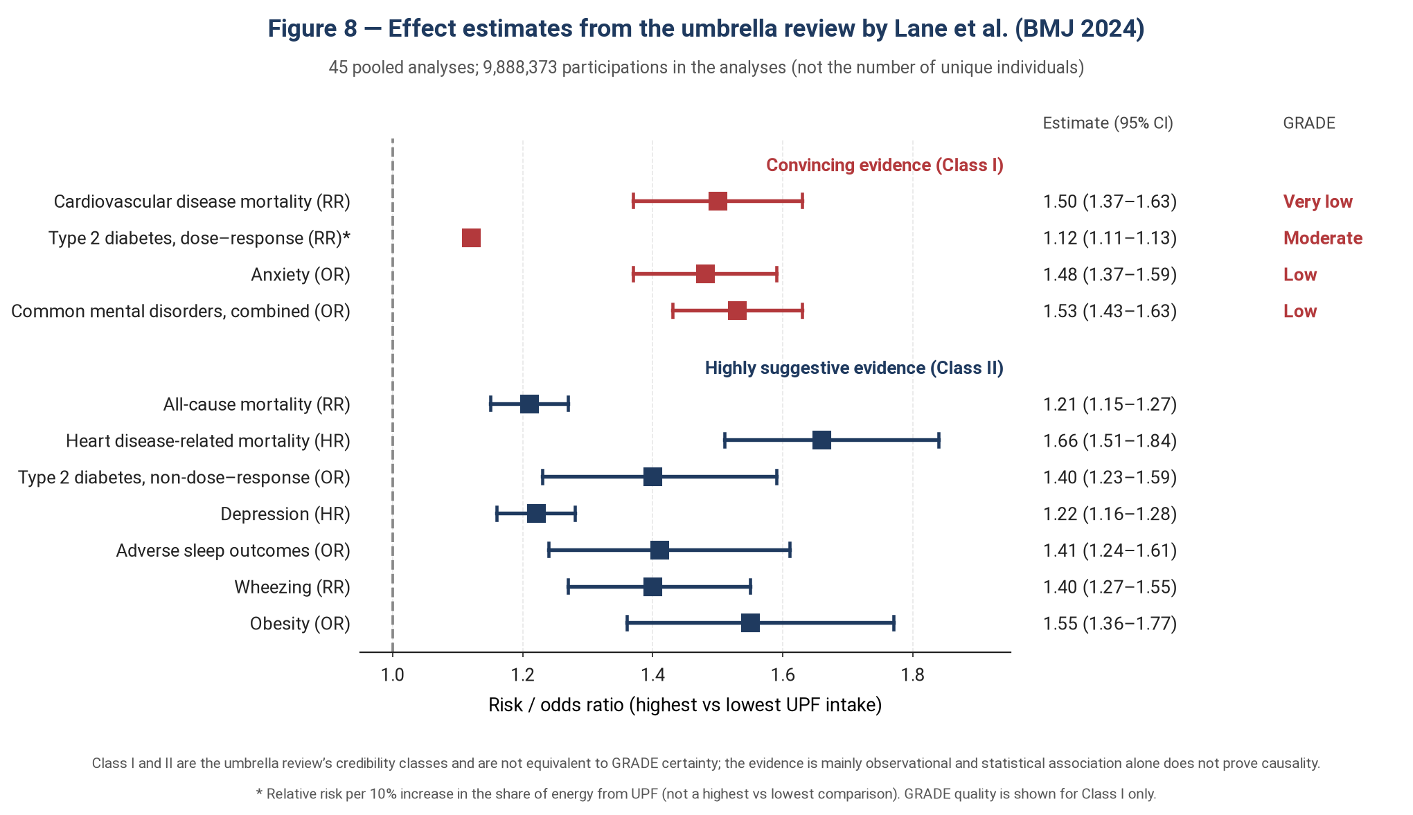
Figure 8 — Effect estimates from the umbrella review by Lane et al. Class I and Class II are the umbrella review’s evidence classes (“convincing” and “highly suggestive,” respectively) and are not equivalent to GRADE certainty. Source: (17).
According to the evidence classification system used in this umbrella review, Class I or “convincing” evidence was obtained for four outcomes: cardiovascular disease-related mortality (risk ratio 1.50; 95% CI: 1.37 to 1.63), type 2 diabetes in the dose–response analysis (risk ratio 1.12 per 10% increase in the share of energy from UPF; 95% CI: 1.11 to 1.13), anxiety (odds ratio 1.48; 1.37 to 1.59) and combined common mental disorders (odds ratio 1.53; 1.43 to 1.63) (17). Class II or “highly suggestive” evidence was reported for all-cause mortality, heart disease-related mortality, type 2 diabetes in the non-dose–response analysis, depression, adverse sleep outcomes, wheezing and obesity. However, a very important methodological distinction should not be overlooked: “Class I” in the classification system used in this umbrella review is not equivalent to “high certainty” in the GRADE system. For example, although the association with cardiovascular disease-related mortality was placed in Class I, its quality of evidence was rated “very low” according to GRADE; for type 2 diabetes in the dose–response analysis, GRADE was “moderate,” and for anxiety and common mental disorders it was “low.” Overall, of the 45 analyses, 22 had low quality according to GRADE, 19 very low quality and only four moderate quality, and none reached the “high” level (17).
This difference arises because the two systems do not assess the same question. The classification used in umbrella reviews assesses the credibility or statistical robustness of an association on the basis of a set of predefined criteria, whereas GRADE assesses the overall quality of the evidence, taking into account factors such as study design, risk of bias, heterogeneity, imprecision and other limitations of the evidence (17, 26). Therefore, large numbers and a “convincing” classification should not be interpreted without regard to the quality of the evidence. In particular, because the evidence in this review comes mainly from observational studies, a strong statistical association between UPF consumption and an outcome does not by itself prove a causal relationship (17). Hence, presenting the effect size, the evidence credibility class and the GRADE quality level together is essential for a balanced interpretation of these findings.

5.4 Prospective Cohorts
Prospective cohort studies make up an important part of the observational evidence on the outcomes of ultra-processed food consumption. In the French NutriNet-Santé cohort (24) of 104,980 participants, each 10% increase in the share of energy from UPF was associated with a 12% increase in overall cancer risk (HR=1.12; 95% CI: 1.06 to 1.18) and an 11% increase in breast cancer risk (HR=1.11; 1.02 to 1.22). These associations remained statistically significant after adjustment for several indicators of nutritional quality. This finding is not fully consistent with the simple explanation that UPF is merely a marker of poor overall diet quality; however, statistical adjustment cannot completely eliminate the possibility of residual confounding or measurement error in dietary intake, and the observational nature of the study precludes causal inference (24). Similar findings have also been reported in some other large cohorts, including UK Biobank and Moli-sani, and are reflected in more comprehensive reviews of the UPF evidence (17). By contrast, the results have not been the same in all populations and for all cancer sites. For example, the prospective EPIC study examined the association between consumption of processed and ultra-processed foods and cancer risk at 25 anatomical sites, and the pattern of association was not the same for all cancer types (94). Therefore, the cohort evidence as a whole supports an association between higher UPF consumption and some adverse outcomes, but the heterogeneity across outcomes and populations must still be taken into account in interpreting it.
In Iran, new prospective data have also been published from the Tehran Lipid and Glucose Study. In the prediabetes analysis, 1954 participants were included, and 766 cases of prediabetes were identified over a median follow-up of 7 years. Compared with the lowest tertile of UPF consumption, the risk of prediabetes was higher in the highest tertile (HR=1.28; 95% CI: 1.07 to 1.52), and in the continuous analysis each 10% increase in the share of energy from UPF was associated with a 12% increase in the risk of prediabetes (HR=1.12; 1.02 to 1.23). This association did not change appreciably after further adjustment for diet quality (25). However, in the type 2 diabetes analysis, which included 2457 people, no significant association was observed between UPF consumption and the incidence of type 2 diabetes (25). Therefore, like many observational studies, the Iranian study does not provide uniform evidence for all metabolic outcomes.
Table 3 — Summary of key human evidence on ultra-processed foods
Study | Design | Sample size | Main finding | Study design and certainty
Hall et al. (16) | Crossover clinical trial | 20 people | About 508 kcal/day higher intake; about 0.9 kg weight gain versus 0.9 kg weight loss | Controlled trial; small sample size and short duration
Dicken et al. (23) | Community-based crossover trial | 55 enrolled; 50 in the ITT analysis | Weight loss of 2.06% on the minimally processed diet versus 1.05% on the ultra-processed diet (difference −1.01 percentage points) | Crossover trial; sample mostly women with overweight/obesity
Lane et al. (17) | Umbrella review of meta-analyses | ≈9.9 million participations in the analyses | Association of higher UPF consumption with 32 of 45 outcomes | Mainly observational evidence; GRADE quality mostly low or very low
Fiolet et al. (24) | Prospective cohort | 104,980 people | 12% increase in overall cancer risk per 10% increase in the share of UPF | Observational study; possible confounding and dietary measurement error
Moslehi et al., TLGS (25) | Prospective cohort | 1954 people for prediabetes; 2457 people for type 2 diabetes | HR=1.28 for prediabetes, highest versus lowest level of intake; no significant association with type 2 diabetes observed | Iranian population; results were not the same for prediabetes and type 2 diabetes.

5.5 Direct Evidence on Addictive-Like Eating: An Obvious Gap
Almost all of the evidence above, including the Hall trial, the Dicken trial, the Lane umbrella review and the large cohorts, answers question (a) of Box 1: the effect of UPF on energy intake, weight and health outcomes (16, 17, 23, 24). None of these studies examined addictive-like eating or the YFAS score as an outcome.
Human evidence that directly examines the relationship between food-processing characteristics and addictive-like eating is far scarcer and consists mainly of YFAS-based cross-sectional studies and early research on food characteristics. For example, Schulte et al. showed in a cross-sectional study that highly processed foods, especially those containing higher amounts of fat and refined carbohydrates, were more strongly associated with the addiction-like behaviors described in the YFAS; however, this study relied on participants’ own rankings and reports about foods and did not constitute an experimental test of UPF addiction (27). Experimental evidence on reward responses to food combinations also exists, but these studies did not necessarily measure addictive-like eating as the primary outcome (77).
Consequently, the available evidence must distinguish between two levels of claim: first, relatively extensive evidence on the association of UPF with energy intake, weight and health outcomes; and second, much more limited evidence on whether these foods directly induce behaviors with addictive-like features. Recent reviews in the field of UPF addiction also show that this line of research is still developing and that direct evidence on specific mechanisms and interventions remains limited (13). Therefore, the link between the two research lines of UPF and food addiction currently rests less on direct human evidence of a causal relationship than on a combination of behavioral evidence, food characteristics and plausible biological mechanisms. Stating this gap explicitly is essential to prevent indirect evidence from being turned into a proven claim about “UPF addiction.”

6. Discussion: Two Competing Narratives
In this chapter, the arguments of the two camps are set side by side systematically.

6.1 The Supportive Camp: The Four-Criterion Framework
Gearhardt and DiFeliceantonio (12) used a different framework: instead of an abstract debate about “addictiveness,” they used a set of scientific criteria that had also been used to assess the addictiveness of tobacco. The 1988 Surgeon General’s report set three main criteria for assessing the addictiveness of tobacco products: compulsive use, psychoactive effects and reinforcement; “triggering strong cravings” was later added to this framework as addiction science advanced (14, 95):
1) Compulsive use: use despite a desire to stop and repeated unsuccessful attempts to cut down (12).
2) Psychoactive effect: producing a change in mood or mental state through effects on the brain (12).
3) Reinforcing effect: the ability of the substance to reinforce consumption behavior and increase the likelihood of its repetition (12).
4) Triggering strong cravings: producing a strong and recurrent desire or urge to consume; a criterion that Gearhardt and DiFeliceantonio added to the three main criteria of the 1988 report on the basis of later advances in addiction science (12).
Their argument is that highly processed foods can meet all four criteria and can therefore be regarded as substances with addictive potential using the same scientific framework applied to assess the addictiveness of tobacco (12). They also argue that searching for a “single active ingredient” is not necessary to explain the addictiveness of these foods, because properties of the final product, including the speed of delivery, sensory properties and other factors related to how active compounds are delivered, can play a role in the addictive potential of tobacco. From this perspective, a focus solely on a single chemical compound is not sufficient to explain the addictive behavior of complex products such as tobacco or highly processed foods (12).

6.2 The Critical Camp
Critics have three main lines of argument.
First, the problem of the addictive agent. Ziauddeen and Fletcher (32) argue that the evidence for the existence of food addiction in humans is limited and that one of the fundamental problems of the model is that the nature of the addictive agent is unspecified. Should sugar, fat, a particular combination of nutrients or some other property of food be regarded as the main agent? In their view, the lack of a clear answer to this question limits the explanatory power and neurobiological grounding of the model (32).
Second, the heterogeneity of human neuroimaging evidence. In a critical review of the neuroimaging evidence on obesity and overeating, Ziauddeen et al. reported weaknesses and inconsistencies in the human findings and concluded that the existing evidence does not provide a coherent neurobiological picture of the food addiction model. They also warned against the selective interpretation of imaging findings to bolster the addiction model (45).
Third, the terminological problem. Hebebrand et al. (30) argue that the term “eating addiction” is more accurate than “food addiction,” because what should be regarded as the addictive-like phenomenon in this framework is the behavioral pattern of eating, not a specific food substance. They consider the evidence for a “substance-based food addiction” to be weak, but regard human and animal data as compatible with a form of addictive-like eating behavior. Accordingly, they propose that this phenomenon be examined within the framework of behavioral addictions or non-substance-related disorders (30).
Fletcher and Kenny, in a direct debate on the validity of the concept of food addiction, also illustrated the fundamental disagreement between the two interpretations. Fletcher emphasized the limitations of the evidence and the problems of transferring the features of substance addiction to eating behavior, whereas Kenny emphasized behavioral and neural similarities between some eating patterns and substance addiction (96). Westwater, Fletcher and Ziauddeen, in a dedicated review of “sugar addiction,” also concluded that human evidence for sugar addiction is scant and that the available animal evidence depends mainly on intermittent-access patterns to sugar; therefore, directly generalizing these findings to sugar addiction in humans is not justified (73).
The intensity of this disagreement can also be seen in the formal 2021 debate, in which Gearhardt and Hebebrand presented their arguments in two opposing papers, one defending the usefulness of the concept of “food addiction” and the other criticizing it (29, 31). The importance of this debate is that the disagreement is not limited to the presence or absence of particular findings, but also concerns the validity of the “food addiction” construct, how behavioral and neurobiological evidence is interpreted, and the consequences of using this framework for understanding and treating overeating and obesity (29, 31).
Table 4 — Arguments for and against the concept of food addiction
Domain | Supportive view | Critical view
Addictive agent | Processed food properties, including nutrient combinations, the speed at which they are delivered and the properties of the food matrix, can increase reinforcing potential and compulsive consumption (11, 12) | No specific agent or compound that could be regarded as equivalent to an addictive agent in substances has been identified; this is one of the fundamental limitations of the food addiction model (32)
Neural evidence | Evidence of overlap in some reward circuits and dopaminergic mechanisms between eating and substance addiction has been reported; some studies have also examined DRD2 and OPRM1 markers in relation to differences in food reward. The combination of fat and carbohydrate can also produce a reward response beyond the effect of either alone (77, 81, 82) | Human imaging findings on obesity, overeating and reward circuits are heterogeneous and in some cases contradictory, and do not provide a coherent neurobiological picture for the food addiction model (45)
Withdrawal syndrome | Development of the ProWS has shown that people who have cut down on highly processed foods report self-reported withdrawal symptoms; this finding has been put forward as preliminary evidence for examining the possible existence of withdrawal symptoms in this domain (74) | It is unclear whether these symptoms can be separated from the general consequences of reduced energy intake or dietary restriction; therefore, the existence of a specific withdrawal syndrome has not yet been established (32)
Terminology | The term “food addiction” emphasizes the role of the properties of the food itself and of the food environment in creating compulsive consumption patterns and can have important social and policy implications (10, 12) | “Eating addiction” is considered more accurate, because in this view it is the eating behavior that is addictive-like, not a specific food substance (30)
Diagnostic status | The absence of an official diagnosis does not necessarily mean the absence of the phenomenon, and diagnostic frameworks have changed over time; gambling is an example of an addictive-like behavior that has found a place in diagnostic classifications (29) | The available evidence is not considered sufficient to recognize “food addiction” as an independent diagnosis, and the concept has not been accepted as an independent diagnosis in DSM-5-TR or ICD-11 (31, 33, 34)
Policy implication | The UPF addiction framework can support new policy approaches, including interventions targeting the food environment (10) | Using a concept whose validity and diagnostic status are still disputed as an independent basis for policymaking may be premature (31)
Effect on stigma | In some studies, the food addiction framework has been associated with reduced blame and stigma toward people with obesity; it may therefore reduce perceived personal responsibility in some contexts (97) | Belief in food addiction can affect how individuals interpret their eating behavior and their attempts at dietary restriction and, in some circumstances, can be associated with adverse behavioral consequences (98)

6.3 Alternative Explanations
- Before accepting the addiction model, simpler explanations must be ruled out. There are at least four competing explanations, each of which accounts for part of the data:
- Energy density hypothesis: increased energy density can increase energy intake for the same volume or weight of food; the concept of addiction is not needed to explain this effect (91).
- Protein leverage hypothesis: dilution of protein in the diet can drive a person to consume more energy in order to reach a protein target (92)—Hall’s finding (16) that absolute protein intake remained constant is consistent with this model, although the authors themselves estimated that this mechanism alone cannot explain the entire observed increase in energy intake.
- Eating rate hypothesis: a soft texture and less need for chewing can increase eating rate, and a faster eating rate is associated with higher energy intake (51).
- Restraint–binge model: a cyclical pattern of dietary restriction followed by overeating can explain, from a cognitive–behavioral perspective, some addiction-like symptoms and binge-eating patterns (99).
The important point is that these explanations do not necessarily compete exclusively with the addiction model; different mechanisms are likely to contribute differently in different individuals, and the addiction model may have greater explanatory power in some more vulnerable subgroups (13).

6.4 Methodological Limitations of the Current Evidence
- Dietary assessment tools: common dietary assessment methods, including food frequency questionnaires and 24-hour recalls, have limitations in accurately capturing UPF intake and classifying foods according to systems such as NOVA; consequently, there is potential for measurement error and misclassification (17, 54).
- Residual confounding: high UPF consumption is associated with a range of social, behavioral and lifestyle factors, and even after statistical adjustment, residual confounding may persist (17).
- Reverse causation: in observational studies of mental health, a bidirectional relationship between UPF consumption and psychological outcomes is possible; therefore, the direction of causality cannot be determined from an observed association alone (100).
- Publication bias and small-study effects: some pooled analyses have shown evidence of excess significance bias and small-study effects, which can affect estimates of the size of associations (17).
- Self-report in the YFAS: most assessments of food addiction or UPF addiction rely on self-report instruments, particularly the YFAS; therefore, the inherent limitations of self-reported measurement must be considered when interpreting prevalence estimates and observed associations (13).

7. Policy Implications and Community-Based Nutrition Interventions
Regardless of how the theoretical debate on “food addiction” is resolved, what should and can be done at the population level? Evidence on the effectiveness of some population interventions has accumulated independently of that debate, and for some intermediate outcomes, including purchases, reformulation and advertising exposure, substantial quasi-experimental evidence is available (18–22). The main outcome of most of these evaluations is intermediate—such as purchases, reformulation, sugar purchased and advertising exposure—rather than hard clinical outcomes. Reduced purchasing should not be implicitly equated with reduced consumption or reduced disease unless independent data or models demonstrate this chain.

7.1 Why Are Individual-Level Interventions Not Enough?
Conventional approaches to nutrition education emphasize transferring knowledge to individuals and changing individual behavior (101). However, if the food environment and the properties of certain products facilitate intake beyond need, an exclusive focus on individual education can place a considerable share of the burden of change on the individual (2, 101). By contrast, environmental interventions can change the determinants of food choice without relying on continuous individual decision-making and self-control and can thereby have greater capacity for impact at the population level (101).
In addition, environmental interventions are important from the perspective of health inequalities. Some evidence suggests that downstream interventions, including some media campaigns, may disproportionately benefit more advantaged groups, whereas structural and some fiscal interventions have in some circumstances been associated with reduced health inequalities (102). With regard to nutrition policies, the study of the sugar-sweetened beverage tax in Mexico reported a larger reduction in purchases of taxed beverages in households of the lowest socioeconomic level (21).

7.2 Front-of-Package Warning Labels: The Chilean Experience
Chile’s Law of Food Labeling and Advertising (Law 20,606) was implemented in phases from 2016 and comprised a set of three main policies: black octagonal warning labels for products “high in sugar,” “high in sodium,” “high in saturated fat” and “high in calories”; restrictions on the marketing of these products to children; and restrictions on their sale and provision in schools (18, 20) .
In a quasi-experimental evaluation using household purchase data, the volume of purchases of regulated beverages after the law was implemented was 23.7% lower than the amount estimated under the counterfactual scenario (18). This study evaluated the effect of Chile’s policy package; therefore, the observed reduction cannot be attributed independently to the warning label.
In the three-year evaluation, compared with the counterfactual scenario, purchases of regulated products contained about 36.8% less sugar, 21.9% less sodium, 15.7% less saturated fat and 23.0% less energy. In the overall shopping basket, after accounting for unlabeled products, the net reduction in the nutrients of interest was about 8.3% to 20.2% (20).
The pattern of changes in purchases was similar in households of lower and higher socioeconomic status; however, the study itself emphasizes that the data cover only part of household purchases and that food consumption data are needed to assess the effect on actual food intake (20).
An important point in attributing the effect is that the Chilean law was a multicomponent policy package—including warning labels, marketing restrictions and restrictions on provision in schools—and the main evaluations measure the effect of this package (18, 20). Therefore, attributing all of the observed reduction to the “warning label” alone is methodologically incorrect, and a distinction must be made between the “effect of the policy package” and the “isolated effect of the label” (20).
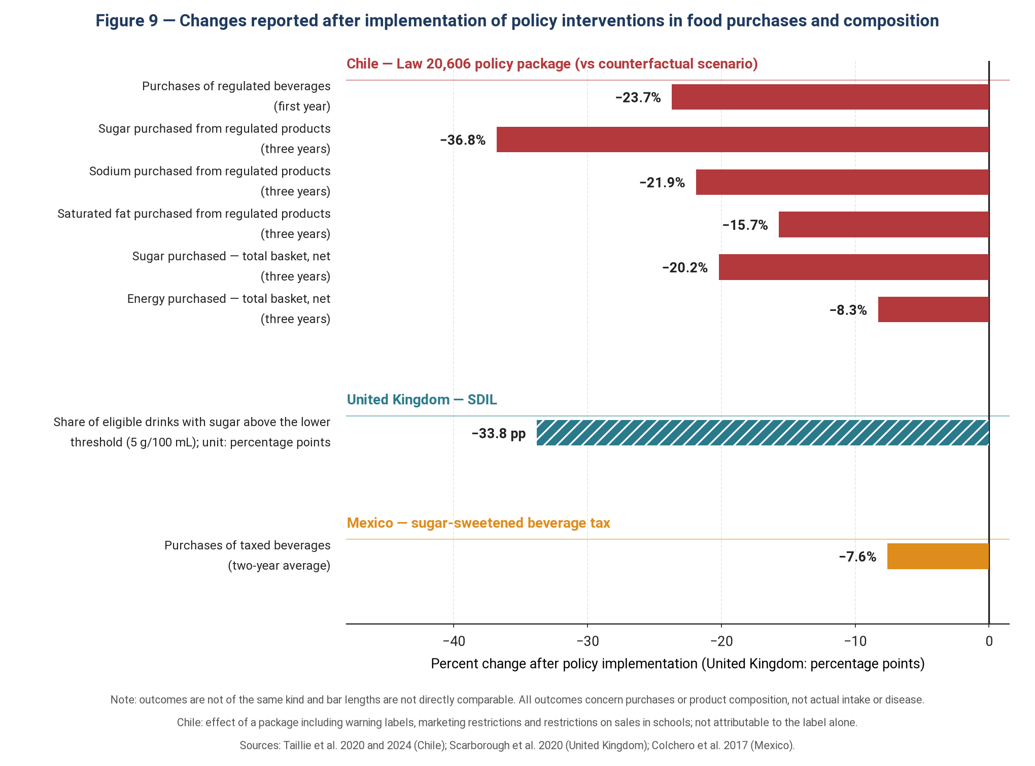
Figure 9 — Changes reported after implementation of policy interventions in food purchases and composition. Note: the outcomes are not of the same kind, and bar lengths are not directly comparable with one another. Chile: in the first year, purchases of regulated beverages were 23.7% lower than the amount estimated in the absence of the policy; over three years, purchases of sugar, sodium and saturated fat from regulated products fell by 36.8%, 21.9% and 15.7%, respectively (18, 20). United Kingdom: the SDIL was associated with an approximately 38% reduction in the sugar content of beverages covered by the policy (19). Mexico: the sugar-sweetened beverage tax was associated with an average 7.6% reduction in purchases over two years (21).

7.3 Taxes on Sugar-Sweetened Beverages
In January 2014, Mexico introduced a tax of 1 peso per liter on sugar-sweetened beverages. In the first year, purchases of taxed beverages fell by about 6% on average, and this reduction reached 12% by December, while purchases of untaxed beverages rose by about 4% (22). Two-year follow-up showed a reduction of 5.5% in the first year and 9.7% in the second year (average 7.6%), and the largest reduction in purchases occurred in low-income households (9.0% and 14.3%) (21). Interpreting this finding from a health-equity perspective requires caution: a larger reduction in purchases in the low-income group does not by itself prove that the policy is “fairer,” because the financial burden of the tax may also fall more heavily on this group (the problem of regressivity), and substitution toward other cheap beverages or foods must be measured at the same time (21, 22). A full assessment of equity requires simultaneous examination of the health benefit, the financial burden and the pattern of substitution.
The UK Soft Drinks Industry Levy (SDIL), announced in 2016 and implemented in April 2018, had a different and instructive design: a tiered levy based on sugar content, with rates at implementation of £0.24 per liter for drinks containing 8 g or more of sugar per 100 mL and £0.18 for 5 to less than 8 g, and an exemption for drinks below 5 g (19). One prominent pathway of effect of this structure was creating an incentive for reformulation: by February 2019, only 15.4% of drinks subject to the intervention remained above the lower levy threshold, and many manufacturers had reformulated their products to below the levy threshold (19). Independent evidence based on household purchase data has also estimated a reduction of about 30 g in sugar purchased from soft drinks per household per week one year after implementation, but this finding comes from a different study.
Policy lesson: a tiered, content-based tax, such as the UK model, can increase the incentive to reformulate products (19); a flat tax, as in Mexico, has been associated with reduced purchases of taxed beverages (21, 22). For a country such as Iran with an active domestic beverage industry, a tiered tax per gram of sugar is an option that merits evaluation and policy modeling—not a recommendation based on local evidence. Before any definitive recommendation, purchasing power and price elasticity, substitution patterns, the tax structure, implementation and monitoring capacity, inflation and the composition of beverage consumption in Iran must be examined.

7.4 Marketing Restrictions and the School Food Environment
Since 2010, the World Health Organization has published a set of recommendations on the marketing of foods and non-alcoholic beverages to children (103). The United Kingdom has brought into force restrictions on television advertising of products covered by the “less healthy food and drink” regulations before 9 p.m. and restrictions on paid online advertising of these products from 5 January 2026 (104). Chile, too, in the successive phases of its law, applied restrictions on marketing to children and then a ban on daytime television advertising of “high-in” products (18, 20). Because of the developmental features of executive-control systems and their more limited ability to recognize the persuasive intent of advertising, children are vulnerable to food marketing (103, 105). From this perspective, the reported 12% prevalence of UPF addiction in children also highlights the importance of this group in the debate on preventive policies (10).
Schools, as one of the important settings in which children’s food choices are shaped, are an important policy lever for changing the food environment (103). Policies such as restricting the sale of products of low nutritional value in schools, removing or restricting sugar-sweetened beverages in vending machines, and strengthening school meal programs based on fresh and minimally processed foods are practical examples of this approach. In Brazil, the emphasis on consuming natural or minimally processed foods and limiting ultra-processed foods in the Dietary Guidelines for the Brazilian Population has provided an important nutritional framework for such an approach (46). Evidence from the evaluation of the Chilean law also shows that the ban on selling “high-in” products in schools was part of that country’s policy package (20).

7.5 National Dietary Guidelines and the Concept of Processing
The second edition of the Brazilian dietary guidelines, published in 2014, was a turning point in the history of nutrition policy: instead of focusing solely on nutrient-based recommendations, it also introduced a processing-based approach into dietary advice. Its “golden rule” is: always prefer natural or minimally processed foods and freshly prepared meals to ultra-processed foods (46). Subsequently, the concept of processing was incorporated to varying degrees into a number of other national dietary guidelines, including those of Uruguay, Peru, Ecuador, France, Belgium and Canada (93). A review of 106 dietary guidelines has shown that although nutrient-based messages still predominate, explicit or implicit reference to the level of processing is found in a considerable proportion of guidelines (93).
One potential advantage of this approach is turning complex nutritional recommendations into simpler messages that the public can understand (46, 57). However, as we saw in Chapter 2, critics warn that simplifying the concept of processing may be accompanied by problems of definition, classification and the feasibility of recommendations, and may have unintended consequences for some population groups (55, 57).

7.6 The Tobacco Industry Analogy and the Commercial Determinants of Health
One of the most important and historically best-documented aspects of this debate is the historical link between the tobacco industry and the food industry. Fazzino et al. (106) showed that between 1980 and 2001, US tobacco companies, including Philip Morris and R.J. Reynolds, owned a number of major US food companies. Their analysis showed that, between 1988 and 2001, food products owned by tobacco companies were 29% more likely to be classified as fat-and-sodium hyper-palatable foods and 80% more likely to be classified as carbohydrate-and-sodium hyper-palatable foods (106).
This finding is consistent with the hypothesis that shared ownership may have provided an avenue for the tobacco industry to influence the characteristics of food products; however, the historical association of ownership does not by itself prove the direct transfer of technical knowledge or specific strategies for increasing sensory addictiveness, and such a claim requires more direct evidence from internal industry documents (14, 106). This issue can also be examined within the framework of the “commercial determinants of health” (107): a set of commercial and political strategies, including lobbying, research funding, shaping public opinion and resisting regulation, can affect health policies and population disease patterns.
Gearhardt et al. (10) put forward the tobacco-control analogy as one of the frameworks worth considering for UPF policy. From this perspective, if the addictiveness of some UPFs were scientifically confirmed, tools such as labeling, taxation, marketing restrictions and other regulatory interventions could be considered. However, this analogy faces important limitations: unlike tobacco, food is an essential biological need, and UPF is also a heterogeneous group of products whose members do not all necessarily have the same addictive potential (30, 57). Moreover, unlike nicotine in tobacco, no single agent or compound has yet been identified that could be regarded as equivalent to a specific addictive substance in UPF (14, 55).
Therefore, the tobacco analogy is useful for analyzing the commercial determinants of health, industry strategies and the history of policymaking, but it should not be used as an independent argument to prove the addictiveness of UPF (15, 107).
Table 5 — Policy interventions and evidence of their effectiveness
Intervention | Implemented example | Documented effect | Feasibility in Iran (author’s qualitative assessment)
Warning-label policy package (together with marketing and school restrictions) | Chile (since 2016); similar models in some Latin American countries | Compared with the no-policy scenario, regulated products were associated with 36.8% less sugar, 23.0% less energy, 21.9% less sodium and 15.7% less saturated fat; in the overall shopping basket, a net reduction of 20.2% in sugar and 8.3% in energy was also reported. This effect relates to the policy package, not to the warning label alone (20) | Facilitator: possibility of using the existing infrastructure for nutrition labeling; barrier: need for regulatory revision, inter-agency coordination and possible industry resistance
Tiered tax based on sugar content | United Kingdom (SDIL, 2018) | After the announcement and implementation of the SDIL, the share of eligible drinks above the 5 g sugar per 100 mL threshold fell by 33.8 percentage points compared with the pre-policy trend scenario; the study showed that this change was mainly associated with a reduction in sugar content through reformulation. The data were not sales-weighted, so the effect on the amount of sugar purchased cannot be inferred from this study (19). | Facilitator: existing tax infrastructure; barrier: need for coordination between the tax administration, the Food and Drug Administration and other relevant bodies; attention to distributional and substitution effects
Flat tax on sugar-sweetened beverages | Mexico (2014) | Purchases of taxed beverages fell by 5.5% in the first year and 9.7% in the second year; the average reduction over two years was 7.6%. The largest reduction was observed in households of the lowest socioeconomic level (21). | Facilitator: relatively simple structure to implement; barrier: possible substitution toward untaxed beverages and distributional considerations
Restricting the marketing of unhealthy foods to children | Chile; WHO recommendations | In the evaluation of the first phase of the Chilean regulations, exposure of preschool children and adolescents to television advertising of products “high in” energy, sugar, sodium or saturated fat fell by 44% and 58%, respectively; advertisements with direct child-directed appeals also fell by 35% and 52%, respectively, although exposure was not completely eliminated (108). In 2010, the WHO also issued a set of recommendations to reduce the impact of the marketing of these foods and beverages on children (103). | Facilitator: possibility of focusing oversight on official media; barrier: difficulty of monitoring digital media, social networks and indirect forms of marketing
School food environment policy | Brazil, Chile | In Chile, the ban on selling products meeting the “high-in” criteria in schools was part of a broad policy package; therefore, the available evidence limits the independent attribution of changes in purchases or consumption to the school sales ban (18). | Facilitator: possibility of implementation through the Ministry of Education and school canteen regulations; barrier: canteen economics, provision of suitable alternatives and continuous monitoring of implementation
Incorporating the concept of processing into national dietary guidelines | Brazil (2nd edition, 2014); subsequently, to varying degrees, in some other national guidelines | A shift in the framework of dietary recommendations toward greater attention to processing; in the Brazilian guidelines, the “golden rule” emphasizes preferring natural or minimally processed foods and freshly prepared meals to ultra-processed foods (46). A comparative review of national guidelines has shown that reference to processing is present in a considerable number of countries’ dietary guidelines (93). | Facilitator: less need to create new implementation infrastructure and the possibility of revising the framework of nutrition messages; barrier: need for education and public communication and the need to evaluate the actual effect of the changed message on eating behavior
National monitoring of UPF consumption and standardization of its classification | NHANES in the United States; NDNS in the United Kingdom | Makes it possible to estimate the share of UPF in energy intake and to examine trends and associations with health indicators. In NHANES, a standard method for classifying foods according to NOVA has been presented, and it has been shown that the estimated energy share of UPF can vary depending on how ambiguous items are handled (62). In the NDNS, foods recorded in the four-day food diary have also been classified according to NOVA (61) | Facilitator: possibility of adding to existing nutrition surveys; barrier: cost, need to standardize NOVA coding and train coders; an important prerequisite for evaluating the effect of policies
Note to Table 5: The “feasibility” column is the author’s qualitative assessment based on four criteria: the existence of legal and institutional infrastructure, implementation cost, monitoring capacity and the expected degree of stakeholder resistance; this assessment does not replace a formal feasibility analysis or stakeholder analysis. In addition, the “documented effect” column refers mainly to intermediate outcomes—such as purchases, reformulation and advertising exposure—and not to hard clinical outcomes. In the case of Chile, the reported effects relate to a multicomponent policy package and should not be attributed to the warning label alone. In the case of the UK SDIL, the cited study evaluated the change in the sugar content of products on the market, not a direct reduction in sugar purchased or consumed.

8. Vulnerable Groups and Clinical Implications

8.1 Children and Adolescents
Children and adolescents are a notable group in the debate on food addiction and UPF, both developmentally and in terms of their exposure to the food environment. First, developmentally: the executive and inhibitory control systems that depend on the prefrontal cortex are still developing during adolescence, and during this period a developmental imbalance is observed between cognitive control systems and subcortical reward systems, although no single definitive age can be called “full maturity” (105). Second, in terms of exposure, children and adolescents are exposed to food and beverage marketing strategies, and the World Health Organization has emphasized the need to reduce the impact of this marketing on children (10, 103). Third, in terms of the formation of food preferences: the childhood years are an important period for the formation of food preferences; these preferences are shaped by the interaction of biological factors, the food environment and eating-related experiences, and at the same time they can change over time (109).
In a systematic review and meta-analysis, the estimated prevalence of “food addiction” in children and adolescents was about 15% across all samples, 12% in community samples and 19% in children and adolescents with overweight or obesity (110). A more recent research review on UPF addiction also reports an estimate of about 15% for youths, but these estimates depend heavily on the definition of the construct and the measurement instrument (13). Therefore, a direct comparison of these figures with the prevalence of substance use disorder in children is not valid, because the measurement instruments, diagnostic status and conditions of definition and access differ between the two domains. Regardless of this comparison, children’s developmental vulnerability and their exposure to food marketing provide an important basis for policy attention and protective measures, although determining the type and intensity of intervention requires contextual evidence and policy evaluation (103).

8.2 Obesity and Eating Disorders
The relationship between food addiction and obesity is one of correlation, not identity: the prevalence of food addiction has been reported to be higher in people with overweight or obesity, but the phenomenon is not limited to people with higher weight; in the systematic review by Pursey et al., the mean prevalence in samples of healthy weight was also reported as 11.1%, compared with 24.9% in samples with overweight or obesity (28). Therefore, using body mass index as a proxy marker of addictive-like behavior is not conceptually or empirically justified (32).
The overlap with binge-eating disorder is much greater, but still incomplete. The study by Cassin and von Ranson showed that 92.4% of participants with binge-eating disorder met the DSM-IV dependence criteria when the substance dependence criteria were applied with “binge eating” substituted for “substance” (111). This study was conducted with a sample of 79 people using an interview design, and the authors themselves raised limitations such as possible demand characteristics and uncertainty about the validity and reliability of the interview. In the qualitative study by Curtis and Davis, all 12 participants with binge-eating disorder and 42% (5 of 12) of obese individuals without this disorder met the relevant criteria on the basis of the mild DSM-5 threshold for substance use disorder (112). Therefore, these findings show a substantial overlap between binge eating, obesity and addiction criteria, but because of their qualitative nature and small sample sizes, they cannot by themselves establish diagnostic equivalence between binge-eating disorder and substance use disorder (38, 112).

8.3 Mental Health and Socioeconomic Factors
The meta-analysis by Lane et al. of observational studies showed that higher UPF consumption was associated with higher odds of depressive and anxiety symptoms; an OR of 1.44 was reported for depressive symptoms and an OR of 1.48 for anxiety symptoms (100). However, most of the evidence in this meta-analysis was cross-sectional, and the authors considered prospective and experimental studies necessary to determine the direction of the relationship and causality. They also raised the possibility of a bidirectional relationship between UPF consumption and adverse mental health outcomes, rather than establishing a specific causal pathway (100). The umbrella review by Lane et al. also identified associations of higher UPF consumption with anxiety and common mental disorders among the outcomes examined, but these findings rest mainly on observational evidence (17).
From a health-equity perspective, LaFata et al., in their review of research on UPF addiction, report evidence of social differences in the prevalence of this phenomenon, including a stronger association with food insecurity and differences among some racial and ethnic groups in US studies (13). However, these social patterns have been described primarily in the US context, and generalizing them directly to Iran requires local data. This point is important for the Iranian context: a study based on Iranian time-series data has shown that inflation was associated with increased consumption of cereals—including bread, cereals, rice and pasta—and decreased fruit consumption (113). In addition, an analysis of data from about one million observations of Iranian households has shown that during periods of severe sanctions, consumption of many food groups declined and that this decline was more severe for low-income households; by contrast, bread consumption increased (114).
In such circumstances, food insecurity and limited purchasing power can push household food choices toward cheaper and more accessible options. Therefore, restrictive policies on UPF, if designed without simultaneous attention to the availability and affordability of healthy alternatives, may have adverse distributional consequences; this consideration must be examined in Iran using local data on prices, availability and consumption patterns (13, 55).

8.4 Clinical Implications and the “Abstinence versus Moderation” Question
If the addiction model is valid for a subgroup of individuals, its therapeutic implications are considerable. In some treatment models for substance use disorder, complete abstinence is one of the treatment goals; at the same time, reduced use and harm reduction are also accepted approaches, depending on the substance and the clinical circumstances (115). In the domain of food, food cannot be given up; hence, instead of abstinence from “food,” some proposals have focused on restricting specific foods or food characteristics—for example, groups of very sweet foods or foods rich in refined carbohydrates. Some peer-support approaches, including Overeaters Anonymous, also include models based on abstaining from certain foods; however, these sources should not be equated with evidence-based clinical interventions (10, 13).
At present, there is no adequately supported intervention specifically designed to treat “UPF addiction.” The 2024 review by LaFata et al. mentions a 10- to 14-week pilot study using a UPF-abstinence approach, as well as several other preliminary studies, but emphasizes that more rigorous randomized trials are needed to establish the efficacy and safety of this approach (13). Therefore, in the absence of sufficient evidence, advice to abstain from “trigger foods” should not be offered as general clinical advice. This caution is especially important in people prone to patterns of dietary restriction and binge eating; the cognitive–behavioral model of eating disorders regards dietary restriction as one of the important processes maintaining some eating disorders (99). Consequently, any therapeutic use of an abstinence approach should take the individual’s condition into account and be undertaken within the framework of a clinical assessment.
By contrast, psychological treatments based on eating disorder models, including cognitive–behavioral therapy and interpersonal therapy, have substantial evidence of efficacy for binge-eating disorder (116). From this perspective, one of the important questions about the addiction model is whether this framework can provide a specific added clinical value beyond existing effective treatments. Critics have argued that the concept of food addiction has not so far led to new and successful treatments for overeating and obesity (31). Therefore, the added clinical value of the addiction model remains an open research question, not a proven therapeutic advantage.

8.5 The Problem of Stigma
One of the important implications of this debate is the effect of the addiction framework on obesity-related stigma, and the available evidence does not point in a single direction. On the one hand, the addiction framework can shift attention from purely individual responsibility toward the role of food and environmental factors, and in some studies it has been associated with reduced blame and stigma. In the experimental study by Latner et al., presenting the food addiction model was associated with reduced stigma, blame and attribution of psychopathology to the individuals described (97). This finding shows that the addiction framework, at least under the experimental conditions of that study, does not necessarily lead to increased stigma and may even reduce weight-related blame.
On the other hand, belief in “food addiction” can affect how individuals interpret their eating behavior. The review by Ruddock and Hardman shows that belief in food addiction is in some circumstances associated with attempts to restrict intake; the authors suggest that short-term dietary restriction may subsequently be associated with increased craving and disinhibited eating, but this cycle is still a research hypothesis and should not be regarded as a definite consequence of belief in addiction (98).
Therefore, the cautious conclusion is that the addiction framework can, in some circumstances, help reduce blame and highlight the role of the food environment, but how this framework is used in clinical conversations matters. The therapeutic use of the concept of addiction should be such that, while attending to environmental and food factors, it does not deny the individual’s agency and capacity for behavior change.

8.6 Limitations of This Review
First, as stated in Section 1.3, this study is a narrative review with a structured search and not a systematic review; therefore, source selection may have been affected by selection bias, although an effort was made to cover supportive and critical views in as balanced a way as possible. Second, inclusion and exclusion criteria were not applied in a predefined, written form, and the quality of studies was not assessed uniformly with a framework such as GRADE for all sections. Therefore, this review should not be regarded as a formal assessment of the quality of the evidence or as a meta-analysis.
Third, Hall’s four-arm study, registered as NCT05290064, has now been completed, but according to the latest information recorded on ClinicalTrials.gov its results have not yet been published in the registry. This study is a randomized crossover trial comparing four diets that differ in degree of processing, non-beverage energy density and hyper-palatable characteristics; therefore, its preliminary data or conference presentations should still be regarded as unpublished, preliminary data and should not serve as the basis for definitive inferences (117).
Fourth, part of the evidence on Iran comes from observational studies with limitations of sampling, measurement and generalizability, or from official reports; therefore, in interpreting the situation in Iran, a distinction must be made between direct data, indirect evidence and contextual inferences. Fifth, the field of UPF and food addiction is evolving rapidly, and the publication of new studies, particularly on mechanisms, interventions and long-term outcomes, could change some of the conclusions of this review. Hence, periodic updating of the review is essential to maintain its scientific validity

9. Research Gaps and Suggestions for Future Studies
Despite the vast volume of publications, this topic still lacks clear answers at several key points. The most important gaps and the studies needed to fill them are:
1. Identifying the active factor: it is still unclear which features of UPF play the greatest role in driving overconsumption—energy density, palatability, eating rate, nutrient composition or additives. To separate the effects of these factors, multi-arm clinical trials with a factorial design and simultaneous control of nutritional variables are essential. The NIH four-arm study has been put forward as an example of such an approach, although the data presented from it were preliminary and unpublished at the time of writing (39).
2. Conceptual validity of food addiction: it is still unclear whether the YFAS identifies a phenomenon distinct from eating disorders, particularly binge-eating disorder, or measures part of the same behavioral spectrum in different language. To answer this question, studies are needed that use the YFAS simultaneously with structured diagnostic interviews and, using latent class analysis and external validation, examine the characteristics and distinctiveness of the identified subgroups.
3. Natural history and risk factors: it is unclear whether food addiction has a specific developmental course and identifiable vulnerability factors. Answering this question requires longitudinal cohort studies that follow individuals from childhood or adolescence into adulthood and measure eating behavior, characteristics of the food environment, psychological status and indicators related to food addiction at several time points.
4. Withdrawal syndrome: one important question is whether the symptoms reported after reducing intake of highly processed foods can be distinguished from the general consequences of dietary restriction or energy deficit. To examine this, selective-elimination trials with matched energy intake and, where possible, control of other nutritional factors are needed to determine whether changes in withdrawal symptoms occur independently of reduced energy intake.
5. Treatment efficacy: it is still unclear whether an intervention explicitly based on the food or UPF addiction framework offers a specific clinical advantage over standard treatments for eating disorders, such as CBT. Answering this question requires comparative randomized trials with an appropriate control group and long-term follow-up that assess, in addition to symptom reduction, outcomes such as quality of life, relapse, dietary restriction and possible adverse effects.
6. Standardizing the definition of UPF: classifying foods by the extent of processing still faces challenges regarding reproducibility, interpretation of certain items and cross-cultural comparability. Therefore, future studies should assess inter-coder agreement and the reproducibility of classification and compare competing classification systems on the same food datasets (54, 56).
7. Iranian data: one of the fundamental gaps in Iran is the lack of an accurate national estimate of the share of UPF in individual food intake and the household food basket, and of its trend over time. To fill this gap, a national nutrition survey should include a dedicated processing module and record information such as product name and brand, ingredient list, place of purchase and type of packaging, so that coding according to NOVA becomes possible.
8. Policy evaluation in Iran: even where nutrition policies exist, direct evidence on their effect on UPF consumption and purchases in Iran is limited. One specific question for the future is to what extent color-coded nutrition labels have affected household purchases and product reformulation. To answer this question, interrupted time-series studies of household purchase or sales data can be used to assess changes before and after policy implementation, taking underlying trends into account.
Of these eight gaps, the last two—generating national data on UPF consumption and the empirical evaluation of nutrition policies in Iran—are a direct priority for the country’s nutrition community. Without a national database on the amount and pattern of UPF consumption, it is possible neither to estimate the attributable disease burden with adequate precision nor to evaluate the effect of future interventions. Fortunately, as we saw in Chapter 3, food addiction measurement instruments have been validated in Persian in the Iranian population (35–37); therefore, at least in terms of access to measurement instruments, population studies in this field are feasible.

10. Summary and Conclusions
This seminar has sought to show that two independent lines of research (one on the industrial processing of food and the other on food addiction) have converged over the past decade and have created a shared question that is both scientifically compelling and urgent from a policy perspective.
1) For ultra-processed foods, there is substantial empirical evidence for some specific interventions. The umbrella review by Lane et al., with 45 pooled analyses and a total of nearly 9.9 million participants, reported a direct association of higher UPF consumption with 32 of 45 health outcomes or indicators (17); however, these figures refer to the participations reported in the pooled analyses and do not necessarily mean 9.9 million unique individuals. Two controlled trials—Hall and Dicken—have also shown that UPF-based diets, compared with minimally processed diets, were associated with different energy intake and weight changes under study conditions (16, 23). These trials provide causal evidence on the effect of the studied diets on short-term outcomes, but not on the causality of all the reported epidemiological associations, nor on the causality of the “degree of processing” as a single factor. On the other hand, the certainty of a large part of the observational evidence is low or very low according to GRADE (17), and this uncertainty must be reflected in interpreting the evidence. At the level of interventions, there is also empirical evidence for actions such as reducing consumption of sugary drinks, restricting the marketing of unhealthy foods and beverages to children and improving the school food environment (18–22, 103). However, for reducing the overall share of NOVA Group 4 as a single target, and particularly for treating “food addiction,” the evidence is far more limited (13, 17).
2) For food addiction, the debate remains unresolved. The concept has not been accepted as an independent diagnosis in any of the official diagnostic systems (33, 34), no specific addictive agent has been identified (32), and human neuroimaging evidence is heterogeneous and in some cases contradictory (45). Nevertheless, these points do not by themselves mean that the concept is entirely invalid. Some findings on food reward, including a reward response to the combination of fat and carbohydrate that exceeds the effect of either component alone, and some pharmacological findings on reduced alcohol craving with semaglutide, have raised hypotheses about an overlap of some reward and addiction mechanisms (77, 88). However, these findings are not specific to addiction and do not by themselves prove the existence of a food addiction mechanism (32); evidence from candidate genes, because of limited replicability and heterogeneous findings, also does not provide strong support for claims of genetic overlap (83, 84).
3) The most plausible conclusion is to maintain an open and testable position. In the general population, alternative explanations such as energy density, eating rate and macronutrient composition can explain part of the observed increase in energy intake (16, 51, 91, 92). By contrast, if the food addiction model applies to a subgroup of individuals, the characteristics and boundaries of this subgroup have not yet been adequately defined. A positive YFAS screen does not by itself prove that the addiction model is conceptually and diagnostically valid for those same individuals, and defining this boundary requires construct-validation studies and comparisons with eating patterns, eating disorders and other competing explanations (13). Therefore, current evidence neither supports the conclusion that all obesity or overeating can be attributed to addiction nor is sufficient to discard this model entirely.
4) From a community nutrition perspective, implementing some interventions does not necessarily depend on a final resolution of the food addiction debate. For warning labels, taxes on sugary drinks and restrictions on the marketing and sale of certain unhealthy products, there is evidence on intermediate outcomes such as changes in purchases, reformulation and reduced advertising exposure; however, the strength of the evidence and the type of outcome assessed are not the same across these interventions (18–22). For example, the Chilean study reported reduced purchases of “high-in” beverages after the implementation of a policy package including warning labels, marketing restrictions and restrictions on sales in schools, but it could not determine the independent contribution of each of these components (18). Therefore, these interventions can be justified on the basis of evidence on consumer behavior, the food environment and health outcomes, without first having to accept the addictiveness of food as an established fact (17).
5) For Iran, three practical priorities are proposed, with the explicit caveat that local data are still fragmentary and that these are priorities for evaluation, not recommendations based on Iranian evidence. First, establishing regular national monitoring of the share of UPF in the household food basket and, where possible, in individual food intake; second, strengthening and evaluating the existing nutrition labeling system in light of the evidence from the experience of countries such as Chile (18, 20); and third, protecting and improving the school food environment as one of the priorities worth considering for intervention, particularly in view of international recommendations on limiting children’s exposure to the marketing of unhealthy foods (103). These priorities should be evaluated in Iranian studies in terms of feasibility, economic and social consequences, availability of healthy alternatives and effects on different population groups.

References
1. GBD 2019 Risk Factors Collaborators. Global burden of 87 risk factors in 204 countries and territories, 1990-2019: a systematic analysis for the Global Burden of Disease Study 2019. Lancet. 2020;396(10258):1223-49. doi:10.1016/S0140-6736(20)30752-2
2. Swinburn BA, Sacks G, Hall KD, McPherson K, Finegood DT, Moodie ML, et al. The global obesity pandemic: shaped by global drivers and local environments. Lancet. 2011;378(9793):804-14. doi:10.1016/S0140-6736(11)60813-1
3. Hall KD, Farooqi IS, Friedman JM, Klein S, Loos RJF, Mangelsdorf DJ, et al. The energy balance model of obesity: beyond calories in, calories out. Am J Clin Nutr. 2022;115(5):1243-54. doi:10.1093/ajcn/nqac031
4. NCD Risk Factor Collaboration (NCD-RisC). Worldwide trends in underweight and obesity from 1990 to 2022: a pooled analysis of 3663 population-representative studies with 222 million children, adolescents, and adults. Lancet. 2024;403(10431):1027-50. doi:10.1016/S0140-6736(23)02750-2
5. Keith SW, Redden DT, Katzmarzyk PT, Boggiano MM, Hanlon EC, Benca RM, et al. Putative contributors to the secular increase in obesity: exploring the roads less traveled. Int J Obes (Lond). 2006;30(11):1585-94. doi:10.1038/sj.ijo.0803326
6. Monteiro CA, Moubarac JC, Cannon G, Ng SW, Popkin B. Ultra-processed products are becoming dominant in the global food system. Obes Rev. 2013;14 Suppl 2:21-8. doi:10.1111/obr.12107
7. Baker P, Machado P, Santos T, Sievert K, Backholer K, Hadjikakou M, et al. Ultra-processed foods and the nutrition transition: global, regional and national trends, food systems transformations and political economy drivers. Obes Rev. 2020;21(12):e13126. doi:10.1111/obr.13126
8. Monteiro CA, Cannon G, Levy RB, Moubarac JC, Louzada ML, Rauber F, et al. Ultra-processed foods: what they are and how to identify them. Public Health Nutr. 2019;22(5):936-41. doi:10.1017/S1368980018003762
9. Monteiro CA, Cannon G, Moubarac JC, Levy RB, Louzada MLC, Jaime PC. The UN Decade of Nutrition, the NOVA food classification and the trouble with ultra-processing. Public Health Nutr. 2018;21(1):5-17. doi:10.1017/S1368980017000234
10. Gearhardt AN, Bueno NB, DiFeliceantonio AG, Roberto CA, Jimenez-Murcia S, Fernandez-Aranda F. Social, clinical, and policy implications of ultra-processed food addiction. BMJ. 2023;383:e075354. doi:10.1136/bmj-2023-075354
11. Gearhardt AN, Schulte EM. Is food addictive? A review of the science. Annu Rev Nutr. 2021;41:387-410. doi:10.1146/annurev-nutr-110420-111710
12. Gearhardt AN, DiFeliceantonio AG. Highly processed foods can be considered addictive substances based on established scientific criteria. Addiction. 2023;118(4):589-98. doi:10.1111/add.16065
13. LaFata EM, Allison KC, Audrain-McGovern J, Forman EM. Ultra-processed food addiction: a research update. Curr Obes Rep. 2024;13(2):214-23. doi:10.1007/s13679-024-00569-w
14. Brownell KD, Warner KE. The perils of ignoring history: Big Tobacco played dirty and millions died. How similar is Big Food? Milbank Q. 2009;87(1):259-94. doi:10.1111/j.1468-0009.2009.00555.x
15. Moodie R, Stuckler D, Monteiro C, Sheron N, Neal B, Thamarangsi T, et al. Profits and pandemics: prevention of harmful effects of tobacco, alcohol, and ultra-processed food and drink industries. Lancet. 2013;381(9867):670-9. doi:10.1016/S0140-6736(12)62089-3
16. Hall KD, Ayuketah A, Brychta R, Cai H, Cassimatis T, Chen KY, et al. Ultra-processed diets cause excess calorie intake and weight gain: an inpatient randomized controlled trial of ad libitum food intake. Cell Metab. 2019;30(1):67-77.e3. doi:10.1016/j.cmet.2019.05.008
17. Lane MM, Gamage E, Du S, Ashtree DN, McGuinness AJ, Gauci S, et al. Ultra-processed food exposure and adverse health outcomes: umbrella review of epidemiological meta-analyses. BMJ. 2024;384:e077310. doi:10.1136/bmj-2023-077310
18. Taillie LS, Reyes M, Colchero MA, Popkin B, Corvalan C. An evaluation of Chile's Law of Food Labeling and Advertising on sugar-sweetened beverage purchases from 2015 to 2017: a before-and-after study. PLoS Med. 2020;17(2):e1003015. doi:10.1371/journal.pmed.1003015
19. Scarborough P, Adhikari V, Harrington RA, Elhussein A, Briggs A, Rayner M, et al. Impact of the announcement and implementation of the UK Soft Drinks Industry Levy on sugar content, price, product size and number of available soft drinks in the UK, 2015-19: a controlled interrupted time series analysis. PLoS Med. 2020;17(2):e1003025. doi:10.1371/journal.pmed.1003025
20. Taillie LS, Bercholz M, Popkin B, Rebolledo N, Reyes M, Corvalan C. Decreases in purchases of energy, sodium, sugar, and saturated fat 3 years after implementation of the Chilean food labeling and marketing law. PLoS Med. 2024;21(9):e1004463. doi:10.1371/journal.pmed.1004463
21. Colchero MA, Rivera-Dommarco J, Popkin BM, Ng SW. In Mexico, evidence of sustained consumer response two years after implementing a sugar-sweetened beverage tax. Health Aff (Millwood). 2017;36(3):564-71. doi:10.1377/hlthaff.2016.1231
22. Colchero MA, Popkin BM, Rivera JA, Ng SW. Beverage purchases from stores in Mexico under the excise tax on sugar sweetened beverages: observational study. BMJ. 2016;352:h6704. doi:10.1136/bmj.h6704
23. Dicken SJ, Jassil FC, Brown A, Kalis M, Stanley C, Ranson C, et al. Ultraprocessed or minimally processed diets following healthy dietary guidelines on weight and cardiometabolic health: a randomized, crossover trial. Nat Med. 2025;31(10):3297-308. doi:10.1038/s41591-025-03842-0
24. Fiolet T, Srour B, Sellem L, Kesse-Guyot E, Alles B, Mejean C, et al. Consumption of ultra-processed foods and cancer risk: results from NutriNet-Sante prospective cohort. BMJ. 2018;360:k322. doi:10.1136/bmj.k322
25. Moslehi N, Mahdavi M, Mirmiran P, Azizi F. Ultra-processed foods and the incidence of pre-diabetes and type 2 diabetes among Iranian adults: the Tehran lipid and glucose study. Nutr Metab (Lond). 2024;21(1):79. doi:10.1186/s12986-024-00854-4
26. Guyatt GH, Oxman AD, Vist GE, Kunz R, Falck-Ytter Y, Alonso-Coello P, et al. GRADE: an emerging consensus on rating quality of evidence and strength of recommendations. BMJ. 2008;336(7650):924-6. doi:10.1136/bmj.39489.470347.AD
27. Schulte EM, Avena NM, Gearhardt AN. Which foods may be addictive? The roles of processing, fat content, and glycemic load. PLoS One. 2015;10(2):e0117959. doi:10.1371/journal.pone.0117959
28. Pursey KM, Stanwell P, Gearhardt AN, Collins CE, Burrows TL. The prevalence of food addiction as assessed by the Yale Food Addiction Scale: a systematic review. Nutrients. 2014;6(10):4552-90. doi:10.3390/nu6104552
29. Gearhardt AN, Hebebrand J. The concept of "food addiction" helps inform the understanding of overeating and obesity: YES. Am J Clin Nutr. 2021;113(2):263-7. doi:10.1093/ajcn/nqaa343
30. Hebebrand J, Albayrak O, Adan R, Antel J, Dieguez C, de Jong J, et al. "Eating addiction", rather than "food addiction", better captures addictive-like eating behavior. Neurosci Biobehav Rev. 2014;47:295-306. doi:10.1016/j.neubiorev.2014.08.016
31. Hebebrand J, Gearhardt AN. The concept of "food addiction" helps inform the understanding of overeating and obesity: NO. Am J Clin Nutr. 2021;113(2):268-73. doi:10.1093/ajcn/nqaa344
32. Ziauddeen H, Fletcher PC. Is food addiction a valid and useful concept? Obes Rev. 2013;14(1):19-28. doi:10.1111/j.1467-789X.2012.01046.x
33. American Psychiatric Association. Diagnostic and Statistical Manual of Mental Disorders. 5th ed., text revision (DSM-5-TR). Washington, DC: American Psychiatric Association Publishing; 2022.
34. World Health Organization. International Classification of Diseases, 11th Revision (ICD-11). Geneva: WHO; 2022.
35. Ghanbari N, Nooripour R, Firoozabadi A, Var TSP, Wisniewski P, Hosseini SR. Psychometric assessment of Persian translation of Yale Food Addiction Scale Version 2.0 (YFAS 2.0) in Iranian college students. J Eat Disord. 2022;10(1):158. doi:10.1186/s40337-022-00689-5
36. Tajik-Esmaeeli S, Ghanbari Jolfaei A, Rashedi V, Kamalzadeh L, Rahimi Z, Salehian R. Psychometric properties of the Persian version of the Yale Food Addiction Scale 2.0 (P-YFAS 2.0) in an Iranian clinical sample. J Iran Med Counc. 2024;7(2):316-27. doi:10.18502/jimc.v7i2.15044
37. Niroumand Sarvandani M, Asadi M, Izanloo B, Soleimani M, Mahdavi F, Gearhardt AN, et al. Confirmatory factor analysis and gender invariance of Persian version of the modified Yale food addiction scale (mPYFAS) 2.0: insight from a large scale Iranian sample. J Eat Disord. 2024;12(1):14. doi:10.1186/s40337-023-00962-1
38. Meule A, Gearhardt AN. Food addiction in the light of DSM-5. Nutrients. 2014;6(9):3653-71. doi:10.3390/nu6093653
39. Hall KD. Unraveling the mechanisms of ultra-processed foods: interim findings of a four-arm inpatient randomized trial (NCT05290064). Conference presentation; 2024. [preliminary, unpublished data]
40. Randolph TG. The descriptive features of food addiction: addictive eating and drinking. Q J Stud Alcohol. 1956;17(2):198-224. doi:10.15288/qjsa.1956.17.198
41. Wang GJ, Volkow ND, Logan J, Pappas NR, Wong CT, Zhu W, et al. Brain dopamine and obesity. Lancet. 2001;357(9253):354-7. doi:10.1016/S0140-6736(00)03643-6
42. Avena NM, Rada P, Hoebel BG. Evidence for sugar addiction: behavioral and neurochemical effects of intermittent, excessive sugar intake. Neurosci Biobehav Rev. 2008;32(1):20-39. doi:10.1016/j.neubiorev.2007.04.019
43. Johnson PM, Kenny PJ. Dopamine D2 receptors in addiction-like reward dysfunction and compulsive eating in obese rats. Nat Neurosci. 2010;13(5):635-41. doi:10.1038/nn.2519
44. Gearhardt AN, Corbin WR, Brownell KD. Preliminary validation of the Yale Food Addiction Scale. Appetite. 2009;52(2):430-6. doi:10.1016/j.appet.2008.12.003
45. Ziauddeen H, Farooqi IS, Fletcher PC. Obesity and the brain: how convincing is the addiction model? Nat Rev Neurosci. 2012;13(4):279-86. doi:10.1038/nrn3212
46. Ministry of Health of Brazil. Dietary Guidelines for the Brazilian Population. 2nd ed. Brasilia: Ministry of Health; 2014.
47. Small DM, DiFeliceantonio AG. Processed foods and food reward. Science. 2019;363(6425):346-7. doi:10.1126/science.aav0556
48. Forde CG, Mars M, de Graaf K. Ultra-processing or oral processing? A role for energy density and eating rate in moderating energy intake from processed foods. Curr Dev Nutr. 2020;4(3):nzaa019. doi:10.1093/cdn/nzaa019
49. Fardet A. Ultra-processing should be understood as a holistic issue, from food matrix, to dietary patterns, food scoring, and food systems. J Food Sci. 2024;89(7):4563-73. doi:10.1111/1750-3841.17139
50. Wang X, Chen H, Xu Y, Xu Q, Cui H, Liu F. The collapse of the food matrix: how ultra-processed foods impact satiety and metabolism by altering physical structure beyond nutrient composition. Front Nutr. 2026;13:1737280. doi:10.3389/fnut.2026.1737280
51. Robinson E, Almiron-Roig E, Rutters F, de Graaf C, Forde CG, Tudur Smith C, et al. A systematic review and meta-analysis examining the effect of eating rate on energy intake and hunger. Am J Clin Nutr. 2014;100(1):123-51. doi:10.3945/ajcn.113.081745
52. Rauber F, da Costa Louzada ML, Steele EM, Millett C, Monteiro CA, Levy RB. Ultra-processed food consumption and chronic non-communicable diseases-related dietary nutrient profile in the UK (2008-2014). Nutrients. 2018;10(5):587. doi:10.3390/nu10050587
53. Haghighatdoost F, Hajihashemi P, Mohammadifard N, Najafi F, Farshidi H, Lotfizadeh M, et al. Association between ultra-processed foods consumption and micronutrient intake and diet quality in Iranian adults: a multicentric study. Public Health Nutr. 2023;26(2):467-75. doi:10.1017/S1368980022002038
54. Petrus RR, do Amaral Sobral PJ, Tadini CC, Goncalves CB. The NOVA classification system: a critical perspective in food science. Trends Food Sci Technol. 2021;116:603-8. doi:10.1016/j.tifs.2021.08.010
55. Gibney MJ. Ultra-processed foods: definitions and policy issues. Curr Dev Nutr. 2019;3(2):nzy077. doi:10.1093/cdn/nzy077
56. Moubarac JC, Parra DC, Cannon G, Monteiro CA. Food classification systems based on food processing: significance and implications for policies and actions: a systematic literature review and assessment. Curr Obes Rep. 2014;3(2):256-72. doi:10.1007/s13679-014-0092-0
57. Astrup A, Monteiro CA. Does the concept of "ultra-processed foods" help inform dietary guidelines, beyond conventional classification systems? Debate consensus. Am J Clin Nutr. 2022;116(6):1489-91. doi:10.1093/ajcn/nqac230
58. Pan American Health Organization. PAHO Nutrient Profile Model. Washington, DC: PAHO; 2016.
59. Fazzino TL, Rohde K, Sullivan DK. Hyper-palatable foods: development of a quantitative definition and application to the US Food System Database. Obesity (Silver Spring). 2019;27(11):1761-8. doi:10.1002/oby.22639
60. Marino M, Puppo F, Del Bo' C, Vinelli V, Riso P, Porrini M, et al. A systematic review of worldwide consumption of ultra-processed foods: findings and criticisms. Nutrients. 2021;13(8):2778. doi:10.3390/nu13082778
61. Rauber F, Steele EM, Louzada MLDC, Millett C, Monteiro CA, Levy RB. Ultra-processed food consumption and indicators of obesity in the United Kingdom population (2008-2016). PLoS One. 2020;15(5):e0232676. doi:10.1371/journal.pone.0232676
62. Steele EM, O'Connor LE, Juul F, Khandpur N, Galastri Baraldi L, Monteiro CA, et al. Identifying and estimating ultraprocessed food intake in the US NHANES according to the Nova classification system of food processing. J Nutr. 2023;153(1):225-41. doi:10.1016/j.tjnut.2022.09.001
63. Haghighatdoost F, Atefi M, Mohammadifard N, Daryabeygi-Khotbehsara R, Khosravi A, Mansourian M. The relationship between ultraprocessed food consumption and obesity indicators in Iranian adults. Nutr Metab Cardiovasc Dis. 2022;32(9):2074-85. doi:10.1016/j.numecd.2022.05.019
64. Asgari E, Askari M, Bellissimo N, Azadbakht L. Association between ultraprocessed food intake and overweight, obesity, and malnutrition among children in Tehran, Iran. Int J Clin Pract. 2022;2022:8310260. doi:10.1155/2022/8310260
65. American Psychiatric Association. Diagnostic and Statistical Manual of Mental Disorders. 5th ed. (DSM-5). Arlington (VA): American Psychiatric Association; 2013.
66. Gearhardt AN, Corbin WR, Brownell KD. Development of the Yale Food Addiction Scale Version 2.0. Psychol Addict Behav. 2016;30(1):113-21. doi:10.1037/adb0000136
67. Schulte EM, Gearhardt AN. Development of the Modified Yale Food Addiction Scale Version 2.0. Eur Eat Disord Rev. 2017;25(4):302-8. doi:10.1002/erv.2515
68. Gearhardt AN, Roberto CA, Seamans MJ, Corbin WR, Brownell KD. Preliminary validation of the Yale Food Addiction Scale for children. Eat Behav. 2013;14(4):508-12. doi:10.1016/j.eatbeh.2013.07.002
69. Meule A. On the prevalence of 'food addiction' in persons with bulimia nervosa. Eur Eat Disord Rev. 2024;32(3):490-2. doi:10.1002/erv.3061
70. Praxedes DRS, Silva-Junior AE, Macena ML, Oliveira AD, Cardoso KS, Nunes LO, et al. Prevalence of food addiction determined by the Yale Food Addiction Scale and associated factors: a systematic review with meta-analysis. Eur Eat Disord Rev. 2022;30(2):85-95. doi:10.1002/erv.2878
71. Grant BF, Goldstein RB, Saha TD, Chou SP, Jung J, Zhang H, et al. Epidemiology of DSM-5 alcohol use disorder: results from the National Epidemiologic Survey on Alcohol and Related Conditions III. JAMA Psychiatry. 2015;72(8):757-66. doi:10.1001/jamapsychiatry.2015.0584
72. Grant BF, Saha TD, Ruan WJ, Goldstein RB, Chou SP, Jung J, et al. Epidemiology of DSM-5 drug use disorder: results from the National Epidemiologic Survey on Alcohol and Related Conditions-III. JAMA Psychiatry. 2016;73(1):39-47. doi:10.1001/jamapsychiatry.2015.2132
73. Westwater ML, Fletcher PC, Ziauddeen H. Sugar addiction: the state of the science. Eur J Nutr. 2016;55(Suppl 2):55-69. doi:10.1007/s00394-016-1229-6
74. Schulte EM, Smeal JK, Lewis J, Gearhardt AN. Development of the Highly Processed Food Withdrawal Scale. Appetite. 2018;131:148-54. doi:10.1016/j.appet.2018.09.013
75. Gearhardt AN, White MA, Masheb RM, Morgan PT, Crosby RD, Grilo CM. An examination of the food addiction construct in obese patients with binge eating disorder. Int J Eat Disord. 2012;45(5):657-63. doi:10.1002/eat.20957
76. Meule A, Kübler A. The translation of substance dependence criteria to food-related behaviors: different views and interpretations. Front Psychiatry. 2012;3:64. doi:10.3389/fpsyt.2012.00064
77. DiFeliceantonio AG, Coppin G, Rigoux L, Edwin Thanarajah S, Dagher A, Tittgemeyer M, et al. Supra-additive effects of combining fat and carbohydrate on food reward. Cell Metab. 2018;28(1):33-44.e3. doi:10.1016/j.cmet.2018.05.018
78. Robinson TE, Berridge KC. The incentive sensitization theory of addiction: some current issues. Philos Trans R Soc Lond B Biol Sci. 2008;363(1507):3137-46. doi:10.1098/rstb.2008.0093
79. Everitt BJ, Robbins TW. Neural systems of reinforcement for drug addiction: from actions to habits to compulsion. Nat Neurosci. 2005;8(11):1481-9. doi:10.1038/nn1579
80. Haber GB, Heaton KW, Murphy D, Burroughs LF. Depletion and disruption of dietary fibre. Effects on satiety, plasma-glucose, and serum-insulin. Lancet. 1977;2(8040):679-82. doi:10.1016/s0140-6736(77)90494-9
81. Volkow ND, Wang GJ, Tomasi D, Baler RD. Obesity and addiction: neurobiological overlaps. Obes Rev. 2013;14(1):2-18. doi:10.1111/j.1467-789X.2012.01031.x
82. Davis CA, Levitan RD, Reid C, Carter JC, Kaplan AS, Patte KA, et al. Dopamine for "wanting" and opioids for "liking": a comparison of obese adults with and without binge eating. Obesity (Silver Spring). 2009;17(6):1220-5. doi:10.1038/oby.2009.52
83. Border R, Johnson EC, Evans LM, Smolen A, Berley N, Sullivan PF, et al. No support for historical candidate gene or candidate gene-by-interaction hypotheses for major depression across multiple large samples. Am J Psychiatry. 2019;176(5):376-87. doi:10.1176/appi.ajp.2018.18070881
84. Hatoum AS, Colbert SMC, Johnson EC, Huggett SB, Deak JD, Pathak GA, et al. Multivariate genome-wide association meta-analysis of over 1 million subjects identifies loci underlying multiple substance use disorders. Nat Ment Health. 2023;1(3):210-23. doi:10.1038/s44220-023-00034-y
85. Christensen R, Kristensen PK, Bartels EM, Bliddal H, Astrup A. Efficacy and safety of the weight-loss drug rimonabant: a meta-analysis of randomised trials. Lancet. 2007;370(9600):1706-13. doi:10.1016/S0140-6736(07)61721-8
86. Blundell J, Finlayson G, Axelsen M, Flint A, Gibbons C, Kvist T, et al. Effects of once-weekly semaglutide on appetite, energy intake, control of eating, food preference and body weight in subjects with obesity. Diabetes Obes Metab. 2017;19(9):1242-51. doi:10.1111/dom.12932
87. Jastreboff AM, Aronne LJ, Ahmad NN, Wharton S, Connery L, Alves B, et al. Tirzepatide once weekly for the treatment of obesity. N Engl J Med. 2022;387(3):205-16. doi:10.1056/NEJMoa2206038
88. Hendershot CS, Bremmer MP, Paladino MB, Kostantinis G, Gilmore TA, Sullivan NR, et al. Once-weekly semaglutide in adults with alcohol use disorder: a randomized clinical trial. JAMA Psychiatry. 2025;82(4):395-405. doi:10.1001/jamapsychiatry.2024.4789
89. Kooij KL, Koster DIJ, Eeltink E, Luijendijk M, Drost L, Ducrocq F, et al. GLP-1 receptor agonist semaglutide reduces appetite while increasing dopamine reward signaling. Neurosci Appl. 2024;3:103925. doi:10.1016/j.nsa.2023.103925
90. Aranäs C, Edvardsson CE, Shevchouk OT, Zhang Q, Witley S, Blid Sköldheden S, et al. Semaglutide reduces alcohol intake and relapse-like drinking in male and female rats. EBioMedicine. 2023;93:104642. doi:10.1016/j.ebiom.2023.104642
91. Rolls BJ. The relationship between dietary energy density and energy intake. Physiol Behav. 2009;97(5):609-15. doi:10.1016/j.physbeh.2009.03.011
92. Simpson SJ, Raubenheimer D. Obesity: the protein leverage hypothesis. Obes Rev. 2005;6(2):133-42. doi:10.1111/j.1467-789X.2005.00178.x
93. Koios D, Machado P, Lacy-Nichols J. Representations of ultra-processed foods: a global analysis of how dietary guidelines refer to levels of food processing. Int J Health Policy Manag. 2022;11(11):2588-99. doi:10.34172/ijhpm.2022.6443
94. Kliemann N, Rauber F, Bertazzi Levy R, Viallon V, Vamos EP, Cordova R, et al. Food processing and cancer risk in Europe: results from the prospective EPIC cohort study. Lancet Planet Health. 2023;7(3):e219-32. doi:10.1016/S2542-5196(23)00021-9
95. U.S. Department of Health and Human Services. The health consequences of smoking: nicotine addiction. A report of the Surgeon General. Rockville (MD): U.S. Department of Health and Human Services, Public Health Service, Centers for Disease Control, Center for Health Promotion and Education, Office on Smoking and Health; 1988. DHHS Publication No. (CDC) 88-8406.
96. Fletcher PC, Kenny PJ. Food addiction: a valid concept? Neuropsychopharmacology. 2018;43(13):2506-13. doi:10.1038/s41386-018-0203-9
97. Latner JD, Puhl RM, Murakami JM, O'Brien KS. Food addiction as a causal model of obesity. Effects on stigma, blame, and perceived psychopathology. Appetite. 2014;77:79-84. doi:10.1016/j.appet.2014.03.004
98. Ruddock HK, Hardman CA. Food addiction beliefs amongst the lay public: what are the consequences for eating behaviour? Curr Addict Rep. 2017;4(2):110-5. doi:10.1007/s40429-017-0136-0
99. Fairburn CG, Cooper Z, Shafran R. Cognitive behaviour therapy for eating disorders: a "transdiagnostic" theory and treatment. Behav Res Ther. 2003;41(5):509-28. doi:10.1016/S0005-7967(02)00088-8
100. Lane MM, Gamage E, Travica N, Dissanayaka T, Ashtree DN, Gauci S, et al. Ultra-processed food consumption and mental health: a systematic review and meta-analysis of observational studies. Nutrients. 2022;14(13):2568. doi:10.3390/nu14132568
101. Frieden TR. A framework for public health action: the health impact pyramid. Am J Public Health. 2010;100(4):590-5. doi:10.2105/AJPH.2009.185652
102. Lorenc T, Petticrew M, Welch V, Tugwell P. What types of interventions generate inequalities? Evidence from systematic reviews. J Epidemiol Community Health. 2013;67(2):190-3. doi:10.1136/jech-2012-201257
103. World Health Organization. Set of recommendations on the marketing of foods and non-alcoholic beverages to children. Geneva: WHO; 2010.
104. The Advertising (Less Healthy Food Definitions and Exemptions) Regulations 2024. United Kingdom; made under the Health and Care Act 2022, Schedule 18; in force 5 January 2026. Available from: https://www.legislation.gov.uk
105. Casey BJ, Jones RM, Hare TA. The adolescent brain. Ann N Y Acad Sci. 2008;1124:111-26. doi:10.1196/annals.1440.010
106. Fazzino TL, Jun D, Chollet-Hinton L, Bjorlie K. US tobacco companies selectively disseminated hyper-palatable foods into the US food system: empirical evidence and current implications. Addiction. 2024;119(1):62-71. doi:10.1111/add.16332
107. Gilmore AB, Fabbri A, Baum F, Bertscher A, Bondy K, Chang HJ, et al. Defining and conceptualising the commercial determinants of health. Lancet. 2023;401(10383):1194-213. doi:10.1016/S0140-6736(23)00013-2
108. Dillman Carpentier FR, Correa T, Reyes M, Taillie LS. Evaluating the impact of Chile's marketing regulation of unhealthy foods and beverages: pre-school and adolescent children's changes in exposure to food advertising on television. Public Health Nutr. 2020;23(4):747-55. doi:10.1017/S1368980019003355
109. Birch LL. Development of food preferences. Annu Rev Nutr. 1999;19:41-62. doi:10.1146/annurev.nutr.19.1.41
110. Yekaninejad MS, Badrooj N, Vosoughi F, Lin CY, Potenza MN, Pakpour AH. Prevalence of food addiction in children and adolescents: a systematic review and meta-analysis. Obes Rev. 2021;22(6):e13183. doi:10.1111/obr.13183
111. Cassin SE, von Ranson KM. Is binge eating experienced as an addiction? Appetite. 2007;49(3):687-90. doi:10.1016/j.appet.2007.06.012
112. Curtis C, Davis C. A qualitative study of binge eating and obesity from an addiction perspective. Eat Disord. 2014;22(1):19-32. doi:10.1080/10640266.2014.857515
113. Rahbarinejad P, Sobhani SR, Sangsefidi N, Irankhah K, Mohamadinarab M. Exploring the association between socio-economic and environmental factors and food consumption in Iran: insights from time series data. BMC Public Health. 2025;25(1):2289. doi:10.1186/s12889-025-23437-1
114. RezaeeDaryakenari B, Asadzade P, Thies CG. Economic sanctions and food consumption: evidence from Iranian households. Int Stud Q. 2024;68(3):sqae103. doi:10.1093/isq/sqae103
115. Marlatt GA, Witkiewitz K. Update on harm-reduction policy and intervention research. Annu Rev Clin Psychol. 2010;6:591-606. doi:10.1146/annurev.clinpsy.121208.131438
116. Hilbert A, Petroff D, Herpertz S, Pietrowsky R, Tuschen-Caffier B, Vocks S, et al. Meta-analysis of the efficacy of psychological and medical treatments for binge-eating disorder. J Consult Clin Psychol. 2019;87(1):91-105. doi:10.1037/ccp0000358
117. National Institutes of Health Clinical Center. Effect of ultra-processed versus unprocessed diets on energy metabolism. ClinicalTrials.gov identifier: NCT05290064. Bethesda (MD): U.S. National Library of Medicine; 2022 [updated 2026 Aug 12]. Available from: https://clinicaltrials.gov/study/NCT05290064

