Solution Proposal
Internal AI Assistant in Microsoft Azure
V1

Background and working assumptions
The organization plans to introduce an internal AI assistant that will support employees when working with internal information, processes and analytical activities. The solution should help mainly with searching internal guidelines, summarizing information, preparing draft responses, analyzing business requirements, drafting user stories and identifying impacts, dependencies and risks.
The basic principle of the solution is that the AI assistant must not automatically make decisions on behalf of the user. It should provide recommendations, drafts and working materials that the user can verify, adjust and approve.
Working assumption: The solution is designed as an Azure-first enterprise architecture with emphasis on security, auditability, governance, permission-aware RAG and human oversight.

Design assumptions
- The organization uses, or is able to integrate, Microsoft Entra ID as the central identity provider.
- Internal documents are stored in multiple sources, for example SharePoint, Confluence, Jira, ServiceNow, Azure DevOps, file shares or data repositories.
- Users have different permissions for documents and systems; therefore, the retrieval layer must respect ACLs and data classification.
- AI assistant responses must be explainable and supported by sources, especially for internal processes and methodologies. This will reduce model hallucination and increase the overall confidence score of the response.
- A human-in-the-loop process will be introduced for risky or uncertain outputs.

Working hypotheses and assumptions
The design of the internal AI assistant is based on the following working hypotheses and assumptions. These assumptions clarify the solution scope, architecture, security model and roadmap.

Users will have different access rights
It is assumed that not all employees have the same access to internal documents, projects, data or systems. The solution must therefore respect existing user permissions and apply authorization before document retrieval, before tool execution and when accessing downstream systems. The AI model must not be the component that decides whether the user is allowed to see specific content.

Documents will vary in quality, freshness and classification
It is assumed that internal documents will not be homogeneous. Some may be outdated, duplicated, incomplete, without a clear owner or without explicit sensitivity classification. Therefore, the solution must include a knowledge base management process, versioning, document ownership, data classification and source validation.

The security model will be based on the least privilege principle
It is assumed that the AI assistant and its integration components will have only the minimum required permissions. Highly privileged accounts, or generic service-to-service access, should not be used when working with documents and tools. The preferred model is delegated user access (On-Behalf-Of principle).

The primary knowledge source will be the organization’s internal documents and systems
It is assumed that the main value of the solution will come from the ability to work with internal guidelines, methodologies, processes, project documentation, requirements, backlogs and knowledge stored in existing enterprise systems. The AI assistant will therefore not be only a general chatbot, but an enterprise knowledge assistant connected to internal sources through a controlled RAG approach.

The solution will use RAG instead of broad model fine-tuning
It is assumed that, for the first phases of the solution, a Retrieval-Augmented Generation approach will be more suitable than extensive fine-tuning or training of a custom model.

External enterprise AI assistants may be used, but only under clearly defined conditions
It is assumed that some use cases may require higher-quality reasoning models or a larger context window than local models combined with the internal assistant can provide. Therefore, a hybrid model for using AI services may be appropriate.

Response quality will be measured and continuously improved. User feedback.
It is assumed that the success of the solution will not be evaluated only by technical deployment, but also by response quality, usability, user satisfaction, citation accuracy, number of hallucinations, time savings and user adoption. Therefore, the solution must include feedback, audit, prompt testing and comparison with reference answers, including positive and negative user feedback.

Regulatory and compliance requirements will be a significant constraint
It is assumed that the solution will need to comply with internal security policies, personal data protection requirements, document management rules and audit requirements. Therefore, it will be necessary to include logging with data minimization, retention policies and clear risk ownership.

Protection of personal data and privacy
The AI assistant should not process personal data unless it is necessary. If personal data is required, it should be processed only to the minimum extent necessary. Sensitive data should be masked, anonymized or redacted.
Only authorized users will have access to tools that work with this type of data.

Solution design

Solution objective
The objective of the proposed solution is to create a secure internal AI assistant for the organization’s employees, supporting work with internal knowledge, methodologies, processes and business requirements. The assistant should reduce the time needed to find information, increase the consistency of analytical outputs and help teams prepare higher-quality materials for decision-making.
The system will not answer only from general model knowledge, i.e. the cut-off knowledge of the model on which it was trained. Instead, it will prepare answers based on internal documents and organizational knowledge.
The main intention is not to automate decision-making, but to increase productivity, quality and transparency of work. The AI assistant should provide drafts, recommendations, summaries and analytical outputs that the user verifies and then uses according to the organization’s internal rules.

Measurable objectives of the first version
Objective | Description | Example metric
More consistent analytical outputs | The assistant uses consistent templates for user stories, acceptance criteria, risks and open questions. | Share of outputs created according to the template.
Higher transparency | Responses include used sources, limitations and uncertainty warnings. | Share of responses with sources and groundedness score.
Safe use of AI | Authorization is enforced outside the LLM and sensitive data is processed according to classification, GDPR and DLP rules. | Number of policy violation events and audit results.

Main use cases
The first version of the solution should focus on use cases with high frequency, clear business value and controllable risk. Therefore, for V1 system validation and measurability monitoring, the initial scenario should focus on searching public organizational sources. The additional scenarios listed below can be prepared gradually in subsequent versions.
Use case | Description | Typical output
Search in public organizational sources | The user asks a question in natural language. The assistant searches relevant documents that the user is allowed to see and prepares an answer with sources. The focus is on publicly available organizational sources. | Short answer, source link, cited section, limitations. Output in a semi-structured format for further processing by the AI assistant.
Business requirements analysis | The assistant breaks down the requirement, identifies ambiguities, impacts, dependencies and questions for business or technical teams. | Analytical breakdown, assumptions, risks and next steps.
Search in internal guidelines | The user asks a question in natural language. The assistant searches relevant documents that the user is allowed to see and prepares an answer with sources. | Short answer, source link, cited section, limitations.
Document summarization | The user uploads or selects a document, which the assistant processes into a structured summary. | Short and detailed summary, decisions, risks and open questions.
Preparation of draft responses | The assistant creates a draft response to an internal email, ticket or request. The output is marked as a draft. | Draft response, rationale, sources and warnings.
Drafting user stories | The assistant prepares draft user stories, acceptance criteria, edge cases and non-functional requirements. | User stories, acceptance criteria and open questions.
Impact and risk identification | The assistant helps estimate affected systems, processes, data dependencies and possible operational or security risks. | Impact map, risks, dependencies and recommended verifications.

Target users
Primary users will be employees who work with internal knowledge, processes, documentation or requirements. The solution should be usable by both regular employees and specialized roles, while outputs and available tools will differ according to permissions and work context.
User group | Typical needs
Business analysts | Requirements analysis, questions for business, user stories, acceptance criteria and identification of open points.
Product Owners | Backlog preparation, prioritization, impacts, communication with stakeholders and teams.
Solution / Enterprise Architects | Impact analysis, dependencies, architectural recommendations and risk assessment.
Project Managers | Meeting note summaries, decisions, risks, next steps and status materials.
Development and Agile teams | Understanding requirements, task drafts, technical impacts and backlog context.
Compliance / Risk / Security teams | Verification of compliance with internal rules, risk checks and security impact checks.
Regular employees | Searching internal guidelines, procedures, methodologies and practical answers, including searching public organizational sources.

Administrative and support roles / teams
Role | Responsibility
AI Product Owner | Defines the backlog, priorities, solution value and acceptance criteria.
AI Architect | Designs the architecture, integrations, security principles and technology decisions.
Data Owner | Responsible for the quality, freshness and permissions of documents and knowledge sources.
Security Officer | Defines security requirements, control mechanisms and rules for sensitive data.
Platform / Cloud team | Operates Azure infrastructure, monitoring, networking and deployment.
AI Governance Board | Approves rules, risks, exceptions, model policies and production use.

Solution boundaries
The solution is designed as an internal AI assistant, not as an autonomous decision-making system. The solution boundaries must be clearly communicated to users and operations teams. In particular, AI may prepare drafts and recommendations, but binding decisions and approvals remain with responsible individuals and existing governance processes.
Part of the first version | Out of scope for the first version
Chat user interface in Teams or an internal portal. | Fully autonomous change approval or decision-making on behalf of the user.
Connection to selected internal documents and knowledge sources. | Automatic execution of actions in production systems without explicit approval.
RAG over internal documents with permission-aware retrieval. | Automatic legal, financial, HR or security statements without validation by an authorized person.
Draft responses, summaries, user stories and analytical outputs. | Access to documents without respecting existing permissions.
Guardrails, audit, monitoring and human-in-the-loop for risky outputs. | Use of public or unapproved AI tools for internal sensitive data.

What the AI solution can and cannot do

The AI solution may
- search relevant internal documents for which the user has permission,
- summarize documents, meeting notes, requirements and discussions,
- prepare draft responses and working materials,
- help analyze requirements and identify ambiguities,
- draft user stories, acceptance criteria, edge cases and open questions,
- identify possible impacts, risks and dependencies,
- compare information from multiple permitted sources,
- indicate uncertainty, missing information or conflicting sources,
- suggest escalation to a human or responsible role if the output is not sufficiently reliable.

The AI solution must not
- make decisions automatically on behalf of the user,
- bypass existing access rights or provide information from documents for which the user has no permission,
- perform changes in systems without explicit approval and authorization checks,
- create binding legal, security, HR or financial statements without validation by an authorized person,
- present unverified claims as facts or hide uncertainty,
- use sensitive data outside an approved cloud or on-premise environment,
- decide on user permissions or determine who may see specific data.

Azure architecture design
The proposed architecture is an Azure-native RAG architecture with enterprise security, audit and human oversight. The solution combines an application orchestration layer, permission-aware retrieval over internal documents, an Azure OpenAI / Azure AI Foundry model layer, guardrails, monitoring and audit mechanisms.

Logical view
- User layer: Microsoft Teams, internal web portal or intranet chat.
- Edge and API layer: Azure Front Door or Application Gateway, Web Application Firewall, Azure API Management.
- Identity layer: Microsoft Entra ID, MFA, Conditional Access, groups, application roles and delegated permissions, access packages - JIT access with renewable access through MyApps.
- Policy enforcement: RBAC
- AI orchestration: application layer on Azure Container Apps, AKS or App Service.
- Retrieval layer: Azure AI Search with hybrid and vector search and ACL pre-filtering, or Azure PostgreSQL server with vector database capabilities.
- Data layer: SharePoint, Confluence, Jira, ServiceNow, Azure DevOps, Blob Storage, Data Lake or other internal sources, including hybrid access to on-premise systems and external organizational systems.
- Model layer: Azure OpenAI Service or Azure AI Foundry Models.
- Control layer: AI Input & Context Verifier, AI Output Verifier, groundedness check, scoring agent and human-in-the-loop.
- Observability: Azure Monitor, Application Insights, Log Analytics, Microsoft Sentinel and audit storage.
- Network interface: VPN Gateway or VPN Hub with VNet access for each branch. Private access points for communication between systems, and a dedicated VNet for the AI Assistant system with access to internal and external organizational data.
- External/on-premise access: Azure Site-to-Site connection to VPN Hub/Gateway, and P2S access for external users.

Main architectural components

User interface
The user interface can be implemented as a Microsoft Teams application, an internal web portal or a chatbot integrated into the intranet. For use cases focused on publicly available organizational sources, existing enterprise AI assistant solutions that guarantee data remains within the organization’s private zone should be considered. The interface must display the answer, used sources, uncertainty warnings, a feedback option and an option to escalate to a human.

API and security entry layer
Azure API Management will serve as the central API layer for publishing internal endpoints, throttling, rate limiting, request validation, routing, logging and separating internal and external calls. Azure Front Door or Application Gateway with Web Application Firewall can be placed in front of the API layer.

Authentication and authorization
Authentication will be handled through Microsoft Entra ID. The solution will use Single Sign-On, MFA, Conditional Access, groups, application roles, delegated permissions and the On-Behalf-Of flow for calls to downstream systems on behalf of the user.
Authorization must be enforced outside the LLM. During retrieval and tool execution, a deterministic policy will be applied based on user claims, document ACLs, data classification and risk rules. Roles will be assigned through Entra ID Access Packages and defined policies.

Orchestration layer
The orchestration layer is the application core of the solution. It can be deployed on Azure Container Apps, Azure App Service or Azure Kubernetes Service. It will be responsible for processing the user request, selecting the workflow, selecting the model, calling the retrieval layer, calling internal tools, applying policies, audit and output validation.
- Agent Manager - manages the task type and suitable workflow.
- Context Engineering / RAG Builder - composes the system prompt, task template, user intent, RAG context, source metadata, authorization context, output schema and security instructions.
- Tool Router - authorizes and calls internal tools or MCP connectors according to policy.
- Model Router - selects the appropriate model based on data sensitivity, task type and required quality.
- Session Context - manages conversation context without unnecessary storage of sensitive data.
- Input & Context Verifier - checks the user prompt, retrieved chunks, external sources and tool outputs.
- Output Verifier - checks the final output for the end user or component.
- Scoring Service - calculates the confidence score based on the list of cited sources in the output.

Retrieval and knowledge layer
The knowledge layer will be built on Azure AI Search/PostgreSQL (vector storage). The index will contain full-text and vector representations of documents, metadata about the source, version and document owner, data classification and ACL information. Retrieval must apply security filtering before the search itself.
Chunk metadata | Purpose
chunk_id, document_id | Unique identification of the document part and its source document.
source_system, source_url | Source traceability and the ability to show the original to the user.
document_version | Distinguishing current and historical document versions.
owner, department | Content ownership and escalation for questions.
classification | Rules for processing sensitive or regulated data.
acl_groups, acl_users | Permission-aware retrieval according to user permissions.
valid_from, valid_to, retention_policy | Validity and retention rule control.

Data ingestion layer - Document Processor.
Internal documents will be processed through a Document Processor application. The goal is to extract text, split documents into suitable chunks, enrich metadata, calculate embeddings and store the results in vector storage.
1. Collect documents from approved sources, for example SharePoint, Confluence, Jira, ServiceNow, Azure DevOps or file shares in the cloud or on-premise.
2. Store original or normalized documents in Azure Blob Storage or Data Lake Storage.
3. Version documents/data used for embedding.
4. Chunking, deduplication, classification, DLP checks and enrichment of ACL metadata.
5. Calculate embeddings and create both full-text and vector indexes in Azure AI Search.
6. Regular synchronization of changes -> see Document Processor / change notifications.
7. Anonymization of sensitive data in normalized documents and embedding data, or pseudonymization depending on the task type.

Model layer
The model layer will be implemented through Azure OpenAI Service or Azure AI Foundry Models. Model selection will be driven by data sensitivity, task type, required output quality and available security controls.
Data type | Recommended model mode
Public or low-risk data | Approved Azure AI model with standard guardrails.
Internal confidential data | Azure OpenAI / Azure AI Foundry with private networking, audit and DLP controls.
Regulated or highly sensitive data | Restricted mode, additional approval, or private/local model if required.
Sensitive data, special data, credentials | Redaction or blocking before sending to the model.

Guardrails and validation
The solution will include protection layers before input is sent to the model and after the response is generated. Guardrails do not replace authorization, but complement it with checks for content, security risks, groundedness and response quality.
- user prompt validation
- validation of retrieved documents, tool outputs and OCR text,
- detection of prompt injection and indirect instructions in documents
- detection of PII, secrets and sensitive data
- output validation, groundedness validation and claim-to-source check
- scoring of response quality and risk, with internal documents prioritized over model knowledge during scoring.
- human-in-the-loop for risky, unsupported or low-confidence outputs.
Situation | System response
Unsupported claim | Reject the claim, adjust the answer or route it to human review.
Prompt injection | Block, isolate malicious instructions or return a safe response.
PII or secrets | Redact, block or escalate according to classification.
High-risk tool or action | Require explicit approval and audit the decision.
Low quality score | Display limitations or route the output to a human.

Audit, monitoring and observability
The audit layer will collect events from all important components: API Gateway, authentication, authorization, orchestrator, retrieval layer, model layer, tools and connectors, input verifier, output verifier, scoring agent and human-in-the-loop decisions.
- user_id, session_id, request_id and correlation_id,
- used model and model configuration version,
- called tools and internal APIs,
- identifiers of used documents and chunks,
- authorization decision and reason for approval or denial,
- input and output validation results,
- quality and risk scoring,
- human-in-the-loop decisions,
- timestamps, errors and policy violations.
- Session chat user/system messages.

Deployment
Source code, scripts, configuration files and project data will be stored in GitHub or Azure DevOps. System deployment will be implemented using Bicep and Infrastructure as Code principles, while infrastructure development will continue together with system development. The goal is to minimize manual interventions when creating environments and managing access to secured data, credentials and permissions.
The solution will be deployed into separate DEV, TEST, UAT and PROD environments. Each environment will use an automated deployment process for both infrastructure and application components. In UAT and PROD, it is recommended to use feature flags in combination with blue-green or canary deployment, so that new functionality can first be released to a limited user group and then gradually rolled out to a broader user base.

Disaster Recovery Plan
Component | DR measure
Frontend / Teams bot | redeployment from CI/CD
API Management | configuration export, IaC redeploy
Orchestration application | container image in Azure Container Registry
Azure AI Search | regular index rebuild from storage and source documents
Postgres | Backup and recovery, setup in another region.
Blob/Data Lake | geo-redundant storage or regular replication
Key Vault | backup of secrets/certificates, soft delete, purge protection
Log Analytics | retention policy, export of critical audits
Azure OpenAI | secondary model deployment in another region, if available
Prompt templates | versioned in a Git repository
Configurations | stored in App Configuration / Git / IaC

RTO a RPO
TBD

Cost
TBD

Proposal summary
The proposed solution is a secure internal AI assistant in Azure that combines RAG, Azure AI Search/PostgreSQL, Azure OpenAI / Azure AI Foundry, Microsoft Entra ID, policy enforcement, guardrails, audit and human-in-the-loop. The solution respects the requirement that AI must not make decisions on behalf of the user, but should provide verifiable drafts, recommendations and working materials.

Business and architectural principles

- Security by design - Security must be part of the design from the beginning, not an add-on before production. The AI assistant must not bypass existing access rules for data, applications or processes.
- Least privilege and deterministic authorization - The user should receive only the information and functions for which they are authorized. The AI solution must not use a generic privileged account to access SharePoint, Jira, databases or other systems.
- Privacy by design - Data protection and data minimization. Only necessary context should be sent to the model. Sensitive data, PII, secrets, internal financial data or regulated data must be redacted, blocked or processed only in an approved environment.
- Response transparency - The user must see that the AI output is a draft, not a decision. The response should clearly state sources, limitations, uncertainty and, if appropriate, a recommendation for manual verification.
- Explainability and groundedness - AI should be able to explain what it is based on. For answers about guidelines, processes or requirement analysis, it must be clear which claims are supported by sources and which are only inferred.
- Human oversight - The AI assistant must not automatically make binding decisions. A human must be involved in cases of low confidence, high risk, unclear sources or process impact.
- Response quality and measurability - Quality should not be evaluated only subjectively. For production, quality metrics must be defined, such as accuracy, groundedness, completeness, source coverage, security score and user satisfaction.
- Auditability and traceability - Every significant interaction must be traceable: who asked, which sources were used, which model answered, which tools were called, which policies were applied and whether a human was involved.
- Vendor independence and model routing - The solution should not depend on a single model or provider. The organization should be able to switch between a local model, cloud enterprise model and specialized model according to use case type, quality requirements and data sensitivity.
- Governance and operational control - The AI solution must have clear rules for approving new sources, tools, AI models and data flows.

Risks and mitigations
- Technical risks - Incorrect or incomplete model responses, hallucinations, poor summarization quality, outdated data in the knowledge base, RAG retrieval failure or incorrectly selected model.
Mitigation: Use RAG with citations to source documents, an output verifier to check groundedness, an AI scoring agent to assess response quality, fallback scenarios, response quality monitoring and regular testing on reference cases.
- Security risks - Unauthorized access to internal documents, leakage of sensitive information, prompt injection, misuse of MCP tools or use of an overly privileged service account.
Mitigation: Authorization outside the LLM, permission-aware vector search with ACL pre-filtering, RBAC/ABAC policy layer, DLP and PII/secrets redaction, input & context verifier, tool allowlist, audit of all accesses and human approval for risky actions.
- Data risks - Poor-quality, duplicate, outdated or inconsistent documents; the embedding index may contain data to which the user should not have access; risk of knowledge base poisoning.
Mitigation: Data classification, metadata for each document/chunk, document versioning, source validation, regular reindexing, knowledge ownership process, approval of sources before inclusion in the knowledge base and immutable retrieval logs.
- Operational risks - Unavailability of AI services or external providers, high latency, scaling costs, missing support model or incident handling issues.
Mitigation: Hybrid architecture with model routing, SLA monitoring, rate limiting, capacity planning, fallback to a local model or restricted mode, incident management, operational dashboards and SIEM integration.
- Organizational risks - Users may over-trust AI outputs, bypass standard processes or use the assistant for inappropriate purposes.
Mitigation: Clear usage rules, user training, labeling AI outputs as drafts, human-in-the-loop for important outputs, user feedback, governance board and regular evaluation of benefits and risks.
- Regulatory and compliance risks - Processing personal data, sensitive internal information or regulated data outside the approved environment; insufficient audit or non-compliance with internal policies.
Mitigation: Data minimization, model routing according to data classification, blocking or redaction of sensitive data, audit trail, retention rules, legal and security assessment of providers, and DPIA/AI risk assessment where relevant.

Governance
- Business proposes a new use case
- Product Owner adds it to the backlog
- AI Architect prepares the technical solution
- Security reviews data access
- Data Owner approves the data source
- Infrastructure Architect assesses the DevOps/DevSecOps solution
- Enterprise Architect assesses it within the organization
- Developer implements the solution
- Key User tests the responses
- DevOps deploys it

Alternative solution options
- Proposed hybrid approach combining cloud models, local models and separated document processing according to data sensitivity.

- Cloud AI services, for example Azure OpenAI / Microsoft Foundry, AWS Bedrock, Google Vertex AI / Gemini Enterprise Agent Platform or direct enterprise APIs from providers.
- On-premise / internal AI models operated in the organization’s infrastructure.

Solution implementation roadmap
The internal AI assistant implementation roadmap should be gradual in order to minimize security, data and operational risk. The goal is not to deploy the entire solution at once, but to verify value, response quality, security controls, integration points and organizational readiness to operate the AI solution.
Phase |  | ETA |  |  | Objective | Main output
1. Discovery |  | TBD |  |  | Define use cases, data, risks and architecture | Approved scope and target architecture
2. Proof of Concept |  | TBD |  |  | Validate RAG, response quality and security | Working PoC and recommendation for MVP
3. MVP |  | TBD |  |  | Create the first usable version of the assistant | MVP with audit, permissions and monitoring
4. Pilot |  | TBD |  |  | Test the solution with real teams | Pilot evaluation and Go/No-Go
5. Production deployment |  | TBD |  |  | Deploy the solution as an enterprise service | Production AI assistant with SLA and support
6. Development and scaling |  | TBD |  |  | Expand use cases, data and integrations | New functionality, optimization and scaling

Conclusion
Before production, it would be necessary to further verify the agentic part of the solution that has access to personal data and sensitive data. This is the riskiest part of the architecture because it can combine internal data, user permissions, generative outputs and tool calls. It will be necessary to verify access to RAG and documents, data loss protection through anonymization or pseudonymization, protection against AI attacks, prompt poisoning and RAG document prompt poisoning, minimization of hallucinations, and auditability and explainability of system behavior.

Appendix A - Component diagram
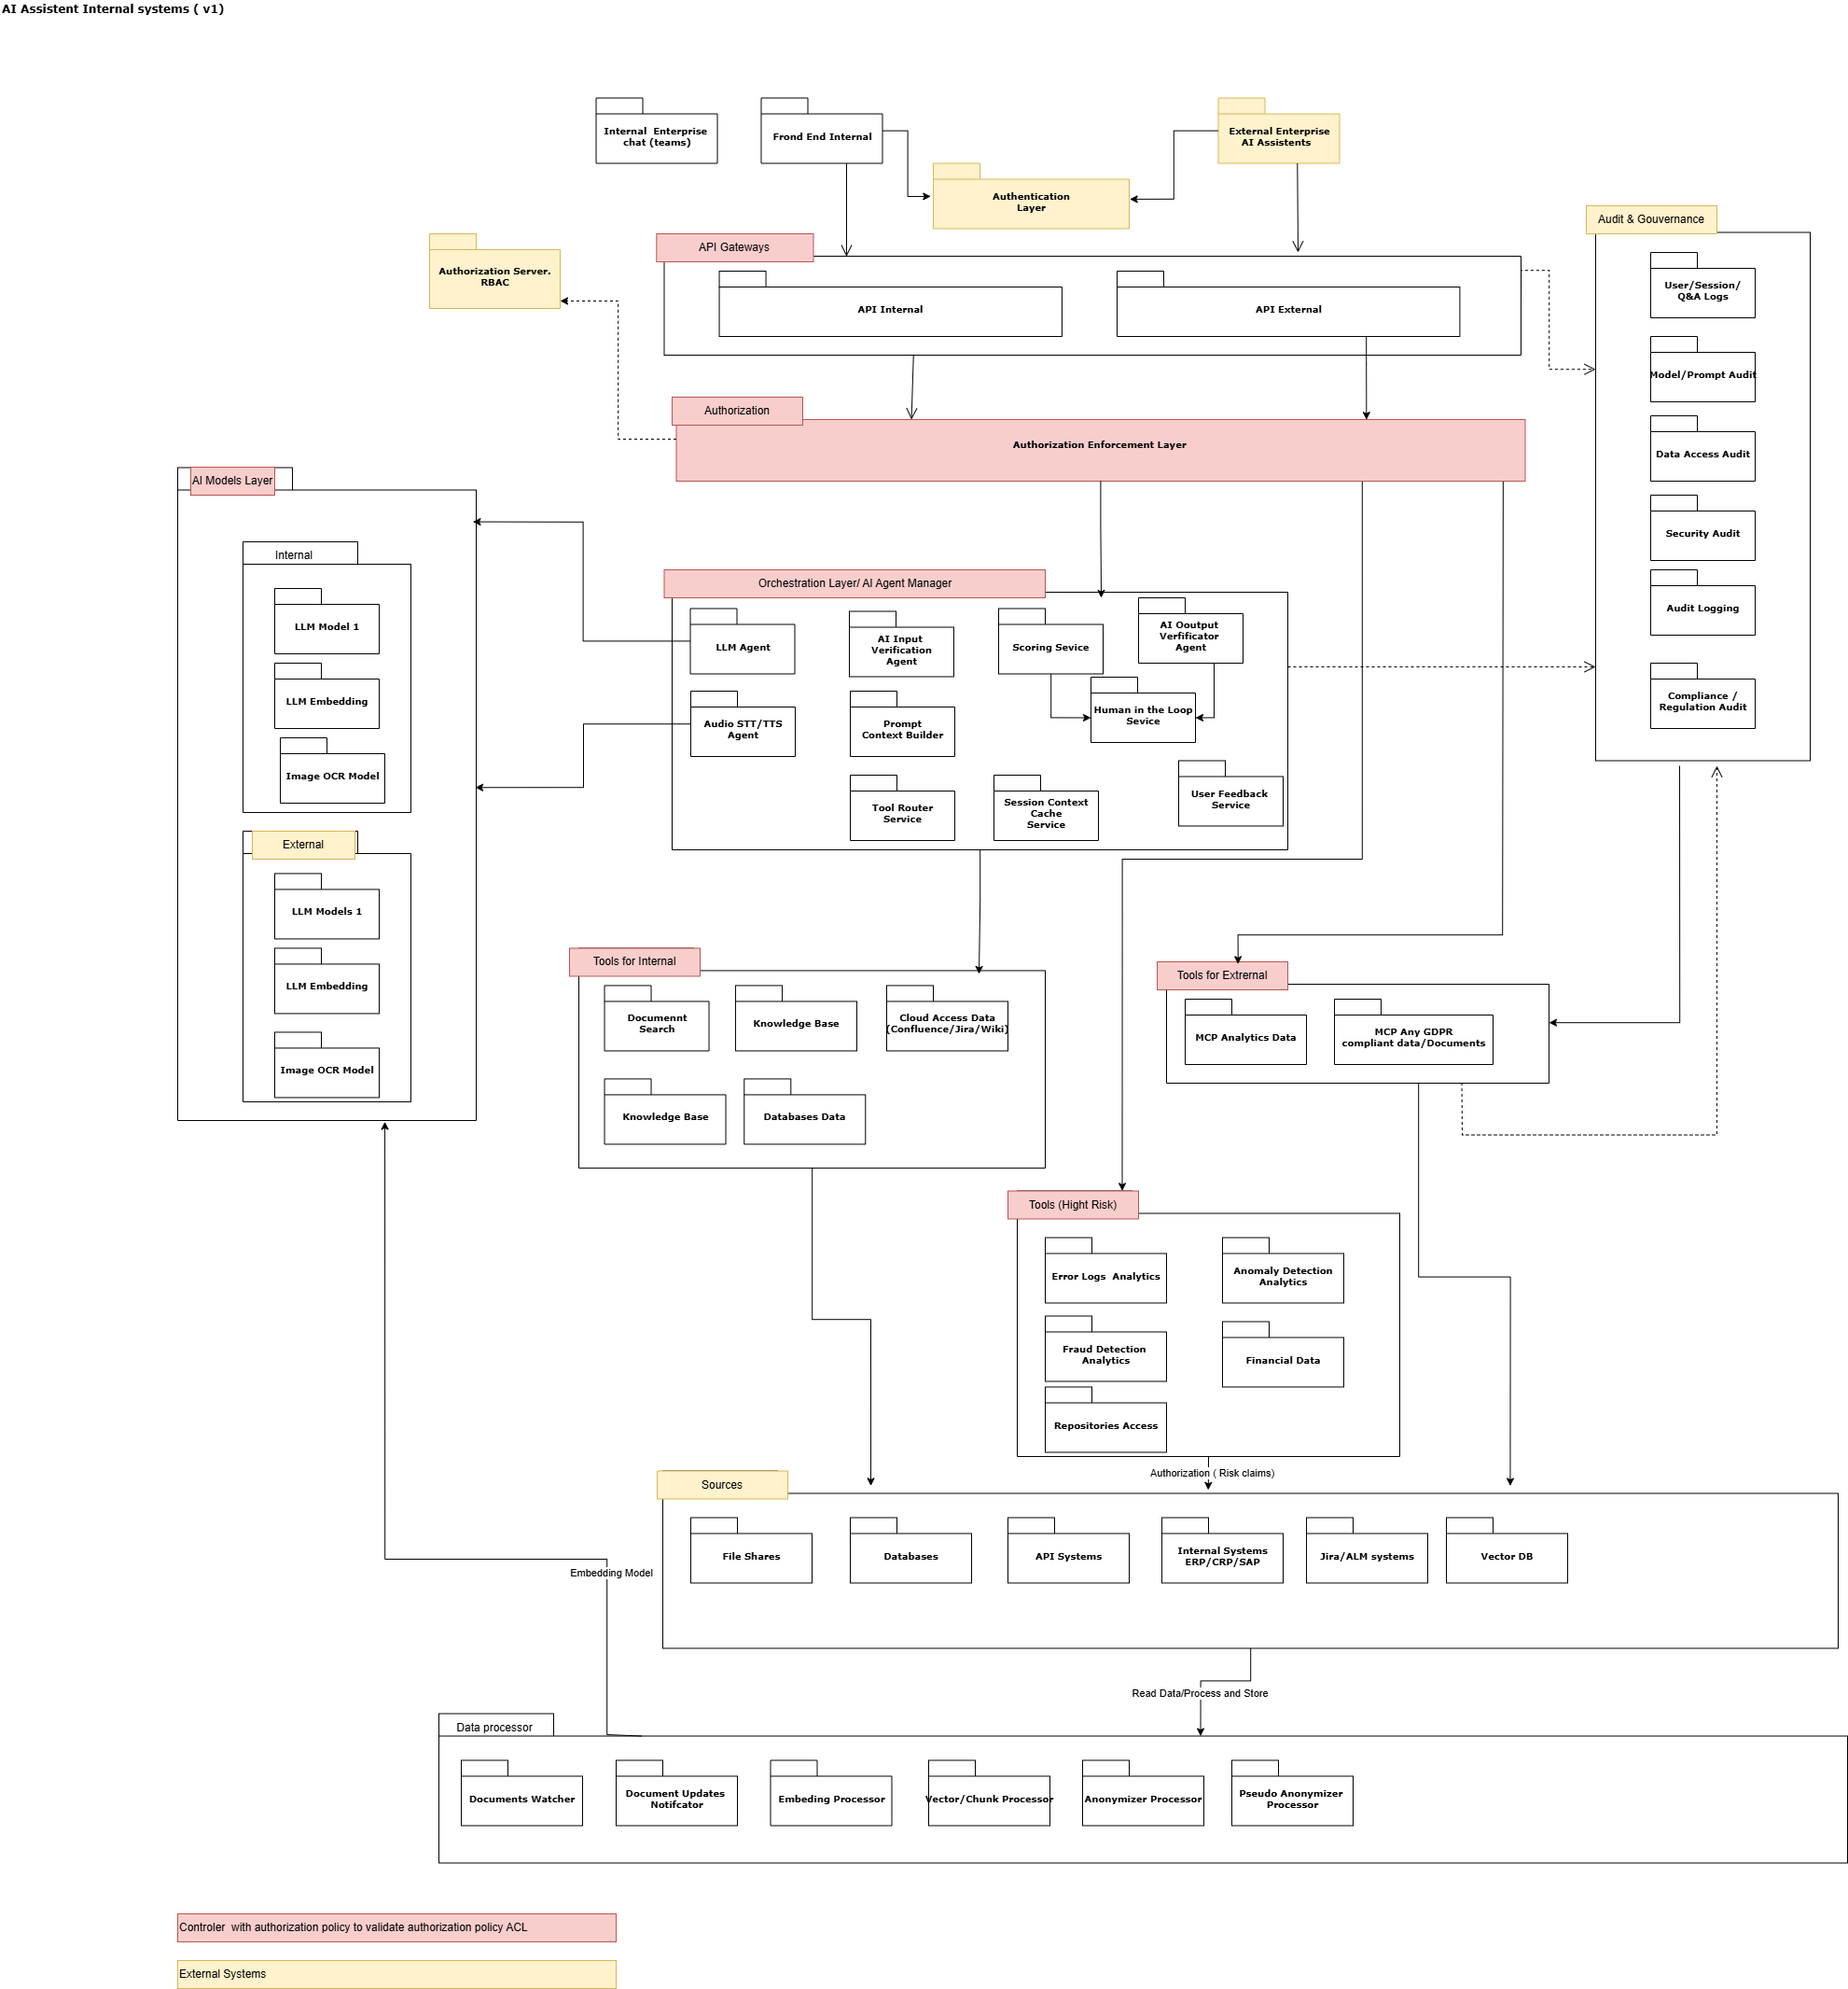

Appendix B - Azure Solution Design

