*************************************************************************************
CSC 590 ─ Graduate Project Design and Analysis Report
Project Title: Medical Text Classification Using LLMs
Student Name: Medha Maisa
*************************************************************************************
1. Architecture/Component Diagram
The project architecture involves multiple stages, including data preprocessing, traditional NLP-based models, and LLM-based models. The system is designed to classify medical text data into 'Cancer' and 'Non-Cancer' categories using the TCGA Pathology Reports Dataset. The architect ture is represented in the following block diagram:
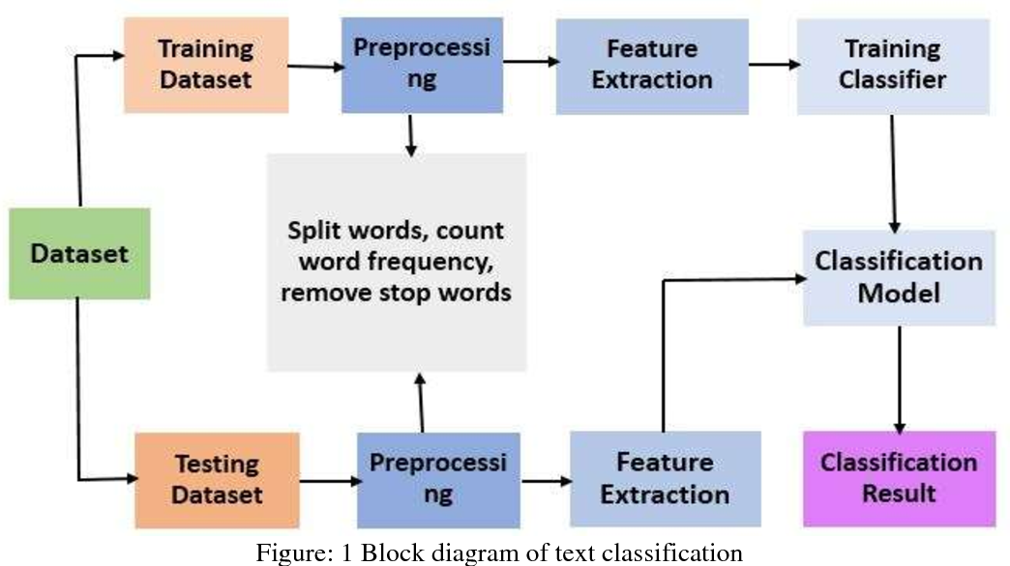
2. Detailed Functions of Components
2.1 Data Preprocessing & Augmentation
- Removing duplicates, null values, and extremely short texts
- Text normalization (lowercasing, removing special characters)
- Handling class imbalance using SMOTE (Synthetic Minority Oversampling Technique)
2.2 Feature Engineering
- TF-IDF Vectorization for traditional models
- Word embeddings (BERT embeddings) for LLM-based models
2.3 Baseline Model (Traditional NLP)
- Logistic Regression
- Random Forest Classifier
- Performance Metrics: Accuracy, F1-Score, Precision, and Recall
2.4 LLM-Based Model
- Fine-tuning BERT or GPT models on the TCGA Pathology Reports Dataset
- Implementing Few-shot learning techniques for enhanced performance
2.5 Evaluation Metrics
- Accuracy
- F1 Score
- Precision and Recall
- Confusion Matrix Visualization
3. Mathematical Formulation and Analysis
- TF-IDF Vectorization
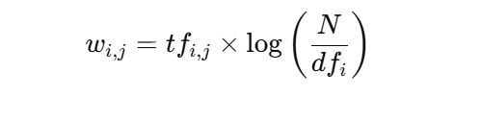
- Logistic Regression Hypothesis Function
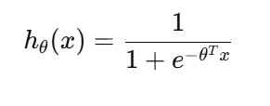
- LLM Fine-Tuning Loss Function (Binary Cross Entropy)
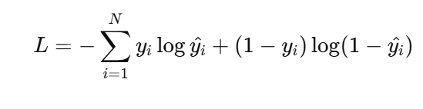
- SMOTE for Handling Class Imbalance
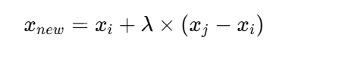
where λ is a random number between 0 and 1, and xi and xj are minority class samples.
4. Expected Outcomes
Baseline Model Performance (Traditional NLP)
- TF-IDF + Logistic Regression: 87.32% accuracy
LLM-Based Model Performance
- Improved accuracy and F1 Score (expected 90%+ accuracy) through fine-tuning BERT
Few-shot Learning Performance
- Enhanced performance with limited data
5. Future Work
5.1 Dataset Expansion and Model Efficiency
  - Future work will focus on exploring additional medical datasets for training and testing the model. This will help build a more robust and efficient model capable of handling a variety of medical domains.
5.2 Extending the Model to Multi-Class Classification
  - The model will be extended from binary to multi-class classification, enabling it to classify a wider range of medical conditions, such as different types of cancers.
5.3 Custom User Input and Feedback Loop Integration
  - The model will allow users to input custom medical text and generate predictions. It will learn from user feedback to continuously improve its predictions, incorporating reinforcement or active learning techniques.

