CSC 590/599 ─ Graduate Project/Thesis (S25)
Project Progress Report
*************************************************************************************
Project Title: Medical Text Classification using LLMs
Student Name: Medha Maisa
*************************************************************************************
1. Description of Completed Work (Itemized)
Below is an itemized summary of the work completed to date for the project “Medical Text Classification using LLMs.” The work is divided into two main phases corresponding to the two datasets explored: TCGA Pathology Reports and Independent Medical Reviews (IMR).
1.1 Work Completed on TCGA Pathology Reports Dataset
- Dataset Acquisition & Loading
  - Successfully downloaded and loaded the TCGA Pathology Reports dataset from Kaggle.
  - Focused on key fields: text (pathology content) and patient_filename (identifier).
- Initial Data Exploration & Cleaning
  - Analyzed text lengths, checked for nulls, and removed duplicate or extremely short records.
  - Applied normalization (lowercasing, punctuation removal, etc.) to standardize the text.
- Label Generation for Binary Classification
  - Assigned binary labels: 1 if the word “cancer” appeared in the report text, 0 otherwise.
  - Evaluated class balance and ensured label reliability.
- Baseline Model (TF-IDF + Logistic Regression)
  - Built a machine learning pipeline using TF-IDF for feature extraction and Logistic Regression for classification.
  - Incorporated class weighting and stratified train-test split for fair evaluation.
  - Evaluated performance using accuracy, precision, recall, and F1-score.
- Multi-Class Classification (Preliminary Exploration)
  - Began examining cancer subtypes (e.g., BRCA, COAD) for potential multi-class tasks.
  - Noted significant class imbalance issues; currently identifying the most frequent subtypes for focused modeling.
- Visualization and Reporting
  - Created visual aids including class distribution charts, word clouds, and text length histograms.
  - Documented all work using Jupyter Notebooks for reproducibility and clarity.
Note: Work on the TCGA dataset is currently paused as I explore an alternative dataset for potentially richer classification tasks.
1.2 Work on Independent Medical Reviews (IMR) Dataset
- Dataset Loading & Inspection
  - Loaded the Independent Medical Reviews dataset (~19,245 records, 11 columns) from a local source.
- Initial Data Exploration
  - Verified dataset shape and schema; identified missing values, especially in sub-category columns.
  - Computed word-level statistics and generated summary statistics on the Findings text length.
- Preprocessing Pipeline
  - Developed a preprocessing function to clean the review text (lowercasing, removing numbers, punctuation, extra spaces).
  - Removed duplicate entries and very short texts (less than 10 characters) to ensure data quality.
  - Resulted in a cleaner, leaner dataset for future classification tasks.
- Analyzing Findings Section
  - Conducted a pattern-based analysis on the Findings text to understand structural cues and consistency across entries.
  - Parsed each entry for the following key phrases:
- “Nature of Statutory Criteria/Case Summary:”
- “Findings:”
- “Final Result:”
  - Computed the distribution of these structured markers:
- Total entries analyzed: 19,130
- Entries with ‘Nature of Statutory Criteria/Case Summary:’: 2,483
- Entries with ‘Findings:’: 13,928
- Entries with ‘Final Result:’: 2,481
- Entries with none of the three phrases: 4,594
- Empty entries: 0
- These results help identify potential anchor points for rule-based or prompt-based labeling strategies for few-shot learning or LLM fine-tuning.
2. Remaining Work and Completion Plan
- Further Analysis of the IMR Dataset
  - Conduct deeper analysis of the Findings field to assess structural patterns, content reliability, and potential for classification tasks.
  - Evaluate the complexity and modeling effort required, considering label generation, text consistency, and practical interpretability.
- Finalize Dataset Selection (TCGA vs. IMR)
  - Based on analysis results and modeling feasibility, select one dataset (either TCGA or IMR) as the sole focus of the remainder of the project.
  - The other dataset will be discontinued, and no further modeling or analysis will be conducted on it.
- Resume Work on Selected Dataset
  - Continue from the previous progress point:
    - For TCGA: Proceed with contextual analysis of section headers and content blocks.
    - For IMR: Focus on improved labeling and content segmentation based on the Findings structure.
  - Refine, clean, and label the dataset to ensure it is suitable for downstream modeling.
- Baseline Model Development (on Refined Dataset)
  - Build an updated baseline model using traditional ML techniques (e.g., TF-IDF + Logistic Regression) on the newly refined and properly labeled dataset.
  - Evaluate the performance using standard classification metrics and visual tools.
- LLM Model Exploration and Few-Shot Learning
  - Fine-tune or prompt existing LLMs (e.g., GPT-4, Mistral) for the classification task using the processed dataset.
  - Experiment with few-shot learning techniques, using labeled examples to guide model predictions and test generalization.
- Final Comparison and Results Visualization
  - Compare performance of the three modeling approaches:
    - Baseline model
    - LLM-based classification
    - Few-shot learning with LLMs
  - Visualize comparative results using confusion matrices, bar plots, and ROC curves.
  - Summarize key findings, challenges faced, and insights gained in the final report.
3. Appendix – Source Code
The full source code for data preprocessing, model training, evaluation, and visualizations for TCGA dataset and The Work on Independent Medical Reviews (IMR) Dataset is included in this section. The code is well organized and properly documented to ensure reproducibility. Specific code snippets and references are provided below:
Appendix A.1: Model building using TCGA Dataset
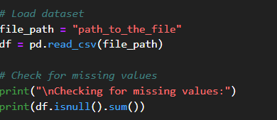
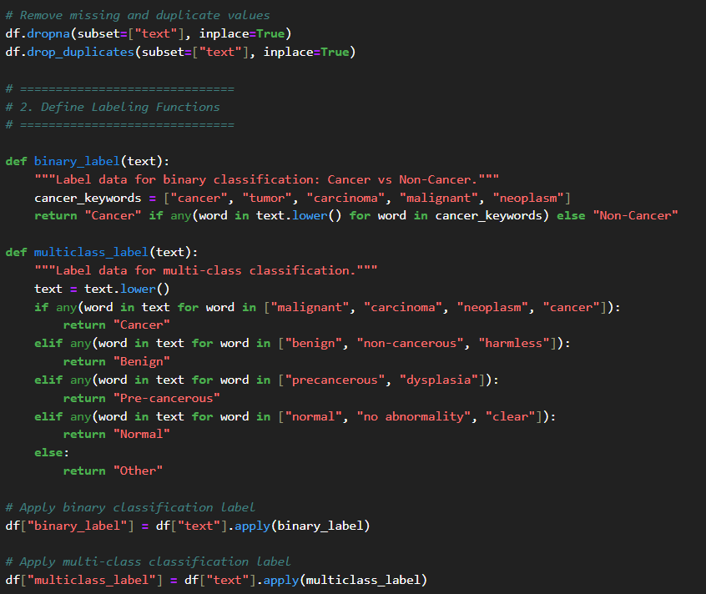
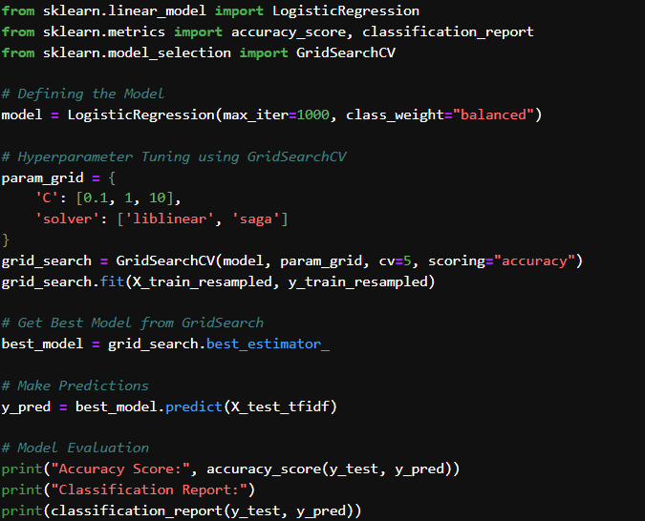
Appendix A.2: Work on Independent Medical Reviews (IMR) Dataset.
import pandas as pd
import numpy as np
import re
import string
import matplotlib.pyplot as plt
import seaborn as sns

# Step 1: Load and Analyze Dataset
file_path = "C:/Users/Medha/Documents/CSUDH/Spring2025/Independent_Medical_Reviews.csv" # Update this with the correct file path
df = pd.read_csv(file_path)

# Display dataset info
print("Dataset Shape:", df.shape)
#print("First 5 rows:\n", df.head())
print("Columns:", df.columns)

print("\n Is NULL:",df.isnull().sum())
#print('\nDiagnosis Category:\n',df['Diagnosis Category'].value_counts())
print(f"\nTotal records: {df.shape[0]}")
df['text_length'] = df['Findings'].apply(lambda x: len(str(x).split())) # For Kaggle
print('\ntext_length\n',df['text_length'].describe())

'''print("\nCOUNTING UPHELD AND OVERTURNED DECISIONS\n")
decision_counts = df['Determination'].value_counts()

# Display the counts
print(decision_counts)'''

# Check for missing values
print("\nMissing values per column:\n", df.isnull().sum())

# Step 2: Preprocessing
def clean_text(text):
if pd.isnull(text):
return "" # Handle NaN values
text = text.lower() # Convert to lowercase
text = re.sub(r'\d+', '', text) # Remove numbers
text = text.translate(str.maketrans("", "", string.punctuation)) # Remove punctuation
text = re.sub(r'\s+', ' ', text).strip() # Remove extra spaces
return text

df["Cleaned_Text"] = df["Findings"].apply(clean_text) # Assuming "Findings" contains the medical reviews

# Remove duplicates and short texts
df.drop_duplicates(subset=["Cleaned_Text"], inplace=True)
df = df[df["Cleaned_Text"].str.len() > 10]

print(f"Dataset after preprocessing: {df.shape}")

#LATEST WORK!!
# Initialize counters

print(“Analysing Findings: \n“)
empty_count = 0
nature_case_summary_count = 0
findings_count = 0
final_result_count = 0
total_count = 0
none_phrases_count = 0

# Loop through each cleaned text
for text in df['Findings']:
if pd.isnull(text) or text.strip() == "":
empty_count += 1
else:
total_count+=1
found = False
text_lower = text.lower()
if "nature of statutory criteria/case summary:" in text_lower:
nature_case_summary_count += 1
found = True
if "findings:" in text_lower:
findings_count += 1
found = True
if "final result:" in text_lower:
final_result_count += 1
found = True
if not found:
none_phrases_count += 1

# Print results
print("Total Entries':", total_count)
print("Number of EMPTY entries in Cleaned_Text:", empty_count)
print("Entries with 'Nature of Statutory Criteria/Case Summary:':", nature_case_summary_count)
print("Entries with 'Findings:':", findings_count)
print("Entries with 'Final Result:':", final_result_count)
print("Entries with NONE of the 3 phrases:", none_phrases_count)
Appendix A.3: Findings from the Independent Medical Reviews (IMR) Dataset.
Dataset shape after preprocessing: (19130, 13) Index(['Reference ID', 'Report Year', 'Diagnosis Category',
'Diagnosis Sub Category', 'Treatment Category',
'Treatment Sub Category', 'Determination', 'Type', 'Age Range',
'Patient Gender', 'Findings', 'Cleaned_Text', 'text_length'],
dtype='object')

Is NULL: Reference ID 0
Report Year 0
Diagnosis Category 59
Diagnosis Sub Category 1898
Treatment Category 447
Treatment Sub Category 1267
Determination 0
Type 0
Age Range 1191
Patient Gender 1191
Findings 0
Cleaned_Text 0
text_length 0
dtype: int64

Analysing Findings:

Total Entries': 19130
Number of EMPTY entries in Cleaned_Text: 0
Entries with 'Nature of Statutory Criteria/Case Summary:': 2483
Entries with 'Findings:': 13928
Entries with 'Final Result:': 2481
Entries with NONE of the 3 phrases: 4594

