**An Opportunity to Invest in a Fast-Growing Residential developments in UK**

**Business Summary:** The Residential Development company, ME Developments was established in 2016 catering to building mid-market luxury houses and high-turnover urban London apartments.

Development Size: - Home Counties projects of around 15+ houses

* Urban London buildings, of 50+ apartments.

Track Record: - Has delivered ------sqft. Of real estate development over last 4 years consistently maintained high standards;

Financial track record:

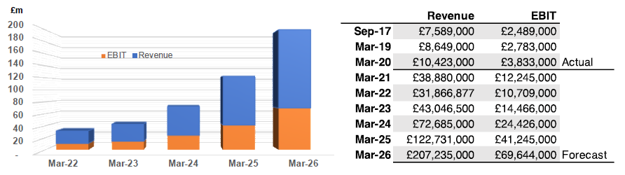

Value Proposition:

* Off-Market Sales;
* Land Banking;
* Urban Regeneration;
* Build -to-Rent;
* Housing Association;
* Company Acquisition

Competitive Advantage:

Sales/Marketing Strategy

**Revenue Model:**

* Sale of completed properties; GDV: GBP 10Million Risk profile: Low Realization: 6-12 months;
* Sale of under construction properties: GDV: GBP 30Million Risk Profile: Medium Realization 12- 18 months
* Sales of properties at design and approval: GDV: GBP 100Million Risk Profile: Medium to High: Realization: 18-24 months
* Acquisition of new land bank: GDV GBP 220Million Risk Profile High Realization: 24- 36 months

**Management:** The Group is led by Simon Marshall, the CEO with his dynamic team built for growth and quality delivery. Simon has extensive experience in retail sector in emerging markets. In his latest assignment, working as CEO for one of largest retailer in the Middle East’, delivered equity growth from $200m to over $12bn over 10 years period with establishing 3400 stores across 16 16 countries in emerging markets establishing the group to became one of the world’s largest shopping mall builders managing more than 5,000,000 sq.ft. of retail space.

**Operational Model:**

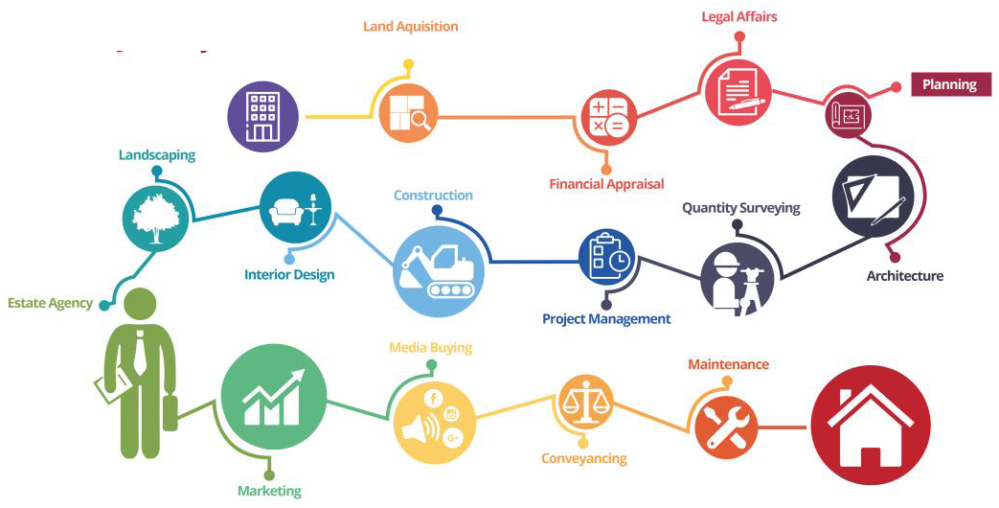

**Proposed Transaction:**

**Financing amount: £5,000,000 for 20% stake**

**Preferred dividends: 15% per annum for first year paid semi-annually;**

**17.5% pr annuum for second year paid semi-annually**

**20% per annum for third year paid semi-annually;**

**Common dividends: As per shareholding post three-year period**

**Expected Equity IRR 30%**

**Use of Funds: Investment is to be entirely allocated to the purchase of new development sites.**

**Funding Vehicle: ME Holdco**

**Capital Commitment: Further capital may be required when projects become available allowing the company to** rapidly expand

.

**Risk Consideration: High cash Yield for first three years;**

**Hard collateral in first three years;**

**Equity build-up over a period;**

**Leverage;**

**Tax advantage;**

