1. Register new EntraID application

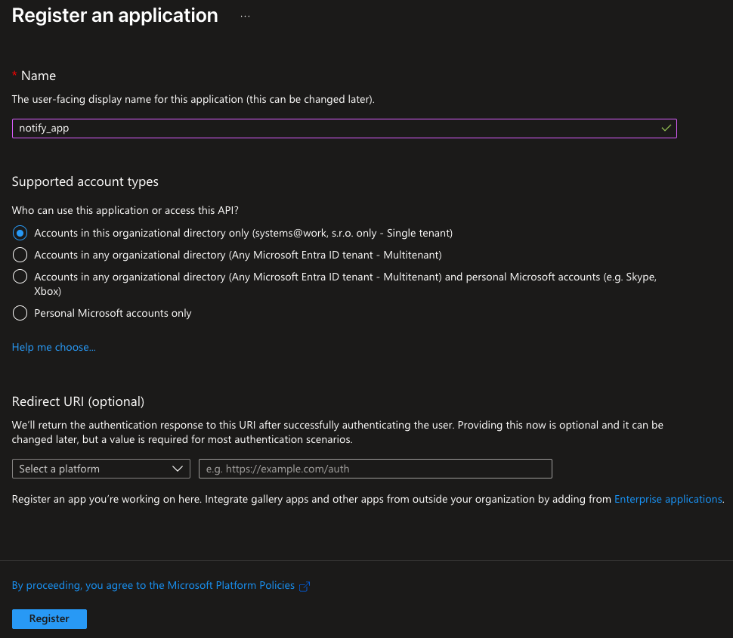

1. Add Mail.Send API permissions

1. Remove User.Read permissions

1. Grant Admin Consent

1. Create new secret and copy the value. Can be read only once at creation!

1. From Application overview make a note of Client ID and Tenant ID

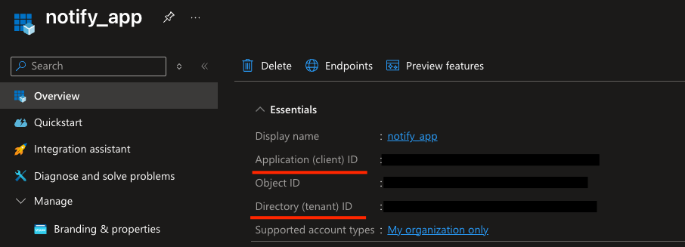

1. Update values in config.yaml file

