Department of Computer Science and Engineering, Brac University
CSE422: Artificial Intelligence
Lab Project Report: Career Switch Using Machine Learning
Group members:
Maliyat Binte Marouf ID: 24101531
Nuzhat Saadat ID: 24141041

1. Introduction
2. Dataset Description
3. Dataset Pre-processing
3.1 Missing / Null Values
3.2 Data Entry Error
3.3 Ordinal Categorical Variables
3.4 Binary Categorical Variable
3.5 Nominal Categorical Variables
3.6 Feature Scaling
4. Dataset Splitting
5. Model Training & Testing
5.1 Logistic Regression
5.2 Naive Bayes
5.3 Neural Network
5.4 K-Means Clustering (Unsupervised)
6. Model Selection / Comparison Analysis
6.1 Overall Accuracy Comparison
6.2 Precision & Recall Comparison
6.3 Confusion Matrices
6.4 ROC Curves and AUC Scores
7. Conclusion

1. Introduction
Career switching is difficult for organizations to predict. When a trained candidate changes careers, the organization may lose the time and money spent on hiring and training. Predicting career switching can help organizations plan recruitment, training, and retention more effectively.
This project treats career switching as a binary classification problem. Using demographic, educational, and professional data from 5,000 candidates, the model predicts whether a candidate will change careers (1) or not (0). Several machine learning models are trained, tested, tuned, and compared, along with K-Means clustering.
The project also demonstrates a complete machine learning pipeline: cleaning missing and incorrect data, encoding categorical features, scaling numerical features, splitting the dataset, training models, and evaluating their performance.

2. Dataset Description
The Career Switch Prediction Dataset contains 5,000 rows and 14 columns.
- Number of data points: 5,000
- Number of columns: 14 (1 identifier, 12 candidate features, 1 target)
- The problem is classification because the target, will_change_career, has two classes: 0 (will not switch) and 1 (will switch).

Feature List:
# | Column | Type | Description
1 | enrollee_id | Identifier | Unique ID per candidate — dropped before modelling
2 | city | Categorical (nominal) | City code of the candidate — dropped (114 unique codes; city_development_index already summarizes city information)
3 | city_development_index | Quantitative (continuous) | Development index of the candidate's city (0–1)
4 | gender | Categorical (nominal) | Male / Female / Other
5 | relevent_experience | Categorical (binary) | Has / does not have relevant work experience
6 | enrolled_university | Categorical (nominal) | Current university enrollment status
7 | education_level | Categorical (nominal) | Highest education level attained
8 | major_discipline | Categorical (nominal) | Discipline of study
9 | experience | Categorical (ordinal) | Years of professional experience (<1 to >20)
10 | company_size | Categorical (ordinal) | Size of current employer
11 | company_type | Categorical (nominal) | Type of current employer
12 | last_new_job | Categorical (ordinal) | Years since last job change
13 | training_hours | Quantitative (discrete) | Hours of training completed
14 | will_change_career | Categorical (binary) — Target | 1 = will switch career, 0 = will not

After removing enrollee_id and the high-cardinality city column, 11 features remain: 2 quantitative features and 9 categorical features.
Categorical features must be converted to numbers because the machine learning models used in this project require numeric input. The encoding method depends on whether a category is nominal, binary, or ordinal.

Correlation Analysis
A Pearson correlation heatmap was generated for the numeric features and the target: city_development_index, training_hours, and will_change_career.
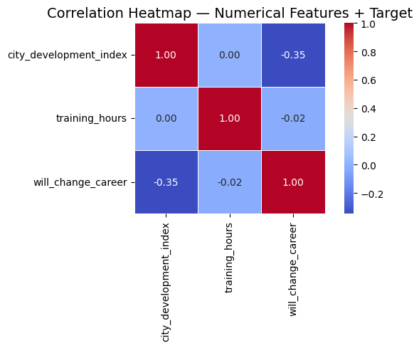
Correlation heatmap of the numeric features and the target variable.
city_development_index has a moderate negative correlation with the target (−0.35), while training_hours has almost no linear correlation (−0.02). The two numeric features are also essentially uncorrelated (0.00).

Class Imbalance
The target is imbalanced: 3,738 candidates (74.76%) will not switch, while 1,262 (25.24%) will switch. The ratio is about 3:1.
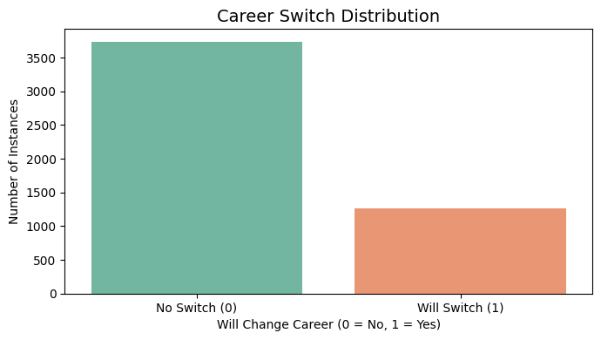
Bar chart of class distribution for will_change_career.
Because a model predicting only class 0 would reach about 74.8% accuracy, accuracy alone is not enough. Precision, recall, F1-score, and AUC are also used.

Exploratory Data Analysis
EDA was performed using descriptive statistics, distributions, correlation, and feature–target relationships.

Descriptive Statistics
The main numeric statistics are shown below.
Feature | Mean | Std Dev | Min | Median | Max
city_development_index | 0.829 | 0.122 | 0.448 | 0.903 | 0.949
training_hours | 65.03 | 59.95 | 1 | 47 | 336

The descriptive statistics show that training_hours has a much wider numerical range than city_development_index, which supports the use of feature scaling.

Distributions
The histograms show different distributions: city_development_index is concentrated near higher values, while training_hours has a long right tail.
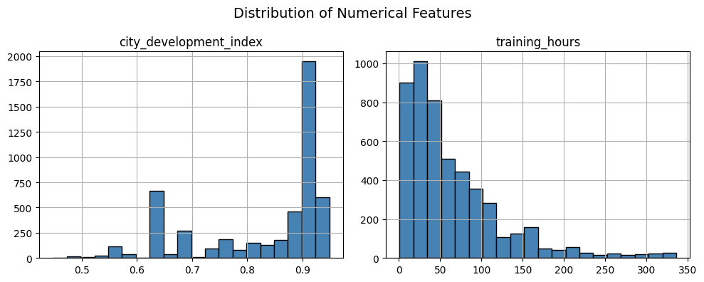
Histograms of the numeric features (city_development_index, training_hours).
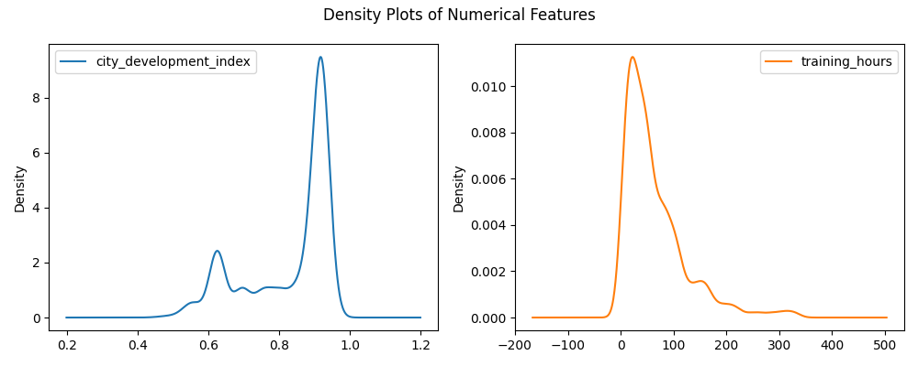
The categorical features were also examined using frequency bar charts.
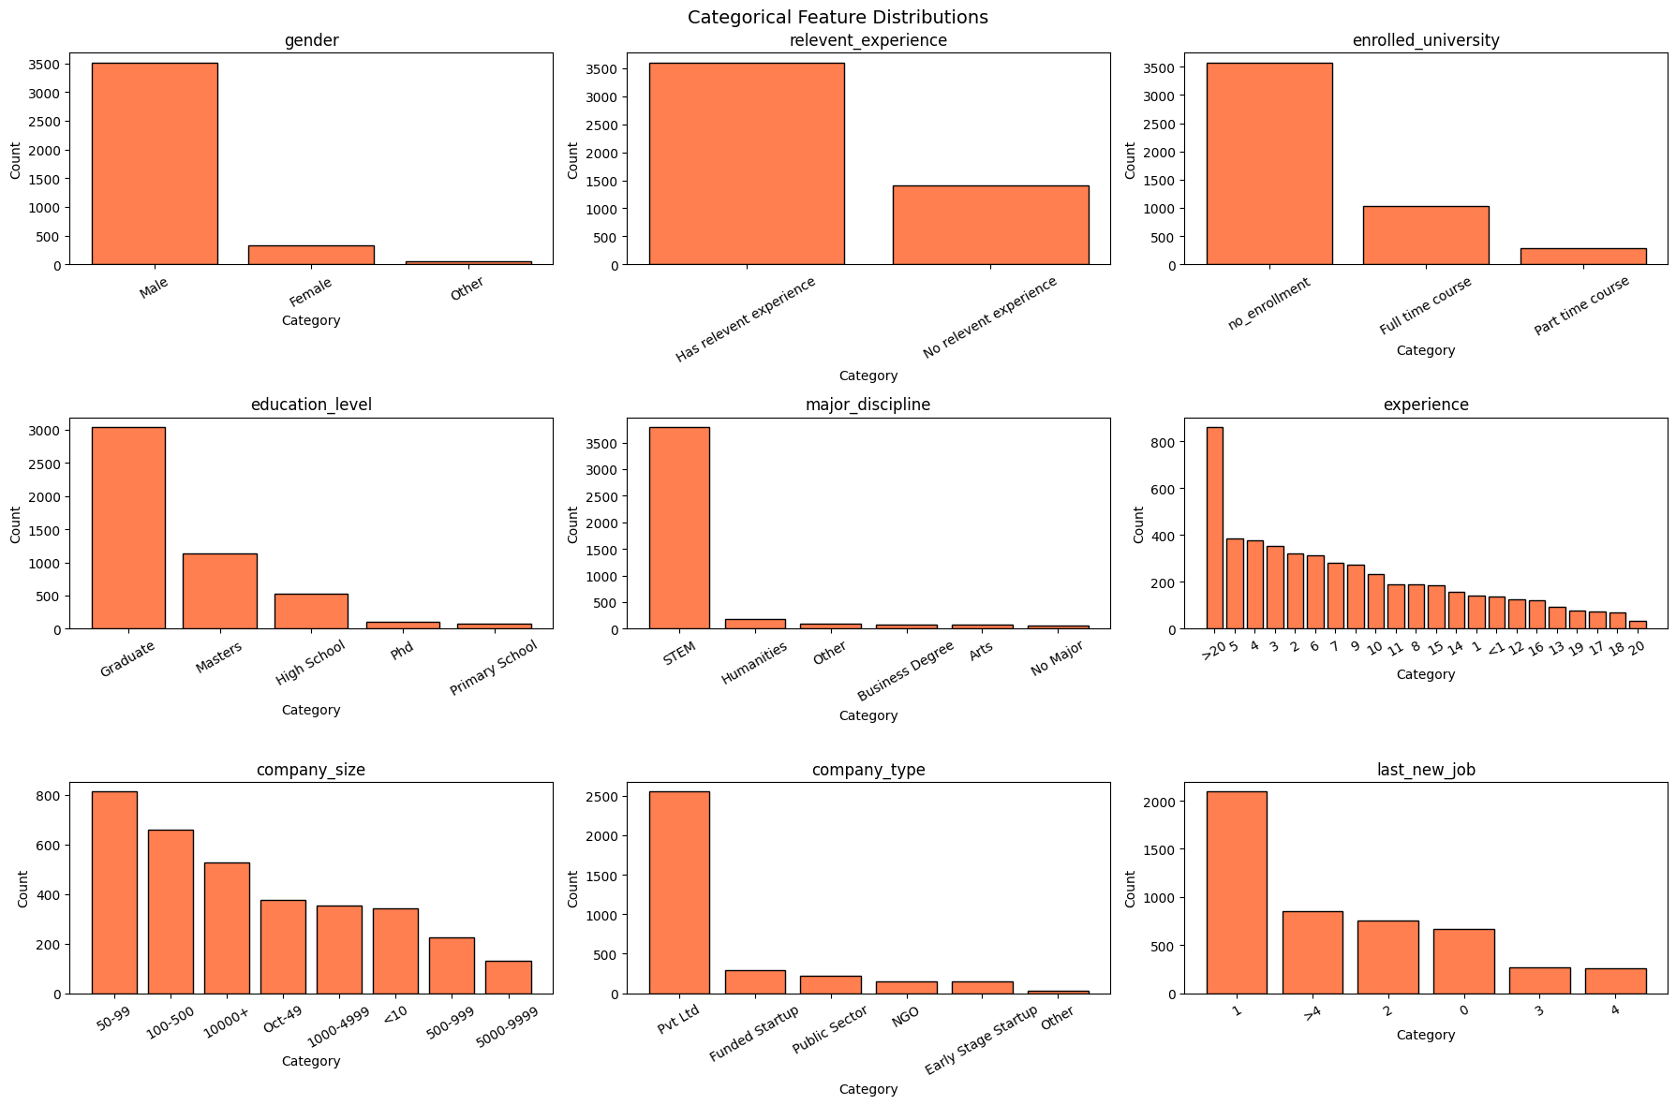
Category frequency distributions for all categorical features.

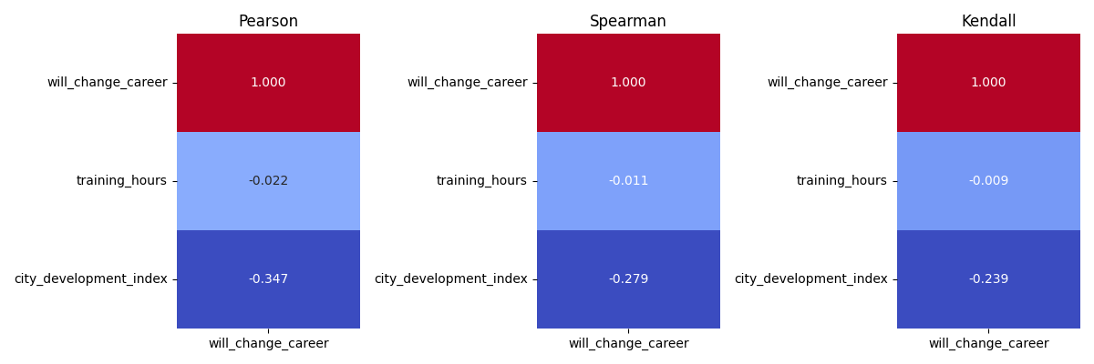

Feature–Target Relationships
The boxplots support the correlation results: candidates who switch careers tend to have lower city development index values, while training_hours has similar spreads across both classes.
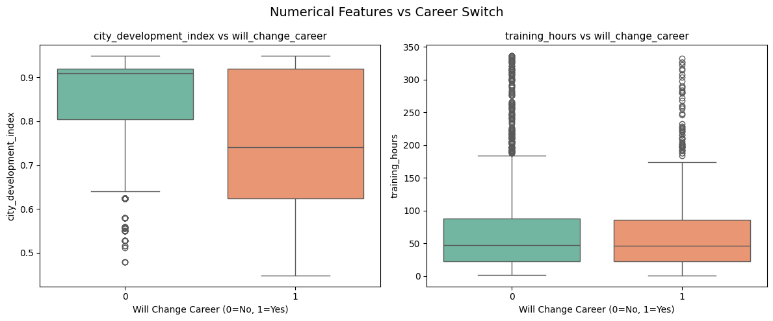
Boxplots of numeric features grouped by will_change_career.
The categorical feature-versus-target plots were also examined visually.
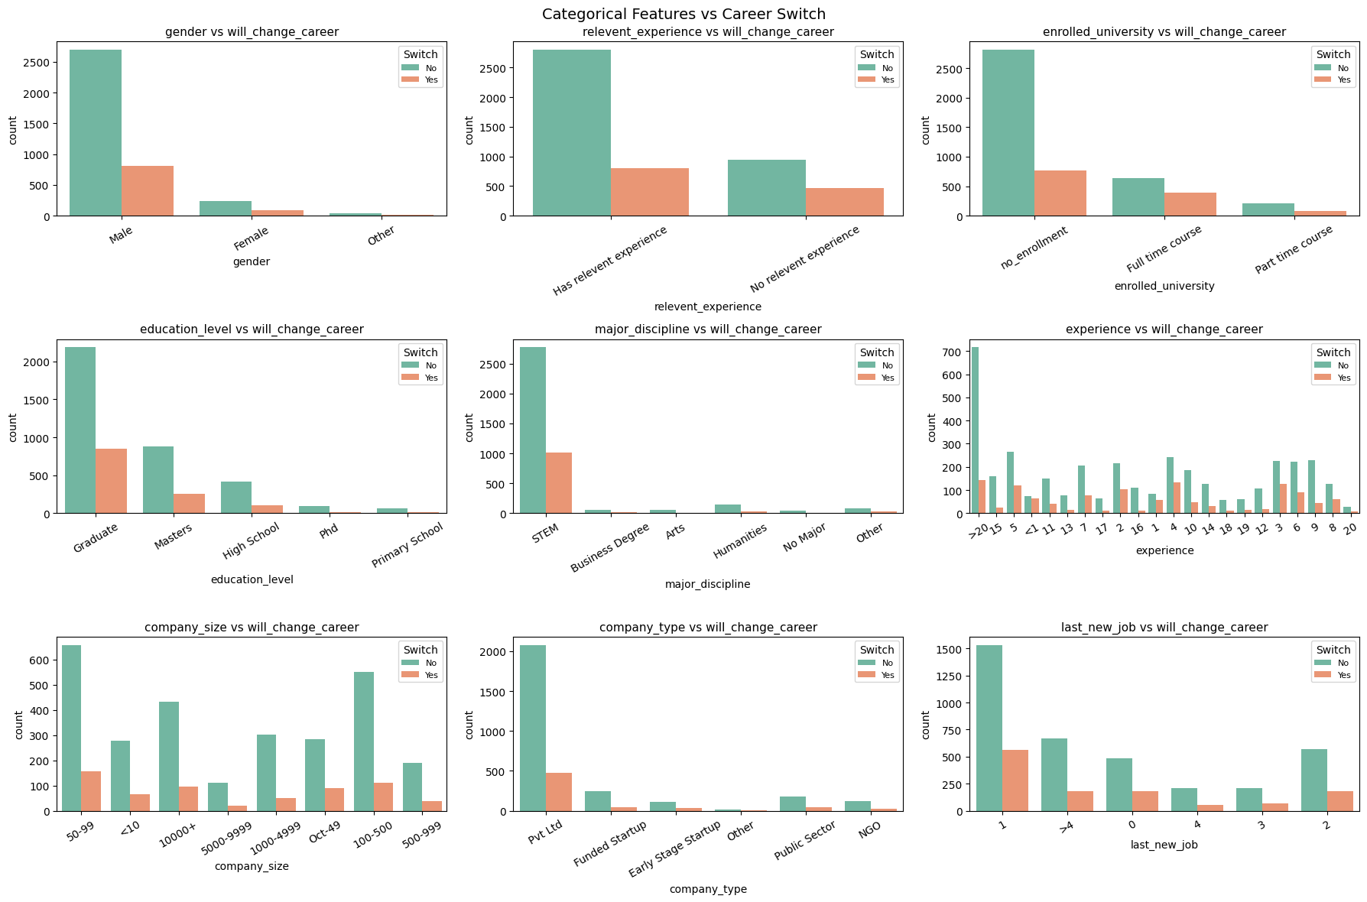
Categorical feature distributions split by will_change_career.

3. Dataset pre-processing
Each data-quality problem was handled before model training, with the reason for each preprocessing step explained below.

Problem 1 — Missing / Null Values
The dataset contained 5,369 missing values across 8 columns.
Column | Missing Count | % Missing
gender | 1113 | 22.3%
company_type | 1621 | 32.4%
company_size | 1571 | 31.4%
major_discipline | 724 | 14.5%
education_level | 118 | 2.4%
enrolled_university | 107 | 2.1%
last_new_job | 104 | 2.1%
experience | 11 | 0.2%

Dropping rows would remove too much of the 5,000-row dataset, so missing values were imputed.
- Numeric columns were filled with the median because it is less affected by skew and extreme values.
- Categorical columns were filled with the mode, or most frequent category.
After imputation, there were no missing values and all 5,000 rows were retained.

Problem 2 — Data Entry Error
company_size contained "Oct-49", caused by spreadsheet conversion of the intended category "10-49". It was corrected to "10-49" before encoding.

Problem 3 — Ordinal Categorical Variables
experience, company_size, and last_new_job have meaningful order. They were ordinal-encoded into integers so their order was preserved.

Problem 4 — Binary Categorical Variable
relevent_experience has two categories, so it was label-encoded as 0/1.

Problem 5 — Nominal Categorical Variables
gender, enrolled_university, education_level, major_discipline, and company_type are nominal variables with no natural order. They were one-hot encoded, with the first category dropped to avoid redundant dummy variables. The feature count increased from 11 to 24.

Problem 6 — Feature Scaling
city_development_index and training_hours use very different scales. StandardScaler converted both to zero mean and unit variance before model training, supporting the scaled input used by Logistic Regression and the Neural Network.
The final dataset has 5,000 rows, 24 features, and no missing values. The target remains 3,738 class-0 and 1,262 class-1 cases.

4. Dataset Splitting
The data was split using an 80/20 stratified split with random_state=42. Stratification kept the class ratio similar in the training and test sets.
Split | Total | Class 0 (No Switch) | Class 1 (Will Switch)
Full dataset | 5000 | 3,738 (74.76%) | 1,262 (25.24%)
Training set (80%) | 4000 | 2,990 (74.75%) | 1,010 (25.25%)
Test set (20%) | 1000 | 748 (74.80%) | 252 (25.20%)

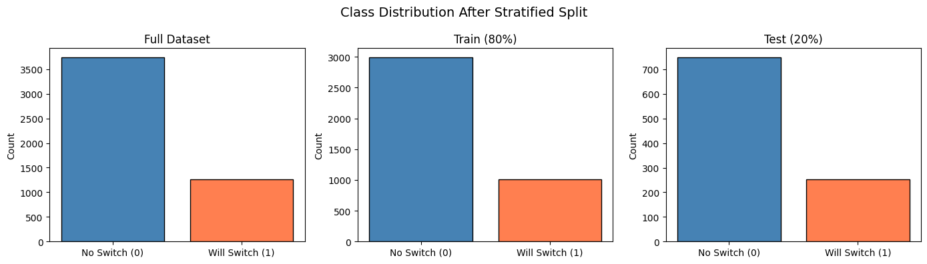
Class distribution preserved across the full dataset, training set, and test set.

5. Model Training & Testing
Four models were evaluated on the same training and test sets: three supervised classifiers and one unsupervised K-Means model.

Logistic Regression
Logistic Regression provides a linear classification baseline. With C=1.0, max_iter=1000, and random_state=42, it achieved 76.70% test accuracy.

Naive Bayes
Gaussian Naive Bayes assumes the features are conditionally independent. It achieved 63.90% test accuracy.

5.3 Neural Network (MLPClassifier)
The Neural Network used hidden layers of 128, 64, and 32 neurons with ReLU, Adam, a learning rate of 0.001, max_iter=1000, and early stopping with a 10% validation fraction. It achieved 78.00% test accuracy, the best of the supervised models.

5.4 K-Means Clustering (Unsupervised)
K-Means (k=2) was trained without using the target label, using n_init=10 and random_state=42. It grouped candidates by feature similarity. The two test clusters contained 658 and 342 points, so these clusters are similarity groups rather than direct career-switch predictions.
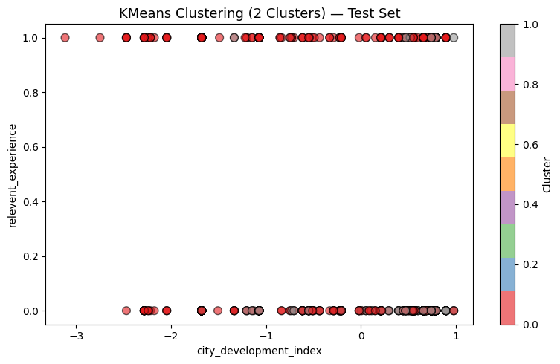
K-Means clustering (k = 2) of the test set, shown using a 2D PCA projection.

6. Model Selection / Comparison Analysis

Overall Accuracy Comparison
The three supervised models were compared using test accuracy, weighted precision, weighted recall, weighted F1-score, confusion matrices, and AUC. K-Means was evaluated separately because it is unsupervised and does not directly predict the target.
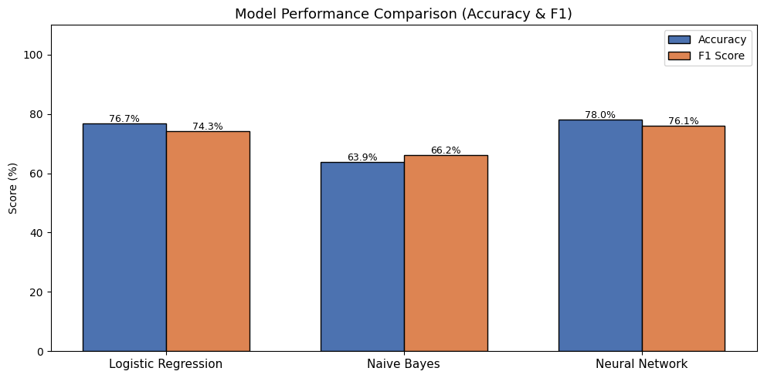
Test accuracy comparison across the three supervised models.
Rank | Model | Test Accuracy
1 | Neural Network | 78.00%
2 | Logistic Regression | 76.70%
3 | Naive Bayes | 63.90%

Precision & Recall Comparison
Because the classes are imbalanced, precision, recall, and F1-score were compared along with accuracy.
Model | Accuracy | Precision | Recall | F1-score
Logistic Regression | 76.70% | 74.15% | 76.70% | 74.28%
Naive Bayes | 63.90% | 73.54% | 63.90% | 66.25%
Neural Network | 78.00% | 75.98% | 78.00% | 76.08%

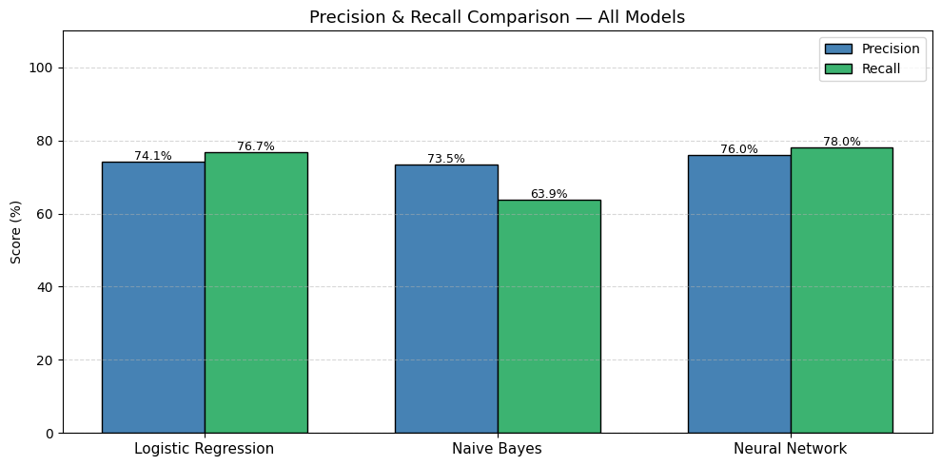
The Neural Network has the strongest weighted precision, recall, and F1-score among the three supervised models, while Naive Bayes has the lowest overall performance.

Confusion Matrices
The confusion matrices for all three supervised models are shown below.
Confusion matrices for the three supervised models.
The Neural Network correctly identifies 92% of the majority No Switch class but only 37% of the Will Switch class. This shows that the model misses many candidates who actually switch careers.
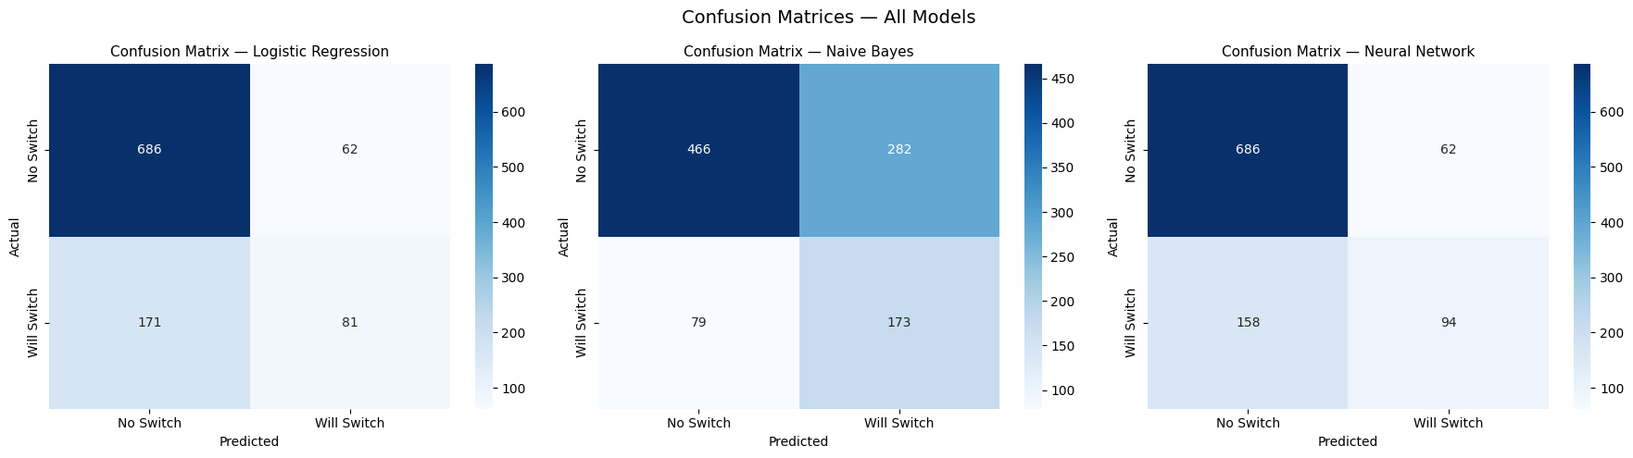
Confusion matrices for all five core models on the test set.

ROC Curves and AUC Scores
Model | AUC
Neural Network | 0.7458
Logistic Regression | 0.7201
Naive Bayes | 0.6904

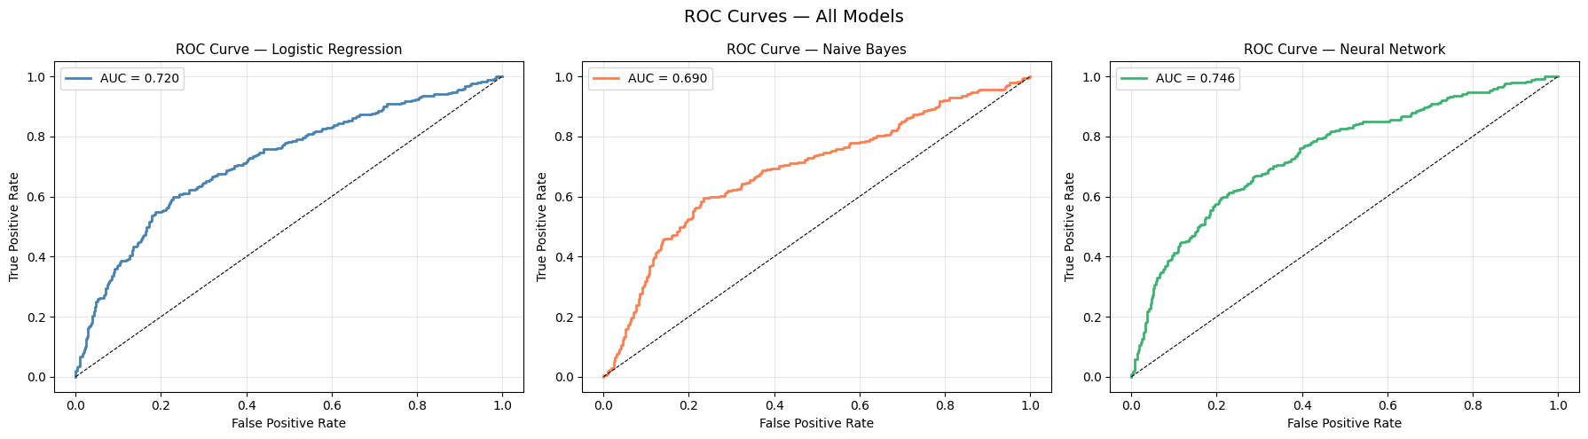
ROC curves and AUC scores for all five core models.
The Neural Network has the highest AUC (0.7458), followed by Logistic Regression (0.7201) and Naive Bayes (0.6904).

7. Conclusion
The three supervised models achieved 63.90%–78.00% test accuracy. The Neural Network performed best at 78.00%, while Naive Bayes achieved 63.90%. This shows that the dataset contains useful but limited predictive information.
Key findings:
- The Neural Network produced the highest accuracy among the supervised models at 78.00%.
- The Neural Network was the strongest supervised model based on accuracy, weighted F1-score, and AUC.
- Naive Bayes performed worst, likely because its independence assumption does not fit features that are naturally related, such as experience and last_new_job.
- The main weakness was minority-class recall. The Neural Network detected only 37% of candidates who switched careers, showing the effect of the 3:1 class imbalance.
The main challenges were handling substantial missing data, choosing the correct encoding for different categorical variables, fixing the "Oct-49" data-entry error, and evaluating an imbalanced target without relying on accuracy alone.
A useful next step would be to address class imbalance using class weighting, SMOTE, or threshold tuning, with the goal of improving recall for the Will Switch class.

