Experiments
[1]
Initial run
CMD (name) | S (state) | PID (process id) | PPID (parent id)
Exp_1 | S | 8739 | 8596
Exp_1 | S | 8740 | 8596

Second run
CMD (name) | S (state) | PID (process id) | PPID (parent id)
Exp_1 | S | 8745 | 8596
Exp_1 | S | 8746 | 8596

Process ID changed, parent ID, name, and state did not change. This suggests that the parent is the same as the initial run.

From observation of the output of ps -l, it just so happens that the parent process is contained in this list. Its name is bash, which to my knowledge, is the terminal. So it would appear that the terminal/bash is forking off new processes whenever you start a program through it.

Killing the parent process closed my terminal. Since my terminal was closed, I wasn't able to see what happened to the child processes. The parent ID for both processes was changed to 1.

[2]
-e view all processes
-l long format, often used with -y, shows additional information with column headers
-f full format listing, adds UID PPID C and STIME columns to output

ps -fu mmallett
Views all proccesses under my user name, with added column to view user name.

[3]
Sleep  Process ID is: 9099  Parent Process ID is 9098  Process ID is: 9098  Parent Process ID is 9097  Process ID is: 9100  Parent Process ID is 9097  Process ID is: 9097  Parent Process ID is 9045 | No sleep  Process ID is: 9162  Parent Process ID is 9161  Process ID is: 9161  Parent Process ID is 9160  Process ID is: 9163  Parent Process ID is 9160  Process ID is: 9160  Parent Process ID is 9045

Process 9045 is the bash. The parent process forks off a copy process, so both have one more fork to go. The forked process completes the second fork then completes. Then the parent process completes its second fork and completes. Adding/removing the sleep may change the order these happen in sometimes, but I didn't see any change.

[tree]

[4]
The child process ID is 9336
The child's parent process ID is 9335
The parent process ID is 9335
The parent's parent process ID is 9045

You need to have a way to differentiate the parent from the child, otherwise, they would be exactly the same process with no way to tell parent from child.

fork() returns 0 for the child, and the new child's process ID for the parent. We have functions to get the parent ID, and the process's own ID. It is redundant to give the child the parent's ID, when the child can just call getppid(). Returning 0 in the parent process means there is no way to get the child process ID.

[5]
Child: 2821
Child: 2822
ChParent: 0
Parent: 1
Parent: 2
Parent: 3

The operating system periodically takes control of the processor via a timer interrupt. This is to prevent one process from using all of the processor's cycles. My guess is that printf prints one char at a time, and it just so happens that the interrupt was fired in the middle of this printf call.

Here is where the child gets the processor back.

Parent: 2604
Parent: 2605
ild: 2823
Child: 2824
Child: 2825
Child: 2826

As you can see, it resumed exactly where it left off, which was in the middle of the word child. The process's state was saved, and then control was given to the parent process. When the child began executing again, it was like nothing happened and it picked up right where it left off.

[6]
Here is where the parent gets control from the child.

Child: 499997
Child: 499998
Child: 499999
Child ends
Parent resumes.
Parent: 0
Parent: 1
Parent: 2
Parent: 3

The child is allowed to fully execute because the parent has called wait(). Timer interrupts still give control to the OS which in turn give control to the parent, but the parent won't do anything until the child has completed. You don't see control being passed mid execution as in experiment 5.

[7]
The printf will not be executed. Exec will only return if there is an error. In normal execution, exec destroys whatever code is currently running in the process, and the new program takes it over. This is why new programs are often spawned with a fork() exec() combo, to prevent the parent from being overwritten by the newly spawned program.

[8]
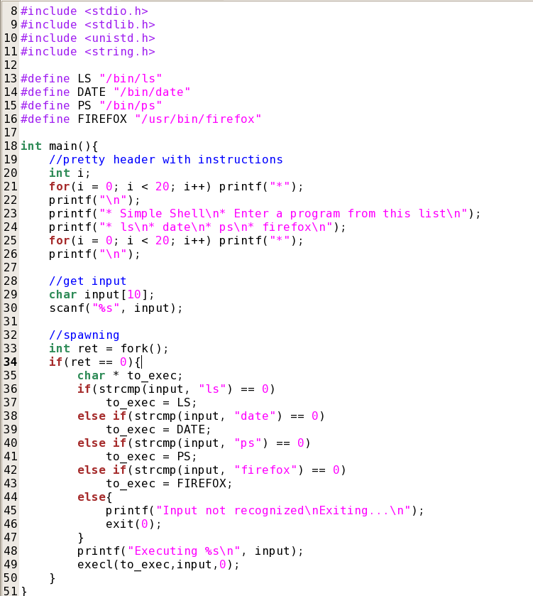
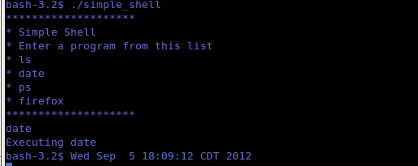
copyable code
/*****************************************************************
* Matt Mallett
* CprE 308
* simple_shell.c
* Basic shell that spawns a new process from a list of programs.
*****************************************************************/

#include <stdio.h>
#include <stdlib.h>
#include <unistd.h>
#include <string.h>

#define LS "/bin/ls"
#define DATE "/bin/date"
#define PS "/bin/ps"
#define FIREFOX "/usr/bin/firefox"

int main(){
//pretty header with instructions
int i;
for(i = 0; i < 20; i++) printf("*");
printf("\n");
printf("* Simple Shell\n* Enter a program from this list\n");
printf("* ls\n* date\n* ps\n* firefox\n");
for(i = 0; i < 20; i++) printf("*");
printf("\n");

//get input
char input[10];
scanf("%s", input);

//spawning
int ret = fork();
if(ret == 0){
char * to_exec;
if(strcmp(input, "ls") == 0)
to_exec = LS;
else if(strcmp(input, "date") == 0)
to_exec = DATE;
else if(strcmp(input, "ps") == 0)
to_exec = PS;
else if(strcmp(input, "firefox") == 0)
to_exec = FIREFOX;
else{
printf("Input not recognized\nExiting...\n");
exit(0);
}
printf("Executing %s\n", input);
execl(to_exec,input,0);
}
}

