Open shell to linux-1.ece.iastate.edu
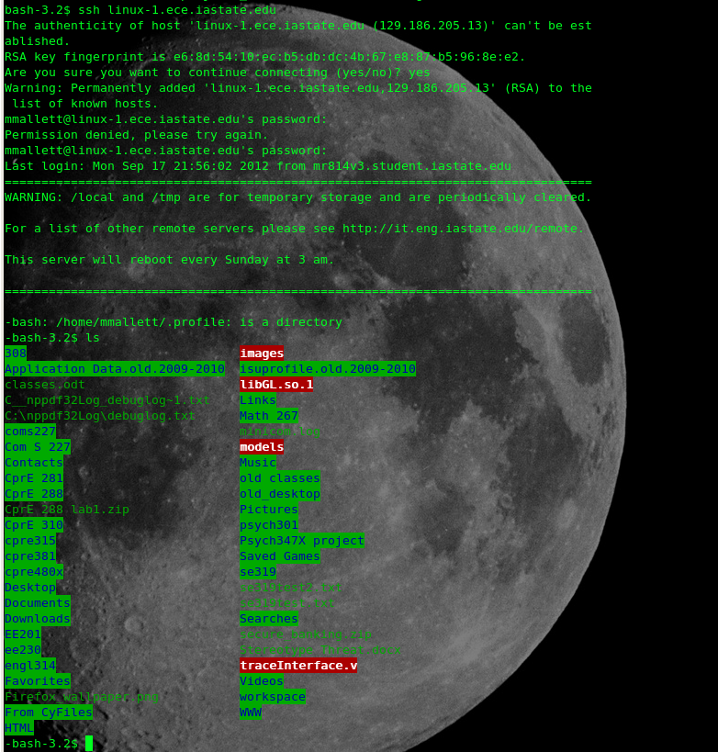
ls is listing files from linux-1.ece.iastate.edu, which happens to use the same remote directory that my computer is using.

Open shell with partner's machine
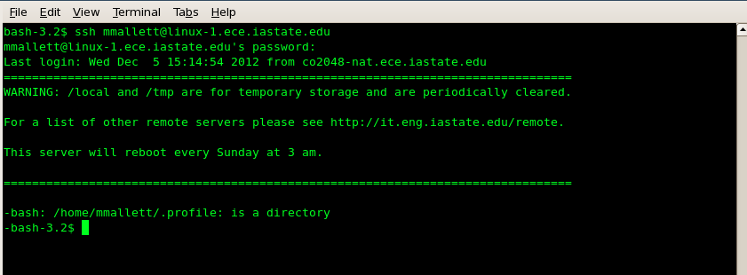

Transfer a file using SCP
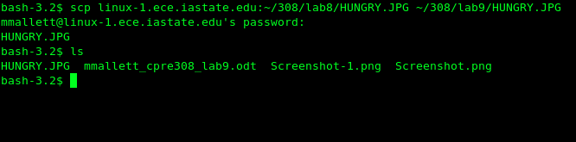

Using someone else's machine
