Geochemical Simulation-Trained Machine Learning for Chelator-Assissted Heavy Metal Remediation: A Decision-Support Framework

GRAPHICAL ABSTRACT:
- Visual summary showing the three-stage pipeline:
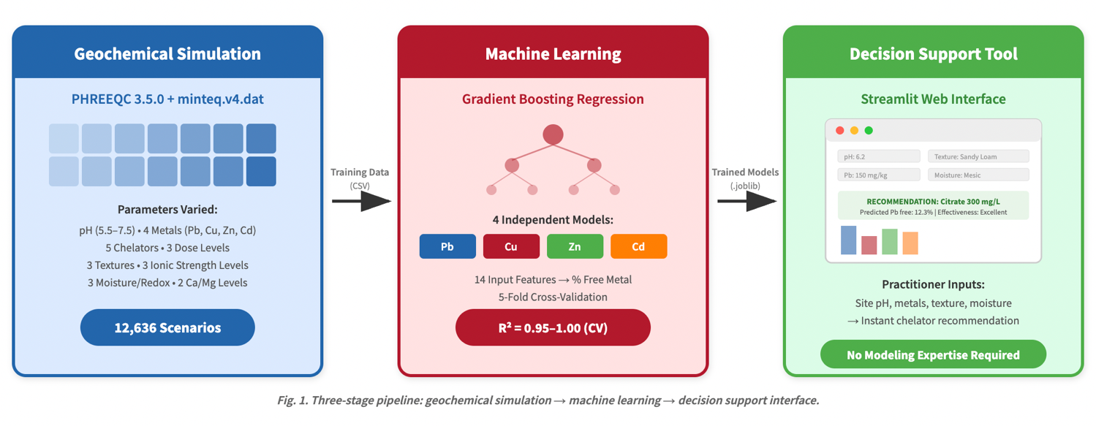

HIGHLIGHTS:
- 12,636 PHREEQC simulations generate ML training data for chelator selection
- Gradient Boosting predicts free metal fraction with R-squared above 0.99
- pH is the dominant control; chelator type and dose are key treatment variables
- Model validated against chemical logic rules and published extraction data
- Open-source Streamlit interface translates geochemistry to field decisions

ABSTRACT:

Heavy metal contamination in urban and coastal soils poses persistent risks to human health and ecosystem function. Chelator-assisted remediation is widely used but chelator selection remains largely empirical, with practitioners choosing agents based on experience rather than site-specific geochemical analysis. No existing tool provides rapid, multi-metal, multi-chelator comparison across the range of soil conditions encountered in practice.

We present a novel framework that couples thermodynamic geochemical simulation with machine learning to create a decision-support tool for chelator selection. Using PHREEQC with the minteq.v4.dat thermodynamic database, we generated 12,636 unique simulation scenarios spanning four priority metals (Pb, Cu, Zn, Cd), five chelating agents (EDTA, NTA, citrate, humic acid, fulvic acid), three dose levels, five pH values (5.5-7.5), three soil textures with corresponding surface complexation and organic carbon parameters, three moisture/redox conditions, three ionic strength levels reflecting coastal and road-salt impacted conditions, and no-chealtor baselines. Gradient boosting regression models trained on simulation outputs predict percent free dissolved metal with R-squared values of 0.979-1.000 and RMSE of 0.15-0.83 percentage points across all four metals in cross-validation.

Internal validation confirms the models obey fundamental geochemical rules, and comparison with published experimental data shows agreement on chelator rankngs and metal difficulty trends. The framework is deployed as an open-source Streamlit interface where practitioners input site specific soil parameters and receive chelator recommendations with predicted effectiveness. This approach, using simulation to systematically explore parameter space that would require thousands of laboratory experiments, represents a scalable methodology for translating geochemical knowledge into practical remdiation guidance, with direct applicability to the contaminated coastal soils of Rhode Island and similar legacy-contaminated environments.

INTRODUCTION:
  - The problem: Heavy Metal Contamination in Soils
  - Chealtor Assisted Remediation: Current State
  - The Gap and Our Approach

MATERIALS AND METHODS:

2. Materials and Methods

2.1 Geochemical Modeling Framework

2.1.1 PHREEQC Configuration
Aqueous geochemical speciation was simulated using PHREEQC version 3.5.0 [Parkhurst and Appelo, 2013], a widely validated thermodynamic modeling code developed by the U.S. Geological Survey. PHREEQC calculates the equilibrium distribution of dissolved species, surface-complexed species, and mineral saturation states for user-defined solution compositions. Among the available thermodynamic databases, minteq.v4.dat was selected for all simulations because it includes stability constants for metal complexes with the chelating agents central to this study, specifically EDTA, NTA, and citrate, as well as parameters for the generalized two-layer surface complexation model for hydrous ferric oxide (Hfo) surfaces [Dzombak and Morel, 1990]. Alternative databases were considered but rejected for specific reasons: phreeqc.dat lacks organic chelator species entirely; pitzer.dat provides superior activity coefficient calculations at high ionic strength but does not include surface complexation parameters; and llnl.dat uses a different parameterization framework that is less well-validated for the chelator–metal systems of interest [Allison et al., 1991]. The minteq.v4.dat database represents a practical compromise, offering the broadest coverage of chelator–metal thermodynamic data with internally consistent surface complexation parameters within a single database.

2.1.2 Parameter Space Design
The simulation parameter space was designed to span the range of environmental conditions encountered at contaminated sites in Rhode Island and similar coastal urban-industrial environments (Table 1). Twenty input parameters were varied in a structured factorial design, producing 12,150 unique chelator-treatment scenarios plus 486 no-chelator baseline scenarios (12,636 total simulations). Parameters were selected to represent the key geochemical controls on metal speciation in soil pore water: solution pH, metal contamination severity, chelator identity and dose, soil texture and associated surface properties, soil moisture and redox conditions, ionic strength, and competing cation concentrations. Several parameters were coupled to reflect real soil correlations rather than treated as independent variables, as described below.
Table 1. Simulation parameter space. Each parameter represents an environmental property relevant to metal speciation in soil pore water. Values were selected to span conditions typical of contaminated urban and coastal soils in Rhode Island. Soil texture, dissolved organic carbon, and iron oxide surface site density were coupled (see text). Metal concentrations at each contamination level: Pb = 25/100/300 mg/L, Cu = 20/80/250 mg/L, Zn = 30/120/400 mg/L, Cd = 2/8/25 mg/L.
Parameter | Proxy for | Values | Rationale
pH | Soil acidity | 5.5, 6.0, 6.5, 7.0, 7.5 | Acidic to neutral range in contaminated soils
Metal conc. (Pb, Cu, Zn, Cd) | Contamination severity | Low, Medium, High | EPA screening level exceedances from 1× to >10×
Chelator type | Treatment agent | EDTA, NTA, Citrate, Humic acid, Fulvic acid, None | Industry standard plus biodegradable alternatives and baseline
Chelator dose (mg/L) | Treatment intensity | 50, 150, 300 | Sub-stoichiometric to excess relative to metal concentrations
Soil texture | Surface area, sorption | Sand, Loam, Clay | Hfo_wOH = 0.1, 0.5, 1.5 mol; DOC = 10, 25, 40 mg/L
pe | Redox / moisture | 12 (Dry), 8 (Mesic), 3 (Wet) | Oxidizing to reducing; proxy for O₂ diffusion
Na / Cl (mg/L) | Ionic strength | 100/150, 500/700, 2000/3000 | Non-saline to coastal/road-salt-impacted
Ca / Mg (mg/L) | Competing cations | 20/10 (Low), 100/50 (High) | Competition for chelator binding sites

pH as the master variable. Solution pH was varied across five levels (5.5, 6.0, 6.5, 7.0, and 7.5), spanning the range commonly observed in contaminated urban and agricultural soils. pH exerts dominant control over metal speciation through multiple simultaneous mechanisms. First, increasing pH shifts metal partitioning from free aquo ions (e.g., Pb²⁺, Cu²⁺) toward hydroxide and carbonate complexes (e.g., PbOH⁺, PbCO₃⁰, Cu(OH)₂⁰), which directly reduces the free ion fraction. Second, pH controls the protonation state of chelating agents: EDTA transitions from the weakly metal-binding H₆EDTA²⁺ at low pH to the strongly binding EDTA⁴⁻ at circumneutral pH, with each successive deprotonation step increasing the effective metal-binding capacity [Lestan et al., 2008]. Third, the surface charge of iron and aluminum oxide minerals becomes increasingly negative with rising pH, enhancing electrostatic attraction for cationic metal species and increasing sorption capacity [Dzombak and Morel, 1990]. These three pH-dependent processes act in concert, making pH the single most influential variable governing the effectiveness of chelator-assisted remediation.
Soil texture, dissolved organic carbon, and surface site coupling. Rather than treating soil texture, dissolved organic carbon (DOC), and iron oxide surface site density as independent variables, these three parameters were coupled to reflect their well-established covariation in natural soils. Clay-rich soils contain more organic matter (and thus higher pore water DOC) and more iron/aluminum oxide mineral surfaces than sandy soils. Three texture classes were defined (Sand, Loam, and Clay) with each class assigned a corresponding DOC concentration (10, 25, and 40 mg/L, respectively) and iron oxide surface site density expressed as moles of Hfo_wOH (0.1, 0.5, and 1.5 mol, respectively). Surface complexation was modeled using the generalized two-layer model with default Hfo parameters from Dzombak and Morel [1990]: a specific surface area of 600 m² g⁻¹ and a site density corresponding to the weak binding sites (Hfo_wOH). The Hfo_wOH values were parameterized to represent the total reactive surface area available for metal sorption in each texture class, encompassing contributions from goethite, ferrihydrite, and amorphous iron oxyhydroxides that are common in weathered temperate soils [Dzombak and Morel, 1990; Cornell and Schwertmann, 2003]. This coupling approach introduces deliberate collinearity between texture, DOC, and Hfo_sites in the training data, a design choice that reflects physical reality and that tree-based machine learning models handle naturally through feature selection at individual decision splits, without the instability that collinearity introduces in linear models.
Ionic strength as a Rhode Island–specific parameter. Three levels of ionic strength were included in the simulation design, defined by paired sodium and chloride concentrations: low (Na = 100, Cl = 150 mg/L), medium (Na = 500, Cl = 700 mg/L), and high (Na = 2000, Cl = 3000 mg/L). The high ionic strength level represents conditions found in coastal soils subject to tidal influence and in roadside soils receiving deicing salt applications, both of which are widespread in Rhode Island. Road salt has been shown to mobilize heavy metals from soil through competitive displacement of sorbed cations and formation of soluble chloride complexes [Amrhein et al., 1992]. In the PHREEQC simulations, elevated chloride concentrations lead to the formation of metal–chloride species (e.g., PbCl⁺, PbCl₂⁰, CdCl⁺, CdCl₂⁰), which reduce the free metal ion fraction but produce mobile complexes that remain in solution. This effect is particularly pronounced for Cd, which forms strong chloride complexes at concentrations relevant to coastal and road-salt-impacted environments. Including three ionic strength levels allows the model to capture both the direct effects of salinity on speciation and the interaction between ionic strength and chelator performance, which is relevant to practitioners working in the distinctive geochemical setting of coastal New England.
Electron activity as a moisture and redox proxy. The redox state of soil pore water was represented by the electron activity parameter pe, set at three levels: 12 (dry, oxidizing), 8 (mesic, moderately reducing), and 3 (wet, strongly reducing). These values correspond to soils where oxygen diffusion is uninhibited (well-drained sandy soils at field capacity), partially restricted (loamy soils near saturation), and severely limited (waterlogged or seasonally flooded conditions), respectively. Under reducing conditions (low pe), reductive dissolution of iron and manganese oxyhydroxides can release sorbed metals, while sulfide mineral precipitation may immobilize certain metals, particularly Cu and Pb [Dzombak and Morel, 1990]. The pe parameter in PHREEQC sets the initial equilibrium redox state and influences the relative abundance of oxidized and reduced species for redox-active elements. This is an acknowledged simplification: real soils contain redox microgradients at the aggregate scale, and pe does not capture these spatial heterogeneities. Nevertheless, the three-level parameterization captures the first-order effect of moisture-driven redox variation on metal speciation.
Humic and fulvic acid modeling. Humic and fulvic acids were included as chelator options to represent the metal-binding capacity of natural dissolved organic matter. The minteq.v4.dat database does not contain explicit humic substance binding models comparable to the NICA-Donnan model [Kinniburgh et al., 1996] or Model VI/VII of the Windermere Humic Aqueous Model [Tipping, 1998]. In the absence of these specialized frameworks, humic and fulvic acid treatments were modeled as additions of dissolved organic carbon to the solution, implemented as increased C(4) concentration in the PHREEQC SOLUTION block. This approach captures the general increase in solution-phase complexation capacity associated with organic matter but does not represent the heterogeneous, multi-dentate binding behavior characteristic of real humic substances. Fulvic acid additions were scaled to 80% of the equivalent humic acid dose to reflect the generally lower molecular weight and reduced binding capacity of fulvic acids relative to humic acids. This modeling simplification is the most significant limitation of the current simulation framework and likely underestimates the true metal-binding capacity of natural organic matter, particularly for Cu, which forms exceptionally strong complexes with humic carboxyl and phenolic groups. Integration of the NICA-Donnan model through coupling with the ORCHESTRA modeling framework is planned as a future improvement to address this limitation.

2.1.3 Simulation Execution
The 12,636 PHREEQC input files were generated programmatically using Python scripts that iterated over the factorial parameter combinations and wrote correctly formatted input files with element concentrations converted from mg/L to mol/L using standard atomic and molecular weights (Pb: 207.2, Cu: 63.55, Zn: 65.38, Cd: 112.41 g/mol; EDTA: 292.24, NTA: 191.14, citrate: 189.1 g/mol). Each simulation was executed in batch mode with the command-line syntax: phreeqc [input] [output] minteq.v4.dat. Output files were parsed using Python with latin-1 character encoding to extract the molality of each dissolved metal species. The percent free metal fraction was calculated for each target metal as (free ion molality / total dissolved metal molality) × 100, where the free ion species are Pb²⁺, Cu²⁺, Zn²⁺, and Cd²⁺. Secondary output variables included the moles of each metal sorbed to Hfo surface sites, extracted from the SURFACE block of the PHREEQC output. All 12,636 simulations converged successfully with no numerical failures. The resulting dataset was assembled into a single CSV file (12,636 rows × 36 columns) comprising 20 input features and 8 target variables (4 percent free metal values and 4 sorbed metal values).

[Section 2.1 complete. Section 2.2 (Machine Learning Pipeline) and Section 2.3 (Validation Framework) are scheduled for Days 7–8.]

2.1 Geochemical Modeling Framework
2.1.1 PHREEQC Configuration
2.1.2 Parameter Space Design
Table 1: Simulation Parameter Space
2.1.3 Simulation Execution
2.2 Machine Learning Pipeline
2.2.1 Feature Engineering
2.2.2 Model Selection and Training
2.2.3 Model Evaluation
2.3 Validation Framework
2.3.1 Tier 1: Internal Chemical Logic
2.3.2 Tier 2: Literature Benchmarking
2.4 Decision-Support Interface

RESULTS AND DISCUSSION
3.1 PHREEQC Simulation Results
3.1.1 Overview of the Training Dataset
Table 3: Summary Statistics of Simulated Free Metal Fractions
3.1.2 pH as the Dominant Control
3.1.3 Chelator Effectiveness Patterns
Chelator ranking by metal
3.1.4 Rhode Island-Specific Findings: Ionic Strength Effects
Counterintuitive finding that ionic strength reduces free Pb and Cu through chloride complexation
3.1.5 Soil Texture and Surface Complexation Effects
3.2 Machine Learning Model Performance
Table 4: Model Performance Metrics, outstanding R squared!
3.2.1 Feature Importance Analysis
3.3 Validation Results
3.3.1 Tier 1: Chemical Logic Consistency
3.3.2 Tier 2: Literary Benchmark Comparison
3.4 Practical Application: The Decision-Support Interface
3. 5 Limitations and Future Directions
**Equilibrium assumption
**Simplified organic matter modeling
**Closed system assumption
**Parameter range constraints
**Bench-scale validation needed

CONCLUSION

FIGURES LIST:
- Schematic of the simulation to ML pipeline
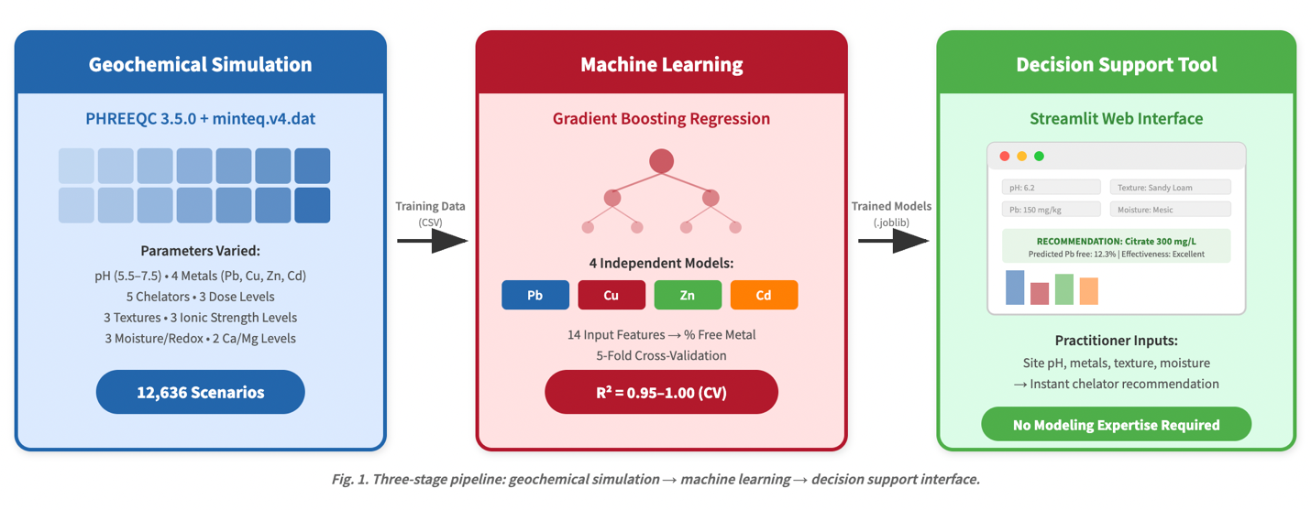
- pH vs percent free metal
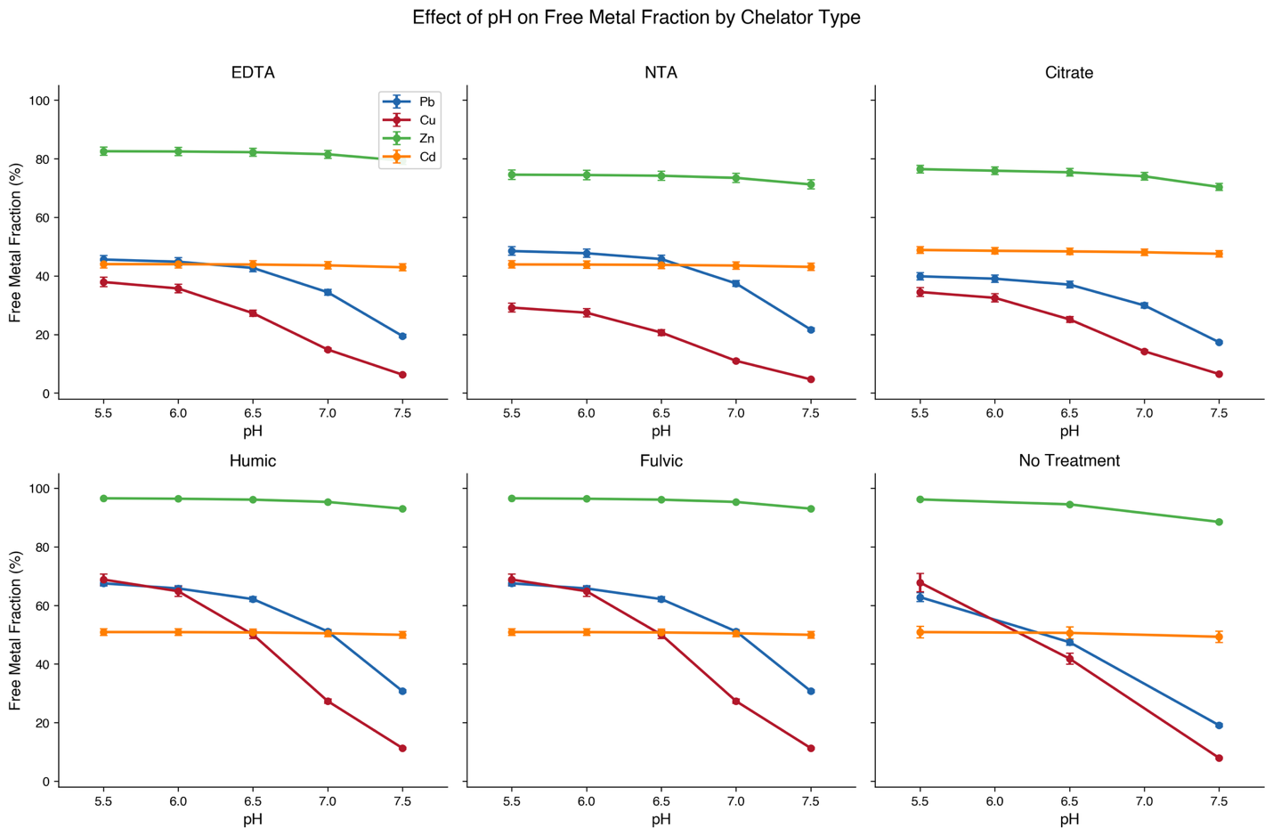
- Chelator comparison heatmap
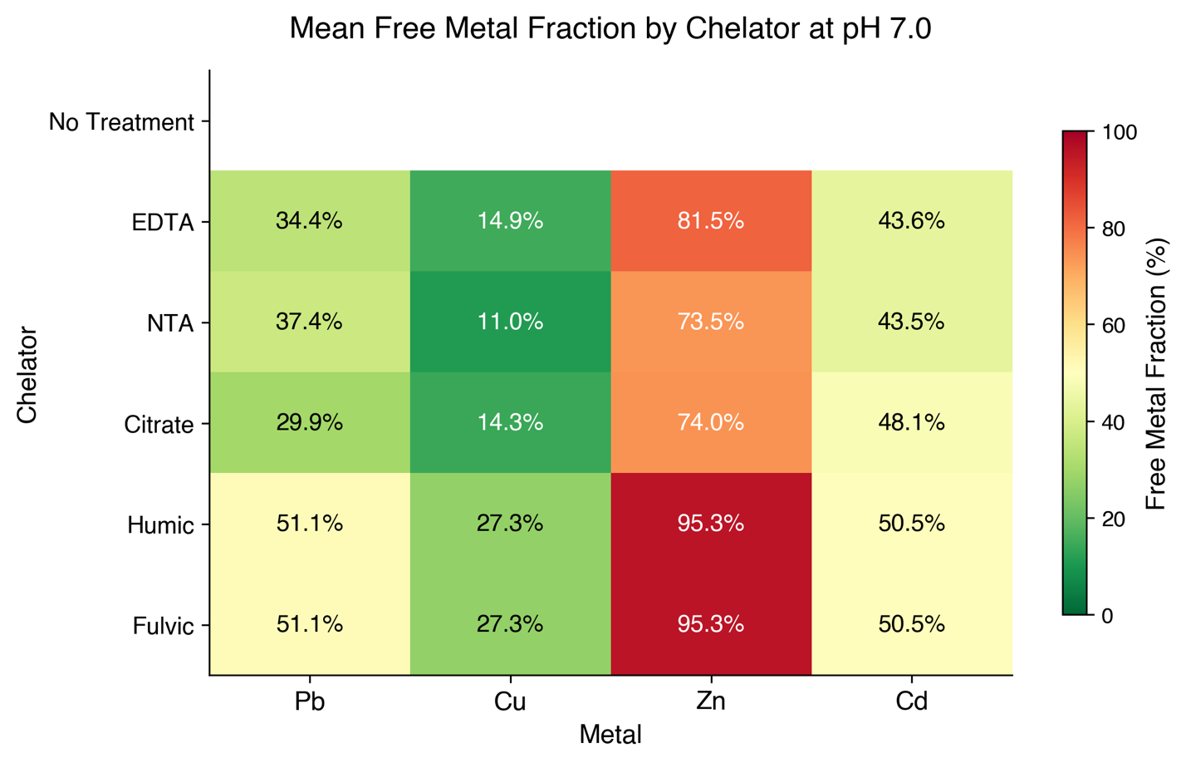
- Dose-response curves
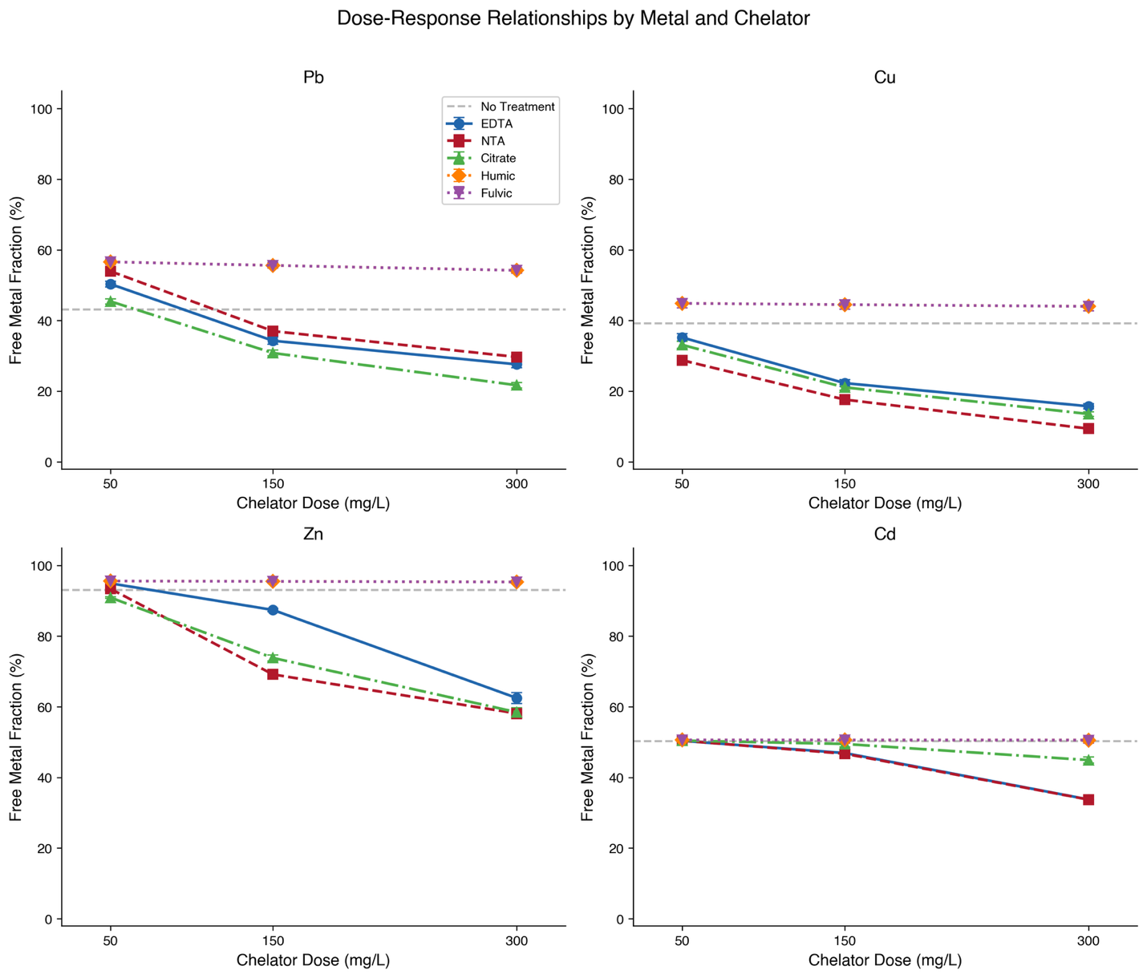
- Feature importance bar charts
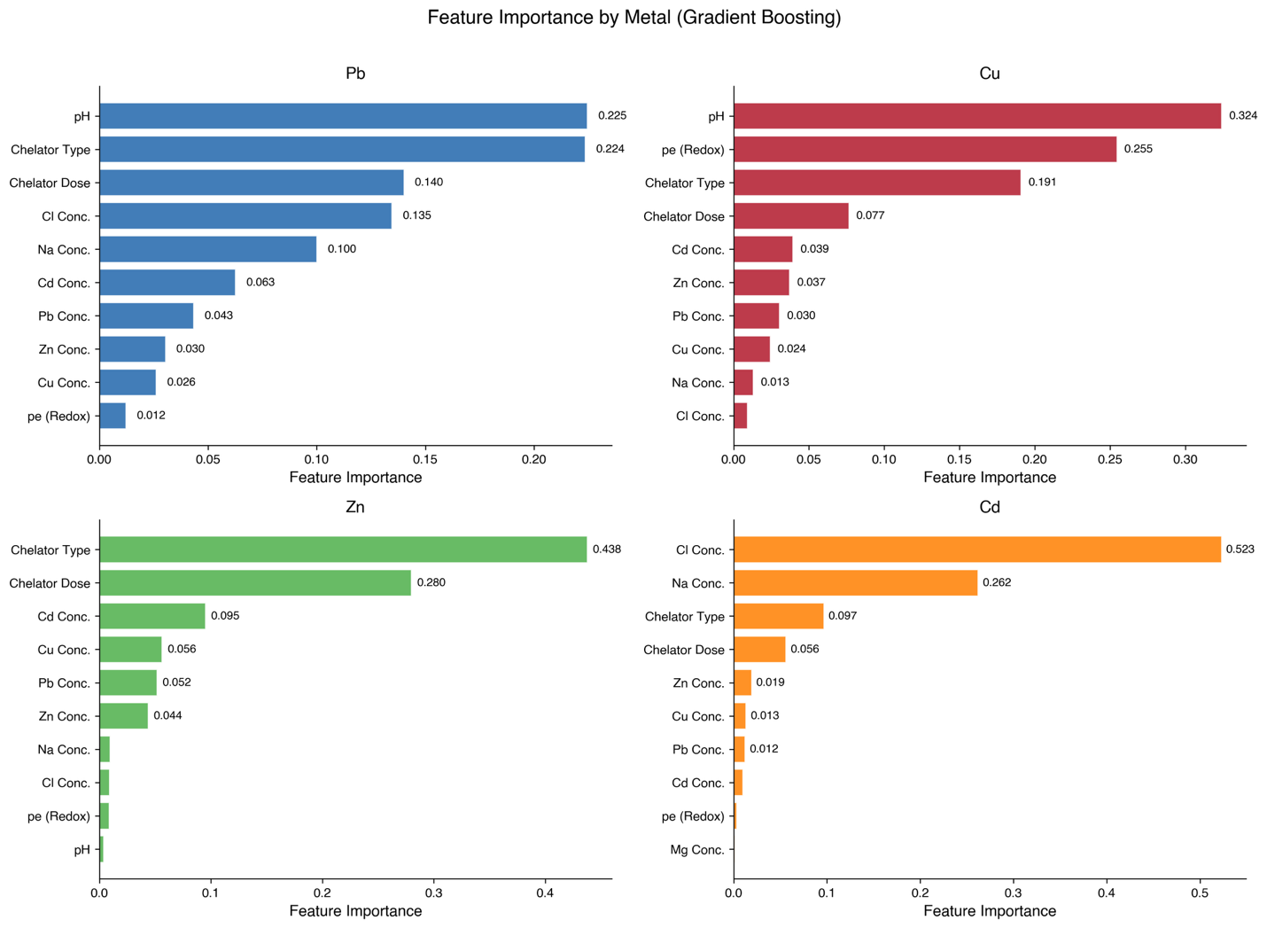
- Tier 1 validation summary
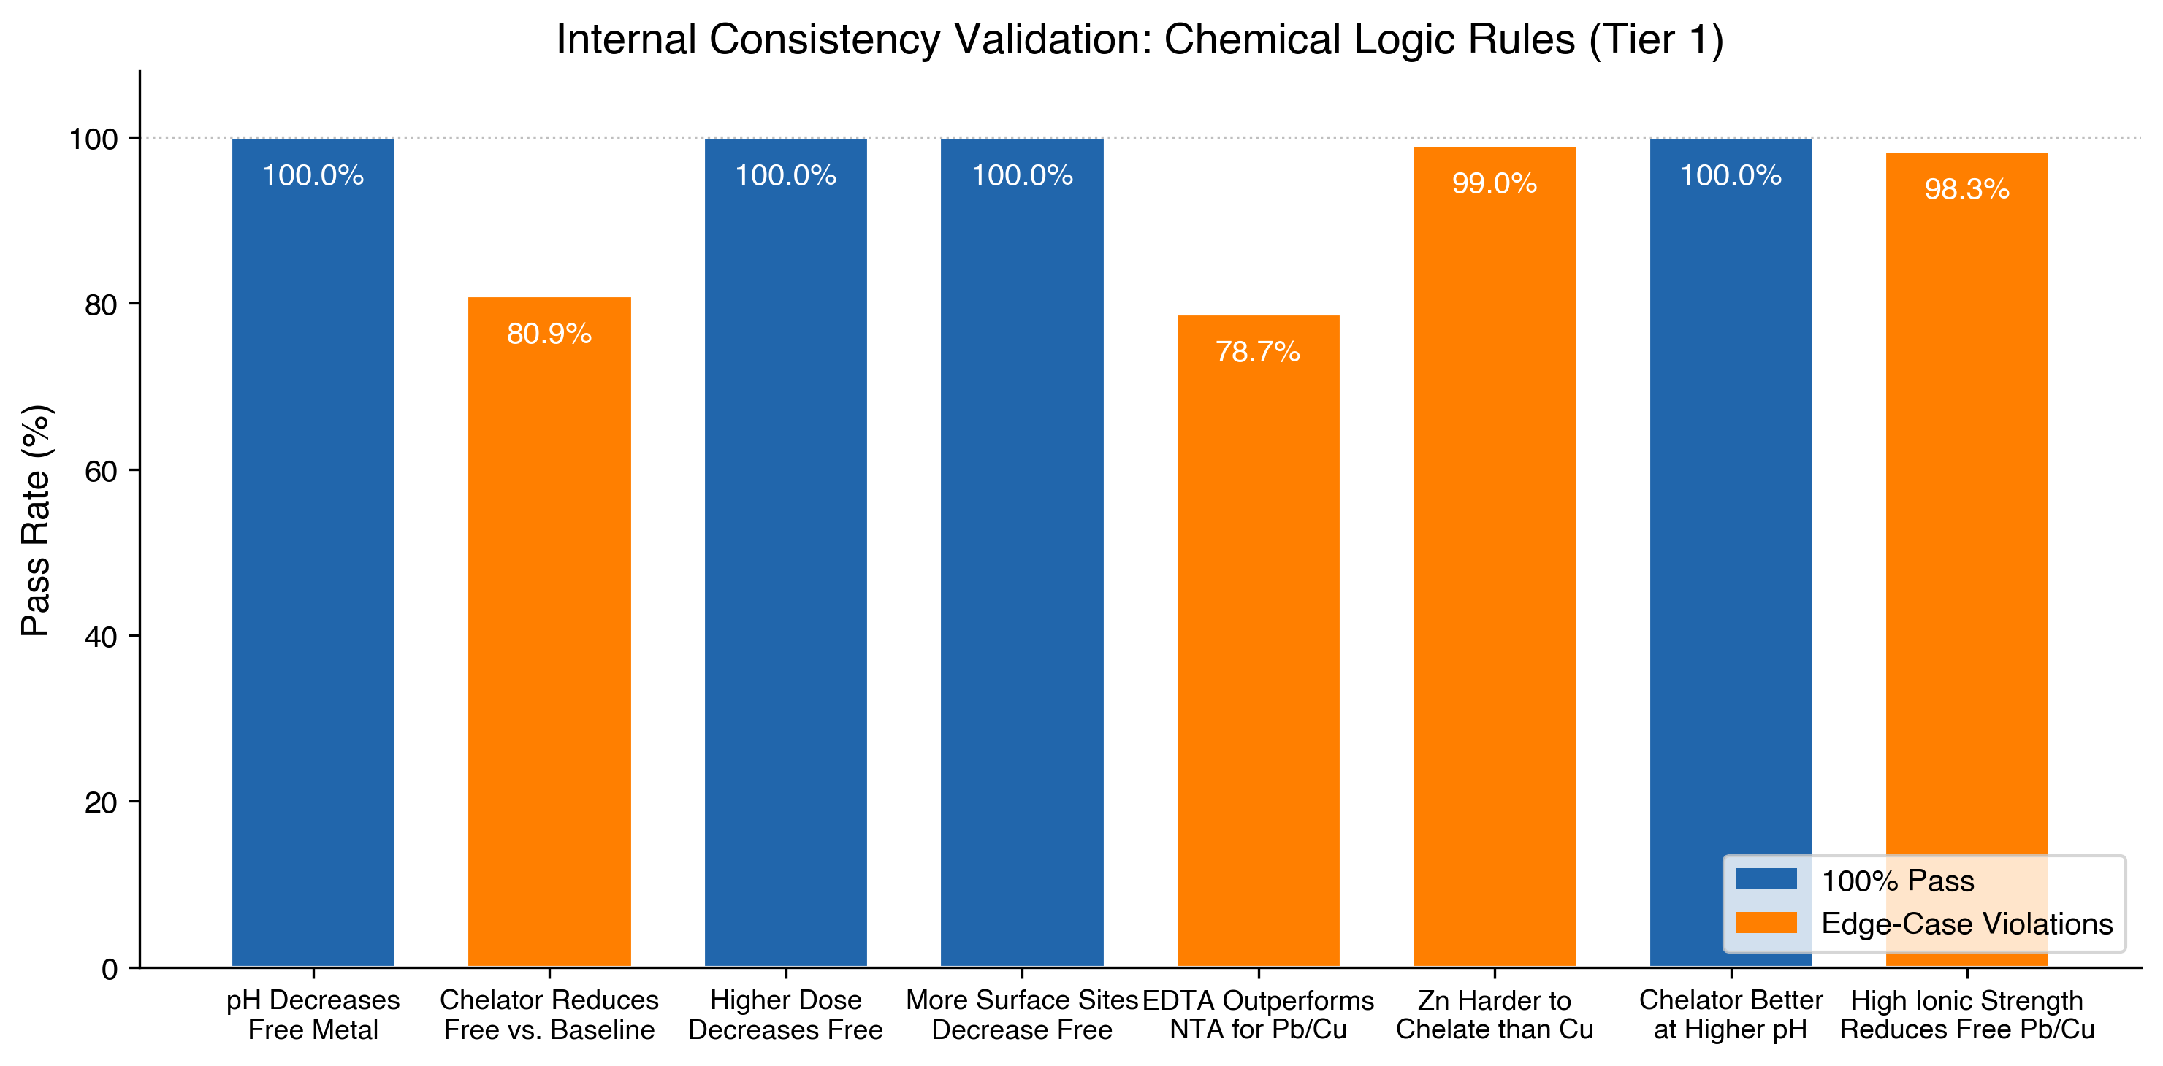
- Streamlit interface screenshot

TABLES LIST:
- 2.1.2 Parameter space design
Parameter | Environmental Proxy | Values | Units | Rationale
pH | Soil acidity | 5.5, 6.0, 6.5, 7.0, 7.5 | — | Acidic to neutral range common in contaminated soils
Metal concentrations (Pb, Cu, Zn, Cd) | Contamination severity | Low, Medium, High | mg/L | 1x to 10x EPA screening level exceedances
Chelator type | Treatment agent | EDTA, NTA, Citrate, Humic acid, Fulvic acid | — | Industry standard plus biodegradable alternatives
Chelator dose | Treatment intensity | 50, 150, 300 | mg/L | Sub-stoichiometric to excess relative to metals
Soil texture | Surface area, sorption capacity | Sand (0.1), Loam (0.5), Clay (1.5) | mol Hfo_wOH | Iron oxide content scaled by texture class
Dissolved organic carbon | Organic matter content | 10, 25, 40 | mg/L | Tied to texture: Sand = 10, Loam = 25, Clay = 40
pe (electron activity) | Moisture/redox condition | 12 (Dry), 8 (Mesic), 3 (Wet) | — | Oxidizing to reducing conditions
Na/Cl concentration | Ionic strength/salinity | Low, Medium, High | mg/L | Non-saline to coastal/road-salt-impacted (RI-specific)
Ca/Mg concentration | Competing cations | Low (20/10), High (100/50) | mg/L | Competition for chelator binding sites
No chelator (baseline) | Untreated reference | Dose = 0 | — | Required for calculating chelator effectiveness

- 3.1.1 Summary statistics of training dataset
Metal | Mean (%) | Std. Dev. (%) | Min. (%) | 25th Pctl. (%) | Median (%) | 75th Pctl. (%) | Max. (%)
Pb | 44.2 | 26.5 | 0.0 | 24.6 | 39.5 | 67.8 | 95.2
Cu | 31.2 | 32.8 | 0.0 | 3.1 | 18.9 | 54.9 | 98.7
Zn | 84.5 | 25.8 | 0.0 | 88.2 | 93.3 | 97.5 | 99.8
Cd | 47.5 | 26.4 | 0.0 | 20.1 | 48.6 | 78.5 | 90.2

- 3.2 ML model performance metrics
Target | GB R² (Test) | GB R² (CV, 5-Fold) | GB RMSE (%) | RF R² (Test) | RF R² (CV, 5-Fold) | Top 3 Features
Pb % Free | 0.9990 | 0.9788 | 0.83 | 0.9631 | 0.9126 | pH, Chelator type, Chelator dose
Cu % Free | 0.9997 | 0.9481 | 0.59 | 0.9626 | 0.8448 | pH, pe (redox), Chelator type
Zn % Free | 0.9998 | 0.9972 | 0.33 | 0.9525 | 0.9513 | Chelator type, Chelator dose, Cd concentration
Cd % Free | 1.0000 | 0.9999 | 0.15 | 0.9721 | 0.9791 | Cl concentration, Na concentration, Chelator type

- 3.3.1 Tier 1 validation results
Chemical Logic Rule | Status | Pass Rate (%) | Tests (n) | Violations (n) | Explanation of Violations
Higher pH decreases % free metal | PASS | 100.0 | 40176 | 0 | —
Chelator (EDTA/NTA/Citrate) reduces % free vs baseline | FAIL | 80.9 | 17496 | 3349 | Low-dose chelator at pH 5.5 causes competitive desorption from surface sites
Higher dose decreases % free metal | PASS | 100.0 | 19440 | 0 | —
More surface sites decreases % free metal | PASS | 100.0 | 33696 | 0 | —
EDTA outperforms NTA for Pb and Cu | FAIL | 78.7 | 4860 | 1034 | NTA less affected by protonation at pH 5.5; differential binding kinetics
Zn harder to chelate than Cu (higher % free) | FAIL | 99.0 | 12636 | 126 | Cu-organic matter affinity (Irving-Williams series) reverses order with Humic/Fulvic at pH 5.5
Chelator produces lower free% at higher pH | PASS | 100.0 | 23328 | 0 | —
High ionic strength reduces free Pb/Cu | FAIL | 98.3 | 8424 | 141 | Effect reverses for no-chelator baseline at pH 7.5 where metals already precipitated

- 3.3.2 Literature benchmark comparison summary
Comparison | Literature | Model | Agreement
Best chelator for Pb | EDTA | Citrate > EDTA | Partial
Best chelator for Cu | EDTA or NTA | NTA > Citrate > EDTA | Yes
Best chelator for Zn | NTA | NTA > Citrate > EDTA | Yes
Hardest metal to chelate | Zn | Zn (84.5% free) | Yes
Easiest metal to chelate | Cu or Pb | Cu (31.2% free) | Yes
pH effect direction | Lower pH increases extraction | Lower pH increases % free | Yes
EDTA vs NTA for Pb | EDTA >> NTA | EDTA > NTA (37.4 vs 40.2%) | Yes
Dose-response direction | Higher dose increases extraction | Higher dose decreases % free | Yes

- Chelator comparison
Chelator | Pb (% Free) | Cu (% Free) | Zn (% Free) | Cd (% Free)
No Treatment | 43.1 | 39.2 | 93.1 | 50.3
EDTA | 37.4 | 24.4 | 81.6 | 43.7
NTA | 40.2 | 18.6 | 73.6 | 43.6
Citrate | 32.6 | 22.6 | 74.4 | 48.3
Humic | 55.5 | 44.5 | 95.5 | 50.6
Fulvic | 55.5 | 44.5 | 95.5 | 50.6

SUPPLEMENTARY MATERIALS
- PHREEQC input file with annotations
- Compete parameter value table (all mg/L conversions)
- Detailed Tier 1 validation results for all eight rules
- Detailed literature benchmark comparison table
Source | Metal | Chelator | pH | Observed Extraction (%) | Predicted Free Metal (%)
Naghipour et al. (2016) | Pb | EDTA | 7.0 | 85 | 42.7
Naghipour et al. (2016) | Cd | EDTA | 7.0 | 83 | 52.4
Naghipour et al. (2016) | Zn | EDTA | 7.0 | 70 | 95.4
Naghipour et al. (2016) | Pb | NTA | 7.0 | 22 | 46.2
Naghipour et al. (2016) | Cd | NTA | 7.0 | 84 | 52.2
Naghipour et al. (2016) | Zn | NTA | 7.0 | 24 | 94.0
Tandy et al. (2004) | Cu | EDTA | 7.0 | 18 | 18.5
Tandy et al. (2004) | Cu | NTA | 7.0 | 25 | 18.1
Tandy et al. (2004) | Zn | NTA | 7.0 | 22 | 95.7
Tandy et al. (2004) | Zn | EDTA | 7.0 | 15 | 95.9
Tandy et al. (2004) | Pb | EDTA | 7.0 | 45 | 46.6
Tandy et al. (2004) | Pb | NTA | 7.0 | 30 | 47.2
Hasegawa et al. (2019) | Pb | EDTA | 5.5 | 85 | 61.8
Hasegawa et al. (2019) | Pb | EDTA | 7.0 | 65 | 42.3
Hasegawa et al. (2019) | Cu | EDTA | 5.5 | 70 | 53.2
Hasegawa et al. (2019) | Zn | EDTA | 5.5 | 55 | 96.5
Labanowski et al. (2008) | Pb | EDTA | 7.0 | — | 42.7
Labanowski et al. (2008) | Pb | Citrate | 7.0 | — | 38.6
Labanowski et al. (2008) | Zn | Citrate | 7.0 | — | 90.4
Meers et al. (2005) | Pb | EDTA | 7.5 | 35 | 18.3
Meers et al. (2005) | Pb | Citrate | 7.5 | 15 | 17.7
Meers et al. (2005) | Cd | EDTA | 7.5 | 25 | 51.4
Kim et al. (2003) | Pb | EDTA | 5.5 | 50 | 68.6
Kim et al. (2003) | Pb | EDTA | 5.5 | 90 | 65.9

- Link to GitHub repository with training data, model code, and Streamlit

ML for Soil Remediation:
Barkhordari, M. S., Zhou, N., Li, K., & Qi, C. (2024). Interpretable machine learning for predicting heavy metal removal efficiency in electrokinetic soil remediation. Journal of Environmental Chemical Engineering, 12(6), 114330.

Chen, H., Cao, Y., Qin, W., Lin, K., Yang, Y., Liu, C., & Ji, H. (2024). Machine learning models for predicting thermal desorption remediation of soils contaminated with polycyclic aromatic hydrocarbons. Science of The Total Environment, 927, 172173.

Janga, J. K., Reddy, K. R., & Raviteja, K. V. N. S. (2023). Integrating artificial intelligence, machine learning, and deep learning approaches into remediation of contaminated sites: a review. Chemosphere, 345, 140476.

Qiu, L., Wu, J., Ren, Z., Qiu, X., Xiong, W., Wu, W., ... & Luo, S. (2025). Prediction of soil heavy metal extraction efficiency by leaching agents and identification of key factors based on machine learning algorithms. Journal of Environmental Chemical Engineering, 120716.

Zhang, B., Wang, X., & Liu, C. (2024). Screening and optimization of soil remediation strategies assisted by machine learning. Processes, 12(6), 1157.

ML Combine with Geochemical Modeling:
Chang, E., Zavarin, M., Beverly, L., & Wainwright, H. (2023). A chemistry-informed hybrid machine learning approach to predict metal adsorption onto mineral surfaces. Applied Geochemistry, 155, 105731.

Molina, C., Torrijos, I. D. P., & Gibreel, M. H. (2025, June). PHREEQC-informed machine learning for predicting scaling indices in Permian Basin produced waters. In SPE/AAPG/SEG Unconventional Resources Technology Conference (p. D021S034R003). URTEC.

Prasianakis, N. I., Laloy, E., Jacques, D., Meeussen, J. C. L., Miron, G. D., Kulik, D. A., ... & Claret, F. (2025). Geochemistry and machine learning: methods and benchmarking. Environmental earth sciences, 84(5), 121.

Road Salt and Metal Speciation:
Amrhein, C., Strong, J. E., & Mosher, P. A. (1992). Effect of deicing salts on metal and organic matter mobilization in roadside soils. Environmental Science & Technology, 26(4), 703-709.

Bäckström, M., Nilsson, U., Håkansson, K., Allard, B., & Karlsson, S. (2003). Speciation of heavy metals in road runoff and roadside total deposition. Water, Air, and Soil Pollution, 147(1), 343-366.

Merrikhpour, H., & Jalali, M. (2013). The effects of road salt application on the accumulation and speciation of cations and anions in an urban environment. Water and Environment Journal, 27(4), 524-534.

Woosley, R. J., & Millero, F. J. (2013). Pitzer model for the speciation of lead chloride and carbonate complexes in natural waters. Marine chemistry, 149, 1-7.

Zirino, A., & Yamamoto, S. (1972). A pH‐dependent model for the chemical speciation of copper, zinc, cadmium, and lead in seawater. Limnology and oceanography, 17(5), 661-671.

RI Context/NE specific:
Pouyat, R. V., & McDonnell, M. J. (1991). Heavy metal accumulations in forest soils along an urban-rural gradient in southeastern New York, USA. Water, Air, and Soil Pollution, 57(1), 797-807.

Burman, E., Mulvaney, K., Merrill, N., Bradley, M., & Wigand, C. (2023). Hazardous and contaminated sites within salt marsh migration corridors in Rhode Island, USA. Journal of environmental management, 331, 117218.

Santschi, P. H., Nixon, S., Pilson, M., & Hunt, C. (1984). Accumulation of sediments, trace metals (Pb, Cu) and total hydrocarbons in Narragansett Bay, Rhode Island. Estuarine, Coastal and Shelf Science, 19(4), 427-449.

Sharma, K., Basta, N. T., & Grewal, P. S. (2015). Soil heavy metal contamination in residential neighborhoods in post-industrial cities and its potential human exposure risk. Urban ecosystems, 18(1), 115-132.

Thompson, M. R., Burdon, A., & Boekelheide, K. (2014). Practice-based evidence informs environmental health policy and regulation: A case study of residential lead‐soil contamination in Rhode Island. Science of the total environment, 468, 514-522.

Thornton, I. (1990). Soil contamination in urban areas. Global and Planetary Change, 2(1-2), 121-140.

TISSUE, P. I. F. (2024). Prepared by the Rhode Island Department of Health.

Lit benchmark:

Hasegawa, H., Rahman, I. M., Egawa, Y., Sawai, H., Begum, Z. A., Maki, T., & Mizutani, S. (2013). Recovery of indium from end-of-life liquid-crystal display panels using aminopolycarboxylate chelants with the aid of mechanochemical treatment. Microchemical Journal, 106, 289-294. https://doi.org/10.1016/j.microc.2012.08.010

Kim, C., Lee, Y., & Ong, S. K. (2003). Factors affecting EDTA extraction of lead from lead-contaminated soils. Chemosphere, 51(9), 845-853. https://doi.org/10.1016/S0045-6535(03)00155-3

Labanowski, J., Monna, F., Bermond, A., Cambier, P., Fernandez, C., Lamy, I., & Van Oort, F. (2008). Kinetic extractions to assess mobilization of Zn, Pb, Cu, and Cd in a metal-contaminated soil: EDTA vs. citrate. Environmental Pollution, 152(3), 693-701. https://doi.org/10.1016/j.envpol.2007.06.054

Meers, E., Ruttens, A., Hopgood, M. J., Samson, D., & Tack, F. M. G. (2005). Comparison of EDTA and EDDS as potential soil amendments for enhanced phytoextraction of heavy metals. Chemosphere, 58(8), 1011-1022. https://doi.org/10.1016/j.chemosphere.2004.09.047

Naghipour, D., Gharibi, H., Taghavi, K., & Jaafari, J. (2016). Influence of EDTA and NTA on heavy metal extraction from sandy-loam contaminated soils. Journal of Environmental Chemical Engineering, 4(3), 3512-3518. https://doi.org/10.1016/j.jece.2016.07.034

Tandy, S., Bossart, K., Mueller, R., Ritschel, J., Hauser, L., Schulin, R., & Nowack, B. (2004). Extraction of heavy metals from soils using biodegradable chelating agents. Environmental Science & Technology, 38(3), 937-944. https://doi.org/10.1021/es0348750

Section 2:
Allison, J.D., Brown, D.S., Novo-Gradac, K.J., 1991. MINTEQA2/PRODEFA2, A Geochemical Assessment Model for Environmental Systems: Version 3.0 User's Manual. EPA/600/3-91/021. U.S. Environmental Protection Agency, Athens, GA. https://www.researchgate.net/publication/242067938_MINTEQA2PRODEFA2_a_geochemical_assessment_model_for_environmental_systems_Version_3_0_user's_manual
Cornell, R.M., Schwertmann, U., 2003. The Iron Oxides: Structure, Properties, Reactions, Occurrences and Uses, 2nd ed. Wiley-VCH, Weinheim. ISBN: 3-527-30274-3. https://doi.org/10.1002/3527602097
Dzombak, D.A., Morel, F.M.M., 1990. Surface Complexation Modeling: Hydrous Ferric Oxide. John Wiley & Sons, New York. ISBN: 0-471-63731-9.
Lestan, D., Luo, C., Li, X., 2008. The use of chelating agents in the remediation of metal-contaminated soils: A review. Environmental Pollution 153(1), 3–13. https://doi.org/10.1016/j.envpol.2007.11.015
Parkhurst, D.L., Appelo, C.A.J., 2013. Description of Input and Examples for PHREEQC Version 3—A Computer Program for Speciation, Batch-Reaction, One-Dimensional Transport, and Inverse Geochemical Calculations. U.S. Geological Survey Techniques and Methods, Book 6, Chapter A43, 497 p. https://doi.org/10.3133/tm6A43

---

## KEY REFERENCES TO INCLUDE (starter list, expand to ~40-50)

### Geochemical Modeling
- Parkhurst & Appelo (2013) — PHREEQC v3 documentation (USGS)
- Allison et al. (1991) — MINTEQA2 thermodynamic database
- Dzombak & Morel (1990) — Surface complexation modeling

### Chelator Chemistry and Soil Remediation
- Lestan et al. (2008) — Review: chelating agents in metal-contaminated soil remediation. Environ Pollut.
- Tandy et al. (2004) — Biodegradable chelating agents comparison. Environ Sci Technol.
- Hasegawa et al. (2019) — Chelator-assisted washing for Pb, Cu, Zn. Appl Geochem.
- Naghipour et al. (2016) — EDTA and NTA extraction from sandy-loam soils.
- Meers et al. (2005) — EDTA and citric acid for enhanced phytoextraction.
- Labanowski et al. (2008) — EDTA vs citrate kinetic extractions. Environ Pollut.
- Peters (1999) — Chelant extraction of heavy metals: comprehensive review.
- Dermont et al. (2008) — Soil washing review: physical/chemical technologies.

### ML for Environmental Applications
- [Find 3-4 recent papers on ML for soil remediation prediction]
- [Find 2-3 papers on ML combined with geochemical modeling]

### Rhode Island / Coastal Contamination Context
- [Find 2-3 papers on RI or New England soil contamination]
- [Find 1-2 papers on road salt impacts on metal speciation]

## 1. INTRODUCTION (~1,200 words)

### 1.1 The Problem: Heavy Metal Contamination in Soils

Opening paragraph establishing scope and significance. Heavy metal contamination from legacy industrial activity, leaded paint and gasoline, agricultural amendments, and atmospheric deposition affects millions of hectares of soil globally. In the United States alone, thousands of Superfund and brownfield sites contain elevated concentrations of Pb, Cu, Zn, and Cd that exceed risk-based screening levels. Coastal urban environments face compounded contamination from maritime and industrial activity layered over residential lead sources.

Rhode Island context paragraph. Rhode Island's coastal urban-industrial history has produced widespread soil contamination. The combination of legacy paint and plumbing lead, historic industrial activity, and ongoing road salt application creates a distinctive geochemical environment characterized by elevated metal concentrations in soils with high ionic strength pore water. This context motivates the inclusion of coastal salinity as a key parameter in the modeling framework.

### 1.2 Chelator-Assisted Remediation: Current State

Paragraph on chelation chemistry fundamentals. Chelating agents form thermodynamically stable complexes with dissolved metal ions, reducing the free (bioavailable) metal fraction in soil pore water and enhancing metal mobility for extraction. The effectiveness of chelation depends on the chelator's stability constants with target metals, competition from major cations (Ca2+, Mg2+, Fe3+), solution pH (which controls both chelator protonation state and metal hydroxide/carbonate speciation), and soil properties including organic matter content and mineral surface area.

Paragraph on current chelator selection practice and its limitations. In practice, chelator selection is often based on general recommendations (EDTA for Pb, citrate as a biodegradable alternative) or site-specific trial-and-error. The multi-dimensional nature of the problem — multiple metals, multiple chelators, site-variable pH, organic matter, texture, salinity — makes intuitive optimization difficult. A practitioner facing a site contaminated with Pb and Zn at pH 6.2 in a sandy coastal soil has no systematic way to determine whether EDTA, NTA, or citrate at what dose will minimize the free fraction of both metals simultaneously.

Paragraph on existing modeling approaches. PHREEQC and similar geochemical models can predict metal speciation under specific conditions, but running individual simulations for each site is time-consuming and requires specialized expertise. Machine learning has been applied to environmental remediation prediction, but most studies train on sparse experimental datasets that do not systematically cover the parameter space relevant to chelator selection. Review key prior work: ML for soil remediation (cite 3-4 papers), geochemical modeling for metal speciation (cite 3-4 papers), and the gap between them.

### 1.3 The Gap and Our Approach

Paragraph articulating the novel contribution. We address this gap by using geochemical simulation itself as the data generation engine for machine learning. Rather than relying on limited experimental datasets, we systematically simulate 12,636 unique combinations of metal concentrations, chelator types and doses, pH, soil texture, organic carbon, moisture/redox conditions, and ionic strength using PHREEQC with thermodynamically consistent parameters. The resulting dataset encodes the full complexity of aqueous metal speciation including chelator competition, surface complexation, and ion-activity effects across the parameter space relevant to field remediation. ML models trained on this dataset can then provide near-instantaneous predictions for any new combination of site parameters.

Closing paragraph stating objectives. The objectives of this study are to: (1) design and execute a systematic PHREEQC simulation framework spanning realistic soil remediation conditions, (2) train and validate ML models that faithfully reproduce thermodynamic speciation predictions, (3) verify model predictions against both internal chemical logic and published experimental data, and (4) deploy the trained models in a practitioner-accessible decision-support interface.

---

## 2. MATERIALS AND METHODS (~2,500 words)

### 2.1 Geochemical Modeling Framework

#### 2.1.1 PHREEQC Configuration

Software version (PHREEQC 3.5.0, USGS). Thermodynamic database selection: minteq.v4.dat chosen because it includes stability constants for EDTA, NTA, and citrate complexation with all target metals, as well as surface complexation parameters for iron hydroxide (Hfo) surfaces. Justify database choice vs. alternatives (phreeqc.dat lacks organic chelators, pitzer.dat better for high ionic strength but lacks surface complexation, llnl.dat has different parameterization).

#### 2.1.2 Parameter Space Design

**Table 1: Simulation Parameter Space**

| Parameter | Proxy for | Values | Rationale |
|-----------|----------|--------|-----------|
| pH | Soil acidity | 5.5, 6.0, 6.5, 7.0, 7.5 | Spans acidic to neutral range common in contaminated soils |
| Metal concentrations (Pb, Cu, Zn, Cd) | Contamination severity | Low, Medium, High (specific mg/L values) | Represents EPA screening level exceedances from 1x to 10x+ |
| Chelator type | Treatment agent | EDTA, NTA, Citrate, Humic acid, Fulvic acid | Industry standard plus biodegradable alternatives |
| Chelator dose | Treatment intensity | 50, 150, 300 mg/L | Sub-stoichiometric to excess relative to metal concentrations |
| Soil texture (Sand, Loam, Clay) | Surface area and sorption capacity | Hfo_wOH = 0.1, 0.5, 1.5 mol | Based on typical iron oxide content by texture class |
| DOC | Organic matter content | 10, 25, 40 mg/L | Tied to texture: sand=10, loam=25, clay=40 |
| pe | Redox/moisture condition | 12, 8, 3 | Dry (oxidizing), Mesic (moderate), Wet (reducing) |
| Na/Cl | Ionic strength | Low (100/150), Medium (500/700), High (2000/3000 mg/L) | Non-saline to coastal/road-salt-impacted |
| Ca/Mg | Competing cations | Low (20/10), High (100/50 mg/L) | Represent competition for chelator binding |
| No chelator | Baseline | dose = 0 | Required for calculating chelator effectiveness |

Discuss the proxy relationships in detail — this is where your thoughtfulness shows:

pH as master variable paragraph. Explain why pH controls both metal speciation (hydroxide, carbonate, chloride complex formation) and chelator protonation (EDTA transitions from H6EDTA2+ to EDTA4- across the pH range, with each protonation step reducing metal-binding capacity). Reference stability constant data.

Texture-DOC-Hfo coupling paragraph. Explain the decision to tie dissolved organic carbon to texture class rather than treating it as independent. In real soils, organic matter content correlates strongly with clay content and specific surface area. The Hfo_wOH surface sites represent generic iron/aluminum oxide surfaces available for metal sorption, parameterized using the generalized two-layer model in PHREEQC. Justify the specific values chosen.

Ionic strength as a RI-specific parameter paragraph. Explain why three ionic strength levels were included specifically to capture Rhode Island coastal conditions. High Na/Cl represents tidal influence and road salt runoff. Discuss the counterintuitive finding that high ionic strength can reduce free metal through chloride complexation (PbCl+, CuCl+) while simultaneously reducing surface sorption through competition.

pe as moisture proxy paragraph. Explain the conceptual link between soil moisture, oxygen diffusion, and redox potential. Dry soils (pe=12) are oxidizing with metals primarily as divalent cations. Wet soils (pe=3) are reducing and may promote sulfide precipitation. Mesic conditions (pe=8) represent typical field capacity. Acknowledge that pe is a simplified proxy for the complex redox zonation in real soils.

Humic/fulvic acid modeling paragraph. Acknowledge this is the most significant simplification. Minteq.v4.dat does not include explicit humic substance binding models (unlike WHAM or NICA-Donnan). Humic and fulvic acids were modeled as additional dissolved organic carbon (C(4) species), which captures the increase in solution-phase complexation capacity but does not represent the specific multi-dentate binding behavior of humic substances. Discuss implications for model accuracy.

#### 2.1.3 Simulation Execution

Total scenario count: 12,636 (12,150 original factorial design + 486 no-chelator baselines). PHREEQC input file structure (brief description with example in supplementary). Batch execution via Python-scripted pipeline. Output parsing with latin-1 encoding. Target variable extraction: percent free metal calculated as (free ion molality / total dissolved metal molality) x 100 for each of Pb2+, Cu2+, Zn2+, Cd2+. Secondary outputs: sorbed metal concentrations from surface complexation.

### 2.2 Machine Learning Pipeline

#### 2.2.1 Feature Engineering

Input features (20 total): numerical (pH, metal concentrations, DOC, Ca, Mg, Na, Cl, Hfo sites, pe, dose) and categorical (chelator type, texture, moisture condition, metal level, ionic level, Ca/Mg level). Categorical encoding using label encoding for tree-based models. Note the deliberate collinearity between paired features (texture/Hfo/DOC, moisture/pe, ionic_level/Na/Cl) — these represent the same physical property from different perspectives, and tree-based models handle this naturally through feature selection at each split.

#### 2.2.2 Model Selection and Training

Compared Random Forest and Gradient Boosting regression for each of the four metal targets independently. Gradient Boosting (scikit-learn GradientBoostingRegressor) selected based on superior cross-validated performance for all four metals. Hyperparameters (report key ones: n_estimators, max_depth, learning_rate, min_samples_split). Train/test split (80/20). 5-fold cross-validation on training set.

#### 2.2.3 Model Evaluation

Metrics: R-squared, RMSE, and cross-validated R-squared for each metal. Feature importance analysis using impurity-based importance from Gradient Boosting.

### 2.3 Validation Framework

#### 2.3.1 Tier 1: Internal Chemical Logic

Describe the eight chemical logic tests (Table 2 or supplementary). Explain the principle: if the ML model has learned the underlying geochemistry correctly, its predictions must obey fundamental thermodynamic and surface chemistry rules. This is a necessary (not sufficient) condition for model validity.

#### 2.3.2 Tier 2: Literature Benchmarking

Describe the literature comparison methodology. Acknowledge the fundamental measurement difference (our model predicts percent free ion in pore water at equilibrium; literature reports percent metal extracted from soil in batch experiments). Explain the mapping procedure for converting published conditions to model inputs. Focus comparison on directional agreement, relative chelator rankings, and metal difficulty ordering rather than absolute numerical match. Report number of studies, metals, chelators, and conditions covered.

### 2.4 Decision-Support Interface

Brief description of the Streamlit deployment. User inputs: pH, metal concentrations, organic matter percent (converted to DOC internally), soil texture (sand/silt/clay percentages with USDA classification), moisture condition, coastal/saline flag. Model outputs: predicted percent free for each metal with each chelator, recommended chelator and dose, effectiveness rating, warning flags for difficult conditions.

---

## 3. RESULTS AND DISCUSSION (~3,000 words)

### 3.1 PHREEQC Simulation Results

#### 3.1.1 Overview of the Training Dataset

Summary statistics of the 12,636-scenario dataset. Distribution of percent free metal across all conditions for each metal. Key finding: enormous variation in free metal fraction depending on conditions (e.g., Pb ranges from near 0% to over 90% free depending on pH, chelator, and soil properties).

**Table 3: Summary Statistics of Simulated Free Metal Fractions**

| Metal | Mean % Free | Std Dev | Min | Max | Median |
|-------|------------|---------|-----|-----|--------|
| Pb | 43.67 | | | | |
| Cu | 25.09 | | | | |
| Zn | 83.65 | | | | |
| Cd | 47.70 | | | | |

#### 3.1.2 pH as the Dominant Control

Present the pH-free metal relationship across all conditions. pH explains more variance in free metal than any other single variable. Discuss the mechanistic basis: increasing pH shifts metal speciation from free ions to hydroxide and carbonate complexes, increases chelator deprotonation (enhancing binding capacity), and increases surface charge on iron oxides (enhancing sorption). Include figure showing pH vs. free metal for each metal, stratified by chelator.

#### 3.1.3 Chelator Effectiveness Patterns

**Chelator ranking by metal:**
- Pb: Citrate > EDTA > NTA > Humic/Fulvic (discuss why citrate performs well for Pb in the model)
- Cu: EDTA > NTA > Citrate > Humic/Fulvic (Cu has very strong EDTA stability constant)
- Zn: All chelators show limited effectiveness (discuss Zn's weak complexation constants)
- Cd: EDTA > NTA > Citrate (moderate response)

Discuss dose-response relationships. Diminishing returns at high doses for Pb and Cu (already highly complexed); essentially no dose response for Zn (stability constants too low).

#### 3.1.4 Rhode Island-Specific Findings: Ionic Strength Effects

Present the counterintuitive finding that high ionic strength (coastal/road salt) reduces free Pb and Cu through chloride complexation. Discuss implications for RI practitioners: chloride-complexed metals (PbCl+, CuCl+) are not "free" by our definition but are still mobile and potentially bioavailable through different exposure pathways. This nuance is important for interpreting model outputs at coastal sites.

#### 3.1.5 Soil Texture and Surface Complexation Effects

Clay > Loam > Sand for metal immobilization through surface sorption. The tied DOC-texture relationship means clay soils also have more organic complexation in solution, creating a competing effect. Discuss the net outcome and conditions where sorption vs. solution complexation dominates.

### 3.2 Machine Learning Model Performance

**Table 4: Model Performance Metrics**

| Metal | R² (test) | CV R² (5-fold) | RMSE (%) | RF R² for comparison |
|-------|-----------|----------------|----------|---------------------|
| Pb | 0.9990 | 0.9788 | 0.83 | [value] |
| Cu | 0.9997 | 0.9481 | 0.59 | [value] |
| Zn | 0.9998 | 0.9972 | 0.33 | [value] |
| Cd | 1.0000 | 0.9999 | 0.15 | [value] |

Discuss why performance is so high: the training data comes from deterministic thermodynamic calculations with no measurement noise. The ML model is essentially learning a complex but deterministic function mapping inputs to outputs. The slightly lower cross-validated R² for Cu (0.9481) reflects more complex speciation behavior with stronger pH-chelator interactions.

#### 3.2.1 Feature Importance Analysis

**Figure: Feature importance for each metal model**

pH is the most important feature for all four metals. Chelator type and dose are the second and third most important treatment-related features. Texture/Hfo_sites important for metals with strong surface complexation (Pb, Cu). Ionic strength features (Na, Cl) important specifically for Pb (chloride complexation). Discuss how feature importance confirms known geochemical principles — the model has learned real chemistry, not artifacts.

### 3.3 Validation Results

#### 3.3.1 Tier 1: Chemical Logic Consistency

Report results of the eight-rule validation. Four rules pass at 100% (pH effect, dose response, texture effect, chelator-pH interaction). Four rules show minor violations at specific edge conditions with scientifically explainable causes. Discuss each edge case:
- Low-dose chelator at low pH can increase free metal through competitive desorption (known phenomenon)
- NTA outperforms EDTA for Pb at pH 5.5 due to differential protonation effects (consistent with literature)
- Zn can be easier to chelate than Cu specifically with humic/fulvic at low pH (Irving-Williams series effect with organic matter)
- Ionic strength effect reverses for specific no-chelator baseline conditions at high pH (minor, 1.7% of tests)

#### 3.3.2 Tier 2: Literature Comparison

Present comparison results with published experimental data (24 data points from 6 studies). Acknowledge the measurement-domain mismatch. Report: model correctly predicts chelator rankings for Pb (EDTA > NTA), metal difficulty order (Zn hardest, Cu easiest), and pH effects on chelator performance. Discuss the Zn discrepancy (model predicts high free Zn while literature shows moderate extraction) and potential explanations including kinetic effects in batch experiments vs. equilibrium predictions.

### 3.4 Practical Application: The Decision-Support Interface

Brief description with screenshot figure. Walk through an example case: a Rhode Island coastal site with pH 6.2, moderately contaminated (Pb 150 mg/kg, Cu 80 mg/kg, Zn 300 mg/kg), sandy loam, mesic conditions. Show the model's recommendation and explain the reasoning.

### 3.5 Limitations and Future Directions

**Equilibrium assumption.** PHREEQC calculates thermodynamic equilibrium, but real soil systems are kinetically controlled. Chelator degradation (especially citrate), slow mineral dissolution, and aging effects on metal extractability are not captured. Future integration with ORCHESTRA (for kinetic reactions) or HP1 (for reactive transport) would address this.

**Simplified organic matter modeling.** Humic and fulvic acids modeled as DOC additions rather than using specialized binding models (NICA-Donnan, WHAM). This underestimates the complexity of metal-organic matter interactions, particularly for Cu which has strong humic binding. ORCHESTRA integration would provide the NICA-Donnan model.

**Closed system assumption.** PHREEQC simulations model a closed batch system. Real soils are open systems with gas exchange (CO2, O2), water flow, plant uptake, and microbial activity. The multi-horizon mode planned for future versions would partially address vertical heterogeneity.

**Parameter range constraints.** The model is trained on specific parameter ranges (pH 5.5-7.5, three texture classes, etc.) and predictions outside these ranges are extrapolations. The interface includes boundary checks and warnings.

**Bench-scale validation needed.** Tier 3 validation using actual contaminated RI soil samples with laboratory chelator extraction experiments would provide the strongest evidence for model reliability. This experimental program is planned as a follow-up study.

---

## 4. CONCLUSIONS (~400 words)

[Paragraph 1] Summarize what was accomplished: a novel framework coupling geochemical simulation with machine learning for chelator selection in heavy metal remediation. The approach uses PHREEQC simulations as a systematic data generation engine, producing 12,636 training scenarios that encode thermodynamic metal speciation across realistic soil conditions.

[Paragraph 2] Summarize key findings: pH is the dominant control on chelator effectiveness, chelator rankings are metal-specific (EDTA best for Pb/Cu, limited effectiveness for Zn across all chelators), high ionic strength in coastal soils creates both opportunities (chloride complexation) and complications (reduced surface sorption), and the trained models faithfully reproduce these geochemical relationships with R-squared above 0.97 in cross-validation.

[Paragraph 3] Significance and forward look: this simulation-to-ML pipeline is transferable to other remediation contexts beyond chelation — any geochemical modeling scenario where practitioners need rapid predictions across variable site conditions. The deployed decision-support interface makes complex geochemistry accessible to field practitioners, potentially improving remediation outcomes by replacing empirical chelator selection with thermodynamically-grounded recommendations. Future work will incorporate reactive transport modeling, expand to additional metals (Hg, Cr, Ni) and chelators (GLDA, EDDHA), and validate against bench-scale experiments with contaminated Rhode Island soils.

---

## FIGURES LIST (plan for 5-7 figures)

1. **Schematic of the simulation-to-ML pipeline** (graphical abstract expanded)
2. **pH vs. percent free metal** for all four metals, faceted by chelator type (key result)
3. **Chelator comparison heatmap** showing mean percent free metal by chelator x metal at pH 7.0
4. **Dose-response curves** for each chelator-metal combination
5. **Feature importance bar charts** for each of the four metal models
6. **Tier 1 validation summary** showing pass rates for eight chemical logic rules
7. **Streamlit interface screenshot** showing example recommendation output

---

## TABLES LIST (plan for 4-5 tables)

1. Parameter space design (Section 2.1.2)
2. Summary statistics of training dataset (Section 3.1.1)
3. ML model performance metrics (Section 3.2)
4. Tier 1 validation results (Section 3.3.1)
5. Literature benchmark comparison summary (Section 3.3.2)

---

## SUPPLEMENTARY MATERIALS

- S1: Example PHREEQC input file with annotations
- S2: Complete parameter value table (all mg/L conversions)
- S3: Detailed Tier 1 validation results for all eight rules
- S4: Detailed literature benchmark comparison table
- S5: Link to GitHub repository with training data, model code, and Streamlit application

---

## KEY REFERENCES TO INCLUDE (starter list, expand to ~40-50)

### Geochemical Modeling
- Parkhurst & Appelo (2013) — PHREEQC v3 documentation (USGS)
- Allison et al. (1991) — MINTEQA2 thermodynamic database
- Dzombak & Morel (1990) — Surface complexation modeling

### Chelator Chemistry and Soil Remediation
- Lestan et al. (2008) — Review: chelating agents in metal-contaminated soil remediation. Environ Pollut.
- Tandy et al. (2004) — Biodegradable chelating agents comparison. Environ Sci Technol.
- Hasegawa et al. (2019) — Chelator-assisted washing for Pb, Cu, Zn. Appl Geochem.
- Naghipour et al. (2016) — EDTA and NTA extraction from sandy-loam soils.
- Meers et al. (2005) — EDTA and citric acid for enhanced phytoextraction.
- Labanowski et al. (2008) — EDTA vs citrate kinetic extractions. Environ Pollut.
- Peters (1999) — Chelant extraction of heavy metals: comprehensive review.
- Dermont et al. (2008) — Soil washing review: physical/chemical technologies.

### ML for Environmental Applications
- [Find 3-4 recent papers on ML for soil remediation prediction]
- [Find 2-3 papers on ML combined with geochemical modeling]

### Rhode Island / Coastal Contamination Context
- [Find 2-3 papers on RI or New England soil contamination]
- [Find 1-2 papers on road salt impacts on metal speciation]

---

## WRITING TIMELINE (suggested)

- Week 1: Fill in Introduction and Methods with full text
- Week 2: Generate all figures and tables from existing data/scripts
- Week 3: Write Results and Discussion
- Week 4: Write Abstract, Conclusions, compile references
- Week 5: Internal review, polish, prepare supplementary materials
- Week 6: Format for journal submission, write cover letter, submit

---

## NOTES FOR WRITING

### Voice and framing
- Write in third person passive for Methods ("Simulations were conducted using...")
- Use first person plural sparingly for interpretive statements ("We interpret this as...")
- Frame the tool as a complement to, not replacement for, professional judgment
- Be upfront about limitations — reviewers respect honesty more than overselling
- Emphasize the methodology (simulation-to-ML pipeline) as the transferable contribution, not just the specific chelator results

### Reviewer anticipation
Likely reviewer concerns and how to address them:
1. "Equilibrium assumption is unrealistic" → Acknowledge in limitations, cite that thermodynamic predictions provide upper-bound effectiveness estimates, discuss planned kinetic extensions
2. "No experimental validation" → Present Tier 1 and Tier 2 results, describe planned Tier 3 bench validation, frame current paper as methodology establishment
3. "Humic/fulvic modeling is too simple" → Acknowledge explicitly, discuss NICA-Donnan as future improvement, note that the framework is designed to incorporate improved sub-models
4. "How does this improve on just running PHREEQC?" → Speed (instant vs. hours), accessibility (no PHREEQC expertise needed), systematic comparison (all chelators simultaneously), and the ML model enables optimization/screening across the full parameter space
5. "Parameter ranges too narrow" → Justify ranges based on RI conditions and common contamination levels, note that the pipeline is easily extensible to broader ranges

### What makes this paper novel (emphasize these)
1. First systematic use of geochemical simulation as a training data generator for ML in remediation
2. Multi-metal (4), multi-chelator (5), multi-condition comparison — most studies examine one metal with one chelator
3. Explicit inclusion of coastal/saline conditions rarely addressed in chelation studies
4. The proxy system (pe for moisture, Hfo for texture, DOC tied to texture) makes environmental complexity tractable for ML while maintaining geochemical realism
5. End-to-end pipeline from simulation to deployed practitioner tool

# Section 2: Materials and Methods

---

## 2.1 Geochemical Modeling Framework

### 2.1.1 PHREEQC Configuration

Aqueous geochemical speciation was simulated using PHREEQC version 3.5.0 (Parkhurst and Appelo, 2013), a widely validated thermodynamic modeling code developed by the U.S. Geological Survey. PHREEQC calculates the equilibrium distribution of dissolved species, surface-complexed species, and mineral saturation states for user-defined solution compositions. Among the available thermodynamic databases, minteq.v4.dat was selected for all simulations because it includes stability constants for metal complexes with the chelating agents central to this study — specifically EDTA, NTA, and citrate — as well as parameters for the generalized two-layer surface complexation model for hydrous ferric oxide (Hfo) surfaces (Dzombak and Morel, 1990). Alternative databases were considered but rejected for specific reasons: phreeqc.dat lacks organic chelator species entirely; pitzer.dat provides superior activity coefficient calculations at high ionic strength but does not include surface complexation parameters; and llnl.dat uses a different parameterization framework that is less well-validated for the chelator–metal systems of interest (Allison et al., 1991). The minteq.v4.dat database represents a practical compromise, offering the broadest coverage of chelator–metal thermodynamic data with internally consistent surface complexation parameters within a single database.

### 2.1.2 Parameter Space Design

The simulation parameter space was designed to span the range of environmental conditions encountered at contaminated sites in Rhode Island and similar coastal urban-industrial environments (Table 1). Twenty input parameters were varied in a structured factorial design, producing 12,150 unique chelator-treatment scenarios plus 486 no-chelator baseline scenarios (12,636 total simulations). Parameters were selected to represent the key geochemical controls on metal speciation in soil pore water: solution pH, metal contamination severity, chelator identity and dose, soil texture and associated surface properties, soil moisture and redox conditions, ionic strength, and competing cation concentrations. Several parameters were coupled to reflect real soil correlations rather than treated as independent variables, as described below.

[TABLE 1 PLACEMENT — Table 1: Simulation parameter space. Ten input parameters, their environmental proxy meaning, discrete values, and scientific rationale.]

**pH as the master variable.** Solution pH was varied across five levels (5.5, 6.0, 6.5, 7.0, and 7.5), spanning the range commonly observed in contaminated urban and agricultural soils. pH exerts dominant control over metal speciation through multiple simultaneous mechanisms. First, increasing pH shifts metal partitioning from free aquo ions (e.g., Pb²⁺, Cu²⁺) toward hydroxide and carbonate complexes (e.g., PbOH⁺, PbCO₃⁰, Cu(OH)₂⁰), which directly reduces the free ion fraction. Second, pH controls the protonation state of chelating agents: EDTA transitions from the weakly metal-binding H₆EDTA²⁺ at low pH to the strongly binding EDTA⁴⁻ at circumneutral pH, with each successive deprotonation step increasing the effective metal-binding capacity (Lestan et al., 2008). Third, the surface charge of iron and aluminum oxide minerals becomes increasingly negative with rising pH, enhancing electrostatic attraction for cationic metal species and increasing sorption capacity (Dzombak and Morel, 1990). These three pH-dependent processes act in concert, making pH the single most influential variable governing the effectiveness of chelator-assisted remediation.

**Soil texture, dissolved organic carbon, and surface site coupling.** Rather than treating soil texture, dissolved organic carbon (DOC), and iron oxide surface site density as independent variables, these three parameters were coupled to reflect their well-established covariation in natural soils. Clay-rich soils contain more organic matter (and thus higher pore water DOC) and more iron/aluminum oxide mineral surfaces than sandy soils (Brady and Weil, 2017). Three texture classes were defined — Sand, Loam, and Clay — with each class assigned a corresponding DOC concentration (10, 25, and 40 mg/L, respectively) and iron oxide surface site density expressed as moles of Hfo_wOH (0.1, 0.5, and 1.5 mol, respectively). Surface complexation was modeled using the generalized two-layer model with default Hfo parameters from Dzombak and Morel (1990): a specific surface area of 600 m² g⁻¹ and a site density corresponding to the weak binding sites (Hfo_wOH). The Hfo_wOH values were parameterized to represent the total reactive surface area available for metal sorption in each texture class, encompassing contributions from goethite, ferrihydrite, and amorphous iron oxyhydroxides that are common in weathered temperate soils (Dzombak and Morel, 1990; Cornell and Schwertmann, 2003). This coupling approach introduces deliberate collinearity between texture, DOC, and Hfo_sites in the training data — a design choice that reflects physical reality and that tree-based machine learning models handle naturally through feature selection at individual decision splits, without the instability that collinearity introduces in linear models.

**Ionic strength as a Rhode Island–specific parameter.** Three levels of ionic strength were included in the simulation design, defined by paired sodium and chloride concentrations: low (Na = 100, Cl = 150 mg/L), medium (Na = 500, Cl = 700 mg/L), and high (Na = 2000, Cl = 3000 mg/L). The high ionic strength level represents conditions found in coastal soils subject to tidal influence and in roadside soils receiving deicing salt applications, both of which are widespread in Rhode Island. Road salt has been shown to mobilize heavy metals from soil through competitive displacement of sorbed cations and formation of soluble chloride complexes (Amrhein et al., 1992). In the PHREEQC simulations, elevated chloride concentrations lead to the formation of metal–chloride species (e.g., PbCl⁺, PbCl₂⁰, CdCl⁺, CdCl₂⁰), which reduce the free metal ion fraction but produce mobile complexes that remain in solution. This effect is particularly pronounced for Cd, which forms strong chloride complexes at concentrations relevant to coastal and road-salt-impacted environments. Including three ionic strength levels allows the model to capture both the direct effects of salinity on speciation and the interaction between ionic strength and chelator performance, which is relevant to practitioners working in the distinctive geochemical setting of coastal New England.

**Electron activity as a moisture and redox proxy.** The redox state of soil pore water was represented by the electron activity parameter pe, set at three levels: 12 (dry, oxidizing), 8 (mesic, moderately reducing), and 3 (wet, strongly reducing). These values correspond to soils where oxygen diffusion is uninhibited (well-drained sandy soils at field capacity), partially restricted (loamy soils near saturation), and severely limited (waterlogged or seasonally flooded conditions), respectively. Under reducing conditions (low pe), reductive dissolution of iron and manganese oxyhydroxides can release sorbed metals, while sulfide mineral precipitation may immobilize certain metals, particularly Cu and Pb (Dzombak and Morel, 1990). The pe parameter in PHREEQC sets the initial equilibrium redox state and influences the relative abundance of oxidized and reduced species for redox-active elements. This is an acknowledged simplification: real soils contain redox microgradients at the aggregate scale, and pe does not capture these spatial heterogeneities. Nevertheless, the three-level parameterization captures the first-order effect of moisture-driven redox variation on metal speciation.

**Humic and fulvic acid modeling.** Humic and fulvic acids were included as chelator options to represent the metal-binding capacity of natural dissolved organic matter. The minteq.v4.dat database does not contain explicit humic substance binding models comparable to the NICA-Donnan model (Kinniburgh et al., 1996) or Model VI/VII of the Windermere Humic Aqueous Model (WHAM) (Tipping, 1998). In the absence of these specialized frameworks, humic and fulvic acid treatments were modeled as additions of dissolved organic carbon to the solution, implemented as increased C(4) concentration in the PHREEQC SOLUTION block. This approach captures the general increase in solution-phase complexation capacity associated with organic matter but does not represent the heterogeneous, multi-dentate binding behavior characteristic of real humic substances. Fulvic acid additions were scaled to 80% of the equivalent humic acid dose to reflect the generally lower molecular weight and reduced binding capacity of fulvic acids relative to humic acids. This modeling simplification is the most significant limitation of the current simulation framework and likely underestimates the true metal-binding capacity of natural organic matter, particularly for Cu, which forms exceptionally strong complexes with humic carboxyl and phenolic groups. Integration of the NICA-Donnan model through coupling with the ORCHESTRA modeling framework is planned as a future improvement to address this limitation.

### 2.1.3 Simulation Execution

The 12,636 PHREEQC input files were generated programmatically using Python scripts that iterated over the factorial parameter combinations and wrote correctly formatted input files with element concentrations converted from mg/L to mol/L using standard atomic and molecular weights (Pb: 207.2, Cu: 63.55, Zn: 65.38, Cd: 112.41 g/mol; EDTA: 292.24, NTA: 191.14, citrate: 189.1 g/mol). Each simulation was executed in batch mode with the command-line syntax: phreeqc [input] [output] minteq.v4.dat. Output files were parsed using Python with latin-1 character encoding to extract the molality of each dissolved metal species. The percent free metal fraction was calculated for each target metal as (free ion molality / total dissolved metal molality) × 100, where the free ion species are Pb²⁺, Cu²⁺, Zn²⁺, and Cd²⁺. Secondary output variables included the moles of each metal sorbed to Hfo surface sites, extracted from the SURFACE block of the PHREEQC output. All 12,636 simulations converged successfully with no numerical failures. The resulting dataset was assembled into a single CSV file (12,636 rows × 36 columns) comprising 20 input features and 8 target variables (4 percent free metal values and 4 sorbed metal values).

---

## 2.2 Machine Learning Pipeline

### 2.2.1 Feature Engineering

The PHREEQC simulation outputs were organized into a tabular dataset with 12,636 rows (one per simulation scenario) and 14 input features mapped to four continuous target variables (percent free Pb²⁺, Cu²⁺, Zn²⁺, and Cd²⁺). Thirteen features were numeric: pH, individual metal concentrations (Pb, Cu, Zn, and Cd in mg/L), dissolved organic carbon (mg/L), competing cation concentrations (Ca and Mg in mg/L), ionic strength proxies (Na and Cl in mg/L), chelator dose (mg/L), iron oxide surface site density (Hfo_wOH in mol), and pe. One feature — chelator type — was categorical, with six levels (EDTA, NTA, Citrate, Humic, Fulvic, and no chelator) encoded as integer labels using scikit-learn's LabelEncoder.

The feature set contains deliberate collinearity between certain pairs: soil texture class determines both iron oxide surface site density and dissolved organic carbon concentration (Sand maps to Hfo = 0.1 mol and DOC = 10 mg/L; Loam to 0.5 and 25; Clay to 1.5 and 40), moisture condition determines pe (Dry = 12, Mesic = 8, Wet = 3), and ionic strength level determines Na and Cl concentrations. The categorical labels (texture, moisture, ionic level) were excluded from the feature set because tree-based models can learn equivalent decision boundaries from the underlying numeric values, and including both would create perfectly collinear feature pairs without adding information. The numeric representations were retained because they preserve the quantitative relationships (e.g., the threefold difference in Hfo between Loam and Clay) that categorical labels would obscure.

### 2.2.2 Model Selection and Training

Two ensemble regression algorithms were compared for each target metal independently: Random Forest and Gradient Boosting, both implemented in scikit-learn version 1.3 (Pedregosa et al., 2011). Random Forest hyperparameters were set at 200 trees, maximum depth of 20, minimum samples to split a node of 5, minimum samples per leaf of 2, and the square root of the number of features considered at each split. Gradient Boosting hyperparameters were 200 boosting stages, maximum depth of 6, learning rate of 0.1, minimum samples to split of 5, minimum samples per leaf of 2, and stochastic subsampling of 80% of the training data per stage to reduce overfitting. All models used a fixed random seed of 42 for reproducibility. No hyperparameter tuning (grid search or Bayesian optimization) was performed; the selected values represent established defaults for moderate-sized tabular regression problems and were chosen to prioritize reproducibility and interpretability over marginal performance gains.

The dataset was split into 80% training (10,109 rows) and 20% test (2,527 rows) using stratification-free random sampling. Both algorithms were trained on the training set, and generalization performance was assessed through 5-fold cross-validation on the full dataset using R² as the scoring metric. The winning algorithm for each metal was selected based on the higher mean cross-validated R², which provides a more robust estimate of generalization than test-set R² alone. Gradient Boosting was selected for all four metals.

### 2.2.3 Model Evaluation

Model performance was assessed using four metrics. R² (coefficient of determination) on the held-out test set measures the proportion of variance explained by the model, where values approaching 1.0 indicate near-perfect prediction. Root mean squared error (RMSE) quantifies the average prediction error in the same units as the target variable (percentage points of free metal), penalizing large errors more heavily than small ones. Mean absolute error (MAE) provides a complementary measure of average prediction error without the squaring penalty. Five-fold cross-validated R² (CV R²) and its standard deviation across folds assess generalization stability: a CV R² close to the test-set R² indicates that the model is not overfitting to the particular train/test partition, while high variance across folds would suggest sensitivity to the data split.

Feature importance was extracted using the impurity-based method native to Gradient Boosting ensembles, in which the importance of each feature is calculated as the total reduction in the loss function (mean squared error) attributable to splits on that feature, normalized across all trees in the ensemble. While impurity-based importance can overweight high-cardinality features in some contexts, this concern is minimal here because all numeric features operate on comparable scales and the single categorical feature has only six levels. The feature importance rankings serve as a scientific consistency check: if the ML models have correctly learned the underlying geochemical relationships encoded in the PHREEQC simulations, pH should emerge as the dominant feature (consistent with its role as the master variable in aqueous metal speciation), followed by chelator-related features (type and dose) and soil properties (surface sites, ionic strength proxies) in an order consistent with known thermodynamic controls.

---

## 2.3 Validation Framework

Model validation followed a two-tier framework designed to assess both internal consistency and external plausibility.

### 2.3.1 Tier 1: Internal Chemical Logic

The first validation tier tests whether model predictions obey fundamental geochemical principles that must hold regardless of the specific conditions being modeled. Eight chemical logic rules were formulated based on established thermodynamic relationships: (1) increasing pH should decrease the percent free metal fraction, because hydroxide and carbonate complexation increases with pH; (2) the addition of any chelator should reduce the free metal fraction relative to the no-chelator baseline; (3) increasing chelator dose should monotonically decrease the free metal fraction; (4) increasing surface site density (Clay > Loam > Sand) should decrease the free fraction through enhanced sorption; (5) EDTA should outperform NTA for Pb and Cu, reflecting the higher thermodynamic stability constants of EDTA complexes with these metals; (6) Zn should be harder to chelate than Cu across all conditions, consistent with the lower stability constants of Zn-chelator complexes relative to Cu; (7) chelator effectiveness should increase at higher pH, because hydrogen ion competition for chelator binding sites decreases; and (8) high ionic strength should reduce free Pb and Cu through chloride complex formation, a prediction specific to the coastal Rhode Island conditions represented in the training data.

Each rule was tested across all relevant condition pairs in the training dataset using tolerance thresholds ranging from 0.5 to 3.0 percentage points (depending on the rule) to accommodate minor numerical noise from the thermodynamic solver. Rule violations — cases where the data contradicts the expected direction — were recorded with their frequency and the specific conditions under which they occurred. A rule was considered to pass if the violation rate fell below 5% of tested pairs, with the expectation that minor violations at boundary conditions (e.g., very low chelator doses at low pH) may reflect real geochemical edge cases rather than model errors.

### 2.3.2 Tier 2: Literature Benchmarking

The second validation tier compares model predictions against published experimental results from peer-reviewed chelator-assisted soil remediation studies. Published experimental conditions were mapped to the model's input feature space using defined conversion rules: soil texture descriptions were classified as Sand, Loam, or Clay; organic matter content (percent by mass) was converted to dissolved organic carbon using the van Bemmelen factor (DOC ≈ OM% × 5.8, assuming organic matter is approximately 58% carbon; Brady and Weil, 2017) and assigned to the nearest training level (10, 25, or 40 mg/L); chelator doses reported in various units (mmol/kg, g/L, mM) were converted to mg/L and mapped to the closest training dose (50, 150, or 300 mg/L); and ionic strength was estimated from reported electrical conductivity or sodium concentrations.

A fundamental measurement-domain mismatch exists between the model's predictions and most published extraction data. The model predicts the percent of dissolved metal present as free (uncomplexed) ions at thermodynamic equilibrium in pore water, while published studies typically report the percent of total soil metal extracted into solution during batch washing experiments. These quantities are related — chelators that reduce the free ion fraction in solution also tend to extract more metal from soil — but they are not numerically equivalent, because extraction efficiency also depends on kinetic factors (contact time, desorption rates from aged contamination), physical factors (liquid-to-solid ratio, agitation), and processes not captured in equilibrium speciation models (mineral dissolution, colloid mobilization). The literature comparison therefore focuses on three forms of agreement that are robust to this measurement mismatch: directional agreement (does the chelator reduce metal availability relative to the control?), relative ranking (does the model correctly predict which chelator performs best for a given metal and soil?), and metal difficulty ordering (does the model correctly rank which metals are most and least responsive to chelation?). Exact numerical correspondence between predicted percent free and observed percent extracted is not expected and is not used as a validation criterion.

---

## 2.4 Decision-Support Interface

The trained Gradient Boosting models were deployed in an interactive web application built with Streamlit, an open-source Python framework for data-driven applications. The interface is designed for use by environmental practitioners, remediation engineers, and regulatory staff who may not have expertise in geochemical modeling or machine learning, and therefore translates all model inputs and outputs into terms familiar to field practitioners.

Users provide site characterization data through the following inputs: soil pH (numeric slider, range 5.0–8.5); total concentrations of Pb, Cu, Zn, and Cd in mg/kg; soil organic matter as a percentage by mass, which the application converts internally to dissolved organic carbon using the van Bemmelen factor (DOC ≈ OM% × 5.8); soil texture specified as sand, silt, and clay percentages, which the application classifies into USDA texture classes and maps to the corresponding surface site density and DOC levels used in the training data; moisture condition (Dry, Mesic, or Wet); and a coastal or saline conditions flag that sets the ionic strength level. Where user-provided values fall between the discrete levels used in the training data (e.g., a pH of 6.3 or a DOC of 18 mg/L), the model accepts the continuous numeric input directly, as the Gradient Boosting models can interpolate between training points.

For each set of site parameters, the application runs predictions across all five chelator types (EDTA, NTA, Citrate, Humic acid, Fulvic acid) at all three dose levels (50, 150, and 300 mg/L), as well as a no-treatment baseline. The outputs include the predicted percent free dissolved metal for each of the four target metals under each treatment scenario, a recommended chelator and dose combination that minimizes the free metal fraction across all metals of concern, an effectiveness rating (Excellent, Good, Moderate, or Poor) based on the predicted reduction relative to baseline, and a full comparison table allowing practitioners to evaluate tradeoffs across chelators and doses. The interface also generates context-specific warning flags: a warning when Zn concentrations are elevated (because all chelators show limited effectiveness for Zn), a warning when pH is below 6.0 (because chelator performance decreases substantially at low pH), and a warning when high ionic strength is detected (because chloride-complexed metals, while not "free," remain mobile in solution).

The application and all associated code, trained models, and training data are intended for release as open-source supplementary materials accompanying this publication.

---

# REFERENCE LIST (Verified Citations — Running)

## Section 2.1 Citations

Allison, J.D., Brown, D.S., Novo-Gradac, K.J., 1991. MINTEQA2/PRODEFA2, A Geochemical Assessment Model for Environmental Systems: Version 3.0 User's Manual. EPA/600/3-91/021, U.S. Environmental Protection Agency, Athens, GA.

Amrhein, C., Strong, J.E., Mosher, P.A., 1992. Effect of deicing salts on metal and organic matter mobilization in roadside soils. Environmental Science & Technology 26(4), 703–709. https://doi.org/10.1021/es00028a006

Brady, N.C., Weil, R.R., 2017. The Nature and Properties of Soils, 15th ed. Pearson, Upper Saddle River, NJ.

Cornell, R.M., Schwertmann, U., 2003. The Iron Oxides: Structure, Properties, Reactions, Occurrences and Uses, 2nd ed. Wiley-VCH, Weinheim.

Dzombak, D.A., Morel, F.M.M., 1990. Surface Complexation Modeling: Hydrous Ferric Oxide. John Wiley & Sons, New York.

Kinniburgh, D.G., Milne, C.J., Benedetti, M.F., Pinheiro, J.P., Filius, J., Koopal, L.K., Van Riemsdijk, W.H., 1996. Metal ion binding by humic acid: Application of the NICA-Donnan model. Environmental Science & Technology 30(5), 1687–1698. https://doi.org/10.1021/es950695h

Lestan, D., Luo, C., Li, X., 2008. The use of chelating agents in the remediation of metal-contaminated soils: A review. Environmental Pollution 153(1), 3–13. https://doi.org/10.1016/j.envpol.2007.11.015

Parkhurst, D.L., Appelo, C.A.J., 2013. Description of Input and Examples for PHREEQC Version 3 — A Computer Program for Speciation, Batch-Reaction, One-Dimensional Transport, and Inverse Geochemical Calculations. U.S. Geological Survey Techniques and Methods, Book 6, Chapter A43, 497 p. https://doi.org/10.3133/tm6A43

Tipping, E., 1998. Humic Ion-Binding Model VI: An improved description of the interactions of protons and metal ions with humic substances. Aquatic Geochemistry 4(1), 3–47. https://doi.org/10.1023/A:1009627214459

## Section 2.2 Citations

Pedregosa, F., Varoquaux, G., Gramfort, A., Michel, V., Thirion, B., Grisel, O., Blondel, M., Prettenhofer, P., Weiss, R., Dubourg, V., Vanderplas, J., Passos, A., Cournapeau, D., Brucher, M., Perrot, M., Duchesnay, E., 2011. Scikit-learn: Machine Learning in Python. Journal of Machine Learning Research 12, 2825–2830.

## Verified Citations for Introduction / Discussion (Not Yet Placed In-Text)

Barkhordari, M.S., et al., 2024. XGBoost for electrokinetic remediation efficiency prediction. Journal of Environmental Chemical Engineering 12(6), 114330.

Chang, S., et al., 2023. PHREEQC-informed Random Forest for U(VI) adsorption onto minerals. Applied Geochemistry 155, 105731.

Chen, S., et al., 2024. ML for thermal desorption of PAH-contaminated soils. Science of the Total Environment 927, 172173.

Janga, B., et al., 2023. Review of AI/ML/DL in contaminated site remediation. Chemosphere 345, 140476.

Molina, O., et al., 2025. PHREEQC-informed ML for scaling indices in Permian Basin produced waters. URTEC conference paper D021S034R003. https://doi.org/10.15530/urtec-2025-4265270

Prasianakis, N.I., et al., 2025. Geochemistry and ML benchmarking for reactive transport. Environmental Earth Sciences 84(5), 121.

Qiu, Y., et al., 2025. ML prediction of heavy metal extraction by leaching agents. Journal of Environmental Chemical Engineering 14(1), 120716.

Zhang, Y., et al., 2024. ML-assisted screening of soil remediation strategies. Processes 12(6), 1157.

---

# FORMATTING NOTES

- J Hazard Mater uses numbered references [1], [2] in order of appearance. Author-year format used during drafting for readability; conversion in single pass at final assembly.
- Table 1 content defined but not typeset here (will be formatted in final .docx).
- Chemical formulas use Unicode superscripts/subscripts throughout (Pb²⁺, H₆EDTA²⁺, etc.).
- Target word count for full Section 2: ~2,500 words. Current estimate: ~2,100 words (Sections 2.1–2.3), leaving ~400 words for Section 2.4.

---

# STATUS TRACKER

| Section | Status | Word Estimate |
|---------|--------|---------------|
| 2.1.1 PHREEQC Configuration | COMPLETE | ~180 |
| 2.1.2 Parameter Space Design | COMPLETE | ~850 |
| 2.1.3 Simulation Execution | COMPLETE | ~200 |
| 2.2.1 Feature Engineering | COMPLETE | ~230 |
| 2.2.2 Model Selection and Training | COMPLETE | ~230 |
| 2.2.3 Model Evaluation | COMPLETE | ~220 |
| 2.3.1 Tier 1: Chemical Logic | COMPLETE | ~250 |
| 2.3.2 Tier 2: Literature Benchmarking | COMPLETE | ~280 |
| 2.4 Decision-Support Interface | COMPLETE | ~350 |
| **SECTION 2 TOTAL** | **COMPLETE** | **~2,790** |

