Contents
1. Problem Statement 1
Abstract 2
2. Design (function calls and Data structures) 3
Packet format 3
Library function calls 4
FTPC 5
TCPD-M2 5
FTPS 8
TCPD-M1 8
Timer 9
Test Cases 10
Application details 11
Screen-Grabs 11
4. Project Management 14
Task split 14
Plan vs Implementation 14
5. Miscellaneous 14
Unique features of our implementation 14
Yet to implement 15
Most complicated part 15
Future plans and extensions 15
6. Acknowledgements 15
7. References 15

Problem Statement
The goal of the project is to implement a TCP-like reliable transport layer protocol using the unreliable service provided by UDP and transfer a file from one application to another. This involves using TCP’s function calls such as - ACCEPT, CONNECT, SEND, RECV – but implemented using UDP’s function calls.

Abstract
UDP is a simple, datagram-oriented, transport layer protocol and provides no reliability. It sends the datagrams to the IP layer, but there is no guarantee that they ever reach their destination. TCP on the other hand provides a connection-oriented, reliable, byte stream service. This means that two applications exchanging data have to first establish a TCP connection with each other before they can start exchanging data. The aim of this project is to transfer data from one machine to another reliably using TCP’s features but implemented using UDP’s system calls.
There are five main portions in this implementation. They are as given below:
- FTPC – the client application that sends the file to the destination.
- FTPS – the server application that receives the file sent by the source.
- TCPD (M1/M2) – The TCP Daemon process is equivalent to the TCP stack in the OS and is responsible for the actual transfer of data. This involves storing the packets in a buffer, sending them via the Troll to the destination TCPD process, making sure that the packets sent are acknowledged before sending the next batch of packets (sliding-window) and communicating with the Timer.
- TROLL - Any normal network is characterized by lot of cross-traffic and other network noise. This is simulated in the project by making use of the TROLL application.
- Timer - The “Timer” process helps in making sure that the packets sent did reach their destination. This is done by means of measuring the round trip time (RTT) taken for the packet and storing that value along with the packet number in the Timer. The TCPD removes the value from the timer if the ACK for the packet comes back, else an interrupt is sent back to the TCPD which resends the packet.

Architecture
The pictorial representation of the overall architecture described in the previous section is shown below.

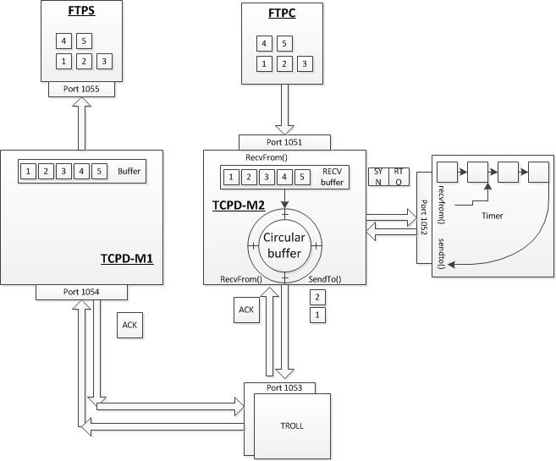
Figure 1: High level architecture

Design (function calls and Data structures)
The design of this process involves making use of data structures such as Linked Lists and Arrays, which is described below.

Packet format

Packet sequence between FTPC and FTPS:
The format of the data packet sent is as follows:
- The first 4 bytes contain the number of bytes in the file being transferred.
- The next 20 bytes will contain the name of the file.
- The rest of the bytes being transferred will contain the data in the file.
- The end of transmission is indicated using a special set of characters.

Packet format between FTPC and TCPD_M2:
FTPC initially sends the name of the file and its size to TCPD_M2. It then starts sending the file in 1000 bytes chunks.

Packet format between TCPD_M2 and Timer:
TCPD_M2 sends the Sequence number of the packet, the RTO value of the packet and a mode (Insert, Delete and End) to the timer.

Variable | Data type | Comment
sequenceNumber | Integer | Contains the sequence number of a particular packet.
time | Integer | Contains the RTT value of the packet.
flag | Integer | Indicates one out of 3 operations:  0 Insert, 1 Delete, 2 End.

Packet format between TCPD_M2 and TCPD_M1:
TCPD_M2 sends the address of the destination (TCPD_M1) and the data payload to the Troll. The communication between these two processes happens using the standard TCP header and payload. The data received from TCPD_M1 to TCPD_M2 would only have the headers to indicate acknowledgements of the data received.
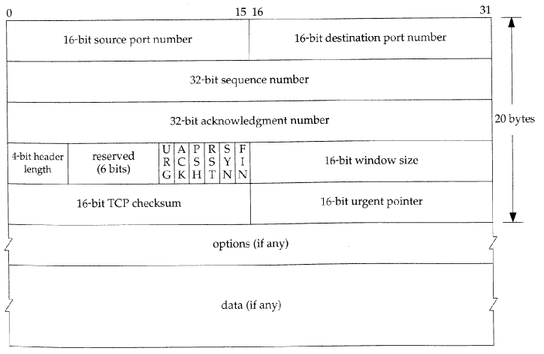

Packet format between TCPD_M1 and FTPS:
The packet format between TCPD_M1 and FTPS is the same as that between FTPC and TCPD_M2.

Library function calls:
  - SOCKET()
Creates a socket connection. Internally uses the standard sock() call but creates a UDP socket.
  - BIND()
Binds the created socket to the address specified. Uses standard bind().
  - ACCEPT()
Implements a select() function call which is a blocking call. FTPS makes use of this function while waiting to receive data from TCPD_M1 so that it unblocks on receipt of data.
  - CONNECT()
Implements a sendto() function call. Library makes use of CONNECT() to send the destination address details of FTPS (where TCPD_M1 is also located) to TCPD_M2.
  - SEND()
Implements a sendto() function call. FTPC makes use of SEND() to send data to TCPD_M2.
  - RECV()
FTPS makes use of this function to receive the file payload from TCPD_M1. Uses the address that was
  - CLOSE()
This function closes the socket connections. If it is FTPC, it also sends the “end-of-file” message to TCPD_M2 which then forwards it to TCPD_M1 (More details in connection shutdown) signaling the end of transmission.

FTPC
This is the client application that splits the file to be transferred into equal parts and sends it to the TCPD-M2 process. Communication with the local TCPD process is via UDP sockets.
Operations:
- Splits the file into packets of 1000-bytes each and send them to the FTPD-M2 process.
- Makes function calls such as SOCKET(), BIND() and CONNECT().
- Read bytes from the file and uses SEND() to send data to FTPS. SEND() is a blocking call and does not return until all bytes are written to the TCPD buffer.
- The FTPC is started using the below command:
Ftpc <remote-IP> <remote-port> <local-file-to-transfer>

TCPD-M2
This process has the implementation of the TCP stack and is roughly equivalent to the TCP in the OS.
Operations:
The operations of the TCP Daemon process in the client side are as given below:
- Receive message from FTPC and store in wrap-around (Circular) buffer.
- Calculate and keep updating the RTT and RTO values.
- Calculate the checksum for a packet.
- Manage the Wrap-around buffer.
- Keep track of the ACKs for the packet and resend is required by communicating with the Timer.
- Close the connections with the Timer and the FTPC process.

RTT and RTO calculation
RTT is the time taken between the transmission of a packet and the reception of its ACK. It can be determined programmatically by sending a packet to a receiver, receiving the ACK and finding out the time it took for the round trip. The RTT and RTO can be calculated using the formulae given below (Jacobson’s implementation):

Err = M – A (M is the current RTT measurement; A is the smoothed RTT (average);
A = A +g Err (g is the gain for the average and is set to 0.125)
D = D + h (|Err| - D) (D is the smoothed deviation of the RTT values)
RTO = A + 4D

The steps followed before sending a packet is as follows:
- Send a packet and receive the ACK to find the RTT.
- Find the average of the RTT.
- Compute the above values and the RTO.
- Use these values as a method of congestion avoidance.

Checksum Computation
For checksum calculation we have used the method defined in RFC 793. As per the RFC a pseudo header was created which contains information taken from fields in both the TCP header and the IP datagram in which the TCP segment was encapsulated. The checksum is calculated over all the octets of the pseudo header, TCP header and data. As the payload + header contains exactly contains an even number of octets, no padding is done at the end of the data. The pseudo header is not transmitted with the packet. The pseudo header is as shown below:

Field | Size | Description
Source address | 4 | 32-bit IP address of the originator of the datagram (taken from IP header)
Destination address | 4 | 32-bit IP address of the recipient of the datagram (taken from IP header)
Reserved | 1 | 8 bits of zeros
Protocol | 1 | The protocol is TCP and this field will have the value 6
TCP length | 2 | The length of the TCP segment including both header and data, which is computed.

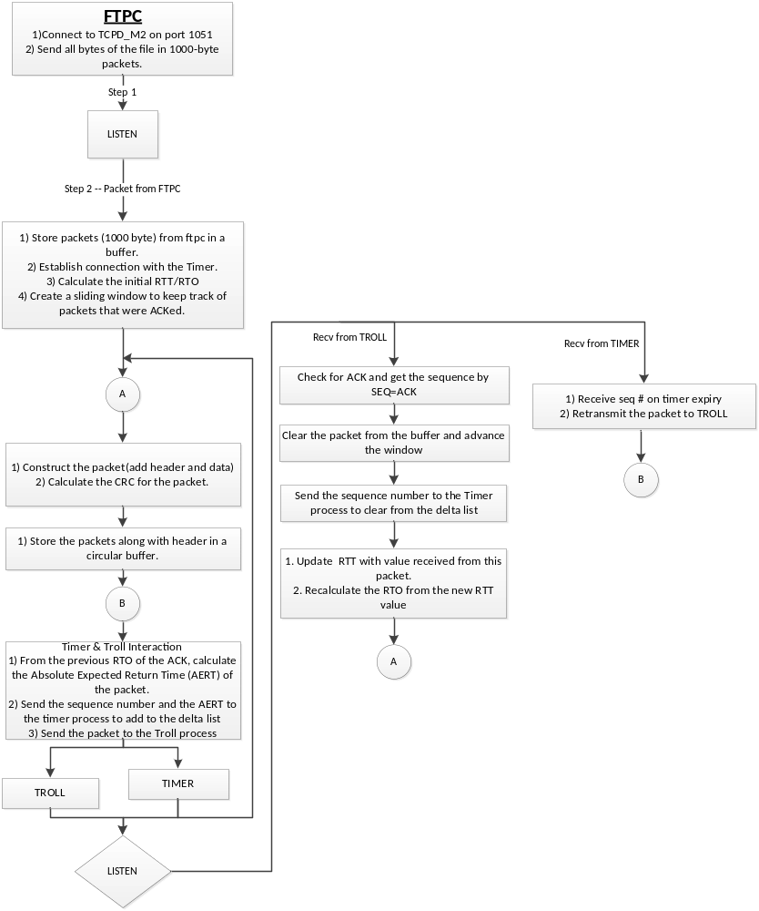
Figure 2: Flow of TCPD_M2

Circular-buffer implementation with sliding window:
The circular buffer helps to keep track of the packets that were sent to the server. It can be implemented by making use of three pointers and a variable to keep track of the count of the values inserted into the buffer. The three pointers are:
- Pointer to the actual buffer location in memory that gives the start of the buffer.
- Pointer to the end of the buffer location in memory that gives the end of the buffer.
- Pointer to insert data into the buffer, which moves along with the data inserted.

FTPS
Operations:
- Receive the file from TCPD-M1 and store it in a directory different from that of FTPC.
- Makes the function calls SOCKET(), BIND() and ACCEPT().
- Blocks until a connection is made to it from the client.

TCPD-M1
Operations:
The operations of the TCP Daemon process in the server side are as given below:
- Receive message from the TROLL and store packets in a buffer.
- Calculate the CHECKSUM for the received packet.
- Send the ACKs for the received packets.
- After receiving all packets, send them to the FTPS process.
- Close the connections with the TROLL and the FTPS process.

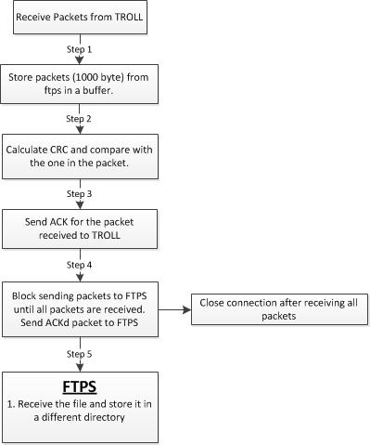
Figure 3: TCPD-M1

Connection shutdown
The 4-way TCP connection teardown has been implemented in this project the library libtcpd_socket, TCPD_M2 and TCPD_M1 have their roles in this. On CLOSE() the library sends “end-of-file” message (##$$CONNECTEND$$##) to TCPD_M2. On its receipt TCPD_M2 sends the FIN to TCPD_M1 and enters into the FIN_WAIT1 state.
TCPD_M1 sends the ACK for the FIN received from TCPD_M2 and enters CLOSE_WAIT, but does not send a FIN back until its buffer is empty (meaning, it has received all data packets). After the buffer becomes empty, M1 sends a FIN and enters into the LAST_ACK state. It also starts a timer so that it can retransmit the FIN if the ACK from TCPD_M2 does not return in time. After the ACK comes back, TCPD_M1 closes its connection and enters CLOSED state.
When a FIN from TCPD_M1 is received TCPD_M2 enters the FIN_WAIT2, sends an ACK when its buffer is empty and enters the TIME_WAIT state where it waits for a period of 2MSL (MSL set to 15seconds). This is to make sure that last ACK sent is not lost. Post 2MSL time it closes the connection and enters CLOSED state.

Timer
The Timer was implemented using a doubly-linked list which stores the sequence number of the packet and its corresponding delta timeout value.
Seq #, time
Seq #, time

The Timer interacts with the TCPD_M2 process using afore mentioned packet format. A timer is maintained that would trigger for every change in the head node and the timeout for the timer is set to the delta timeout value in head.
To keep a track of from what time the delta differs from a time variable called total_elapsed_time is maintained. This time is initialized to the current time whenever the first packet is added to the delta list. Every packet is added to the list would calculate its delta time with respect to this time.

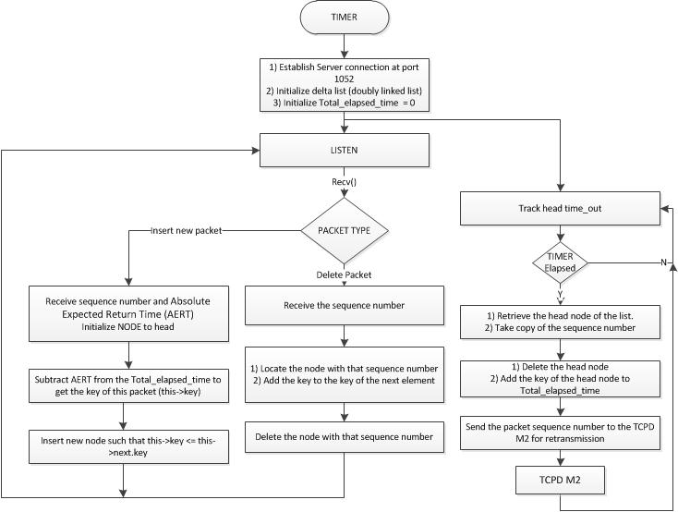
Figure 4: Timer

Results

Test Cases
We tested our implementation with different file types, different sizes and with different troll parameters, as shown below:
File name | File size (kb) | Troll parameters | Result
piano.xls | 321.5 | Drop – 5, 10 and 25%  Delay – 5, 10 and 25%  Garble – 5, 10 and 25%  Duplicate – 5, 10 and 25% | PASS
IOC-LOGO.jpg | 6.6 | Drop – 5, 10 and 25%  Delay – 5, 10 and 25%  Garble – 5, 10 and 25%  Duplicate – 5, 10 and 25% | PASS
test.pdf | 82 | Drop – 5, 10 and 25%  Delay – 5, 10 and 25%  Garble – 5, 10 and 25%  Duplicate – 5, 10 and 25% | PASS

Application details

Application | Server | Port
Ftpc | 164.107.112.41 (mu) | -
TCPD-M2 (client) | 164.107.112.41 (mu) | 1051
Timer | 164.107.112.41 (mu) | 1052
Troll | 164.107.112.41 (mu) | 1053
TCPD-M1 | 164.107.112.23 (Kappa) | 1054
Ftps | 164.107.112.23 (Kappa) | 1055 (Used internally)

Screen-Grabs
The screen-grabs of the applications are shown below:

- List of test files.
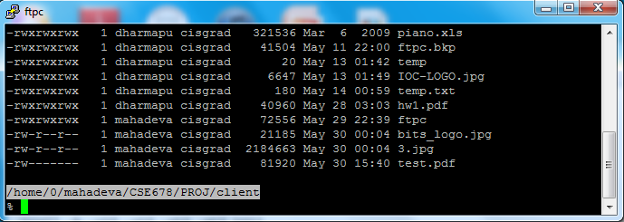
Figure 5

- Absence of the file at the server.
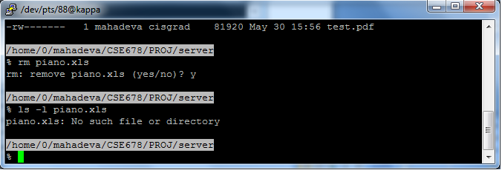
Figure 6
- File being transmitted – Initial stage:
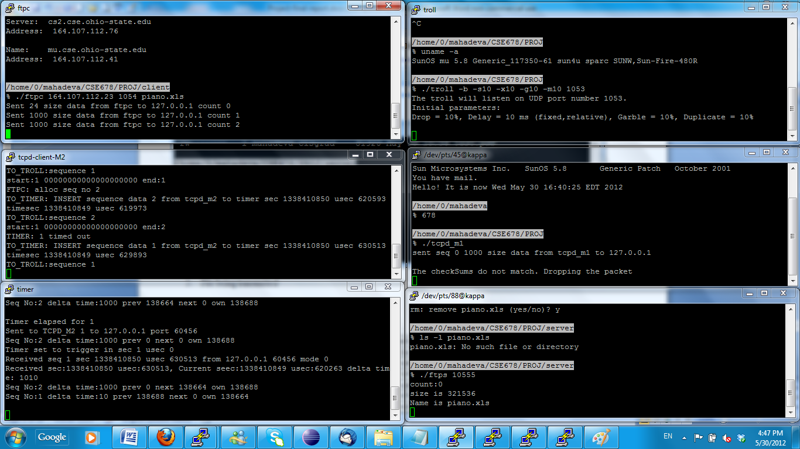
Figure 7

Intermediate stage:

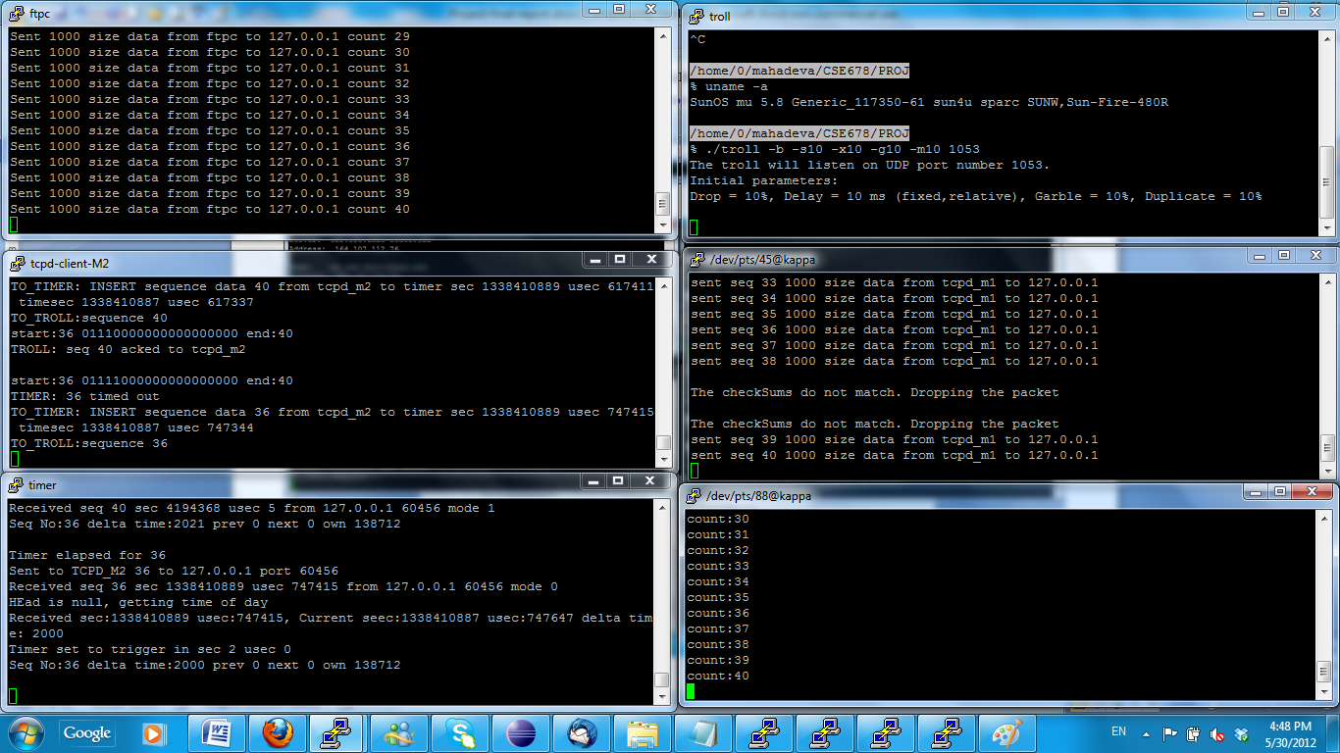
Figure 8

- MD5 checksum of the file:

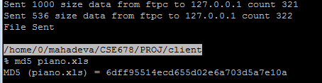
Figure 9

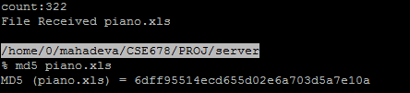
Figure 10

Project Management

Task split
Task | Responsibility
Project proposal | Ananth | Abhishek
Architecture design | Ananth | Abhishek
Coding – Timer, Sliding window |  | Abhishek
Coding – Circular Buffer, RTO, Checksum | Ananth
Testing | Ananth | Abhishek
Final report | Ananth | Abhishek

Plan vs Implementation
There were quite a few changes between our plan and the actual implementation. Abhishek implemented the timer and the sliding window, while Ananth implemented the Circular buffer, RTT/RTO computation and the checksum computation. This is how we worked:
- Created a common shared directory in the stdsun machine so that both of us could compile our code with the main code if required.
- After implementing our individual components, we merged the code.
- Both of us tested the entire project together so that when there were issues, we were able to exchange ideas while troubleshooting. This helped us clear quite a lot of confusion and enabled us to understand the concepts much better.

Miscellaneous

Unique features of our implementation
- Better readability of the code: Features provided by the C language have been used to help read the code better. Comments have been used at several places to aid understanding of the flow. Macros and enumerations have been used at all possible places to denote TCP states, flags etc. Union used for checksum calculation; the packet would be copied into the struct and over the same memory an array of short integers were used to aid in calculation of checksum. Programs have been compiled and tested against “gcc –Wall” option to have good quality code.
- Shared library has been created for the TCPD calls SOCKET(), BIND() etc. mentioned earlier. This library can be used by other applications as well.
- Bit maps used to implement the sliding window at TCPD_M1. This uses less space as compared to keeping an array of elements to monitor the packets sent and the acknowledgements received. Simple shift operations (left shift) required to move window as acks are received.
- The address of the destination is dynamically made known to TCPD_M2 by the CONNECT() call invoked by FTPC. The destination/source IP is not required as an argument to any of the daemons.

Yet to implement
We don’t have anything else to be implemented and have completed what was required of the project.

Most complicated part
The following were according us the most complicated part:
- Timer:
Implementation of the delta list took a long time as we had difficulty testing for its functioning. We were initially not sure how situations when 2 timers expire at the same time would work.
- Sliding window:
Implementing the sliding window was easy as compared to testing for correctness. Testing it across the daemon processes for consistent behavior was tedious.
- Maintaining the sequence numbers for the packets:
We had issues where the packets that were not sent to TCPD-M1 were being acknowledged and the sliding window at TCPD-M2 started moving towards the right. It took us lot of hours to figure out the cause of the issue.

Future plans and extensions
- We plan to implement a JPEG/MPEG encoder for compression.
- Steganography - To use this project in order to transfer and receive encrypted messages.

Acknowledgements
- We wish to acknowledge our instructor Mr. Peter Dohm for his guidance during the project.
- We also wish to acknowledge the known and unknown individuals whose code or postings in bulletin boards guided us when we were stuck while troubleshooting.

References
- TCP/IP Illustrated, Volume 1 – The Protocols by W. Richard Stevens.
- https://en.wikipedia.org/wiki/Circular_buffer
- https://en.wikipedia.org/wiki/Sliding_window_protocol
- https://en.wikipedia.org/wiki/Round-trip_delay_time
- https://en.wikipedia.org/wiki/Transmission_Control_Protocol
- http://www.tcpipguide.com/free/t_TCPChecksumCalculationandtheTCPPseudoHeader-2.htm
- http://www.netfor2.com/tcpsum.htm
- http://ssfnet.org/Exchange/tcp/tcpTutorialNotes.html#SW
- http://akomaenablog.blogspot.com/2008/06/simple-senderreceiver-program-to.html

