Django manage.py server running, (Note: /accounts/facebook/login depicted below)

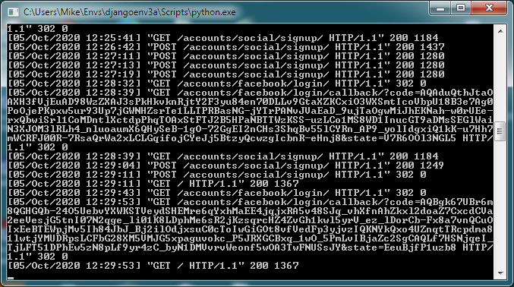

Django admin:

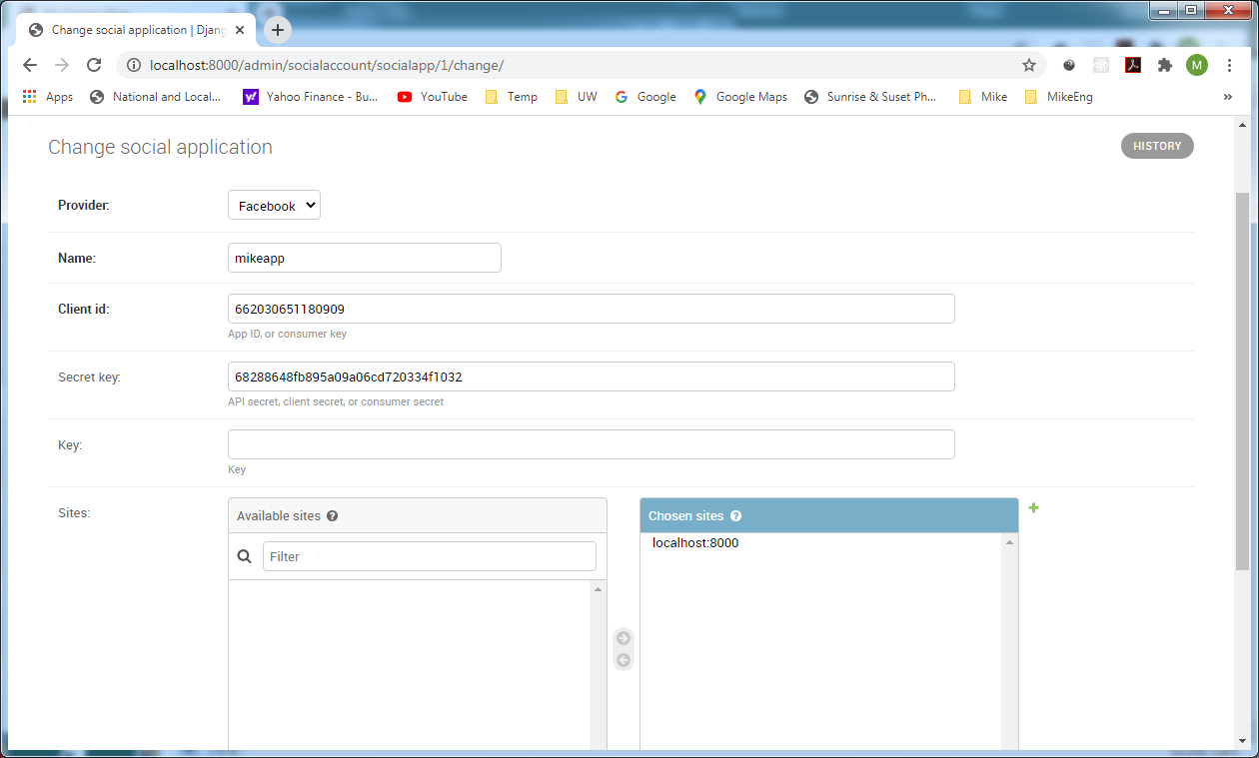

http://localhost:8000/accounts/facebook/login redirected to FB login:

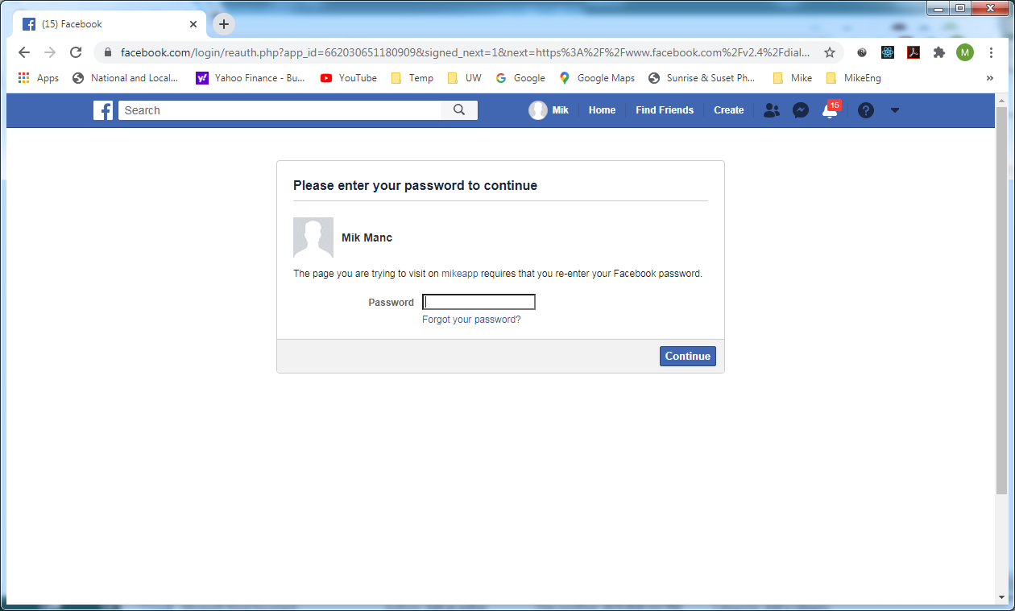

Successfully logged in to Facebook, redirected to Profile page http://localhost:8000/#_=_

