Django manage.py server running, (ModelForm create short post processed, http://localhost:8000/create)

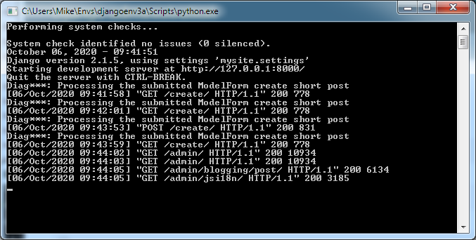

http://localhost:8000/create: (using ModelForm create short post, http:8000/localhost/create)

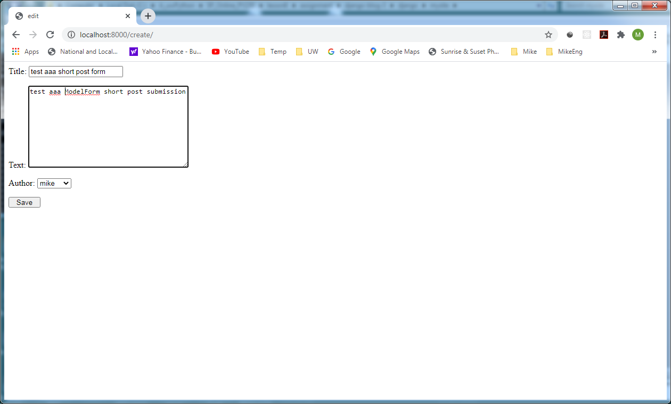

Use django Admin to verify the submitted create short post form (ModelForm) processed successfully post added)

