**Purpose**

The Keyword Driven Framework is designed to minimize the manual testing efforts. The framework should help to reduce the efforts for regression testing by 80%. For this purpose, the datasheet is created, with separate sheets for the keywords to execute the test cases, and to hold and supply the data corresponding to it.

The purpose of this document is to elaborate the structure of the excel sheet, with the sheets inside it and the columns present in them, along with the values required to enter and the functionality behind it.

**Overview**

The excel sheet can have these sheets present in it, viz:

* Test Suite Sheet: Must be suffixed by ‘_Suite’
* Test Data Sheet: Must be suffixed by ‘_Data’
* Global Test Data Sheet: Must be suffixed by ‘_Global_Data’

Multiple test suites can be maintained in one excel file, separated by the sheets. If so, unique names should be maintained for each of them. The data present in the Global Data Sheet can be used by all of these Suites.  
  
For the data, specific to a certain suite a separate sheet can be created, apart from the Global Data Sheet. Generally, This sheet should be named in such a way that the user is able to correspond the data present in Data Sheet with the Suite.

e.g. If the name of the Test Suite is ‘RegressionSuite_Suite’ the corresponding Data Sheet name should be: ‘RegressionSuite_Data’.

**Detailed** **Description**

**Suite**

The sheet for suite appears like this:

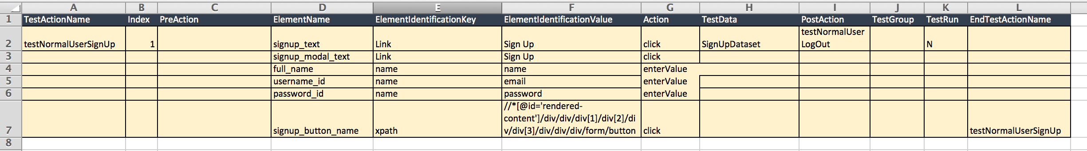

1. **TestActionName**

This column mentions the name of the test cases to be executed. The name can be chosen by the user. The same name must be used to start and end the test case.

1. **Index**

Shows the Priority of the Test Cases to be executed. The decimal numbers are also accepted for this purpose, and a whole integer is not needed.

1. **PreAction**

Lists the test cases, that are required to be executed before the current test case is executed. The name of the test case is entered in the first cell of the column, and the rest of the column is left blank.

In case of multiple test cases are required to be executed, they should be separated by a comma

1. **ElementName**

This columns contains the name of the element, on which the action is performed. The name present in this column needs to be accurately mapped with the name in the corresponding dataset

1. **ElementIdentificationKey**

The attribute by which the element is identified.

List of the supported attributed: Link, Name, Xpath, CSS Selector, ID.

The element cannot be selected from the attributes not mentioned above

1. **ElementIdentificationValue**

Actual value of the element to be identified.

1. **Action**

This column indicates the action to be performed on the element selected. It can be selected from a list of pre-determined actions. The list:

|  |  |  |  |
| --- | --- | --- | --- |
| clear | getCoordinates | isSelected | scrollUp |
| click | getCssValue | loadPage | selectDropDownList |
| certificateErrorClick | getSize | navigateToUrl | sendKeys |
| check | getText | OpenBrowser | sleep |
| clickEvent | getWebElement | openNewTab | submit |
| close_ToggleWindow | hasImage | pinch | swipe |
| closeBrowser | hasValue | reSize | tap |
| contains | hover | scrollBottom | toggleWindow |
| doubleClick | IsChecked | scrollDown | uncheck |
| dragAndDrop | isDisplayed | scrollLeft | url |
| enterValue | isElementVisible | scrollRight | zoomIn |
| executeJava | isEnabled | scrollToElement | zoomOut |
| getAttribute | isGreaterThan | scrollTop | zoomTo100 |
| getBackToURL | isLessThan |  |  |

1. **TestData**

This column lists the dataset name, from which the data is to be used for the test case. The name for the columns in the dataset should be exactly the same as the ‘ElementName’ of the element for which the data is to be populated

1. **PostAction**

Lists the test cases that are to be executed after the main test case is executed.

1. **TestGroup**

Contains the name of the TestGroup, to which the test case belongs

1. **TestRun**

This is the flag, that determines if the test case is executed or not.

If the test case is executed as part of PreAction or PostAction of another test case, this flag does not affect the execution

1. **EndTestActionName**

This column signifies the end of the test case, and lists the name of the same in the bottom cell

**Data**

The sheet for data looks like this:

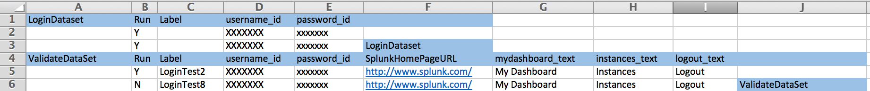

In the Data Sheet, there are datasets present, which hold the data that can be passed to the test cases. The dataset name is unique, and marks the beginning and end of the dataset.

The same dataset can be used for multiple testcases.

**Dataset**

In the dataset, there are a few mandatory columns, which contains the information regarding the dataset. The other columns, which contain the data for the testcases, can vary in the number according to the values required for test case/s using the dataset.

**Columns:**

1. **Beginning of the dataset**

This column contains the name of the dataset, in the first cell. This column does not have a heading. The dataset name serves as the heading instead

1. **Run**

This column contains the flag, that determines if the values listed in the column will be considered for testcase execution or not

1. **Label**

This column contains the label for the data in the subsequent row. The values in this column are optional.

1. **Data Columns**

These columns, which vary in number contain the actual data that is passed to the test cases.   
The names of these column headers should be exactly as the corresponding values in the ‘ElementName’ column of the test case, which is using the data for execution

1. **End of the dataset**

This Column indicates the end of the dataset. It contains the name of the dataset in the last cell, to mark the end. This column, like the first column does not have a header.